Machine Learning-Based Streamflow Forecasting in the Bosna River Basin (Bosnia and Herzegovina)

Introduction

Reliable streamflow predictions are fundamental for strengthening resilience and sustainability in water resources management (Kenyi & Yamamoto, 2024). The management practices commonly involve assessments that incorporate hydrological extremes analysis, reservoirs functioning, public water use, hydraulic infrastructure planning at the national scale and agricultural systems (Kaur & Chavan, 2025; Zhao et al. 2024). At the same time, pronounced shifts in the hydrological cycle, driven by anthropogenic climate change forcing, continue to raise further concerns given that projected changes in hydrological regimes suggest overall decline in annual precipitation, coupled with an elevated likelihood of droughts and amplification of rapid extreme events (Luppichini et al. 2024). Accurate streamflow prediction is a demanding task owing to the perplexed and non-linear behavior of hydrological systems which are shaped by precipitation patterns, temperature variations, land use, human interventions and alongside a lack of empirical data (Hamzeh et al. 2025; Suwal et al. 2025).
Significant endeavors have been devoted to creating and implementing various approaches aimed at enhancing the reliability and forecast precision, which can generally be grouped into two categories. The first category entails models indented to simulate the rainfall-runoff response grounded in physical principles, while depending on simplified premises, they necessitate substantial data inputs (Ni et al. 2020). The second category encompass data-driven models, consisting of statistical and ML methodologies, which rely on historical observations rather than physical process information, enabling for empirical utilization and straightforward to implement (Kedam et al. 2024; Ni et al. 2020). Over the past decade, machine learning (ML) models have established a significant role in hydrological modeling, especially in streamflow forecasting, where they tend to outperform traditional physically based approaches in forecast precision (López-Chacón et al. 2025).
The use of ML techniques for streamflow forecasting has been becoming increasingly common among scientists over the past decade primarily due to their capability to capture non-linear dynamics and temporal variability in hydrological processes and interacting factors without requiring explicit representation of underlying physical processes (Feng et al. 2020; Kedam et al. 2024). A broad range of models has been utilized in streamflow prediction research, with Artificial Neural Networks (ANNs) (Dalkiliç & Hashimi, 2020; Ha et al. 2021; Khan et al. 2023), Long short-term memory (LSTM) (Hunt et al. 2022; Leščešen et al. 2025; Nguyen et al. 2025), Deep Neural Networks (DNNs) (Liu et al. 2025; Huang et al. 2025), Support Vector Regression (SVR) (Callegari et al. 2015; Sharma & Goel, 2024), Random Forest (RF) (Pham et al. 2021; Puri et al. 2024), Light Gradient Boosting Machine (LGBM) (Kumar et al. 2023; Xu et al. 2023), and eXtreme Gradient Boosting (XGBoost) (Alipour 2025; Guo et al. 2025; Reddy & Srivastav, 2026) among the most commonly employed techniques.

This research examines the utilization of RF, XGBoost and LSTM networks for the forecast of streamflow at the Doboj hydrological stations in the Bosna River Basin (BRB) in Bosnia and Herzegovina (BH). These techniques have proven remarkably scalable, robust, and highly efficient in solving various problems (Le et al., 2019) not only in already mentioned forecasting in hydrology, but also in other, complementary fields such as finance (Liu et al., 2015), remote sensing (Belgiu & Drăguţ, 2016), sentiment analysis (Hama-Aziz & Dimililer, 2021), and even solar energy forecasting (Jailani et al., 2023), thus making them an attractive choice for a suitable predictive model.
To the best of our knowledge, this study represents the first application of machine learning (ML) methods for streamflow forecasting in Bosnia and Herzegovina. The primary objective was to address a critical gap in the existing literature by demonstrating the potential of ML techniques in water sciences through a case study of the Bosna River Basin (BRB), thereby moving beyond the predominantly descriptive analyses of streamflow previously conducted in the country. An additional objective was to provide a foundation for understanding basin-specific hydrological processes and water management challenges within the BRB, with particular emphasis on accurate and interpretable forecasting. To this end, explainable artificial intelligence (XAI) tools were employed (Dwivedi et al., 2023) to relate model predictions to fundamental hydrological drivers and their temporal lags. This approach offers new insights into the relative influence of individual features, facilitating high-quality predictions while enhancing model transparency and hydrological interpretability.

A comprehensive evaluation of multiple ML frameworks over the BRB is expected to inform future research directions and facilitate the effective integration of machine learning into water resources management practices worldwide.

Study area

The Bosna River Basin (BRB) is the largest and one of the principal basins of Bosnia and Herzegovina (BH), with its entire area situated within the national territory, extending across central, eastern and northern parts of the country. The BRB encompasses primary urban and industrial centers, such as Sarajevo, Zenica, Tuzla, and Doboj, which together host more than 50% of the national population, thereby establishing the basin as an economic hotspot. The basin occupies an area of 10457 km², covering ~20% of the overall area of BH, whereas the length of river and mean elevation of the basin are 275 km and 640 m, respectively (Gnjato et al. 2025). The river has its source at the foot of Mt Igman at 500 m a.s.l., emerging as a substantial karst spring at the transition between the limestone formation and the alluvial plain. The upper section of the BRB features a well-developed drainage network, comprising several major and numerous smaller torrential streams that rise significantly during heavy precipitation events, often causing floods. It extends from the river source to the city of Zenica. This upper section of the basin is mainly made of schists, sandstones, limestones and lacustrine sediments, but unlike in most other river basins in BH, limestone effect in the BRB is minor (Gnjato 2022). Extending from Zenica to Doboj, the middle section of the BRB is supplied by several major tributaries, including the Usora, Krivaja, and Spreča Rivers. The lower northern part of the Bosna River Basin extends from the town of Doboj to the confluence of the Bosna with the Sava River. This segment lacks major tributaries, and the geology of the area is predominately marked by alluvial sediments. Bosna River along with its main affluents are distinguished by the Posavina subtype of the pluvial-nival water regime and are marked by peak streamflows in April and March, and minimum in August and September (Gnjato et al. 2021). Climatic patterns in the Bosna River basin differ from mountainous conditions in the south to continental and moderately continental types in the central and northern segments of the basin (Gnjato et al. 2023).

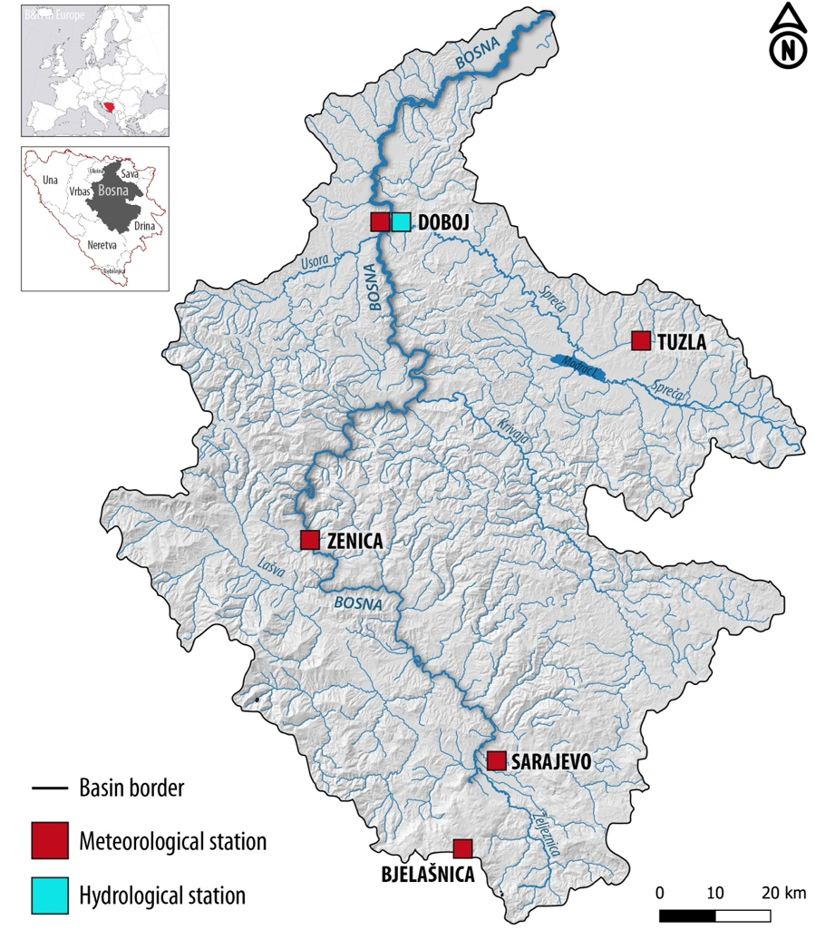

Figure 1. Map of the Bosna River Basin

DATA AND METHODS

Computational Framework

Compared Models. In this study, three data-driven modeling approaches were evaluated for predicting mean monthly streamflow in the Bosna River: Random Forest (RF), Extreme Gradient Boosting (XGBoost), and Long Short-Term Memory (LSTM) neural networks. Random Forest is an ensemble learning method based on bootstrap aggregation of decision trees (Breiman, 2001). Owing to its robustness to noise, ability to capture nonlinear relationships, and reduced sensitivity to multicollinearity, RF has been widely adopted in hydrological modeling and is commonly used as a strong baseline approach (Tyralis et al., 2019; Yaseen et al., 2018). XGBoost is a gradient boosting framework that sequentially constructs decision trees, with each new tree aiming to correct the errors of its predecessors (Chen & Guestrin, 2016). Compared to RF, XGBoost provides enhanced control over model complexity through regularization and learning-rate parameters and has demonstrated strong performance in hydro-climatic prediction tasks (Li et al., 2020; Fan et al., 2021). LSTM represents a class of recurrent neural networks specifically designed to capture long-term temporal dependencies in sequential data (Hochreiter & Schmidhuber, 1997). It is included in this study to assess whether deep learning models can extract additional predictive skill from long-term hydro-climatic time series compared to tree-based ensemble methods, as demonstrated in recent rainfall–runoff and streamflow forecasting studies (Kratzert et al., 2018; Shen, 2018).
Together, these models represent complementary modeling paradigms: bagging-based ensembles (RF), boosting-based ensembles (XGBoost), and sequence-based deep learning (LSTM).

Dataset Description

The dataset consists of monthly aggregated observations spanning the period from 1961 to 2020. Each record corresponds to a single month.
Meteorological predictors include the mean monthly precipitation (P) and mean monthly air temperature (T), observed at five meteorological stations located within the Bosna River basin: Bjelašnica, Sarajevo, Zenica, Tuzla, and Doboj. The target variable for prediction is the mean monthly streamflow (Q), measured at the basin outlet. All variables were aggregated to monthly resolution to ensure temporal consistency and long-term coverage. In addition, we found a few missing data for the Zenica station within a gap of 6 month in 2017. These are properly filled in by applying the Climatological Monthly Mean Filling across all historical data for that station.

Feature Engineering and Lagged Variables

To account for hydrological memory effects and delayed basin response, lagged predictor variables were introduced. Let 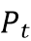, , and 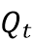 denote precipitation, temperature, and streamflow at time step , respectively.

The following lag structure was applied:
- Precipitation lags: 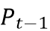, 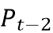, 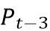
- Temperature lags: 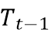, 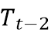
- Autoregressive streamflow term: 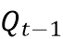

The autoregressive streamflow term represents short-term persistence in river flow and is commonly used in hydrological forecasting to improve predictive performance. Lagged features were generated independently for each station and variable. Observations containing missing values caused by lagging were removed prior to model training.

Performance Metrics

Model performance was evaluated using hydrologically relevant efficiency metrics. Besides Minimum Absolute Error (MAE) and the Root Mean Square Error (RMSE), Nash–Sutcliffe measure, and Kling–Gupta measure are determined.
The Nash–Sutcliffe Efficiency (NSE) measures the predictive skill of a model relative to the mean of observed streamflow values and is defined as:
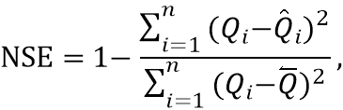
where 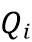 and 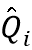 denote observed and predicted streamflow values, respectively, and is the mean of observed streamflows.

The Kling–Gupta Efficiency (KGE) decomposes model performance into correlation, bias, and variability components:
where is the Pearson correlation coefficient, is the bias ratio, and is the variability ratio between predicted and observed streamflows.
NSE was used as the primary optimization criterion during model tuning, while KGE was employed for complementary evaluation.

Training, Validation, and Temporal Splitting

To respect the temporal structure of the data and avoid information leakage, a time-based splitting strategy was adopted. The dataset was divided into:
- Training period: 1961–2010
- Testing period: 2011–2020
Within the training period, rolling-origin cross-validation was implemented using a time-series split with five folds. In this setup, validation sets always occur chronologically after the corresponding training subsets.

Hyperparameter Tuning of XGBoost, RF, and LSTM

To tune the parameters of all three models, the basic grid search technique combined with time-series cross-validation is utilized on the train data. For example, for XGBoost, the following parameters were considered:
- Number of trees (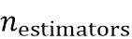)
- Maximum tree depth (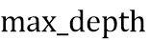)
- Learning rate ()
- Subsampling ratio
- Column subsampling ratio

For each parameter combination, initially pre-defined, model performance was evaluated using the mean NSE across the five validation folds. The parameter set yielding the highest NSE was selected as optimal.

The following values of parameters are produced from the grid search:

- RF: max_depth: 30, max_features: sqrt, min_samples_leaf: 1 min_samples_split: 2, n_estimators: 2000
- XGBoost: colsample_bytree: 0.8 learning_rate: 0.05, max_depth: 4, n_estimators: 600, subsample: 0.7
- LSTM: units: 64, lr: 0.001, batch_size: 16, epochs: 200,

One-Step-Ahead Forecasting and Bias Correction

Using the optimized model, one-step-ahead forecasts were generated for the testing period. To reduce systematic bias, a linear scaling correction was applied. A linear regression model was fitted between predicted and observed streamflow values on the training set:
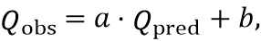
where and are regression coefficients estimated from the training data.
The derived correction was subsequently applied to test-period predictions, preserving temporal dynamics while improving distributional consistency.

Summary of the Computational Workflow
The complete modeling workflow consists of the following steps:

- Construction of lagged hydro-meteorological features
- Time-based train–test splitting
- Rolling-origin cross-validation for hyperparameter tuning
- Model selection based on NSE
- One-step-ahead streamflow forecasting
- Linear bias correction
- Performance evaluation using NSE, KGE, RMSE, and MAE

RESULTS & DISCUSSION

The performance metrics presented in Table 1 reveal notable differences in both fitting capacity and generalization ability among the evaluated models. XGBoost achieved near-perfect accuracy on the training dataset (NSE = 0.999, KGE = 0.993), indicating a very strong ability to capture nonlinear relationships between hydro-meteorological predictors and streamflows. However, this excellent training performance does not fully translate to the testing period, where NSE and KGE drop to approximately 0.59 (Table 1). The substantial gap between training and testing accuracy suggests that XGBoost may partially overfit the historical training data, despite the use of time-series cross-validation and regularization parameters.
Random Forest exhibits slightly lower training accuracy (NSE = 0.964, KGE = 0.884) compared to XGBoost, but achieves nearly identical performance on the testing dataset (NSE = 0.591, KGE = 0.591) (Table 1). This behavior indicates a more balanced bias–variance trade-off and suggests that Random Forest generalizes marginally better to unseen data. The similarity of test performance between Random Forest and XGBoost implies that, for the considered feature set and temporal resolution, additional model complexity does not yield substantial gains in predictive skill. The LSTM model shows the weakest performance among the evaluated approaches. Training accuracy is moderate (NSE = 0.443), and testing performance remains limited (NSE = 0.445), indicating that the model struggles to effectively learn the streamflow dynamics (Table 1). Several factors may contribute to this behavior. First, the dataset consists of monthly aggregated observations, which may not provide sufficient temporal resolution for LSTM models to exploit long-range dependencies. Second, the relatively limited number of training samples compared to the high parameterization of LSTM networks may hinder stable learning. Finally, the use of a single-step input structure with engineered lag features may reduce the advantage of sequence-based deep learning relative to tree-based methods.

Model | Dataset | RMSE | MAE | NSE | KGE
XGBoost | Training | 2.920 | 2.208 | 0.999 | 0.993
 | Testing | 64.680 | 48.029 | 0.589 | 0.589
Random Forest | Training | 20.769 | 14.888 | 0.964 | 0.884
 | Testing | 64.500 | 47.169 | 0.591 | 0.591
LSTM | Training | 81.581 | 57.432 | 0.443 | 0.382
 | Testing | 75.086 | 54.763 | 0.445 | 0.489
Table 1. Performance comparison of the evaluated models on training and testing data. RMSE and MAE are expressed in streamflow units, while NSE and KGE are dimensionless.

Overall, the results demonstrate that tree-based ensemble models outperform deep learning approaches for monthly streamflows prediction of the Bosna River under the given data availability and feature configuration. While XGBoost achieves the highest fitting accuracy, Random Forest provides comparable test performance with greater robustness. The observed performance gap between training and testing across all models also highlights the challenge of nonstationarity in long-term hydro-climatic time series, emphasizing the importance of careful validation strategies and model selection. These findings suggest that, for long-term monthly streamflow prediction in data-limited settings, well-regularized ensemble methods combined with physically motivated lag features can provide reliable predictive performance without the complexity of deep learning architectures.
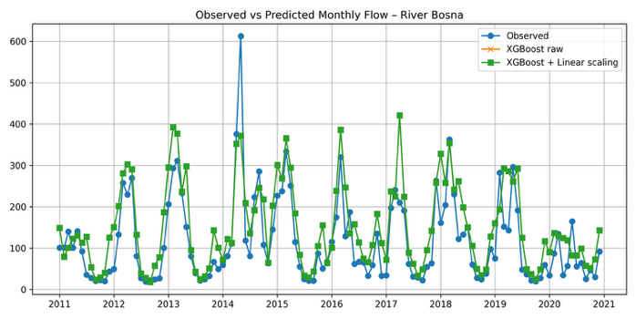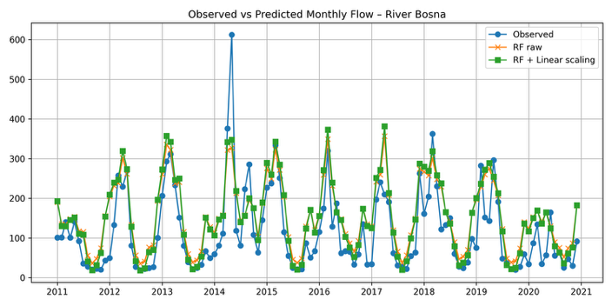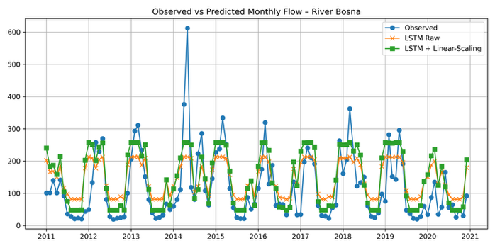
Figure 2. Observed versus predicted monthly streamflows during the testing period (2011–2020) for the evaluated models: (a) XGBoost, (b) Random Forest, and (c) LSTM. All predictions correspond to one-step-ahead forecasts after linear bias correction.
Feature Importance and Explainable Artificial Intelligence

While predictive accuracy is essential, understanding the contribution of individual hydro-meteorological predictors is equally important for decision support and scientific insight. To this end, an Explainable Artificial Intelligence (XAI) analysis was conducted to assess the relative importance of input features and their influence on streamflow prediction.
Given the heterogeneous nature of the evaluated models, different yet conceptually consistent feature importance approaches were employed. For the tree-based models (XGBoost and Random Forest), feature importance was derived from model-based importance measures, while for the LSTM model a permutation-based approach was adopted to ensure comparability across model classes.

Permutation-Based Feature Importance

Permutation importance quantifies the contribution of a feature by measuring the decrease in model performance when the feature’s values are randomly permuted. Let denote a trained model and 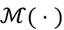 a performance metric, here the Nash–Sutcliffe Efficiency (NSE). The importance of feature is computed as:
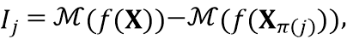
where 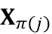 denotes the input matrix with feature permuted across samples.
A larger decrease in NSE indicates a more influential feature. This model-agnostic approach enables consistent interpretation across both tree-based and neural network models and directly reflects the impact of each feature on predictive skill.
Dominant Predictors of Streamflows

The analysis focused on the five most influential features for each model, ranked by their contribution to NSE reduction. Results indicate that lagged precipitation variables consistently dominate model predictions, particularly precipitation from the preceding one to three months. This finding is hydrologically meaningful, reflecting basin-scale storage effects and delayed runoff generation.
The autoregressive streamflow term () also emerges as a key predictor, highlighting the strong persistence of monthly river flow and confirming the importance of short-term memory in streamflow dynamics. Temperature-related features exhibit comparatively equally important influence, especially T_bjelasnica, likely capturing seasonal snowmelt and evapotranspiration effects, especially for upstream stations such as Bjelašnica.
Notably, feature importance rankings remain broadly consistent across XGBoost and Random Forest, especially the two most inflential features—T_bjelasnica and the auto-regressive Q_lag1—suggesting stable hydro-climatic controls on streamflows. In contrast, the LSTM model displays weaker and less structured importance patterns, consistent with its overall lower predictive performance. The agreement between data-driven feature importance and established hydrological understanding provides confidence in the physical plausibility of the models. The dominance of lagged precipitation and streamflows terms in both reasonably efficient models aligns with conceptual rainfall–runoff processes, while the secondary role of temperature in Bjelasnica reflects its indirect influence at monthly time scales.
From an operational perspective, these results demonstrate that explainable machine learning techniques can support transparent and trustworthy streamflow forecasting. By identifying the most influential predictors, the proposed framework enables both improved model diagnostics and enhanced interpretability for water resource management and decision-making.
Overall, the XAI analysis confirms that the tree-based ensemble models not only achieve higher predictive skill but also produce feature importance patterns that are consistent with hydrological theory, reinforcing their suitability for long-term monthly streamflow prediction in the BRB.

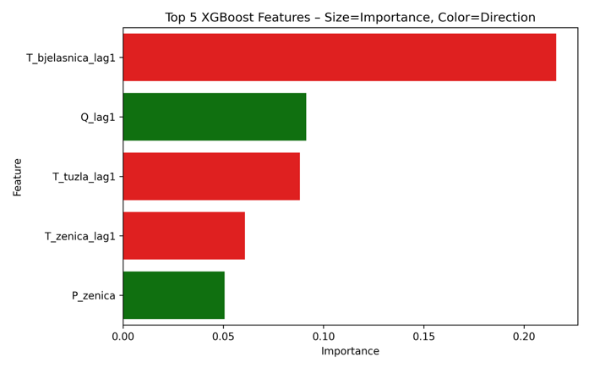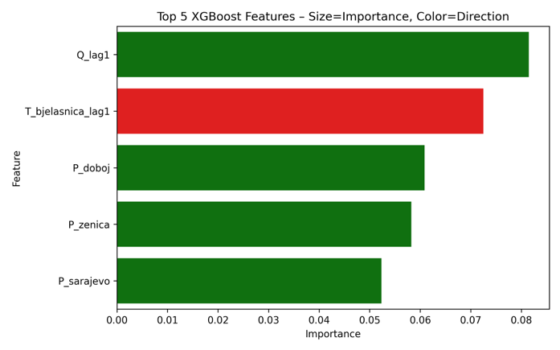
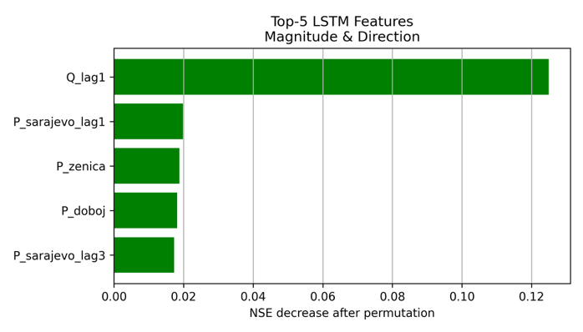
Figure 3. Direction and magnitude of the five most influential features identified through explainable artificial intelligence analysis: (a) XGBoost, (b) Random Forest, and (c) LSTM. Bars indicate the decrease in Nash–Sutcliffe Efficiency (NSE) after feature permutation, while color denotes the direction of influence (positive (green) or negative (red) contribution to predicted streamflows).

Figure 3 illustrates the relative importance and directional influence of the dominant predictors for each model, highlighting the consistent dominance of lagged precipitation and autoregressive streamflow terms across tree-based ensemble models.

References

- Alipour, M.H. (2025). Streamflow prediction in ungauged basins located within data-scarce areas using XGBoost: role of feature engineering and explainability. International Journal of River Basin Management, 23(1), 71–92. https://doi.org/10.1080/15715124.2023.2245809
- Callegari, M., Mazzoli, P., De Gregorio, L., Notarnicola, C., Pasolli, L., Petitta, M., & Pistocchi, A. (2015). Seasonal River Discharge Forecasting Using Support Vector Regression: A Case Study in the Italian Alps. Water, 7(5), 2494–2515. https://doi.org/10.3390/w7052494
- Feng, D., Fang, K., & Shen, C. (2020). Enhancing streamflow forecast and extracting insights using long–short term memory networks with data integration at continental scales. Water Resources Research, 56(9), e2019WR026793. https://doi.org/10.1029/2019WR026793
- Gnjato, S., Popov, T., & Gnjato, R. (2025). Climate Change Impact on Streamflows in Bosnia and Herzegovina: A Case Study of the Lower Bosna River Basin. Central Asian Journal of Geographical Research, 1-2, 95–101. https://doi.org/10.5281/zenodo.15501323
- Gnjato, S., Popov, T., Ivanišević, M., & Trbić, G. (2023). Long-term streamflow trends in Bosnia and Herzegovina (BH). Environmental Earth Sciences, 82. https://doi.org/10.1007/s12665-023-11040-9
- Gnjato, S. (2022). Climate change impact on river discharges in Bosnia and Herzegovina. Dissertation, University of Belgrade.
- Gnjato, S., Popov, T., Adžić, D., Ivanišević, M., Trbić, G., & Bajić, D. (2021). Influence of climate change on river discharges over the Sava river watershed in Bosnia and Herzegovina. Idöjárás, 125(3 ), 449–462. https://doi.org/10.28974/idojaras.2021.3.5
- Guo, J., Zhang, F., Li, W., Yang, A., Fan, Y., & Li, J. (2025). Runoff Prediction in the Xiangxi River Basin Under Climate Change: The Application of the HBV-XGBoost Coupled Model. Water, 17(16). https://doi.org/10.3390/w17162420
- Ha, S., Liu, D. & Mu, L. (2021). Prediction of Yangtze River streamflow based on deep learning neural network with El Niño–Southern Oscillation. Scientific Reports 11. https://doi.org/10.1038/s41598-021-90964-3
- Hamzeh, H.A., Zahra, A., & Mohammad, N.T. (2025). A comparative study between time series and soft computing models for river discharge forecasting. Applied Water Science, 15. https://doi.org/10.1007/s13201-025-02632-w
- Huang, J., Chen, J., Huang, H., & Cai, X. (2025). Deep Learning-Based Daily Streamflow Prediction Model for the Hanjiang River Basin. Hydrology, 12(7), 168. https://doi.org/10.3390/hydrology12070168
- Hunt, K. M. R., Matthews, G. R., Pappenberger, F., & Prudhomme, C. (2022). Using a long short-term memory (LSTM) neural network to boost river streamflow forecasts over the western United States, Hydrology and Earth System Sciences, 26(21), 5449–5472, https://doi.org/10.5194/hess-26-5449-2022.
- Dalkiliç, H.Y., & Hashimi, S.A. (2020). Prediction of daily streamflow using artificial neural networks (ANNs), wavelet neural networks (WNNs), and adaptive neuro-fuzzy inference system (ANFIS) models. Water Supply, 20(4), 1396–1408. https://doi.org/10.2166/ws.2020.062
- Kaur, S., & Chavan, S.R. (2025). Comparative analysis of deep learning and machine learning models for one-day-ahead streamflow forecasting in the Krishna River basin. Journal of Hydrology: Regional Studies, 60. https://doi.org/10.1016/j.ejrh.2025.102549
- Kedam, N., Tiwari D.K., Kumar, V., Khedher, K.M., & Salem, M.A. (2024). River stream flow prediction through advanced machine learning models for enhanced accuracy. Results in Engineering, 22. https://doi.org/10.1016/j.rineng.2024.102215
- Kenyi, M.G.S., & Yamamoto, K. (2024). A hybrid SARIMA-Prophet model for predicting historical streamflow time-series of the Sobat River in South Sudan. Discover Applied Sciences 6. https://doi.org/10.1007/s42452-024-06083-x
- Khan, M., Khan, A.U., Khan, J., Khan, S., Haleem, K., & Khan, F.A. (2023). Streamflow forecasting for the Hunza river basin using ANN, RNN, and ANFIS models. Water Practice and Technology, 18(5), 981–993. https://doi.org/10.2166/wpt.2023.060
- Kumar, V., Kedam, N., Sharma, K. V., Mehta, D. J., & Caloiero, T. (2023). Advanced Machine Learning Techniques to Improve Hydrological Prediction: A Comparative Analysis of Streamflow Prediction Models. Water, 15(14), 2572. https://doi.org/10.3390/w15142572
- Leščešen, I., Tanhapour, M., Pekárová, P., Miklánek, P., & Bajtek, Z. (2025). Long Short-Term Memory (LSTM) Networks for Accurate River Flow Forecasting: A Case Study on the Morava River Basin (Serbia). Water, 17(6), 907. https://doi.org/10.3390/w17060907
- Liu, Y., Hou, G., Huang F., Qin, H., Wang, B., & Yi, L. (2022). Directed graph deep neural network for multi-step daily streamflow forecasting. Journal of Hydrology, 607. https://doi.org/10.1016/j.jhydrol.2022.127515
- López-Chacón, S. R., Salazar, F., & Bladé, E. (2025). Interpretation of a Machine Learning Model for Short-Term High Streamflow Prediction. Earth, 6(3), 64. https://doi.org/10.3390/earth6030064
- Luppichini, M., Vailati, G., Fontana, L., & Bini, M. (2024). Machine learning models for river flow forecasting in small catchments. Scientific Reports, 14. https://doi.org/10.1038/s41598-024-78012-2
- Nguyen, N.Y., Kha, D.D., Van Ninh, L., Anh, V.T., & Anh, T.N. (2025). Streamflow prediction using Long Short-Term Memory networks: a case study at the Kratie Hydrological Station, Mekong River Basin. Journal of Hydroinformatics, 27(2), 275–298. https://doi.org/10.2166/hydro.2025.276
- Pham, L.T., Luo, L., & Finley, A. (2021). Evaluation of random forests for short-term daily streamflow forecasting in rainfall- and snowmelt-driven watersheds, Hydrology and Earth System Sciences, 25(6), 2997–3015. https://doi.org/10.5194/hess-25-2997-2021.
- Puri, D., Sihag, P., Thakur, M.S., Jameel, M., Chadee, A.A., & Hazi, M.A. (2024). Analysis of data splitting on streamflow prediction using random forest. AIMS Environmental Science, 11(4), 593–609. https://doi.org/10.3934/environsci.2024029
- Reddy, N.M., & Srivastav, R. (2026). Exploring the Impact of Optimization Techniques on Streamflow Prediction Using XGBoost: A Comparative Analysis with Satellite and Reanalysis Precipitation Datasets. Water Resourcr Management 40. https://doi.org/10.1007/s11269-025-04417-x
- Sharma, B., & Goel, N.K. (2024). Streamflow prediction using support vector regression machine learning model for Tehri Dam. Applied Water Sciences, 14. https://doi.org/10.1007/s13201-024-02135-0
- Suwal, N., Khatakho, R., Jha, A.N., Ankon, S.B., Lamichhane, M., & Kuriqi, A. (2025). Streamflow forecasting using machine learning and remote sensing data in the Himalayan region. Water Practice and Technology, 20(12), 2472–2491.https://doi.org/10.2166/wpt.2025.153
- Xu, K., Han, Z., Xu, H., & Bin, L. (2023). Rapid Prediction Model for Urban Floods Based on a Light Gradient Boosting Machine Approach and Hydrological–Hydraulic Model. International Journal of Disaster Risk Science, 14, 79–97. https://doi.org/10.1007/s13753-023-00465-2
- Zhao, Y., Chadha, M., Barthlow, D., Yeates, E., Mcknight, C.J., Memarsadeghi, N.P., Gugaratshan, G., Todd, M.D., & Hu, Z. (2024). Physics-enhanced machine learning models for streamflow discharge forecasting. Journal of Hydroinformatics, 26(10), 2506–2537. https://doi.org/10.2166/hydro.2024.061
- Liu, C., Chan, Y., Kazmi, S. H. A., & Fu, H. (2015). Financial fraud detection model: Based on random forest. International journal of economics and finance, 7(7), 178.
- Belgiu, M., & Drăguţ, L. (2016). Random forest in remote sensing: A review of applications and future directions. ISPRS journal of photogrammetry and remote sensing, 114, 24-31.
- Hama Aziz, R. H., & Dimililer, N. (2021). SentiXGboost: enhanced sentiment analysis in social media posts with ensemble XGBoost classifier. Journal of the Chinese Institute of Engineers, 44(6), 562-572.
- Le, X. H., Ho, H. V., Lee, G., & Jung, S. (2019). Application of long short-term memory (LSTM) neural network for flood forecasting. Water, 11(7), 1387.
- Jailani, N. L. M., Dhanasegaran, J. K., Alkawsi, G., Alkahtani, A. A., Phing, C. C., Baashar, Y., ... & Tiong, S. K. (2023). Investigating the power of LSTM-based models in solar energy forecasting. Processes, 11(5), 1382.
- Dwivedi, R., Dave, D., Naik, H., Singhal, S., Omer, R., Patel, P., ... & Ranjan, R. (2023). Explainable AI (XAI): Core ideas, techniques, and solutions. ACM computing surveys, 55(9), 1-33.
- Breiman, L. (2001). Random forests. Machine Learning, 45(1), 5–32. https://doi.org/10.1023/A:1010933404324
- Chen, T., & Guestrin, C. (2016). XGBoost: A scalable tree boosting system. In Proceedings of the 22nd ACM SIGKDD International Conference on Knowledge Discovery and Data Mining (pp. 785–794). ACM. https://doi.org/10.1145/2939672.2939785
- Fan, J., Yue, W., Wu, L., Zhang, F., Cai, H., Wang, X., & Lu, X. (2021). Evaluation of random forest and XGBoost for predicting groundwater levels in complex hydrogeological environments. Water, 13(8), 1002. https://doi.org/10.3390/w13081002
- Hochreiter, S., & Schmidhuber, J. (1997). Long short-term memory. Neural Computation, 9(8), 1735–1780. https://doi.org/10.1162/neco.1997.9.8.1735
- Kratzert, F., Klotz, D., Brenner, C., Schulz, K., & Herrnegger, M. (2018). Rainfall–runoff modelling using Long Short-Term Memory (LSTM) networks. Hydrology and Earth System Sciences, 22, 6005–6022. https://doi.org/10.5194/hess-22-6005-2018
- Shen, C. (2018). A transdisciplinary review of deep learning research and its relevance for water resources scientists. Water Resources Research, 54(11), 8558–8593. https://doi.org/10.1029/2018WR022643
- Tyralis, H., Papacharalampous, G., & Langousis, A. (2019). A brief review of random forests for water scientists and practitioners and their recent history in water resources. Water, 11(5), 910. https://doi.org/10.3390/w11050910
- Yaseen, Z. M., El-Shafie, A., Jaafar, O., Afan, H. A., & Sayl, K. N. (2018). Artificial intelligence based models for streamflow forecasting: 2000–2015. Journal of Hydrology, 530, 829–844. https://doi.org/10.1016/j.jhydrol.2015.10.038

