From: Micronutrients.org

Sampling

This document describes how to calculate proportions with confidence intervals assuming simple random sampling (SRS), proportionate to population size (PPS) sampling, and stratified PPS sampling. Sample size calculations are also presented.

SIMPLE RANDOM SAMPLING (SRS)

Point and Variance Estimation for a Proportion Assuming SRS

Simple random sampling (SRS), when applied to population surveys, is when every eligible individual in the population has the same chance of being selected. This usually means the availability of a list of all eligible individuals and, using a random selection scheme, a sample of individuals is selected to be surveyed. This type of sampling could be used in a situation where a listing of the population is available, such as a university, where a listing of all enrolled students could be obtained, or a survey of voters could use a voter registration list. However, in many situations no such listing of individuals in a population is available. For example, for a national survey of the immunization level of children 12-23.9 months of age, rarely would there be a listing of all children in this age group at a national level.
When analyzing data, most statistical software assumes that SRS was used. The formula for calculating a proportion, variance, and confidence interval are presented next.

Point estimate for simple random sampling

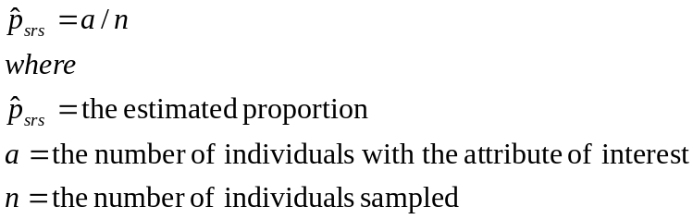

Variance estimate for simple random sampling

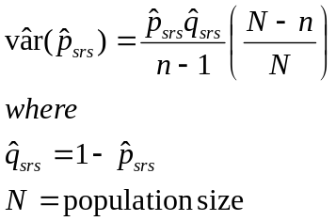

The (N-n)/N term is called the “finite population correction” or fpc. If the size of the population N is large relative to the number sampled n, then this term will have little effect on the variance estimate. For example, say the population size is 1,000,000 and 900 individuals are sampled, the fpc would be:

fpc = (1,000,000-900)/1,000,000 = .9991 ≈ 1

In this example the fpc will have little influence on the variance estimate. When the proportion of the population sampled is relatively high, the use of the fpc will decrease the size of the variance estimate. This will reduce the width of the confidence interval. Many textbooks ignore the fpc in their presentation on how to calculate the variance or sample size for a proportion.

Two-sided confidence interval for the point estimate (SRS)

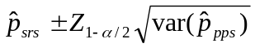

Example

Assume that an SRS survey was performed for immunizations and it was found that 48 children out of 70 were properly immunized. The SRS point estimate, variance estimate, and 95% confidence interval are calculated as:

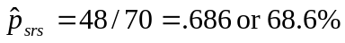

The variance will be calculated assuming that fpc will be close to 1 and therefore ignored.

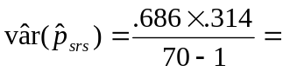.00312

The interpretation would be that, assuming SRS, the immunization level in the area sampled is estimated to be 68.6%; we would be 95% confident that the true immunization level is captured between 57.7% and 79.5%. (Note that if the fpc had been used, to narrow the confidence interval in this example by 0.1% or more, the population size N would need to be 2,500 or less).

Sample Size Calculation for Simple Random Sampling

The formula for calculating a sample size with simple random sampling (SRS) using the “specified absolute precision” approach is presented below. This formula assumes that the investigator desires to have a 95% confidence interval (the 1.96 value in the formula). The formula also incorporates the fpc.

Sample size formula for simple random sampling (SRS) with the finite population correction factor (fpc)

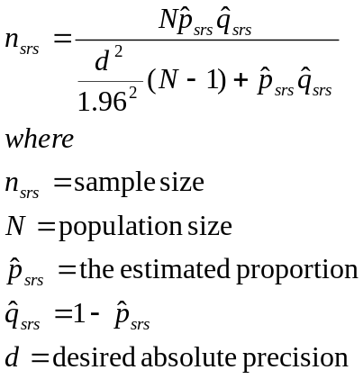

If a very small proportion of the population is to be sampled, then the fpc could be dropped from the formula as shown below:

Sample size formula for simple random sampling (SRS) without the finite population correction factor (fpc)

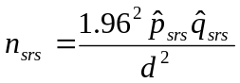

For both of the above sample size formulae (with or without the fpc), the investigator must come up with an estimate or educated guess for the proportion p of the population that will have the factor under investigation and the desired level of absolute precision d. If the investigator is unsure of the proportion, usually a value of .5 or 50% is used. The reason for selecting .5 is that, for a given level of precision, a p of .5 has the largest sample size. To see this, in the numerator of the sample size formula is pq. The larger the value of pq, the larger will be the sample size. When p=.5 and q=.5, then pq = .25. When p=.6, pq = .24. Finally, as one more example, when p=.9, pq = .09.
The other value the investigator must provide is the level of desired absolute precision d. The level of precision is how far (in absolute terms) the lower and upper bound of the confidence limits should be from the point estimate. For “common” events (10% to 90%), the d value is usually set at .05. For example, say the investigator has decided that the proportion p is 50% and the level of precision d is 5%. If the investigator’s estimate of p was correct, then the 95% confidence limits would be from 45% to 55% (i.e., +5%).

Example

Investigators want to determine the proportion of health providers in a large metropolitan hospital who have received three doses of Hepatitis B vaccine. They go to the personnel office and are told that there are 1,536 health providers employed. The investigators believe that 80% of health providers have received 3 doses of Hepatitis B vaccine, but to be sure they want to perform a survey. They decide that they want their estimate to be +3% (i.e., the d value) with 95% confidence.

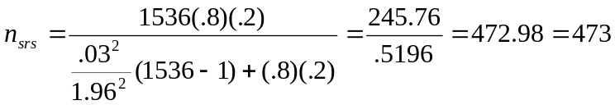

Therefore, 473 health care providers need to be surveyed. If the sample size formula without the fpc had been used, the sample size would be 683 providers.

Proportionate to Population Size (PPS) Sampling

Point and Variance Estimation for a Proportion Assuming PPS

Proportionate to population size (PPS) sampling differs from SRS. Frequently PPS sampling is used because a listing of all eligible individuals is not available and therefore simple random sampling cannot be performed. Another reason for using PPS sampling rather than SRS is that from a logistical viewpoint, PPS surveys in large geographic areas tend to be more efficient. Assuming a household-based survey, with PPS sampling, at the first stage, a listing of communities, enumeration units, or census tracts (hereafter referred to as primary sample units or PSU) is created. From this list, PSUs are selected using the PPS method for inclusion of the survey; the selected PSUs are referred to as “clusters.” At the second stage, when the survey team arrives at the cluster, under ideal conditions, individuals eligible for the survey are randomly selected. The formulae for estimating a proportion, its variance, and 95% confidence interval are presented next.

Point estimate for PPS

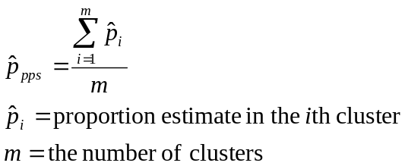

Note that the point estimate for simple random sampling will be the same as the point estimate for PPS when the number of individuals sampled per cluster is equal across all clusters.

Variance estimate for PPS sampling

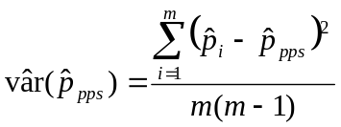

Two-sided confidence interval (PPS)

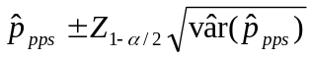

Example

An example of a 10-cluster immunization survey is presented in Table S.1. Usually 30-clusters are selected, but for purposes of performing the calculations by hand, only 10 clusters are presented. Within each cluster, seven children were selected and it was determined if they were completely immunized (“VAC”=1) or not completely immunized (“VAC”=2). The PPS point estimate, variance estimate, and 95% confidence interval are calculated as:

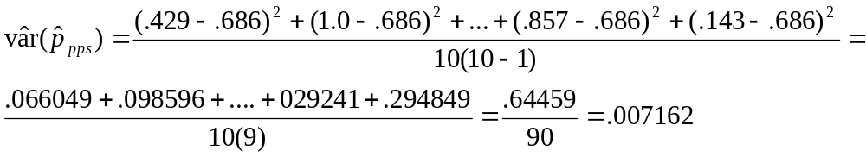

The interpretation would be that the immunization level of children in the area sampled is estimated to be 68.6%; we would be 95% confident that the true immunization level is captured between 52.0% and 85.2%. Note that the point estimates assuming SRS calculated earlier and PPS are the same. This is because the number of children sampled per cluster was the same. Also note that the confidence interval assuming PPS is wider than when SRS is assumed (95% CI for SRS, 57.7%, 79.5%; see Figure S.1). In general, confidence intervals calculated from a PPS survey will be wider than those calculated assuming the data were collected using SRS. The wider confidence interval for PPS surveys is attributed the fact that there are two stages of sampling: in the first stage, the communities are selected using the PPS methodology; in the second stage, individuals within each selected community are randomly selected. Note that some PPS surveys, such as the Expanded Program on Immunization (EPI) survey, do not always randomly select individuals at the cluster level.

Table S.1. Example Data

VAC
CLUSTER | 1 2 | Total
-----------+---------------------+------
1 | 3 ( 42.9%) 4 | 7
2 | 7 (100.0%) 0 | 7
3 | 4 ( 57.1%) 3 | 7
4 | 5 ( 71.4%) 2 | 7
5 | 5 ( 71.4%) 2 | 7
6 | 7 (100.0%) 0 | 7
7 | 4 ( 57.1%) 3 | 7
8 | 6 ( 85.7%) 1 | 7
9 | 6 ( 85.7%) 1 | 7
10 | 1 ( 14.3%) 6 | 7
-----------+---------------------+------
Total | 48 ( 68.6%) 22 | 70

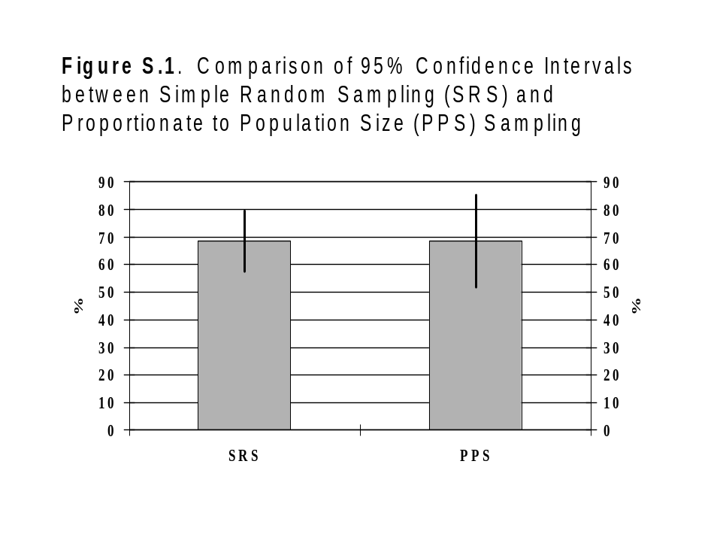Design Effect

The ratio of the variance calculated assuming PPS divided by the variance calculated assuming SRS is called the design effect (deff):

Formula for calculating the design effect (deff)

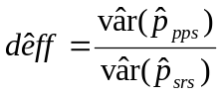

In most circumstances, the deff will be > 1, indicating that the variance estimated assuming PPS sampling is larger that the variance assuming SRS. From the example data in Table S.1, the deff is:

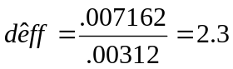

The interpretation would be that the variance assuming PPS is 2.3 times larger than the variance assuming SRS. What effect does the deff have in planning a study? An estimate of the deff is needed for sample size calculations for a pps survey. Note that while the deff estimated above was 2.3, the confidence interval width is increased by a smaller amount. In the example in Table S.1, to derive the confidence interval limits, for the SRS they are 68.6%+10.9%; compare this to the PPS which is 68.6%+16.6%; therefore, the PPS interval is approximately 1.5 times wider than the SRS interval in this example.
The three most important factors that affects the size of the deff:

- The inherent variability of the proportion of the factor between clusters; the more the clusters differ in the proportion with the attribute, the larger the deff.
- The number of individuals sampled in each cluster; the more individuals sampled per cluster, the larger the deff.
- Estimates near 50% tend to have larger deffs than estimates near the extremes (given equal sample sizes)

The investigator has little or no control over 1 and 3 above, but in designing a survey, can determine the number of individuals to sample per cluster. Sample size issues are discussed further in the next section.

Sample Size Calculation for Proportionate to Population Size (PPS) Sampling

The sample size formula for a PPS survey is the sample size estimate assuming SRS multiplied by the deff:

Sample size formula for proportionate to population size (PPS) sampling

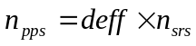

The investigator needs to have an estimate of the deff. This estimate is usually from surveys of the same size performed previously in the area or based on the experience in other areas. For surveys on immunization and anthropometry, usually a value of 2 is used for the deff. For water and sanitation-related factors, usually a larger estimate of the deff is used, generally in the range of 5 to 9. Once the total sample size has been calculated, the next step is to determine the number of individuals to be sampled in each cluster. This would be:

Formula for calculating the number of individuals to sample per cluster in a PPS survey
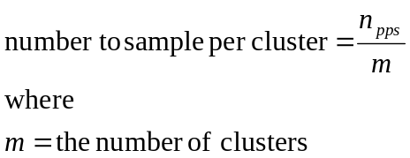

Usually there are 30 clusters. Always round up on the number of individuals to survey per cluster, which will increase the total sample size.

Example

The Ministry of health is interested in determining the proportion of households using iodized salt. It has been decided to conduct a 30-cluster pps survey. They are unsure of the iodized salt coverage so an estimate of 50% is used and they want the precision to be +5% with 95% confidence. The deff is estimated to be 2 and they will ignore the fpc in the sample size calculation. What is the total sample size and how many per cluster? Another way to write the formula for a PPS survey is:

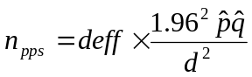

In this example:

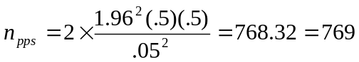

The total sample size is 769. How many needs to be sampled in each cluster? Assuming a 30-cluster survey, the number to sample per cluster would be 769/30=25.6. This would generally be rounded to 26 individuals per cluster; therefore, the total sample size would be 30 x 26 = 780.
The Expanded Program on Immunization (EPI) sample size is based on a p=.5, d=.1, and deff=2 with 95% confidence and ignoring the fpc. What is the sample size?

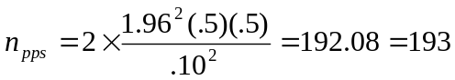

The EPI is a 30-cluster survey, so the number to sample in each cluster is 193/30=6.4, which is rounded to 7. Therefore, the sample size is 30 x 7 = 210 children.

STRATIFIED PROPORTIONATE TO POPULATION SIZE (PPS) SAMPLING

For national surveys, frequently the country is divided into two or more areas and a separate survey carried out in each area. The separate areas could be provinces or states, by urban/rural status, by topography (mountainous area vs. coastal region), or other designations. For example, a country may want to assess the immunization status of children and has a number of choices concerning the sampling. One choice could be to perform one survey nationwide that would provide a national estimate. Another option would be to perform a separate survey in each province, which would be used to calculate provincial estimates, and then to combine all of the provincial surveys to derive a national estimate. This latter method is referred to as stratified sampling. With stratified sampling, a geographic area is divided into mutually exclusive and exhaustive strata. Mutually exclusive means that there is no overlap between the strata/geographic areas, and exhaustive means that all areas in the geographic area must fall into one of the strata. For this section we will assume that PPS sampling was performed in each stratum/subnational area. The point and variance estimate and confidence interval are calculated as:

Point Estimate for Stratified PPS Sampling
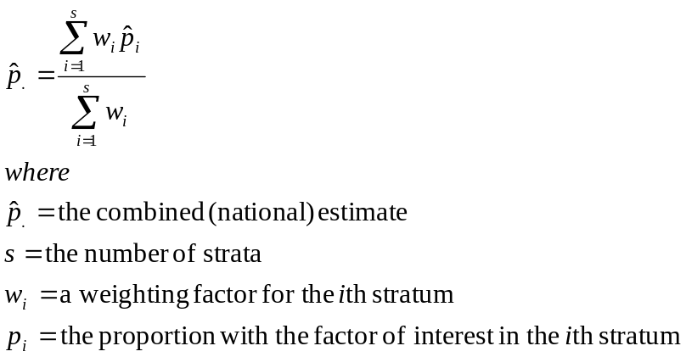

Information on how to calculate the weight w will be provided in the example.

Variance Estimate for Stratified PPS Sampling
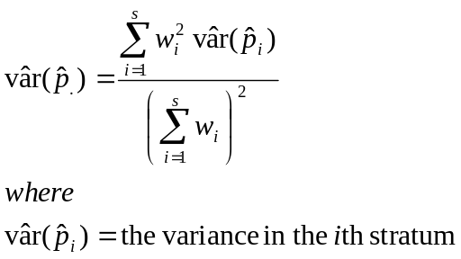

Two-sided confidence interval for Stratified PPS sampling

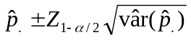

Example

A stratified PPS survey to assess immunization levels in children 12 months up to 24 months of age is performed in a country. The country was divided into 3 strata, and an EPI survey performed in each stratum (30 clusters, 7 children in each cluster). Table S.2 has the information relevant to the survey. In the first column are the strata numbered as 1, 2, and 3. In columns 2 and 3 is information on the estimated population size and percent distribution by stratum for children in the selected age group. The estimated population size is from the most recent national census. The number and percent of children sampled in each stratum are shown in columns 4 and 5. The number sampled by stratum differs slightly, but approximately one-third of the children are from each stratum. Columns 6 through 8 are the results of the survey. The last column for weights will be described in a moment. Generally one would like to calculate the national immunization coverage based on the three strata. A naïve approach would be to count up the number of children immunized, in this example 369, and divide this by the total surveyed: 369/656=.563 or 56.3% (95% confidence interval assuming srs: 52.4%, 60.0%). Sometimes this is referred to as an “unweighted” estimate. This unweighted estimate ignores the fact that population size in stratum 2 is around three times larger than stratum 1 and two times larger than stratum 3. To derive a nonbiased or correct estimate of the proportion of children immunized in the nation, there is a need to take into account the differences in the population size of each stratum. This is where the weight w variable is important. There are a number of ways to calculate a weight and we will present one method. The weight is calculated as:

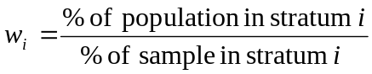

For the example in Table S.2, the weight information is presented in the last column. Assuming an approximately equal sample size in each stratum, the larger the population size in a stratum, the larger the weight for that stratum.

Table S.2. Example stratified PPS data
Strata | Population distribution |  | Sample distribution |  | Survey results |  |  | w_{i}
Strata | N | % | n | % | p_{i} | Var(p_{i}) | deff_{i} | w_{i}
1 | 9,870 | 17.14 | 225 | 34.30 | .813 | .0008779 | 1.301 | .4997
2 | 33,599 | 58.33 | 219 | 33.38 | .548 | .0015555 | 1.379 | 1.7475
3 | 14,130 | 24.53 | 212 | 32.32 | .311 | .0038950 | 3.851 | .7590
Sum | 57,599 | 100.00 | 656 | 100.00

The point estimate would be

The weighted estimate of the immunization coverage would be 53.2%; note that this estimate is has a lower value (but more valid) than the unweighted estimate of 56.3%. In this example the value of the weighted estimate is closer to the stratum with the greatest weight (stratum 2) than the unweighted estimate. The variance for the weighted estimate is:

The 95% confidence interval for the weighted estimate would be calculated as:

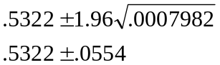

The weighted point estimate and 95% confidence interval would be 53.2% (47.7%, 58.8%). A comparison of the naïve estimate with 95% confidence interval assuming srs and the weighted estimate can be seen in Figure S.2. The naïve approach in this example has a biased estimate and too narrow a confidence interval compared to the unbiased weighted stratified pps estimate.

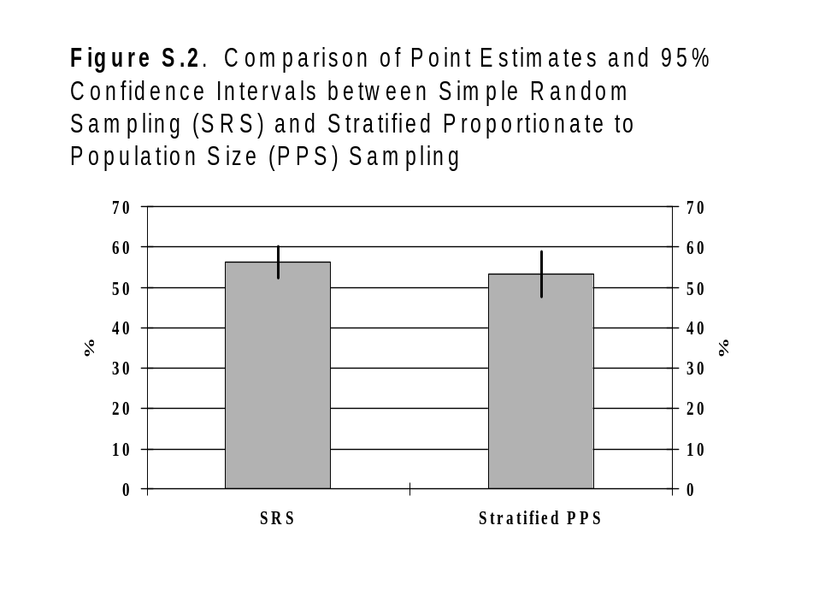

Sample size for Stratified PPS surveys

To calculate the sample size for stratified PPS surveys, generally one would determine the desired level of precision for each stratum using the sample size formula described in the section on PPS surveys. Note that the nationally stratified PPS estimate will be generally more precise than the estimates for each stratum. Using the example from Table S.2, the variance and the value added and subtracted from the point estimate (“+” for CI) to determine the upper and lower confidence bound for each stratum and for the nationally weighted estimate are shown in Table S.3. The national estimate has more precision (i.e., narrower confidence limits) than each of the strata. A comparison of the estimates is presented in Figure S.3.

Table S.3. Example stratified PPS data
Strata | Survey results
Strata | Percent | Var(p_{i}) | + for CI (%)
1 | 81.3% | .0008779 | +5.8%
2 | 54.8% | .0015555 | +7.7%
3 | 31.1% | .0038950 | +12.2%
Weighted | 53.2% | .0007982 | +5.6%

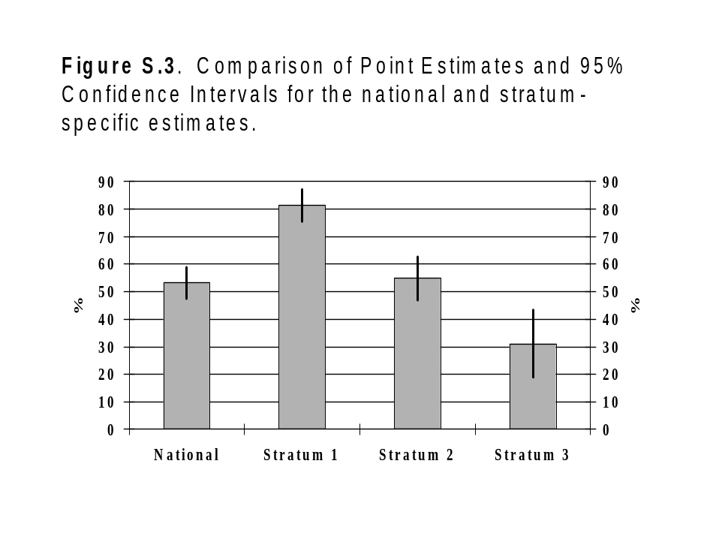
ADDITIONAL DISCUSSION ON THE NUMBER OF CLUSTERS AND NUMBER OF INDIVIDUALS TO SAMPLE PER CLUSTER

The number of clusters to select in a cluster survey

In general, it has been found that collecting information on around 30 clusters will provide good estimates of the true population with an acceptable level of precision (Binkin et al., 1992). For a fixed number of individuals selected per cluster (e.g., 10 per cluster or 30 per cluster), collecting information on more than 30 clusters can improve precision, however, beyond around 60 clusters the improvement in precision is minimal. Some surveys, such as the UNICEF Multiple Indicator Cluster Survey (MICS) (UNICEF, 2000) recommends many more clusters, up to 300 or more. However, in the MICS, some of the indicators occurred infrequently, and many clusters may not have any eligible individuals. The MICS is a household-based survey where a fixed number of households are selected in each cluster. For example, if 40 households are selected in a cluster, things that occur infrequently (in some populations) include: the number of children within any one-year age interval (such as for immunizations or anthropometry); the number of children 0-4 months by breastfeeding status; and the number of women who have given birth in the previous year. In some populations there may only be one or two eligible individuals within each cluster. In addition, some of the factors studied have very large design effects (deff), such as factors relating to access to potable water and adequate sanitation. Finally, the data will be frequently be presented by sex, by urban/rural status, age groups, and other factors, therefore requiring larger sample sizes and a larger number of clusters. Therefore, for relatively frequent events, around 30 clusters should be sufficient. For rare events and events with a large design effect, selection of more than 30 clusters may be necessary. Another reason to select more than 30 clusters is if the precision from a 30-cluster survey is not adequate; selecting more than 30 clusters will usually result in more precise estimates.

The number of individuals to sample in a 30-cluster survey

Based on the analysis of many 30-cluster surveys, it is recommended that the minimum number of samples to be collected in each cluster is 10 and the maximum 40. Collecting information on fewer than 10 samples per cluster can lead to unstable variance estimates. Collecting information on more than 40 per cluster has little effect on precision. An example of a survey where the number of individuals sampled per cluster was varied from 6 to 48 is shown in Figure S.4. In this figure, 48 children were selected in each cluster. From the data file, every other child was selected and the analysis performed again on 24 children per cluster. This was repeated selected every third child, every fourth child, etc. Note that the point estimates and confidence interval width vary little from around 16 sampled per cluster and above. Below 10 sampled per cluster the point estimates become more variable and the confidence intervals get wider. If the collection of information is at great cost, such as collecting blood specimens, then the fewest samples per cluster with adequate precision should be collected. If the cost of collecting the information were minimal, such as palpating children for goiter, then doing more than 40 would be acceptable.
One reason to increase the number of samples per cluster would be a desire to compare two or more groups. For example, say the investigator wants to determine if the prevalence of anemia in females is different than the prevalence in males. If this comparison is important, then the sample size information mentioned in the previous paragraph might need to be increased to assure adequate precision for each group.
While it would seem that collecting more samples be cluster would lead to improved precision in PPS surveys, the improvement in precision in minimal beyond 40 samples. The reason for this is that as more samples are collected per cluster, the DEFF increases (see Figure S.5). In this figure, as more individuals were sampled per cluster, the distance between the variance calculated assuming SRS and variance calculated assuming PPS gets wider. This results in the DEFF becoming larger as the number sampled per cluster increases. Also note that as the number sampled per cluster increases, there is little reduction in the variance, assuming PPS, with the larger numbers sampled per cluster. Also note the instability of the variance estimates assuming PPS when the sample size is less than 10. This instability in the variance estimate assuming PPS results in instability in the DEFF estimate. Figure S.6 presents an example of the effect on precision as the number sampled per cluster increases for various prevalence levels.

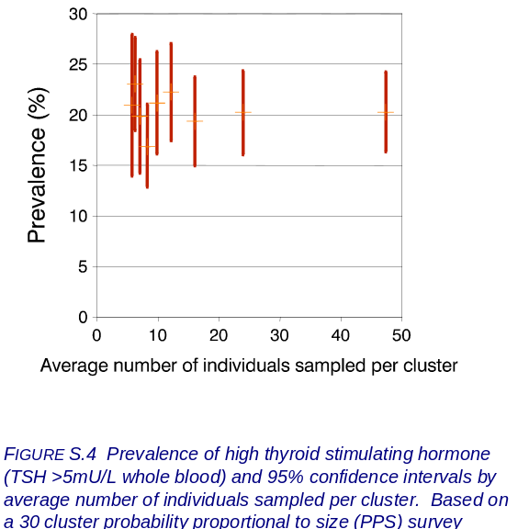

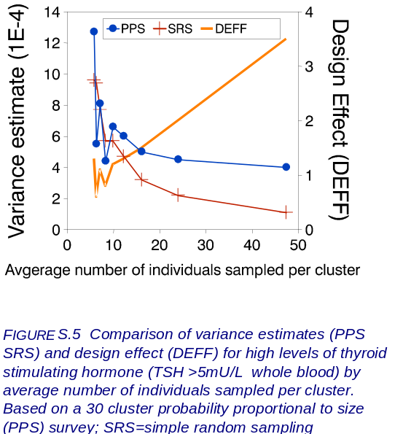

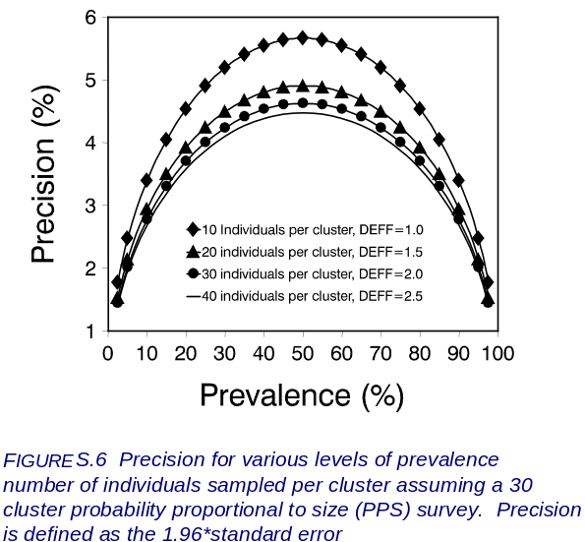

Some common misperceptions and errors in sampling

There are a number of misperceptions in sampling populations. One misperception is that the larger the target population, the sample size should be larger. While this may be true with small populations where use of the fpc can be used to reduce the sample size for small populations, for large populations, whether the population is 100,000 or 100,000,000, the sample size for a survey would be the same. In some situations where there is a large population, there may be a decision to perform stratified pps surveys, which would increase the sample size overall sample size.
Another misperception is that rather than sampling 30 children in each of 30 clusters, why not sample 60 children in 15 clusters? This would result in the same overall sample size and be less costly because fewer clusters would need to be sampled. In general, if there is variability between clusters in the
factor under study, in the desire to have a point estimate reasonably close to truth, one cannot compensate fewer clusters with more samples per cluster. The issue is one of precision and that the point estimate from a 15-cluster survey may be quite a distance from truth (it could be close to truth, but you will never know whether or not the estimate is close to truth in a field setting). Also, on average, there will be less precision in the 60x15-cluster survey compared to a 30x30-cluster survey.
Another common error is that if a 30-cluster survey were performed in an area, that groups of clusters in one area could be grouped together as an estimate for that area. For example, if a national survey was performed and five clusters were located in a specific are of the country, the results of these five clusters could be summed together as a sub-national estimate for that area. This problem is similar to the one discussed in the previous paragraph, where when substantially fewer than 30 clusters are used to represent a geographic area, there is a chance that the estimate could be quite different from the truth. If a point estimate is needed for a specific area, then a stratified pps survey should be performed.
In some situations, a pps sampling approach does not work well. For example, say there are three refugee camps and there is a desire to estimate the proportion of children less than 5 years of age who are malnourished. Should the investigator divide 30 clusters among the three camps? Or should the investigator perform a 30-cluster survey in each camp? While there are many possible ways to approach this problem, here are two suggested approaches. If only one estimate is needed for all five camps (i.e., camp-specific estimates are not a priority), then one approach would be to calculate a sample size assuming simple random sampling, and then divide the sample proportionally among the camps. For example, assume it is estimated that the prevalence of malnutrition is 50% and the d value is .05. The sample size (ignoring the fpc) would be [1.96² (.5)(.5)]/.05²=385. Next, based on population size estimates in each camp, determine the proportion of refugees in each camp. For example, if exactly one-third of the refugees were in each camp, then one would sample (.333)(385)=128.2 or 129 children in each camp. Ideally, within each camp, the children to be surveyed would be randomly selected. This would result in a total sample size of 3 x 129 = 387.
In the refugee situation with three camps, if an estimate is needed for each camp, then a stratified simple random sampling approach could be used. Assuming the p and d values in the previous paragraph, one would sample 385 children in each camp and calculate camp-specific point estimates with confidence intervals. Then, for an overall estimate, a stratified srs approach similar to the stratified pps method described earlier would be used for a weighted point estimate and confidence interval.
Frequently individuals will state that one cannot use information from a single cluster - only the combined 30-cluster information can be analyzed and presented. While this is correct in terms of presenting overall estimates, the results of individual clusters can be useful in identifying problem areas. For example, if an EPI survey on immunizations is performed, if 29 clusters had immunization coverage levels of 90% or better and one cluster had a coverage of 30%, the cluster with a low coverage should be investigated further to determine the cause of the low coverage. Is the problem only in the PSU selected or is the coverage also low in the surrounding communities? Why is the coverage low? Is it due to an inadequate supply of vaccines? Therefore, individual cluster information can be used to investigate potentially problematic areas.
A common error seen in the field is when stratified data are averaged together without consideration of the population size from each stratum. Weighted averages should be calculated in these situations.

Summary

This chapter presents the formulae and examples on how to analyze data from simple random sampling (srs), proportionate to population size (pps) sampling, and stratified pps surveys. Sample size formulae were presented and a number of issues discussed in the application of pps surveys in populations.

Notation

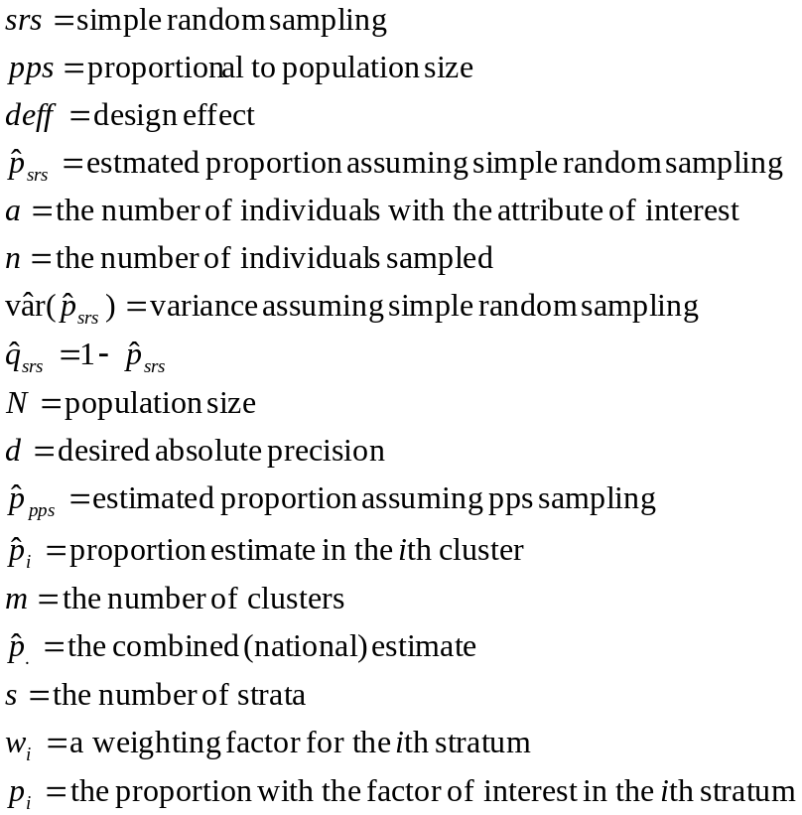

Exercises

- Which study design usually has a larger variance, and therefore a wider confidence interval?

srs

pps

2. What is the formula for the deff?
- var(p_{srs})/ var(p_{pps})
- var(p_{pps})/var(p_{srs})
- p_{srs}/p_{pps}
- p_{pps}/p_{srs}

3. The inclusion of the fpc into the srs sample size formula in generally has the following effect:
- Can reduce the sample size
- Can increase the sample size
- Has no effect on the sample size

4. A 30-cluster survey on the prevalence of goiter in school children was performed. Results from 8 of the clusters are shown in Table S.4 (only 8 clusters are presented to simplify hand calculations). Calculate the following from the data in Table S.4:

a. Prevalence of goiter, variance, and 95% confidence limits assuming Simple Random Sampling:

Prevalence (%) = Variance =

95% confidence interval (%) =

b. Same as question 4.a.except perform the calculations assuming Proportional to Population Size sampling:

Prevalence (%) = Variance =

95% confidence interval (%) =

- Calculate the design effect:

DEFF =

Table S.4. Results from 8 clusters on the prevalence of goiter in school children.

Cluster Goiter Total PERCENT
------- ------ ------ -------
1 27 40 67.5
2 37 40 92.5
3 34 40 85.0
4 36 40 90.0
5 34 40 85.0
6 40 40 100.0
7 37 40 92.5
8 34 40 85.0
------- ------ ------ -------
Total 279 320

- The results of a stratified PPS survey are presented in Table S.5. Fill in the blank cells in the table. Then, calculate the following:

- Weighted prevalence (%)

b. 95% confidence interval around the weighted prevalence (%)

Table S.5. Stratified PPS data
Strata | Population distribution |  | Sample distribution |  | Survey results |  |  | w_{i}
Strata | N | % | n | % | p_{i} | Var(p_{i}) | deff_{i} | w_{i}
1 | 45,993 |  | 1,200 |  | .836 | .0006017 | 5.3
2 | 21,023 |  | 1,200 |  | .571 | .0007975 | 3.9
 |  | 100.00 |  | 100.00 | - | - | - | -

- Use the Csample program in Epi Info (DOS version) to calculate the immunization coverage with 95% confidence interval and DEFF. This data file contains the results of a 30-cluster survey where the immunization status was determined on 7 children in each cluster. Open Epi Info, under "Programs" select "CSAMPLE." In the first screen of CSAMPLE, select the file "EPI1.REC." On the second screen, under "Main" put VAC (the variable for vaccinated; 1= yes and 2= no); under "PSU" put "cluster." Then click on the "Tables" button." Write the vaccine coverage with 95% confidence interval below; also write down the DEFF.

- Using the CSAMPLE program again, perform the analysis of a stratified cluster survey on immunization levels. There are 10 strata in this survey. To analyze the data correctly, a weighted approach is needed. On the first screen of CSAMPLE, select the file "EPI10.REC." On the second screen, under "Main" put VAC (the variable for vaccinated; 1= yes and 2= no); under "Strata" put "Location"; under "PSU" put "cluster"; under "Weight" put "Popw." Then click on the "Tables" button." Write the vaccine coverage with 95% confidence interval below; also write down the DEFF.

8. Table S.6 lists 100 enumeration units in an area of Nepal (in Nepal referred to as "wards"). A 30-cluster survey is to be performed in this area. Perform the following:

- Calculated the cumulative population in Table S.6
- Calculate the sampling interval
- Assume the random starting point is 356; select the clusters in Table S.6

Table S.6. Population size in 100 communities/wards
Ward # Pop. Cum. Cluster # | Ward # Pop. Cum. Cluster #
1 259  2 207  3 664  4 450  5 483  6 302  7 398  8 148  9 281  10 696  11 518  12 565  13 450  14 790  15 684  16 984  17 563  18 440  19 267  20 273  21 324  22 346  23 380  24 506  25 643  26 376  27 367  28 536  29 382  30 401  31 891  32 303  33 1149  34 482  35 454  36 1251  37 324  38 554  39 511  40 463  41 435  42 841  43 943  44 1186  45 923  46 448  47 475  48 292  49 189  50 353 | 51 283  52 327  53 319  54 395  55 542  56 590  57 564  58 331  59 490  60 521  61 364  62 379  63 917  64 423  65 172  66 232  67 286  68 256  69 174  70 245  71 278  72 372  73 208  74 481  75 245  76 306  77 292  78 328  79 257  80 212  81 598  82 257  83 297  84 267  85 262  86 340  87 344  88 370  89 380  90 247  91 403  92 224  93 163  94 262  95 143  96 233  97 543  98 298  99 539  100 329

References

Binkin N, Sullivan K, Staehling N, Nieburg P. Rapid nutrition surveys: how many clusters are enough? Disasters, 16(2):97-103, 1992.

Lemeshow S, Stroh G Jr. Sampling Techniques for Evaluating Health Parameters in Developing Countries. National Academy Press, Washington D.C. 1988.

Schaeffer RL, Mendenhall W, Ott L. Elementary Survey Sampling, Fourth Edition. Duxbury Press, Belmont, California 1990.

Sullivan K. The effect of sample size on validity and precision in probability proportionate to size (PPS) cluster surveys (abstract). 28th Annual Meeting of the Society for Epidemiologic Research, Snowbird, Utah, June 21-24, 1995; American Journal of Epidemiology 141(11), S47, 1995.

UNICEF. End-Decade Multiple Indicator Survey Manual: Monitoring Progress Toward the Goals of the 1990 World Summit for Children. Division of Evaluation, Policy and Planning Programme Division, UNICEF, New York, 2000.
Answers

**PPS Sampling Analysis**
10/11/2000 11:35:40 AM

Total number of individuals with known outcome: 320
Number of individuals with outcome of interest: 279
Number of clusters selected: 8
Average number of individuals per cluster: 40

Results taking into account the cluster design:
Proportion (%) and 95% CI = 87.18 (80.61, 93.76)
Standard Error (%) = 3.35 Variance = 0.00112583705

Results ignoring design (i.e., assuming random sampling):
Proportion (%) and 95% CI = 87.18 (83.51, 90.85)
Standard Error (%) = 1.87 Variance = 0.0003501849

- Design effect = 3.21 Calculate the proportion, variance, and 95% confidence interval for the following data assuming srs. A survey was performed in a village to determine the number of children attending an immunization clinic who had also received a vitamin A capsule within the previous six months. The survey found 58 children out of 134 surveyed had received a vitamin A capsule within the previous six months.

Estimated percent of children who received vitamin A capsule in previous six months = _______

A 95% confidence interval around the estimate = (________, _________)

