1. Data je gramatika G sa terminalima %, #, a i b. Kreirati tabelu LR(0) parsera za datu gramatiku.

X -> Y % X | Y

Y -> Z # Y | Z

Z -> a | b

|  |  |  |  |  |  |  |  |  |  |
| --- | --- | --- | --- | --- | --- | --- | --- | --- | --- |
|  | Action | | | | | Goto | | | |
|  | % | # | a | b | $ | X | Y | Z |
| 0 |  |  | S4 | S5 |  | 1 | 2 | 3 |
| 1 |  |  |  |  | accept |  |  |  |
| 2 | S6, R2 | R2 | R2 | R2 | R2 |  |  |  |
| 3 | R4 | S7, R2 | R4 | R4 | R4 |  |  |  |
| 4 | R5 | R5 | R5 | R5 | R5 |  |  |  |
| 5 | R6 | R6 | R6 | R6 | R6 |  |  |  |
| 6 |  |  | S4 | S5 |  | 8 | 2 | 3 |
| 7 |  |  | S4 | S5 |  |  | 9 | 3 |
| 8 | R1 | R1 | R1 | R1 | R1 |  |  |  |
| 9 | R3 | R3 | R3 | R3 | R3 |  |  |  |

Tabela 1 – LR(0)

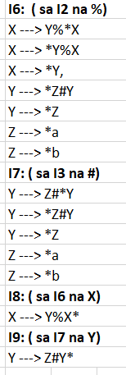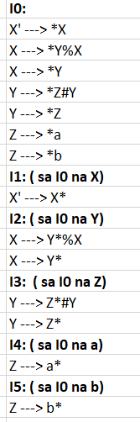

1. Data je gramatika G sa terminalima %, #, a i b. Kreirati tabelu LR(1) parsera za datu gramatiku.

X -> Y % X | Y

Y -> Z # Y | Z

Z -> a | b

|  |  |  |  |  |  |  |  |  |
| --- | --- | --- | --- | --- | --- | --- | --- | --- |
|  | Action | | | | | Goto | | |
|  | % | # | a | b | $ | X | Y | Z |
| 0 |  |  | S4 | S5 |  | 1 | 2 | 3 |
| 1 |  |  |  |  | accept |  |  |  |
| 2 | S6 |  |  |  | R2 |  |  |  |
| 3 | R4 | S7 |  |  | R4 |  |  |  |
| 4 | R5 | R5 |  |  | R5 |  |  |  |
| 5 | R6 | R6 |  |  | R6 |  |  |  |
| 6 |  |  | S4 | S5 |  | 8 | 2 | 3 |
| 7 |  |  | S4 | S5 |  |  | 9 | 3 |
| 8 |  |  |  |  | R1 |  |  |  |
| 9 | R3 |  |  |  | R3 |  |  |  |

Tabela 2 – LR(1)

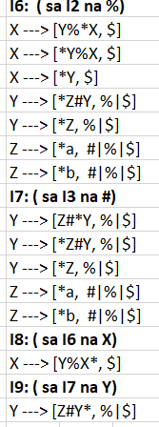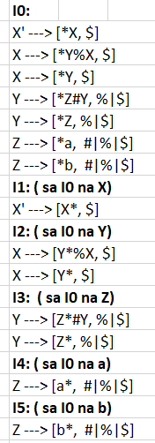

1. Data je sljedeća nejasna gramatika za aritmetičke izraze: E -> E+E | E*E | E^E | (E) | id , gdje simbol ^ označava stepenovanje. Kreirati tabelu SLR(1) parsera za datu gramatiku, a zatim eliminisati konflikte u tabeli koristeći prioritet i asocijativnost operatora +, * i ^. Koristite slajdove lekcije LALR.

|  |  |  |  |  |  |  |  |  |
| --- | --- | --- | --- | --- | --- | --- | --- | --- |
|  | Action | | | | | | | Goto |
|  | + | * | ^ | id | ( | ) | $ | E |
| 0 |  |  |  | S3 | S2 |  |  | 1 |
| 1 | S4 | S5 | S6 |  |  |  | accept |  |
| 2 |  |  |  | S3 | S2 |  |  | 7 |
| 3 | R5 | R5 | R5 |  |  | R5 | R5 |  |
| 4 |  |  |  | S3 | S2 |  |  | 8 |
| 5 |  |  |  | S3 | S2 |  |  | 9 |
| 6 |  |  |  | S3 | S2 |  |  | 10 |
| 7 | S4 | S5 | S6 |  |  | S11 |  |  |
| 8 | S4, R1 | S5, R1 | S6, R1 |  |  | R1 | R1 |  |
| 9 | S4, R2 | S5, R2 | S6, R2 |  |  | R2 | R2 |  |
| 10 | S4, R3 | S5, R3 | S6, R3 |  |  | R3 | R3 |  |
| 11 | R4 | R4 | R4 |  |  | R4 | R4 |  |

Tabela 3 - SLR(1)

|  |  |  |  |  |  |  |  |  |
| --- | --- | --- | --- | --- | --- | --- | --- | --- |
|  | Action | | | | | | | Goto |
|  | + | * | ^ | id | ( | ) | $ | E |
| 0 |  |  |  | S3 | S2 |  |  | 1 |
| 1 | S4 | S5 | S6 |  |  |  | accept |  |
| 2 |  |  |  | S3 | S2 |  |  | 7 |
| 3 | R5 | R5 | R5 |  |  | R5 | R5 |  |
| 4 |  |  |  | S3 | S2 |  |  | 8 |
| 5 |  |  |  | S3 | S2 |  |  | 9 |
| 6 |  |  |  | S3 | S2 |  |  | 10 |
| 7 | S4 | S5 | S6 |  |  | S11 |  |  |
| 8 | R1 | S5 | S6 |  |  | R1 | R1 |  |
| 9 | R2 | R2 | S6 |  |  | R2 | R2 |  |
| 10 | R3 | R3 | S6 |  |  | R3 | R3 |  |
| 11 | R4 | R4 | R4 |  |  | R4 | R4 |  |

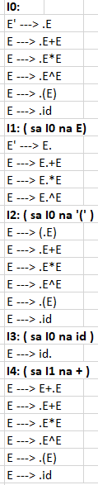Tabela 4 – bez konflikata

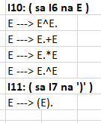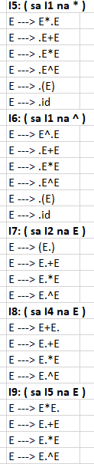ss