Criterion C: Development

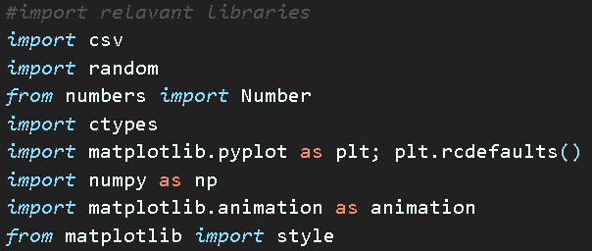
Imported libraries
Figure 1.1
Csv is used to handle the csv file used to import the board
Random is used to shuffle the deck
Numbers is used to verify if a variable is integer data type
Ctypes is a library that enhanced different C data type handling
Matplotlib is used to produce graphs of results
Numpy is used for calculations and rounding to be used with matplotlib for outputting results
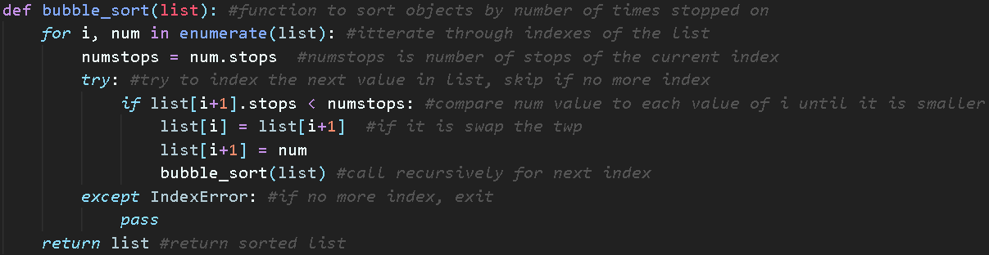
Figure 2.1
Figure 2.1 is the bubble_sort function used to sort the properties by the number of times they have travelled in. Unlike in the design, I decided to go with a recursive function rather than the one designed as it allow for less code and more efficient.
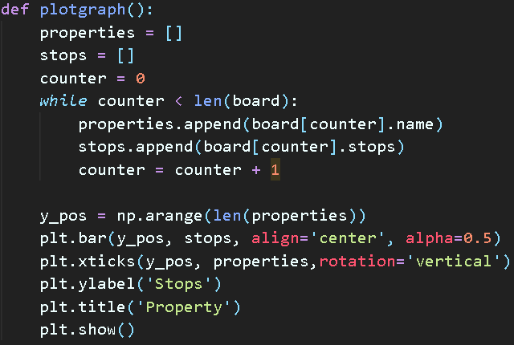
Figure 3.1
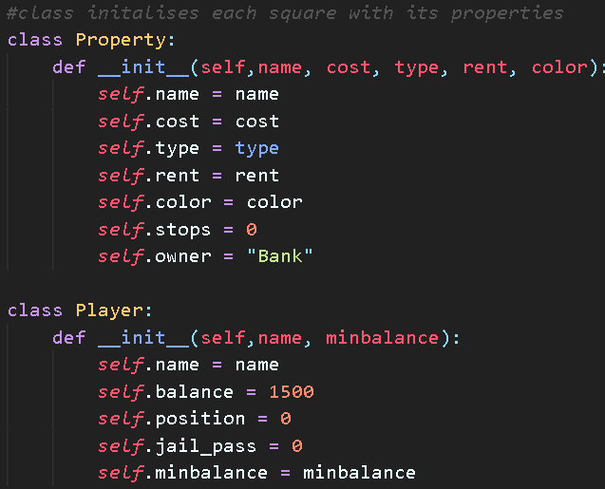
Figure 3.1 is the function that plots the graph, the while loop is used to fill the x and y axis, properties and stops while there is more data. After they are filled up, matplotlib is then used to make and display the graph.
Figure 4.1
Figure 4.1 shows the two main objects of the program. An object was used for properties because they allow me to store all of the individual variables specific to each property to the object of that property and then use an array to encapsulate all the properties in one simple array of properties.
Player object was used for a similar reason. Each player has his own position and balance which must be stored to the individual player. This is why objects are great as I can access each player and his properties easily just by using his name and the property I am looking for. Then I can encapsulate all the player objects in an array of players which is a simple solution.

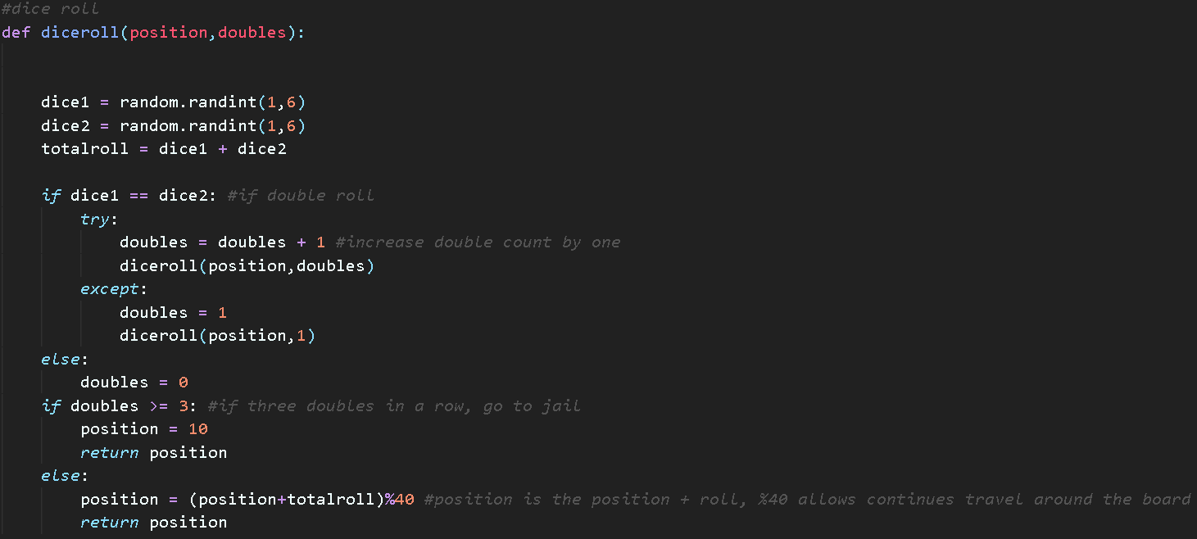
Figure 5.1
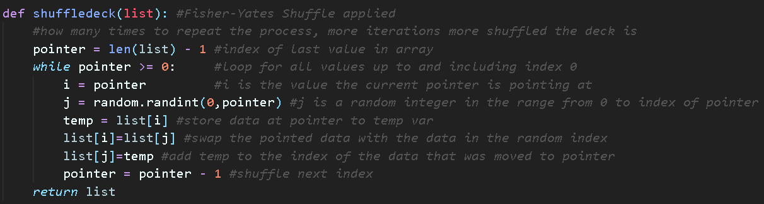
The random library was used to produce the two random dice rolls then the sum of the two dice is taken. There is a recursive element to this function which is the first if statement. If there is a double roll, increment the double roll and call a new dice roll. This was done to minimize the code and achieve an elegant solution for the rest of the function which manages how many doubles there were and what to do if there are three doubles. The recursion will continue until there are two different rolls and return the new position of the player after the total roll is added to his position or if there were three double rolls, to jail.
Figure 6.1
The shuffle deck function in Figure 6.1 uses a Fisher-Yates shuffle algorithm which I created in python. It is used rather than the shuffle algorithm from the Random library because I was unsure how it worked and wanted to create my own which would be similar to how real decks are shuffled. This is achieved be using two counter variables, i which is the top card on the deck and j which is a random card below it in the deck, then those two are swapped. This is done using a while loop that loops while there are more cards in the array and a temporary variable used to store the value from the lists to be swapped.

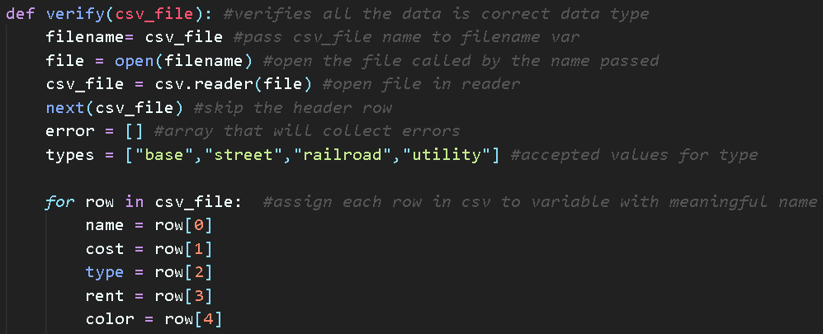
Figure 7.1
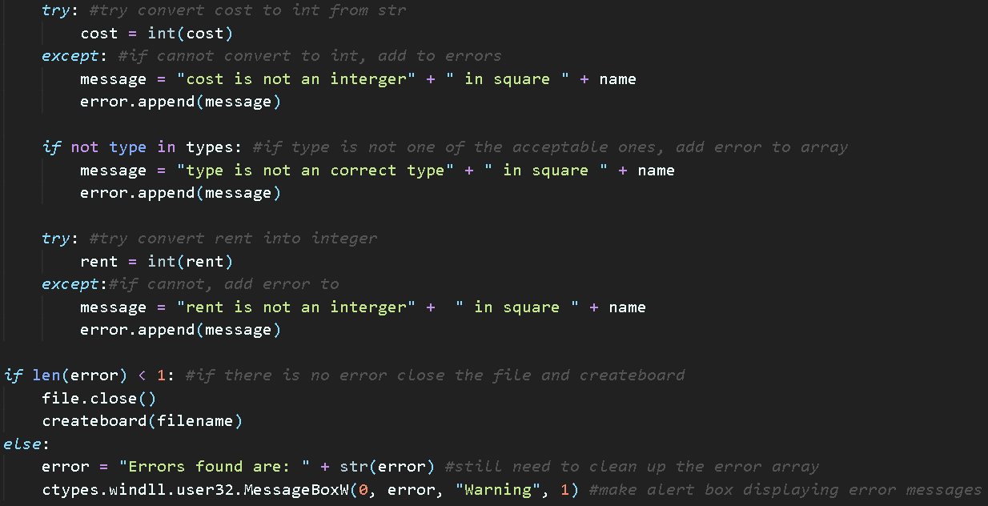
Figure 7.1 is the first part of the verify function, used to validate the csv file used to import the board is valid and the data types are correct for the different fields. The CSV library was used to handle the csv files. In line 5 next() is used which skips the first row of the csv file which is the header, then an error array is made to store all the invalid fields and output them at the end. A for loop is then used to loop the variable assigning while there are more rows in the csv file
Figure 7.2
Figure 7.2 conitnues the verify function. A try is used to make change the cost value from the csv file to an integer as that is the correct data type. If an error occurs when this happens, that means the cost cannot be converted and so an error message is assigned to the error[] with the name of the field at the end so the user can easily find the error. This is repeated for the rent value.
Similarly, and if statement is used to compare if the type stated in the csv file is one of the accepted ones from the types[]. If it is not, an error is created and added to errors[]

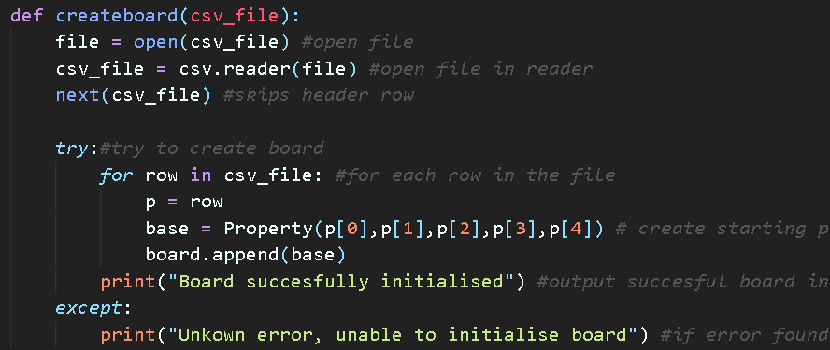
Finally, if statement is used to compare if the errors array is empty or not, if its length is less then one, it is empty and the file is closed and the board generating function is called and the file is passed to it, otherise ctypes library is used to create a windows alert box with the contents of all the errors so the user can fix those fields easily.
Figure 8.1
Figure 8.1 is the function that creates the board, it uses a for loop nested in a “try” to create the Property object for each row in the csv file. The try is used incase there is an error that occurs it will output a message that an error occurred rather then crashing the program.

