Criterion B: Design

Flowchart of one game of monopoly()
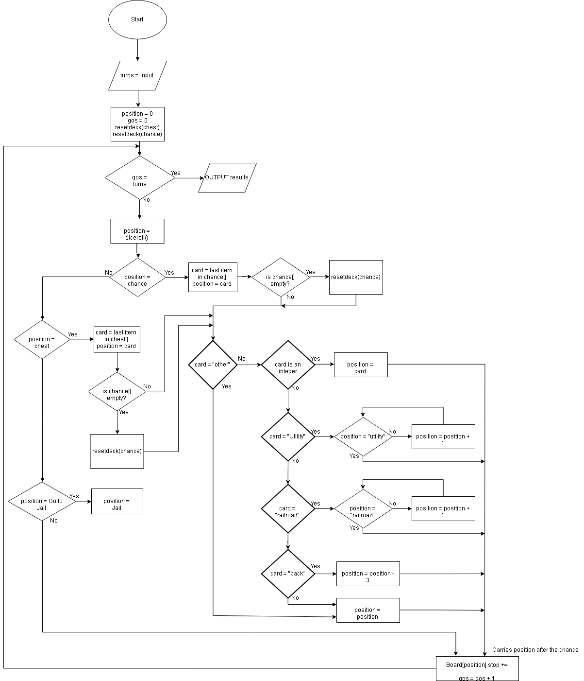

Input Screens
>> Name of the .CSV file you wish to use?
Custom input:

>> Is money a factor in the game? (y/n)
y/n:

>> How many turns of the game do you wish to play?
1. Custom Value
2. Until a player has 0 money

Input csv containing all the properties, price and rent values
How it looks in spreadsheet: | How it looks in text:  name , cost , type , rent , color  Go , 0 , base , -200 , None  …
  name | cost | type | rent | color
  Go | 0 | base | -200 | None
  … | … | … | … | …

class Property (name, cost, type, rent, color)
declare NAME as string
declare COST as integer
declare TYPE as string
declare RENT as integer
declare COLOR as string
declare STOPS as integer = 0

PSEUDOCODE of Each separate function
Bubble Sort
input LIST[]
while POINTER< LIST[].length:
for POINTER = 1 to LIST[].length – 1
while LIST[POINTER-1] > LIST[POINTER] then
TEMPORARY = LIST[POINTER-1]
LIST[POINTER-1] = LIST[POINTER]
LIST[POINTER] = TEMPORARY
end while
end for
output list
end BubbleSort

Show Results

input LIST[]
input SORT
RESULTS = []
COUNTER = 0
if SORT = yes:
bubblesort(LIST)
endif
while COUNTER < LIST.length:
OUTPUT LIST[i].name was stepped on LIST[i].stops times
RESULTS[i] = (LIST[i].stops)
COUNTER += 1
endwhile
OUTPUT RESULTS

plotGraph

PROPERTIES = []
STOPS = []
COUNTER = 0
while COUNTER < BOARD.length
properties[COUNTER] = BOARD[i].name
stops[COUNTER] = BOARD[i].stops
COUNTER = COUNTER + 1
endwhile
y = STOPS[]
x = PROPERTIES[]
plot(x,y)

diceroll()

input POSITION
DICE_1 = random integer in range 1 to 6
DICE_2 = random integer in range 1 to 6
TOTALROLL = DICE_1 + DICE_2
if DICE_1 = DICE_2
if doubles = 0
doubles = 1
endif
doubles = doubles + 1
diceroll()
endif
else DOUBLES = 0
if DOUBLES => 3
position = Jail
endif
else POSITION = (POSITION + TOTALROLL) MOD 40
return POSITION

shuffledeck(LIST)
input LIST
POINTER = LIST.length
while POINTER >= 0:
i = pointer
j = random int in range 0 and LIST.length
TEMPORARY = LIST[i]
LIST[i] = LIST[j]
LIST[j] = TEMPORARY
POINTER = PONTER – 1
endwhile
return LIST

verify()
input file.csv
skip first row //skip header row
ERROR = []
TYPES = ["base","street","railroad","utility"]
for row in file.csv
NAME = row[0]
COST = row[1]
TYPE = row[2]
RENT = row[3]
COLOR = row[4]
if COST is not an integer
ERROR.push (“Cost is not an integer in row” row)
endif
if TYPE not in TYPES
ERROR.push (“Type is not an accepted type in row” row)
endif
if RENT not an integer
ERROR.push (“Rent is not an integer in row” row)
endif
if ERROR.length < 1
OUTPUT “no errors”
createboard(file.csv)
else
OUTPUT ERRORS
endif

createBoard()

