

# ADL Courseware Development

## Styles & Standards Guide

### January 2018

# Interface

## Required Standards: C:\Users\act.williams4\Downloads\LMS-buttons.png

* The navigation bar located at the bottom of each page contains controls you use to move through the course or to perform other specific functions:
  + About – Course development information (opens in new tab/window)
  + Help – Help information for student (opens in new tab/window)
  + Glossary (if available) – Contains course terms, definitions, and abbreviations (opens in new tab/window)
  + References (if available) – Lists additional resource/reference documents (opens in new tab/window)
  + Comment (if available) – Used to provide feedback by student or course reviewer (opens in new tab/window)
  + CC (closed captioning) – Displays narrative script for each page of the lesson that contains narration audio
    - Closed captioning requires advanced action scripting to hide/show all CC shape objects and change state of CC button to active or inactive. See example in Captivate template file.
  + Play – Resume current page
  + Pause – Pause current page
  + Replay – Restart current page
  + Audio – Mute/unmute narration audio
  + Back and Next buttons – Used to review or advance pages within current lessons. Lesson pagination and page progress bar are also displayed here. Note: a grey next button indicates the page has graphic transitions. It will turn white when animations/transitions are complete.
  + Note: Navigation bar icons require fonts: webdings, webdings 3, and FontAwesome 4.7
* Top GUI Bar:
  + To change the course name, go to Project > Variables. Enter the lesson title as the courseName variable.
  + 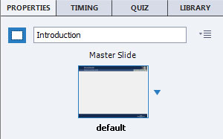To change a screen title, use the screen properties
  + Use the appropriate community logo/crest on each screen. To determine the appropriate community for a course, see the ETF Officer of Primary Responsibility (OPR) in the course’s CCD1.
  + Classification must be edited in the Master Slides (if needed)
* 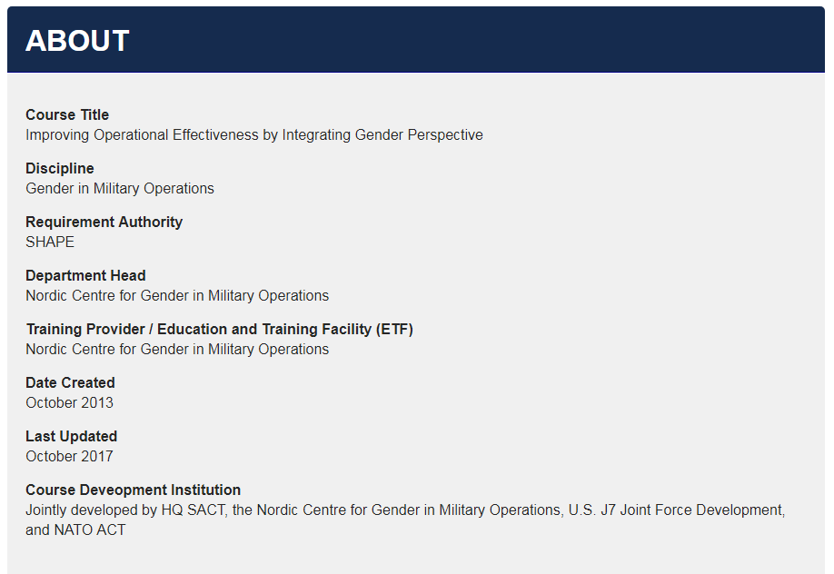About page includes Course Title, Discipline, Requirement Authority, Department Head, Training Provider/ETF, Date Created, Last Updated, Course Development Institution
* Glossary page includes hyperlink anchors for letters with populated terms. Letters without terms are inactive and greyed out.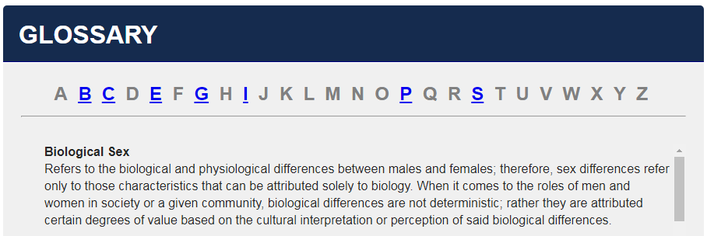
* Resources page includes list of links to documents through relative path. Should not link to external paths.

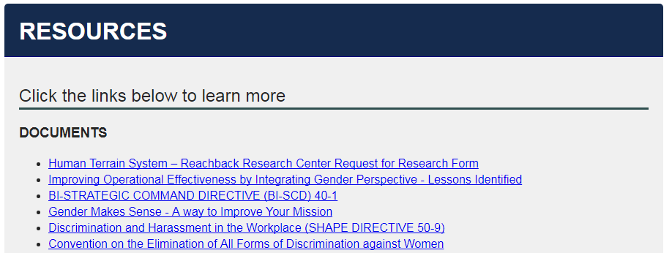

* 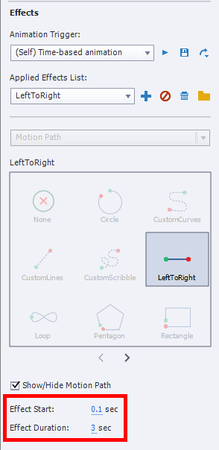Page progress bar is dynamically animated via Captivate Effects and requires timing adjustment for each page. LeftToRight and ScaleTo effects must be adjusted to start at 0.1 sec and end at the end of the slide timeline (0.1 second less than total time). It is most effective to manually enter the times through the Timing/Effects window panel. **Note:** timeline pause object(s)   
  must sync with the end of the slide timeline for this to work

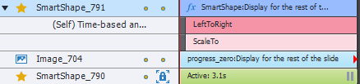

Recommended Standards:

* CC text boxes are created with Rounded Rectangles at bottom of screen

|  |  |  |
| --- | --- | --- |
| General Settings: |  |  |
| Stroke Color: #343434 Stroke Width: 3 | *FillColor*: #282828 | *Opacity*: 95% |
| Font Settings: | | |
| *Family:* Arial Regular All Margins: 5 Drop Shadow: Outer Color: #000000 Angle: 55 deg | *Size:* 14   Blur: 4 Opacity: 40% | *Color: #*FFFFFF   Distance: 3 |

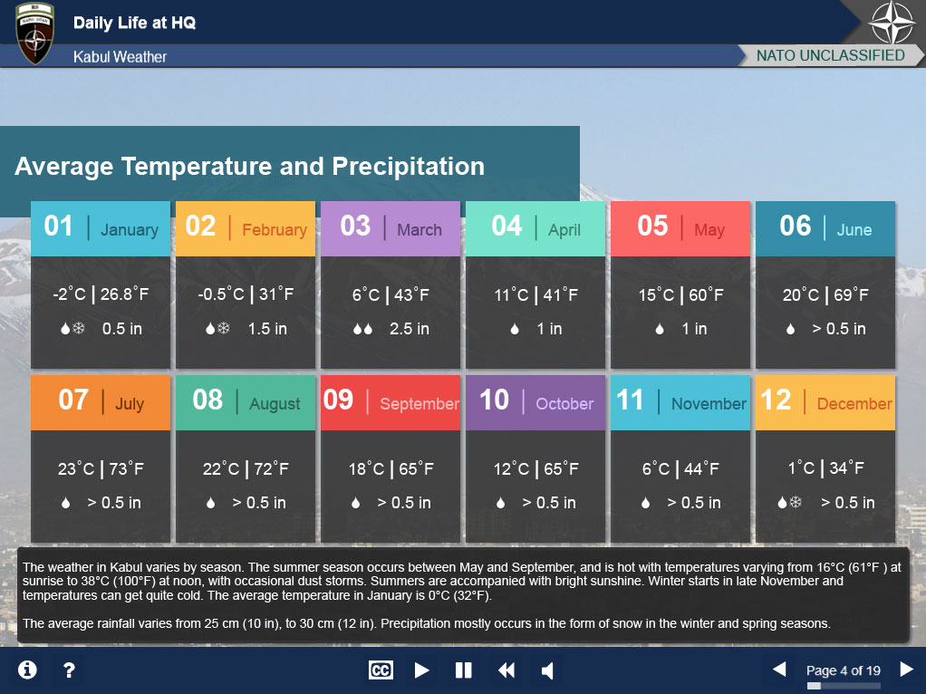

# On-Screen Text

### Required Standards:

* Any acronym used in the on-screen text or in a graphic/animation should be included in the acronym list
* When using bullets:
  + Be consistent with sentence structure – if one bullet in a series is written a complete sentence with punctuation, all bullets in that series should be complete sentences with punctuation
  + Use the bullet styles identified below for sorted and unsorted lists:



* If a screen contains interactivity, include an on-screen text prompt as well as narration.
  + All prompts for on-click items shall use the term ‘Select’. Do not use ‘Click’.
  + Style for prompt text:

|  |  |  |  |
| --- | --- | --- | --- |
| *Style*: Arial | *Size*: 14 | *Strength*: Bold | *Color*: #152B4E |

### Recommended Standards:

* Standard Font for Content, Knowledge Checks, and Assessments:

|  |  |  |  |
| --- | --- | --- | --- |
| *Color*: #000000 | *Style*: Arial | *Strength*: Regular* | *Size*: 14 |
| *Margins*: N/A | *Justified*: Left | *Vert* Position: Top | Spacing: 1.1 |
| *\**Use a Bold strength for any on-screen headers | | | |

* Do not use periods at the end of prompts
* Use a serial/oxford comma when listing a series of items in a sentence
* Words are to be spelled according to either British English (BrE) or American English (AmE). Be consistent with the use of only one form throughout a course.
* Avoid using the word ‘slide(s)’ when referring to pages/screens. Recommend either ‘page(s)’ or ‘screen(s)’
* First use of an acronym should include the longform followed by the acronym in parentheses. For example, “the Global Programming approach to NATO’s Education and Training (E&T)”

# Narration

### Required Standards:

* Allow a half second (0.5) pause before starting narration (when entering a screen)
* Narrate prompt text at the end of narrated screens

|  |  |
| --- | --- |
|  |  |

### Recommended Standards:

* When using built-in Captivate text-to-speech, Kate, and Paul are the preferred voices.

# Graphics/Animation

### Required Standards:

* General design style will take flat, modern approach. Use of gradients and drop-shadows on objects should be minimized, if used at all. Use of vector artwork and infographic approach is preferred.
* For all buttons:
  + Under the ‘Actions’ tab, select the ‘Hand Cursor’ and the ‘Disable Click Sound’ boxes.
  + Disable the ‘Down’ state (only ‘Normal’ and ‘Rollover’ should be enabled)
* Pages with animations will have a greyed out forward arrow (#676767) in the bottom GUI bar until all animations on the page are complete.
* Title Screen:
  + Course Text/Font:

|  |  |  |  |
| --- | --- | --- | --- |
| *Color*: #000000 | *Style*: Arial | *Strength*: Bold | *Size*: 40 |
| *Margins*: N/A | *Justified*: Center | *Vert* Position: Center |  |

* + Lesson Text/Font:

|  |  |  |  |
| --- | --- | --- | --- |
| *Color*: #000000 | *Style*: Arial | *Strength*: Regular | *Size*: 30 |
| *Margins*: N/A | *Justified*: Left | *Vert* Position: Middle |  |

* + Date Text/Font:

|  |  |  |  |
| --- | --- | --- | --- |
| *Color*: #000000 | *Style*: Arial | *Strength*: Regular | *Size*: 15 |
| *Margins*: N/A | *Justified*: Right | *Vert* Position: Bottom |  |

* + Background:

|  |  |  |  |
| --- | --- | --- | --- |
| *Fill*: Gradient | *Direction*: Top-Bottom | *Opacity*: 50% - 70% | *stroke*: 0 |
| *Size*: 1024x150 | *X/Y*: 0/134 | *Color: #*F2F2F2 - #BFBFBF |  |

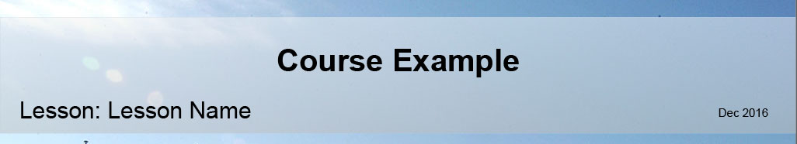

* Any items that have Fade In or Fade Out transitions will be set to duration of 0.5 sec.

### Recommended Standards:

* Drop Shadows:

|  |  |  |  |
| --- | --- | --- | --- |
| *Color*: #000000 | *Blur (px)*: 4 | *Opacity (%)*: 40 | *Distance*: 3 |
| *Angle*: 45° |  |  |  |

|  |  |  |  |
| --- | --- | --- | --- |
|  |  |  |  |

# Branching Screens

### Required Standards:

* Narration for a branching screen will only play on the user’s first entrance to the screen. When the user returns to the branch screen from a branched page, no audio needs to play
* Hide the Next arrow until all branches are visited
* Provide feedback as to which branches have been visited (button state change)

### Recommended Standards:

# \\nuactsvfs-access.u000.nato.int\users$\act.williams4\Desktop\questions.jpgAssessments/Knowledge Checks

### Required Standards:

* Progress bar is NOT to be included in the GUI on knowledge check and assessment screens
* Ungraded ‘Knowledge Check’ questions require the ‘Points’ field be set to ‘0’. For graded questions, set ‘Points’ to 10
* Under the ‘Actions’ sub-header in the ‘Quiz Properties’ tab for an assessment or knowledge check screen, allow two attempts for all questions (except for True/False questions). Provide feedback after the 2nd failed attempt

### Recommended Standards:

* In the ‘Quiz Properties’ tab for an assessment or knowledge check screen, shuffle answers when possible
* Avoid “All of the Above” multiple-choice questions. Instead, make the question a multiple select where learner can select all correct answers
* Avoid lettering/numbering for distractors
* Set the passing benchmark for assessment questions at 80%

# Miscellaneous

### Required Standards:

* Hyperlinks and buttons that open any documents or files outside of captivate must open in a new browser window or tab. Pause the playing of the screen’s timeline upon click (uncheck ‘Continue Playing the Project’)
* If a screen/page only contains a video, the video should play automatically. Additionally, the screen should not contain any additional audio or narration. If a video is embedded in a screen that contains on-screen text, the narration should play automatically (as opposed to the video). Such screens should include on-screen prompt text instructing the user to play the video. Recommend videos have maximum length of 5 minutes in mp4 format

### Recommended Standards:

* Recommended resolution: 1024 x 768 pixels
* Hyperlinks to only official NATO hyperlinks or embedded files.
* If a screen has no narration and/or animation, the progress bar should function normally for the duration of three (3) seconds.
* Introduction Screen:
  + The second page of a lesson should outline the lesson objectives. This page, which has been standardized in the Captivate Template
  + Learning objectives and Bloom’s Taxonomy verbs:

|  |  |  |  |
| --- | --- | --- | --- |
| Verb | Font Name | Character | Output |
| Analyze | Webdings | q | ❑ |
| Apply | Wingdings 2 | P |  |
| Compare | Webdings | . |  |
| Define | Wingdings | & |  |
| Demonstrate | Wingdings | z |  |
| Describe | Wingdings | ! |  |
| Discuss | Webdings | _ |  |
| Verb | Font Name | Character | Output |
| Explain | Webdings | O |  |
| Identify | Webdings | L | ☹ |
| List | Wingdings | 2 |  |
| Paraphrase | Webdings | U |  |
| Recall | Wingdings | I |  |
| Recognize | Webdings | N |  |
| Summarize | Webdings | + |  |

# Color Scheme

Use the provided color scheme to create various objects, to include but not limited to:

* Buttons
* Shape Objects
* Chart items
* Vector Artwork

|  |  |  |  |  |
| --- | --- | --- | --- | --- |
| **4CC2D9** |  | **348EA9** |  | **246277** |
|  |  |  |  |  |
| **78E5CE** |  | **52BA9B** |  | **38866B** |
|  |  |  |  |  |
| **FDBF50** |  | **F48B37** |  | **D85F26** |
|  |  |  |  |  |
| **FC6966** |  | **EF4848** |  | **CD3130** |
|  |  |  |  |  |
| **B98DD4** |  | **8561A2** |  | **5B4271** |

# Comment Tool

To insert the comment tool into a course:

1. Log into a Google account in a web browser (preferably Chrome)
2. Open “My Drive” at <https://drive.google.com>
3. Select the “New” icon and create a Google Form
4. Build a form to include the following:
   1. Instructions (Long answer text)
   2. Category (Dropdown)
      1. Text
      2. Graphic
      3. Narration
      4. Functionality
      5. Other
   3. Lesson (Short answer)
   4. Page (Short answer)
   5. Reviewer Name & Organization (Short answer)



1. Select More (…) from the form taskbar at the top right of the window (see below)
   1. Select “Get prefilled link”
   2. Enter a unique (a few characters) id for “Your answer” of “Lesson” and a different unique id for “Your answer” to “Page”
   3. Select the “Submit” icon to get a prefilled link at the top of the page
   4. Copy the link text
2. In your captivate file, select the comment icon or the GUI taskbar
   1. Select the Actions tab in the properties pane for the comment icon
   2. In the “On Success” dropdown menu, select “Open URL or file”
   3. Paste the URL copied from step 5.d into the “URL” text box that appears below dropdown menu
   4. Within the URL, find the unique id entered for “Your answer” of “Lesson” and change the text to match the lesson number
   5. Repeat the previous step (6.d) for the unique id entered for “Your answer” of “Page” to match the page number
   6. Select the dropdown arrow next to the URL text entry box and select “New”
   7. Repeat this step (6) for each page in the lesson



https://docs.google.com/forms/d/e/1FAIpQLSeSB1C1uBXVKXnEtLzRmgZYtdeKDHh1n4QGg9KufbDlI3AN9Q/viewform?entry.1429375351&entry.1916284154=XXX&entry.525180614=YYY&entry.868915993

# Publishing Settings

### SCORM Publish Settings

SCORM publish settings are required for upload and progress tracking in JADL ILIAS Learning Management System.

1. In Captivate, select File > Publishing Settings…
2. Under ‘Quiz’ section, select ‘Reporting’
   1. Check ‘Enable reporting for this project’
   2. In the ‘LMS’ dropdown, select ‘Other Standard LMSs’
   3. In the ‘Standard’ dropdown, select ‘SCORM 1.2’ (best compatibility option for ILIAS)
   4. Next to ‘Standard’, select ‘Configure’ button
      1. Provide ‘Course Identifier’ (no spaces or special characters, ex: ADL213)
      2. Provide ‘Course lesson Title’
      3. Provide ‘SCO Identifier’ (no spaces or special characters, ex: ADL2130101)
      4. Provide ‘SCO Title’
      5. Select ‘OK’ to close windows
   5. In the ‘Template’ dropdown, select ‘Default’
   6. Under ‘Status Representation’, select ‘Incomplete 🡪 Complete’
   7. Under ‘Success/Completion Criteria’, select ‘Slide views and/or quiz’
      1. If there is NO assessment for the SCO, select ‘Slide views’, ‘100%’
      2. If there is a graded assessment, select ‘Quiz’, ‘Quiz Passed’
   8. Under ‘Data To Report’, select ‘Percentage’
   9. Leave ‘Interaction Data’ checked
   10. Under ‘LMS Initialization Text’, enter ‘Loading’
   11. Select the ‘Advanced’ button
       1. Check ‘Send Resume Data’
       2. Check ‘Set exit to normal after completion’
       3. Check ‘Escape Version and Session ID’
       4. 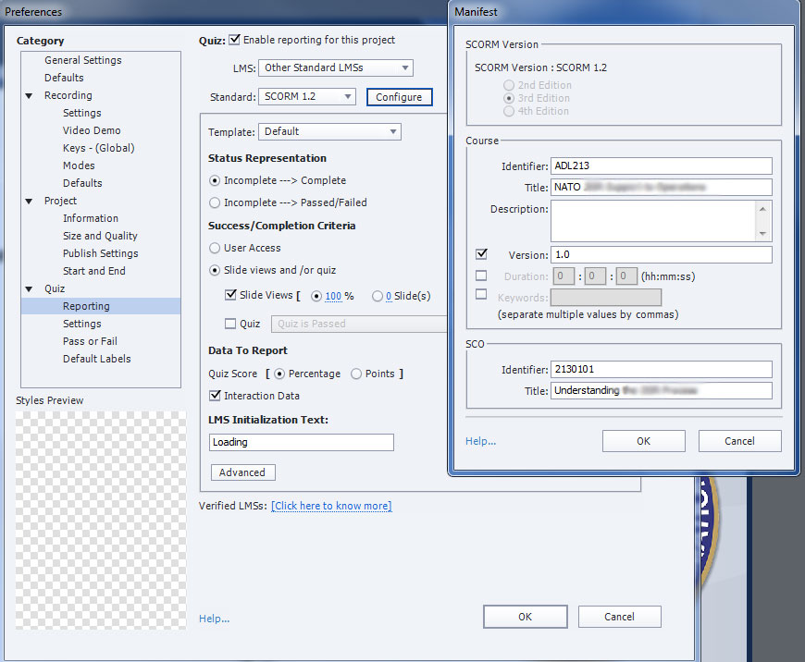Select ‘OK’
3. Under ‘Quiz’ section, select the ‘Settings’ menu
   1. Provide unique ‘Objective ID’ identifier (ex: QuizADL2130101)
   2. Check ‘Allow Backward Movement’
4. Under ‘Quiz’ section, select ‘Pass or Fail’
   1. For pass/fail options, recommend ‘80’ % or more of total points to pass
   2. Check ‘Show Retake Button’

### Quality Publishing Settings

1. In Captivate, select File > Publish Settings…
2. Under ‘Project’ section, select ‘Size and Quality’
   1. Uncheck ‘Retain Slide Quality Settings’
   2. In the ‘Bmp’ dropdown, set to ‘High (24 bit)’
   3. Check ‘Advanced Project Compression’
   4. Check ‘Compress SWF File’

### Final project publishing

1. In Captivate, Select File > Publish…
2. In the ‘Publish’ dropdown, select ‘HTML5/SWF’
3. Provide a ‘Project Title’ (no special characters or spaces ex: 2130101)
4. Provide a ‘Location’ path
5. Check ‘Zip Files’
6. Under ‘Output Format’, select only ‘HTML5’ buttons
7. Uncheck all other options
8. Select the ‘Publish’ button 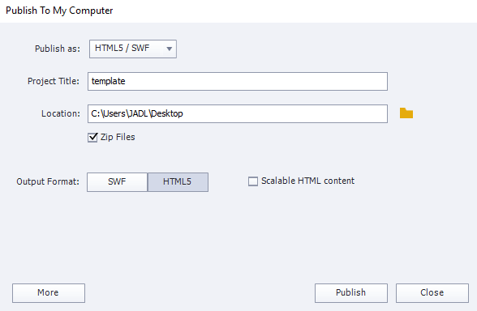

# Project Folder Structure

Each project should have a folder in the “B-Course_Development” parent-folder. The project folder should be named according to the ADL number and the course title (i.e. ADL212_GlobalProgramming). If a project does not yet have an ADL number, use ADLXXX instead of a number. Place the project folder in either the Current Projects folder (BB-Current_Projects), Future Projects folder (BC-Future_Projects), or Completed Projects folder (BD-Completed_Projects) according to the state of the project. Within each project folder, files should be organized as follows:

* 01 – Planning
  + 010 – Status
  + 011 – TNA –POI
  + 012 - Meetings
* 02 – Design (SBD)
  + 020 – CCDs
    - *CCD1 (document)*
    - *CCD2 (document)*
    - *CCD3 (document)*
  + 021 – Storyboards
  + 022 – Archive
  + *Acronyms word document*
* 03 – Development (MMD)
  + Lesson 1
    - *Lesson 1 (Captivate File)*
    - *Lesson 1 (Compressed course package)\**
    - sharedFiles
    - Images
      * PSDs
    - Video
  + Lesson 2
    - …
  + …
  + Source Images**
  + acronym.html (acronym file for course)
* 04 – Product Resources
  + 040 – Source Documents
  + 042 – References
  + …
* 05 – Final Product
  + *ADLXXX (compressed course package)*

**\***Compressed course packages (zip file) published from Captivate

**Source Images are the original, un-manipulated versions of images used in the course. These source images are not the Photoshop documents, but rather the untouched/original images that are later edited (cropped, scaled-down, etc.) for use and imported into a Captivate file.