***First Page: Model 1 – Fit the Model with Male and Female data from 1967 to 2007***

Using income data from 1967 to 2007 we predicted the 2007 to 2017 data and compared to the actual data. Then we predicted the data to the next 10 years, 2017 to 2027.

Male Income: (Picture: Male Income 1967_2007.png)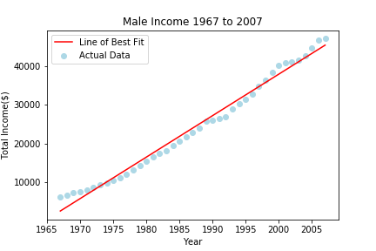

Female Income: (Picture: Female Income 1967_2007.png)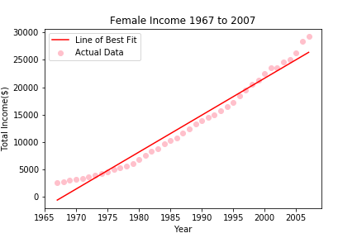

(These 2 charts above can be next to each other on the page, like this:)



Male Prediction 2007 to 2017: (Picture: Male Income 1967_2017.png)

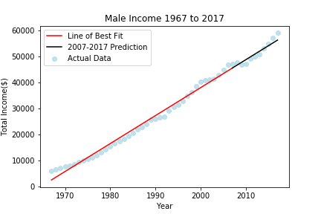

Female Prediction 2007 to 2017: (Picture: Female Income 1967_2017.png)

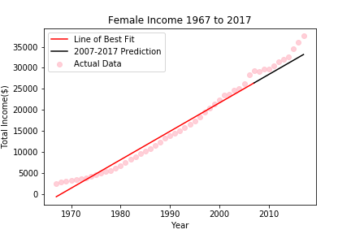

(These 2 charts above can also be next to each other on the page)

Actual data Vs. Predicted data and the Residual Plot:

Male: (Picture: Male_Predicted_Actual.png)

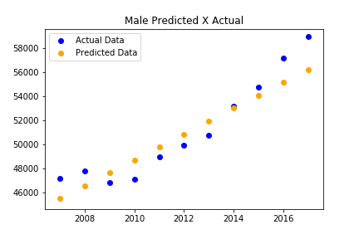

Male Residual Plot: (Picture: Male_Residual_Plot.png)

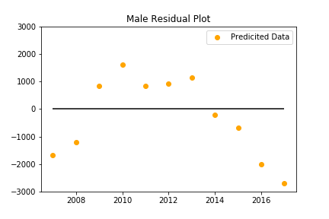

(These 2 charts above can also be next to each other on the page)

Female: (Picture: Female_Predicted_Actual.png)

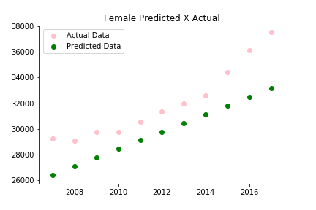

Female Residual Plot: (Picture: Female_Residual_Plot.png)

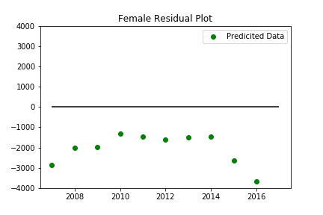

(These 2 charts above can also be next to each other on the page)

Prediction to the next 10 years using first model:

Male: (Picture: Future Male Income.png)

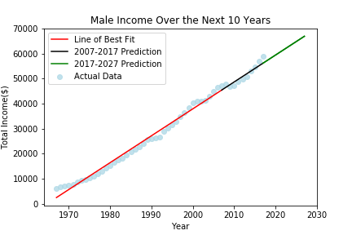

Female: (Picture: Future Female Income.png)

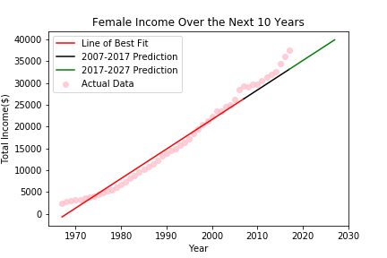

(These 2 charts above can also be next to each other on the page)