***Second Page: Model 2 – Fit the Model with Male and Female data from 1967 to 2017***

Using income data from 1967 to 2017 we predicted the data to the next 10 years, 2017 to 2027. Then we can compare the predictions between first and second models.

Male Income: (Picture: Male Income 1967_2017_2.png)

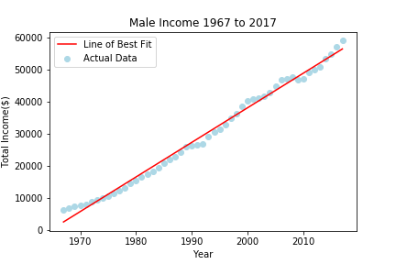

Female Income: (Picture: Female Income 1967_2017_2.png)

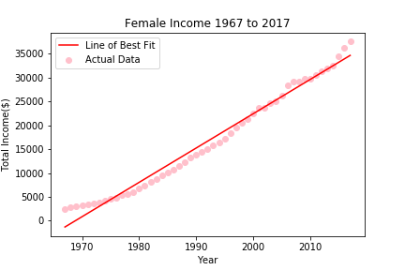

(There 2 charts can be next to each other on the page)

Male Prediction 2017 to 2027: (Picture: Future Male Income_2.png)

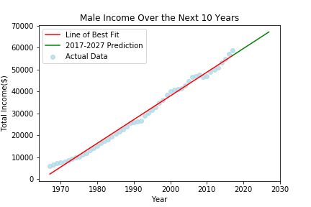

Female Prediction 2017 to 2027: (Picture: Future Female Income_2.png)

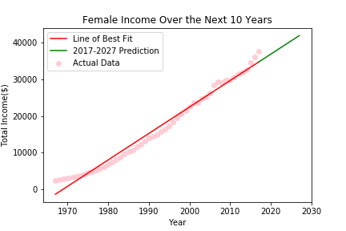

(There 2 charts can be next to each other on the page)

Comparison between the prediction from 2017 to 2027 using First and Second Model:

Male: (Picture: Comparison_Male.png)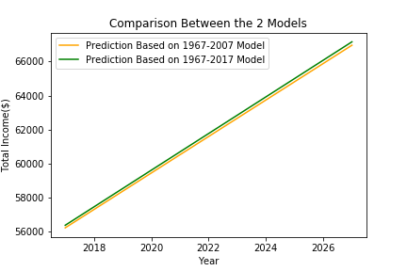

Female: (Picture: Comparison_Female.png)

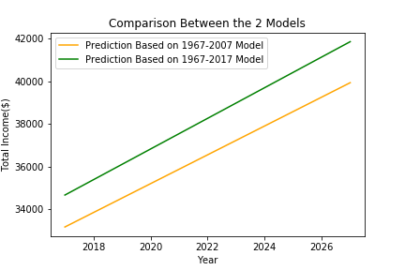

(There 2 charts can be next to each other on the page)

Comparison between male and female predictions, based on the second model: (Picture: Comparasion_Male_Female.png)

