***Third Page: Model 3 – Fit the Model with Male and Female data from 21st Century – 2000 to 2017***

Using income data from 2000 to 2017 we predicted the data to the next 10 years, 2017 to 2027 to check if there is a tendency of the wages gap between male and female decreases using more recent data.

Male Income: (Picture: Male Income 2000_2017.png)

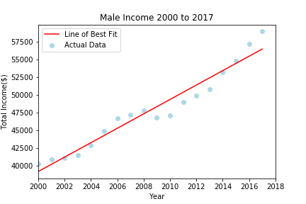

Female Income: (Picture: Female Income 2000_2017.png.png)

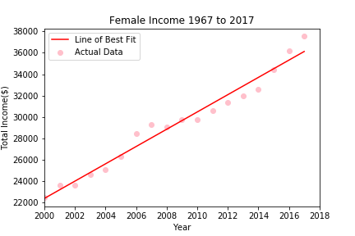

(There 2 charts can be next to each other on the page)

Male Prediction 2017 to 2027: (Picture: Future Male Income_3.png)

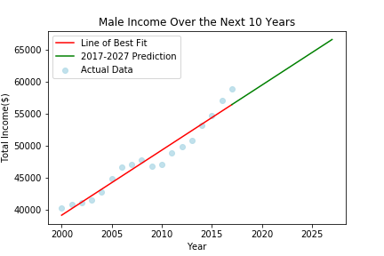

Female Prediction 2017 to 2027: (Picture: Future Male Income_3.png)

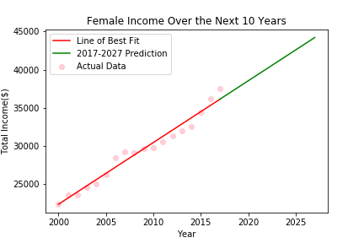

(There 2 charts can be next to each other on the page)

Comparison between the prediction from 2017 to 2027 using Third Model: (Picture: Comparasion_Male_Female_21_century.png)

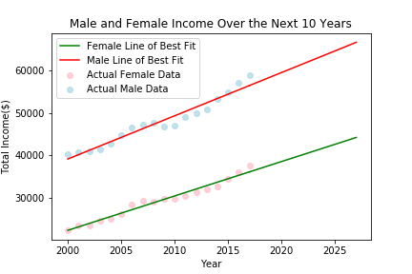

Final chart comparing all the 3 models: (Picture: Last_Chart.png)

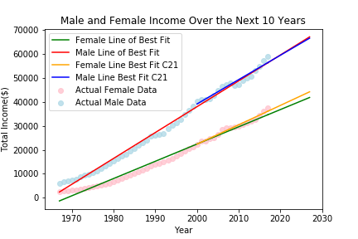

Based on this we can see that if we consider the data from 1967 where the wages gap between male and female were higher, looks like in the future the gap will be growing. But even the gap still existing, when we consider more recent data we can see the gap is decreasing. We still have a long way to go but there is a tendency of this gap being smaller in the future.