Contents
Purpose 2
Current Schema 2
Schema Diagram: 2
Example Schema: 3
Suggested Schema by EDGE Team 4
Schema Diagram: 4
Changes: 4
Example Schema: 5
Proposed Schema: 5
Schema Diagram: 5
Suggested Changes: 6
Example Schema: 6
Appendix: 7
Current Solution – Json Schema: 7
Current Solution – Summary Table: 7
Edge Suggested Solution – Json Schema: 7
Edge Suggested Solution – Summary Table: 7
Suggested Solution – Json Schema: 7
Suggested Solution – Summary Table: 7
Suggested changes: 9

Purpose
King’s Canvas is the student life plan functionality within King’s Edge. Each student has a plan made up of:
- Intentions: high-level goals
- Steps: agreed actions that contribute to an intention
- Opportunities: specific ways of completing a step (catalogue-backed or free text)
The information mentioned above will be stored within a JSON schema in a database. The rest of the document reviews the current schema, schema suggested by King’s Edge and the new schema suggested by DISS.

Current Solution
The current solution is a flat schema, which stores the long-term goal of the user, priority of said goal and progress to achieving it. The schema lacks some level of complexity to be able to store the long-term goals of the user and the steps in which the user will take to achieving their goal, therefore a new schema structure will be required to do so.

Schema Diagram:

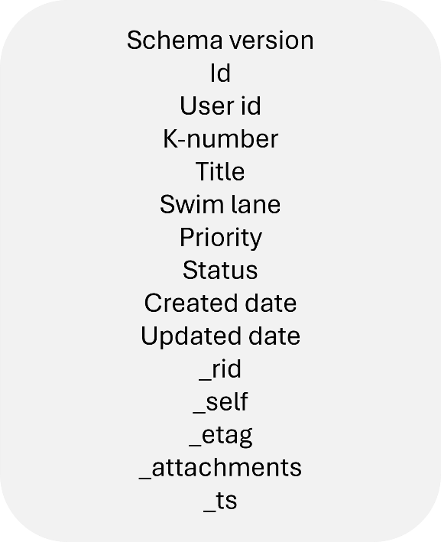

Example Schema:
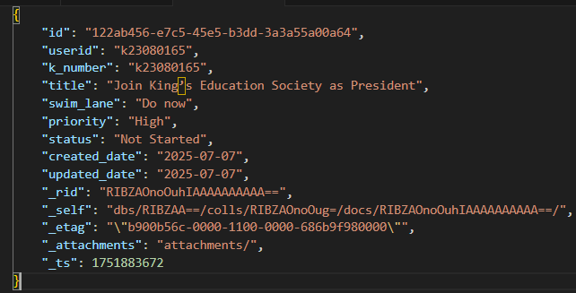

Suggested Solution by EDGE Team
The suggested schema from the Edge team introduces a hierarchical schema, which consists of an array of long-term goals made by the user, labelled as ‘intentions’. Within this array are ‘steps’, which are actions agreed by the user to help achieve their long-term goals. Within this are a series of opportunities provided by the Edge Coach agent for the user to select as steps.
Other notable introductions are the ‘events’ and ‘metrics’ array, which logs activity and updates done to the intention (i.e. when an item is created or updated) respectively.

Schema Diagram:
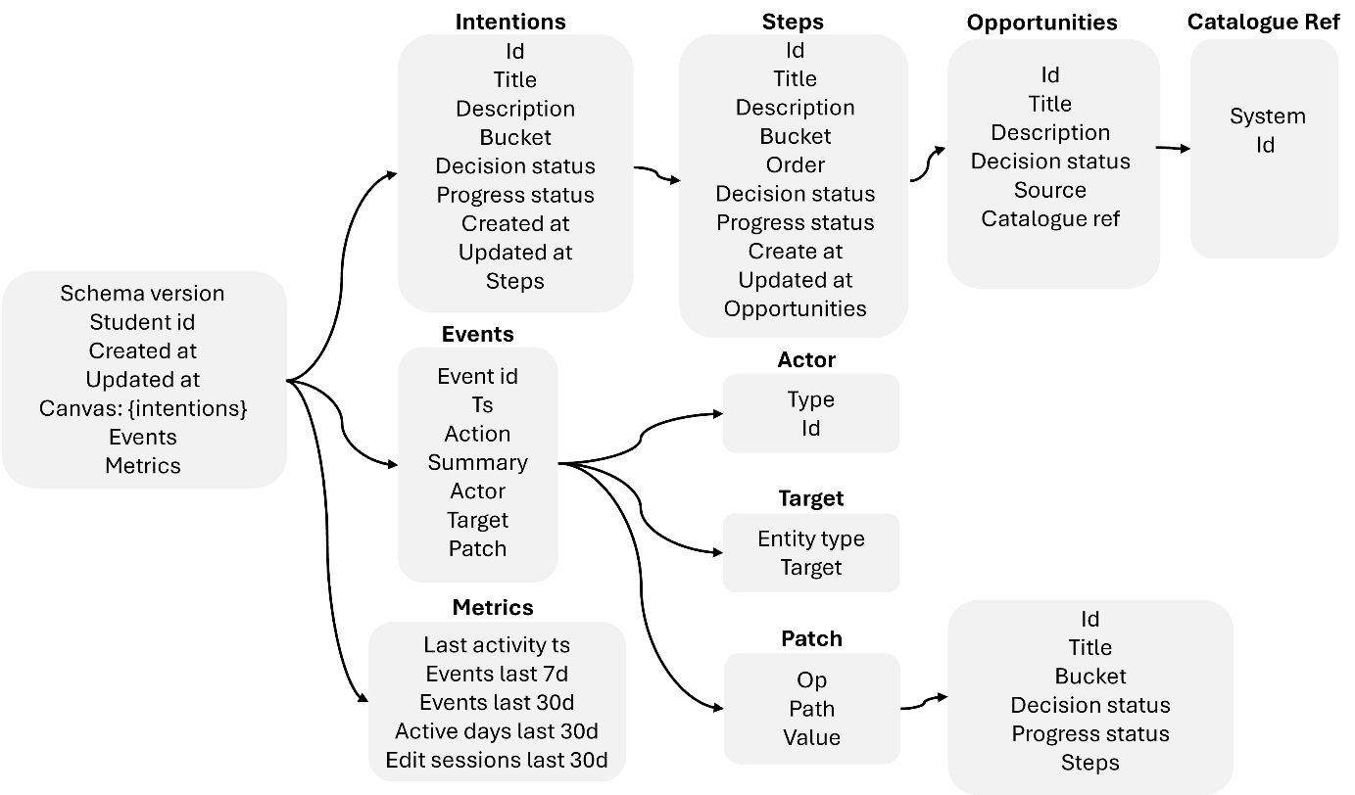

Example Schema:

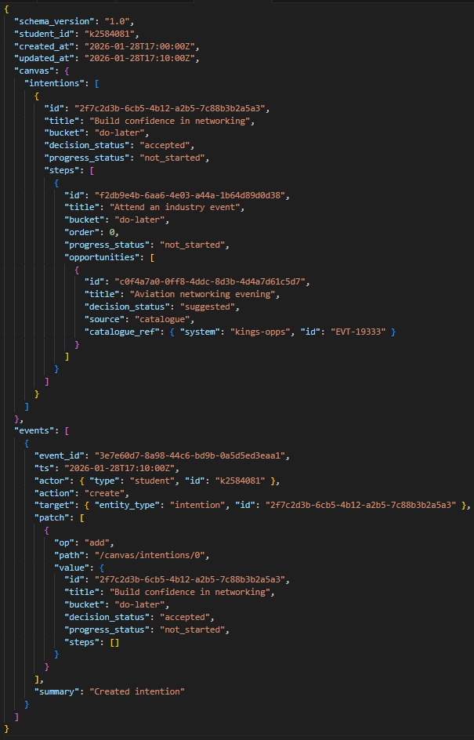

Proposed Solution by DISS:
The suggested solution consists of a similar hierarchical structure as the one suggested by the Edge Team. The new schema structure is designed to reduce some of the redundancies present in the Edge Team solution, whilst maintaining the same purpose: a schema structure capable of holding a set of user’s long-term goals, steps to achieving the goals and opportunities suggested by the Edge Coach agent.
Here is an overview of the changes made:
- Removed created_at and updated_at from the root schema as these parameters are included within each nest, making said parameters at root schema redundant.

- Removed decision_status from within the intention and steps nest, as actions within these nests will not be added unless the user confirms to the agent for it to be added to their life plan. The only reason this parameter would be required is if the Edge team would also like to store actions the student has rejected.

- Updated allowed values for decision_status within the opportunities nest to only include ‘Accepted’ and ‘Suggested’. The excluded parameter ‘Rejected’ may not be necessary as users can have different views on an opportunity when it is presented twice at different dates.

- Removed event nest, logging when items are created/updated seems redundant unless the Edge Team foresee a UI feature, which enables students to view their lifeplan history.

- Removed the cataloague_ref nested list within opportunities and added the parameters within nested list as individual parameters within the opportunities nest. The reason for this change is to reduce unnecessary complexity to the schema.

- Removed the source parameter within opportunities nest. This decision is dependent on whether the Edge Team foresee the Edge Coach agent providing opportunities that are external to the Edge ecosystem.

Schema Diagram:
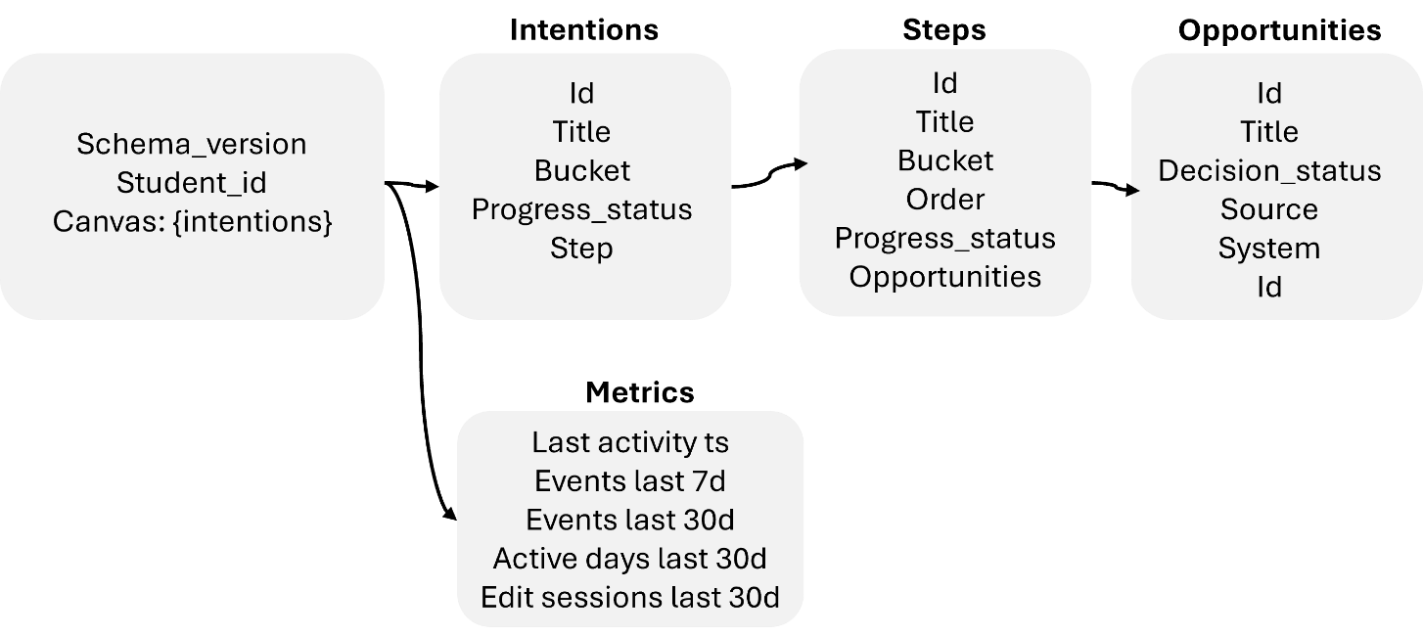

Example Schema:
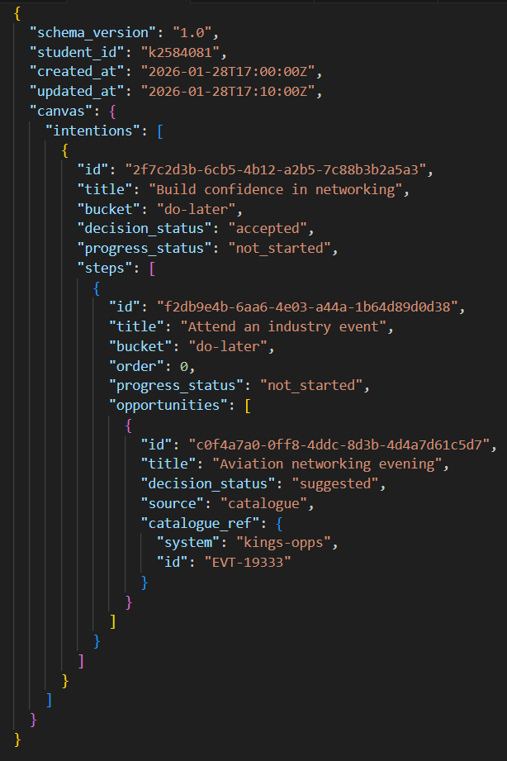

Appendix:

Current Solution – Json Schema:
{
"$schema": "https://json-schema.org/draft/2020-12/schema",
"$id": "https://example.org/schemas/goal-record.schema.json",
"title": "Goal Record (Legacy)",
"type": "object",
"additionalProperties": false,
"required": ["id", "userid", "k_number", "title", "swim_lane", "priority", "status", "created_date", "updated_date"],
"properties": {
"id": {"type": "string", "description": "Unique identifier for the record (UUID)."},
"userid": {"type": "string", "description": "User identifier (often a K-number).", "minLength": 1},
"k_number": {"type": "string", "description": "K-number of the user.", "minLength": 1},
"title": {"type": "string", "description": "Goal title.", "minLength": 1},
"swim_lane": {"type": "string", "description": "Workflow lane / category (e.g., Do now).", "minLength": 1},
"priority": {"type": "string", "description": "Priority level (e.g., High).", "minLength": 1},
"status": {"type": "string", "description": "Progress status (e.g., Not Started).", "minLength": 1},
"created_date": {"type": "string", "description": "Created date (YYYY-MM-DD).", "format": "date"},
"updated_date": {"type": "string", "description": "Updated date (YYYY-MM-DD).", "format": "date"},
"_rid": {"type": "string", "description": "Cosmos DB resource ID."},
"_self": {"type": "string", "description": "Cosmos DB self link."},
"_etag": {"type": "string", "description": "Cosmos DB ETag for optimistic concurrency."},
"_attachments": {"type": "string", "description": "Cosmos DB attachments path."},
"_ts": {"type": "integer", "description": "Cosmos DB last modified timestamp (Unix epoch seconds).", "minimum": 0}
}
}

Current Solution – Summary Table:
Field | DataType | Required | Allowed Values | Description
Id | String | Yes |  | Unique identifier of the task
userid | String | Yes |  | User identifier
k_number | String | Yes |  | K-number associated with user
title | String | Yes |  | Title of task
swim_lane | String | Yes | Do now, Think about it, Do later | Task swim lane classification
priority | String | Yes | Low, Medium, High | Priority level of task
status | String | Yes | Not Started, In Progress, Completed | Current task status
created_date | String | Yes |  | Date when task was created
updated_date | String | Yes |  | Date when task was updated
_ts | String |  |  | Unix timestamp
_rid | String |  |  | Cosmos DB resource ID
_etag | String |  |  | Unique identifier of resource
_self | String |  |  | Cosmos DB self-link
_attachments | String |  |  | Stores binary files such as videos, images and documents

Edge Suggested Solution – Json Schema:
{"$schema":"https://json-schema.org/draft/2020-12/schema","$id":"https://kcl.ac.uk/kings-edge/kings-canvas.schema.json","title":"King's Canvas Document","type":"object","additionalProperties":false,"required":["schema_version","student_id","canvas","events"],"properties":{"schema_version":{"type":"string","pattern":"^[0-9]+\\.[0-9]+(\\.[0-9]+)?$"},"student_id":{"type":"string","minLength":1},"created_at":{"type":"string","format":"date-time"},"updated_at":{"type":"string","format":"date-time"},"tutorial_state":{"type":"object","additionalProperties":true},"canvas":{"$ref":"#/$defs/CanvasState"},"events":{"type":"array","items":{"$ref":"#/$defs/CanvasEvent"},"default":[]},"metrics":{"type":"object","additionalProperties":false,"properties":{"last_activity_ts":{"type":"string","format":"date-time"},"events_last_7d":{"type":"integer","minimum":0},"events_last_30d":{"type":"integer","minimum":0},"active_days_last_30d":{"type":"integer","minimum":0},"edit_sessions_last_30d":{"type":"integer","minimum":0}}}},"$defs":{"UUID":{"type":"string","format":"uuid"},"BucketId":{"type":"string","enum":["do-now","do-later","before-graduation","after-graduation"]},"DecisionStatus":{"type":"string","enum":["suggested","accepted","rejected"]},"ProgressStatus":{"type":"string","enum":["not_started","in_progress","completed","abandoned"]},"CanvasState":{"type":"object","additionalProperties":false,"required":["intentions"],"properties":{"intentions":{"type":"array","items":{"$ref":"#/$defs/Intention"},"default":[]}}},"Intention":{"type":"object","additionalProperties":false,"required":["id","title","bucket","decision_status","steps"],"properties":{"id":{"$ref":"#/$defs/UUID"},"title":{"type":"string","minLength":1},"description":{"type":"string"},"bucket":{"$ref":"#/$defs/BucketId"},"decision_status":{"$ref":"#/$defs/DecisionStatus"},"progress_status":{"$ref":"#/$defs/ProgressStatus"},"created_at":{"type":"string","format":"date-time"},"updated_at":{"type":"string","format":"date-time"},"steps":{"type":"array","items":{"$ref":"#/$defs/Step"},"default":[]}},"allOf":[{"if":{"properties":{"decision_status":{"const":"rejected"}},"required":["decision_status"]},"then":{"not":{"required":["progress_status"]}}},{"if":{"properties":{"progress_status":{"enum":["in_progress","completed"]}},"required":["progress_status"]},"then":{"properties":{"decision_status":{"const":"accepted"}},"required":["decision_status"]}}]},"Step":{"type":"object","additionalProperties":false,"required":["id","bucket","order","progress_status","opportunities"],"properties":{"id":{"$ref":"#/$defs/UUID"},"title":{"type":"string"},"description":{"type":"string"},"bucket":{"$ref":"#/$defs/BucketId"},"order":{"type":"integer","minimum":0},"decision_status":{"$ref":"#/$defs/DecisionStatus"},"progress_status":{"$ref":"#/$defs/ProgressStatus"},"created_at":{"type":"string","format":"date-time"},"updated_at":{"type":"string","format":"date-time"},"opportunities":{"type":"array","items":{"$ref":"#/$defs/Opportunity"},"default":[]}}},"OpportunitySource":{"type":"string","enum":["catalogue","free_text"]},"CatalogueRef":{"type":"object","additionalProperties":false,"required":["system","id"],"properties":{"system":{"type":"string","minLength":1},"id":{"type":"string","minLength":1}}},"Opportunity":{"type":"object","additionalProperties":false,"required":["id","decision_status","source"],"properties":{"id":{"$ref":"#/$defs/UUID"},"title":{"type":"string"},"description":{"type":"string"},"decision_status":{"$ref":"#/$defs/DecisionStatus"},"progress_status":{"$ref":"#/$defs/ProgressStatus"},"source":{"$ref":"#/$defs/OpportunitySource"},"catalogue_ref":{"$ref":"#/$defs/CatalogueRef"},"created_at":{"type":"string","format":"date-time"},"updated_at":{"type":"string","format":"date-time"}},"allOf":[{"if":{"properties":{"source":{"const":"catalogue"}},"required":["source"]},"then":{"required":["catalogue_ref"]}},{"if":{"properties":{"source":{"const":"free_text"}},"required":["source"]},"then":{"not":{"required":["catalogue_ref"]}}},{"if":{"properties":{"decision_status":{"const":"rejected"}},"required":["decision_status"]},"then":{"not":{"required":["progress_status"]}}},{"if":{"properties":{"progress_status":{"enum":["in_progress","completed"]}},"required":["progress_status"]},"then":{"properties":{"decision_status":{"const":"accepted"}},"required":["decision_status"]}}]},"ActorType":{"type":"string","enum":["student","staff","llm"]},"Actor":{"type":"object","additionalProperties":false,"required":["type"],"properties":{"type":{"$ref":"#/$defs/ActorType"},"id":{"type":"string"}}},"EntityType":{"type":"string","enum":["canvas","intention","step","opportunity"]},"EventAction":{"type":"string","enum":["create","update","move_bucket","status_change","delete","reorder"]},"EventTarget":{"type":"object","additionalProperties":false,"required":["entity_type","id"],"properties":{"entity_type":{"$ref":"#/$defs/EntityType"},"id":{"$ref":"#/$defs/UUID"}}},"JsonPatchOp":{"type":"object","additionalProperties":false,"required":["op","path"],"properties":{"op":{"type":"string","enum":["add","remove","replace","move","copy","test"]},"path":{"type":"string","minLength":1},"from":{"type":"string"},"value":{}}},"CanvasEvent":{"type":"object","additionalProperties":false,"required":["event_id","ts","actor","action","target","patch"],"properties":{"event_id":{"$ref":"#/$defs/UUID"},"ts":{"type":"string","format":"date-time"},"actor":{"$ref":"#/$defs/Actor"},"action":{"$ref":"#/$defs/EventAction"},"target":{"$ref":"#/$defs/EventTarget"},"patch":{"type":"array","items":{"$ref":"#/$defs/JsonPatchOp"},"default":[]},"summary":{"type":"string"}}}}}

Edge Suggested Solution – Summary Table:
Field | DataType | Required | Allowed Values | Description
student_id | String | Yes |  | K number of student
created_at | String | Yes |  | ? why required if intention column has created at and so does event?
updated_at | String | Yes |  | ? not required
Tutorial_state | Object | Yes
canvas | Array | Yes |  | Task swim lane classification
Intentions | Array | Yes |  | Long-term objective
Steps | Array | Yes |  | List of Actions to achieve long-term objective
Events | Array | Yes |  | History of changes made to the event

Intentions
Field | DataType | Required | Allowed Values | Description
id | String | Yes
Title | String | Yes |  | Title of intention
Created at | String | No
Updated at | String | No
Description | String | No
Bucket | String | Yes | Do now, Do later, Before graduation, After graduation | When intention will be started
Decision status | String | Yes | Accepted, Rejected, Suggested | Whether the student has accept this intention as a goal
Progress status | String | No | Not started, In progress, Completed, Abandoned | The progress the student has made with the intention
Steps | Array | Yes |  | List of Actions to achieve long-term objective

Steps:
Field | DataType | Required | Allowed Values | Description
id | String | Yes |  | Unique identifier
Title | String | Yes |  | Title of step
Created at | String | No
Updated at | String | No
Description | String | No
bucket |  | Yes | Do now, Do later, Before graduation, After graduation | When intention will be started
Progress status | String | No | Not started, In progress, Completed, Abandoned | The progress the student has made with the intention
Order | Integer | Yes
Opportunity | Array | Yes

Opportunity:
Field | DataType | Required | Allowed Values | Description
id | String | Yes |  | Unique identifier
Title | String | No |  | Title of step
Created at | String | No
Updated at | String | No
Description | String | No
Decision status |  | Yes | Accepted, Rejected, Suggested | Whether the student has accept this intention as a goal
Progress status | Integer | No | Not started, In progress, Completed, Abandoned | The progress the student has made with the intention
Source |  | Yes | Custom, Catalogue
Catalogue ref |  | No

Events:
Field | DataType | Required | Allowed Values | Description
Event id | String | Yes |  | Unique identifier
Ts | String | No |  | Unix time stamp
Actor | Array | Yes
Action | String | Yes
Target | Array | No
Patch | Array | Yes
Summary | String | No

Actor:
Field | DataType | Required | Allowed Values | Description
Actor | String | Yes | Student, Staff, LLM
Id | String | No |  | Unique identifier

Target:
Field | DataType | Required | Allowed Values | Description
Entity type | String | Yes | Student, Staff, LLM
Id | String | No |  | Unique identifier

Patch:
Field | DataType | Required | Allowed Values | Description
Op | String | Yes
Path | String | No
Value | Array | Yes

Value:
Field | DataType | Required | Allowed Values | Description
Id | String | Yes |  | Unique Identifier
Title | String | No
Bucket | Array | Yes | Do now, Do later, Before graduation, After graduation | When intention will be started
Decision status | String | Yes | Accepted, Rejected, Suggested | Whether the student has accept this intention as a goal
Progress status | Array | No | Not started, In progress, Completed, Abandoned | The progress the student has made with the intention
Steps | List | Yes

Suggested Solution – Json Schema:
{
"$schema": "https://json-schema.org/draft/2020-12/schema",
"$id": "https://example.com/student-canvas.schema.json",
"title": "Student Canvas Schema",
"type": "object",
"required": ["schema_version", "student_id", "created_at", "updated_at", "canvas"],
"properties": {
"schema_version": {"type": "string"},
"student_id": {"type": "string"},
"created_at": {"type": "string", "format": "date-time"},
"updated_at": {"type": "string", "format": "date-time"},
"canvas": {
"type": "object",
"required": ["intentions"],
"properties": {
"intentions": {
"type": "array",
"items": {
"type": "object",
"required": ["id", "title", "bucket", "progress_status", "steps"],
"properties": {
"created_at": {"type": "string"},
"updated_at": {"type": "string"},
"id": {"type": "string"},
"title": {"type": "string", "description": "title of long-term objective"},
"bucket": {"type": "string", "enum": ["Do now", "Do later", "Before graduation", "After graduation"], "description": "when intention is started"},
"progress_status": {"type": "string", "enum": ["Not started", "In Progress", "Completed", "Abandoned"], "description": "progress the user has made with the intention"},
"steps": {
"type": "array",
"items": {
"type": "object",
"required": ["id", "title", "bucket", "order", "progress_status", "opportunities"],
"properties": {
"created_at": {"type": "string"},
"updated_at": {"type": "string"},
"id": {"type": "string"},
"title": {"type": "string"},
"bucket": {"type": "string", "description": "when step is started"},
"order": {"type": "integer", "minimum": 0, "description": "priority of step"},
"progress_status": {"type": "string", "enum": ["Not started", "In Progress", "Completed", "Abandoned"], "description": "progress the user has made with the step"},
"opportunities": {
"type": "array",
"items": {
"type": "object",
"required": ["id", "title", "decision_status", "source", "catalogue_ref"],
"properties": {
"id": {"type": "string"},
"title": {"type": "string", "description": "title of opportunity"},
"decision_status": {"type": "string", "description": "whether the user has agreed to pursue the opportunity as a step"},
"source": {"type": "string"},
"catalogue_ref": {
"type": "object",
"required": ["system", "id"],
"properties": {
"system": {"type": "string"},
"id": {"type": "string"}
},
"additionalProperties": false
}},
"additionalProperties": false
}}},
"additionalProperties": false
}}},
"additionalProperties": false
}}},
"additionalProperties": false
}},
"additionalProperties": false
}

Suggested Solution – Summary Table:

Field | DataType | Required | Allowed Values | Description
student_id | String | Yes |  | K number of student
created_at | String | Yes |  | ? why required if intention column has created at and so does event?
updated_at | String | Yes |  | ? not required
Tutorial_state | Object | Yes
canvas | Array | Yes |  | Task swim lane classification
Intentions | Array | Yes |  | Long-term objective
Steps | Array | Yes |  | List of Actions to achieve long-term objective
Events | Array | Yes |  | History of changes made to the event

Intentions
Field | DataType | Required | Allowed Values | Description
id | String | Yes
Title | String | Yes |  | Title of intention
Created at | String | No
Updated at | String | No
Description | String | No
bucket | String | Yes | Do now, Do later, Before graduation, After graduation | When intention will be started
Progress status | String | No | Not started, In progress, Completed, Abandoned | The progress the student has made with the intention
Steps | Array | Yes |  | List of Actions to achieve long-term objective

Steps:
Field | DataType | Required | Allowed Values | Description
id | String | Yes |  | Unique identifier
Title | String | Yes |  | Title of step
Created at | String | No
Updated at | String | No
Description | String | No
bucket |  | Yes | Do now, Do later, Before graduation, After graduation | When intention will be started
Progress status | String | No | Not started, In progress, Completed, Abandoned | The progress the student has made with the intention
Order | Integer | Yes
Opportunity | Array | Yes

Opportunity:
Field | DataType | Required | Allowed Values | Description
id | String | Yes |  | Unique identifier
Title | String | No |  | Title of step
Created at | String | No
Updated at | String | No
Description | String | No
Decision status |  | Yes | Accepted, Suggested | Whether the student has accept this intention as a goal
Source |  | Yes
Catalogue ref |  | No

