Style Guide for User Documentation

# Purpose and Goal

The purpose of this style guide is to provide authors and editors with the standardized usage and formatting for the documentation appearing at <http://docs.brightspot.com>. Some of the standards appearing in this style guide are taken from the sources listed in “References.” Other standards are unique to Perfect Sense.

# Brightspot’s User Interface

Brightspot has the following primary user interfaces: dashboard, content edit page, settings, and content picker. The callouts in the following illustrations provide the terms to use in user documentation.

## Dashboard

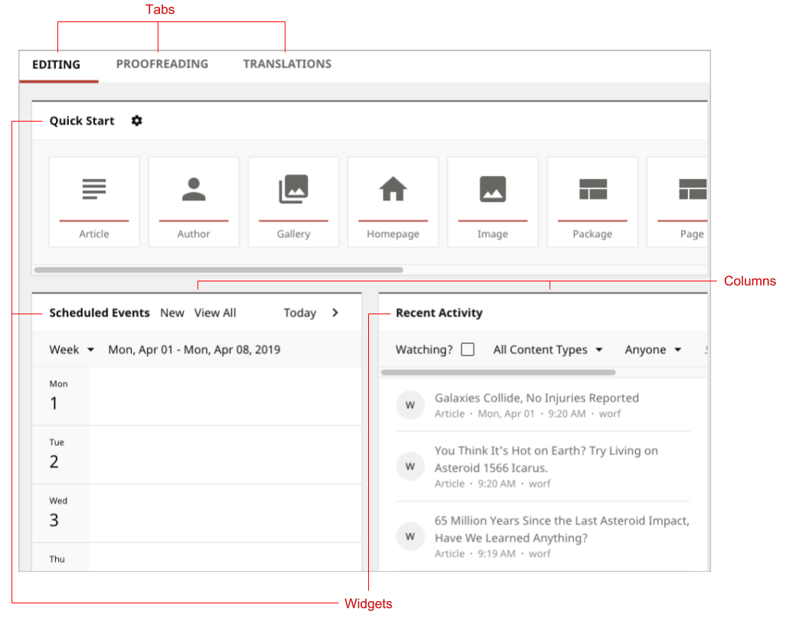

Figure 1: Dashboard

## Content Edit Page

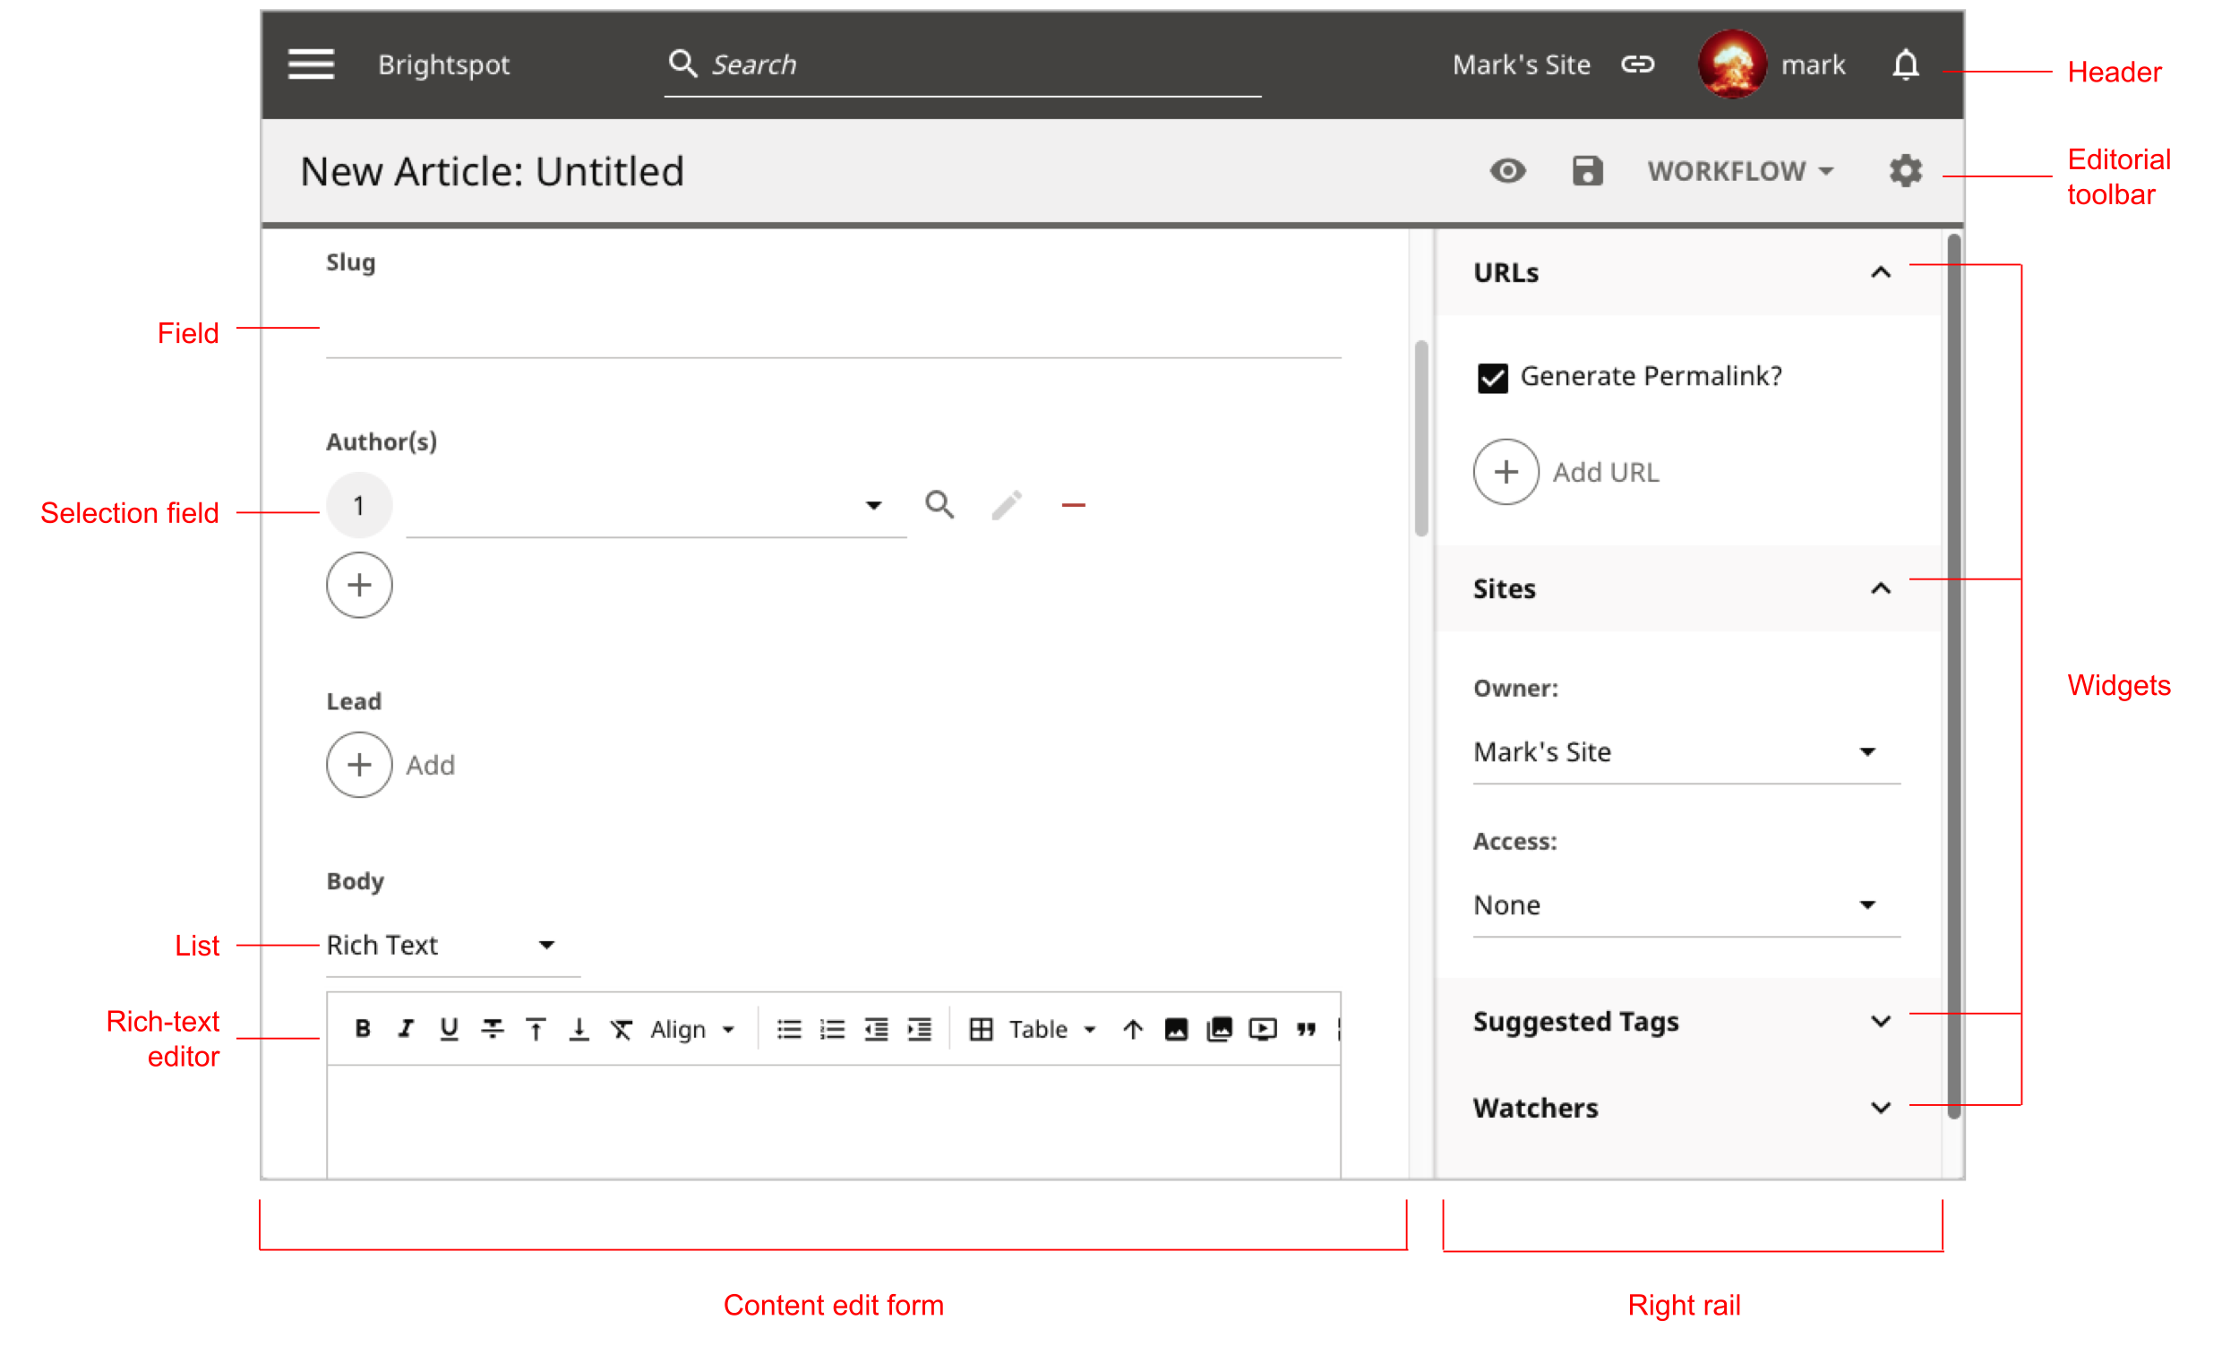

Figure 2: Content edit page

## Settings Pages

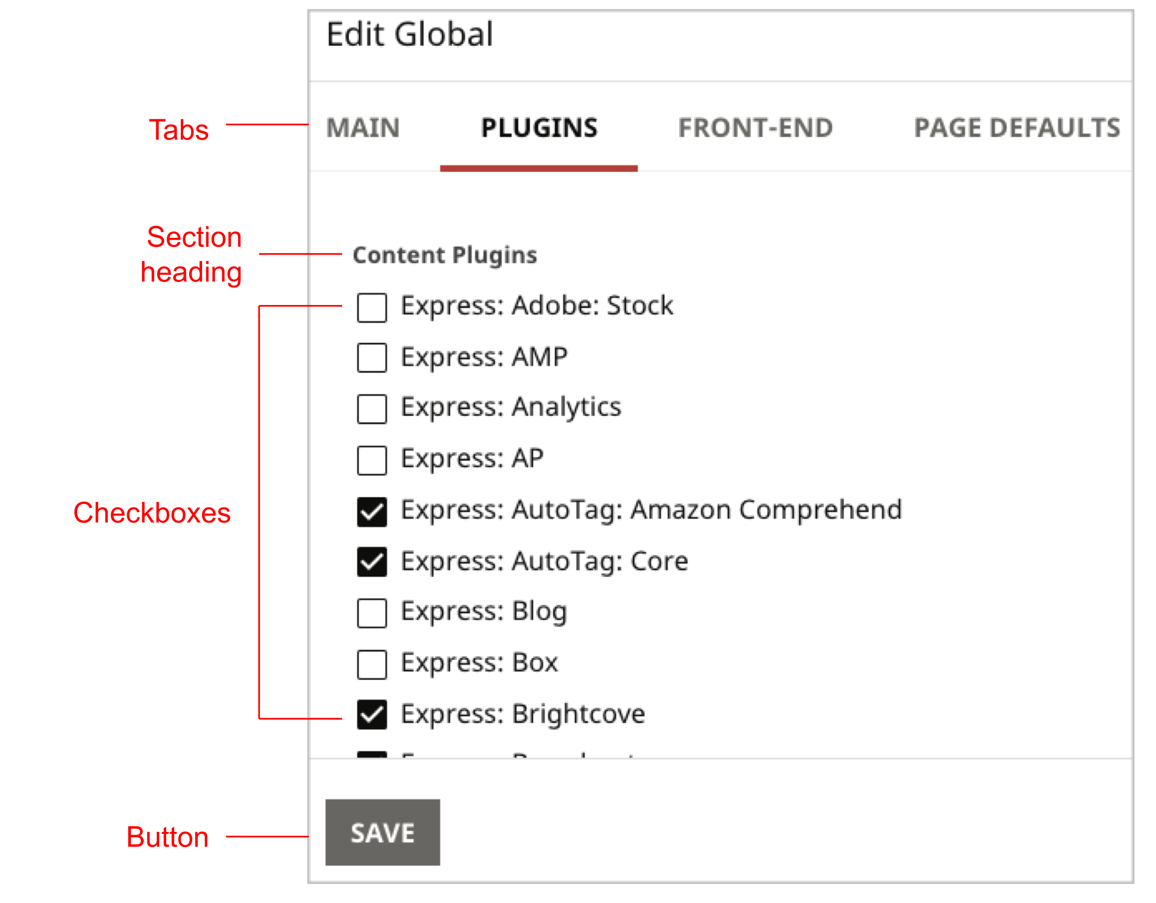

Figure 3: Settings page, plugins

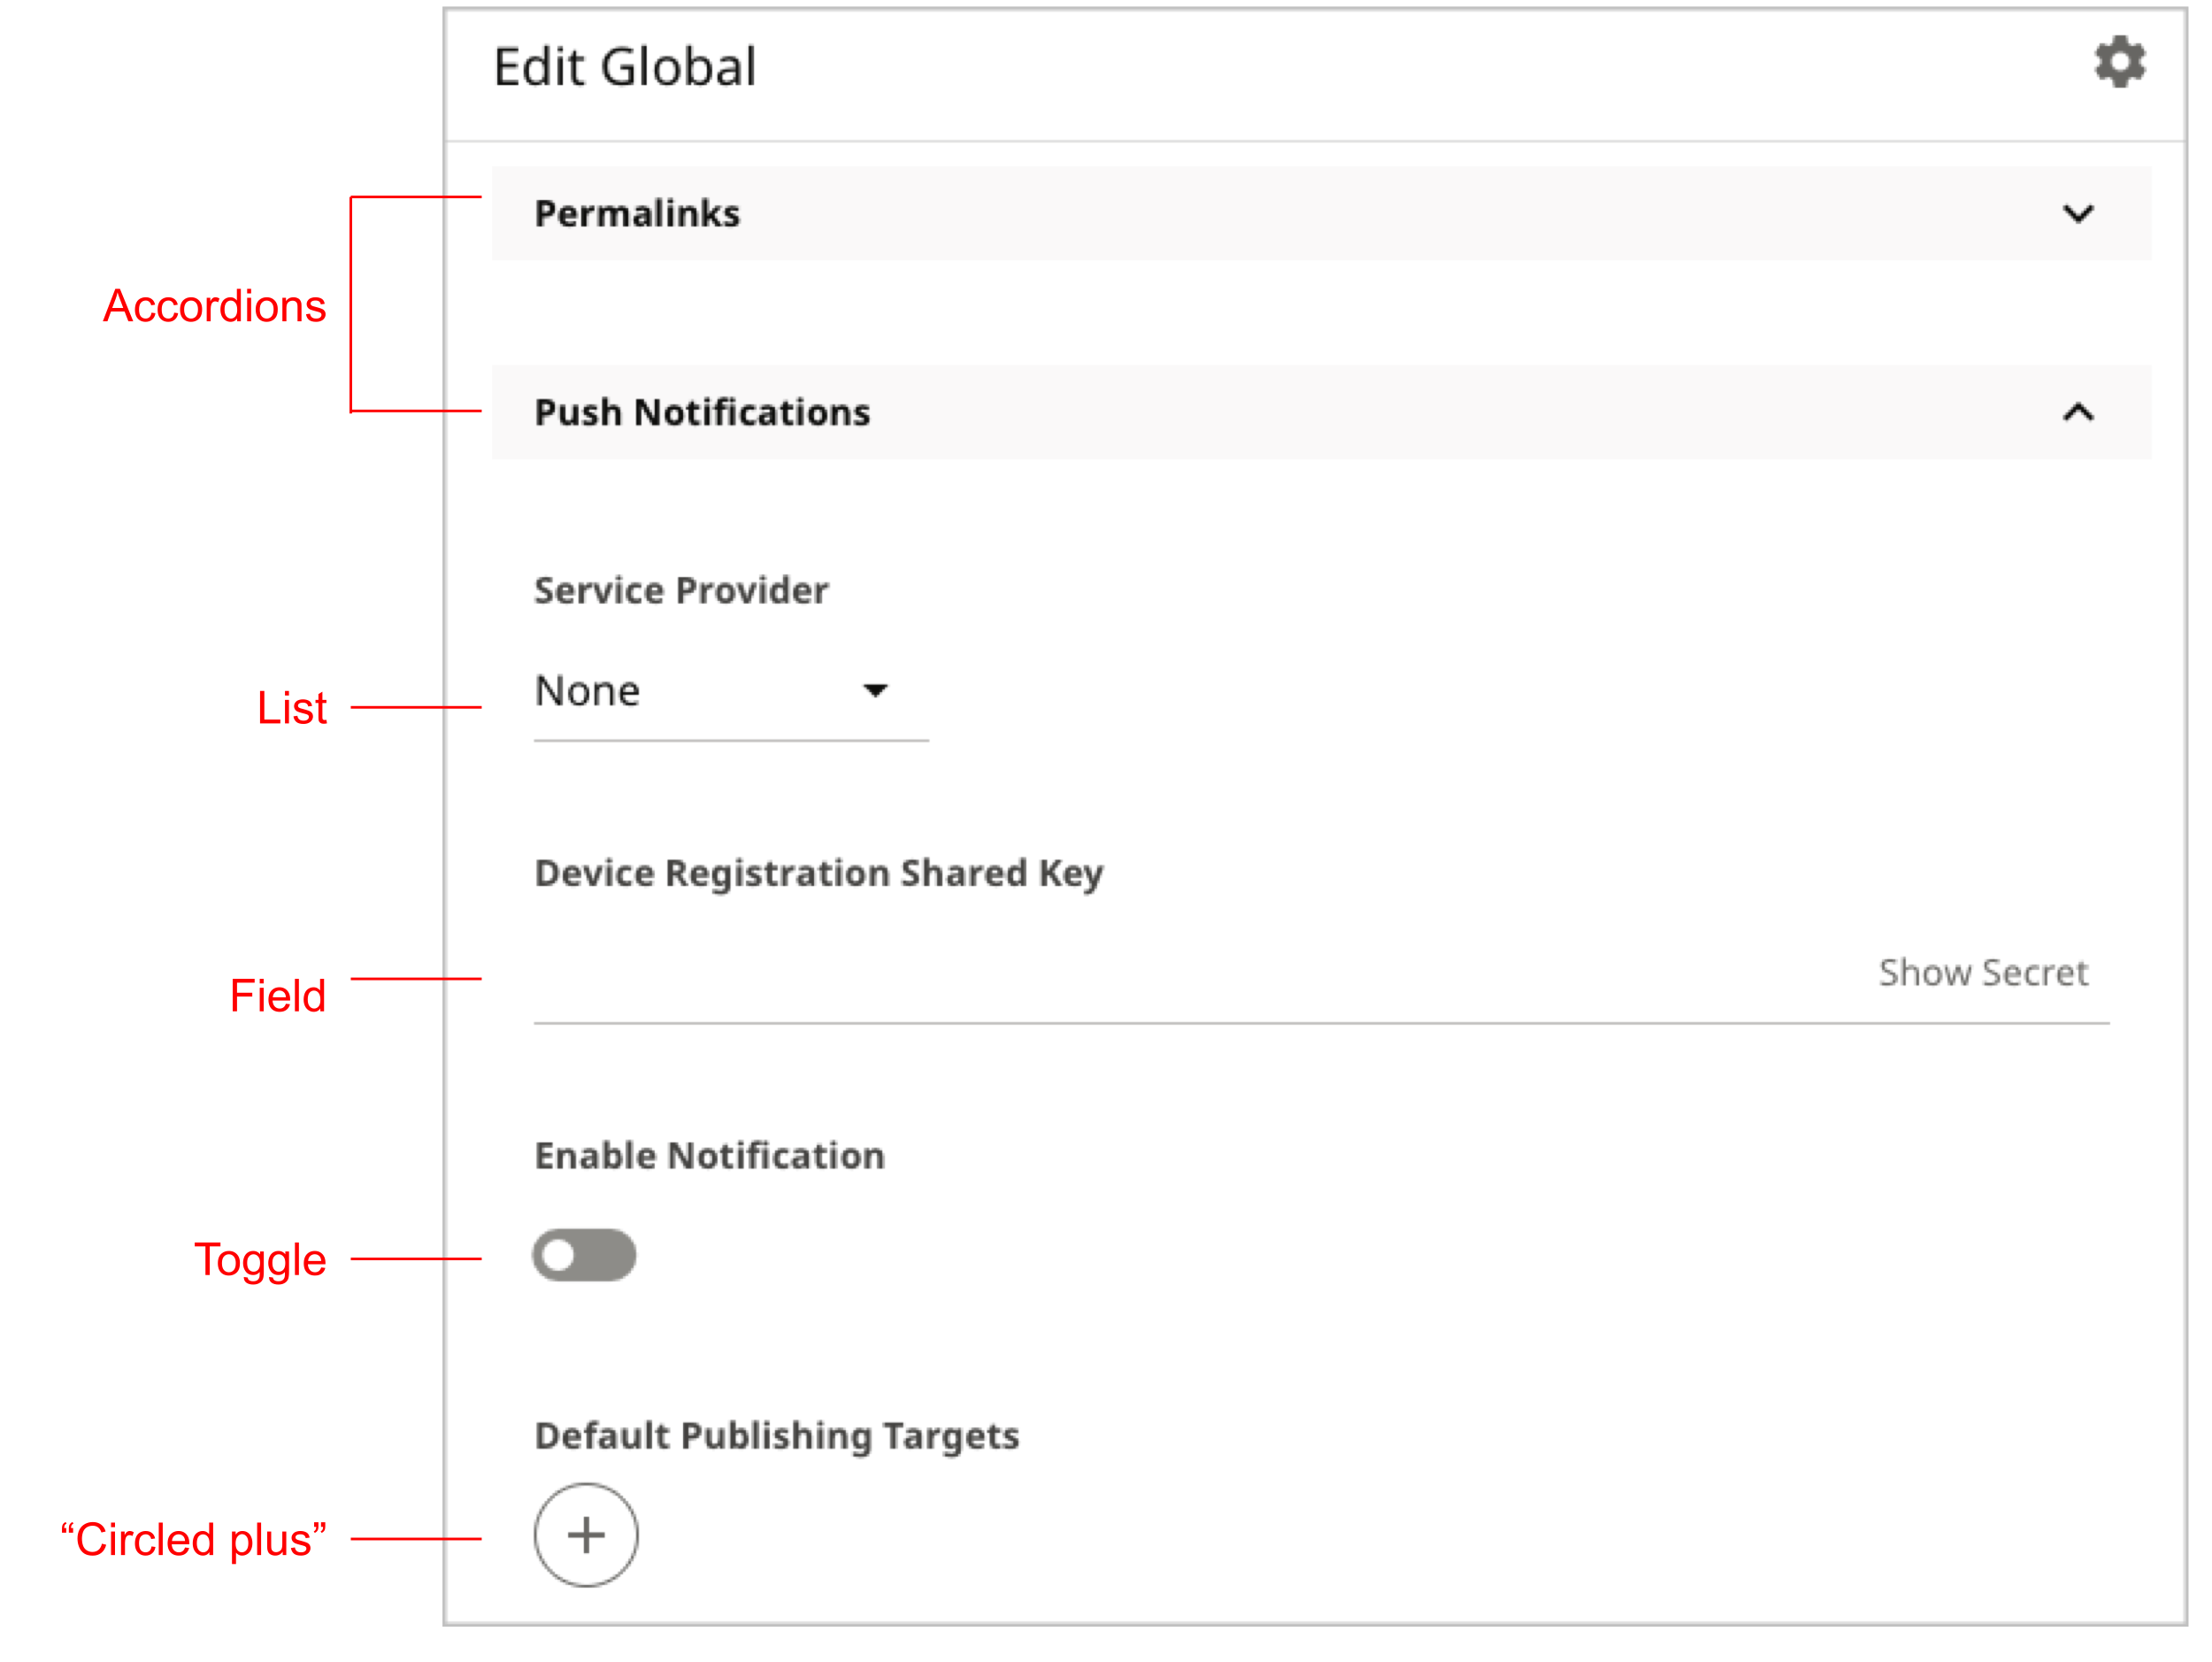

Figure 4: Settings page, frontend

## Content Picker

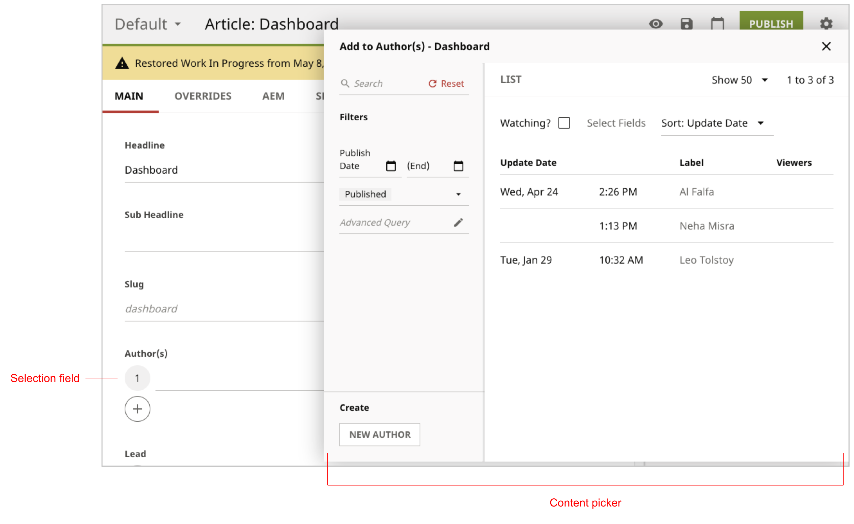

Figure 5: Content picker

# Character-Level Formatting

## Body text

|  |  |  |
| --- | --- | --- |
| Item | Convention | Note |
| Paths, code samples, anything typed at command line, anything a user types in the GUI, file names. | Monospace | Paths include trailing slash. |
| Keyboard Shortcuts | Monospace font, abbreviate using Ctrl, Alt, Cmd, Shift, use a hyphen for compound key combinations. | Best to avoid mentioning keyboard shortcuts if possible due to cross-platform environments. |
| UI elements not in a procedure. | Use formatting indicated in Table 1. | Example: You compose your article in the **Body** field. |
| Elements in UI | See the section “User Interface.” |  |
| Captions | For images, set in italic gray. See the example in [Report](http://docs.brightspot.com/cms/editorial-guide/dashboard/standard-dashboard/report.html). |  |
| Terms in lists | Term set in boldface followed by a space, no subsequent punctuation. (See an example in the section “Make text scannable” in Microsoft Manual of Style.) | (Example)  The following forms are available:   * **Basic** Use this feature for most forms. * **Dynamic** Use this feature to change the form based on the user’s login. * **Advanced** Use this feature to customize a form based on your organization’s criteria. |

For specifications regarding the HTML appearance of these elements, see the section “CSS Styling Specification.”

## User Interface Elements

The following table lists Brightspot’s UI elements and standard usage.

Table 1: Usage and formatting for UI elements

| Element | Definition | Usage | Example |
| --- | --- | --- | --- |
| Text field | Holds a single line of text. | Set field’s label in boldface, with the field’s name before the word “field.” | In the **Slug** field, type **here-today-gone-tomorrow** (see Figure 2). |
| Selection field | Opens the content picker for selecting an item. | Set field’s label in boldface, preceded with the word “field.” | Under **Lead**, click ⊕ (see Figure 2). |
| List | Displays values for selecting. | Set field’s label in boldface, bracketed with the phrase “From the <blah> list.” Similarly, set the selected value in boldface. | From the **Body** list, select **Rich Text** (see Figure 2). |
| Widget | A group of UI elements. | Set widget’s label in boldface, bracketed with the phrase “In the <blah> widget.” | In the **URLs** widget, click ⊕ (see Figure 2). |
| Checkbox | Square box that is marked or cleared to turn an option on or off. | Set the checkbox’s label in boldface, using the verb “mark” or “clear.” | Clear **Express: Box**.  Mark **Express: Brightcove**.  (See Figure 3.) |
| Section heading | Introduces a group of UI elements under the same tab. | Set the section heading in boldface, preceded with the word “Under.” | Under **Content Plugins**, clear **Express: Box** (see Figure 3). |
| Button | Initiates an action, often save or publish. | Set the button’s label in boldface, preceded with the verb “Click.” | Click **Save** (see Figure 3). |
| Tab | Contains UI elements. | Set the tab’s label in boldface, preceded with the word “Under.” | Under **Plugins**, under **Content Plugins**, clear **Express: Box** (see Figure 3). |
| Accordions | Collapsible area of the UI. | Set the accordion’s label in boldface, preceded with the word “Under.” | Under **Push Notifications**…(see Figure 4). |
| Content Picker | Displays a UI for searching for and selecting an item of a given content type. | The typical phrasing is to combine with the label for the selection field. | Under **Authors**, click ⊕. The content picker appears (see Figure 5). |
| Header | Header appearing at the top of all Brightspot pages. | Used as a locator for another UI element. | In the header, click **Search** (see Figure 2). |
| Menu selections | A sequence of menu selections starting at the navigation menu. | Start with “Select,” then the list of menu items separated by a bracket. Most menu selections start with the navigation menu. | From the Navigation menu, select **Admin > Sites and Settings**. |
| Selections from a “more” contol | A sequence of menu selections starting from the more icon (horizontal mid-line ellipsis), most often found in the content edit form. | This wording is inspired by, but not taken directly from, [Manage Your Google Settings](https://support.google.com/accounts/answer/3118621?hl=en). In Google’s Help Center topics, they write the name of the icon as well as display the icon itself. Examples:  Tap Share Share > Link  Tap More More  > Clear app data  We adopted only the icon. | Toward the right of the form, select ⋯ **> Overrides**. |
| Text a user types. | Literal text a user types inside a field. | Set in boldface. | In the **Slug** field, type **here-today-gone-tomorrow**. |
| Toggle | A button-like display that shows how to turn a feature “on” or “off.” | Start with the verb, then preposition, then toggle label. Set toggle label in boldface. | Turn on **Enable Notification** (see Figure 4). |
| Editorial toolbar | A toolbar in the content edit form. See [Editorial Toolbar](http://docs.brightspot.com/cms/glossary/index.html#term-editorial-toolbar). | Following the usage for Backstage view in the [Microsoft Manual of Style](%20http://jasonhall.ca/wp-content/uploads/2015/08/Microsoft.Press_.Microsoft.Manual.of_.Style_.4th.Edition.Jan_.2012.pdf), use Editorial toolbar without any formatting. | In the Editorial toolbar, click **Publish**. |

## Punctuation

| Item | Example |
| --- | --- |
| No space between text and dashes, ellipsis. | In the following snippet—  To publish an article… |
| No hyphen after prefixes such as re and pre. | Reuse the object  Preempt the processing |
| Punctuation inside closing quote as customary. | Assets are sometimes referred to as “items.” |

# Precautionary Messages

|  |  |  |
| --- | --- | --- |
| Message | Context | Example |
| Tip | A tip suggests a best practice for using Brightspot. | Tip: You can tag content with visitors’ search terms; for details, see “Tagging Content with a Brand, Country, Product, or Topic.” |
| Note | A note supplies information that may apply only in special cases. | Note: If you experience excessively slow performance with either the host OS or the guest Ubuntu OS, you may need to adjust memory allocation in the VirtualBox Manager. |
| Caution | A caution advises users that failure to take or avoid a specific action could result in disruption in workflow. | Caution: Enabling two-factor authentication for a role locks all accounts associated with that role until the users are able to enter an authentication password. Ensure your users are trained and have an authenticator installed on their phones before enabling two-factor authentication at the role level. |
| Warning | A warning advises users that failure to take or avoid a specific action could result in loss of data. | Warning: If you replace a one-off dashboard with another dashboard, Brightspot permanently deletes the replaced dashboard. |

# Restructured Text Markup

|  |  |  |
| --- | --- | --- |
| Item | Convention | RST Markup |
| Code samples | Indent with three spaces. | Within .. code-block:: , press spacebar as appropriate. |
| Heading level 1 |  | Equals sign |
| Heading level 2 |  | Dash |
| Heading level 3 |  | Carrot |
| Heading level 4 |  | Tilde |
| Numbering |  | #. |
| Bullets |  | * |
| Paths |  | :code:`path/to/directory/` |
| Keyboard shortcut |  | :kbd:`Alt-S` |

## Locations of Graphics Files

All images are in an image/ subdirectory.

## Relative Paths

All paths within a Sphinx project must be relative.

## File names

File names match, or very closely match, the topic title. For example, the file name for the topic [Global Dictionaries](http://docs.brightspot.com/cms/editorial-guide/site-settings/global-dictionaries.html) is global-dictionaries.txt.

# Nomenclature and Spelling

| Correct/Preferred | Example | Incorrect |
| --- | --- | --- |
| frontend | Check with the frontend developer. | front end or front-end |
| backend | Check with the backend developer. | back end or back-end |
| Dashboard is a proper noun. | The Dashboard is on the landing page.  Brightspot has a standard dashboard. You can create a custom dashboard. | The Dashboard is on the landing page. |
| Model, View, ViewModel | Initial cap only at beginning of sentence. Spell as a common noun. “view model” is two words.  I coded a model.  I coded a view.  I coded a view model. |  |
| Model-View-ViewModel | Spelled Model-View-ViewModel. | <https://en.wikipedia.org/wiki/Model%E2%80%93view%E2%80%93viewmodel> |
| Drag and drop | Hyphenate when used as an adjective; no hyphenate when used as a verb.  The RTE supports drag-and-drop technology.  You can drag and drop an image into the RTE. |  |
| runtime | runtime (one word) | Run-time, run time |
| Properties and methods within classes | Use a hash tag to identify members of a class. Example: The StorageItem to use for preview can then be accessed via State#getPreview(). | Don't use the dot operator. |
| file name | "File name" is two words, following "folder name" and "directory name." | Filename |
| Cast |  | ML misuses this word, prefer "render." Cast is a reserved word in programming. |
| Less | Open the Less file. | Less is a CSS pre-processor. It isn't an acronym, so set in initial cap. |
| gulp | gulp is a package manager | Always in lower case, following https://gulpjs.com/ |
| Asset | An instance of a content type. When an editor creates a new article, image, video, page, section, or anything else, the editor is creating an **asset**. | Avoid "instance of a content type" or "content type," particularly in editorial docs.  The user documentation has instances of "item," which at some point should be expunged. |
| Website, websites | A single word.  A theme is a collection of layouts, styling, and behaviors that give a website consistency. | A theme is a collection of layouts, styling, and behaviors that give a web site consistency. |
| .zip | A .zip file (support.google.com, also on adobe.), although we have ZIP (Wikipedia). No additional character formatting.  Open the .zip file. | Open the ZIP file.  Open the Zip file. |
| Spell out numbers 10 or greater, follow guidelines in Microsoft Manual of Style, “Numerals vs. words.” | You can type up to 10 words in a text field. | You can type up to ten words in a text field. |
| Drop-down list. Use this nomenclature only when distinguishing from a Java List. (See List in Table 1.) | Brightspot renders List fields as a drop-down list. | Dropdown list (without hyphen) |
| Editors work “on” a site. | If you are working on the “Candy Corn” site… | While the editor is logged in to a site. |
| Screen shot | Looking at the screen shot | Looking at the screenshot |

# Headings, Captions, and Lists

Headings and captions:

* Use sentence case: initial cap on first word only, remaining are lower case (c.f. “Capitalization of titles and headings” in Microsoft Manual of Style).
* Periods only if the caption is a full sentence.
* Apply captions to tables and graphics only if they are the target of a cross-reference.

Bulleted and numbered lists should follow a classic format:

* First level bullet/number flush to left margin.
* Lower-level bullets/numbers are left-aligned under the higher-level bullet/number.
* Intermediate text is left-aligned under the previous bulleted/numbered paragraph.

Below is an example of a properly indented bulleted list.

* This is a top-level bullet. Text wraps evenly at a uniform indent under the bullet. This is a top-level bullet. Text wraps evenly at a uniform indent under the bullet. This is a top-level bullet. Text wraps evenly at a uniform indent under the bullet. This is a top-level bullet. Text wraps evenly at a uniform indent under the bullet.

This is intermediate text under a top-level bullet. The text is aligned to the left under the text in the previous bullet.

* + This is a second-level bullet. The bullet is aligned to the left under the text of the previous bullet. Text wraps evenly at a uniform indent under the bullet. This is a second-level bullet. The bullet is aligned to the left under the text of the previous bullet. Text wraps evenly at a uniform indent under the bullet.

This is intermediate text under a second-level bullet. The text is aligned to the left under the text in the previous bullet.

* + - This is a third-level bullet. The bullet is aligned to the left under the text of the previous bullet. Text wraps evenly at a uniform indent under the bullet. This is a third -level bullet. The bullet is aligned to the left under the text of the previous bullet. Text wraps evenly at a uniform indent under the bullet.

This is intermediate text under a third-level bullet. The text is aligned to the left under the text in the previous bullet.

Below is an example of a properly indented numbered list.

1. This is a top-level number. Text wraps evenly at a uniform indent under the number. This is a top-level number. Text wraps evenly at a uniform indent under the number. This is a top-level number. Text wraps evenly at a uniform indent under the number. This is a top-level number. Text wraps evenly at a uniform indent under the number.

This is intermediate text under a top-level number. The text is aligned to the left under the text in the previous number.

1. This is a second-level number. The number is aligned to the left under the text of the previous number. Text wraps evenly at a uniform indent under the number. This is a second-level number. The number is aligned to the left under the text of the previous number. Text wraps evenly at a uniform indent under the number.

This is intermediate text under a second-level number. The text is aligned to the left under the text in the previous number.

* + 1. This is a third-level number. The number is aligned to the left under the text of the previous number. Text wraps evenly at a uniform indent under the number. This is a third -level number. The number is aligned to the left under the text of the previous number. Text wraps evenly at a uniform indent under the number.

This is intermediate text under a third-level number. The text is aligned to the left under the text in the previous number.

For specifications regarding the HTML appearance of these elements, see the section “CSS Styling Specification.”

# Procedures

## Introduction to a procedure

Introduce each procedure with a prepositional phrase terminated with a colon, such as “To publish an article:”

## Multi-step

Arabic at level 1, lower-case Latin at level 2, lower-case Roman at level 3.

## Single step

A bullet before the single step.

## Optional step

Introduce an optional step with (Optional).

To boil water:

1. Turn on heat source.
2. Place pot on heat source.
3. (Optional) Place cover on pot.

## Punctuation

End each step with a period, regardless if it is a full sentence or not.

## Effects

* If a step has an effect, the effect is part of the same paragraph. “Click ⊕. A **Dashboard** widget appears.”
* The effect of an entire procedure is in its own paragraph aligned to the left margin.

## Standard Phrases

When a procedure describes an editor’s workflow, end the procedure with something similar to Complete your site's workflow and publish the promo.

When a procedure describes a setting at the global or site level, use the wording: In the Sites widget, select the site for which you want to configure an ad feed, or select Global to configure an ad feed for all sites.

# Cross References

## List of Cross-Referenced Topics

Cross references at the end of a topic are introduced with **See also:** Each cross-reference is bulleted. These references should be in blue and hyperlinked to the relevant topic.

**See also:**

* Bulk Archiving and Restoring
* Upload
* Collections

## Cross References to Tables and Figures

Indicate the type of cross references before the cross-reference itself.

* For details, see the table Language Modes for Syntax Highlighting.
* For an overview, see the illustration DIMS URL.

For specifications regarding the HTML appearance of these elements, see the section “CSS Styling Specification.”

## Cross References to Glossary Entries

Add a cross reference to terms in the glossary upon first occurrence in each section; subsequent occurrences of the same term do not have a cross reference. The implication is that even if a section is one paragraph long full of cross references, the following section also has cross references to the same terms upon first occurrence.

# Graphics

* OK to compose screenshots on low-resolution devices, use high-resolution devices where effective.
* Border around all screen shots. Border is 3 pixels wide, color #C0C0C0.
* Left-align all screen shots and ensure that they are relatively aligned with the rest of the screen shots within the page
* For drawings created in a drawing program (typically graphics with callout or line drawings), export to SVG and import into the documentation project.
* Callouts use embedded text, not numbered references to body rST text.
* Callouts are in red lines and red text. In Google Draw, the red text is Arial 13 pt.
* Drawings, without callouts, are in blue lines and blue text.
* Crop screen shots so that they are as small as possible but still give the reader a cue regarding the UI element under discussion.

# Code Samples

## Java

* Reformat code in IntelliJ using the following settings (Preferences > Editor > Code Style > Java).
* Use the IntelliJ defaults for the following tabs: **Tabs and Indents**, **Spaces**, **Wrapping and Braces**, **Blank Lines**.
* The only exception to the defaults is under **Blank Lines**, **Keep Maximum Blank Lines**. All entries are set to 1 to avoid more than one blank line.

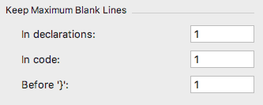

* No blank line after a method declaration (but, using IntelliJ default, a blank space before and after the method itself).
* When using page.writeStart and page.writeEnd statements to write HTML, use nested indents of four spaces, and indicate the closing tag.

page.writeStart("table");

page.writeStart("tr");

page.writeStart("th");

page.writeHtml("City");

page.writeEnd(); /* th */

page.writeStart("th");

page.writeHtml("Time");

page.writeEnd(); /* th */

page.writeEnd(); /* tr */

page.writeEnd(); /* table */

## Other Languages

* XML, HTML, SQL—Indent nested levels four spaces.
* JSON, JavaScript, CSS, LESS—Indent nested levels two spaces.
* Line numbers—Apply line numbers to code samples only if an explanation of the sample refers to a line number.

# CSS Styling Specification

The following table provides the basic settings for a CSS style sheet applied to <http://docs.brightspot.com>.

| Element | Typeface | Block |
| --- | --- | --- |
| Heading 1 | Family: Open Sans, sans-serif  Size: 30px  Color: #ff1e3c  Weight: 400 | Margin top: 20.1px  Margin bottom: 20.1px  Margin left: 0px  Margin right: 0px |
| Heading 2 | Family: Open Sans, sans-serif  Size: 24px  Color: #343434  Weight: 400 | Margin top: 19.92px  Margin bottom: 19.92px  Margin left: 0px  Margin right: 0px |
| Heading 3 | Family: Open Sans, sans-serif  Size: 20px  Color: #343434  Weight: 400 | Margin top: 20px  Margin bottom: 20px  Margin left: 0px  Margin right: 0px |
| Heading 4 | Family: Open Sans, sans-serif  Size: 18px  Color: #343434  Weight: 400 | Margin top: 23.94px  Margin bottom: 23.94px  Margin left: 0px  Margin right: 0px |
| Body text | Family: Open Sans, sans-serif  Size: 16px  Color: #343434  Weight: 400 | Margin top: 16px  Margin bottom: 16px  Margin left: 0px  Margin right: 0px |
| Hyperlinks | Color: #00b6de  Underline: none | N/A |
| Paths, code samples, anything typed at command line, anything a user types in the GUI, file names. | Family: monospace  Color: #008cab  Background color: #f3f3f3 | N/A |
| Keyboard Shortcuts | Family: Monospace  Color: #343434  Weight: 400 | N/A |
| Code samples | As output by Pygments. | As output by Pygments. |
| Images | N/A | Margin top: 40px  Margin bottom: 40px  Margin left: 0px  Margin right: 0px |
| Code caption | Family: Open Sans, sans-serif  Size: 12px  Color: #343434  Background color: #f4f5f6  Weight: 600 | Margin top: 0px  Margin bottom: 0px  Margin left: 0px  Margin right: 0px  Padding top: 4px  Padding bottom: 4px  Padding left: 10px  Padding right: 10px |
| Image caption | Family: Open Sans, sans-serif  Size: 12px  Color: #737373  Weight: 400  Style: Italic | Margin top: 0px  Margin bottom: 0px  Margin left: 0px  Margin right: 0px |
| Table caption | Family: Open Sans, sans-serif  Size: 12px  Color: #737373  Weight: 400 | Margin top: 0px  Margin bottom: 0px  Margin left: 0px  Margin right: 0px |

# References

* [Microsoft Writing Style Guide](https://docs.microsoft.com/en-us/style-guide/welcome)
* [Microsoft Manual of Style](%20http://jasonhall.ca/wp-content/uploads/2015/08/Microsoft.Press_.Microsoft.Manual.of_.Style_.4th.Edition.Jan_.2012.pdf)