**Temasek Polytechnic**

**School of Informatics and IT**

**Diploma in Information Technology (IT)**

Terms of Reference

**Project Particulars**

|  |  |
| --- | --- |
| **Tutor** | Mr Mel Goh |
| **Class** | P04 |
| **Project Title** | Delonix Regia Hotel Management System |

**Project Team’s Particulars**

|  |  |
| --- | --- |
| **Matric Number** | **Student Name** |
| **1404150C** | **Shaun Chua** |
| **1405306J** | **Parmesher Singh** |
| **1404555C** | **Quinones Mark Joseph** |
|  |  |

**1. Introduction**

Delonix Regia is run by a couple Mr. and Mrs. Wang. The hotel has been struggling as they have not been getting as many guest as they would have liked despite being in a strategic location. Therefore, we are tasked by the couple to create a working hotel management system that is to be used by the owner, manager( if applicable) and receptionist. Some of the main function of the system would be for editing booking, booking details and staff information.

**2. Objectives of the Project**

We have a couple of objectives that we want to achieve throughout this project those objectives are explained below

1. **Easy Management of Hotel**

The main objective of this project is to make the job of the manager a lot easier by providing a system in which they can easily create, update, retrieve and delete booking in just a few clicks. Staff detail and even room information can easily be managed for when you want to change the rates or create a promotion.

1. **Implement All Features**

Another objective that we hope to achieve is to implement all features that we originally planned to create. Sometimes while developing a system we would almost certainly have increasing features due to getting more ideas and having a wider scope as the system gets built so we sometimes use the time to improve a certain feature instead of implementing all features.

1. **Well Tested System**

Making sure that the system is well tested is also important as this ensures that there would be as little bugs or compilation errors once we deploy the application and client starts using the system. Testing would also allow us to determine whether the system actually does cater to the requirements by the client.

1. **Member Involvement**

Another objective we will try and meet is to ensure that every single member participates actively for every phase of the project. This is to ensure that everyone learns something and that they would have people that can help them if they are unsure of their part. Having everyone’s involvement would also lead to more ideas and better quality of work.

1. **Equal Workload**

Throughout the entire duration of this project, our objective is to ensure that the members are given equal workload and that the work that they were given to do is something that they are skilled. This is to ensure that the project would be of a higher quality and a happier team.

**3. Scope of the Project**

Our project would be based on a simple hotel management system, the main functions that the team would like to implement is explained below.

**Booking**

The booking function is the most important of all the functions this is allows the management to create booking, edit booking for when users want to change booking details for example, room type. They are also able to delete the booking for when users want to cancel the booking. Information can also be retrieved by any hotel staff for when they can see any existing bookings that were made.

**Room Management**

This function lets the management edit the details of a room for example the nightly rate and room name for when the hotel decide to hold a promotion. Not only that it also allows the user to retrieve the information regarding the room such as how many people it can accommodate and which guest are staying in it.

**Staff**

Here the managers are able to check out their existing staffs personal particulars and are given the opportunity to edit any information that they want to change for example, the employee changed address and would like to update the database. The manager would also be given the chance to create or delete any staff member information if they want to incase a staff retires and a new one joins in.

**4. Distribution of Workload**

|  |  |
| --- | --- |
| **Objectives/Deliverables** | **Members** |
| Introduction(Project Plan), Product Positioning in market place and Approach methodology of project | Shaun Chua |
| Budget Summary(TOR), Risk Management Plan(TOR) and Approach methodology of project. | Parmesher Singh |
| Work Breakdown Structure, Project Schedule, Introduction(TOR), Objective of project(TOR), Scope of Project(TOR),Constraints(TOR) and Approach methodology of project. | Quinones Mark Joseph |

**5. Constraints**

Throughout this assignment, our group faced multiple constraints. The first constraint is that we were in a different class which meant that our timetable was completely different so we only had one lesson in which we were able to meet face to face. Another constraint that my team faced was personal commitments. Some of us had made important prior arrangement, this along with the fact that we were in different class was a huge hurdle for us to overcome before we are able to either have face to face or voice chat using Skype. We also have different ideas so we need to discuss and tell each other more about why we think our ideas is better and come to a conclusion and choose as a team the idea that we feel is the best.

**6. Resources**

**Hardware**

* Laptop
* Printer

**Software**

* Google Chrome
* Visual Studio 2013
* Microsoft Word
* Microsoft project

**7. Product Positioning in the Market/Company**

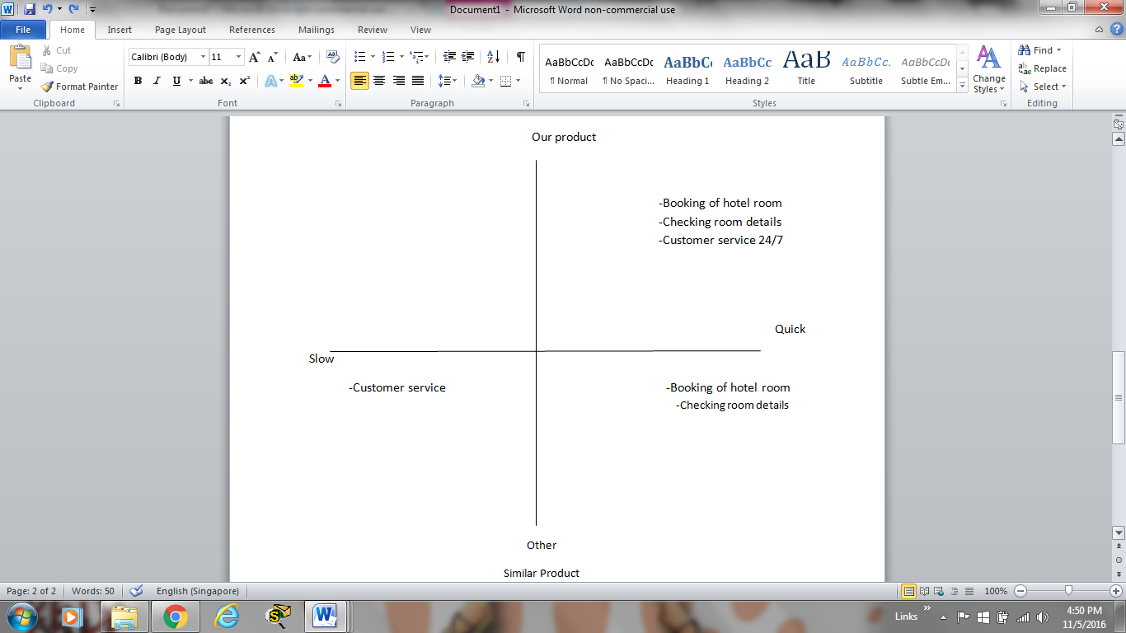

For other similar products in the market, they are just mostly to help the hoteliers to manage their hotel and properties more efficiently while in our case we also help them to manage their hotel and properties but we also provide 24/7 service which we can help the customer if they have any problems with our qualified staffs. However we made this system as simple as possible because managers might not be as tech savvy.

**8. Approach and Methodology of the Project**

Describe the development model your team will be adopting for the project. Describe any potential risks or problems your team might have adopting the development model and what you can do to overcome them.

**Waterfall Model**

The team has decided to adopt the waterfall model for various reasons. Firstly it is the most simple and the easiest to understand among the models so we are a lot more confident in using it. Another reason is that in this model, phases are completed one step at time and there is always a review phase at the end of each phase where the team can discuss whether the project is going on the right track.This could help prevent the project from going out of scope. Another reason why we decided to go with the waterfall model is the fact that each phase was easy to manage and since our project is short term this would be a good model to follow.

**Challenges**

A challenge that the team could face is the fact that once our application has been created it would be very difficult for us to try and change it again if we didn’t plan our systems concept correctly. To help prevent this from happening the team would gather the requirements diligently, ensuring that all the proper conditions are recorded and there is a proper plan to meet all the requirement in the system.

Another challenge that we could face is that the team would take too long to complete the project due to one of the members taking too long to finish their phase which could delay the entire project due to the fact that since we can only start on our part once the team member finishes the phase before us. To prevent that we are able to complete the project on time we should always check on each other to ensure that everyone is on the right track and ensure that all of us are doing their part correctly so as to not delay the person which have to complete his phase after the 1st person.

Another challenge which could arise is no working software is produced until later stages of the life cycle. This would compel the team to estimate of how the end product would look like in the end which is risky as should there be any hiccups, it will be very difficult to solve it.

**Approaches**

In order to have a better idea of how the end product would turn out, the team should constantly brainstorm new ideas for the end product. As the team is brainstorming, they will eventually discover potential errors which would make it easier to avoid these errors. This would keep the team’s options open and will also minimise the amount of errors that will be made throughout the course of this project.