General info
Commands are sent to the modem over a serial connection. To connect to the modem, use 9600 baud, 8N1. Generally, the first character of your command specify what you want to do, such as setting an option or sending a packet. For example, you can send a packet with the content “Hi APRS” by sending “!Hi APRS” to the modem. The “!” character specifies that all following data should be treated as packet content, and be sent out. Please note that “Hi APRS” is not really a valid APRS packet, even though it will be sent out, digipeated and such just fine. Using the trim-potentiometer on the board, you can adjust the modem output level. The board comes with the level set at microphone level (about 20mV peak-to-peak). Most handheld radios will need microphone level audio on the input port, otherwise the transmitted audio will distort, making packets hard to decode. The PTT circuit works by closing a switch (using a MOSFET) between the PTT+ and PTT_GND pins. Most Kenwood-style handhelds will have +3v on the ground pin of the MIC jack, that will trigger PTT when connected to the ground pin on the SPK jack.

SimpleSerial commands
Command | Description
!<data> | Send raw packet
@<cmt> | Send location update (cmt = optional comment)
#<msg> | Send APRS message
c<call> | Set your callsign
d<call> | Set destination callsign
1<call> | Set PATH1 callsign
2<call> | Set PATH2 callsign
sc<ssid> | Set your SSID
sd<ssid> | Set destination SSID
s1<ssid> | Set PATH1 SSID
s2<ssid> | Set PATH2 SSID
lla<LAT> | Set latitude (NMEA-format, eg 4903.50N)
llo<LON> | Set latitude (NMEA-format, eg 07201.75W)
lp<0-9> | Set TX power info
lh<0-9> | Set antenna height info
lg<0-9> | Set antenna gain info
ld<0-9> | Set antenna directivity info
ls<sym> | Select symbol
lt<s/a> | Select symbol table (standard/alternate)
mc<call> | Set message recipient callsign
ms<ssid> | Set message recipient SSID
mr<ssid> | Retry last message
ma<1/0> | Automatic message ACK on/off
ps<1/0> | Print SRC on/off
pd<1/0> | Print DST on/off
pp<1/0> | Print PATH on/off
pm<1/0> | Print DATA on/off
pi<1/0> | Print INFO on/off
v<1/0> | Verbose mode on/off
V<1/0> | Silent mode on/off
w<X> | Set preamble time in ms
W<X> | Set transmission tail time in ms
S | Save configuration
L | Load configuration
C | Clear configuration
H | Print configuration

Examples
To set your callsign to XX1YYY-5, and then save the configuration, send these three commands:
cXX1YYY
sc5
S
To send an APRS message to ZZ5ABC-1 with the content “Hi there!”, send these commands:
mcZZ5ABC
ms1
#Hi there!
To send a location update, with the comment “MicroAPRS”, you can do something like this:
lla5230.70N
llo01043.70E
@MicroAPRS
To send an APRS message to ZZ5ABC-1 with the content “Hi there!”, using a raw packet, send this command:
!:ZZ5ABC-1 :Hi there!{01
Here’s an example of how to send a location update with power, height and gain information, using a raw packet:
!=5230.70N/01043.70E-PHG2410Arduino MicroAPRS
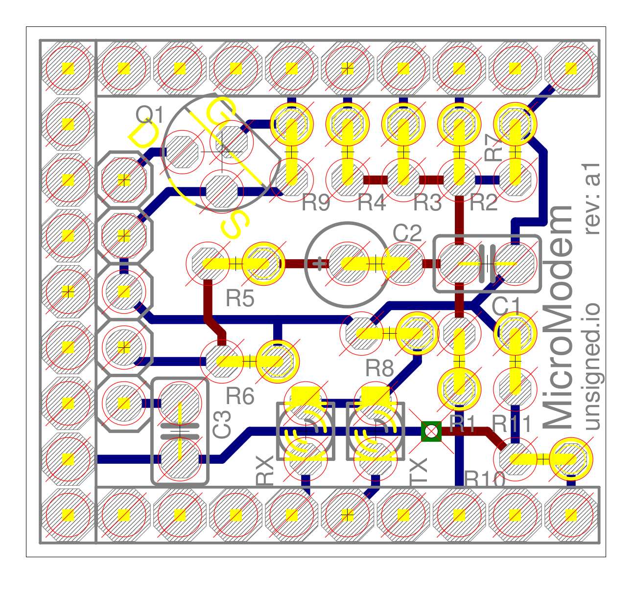
Audio in (SPK from radio)
Audio out (MIC to radio)
GND
PTT GND
PTT+

