**CS401 Intro to Algorithm**

**Group Name:** ERROR 404

**Group Leader:** Mark Decello

**Group Members:** Mark Decello, Julius Lopez, Gene Olivia, Hanel Duran, Naglaa Saeid

**Topic:** Dynamic Approach

**Example 1** …………………………………………………………….page 2

**Exercise 2** ……………………………….……………………………page 3

**Exercise 3** ……………………………….……………………………page 4

**Exercise 4** ……………………………….……………………………page 5

**Exercise 5** ……………………………….……………………………page 6

**Exercise 6** ……………………………….……………………………page 7

**Example 1**

$$D_{0}$$

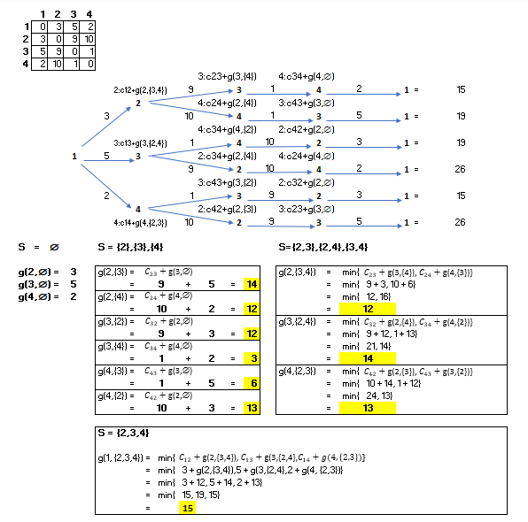

**Exercise 2**

**Exercise 3**

**Exercise 4**

**Exercise 5**

**Exercise 6**

