BCDE102 Introduction to Software Engineering -**Assessment Three - Portfolio**

**Iteration 1**

**Class Diagram:**

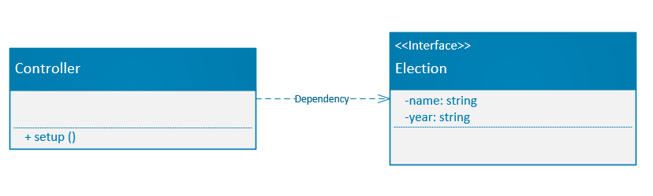

**Goal and Planning for Iteration 1:**

**Goal:**

The goal for this iteration is to display the name and year of the election through the browser using HTML and JavaScript for browser interactivity. Some basic styling will also be added to enhance user experience. A directory called Iteration1 will be created which will include sub-directories such as lib, spec, and src that will contain all the necessary files for the project. An index.html file will also be produced to allow users to view the progression of the project. Also, a SpecRunner.html file will be created for the purpose of unit testing.

**Planning:**

Planning for iteration 1 includes following client specifications such as outputting “New Zealand 2020” on the browser page as well as election attributes such as name and year on the browser console. More time learning JavaScript will be needed to produce the outcome the client requires. The hours that will be spent on the project will also be calculated and tabulated.

**Analysis:**

In this iteration, the appropriate classes will be decided, as well as important attributes and methods necessary for this version of the project to function.

**Design:**

The design will take inspiration from the real New Zealand Electorate’s existing design. For example, the colour orange has been included as the main theme for this project. The layout, fonts and other design elements will be decided further in the later iterations of the project. A wireframe diagram is included below.

**Coding:**

The coding for this project will be basic at first but will be much more complex as time and the project progresses. This iteration of the project should take no longer than 4 to 5 hours to complete, of these 4 to 5 hours, approximately 1 hour will be spent on coding as both HTML and JavaScript will need to be coded. Testing will also have to be conducted therefore; I have decided to use the Jasmine framework for my unit test, Nu HTML and ESLint to check for code errors.

**Time Estimated and Actual Time Taken for each task:**

|  |  |  |  |  |
| --- | --- | --- | --- | --- |
| **Task** | **Task Details** | **Time Estimated** | | **Actual Time** |
| **Planning** | Plan the initial layout of the project.  Figure out what the client wants for the outcome of the project. | 60 minutes   30 minutes | | 60 minutes  25 minutes |
| **Analysis** | Decide which classes, attributes and methods to use. | 30 minutes | | 35 minutes |
| **Design** | Design the layout, inspiration, and theme for the project. | 40 minutes | | 50 minutes |
| **Coding** | Output information on the browser and console using JavaScript and HTML. | 60 minutes | | 90 minutes |
| **Testing** | Test code to check for errors. | 30 minutes | | 45 minutes |
| **Total Time** |  | 250 minutes or 4.17 hours | 305 minutes or 5.08 hours | |

**Wireframe Diagram:**

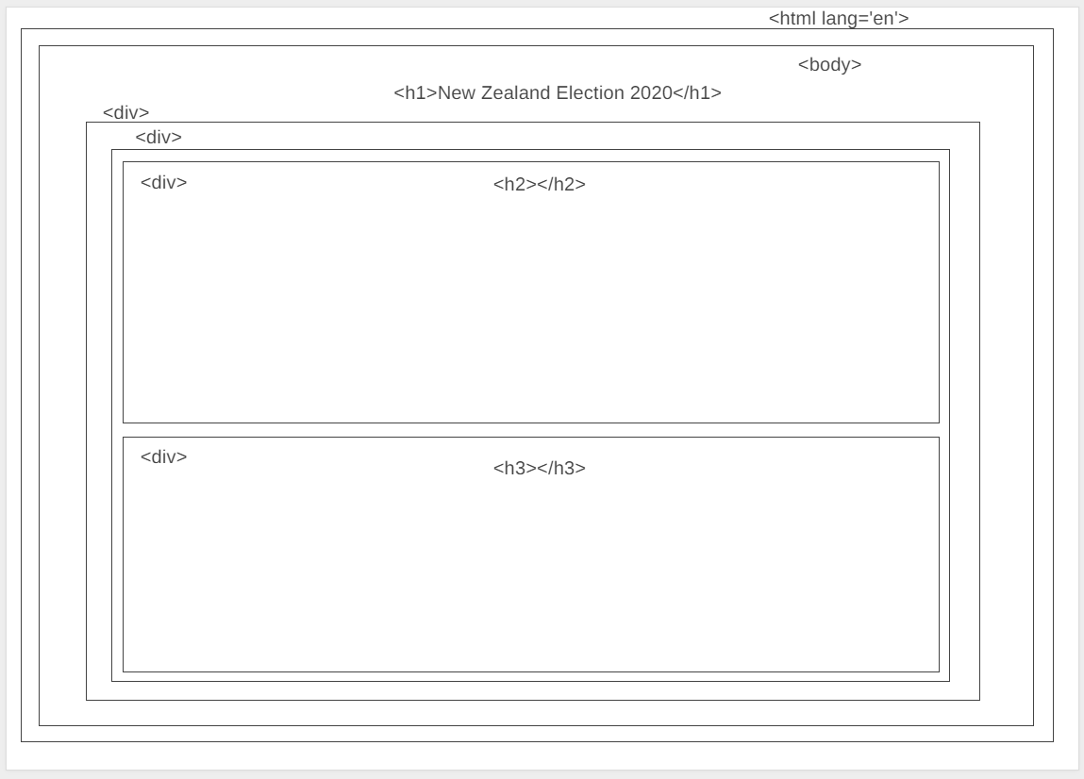

**First Iteration Output:**



**Console result:**

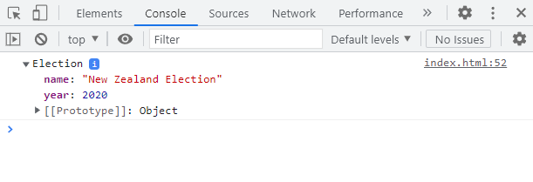

**Jasmine Unit Testing:**

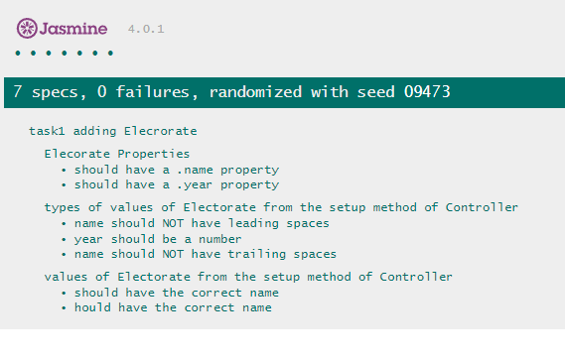

**Code checks:**

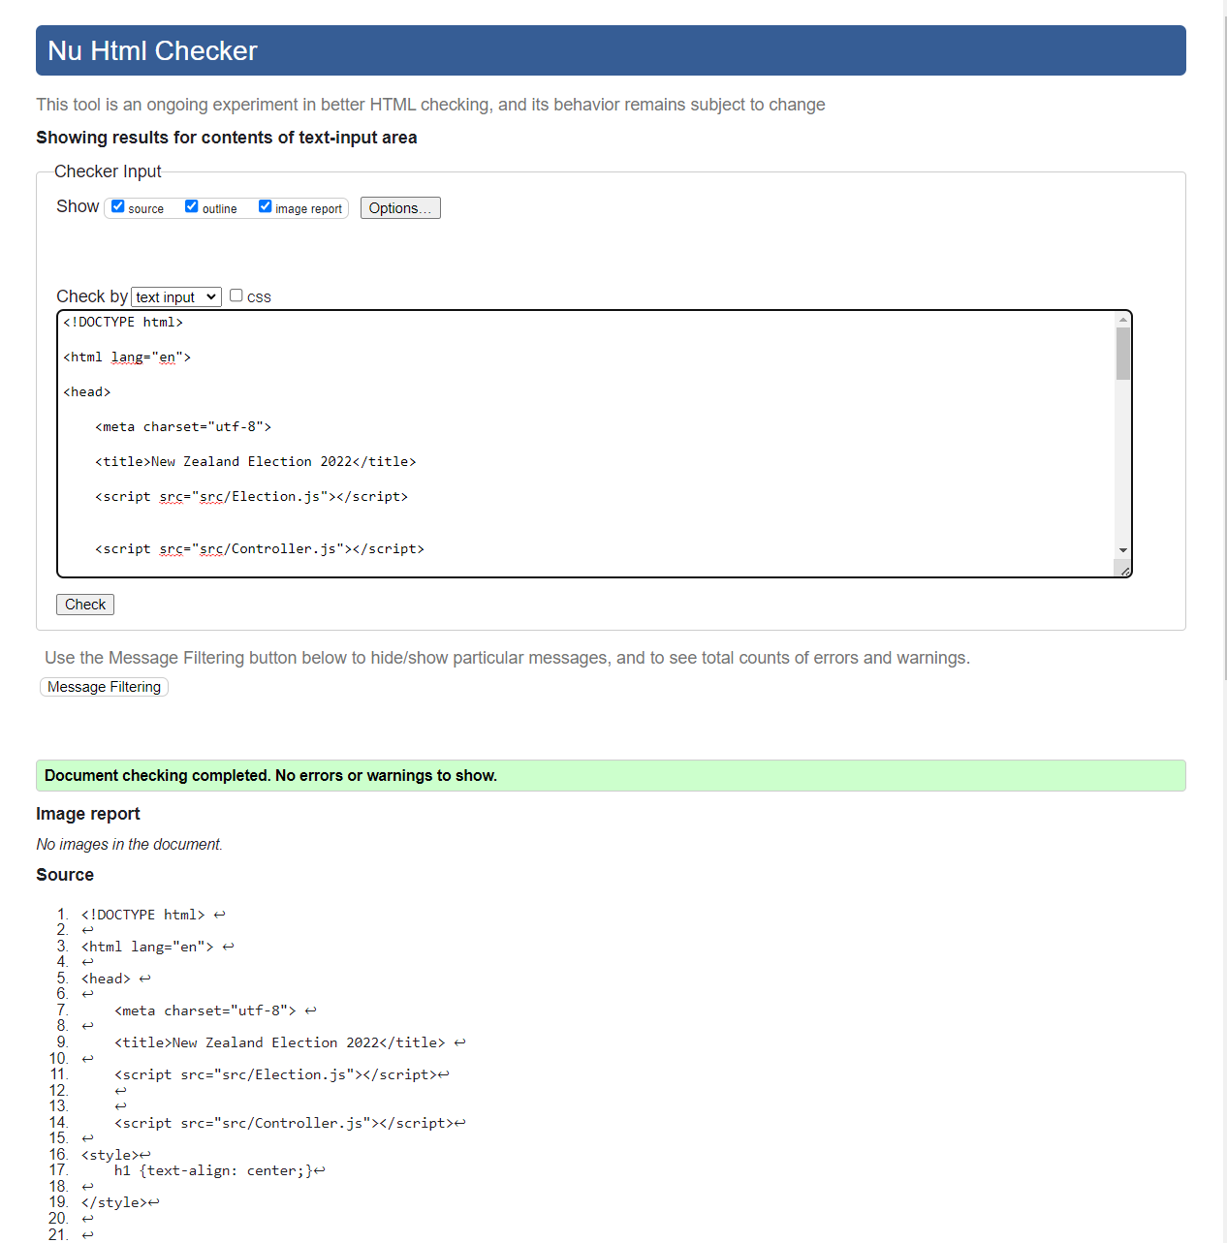

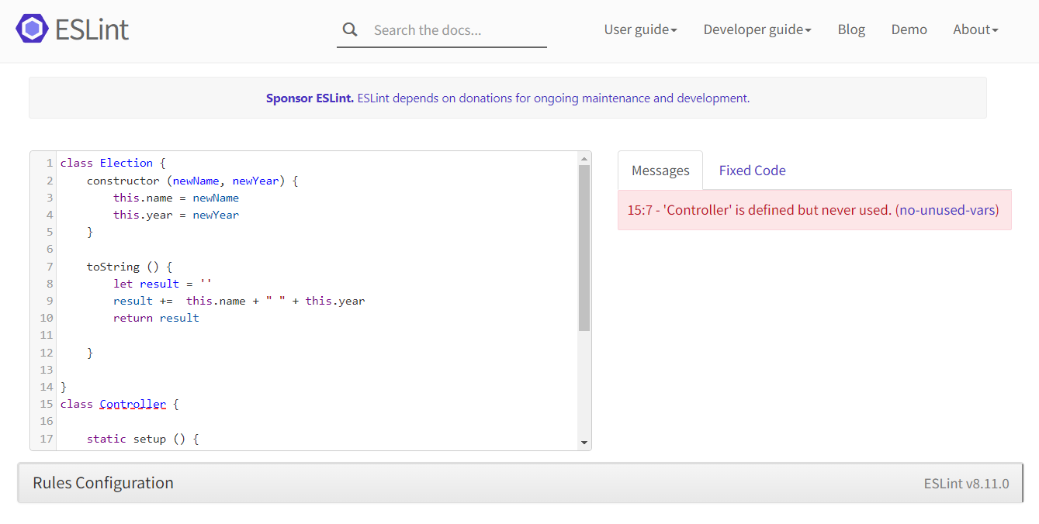

The checker threw an error because the Controller is invoked within the HTML code and not within the JS file. This will be fixed in the next project iteration.

**What happened vs what was planned:**

I ended up spending more time tinkering with the code and learning JavaScript than planned. I had to familiarise myself with the JS environment as it was my first time using the language for a project. I also had to research more about the Jasmine framework for my unit testing as it was foreign to me.

**Performance Review:**

**What worked:**

I initially thought that I was going to run out of time and not be able to tinker with the design of the first iteration but I was able to overcome the issues and get it done. Although it looks rather basic, I now understand more about webpage styling and I will be able to utilise this knowledge and incorporate them in future iterations of the project. I will include CSS for the next iteration as well.

**What didn’t work:**

I originally wanted to invoke the Controller class within the same file using the function ‘go’ rather than from within the HTML file. I was successful at making the webpage and console to display the specifications however, I could not get the Jasmine Unit Tester to work. It was throwing "Cannot set property 'innerHTML' of null" error within the console and I could not figure it out, so I had to invoke it back within the HTML file. I will figure this out and fix it in the next iteration.

