BCDE102 Introduction to Software Engineering -**Assessment Three - Portfolio**

**Iteration 2**

**Class Diagram:**

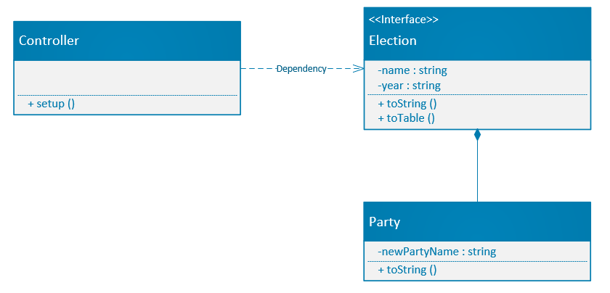

**Goal and Planning for Iteration 2:**

**Goal:**

The goal for this iteration is to add party to election then display all the parties on the browser using HTML and JavaScript for browser interactivity. The styling is going to be edited using a CSS file as well. A directory called Iteration2 will be created which will include sub-directories such as lib, spec, src, and style that will contain all the necessary files for the project. An index.html file will also be produced to allow users to view the outcome of the second iteration. Also, a SpecRunner.html file will be created for unit testing through jasmine framework.

**Planning:**

The plan for this iteration is to output all the parties from the New Zealand Election 2020 using the index.html file which will make use of the browser. The parties will be passed through an array which will list the party count and the names of the parties which will be seen through console.log. The election name and year will still be passed through console.log as well. Also, CSS will be introduced and implemented to edit the style of the page.

**Analysis:**

This iteration is a continuation of the previous iteration1. A new class called party and its attributes was created and interrelationship with the other classes was established.

**Design:**

The design from the first iteration was altered but the main theme still stands. The orange colour signifies the New Zealand Election therefore, it was not changed. A white background was added behind the title to make it more readable. All of the parties involved now shows on the browser beneath the title. A snippet of the design as well as a wireframe diagram is included below.

**Coding:**

The whole second iteration including the coding should take approximately 4 to 5 hours in total. The first iteration took a bit longer to do as I had to familiarize myself with JavaScript and HTML environment. In my estimate, this iteration will take less than 5 hours to complete because I now have more understanding of JavaScript. The coding should take around 50 to 60 minutes to complete and unit testing should take no longer than 30 minutes.

**Time Estimated and Actual Time Taken for each task:**

|  |  |  |  |  |
| --- | --- | --- | --- | --- |
| **Task** | **Task Details** | **Time Estimated** | | **Actual Time** |
| **Planning** | Plan for second iteration layout.  Figure out second iteration outcome. | 50 minutes   30 minutes | | 50 minutes  35 minutes |
| **Analysis** | Decide which classes, attributes and methods to use. | 40 minutes | | 30 minutes |
| **Design** | Design the layout, inspiration, and theme for the second iteration. | 40 minutes | | 45 minutes |
| **Coding** | Output information on the browser and console. | 60 minutes | | 60 minutes |
| **Testing** | Test code to check for errors. | 40 minutes | | 50 minutes |
| **Total Time** |  | 260 minutes or 4.33 hours | 270 minutes or 4.5 hours | |

**Wireframe Diagram:**

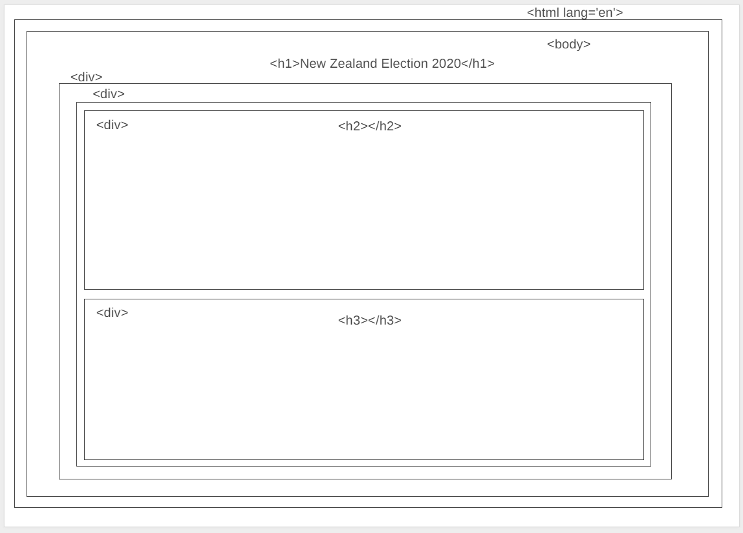

**Second Iteration Output:**

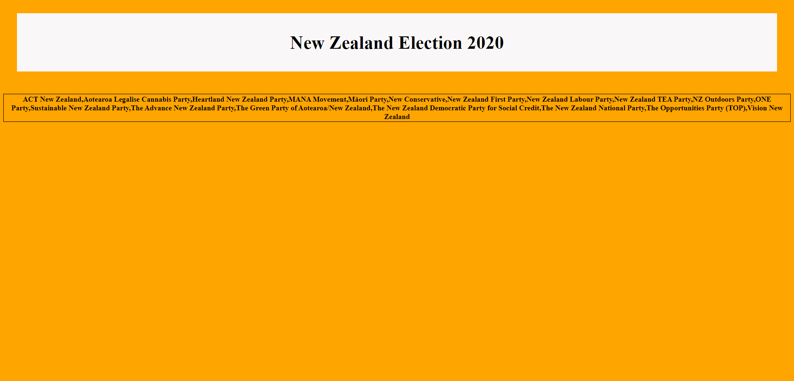

**Console result:**

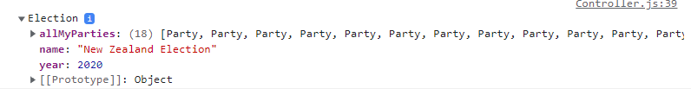

**Jasmine Unit Testing:**

**Code checks:**

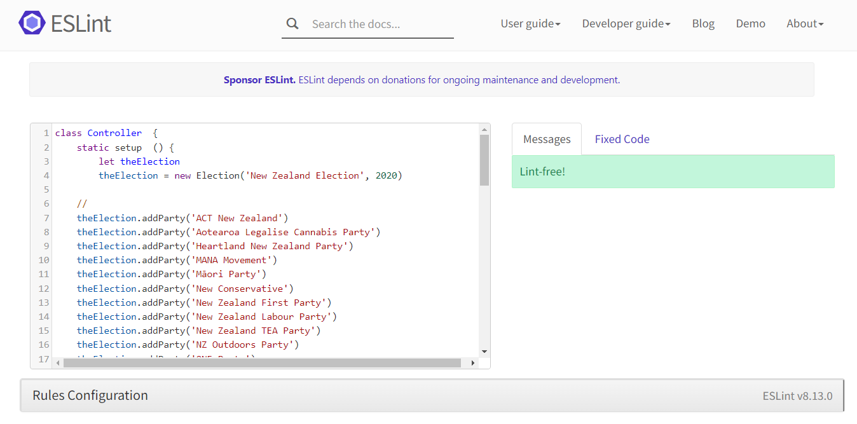

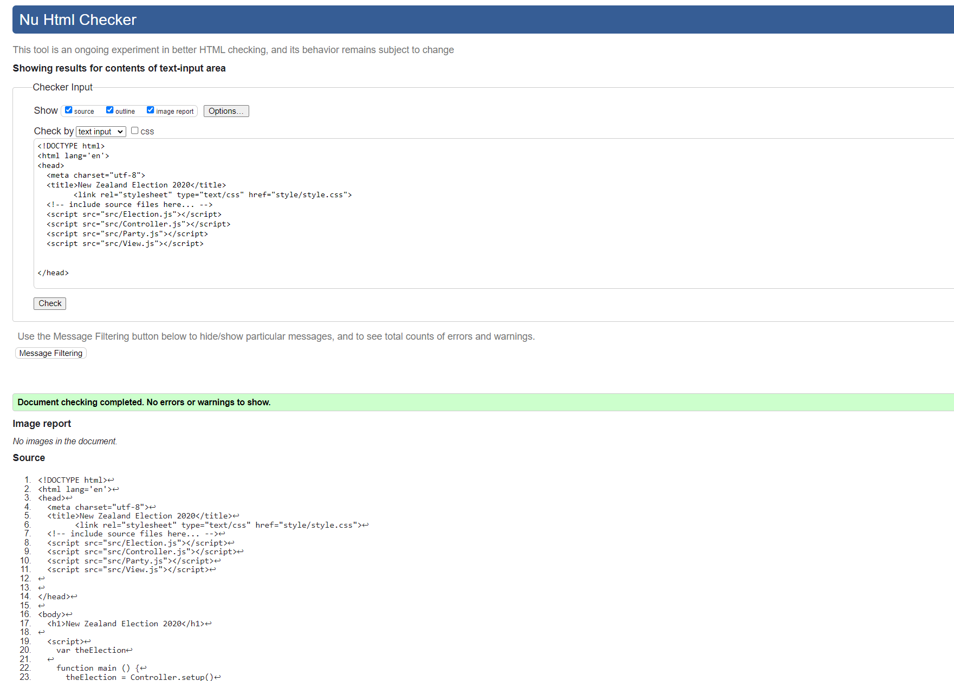

**What happened vs what was planned:**

The second iteration went exactly as planned and the coding took a lot less time compared to the first iteration. However, I had to spend more time on unit testing for this iteration because I had to add more test codes using Jasmine. I added a new task2 file in the spec folder for the testing of the new Party class I added.

**Performance Review:**

**What worked:**

The code checks worked well this time without any error. Adding some of my own Jasmine unit test was tricky but I was able to make it work after looking at the previous example tests. I also added the parties in a table to make it more presentable.

**What didn’t work:**

I tried to list all the parties separately in different rows, but I could not get it to work. I will need do more research regarding editing the looks of array output to fix this. I will try to get this sorted as part of the next iteration.