BCDE102 Introduction to Software Engineering -**Assessment Three - Portfolio**

**Iteration 3**

**Package Diagram:**

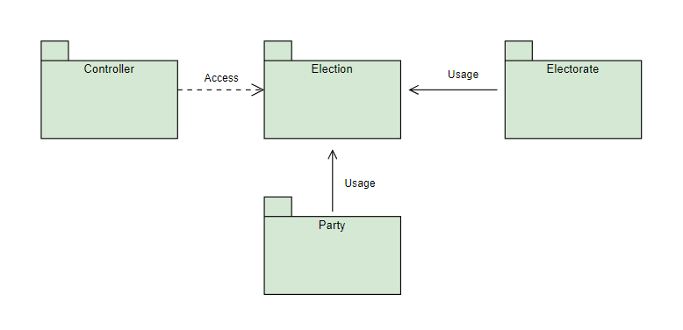

**Goal and Planning for Iteration 3:**

**Goal:**

The goal for the third iteration is to add electorates to the election as well as display these electorates on the browser for the client to review. The styling is to be changed due to the specifications being altered by the client. I will now have to display the name of the election, parties, and electorates inside a table. I will also change and improve the styling to beautify the outcome. I will create a directory named iteration3 which will still include all the necessary directories such as lib, spec, src, style, and view. As per standards, I will also include an index.html to enable the client to view the outcome of this iteration as well as a SpecRunner.html for the Jasmine unit testing framework to check for errors.

**Planning:**

The plan for this iteration is to output all electorates from the New Zealand Election 2020 using the index.html file via any browser of choice. The electorates will be passed through an array which will list the electorate count and the location of the electorates which will be seen through console.log like what I have previously done in past iterations. I will also have to adapt to the new client specification as well.

**Analysis:**

This iteration is a continuation of the previous two iterations. A new class called electorate and its attributes were created and its interrelationship with the other previously created classes were generated.

**Design:**

The design from the first iteration was altered but the main theme still stands. The orange colour signifies the New Zealand Election therefore, it was not changed. A white background was added inside the tables to beautify it and enable better viewing pleasure. All the parties and electoral locations now shows on the browser beneath the title. A snippet of the design as well as a wireframe diagram is included below.

**Coding:**

The third iteration should take approximately 5 hours to complete. The first two iterations took some time to complete as I had to familiarize myself with JavaScript, CSS, and HTML. But for this iteration, I estimate that it will take less than 5 hours to complete because I now have more understanding of the programming languages required for this project.

**Testing:**

For testing, I am using Jasmine as my framework. I have been using this framework for the past iterations as well and it works well.

**Time Estimated and Actual Time Taken for each task:**

|  |  |  |  |  |
| --- | --- | --- | --- | --- |
| **Task** | **Task Details** | **Time Estimated** | | **Actual Time** |
| **Planning** | Plan for third iteration layout.  Formulate third iteration outcome. | 40 minutes   30 minutes | | 55 minutes  40 minutes |
| **Analysis** | Formulate which classes, attributes and methods to use. | 40 minutes | | 35 minutes |
| **Design** | Design the layout for the third iteration based on new specification. | 50 minutes | | 45 minutes |
| **Coding** | Output information on the browser and console. | 60 minutes | | 60 minutes |
| **Testing** | Test code to check for errors. | 50 minutes | | 45 minutes |
| **Total Time** |  | 270 minutes or 4.5 hours | 280 minutes or 4.67 hours | |

**Pseudocode:**

This part of the iteration will allow the user to view a table with all electoral locations within New Zealand.

/Creating a class called Electorate

class Electorate {

constructor (newElectorate) {

this.electorate = newElectorate

this.myParty = theParty

}

/Display electorate in a string

toString () {

return electorate

}

/Display electorate in a table

asHtmlTable () {

return electorate in a table

}

}

This new class will be added to the index.html as one of the sources.

**Second Iteration Output:**

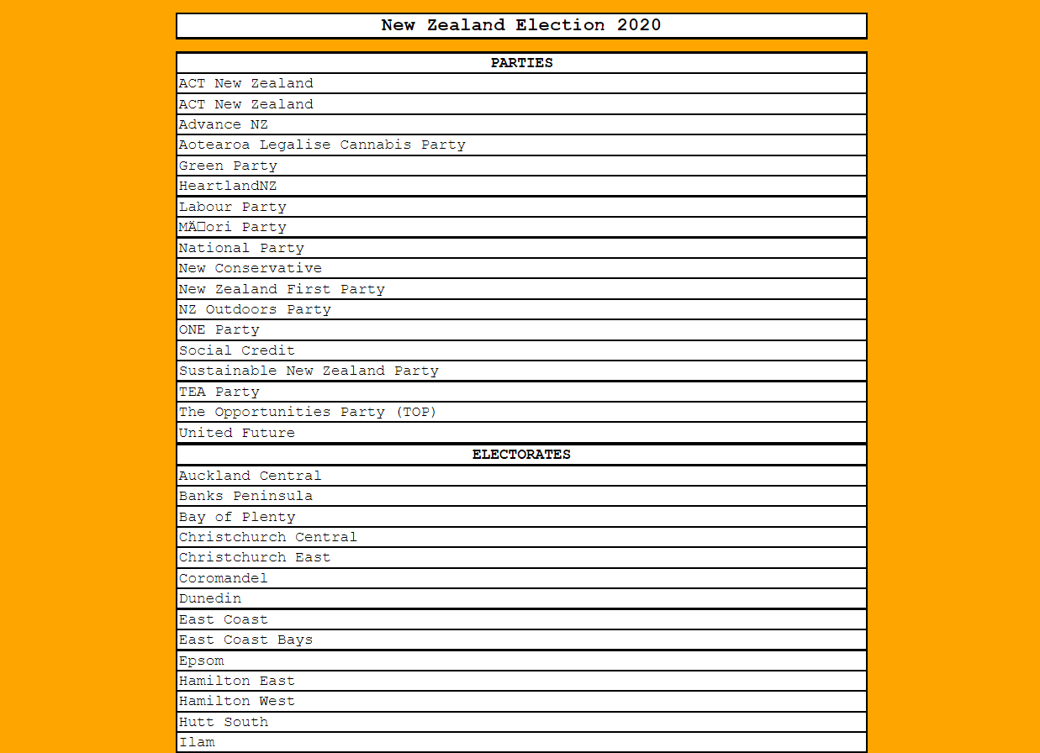

**Console result:**

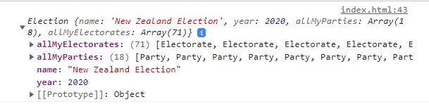

**Jasmine Unit Testing:**

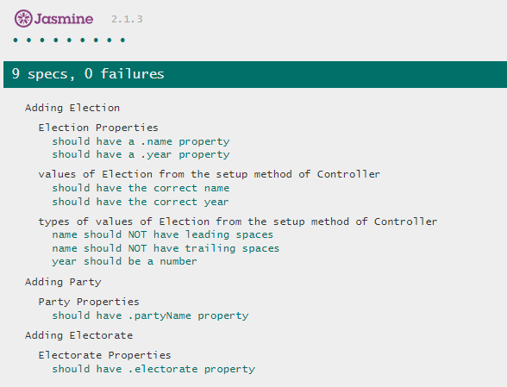

**Code checks:**

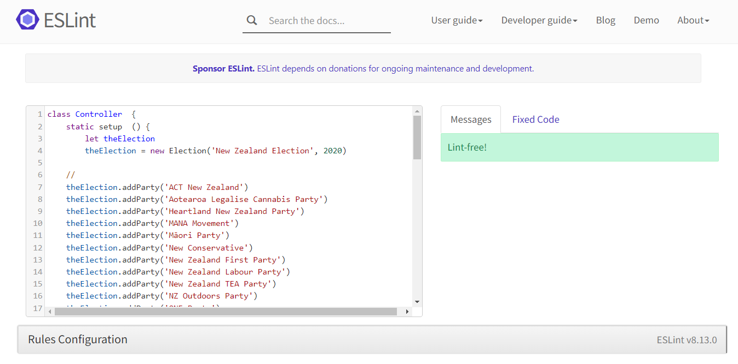

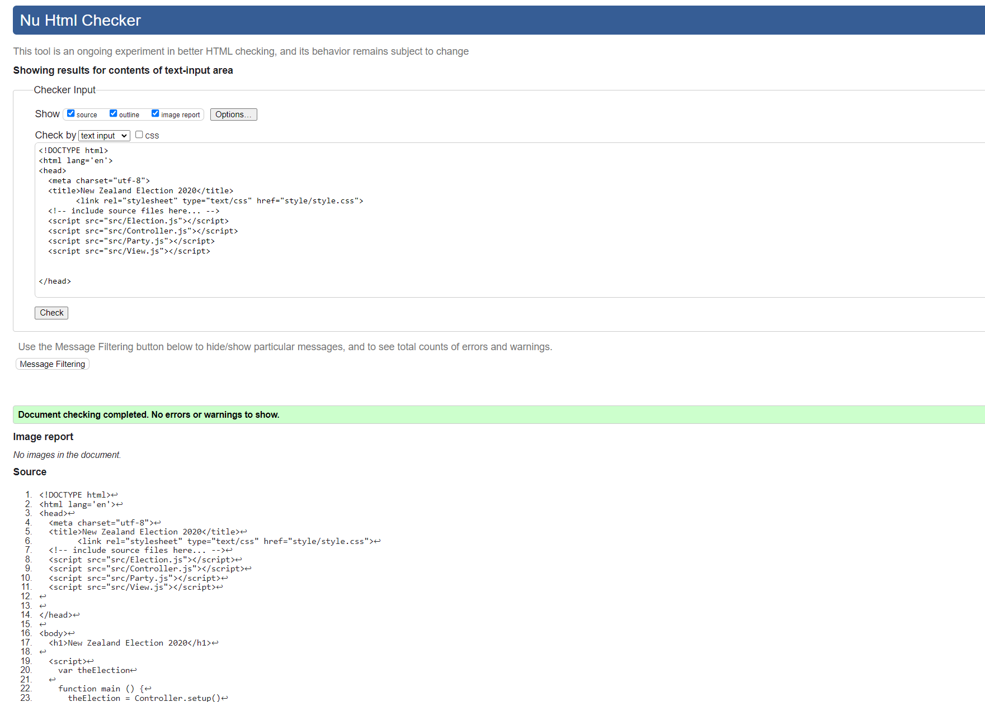

**What happened vs what was planned:**

The original wireframe I have created is now no longer needed due to the change in specifications by the client, but I will keep it as evidence of progressive work. Other than that, everything went according to plan.

**Performance Review:**

**What worked:**

This iteration is simpler compared to the previous two iterations as I have already created a table and inserted all the parties in it from the previous iteration. I only needed to alter my codes to list them in separate rows as well as add and display the electorates. I also added another Jasmine unit test question which is relevant to this iteration.

**What didn’t work:**

I initially wanted to attach the title of the election to the parties table by removing the break, but I could not get it to work. However, it looks good the way it is now therefore, I am debating with myself if I will try to fix this issue or keep it for the next iteration.