BCDE102 Introduction to Software Engineering -**Assessment Three - Portfolio**

**Iteration 4**

**Class Diagram:**

**Goal and Planning for Iteration 4:**

**Goal:**

The goal for the fourth iteration is to add electoral area winners to the election as well as display these electoral winners on the browser. The styling from the previous iteration will remain the same. The only change to the styling will only come from an extra column called “winning party” next to the “electorates” column. Following the patterns from the previous iterations, I will also create a directory named iteration4 which will still include all the necessary directories such as lib, spec, src, and style. As per standards, I will also include an index.html to enable the client to view the outcome of this iteration as well as a SpecRunner.html for the Jasmine unit testing framework to check for errors.

**Planning:**

The plan for this iteration is to add and output all electoral winners from the New Zealand Election 2020 using the index.html file using a browser. The electoral winners will be the parties with the most vote in a particular location. I will also pass the electoral winners using the name myParty through the console.

**Analysis:**

This iteration is a continuation of the previous three iterations. The class called electorate will be updated alongside the controller to enable the winners to show on the browser.

**Design:**

The design from the third iteration will be altered as I intend this iteration to look as close to the final iteration as possible. I have added a two-tone background colour to make it more visually appealing. The orange colour signifies the New Zealand Election therefore, it remains the main theme. All parties, electoral locations and winners now show on the browser. A snippet of the design as well as a package diagram is included below.

**Coding:**

The fourth iteration should take 4 to 5 hours to complete as per specifications. I have also started using the test codes provided to us via moodle. However, some of the tests were irrelevant for this iteration therefore, I had to comment them out for the mean time.

**Testing:**

For testing, I am using Jasmine for the framework. I have been using this framework for the past iterations and it works well for the purpose of testing.

**Time Estimated and Actual Time Taken for each task:**

|  |  |  |  |  |
| --- | --- | --- | --- | --- |
| **Task** | **Task Details** | **Time Estimated** | | **Actual Time** |
| **Planning** | Plan for fourth iteration layout.  Formulate fourth iteration outcome. | 45 minutes   30 minutes | | 45 minutes  30 minutes |
| **Analysis** | Formulate which classes, attributes and methods to use. | 45 minutes | | 30 minutes |
| **Design** | Design the layout for the fourth iteration based on new specification. | 45 minutes | | 30 minutes |
| **Coding** | Output information on the browser and console. | 60 minutes | | 60 minutes |
| **Testing** | Test code to check for errors. | 60 minutes | | 45 minutes |
| **Total Time** |  | 285 minutes or 4.75 hours | 240 minutes or 4 hours | |

**Package Diagram:**

**Fourth Iteration Output:**

**Console result:**

**Jasmine Unit Testing:**

**Code checks:**

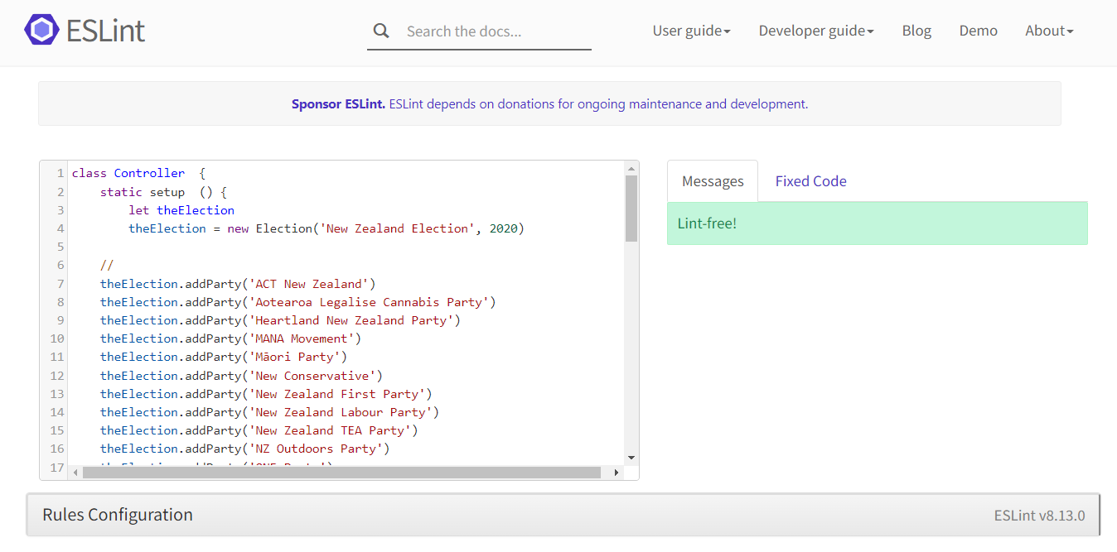

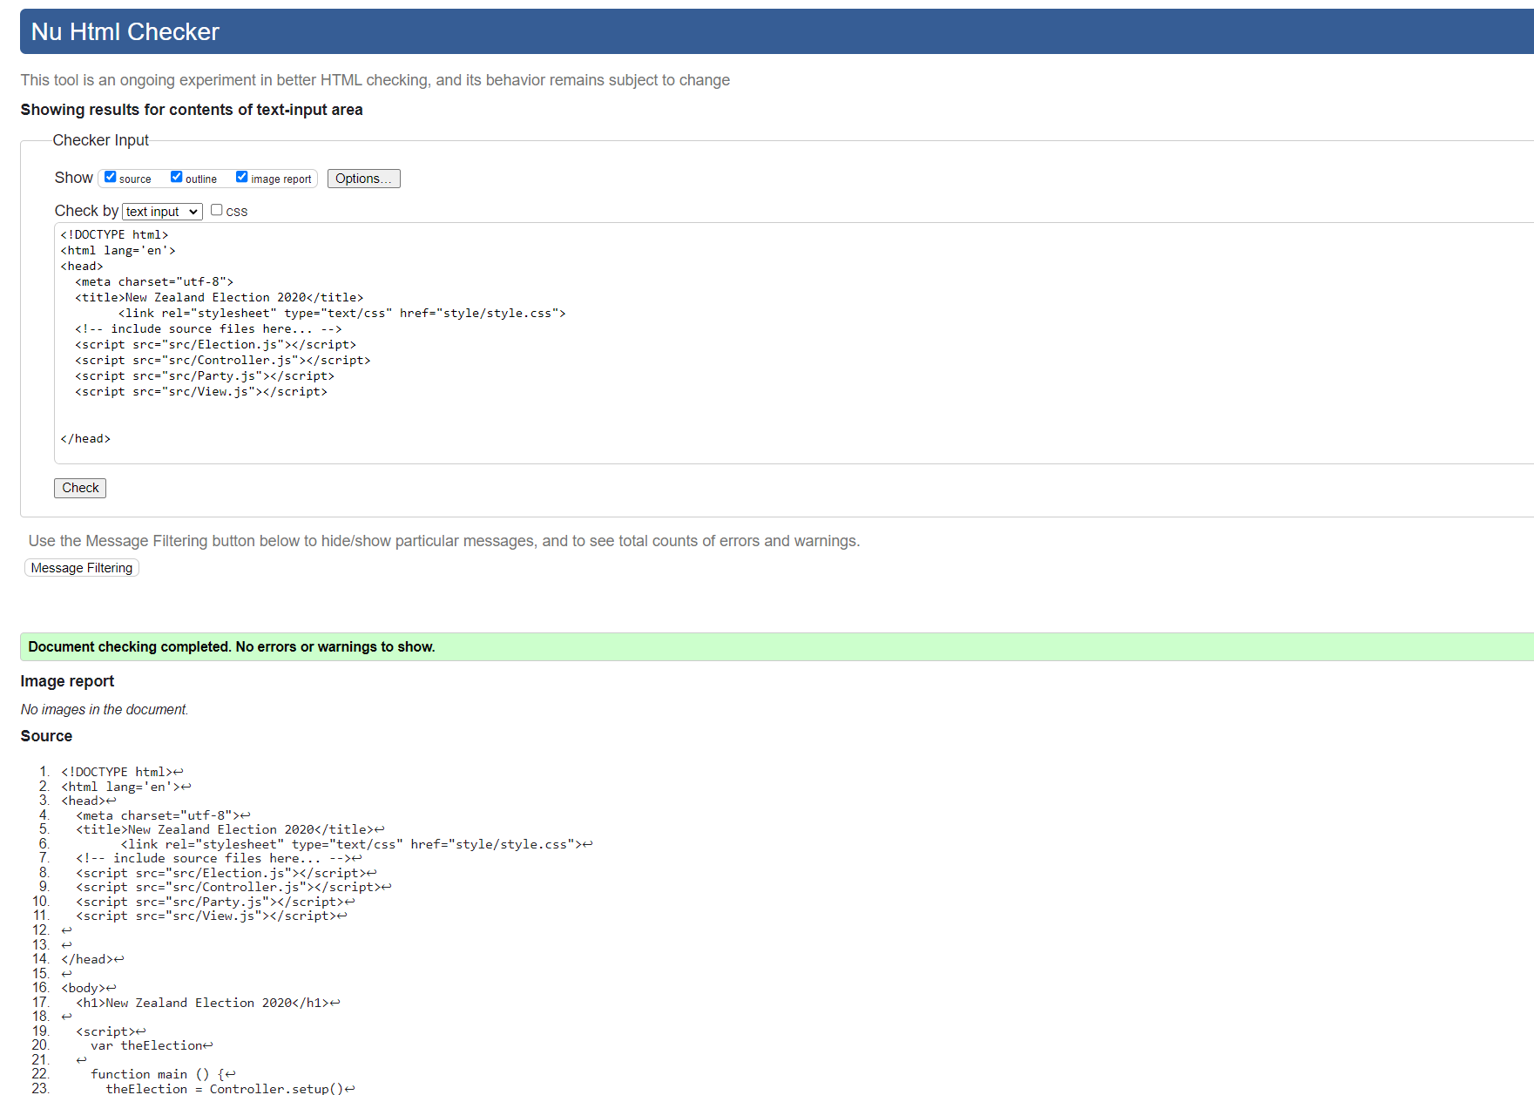

**What happened vs what was planned:**

Everything worked according to plan. No issues were encountered in this iteration.

**Performance Review:**

**What worked:**

Everything worked for this iteration. I have also used a different diagram for planning as I used pseudocode for the last iteration. This iteration is just a build-up from the previous ones therefore, I understood what is required out of me.

**What did not work?**

I tried using all the test codes provided to us via moodle but I had issues with some of them. I had to comment some of them out, but I plan to use them all for the final iteration of this project.