**STUDENT INTERNSHIP MANAGEMENT AND**

**MONITORING SYSTEM**

A Proposal

Presented to the Faculty of the

College of Computer Studies and Information Technology,

Southern Leyte State University

In Partial Fulfillment of the Requirements

for the degree Bachelor of Science in Information Technology

By

Tiempo, Gale Nathalie

Calape, Armelen

Fernandez, Ana Jean

Pelisco, Aira

Arguilles, Shaina

Tagupa, Mechelle

Dr. Geraldine Mangmang

Adviser

August 2022

Appendix G. Approval Sheet

Republic of the Philippines

**SOUTHERN LEYTE STATE UNIVERSITY**

Sogod, Southern Leyte

Website: www.slsuonline.edu.ph

Email: slsumaincampus@gmail.com/

op@slsuonline.edu.ph

Telefax: (053) 382-3294

***College of Computer Studies and Information Technology***

## **APPROVAL SHEET**

The Capstone Project Study entitled **Student Internship Management and Monitoring System** prepared and submitted by **THE BARDEN BELLAS** has been examined and is recommended for approval and acceptance.

RECOMMENDED:

_GERALDINE MANGMANG_ ______________________ _CZARINA ANCELLA GABI_

Adviser ITSO Manager Research Facilitator

APPROVED by the Committee on Oral Examination with a grade of PASSED on ____________________.

_JAMES BRIAN FLORES, Ph.D._

Chairman

_JORTON TAGUD, MSIT_ _JANNIE FLEUR ORAÑO_

Member Member

ACCEPTED and APPROVED in partial fulfillment of the requirements in Bachelor of Science in Information Technology.

DR. JAMES BRIAN FLORES_

Department Head, CCSIT

Date: _______________

**DEDICATION**

We humbly dedicate first and foremost this proposal to the Southern Leyte State University-Main Campus` assigned internship coordinators who badly need this system to help of managing and monitor student interns, which also led to having a safe and productive internship for the interns. This system straight aids the administrative tasks the internship coordinators do every time an internship happens. Also, it made the work of the internship coordinators more efficient and effective.

To the College of Computer Studies and Information Technology of Southern Leyte State University-Main Campus, we also heart fully dedicate this project proposal to them for allowing us to nurture and letting us learn and grow everything we might face soon, specifically in the IT industry.

We also dedicate this proposal to our families, friends, and block mates for their undying support and love in the process of making this proposal, even though it takes a toll on our time for them and financially. They never failed us to show what is like to have somebody who believes in you when the world is against us. Because of their love and support, we, the authors have the strength and courage to produce this paper, which will be a system soon that can be a great help to the University.

Ultimately, we dedicate this proposal to our Almighty Father who is the wellspring of wisdom and knowledge, the source of everything we outpoured for this proposal.

**ACKNOWLEDGEMENT**

First of all, we would love to give heartfelt appreciation to Dr. Geraldine Mangmang for her unwavering patience in understanding us in times we have our lapses, to her *“tough yet gentle”* mentoring that made us push and work hard to have this proposal successful, and to her time that even she has her fair share of works as a CCSIT internship coordinator, a faculty, and now our College Dean. She never failed to give her attention and knowledge to us her students. Indeed, she is a suitable project adviser for our project proposal since she knows the flow and process before, during, and after the internship.

To the CCSIT Faculty and Staff for having this opportunity for us students to make something out of our comfort zone, that improves our knowledge and skills.

To our families, friends, block mates, and “board mates”, thank you for your undying support, love, and understanding that made us produce this proposal successfully.

Ultimately, we would love to send our heartfelt gratitude to our Almighty Father who is the wellspring of wisdom and knowledge, the source of everything we outpoured for this proposal, and his limitless love and guidance.

Thank you, Thank you, and Thank you.

**TABLE OF CONTENTS**

**TITLE PAGE**

**APPROVAL SHEET i**

**DEDICATION ii**

**ACKNOWLEDGMENT iii**

**TABLE OF CONTENTS iv**

**LIST OF FIGURES v**

**CHAPTER 1**

PROJECT CONTEXT 1-2

PURPOSE AND DESCRIPTION OF THE PROJECT 2

OBJECTIVES OF THE PROJECT 2

SCOPE AND LIMITATION 2

**CHAPTER 2**

RELATED LITERATURE 3-4

RELATED STUDIES 5-6

**CHAPTER 3**

TECHNICALITY OF THE PROJECT 7-8

DETAILS OF THE TECHNOLOGIES TO BE USED 8

HOW THIS PROJECT WILL WORK? 9-12

**BIBLIOGRAPHY** 13

**APPENDICES**

WORKING TITLE FORM 14

CURRICULUM VITAE 15-19

**LIST OF FIGURES**

**Figure 1**. Functional Decomposition of the Proposed System

**Figure 2.** Sample Interface of Evaluation Page

**Figure 3**. The Proposed Architectural Layout

**CHAPTER I**

**INTRODUCTION**

**Project Context**

An internship is a great experience every student wishes to have before graduating. It is also a great program to give students a chance to put their knowledge from what they have learned in school into the formal workplace, where it exposes them to the reality of working their dream job. This On-The-Job Training, Internship, and Practice Teaching Program of Southern Leyte State University allows students to work domestically and internationally to promote global competitiveness through the students` practical knowledge, work ethics, and professionalism toward the foreign country. However, managing and monitoring student interns is an immense task for an internship coordinator, a time-consuming task. It starts with the application for an internship, to monitoring interns from different workplaces until giving their grades for the work they have done.

Management and monitoring by the internship coordinators play a huge part in the student interns’ welfare and performance at work. This managing and monitoring are just one of the many tasks of an internship coordinator. Not to mention the number of interns and where they have been deployed (locally and internationally). Internship management is generally done where it does manually, resulting in unsystematic arrangement and collecting of the data of students and companies or institutions at the time of the internship. This can also lead to problems like unorganized deployment of student interns into their designated workplaces, monitoring the student interns by doing on-site visits at the time of internship, and withdrawing student interns from the workplace at the end of the internship (Hardyanto et al. 2018). The managing and monitoring way of the internship coordinators does not have a systematic way even though they followed an internship plan provided by the Southern Leyte State University that is also following Commission on Higher Education policies for their Student Internship Program in the Philippines (SIPP) and Student Internship Abroad Program (SIAP). These make it harder not only for the coordinators but also for student interns who undergo the process. According to the study conducted by Abdullah et al. (2017), the main reason for the unorganized management of internship coordinators was caused by the increasing number of students in universities. The study highlighted that the manual management of student interns needs extra time and effort, and these extras can lead to poor management and monitoring. Aside from making internship objectives ineffective, poor management and monitoring of student interns also risked the safety and security of the interns in the workplace.

The University needs a system that can effectively manage student interns. Thus, the internship coordinators can do their duties efficiently. Because the Internship Coordinator and student interns need a system computer application that fits their needs to make the internship productive and successful, the proponents propose a systematic procedure and methodology to solve the issues and objectives of student internship at Southern Leyte State University.

**Purpose and Description of the Project**

The purpose is to design and construct a user-friendly, secure, and safe student internship management and monitoring system.

The proposal project will provide an efficient system that aids internship coordinators in managing and monitoring the Internship Program and will have a user-friendly interface for the internship coordinators and student interns.

**Objectives of the Project**

The study aims to create and design a web-based Student Internship Management and Monitoring System.

This project specifically aims to achieve the following:

* To create a secure and safe database for all data about the internship Program; and
* To introduce a system that facilitates internship coordinators in monitoring their student interns.

**Scope and Limitations of the Project**

The scope of this study is to assess the current dilemma every internship coordinator has to go through in managing their student interns.

On the other hand, this study, as well as the proposed project, will not expand its task that does not deal with anything related to student intern management and monitoring. The proposed system is likewise not intended for use by HTEs/FHEOs in monitoring and managing the student interns. This is just for the use of the respective internship coordinators and student interns. Because this is a web-based system, an internet connection is required. Any abrupt electricity or internet interruptions cannot disrupt all relevant data as long as the internship coordinators administer backups of the data habitually.

**CHAPTER II**

**RELATED LITERATURE**

An internship program can immensely influence a student's life. It provides student interns to establish their skills and expertise in their chosen industry, which they can then apply when working in a professional environment once they graduate (All About Careers 2022). As per the Commission on Higher Education (CHED) Memorandum Order No. 104, S. 2017, Article 1 Section 1, “The internship program is meant to provide students with an opportunity to complement their formal learning with practical knowledge, skills, and desirable attitudes and to gain hands-on experience in recognized Host Training Establishment (HTE)." Student interns can learn as much about their desired field and possibly work abroad after graduating from college with the assistance of some qualified and respected HTEs. The student interns are offered the opportunity to work not only locally, but also worldwide (voluntarily) to develop global competitiveness within themselves. Allowing student interns to work globally is an excellent approach to training them in a foreign culture's work ethics and professionalism. Those lessons can also be applied to their lives as Filipino citizens.

Because some student interns want to complete their internships abroad, internship coordinators face a significant issue in managing and monitoring their student interns. Ishak et al (2020) disclosed that the university, specifically the internship coordinators, is one of the variables in the overall internship experience of interns. The university has internship coordinators whose role is not only to find reputable organizations that can assist student interns in having a successful and productive internship but also to mentor and monitor the interns. So, if any substantial issues arise, the university will also be held accountable for any concerns about the student interns' safety in the workplace if it is discovered that the coordinators are also being negligent.

The internship coordinator managed and monitored the student interns at the same time to ensure their welfare while also documenting their progress in their internship. Management is the practice of leading other people and working efficiently and effectively as a team to attain and achieve the intended aim of all (IET 2019). Monitoring, on the other hand, is a routine inspection and documenting of what happens in a project (Bartle 2011). Having the responsibilities of an internship coordinator is extremely important because it not only looks after the student interns but also the university's reputation as an institution.

Annually, state universities and colleges in the Philippines conduct an internship program that is open to all eligible students in tertiary education. However, as the number of students applying for internships expanded over time, internship coordinators found it impossible to manage and monitor the student interns individually. The main reasons for inadequate management by internship coordinators in the internship are the increasing number of students and the manual management and monitoring that has been done (Abdullah et al. 2017).

In a selective review made by Fei et al. (2020), the authors mentioned that the internship management system has slowly turned from the traditional approach to the modern way. Although the management and monitoring system is changing, many internship coordinators continue to employ the old (paper-based) process, causing many problems in managing and monitoring student interns because the internship application already takes too much time. Furthermore, by employing a paper-based way in the application process, the students' data are already at high risk of data loss and redundancy, communication challenges, disruption in the grading process, and loss of track in managing and monitoring the student interns' development. The challenge for internship coordinators has been significantly increased by information from institutions, practice teaching interns, and changes in their internship as the program progressed (Ji et al. 2019).

Adopting information technology to create an online internship management system that can improve the effectiveness, productivity, and quality of the previous and manual-processed system (Yu et al. 2009). OJT coordinators can easily store the necessary data required by utilizing the innovative method for managing and monitoring student interns. They may work whenever and wherever they want since this is a web-based system that doesn't require extra paper or pens as long as there's an internet connection. They can also easily monitor their interns' progress and the situation at their respective workplaces.

**RELATED STUDIES**

**Exploration and Practice of "Diversified and Interactive" Internship Assessment System for Accounting Majors Based on Mobile Intelligent Technology**

This study, particularly the system focuses on overcoming challenges in the internship process through online interactive communication with teachers, providing emotional support to student interns, understanding the various evaluation processes and subjects, and assessing students' performance in the internship. Internship coordinators can now construct internship evaluation content with the help of the internship platform developed by mobile intelligent information technology. They can now generate "insightful and modern internship files" to spark students' interest in internships and create a "diversified and interactive" internship management system. Interns can now use the app to submit their total internship materials as well as upload photographs and videos related to their internship to the cloud platform. Internship coordinators can provide feedback and utilize it as a foundation for evaluating the internship process. The internship's assessment, which is based on mobile intelligent technology, has the quality of timeliness, diversification, and interaction, which documents the performance of student interns. Internship coordinators and student interns can also have online discussions about internships to provide emotional support and feedback. The internship assessment cloud platform uses information technology to provide a comprehensive and process-based internship file. Internship coordinators can learn about each student's internship work through internship management, or they can directly acquire statistical charts that include internship process results and comprehensive results, allowing them to understand the overall situation of students' internships at any time (FengYan 2020). According to Merriam-Webster, diversified means uniting different elements or qualities into one.

**E-Portfolio Web-based for Students’ Internship Program Activities**

Journals are not only one of the prerequisites for completing an internship, but they are also used as a reference by internship coordinators to track the student intern's development. The E-Portfolio feature built in this website-based Internship Program Portal has seen potential assistance in documenting the student interns' outputs throughout the internship program and is valuable in providing an efficient management and monitoring tool. This feature's accessibility is rated user-friendly for student interns running the system while interacting with internship coordinators, particularly during consultations. This feature can be accessed on the Internship Program Portal's main page. When clicked, it redirects the user to the feature's designated page. Student interns can post the journals of their internship from their PC. They can also add the journal's title, description, and file type before uploading it. The interns' uploaded file can be found in the main body of the E-Portfolio page. It contains a Regular Preview button that, when clicked, displays the first part of the content to allow users to know what is in that file without having to click and open the entire file all the time. It also has Detail, Edit, and Delete buttons, allowing student interns to view the full details of their uploaded work (shows the title of the file, file type, and the description). The comment section is also accessible to users (both student interns and internship coordinators) using this function. A comment box is an excellent place for coordinators to provide comments or suggestions about the student intern's portfolio. The student intern can also respond to that comment, making it an effective form of interaction (Juhana et al. 2018).

**Research on Effective Management of the Internship Process in Colleges and Universities under the Background of "Internet +"**

The authors of this study proposed utilizing the "Internet +" platform as a background to create an online management system, which provides comprehensive practice assistance to achieve management efficiency and practice consistency in universities and colleges. The interns are registered for attendance using the Electronic Fence, the GPS or Global Positioning System, and the Mobile Software. To minimize unexpected events such as offsite situations and missing interns, interns must register in their designated institutions so that the school can track their attendance throughout their internship at any time. The interns' data can also be linked with the system if the interns have to change their workplace due to health concerns, job, school demands, or any other cause. By sending private messages to interns, practice instructors can communicate with them through the system (Ji et al. 2019). China developed the "Internet Plus" platform to change and upgrade existing industries into new ones. For example, the country got "Alipay," an online banking program, to help them with their regular banking activities via the Internet (SESEC. 2015).

**CHAPTER III**

**TECHNICALITY OF THE PROJECT**

Southern Leyte State University needs a systematic way of managing and monitoring its student interns. In that way, the internship coordinators can comply with their job effectively, as well as ensure the safety of the student interns for the entire duration of the internship. The proposed project is a web-based Student Management and Monitoring System for internship coordinators to use as a guiding tool for student interns. Since it is web-based, it can be accessed through mobile phones, laptops, and even personal computers with available internet connections with it.

The proposed system aims the following features:

* Design Internship Coordinator’s account and dashboard where it has:
* Calendar for setting interviews and conferences schedule, together with student interns, and site visitations;
* Notepad for essential notes regarding the Internship;
* Contact Details for easy access in case of emergencies (contact information of the Grievance Committee, student intern’s parent or guardian, SLSU);
* Quality Forms Folder where the coordinator will upload the necessary forms;
* Chat box for direct communication with the Interns (this only includes simple messaging for notification);
* Manage Interns where the coordinator will create and modify interns’ account and their internship status;
* Report Generator where the internship coordinator can download reports in regard to the submitted requirements, e-journals, and reports from the student interns;
* Evaluation Page for the intern’s work progress and submitted e-journals and reports and the needed requirements; and
* Settings (where the coordinator can modify the account’s password and personal information).
* Design Student Intern’s account and dashboard where it has:
* Intern’s account, and Internship Status Banner;
* Checklist to track down the requirements;
* Quality Forms Folder where the students can download the uploaded necessary forms;
* Submission Page where interns’ can upload e-journals and reports; and
* Chat box to have direct and private communication with the internship coordinator.

In developing the system, the proponents will use CSS, HTML, Bootstrap, PHP, JavaScript, XAMPP, and MySQL.

**DETAILS OF THE TECHNOLOGIES TO BE USED**

Since the proposed system is web-based, an internet connection is highly needed. The user can access the system on their smartphones, laptops, or personal computer.

In developing the system, the proponents will use CSS, HTML, Bootstrap, PHP, JavaScript, and MySQL. In order to understand the aforementioned tools in developing the system, the following are its uses.

**Bootstrap** – Bootstrap is a collection of free and open-source tools for building responsive websites and web apps. It is the most widely used HTML, CSS, and JavaScript framework for designing mobile, responsive websites.

**CSS** – (Cascading Style Sheets) is a stylesheet language that is used to make a webpage more presentable. It is compatible with HTML.

**HTML** – stands for HyperText Markup Language. It is used in the development of web pages.

**JavaScript** – It is well-known for web page development, but it is widely used in numerous non-browser applications. Server-side extensions enable an application to interface with a database, offer information consistency from one program execution to the next, and manipulate files on a server.

**MySQL** – It is used for data operations such as table querying, sorting, filtering, grouping, altering, and merging. MySQL is an open-source relational database management system that is used widely in online applications.

**PHP** – known to this day as PHP: Hypertext Processor. PHP is a server-side scripting language, also known as the backend of a website. It's primarily used to create dynamic web pages and applications. This scripting language is also ideal for a database.

**XAMPP** - stands for **cross-platform**, **Apache**, **MySQL**, **PHP**, and **Perl**, and it allows you to develop a WordPress site offline, on your computer's local web server. This simple and lightweight solution is cross-platform, meaning it works on Windows, Linux, and Mac.

**HOW THE PROJECT WILL WORK**

Shown in Figure 1 is the Functional Decomposition Diagram of the proposed Student Internship Management and Monitoring System of Southern Leyte State University.

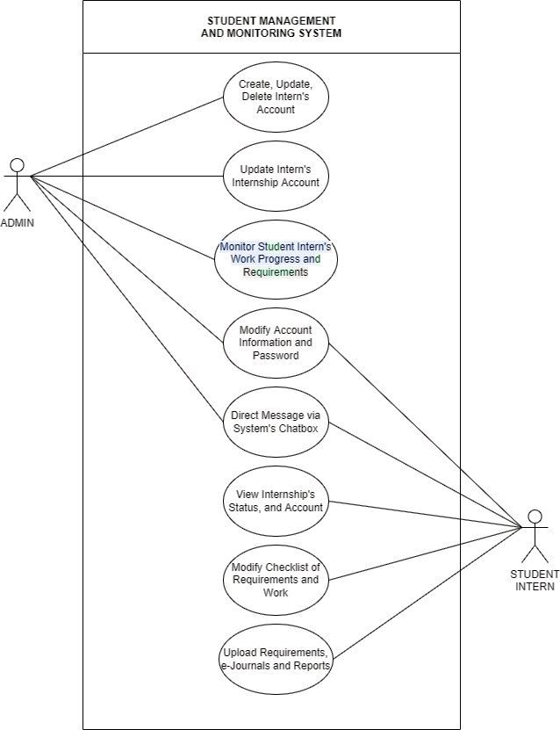

*Figure 1. Functional Decomposition of the Proposed System*

Figure 1 shows that the Internship or OJT Coordinator and the Student Interns will be the two target audiences for this system. The system's administrator is the College's internship coordinator. They are in charge of creating, updating, and deleting intern accounts. To avoid data loss or tampering, the coordinators must back up the data. Manual data backup should be done on a regular basis to ensure data protection. Whenever the data is backed up, the file that the Internship Coordinator will have is already in an excel form where it can be saved in their laptops or PCs. They can also monitor interns by visiting the evaluation page, which displays the interns' progress on the job site, as well as the journals and reports they have produced. They can also update the status of the student intern's internship, particularly if the intern is actively involved in a significant problem that requires legal action. In the Internship coordinator’s dashboard, it will show the progress of each student intern’s e-journals, requirements, and reports submission. Sample interface is provided below:

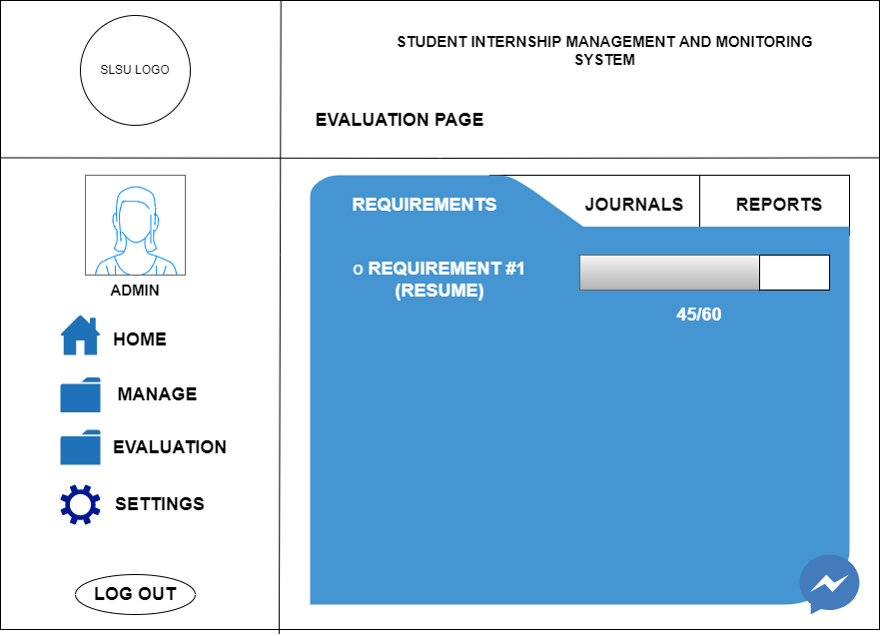

*Figure 2. Sample Interface of Evaluation Page*

Figure 2 presents that student interns, on the other hand, can access their online checklist after logging into the system, which shows their completed and unfinished work as well as requirements that must be presented to the coordinator. It's similar to keeping track of their work. They can also check the status of their internship and their account information. They can also upload reports and e-journals to be shown to the coordinators. The student interns can also upload the necessary requirements in the system before deployment. The following requirements are:

1. Application Letter
2. Resume
3. Notarized Parent’s Consent
4. Medical Certificate
5. Notarized MOA (Memorandum of Agreement)
6. Letter of Recommendation
7. Photocopy of Study Load with the OJT subject officially enrolled
8. 2 pcs. 2x2 pictures – formal attire, white background; and
9. Other documents as required by the HTE/s.

The requirements below are needed to be submitted AFTER the Internship coordinator. These are also to be uploaded in the system by the student interns:

1. OJT Journal/Portfolio
2. Daily Track Record
3. Monthly Report
4. Performance Rating (from the HTEs/ FHEOs)
5. Certificate of Completion
6. Evaluation report of the HTEs/FHEOs
7. Descriptive Feedback
8. Evaluation Form of OJT Experiences; and
9. Final Rating Sheet.

The internship coordinator and student interns can use the chat box to communicate privately in the system. Both can modify their passwords and personal information on their accounts.

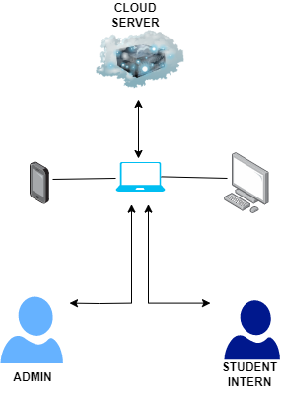

*Figure 3. The Proposed Architectural Layout*

On the other hand, figure 3 shows the proposed architectural layout of the project.

This is a web-based system that requires the use of a phone, laptop, or personal computer with an internet connection. When logging into the system, the administrator should use a laptop or computer to get a better view of the system's interface. Student interns, on the other hand, can utilize their phones to access the system, particularly when posting e-journals and reports. The system has to be safe and secured from unexpected data loss or damages by encrypting it, allowing the Internship Coordinator/s will only to have access.

**BIBLIOGRAPHY**

Abdullah FS, Seman AA, Ibrahim N, Majid NA, Wahab NMA, Mustafa MS, Sani NFM . 2017. Web-Based Application of the Internship Management System. Journal of Computing Research and Innovation. 2(3): 46-51.

All About Careers. 2022 Mar 26. What is an Internship? [accessed 2022 August 18]; <https://www.allaboutcareers.com/internships/what-is-an-internship/>

Bartle P. 2011 Sept 30. THE NATURE OF MONITORING AND EVALUATION: Definition and Purpose. Community Empowerment Collective. [accessed 2022 May 05]; http://cec.vcn.bc.ca/cmp/modules/mon-wht.htm.

Fei YC, Waheeb W, Sulaiman SB. 2020. Student Internships: A Selective Review. Journal of Applied Technology and Innovation (e -ISSN: 2600-7304). 4(2): 1-5.

FengYan W. 2020. Exploration and Practice of “Diversified and Interactive” Inter Assessment System for Accounting Majors Based on Mobile Intelligent Technology. IOP Conference Series: Earth and Environmental Science. [accessed 2022 May 17]; 1-5. https://www. doi:10.1088/1755-1315/510/6/062009.

Hardyanto W, Purniwarko A, Sudana IM, Supraptono E. 2018. Model Development ofManagement Information System of Internship. Advances in Social Science, Education and Humanities Research. 247: 196-199.

Ji G, Ye D, Zhang R. 2019. Research on Effective Management of the Internship Process in Colleges and Universities Under the Background of "Internet +". Advances in Social Science, Education and Humanities Research. 298: 249-253.

Juhana A, Abdullah AG, Somantri M, Aryadi S, Zakaria D, Amelia N, Arasid W. 2018. E- Portfolio Web-based for Students’ Internship Program Activities. IOP Conference Series: Materials Science and Engineering. [accessed 2022 May 20]; 1-9.

<https://www.doi:10.1088/1757-899X/306/1/012003>.

Soffi MNE, Mohamad SF, Ishak FAC. 2020. Challenges to Achieving a Successful Hospitality Internship Program in Malaysian Public Universities. MacroThink Institute: International Journal of Human Resource Studies ISSN 2162-3058. [accessed 2022 May 05]; 10(4): 12-24. https://www. doi:10.5296/ijhrs.v10i4.17510.

XU B. 2015. China Internet Plus Strategy. Second European Standardization Expert in China Project. 1-5.

Appendix C. Project Working Title Form

Republic of the Philippines

**SOUTHERN LEYTE STATE UNIVERSITY**

Sogod, Southern Leyte

Website: www.slsuonline.edu.ph

Email: slsumaincampus@gmail.com/

op@slsuonline.edu.ph

Telefax: (053) 382-3294

***College of Computer Studies and Information Technology***

### Proponents/Researchers:

1. Gale Nathalie Tiempo

2. Armelen Calape

3. Ana Jean Fernandez

4. Aira Pelisco

5. Shaina Arguilles

6. Mechelle Tagupa

**Proposed Project Title:**

STUDENT INTERNSHIP MANAGEMENT AND MONITORING SYSTEM

|  |  |
| --- | --- |
| **Submitted by:**  **GALE NATHALIE A. TIEMPO**  (Signature of Project Manager over printed name)  Date: March 16, 2022_ | **Noted:**  **DR. GERALDINE MANGMANG, DIT**  (Signature of Adviser over printed name) Date: |
| **Recommending Approval:**  (Signature of Patent Searcher over printed name)  Date: | **Approved:**  **DR. ALEX BACALLA, DIT**  (Signature of the Dean over printed name) Date: |

**CURRICULUM VITAE**



GALE NATHALIE A. TIEMPO

Team Position: Project Manager, Programmer

Poblacion Ibabao, Pintuyan,

Southern Leyte

09465211828

[galenathalietiempo30@gmail.com](mailto:galenathalietiempo30@gmail.com)

**PERSONAL INFORMATION ___________________________________________________**

BIRTHDAY: 30 March 2001

AGE: 21

NATIONALITY: Filipino

RELIGION: Roman Catholic

CIVIL STATUS: Single

**EDUCATIONAL BACKGROUND _______________________________________________**

SCHOOL: Southern Leyte State University-Main Campus

ADDRESS: San Roque, Sogod, Southern Leyte

COURSE AND YEAR: Bachelor of Science in Information Technology, major in Networking, 4TH Year

**CURRICULUM VITAE**



ARMELEN M. CALAPE

Team Position: Programmer

Sitio Tubod, Himama-a,

Bato, Leyte

09352728586

[armelencalape@gmail.com](mailto:armelencalape@gmail.com)

**PERSONAL INFORMATION ___________________________________________________**

BIRTHDAY: 19 June 2000

AGE: 22

NATIONALITY: Filipino

RELIGION: Roman Catholic

CIVIL STATUS: Single

**EDUCATIONAL BACKGROUND _______________________________________________**

SCHOOL: Southern Leyte State University-Main Campus

ADDRESS: San Roque, Sogod, Southern Leyte

COURSE AND YEAR: Bachelor of Science in Information Technology, major in Networking, 4TH Year

**CURRICULUM VITAE**



ANA JEAN FERNANDEZ

Team Position: System Analyst

Hitudpan, Hilongos, Leyte

09754582097

AJF231000@gmail.com

**PERSONAL INFORMATION ___________________________________________________**

BIRTHDAY: 23 October 2000

AGE: 21

NATIONALITY: Filipino

RELIGION: Roman Catholic

CIVIL STATUS: Single

**EDUCATIONAL BACKGROUND _______________________________________________**

SCHOOL: Southern Leyte State University-Main Campus

ADDRESS: San Roque, Sogod, Southern Leyte

COURSE AND YEAR: Bachelor of Science in Information Technology, major in Networking, 4TH Year

**CURRICULUM VITAE**



AIRA L. PELISCO

Team Position: Tester

San Agustin, Tomas Oppus,

Southern Leyte

09954647056

peliscoaira@gmail.com

**PERSONAL INFORMATION ___________________________________________________**

BIRTHDAY: 15 December 2000

AGE: 21

NATIONALITY: Filipino

RELIGION: Roman Catholic

CIVIL STATUS: Single

**EDUCATIONAL BACKGROUND _______________________________________________**

SCHOOL: Southern Leyte State University-Main Campus

ADDRESS: San Roque, Sogod, Southern Leyte

COURSE AND YEAR: Bachelor of Science in Information Technology, major in Networking, 4TH Year

**CURRICULUM VITAE**



MECHELLE E. TAGUPA

Team Position: Technical Writer

Zone 4, Sogod, Southern Leyte

09555610982

mechellehide@gmail.com

**PERSONAL INFORMATION ___________________________________________________**

BIRTHDAY: 7 August 1999

AGE: 22

NATIONALITY: Filipino

RELIGION: Roman Catholic

CIVIL STATUS: Single

**EDUCATIONAL BACKGROUND _______________________________________________**

SCHOOL: Southern Leyte State University-Main Campus

ADDRESS: San Roque, Sogod, Southern Leyte

COURSE AND YEAR: Bachelor of Science in Information Technology, major in Networking, 4TH Year