**Project 2 ETL Report  
Stock Market influence of COVID 19**

**Authors**

* Mark Rotil
* Nikita Case
* Eric Lee
* Hadi Hanif
* Murat Cagri KOC

**Introduction**

Conventional thinking reveals that when calamities occur, the stock market is impacted negatively. These calamities stem from a variety of factors ranging from inaccurate economic modelling to climate change.

The Covid-19 pandemic, however, can be classified as a black swan event. News cycles inundate us with recovery rates, death rates, and lockdowns. The goal of this study is to determine just how sensitive the stock market is to these events.

We have identified 9 stocks across following industries:

* Hospitality
* Aviation
* Entertainment
* Technology
* Telecommunications

We will track and observe these stock prices from the 1st of January 2020 to the 4th of December 2020 and then compare it to the previous year.

Afterwards, we will identify key events related to the pandemic (e.g., the first case of Covid-19 in Canada) and look to see if there are any corresponding fluctuations in price.

We hypothesize that fluctuations of stock prices are strongly correlated with key events in Covid-19 such as lockdowns and that the correlation weakens as key events pass. This correlation applies to all industries within the stock market.

**Extraction Process**

Our first step is to extract the stock market data from Yahoo Finance in the form of CSVs.

Once that is done, we proceed to prepare the necessary initial import parameters into Jupyter Notebooks.

**Step 1**



Once completed, we will then import the CSV into Jupyter notebook and check to see if the data is accurate.

**Step 2**



Here we see that the data is accurate after being imported from the CSV.

**Step 3**

We then proceed to scrape the dates of key events from the Global News source.



**Transformation Process**

Now that the data has been loaded, we will begin the transformation process. 

We drop the “CLOSE” column from the dataset because we will be using use the Adjusted Close (Adj_Close) on a day-to-day basis. The difference between the two is that the adjusted close factors in the price after dividend issuances.

We also converted the Date format because it will make the querying process much simpler. We also checked to determine how the data will be represented.

This process is replicated 9 times, once for each stock.

**Step 4**

After extracting the data from the news sources, we begin to clean up the news sources by filtering it into a dictionary.

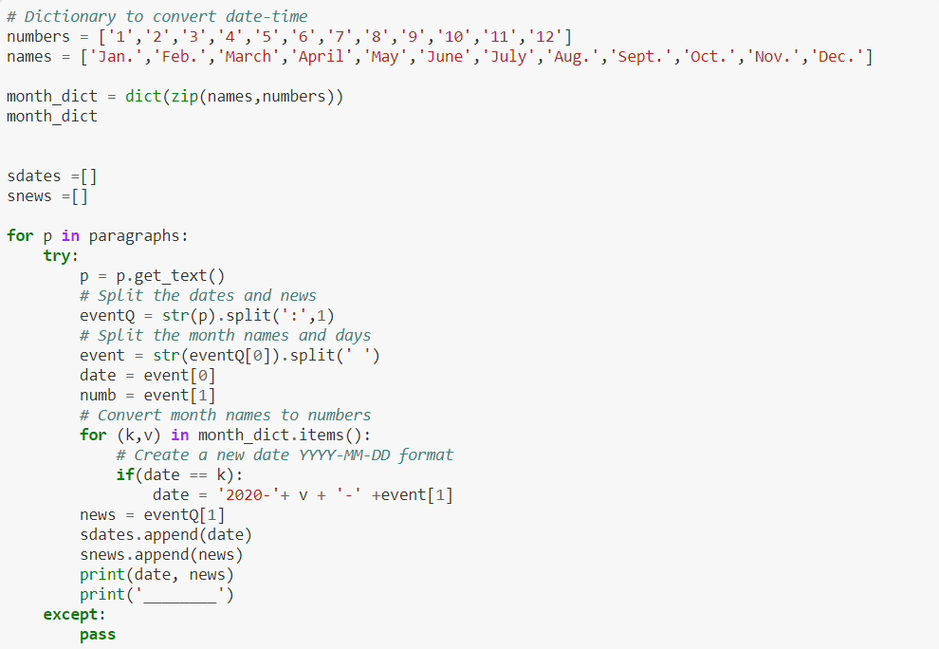

**Step 5**

Next, we convert the dates into a data frame with ‘Date’ and ‘News’.



**Step 6**

We then apply a filtration of key words, which includes these three words: *lockdown, shutdown, Toronto*.



**Loading Process**

**Step 8**

After cleaning, data was loaded into ElephantSQL. ElephantSQL allows us to aggregate the data into single SQL table. Below is the code that was used.



**Step 9**

We first create an engine that allows us to export our transformed files onto ElephantSQL.



It is also important to note that ElephantSQl limits the number of users that can concurrently function.

Next, we do a check to see if all the tables have been placed correctly. To do that, we do a table name check.



As seen above, the tables are correctly showing up.

**Step 10**

The first query is to find out if there have been any changes of 7% or more to the prices of each stock.



**Step 11**

The second query was to determine which stocks have had only negative changes in 2020.



Another way of doing this is like so:



**Step 12**

We then test if the collection has been properly done before beginning the query process.



We see here that this is the case and that the dates correspond to the prices.

**Step 13**

We start to define the quarters for 2019 and 2020 so that we can calculate the high, lows, and averages of each stock price per quarter in 2019 and 2020.



**Step 14**

Last of all, we appended our news article to the datasets to determine if there is a correlation between the key words and the fluctuations in price.



**Limitations**

The first challenge we encountered is the user limitations for ElephantSQL. Our team consisted of five members; we were able to have two users fetch the information for ElephantSQL. We had to constantly keep track of which users were accessing ElephantSQL and terminate connections when the users were done.

Our attempts to use other applications for loading purposes, such as MongoDB, were unsuccessful also.

Another challenge we faced was in our transformation process. We had multiple iterations of deletions and uploads of our tables. This is due in part to the fact that when we made modifications, we would have to apply them across 9 files, one for each stock. In another cycle we might have merged all the files before putting up on ElephantSQL or restricting the number of stocks.

**Following Steps**

Following steps would include visualizing the tables on a line graph then plotting all the stocks across a single graph with time and stock prices as the variables. We would then apply dates of key events to determine whether decreases in prices correspond to the dates.

**Data Sources**

* Yahoo Finance where we will obtain the CSV’s for the stock prices on a day-to-day basis.
* Global News which provides a timeline which we will take and convert into a CSV. (<https://globalnews.ca/news/6859636/ontario-coronavirus-timeline/>)