
PRODUCT OVERVIEW
ModelHop for Claude Code
A provider, compatibility, and continuity layer for developer AI workflows
Keep Claude Code’s editor interface and tool harness while choosing Anthropic, Synthetic, OpenAI API, or a ChatGPT/Codex allowance for inference.
MULTI-PROVIDER • SAME CONVERSATION • LOCAL-FIRST • PHONE CONTINUATION
Choose the model. Keep the workflow.
August 2026 • Packaged version 2.2.4 • MIT licensed
github.com/markrpg/modelhop-for-claude-code

Why ModelHop exists
THE PRODUCT ModelHop separates Claude Code’s interface and tool harness from the model provider, then supplies the compatibility, state, and safety needed to make that separation usable.

Claude Code is a strong developer workflow, but the default experience couples that workflow to one provider, one billing route, and one model catalogue. Moving elsewhere usually means editing environment variables, losing usage visibility, or starting over when a tool-heavy conversation becomes incompatible.
ModelHop keeps the graphical Claude Code extension in Cursor or VS Code as the place where work happens. It manages authentication, per-role model routing, provider translation, conversation repair, context pressure, usage, and optional phone continuation around that workflow. It does not configure standalone Claude Code CLI sessions.

Developer problems solved
Developer friction | ModelHop response
Model and billing lock-in | Four provider routes behind the same Claude Code workflow.
Risky manual configuration | In-extension credentials, validation, owned-key updates, snapshots, and rollback.
One model for every task | Separate Default, Opus, Sonnet, Haiku, and subagent mappings.
Broken chats after switching | Automatic repair of tool names, IDs, result links, callers, and thinking blocks.
Long conversations hit context limits | Model-aware counting and safe, automatic bridge-side compaction.
Quota and cost are hidden | Provider-specific usage, cost, headroom, reset timing, and allowance views.
Remote work needs broad machine access | An encrypted, task-focused phone continuation instead of remote desktop.
Provider failures route unpredictably | Fail-closed behaviour with no silent fallback to Anthropic.

Designed for
- Claude Code extension users who want more model and billing choice without leaving the editor workflow they already use.
- Power users who run long, tool-heavy conversations and need reliable provider transitions, usage visibility, and context continuity.
- Developers on the move who want to monitor, steer, approve, and inspect a Mac-hosted coding task from a phone.

Core product capabilities

Provider and credential management
- One control surface. Switch among Anthropic, Synthetic, OpenAI API, and OpenAI via ChatGPT/Codex from the status bar or command palette.
- Independent, owned configuration. Secrets live in VS Code SecretStorage, Anthropic OAuth stays under Claude Code’s control, and unrelated settings survive verified writes or rollback.

Model routing and reasoning
- Five role mappings. Assign different models to Default, Opus, Sonnet, Haiku, and subagent work for deliberate quality, latency, and cost trade-offs.
- Canonical, capability-aware choices. Pickers show the real provider model, reject missing configurations, and expose supported effort; the development build adds Claude-harness Thinking, Workflows, and conditional Ultracode.

Conversation continuity
- Same conversation. Deterministic transcript repair keeps tool-heavy chats usable when providers disagree about identifiers, names, links, or thinking signatures.
- Safe transition. Malformed tool graphs stop the switch, originals are backed up, and a full-window reload refreshes Claude Code before reopening the intended conversation.

Automatic context management
- Whole-request budgeting. System instructions, tool schemas, images, conversation history, and reserved output are counted against the selected model’s context.
- Tool-safe compaction. Older completed work is summarized, recent history stays verbatim, linked tools remain atomic, and terminal context failures never become retry loops or forced fresh chats.

Usage and cost visibility
- Synthetic. Rolling five-hour and weekly quota plus regeneration timing.
- OpenAI API. Session tokens, cache use, request count, estimated cost, and rate-limit headroom.
- ChatGPT/Codex. Subscription limits, reset timing, and confirmation-gated reset credits.

Providers, models, and billing
BILLING CLARITY Synthetic and both OpenAI routes use their own quota, API billing, or ChatGPT/Codex allowance. They do not consume Anthropic model usage.

Provider | Authentication | Usage charged to | Maturity
Anthropic | Claude OAuth or Anthropic API key | Anthropic / Claude | Stable
Synthetic | Synthetic API token | Synthetic quota | Stable
OpenAI API | OpenAI Platform API key | OpenAI API billing | Release candidate
ChatGPT / Codex | Managed Codex browser sign-in | ChatGPT / Codex allowance | Experimental

Default OpenAI role routing
Claude role | OpenAI model | Reasoning
Default and Opus | gpt-5.6-sol | high
Sonnet and subagents | gpt-5.6-terra | medium
Haiku | gpt-5.6-luna | low

The direct API picker exposes only models in ModelHop’s Claude-tool compatibility catalogue. The Codex route uses the signed-in account’s live model/list response, including its supported effort levels. ModelHop never silently replaces a missing configured model.

Synthetic defaults
- Kimi K3. Used by default for Default, Opus, Sonnet, and subagent roles, shown as the canonical ID hf:moonshotai/Kimi-K3.
- GLM-4.7-Flash. Used by default for the Haiku role; other compatible Synthetic models are discovered from the live catalogue.
Synthetic publishes provider-native reasoning metadata, but the current Anthropic-compatible Synthetic route does not yet guarantee that every native effort level reaches the upstream model. The UI should distinguish Claude-harness Thinking from provider-private reasoning.

Experimental orchestration
Claude Workflows and Claude Ultracode operate at the Claude harness layer in the current development build. Codex-native Ultra is a separate capability and remains disabled until ModelHop can mediate descendant threads, approvals, recovery, cancellation, usage, and replay protection end to end.

How ModelHop works
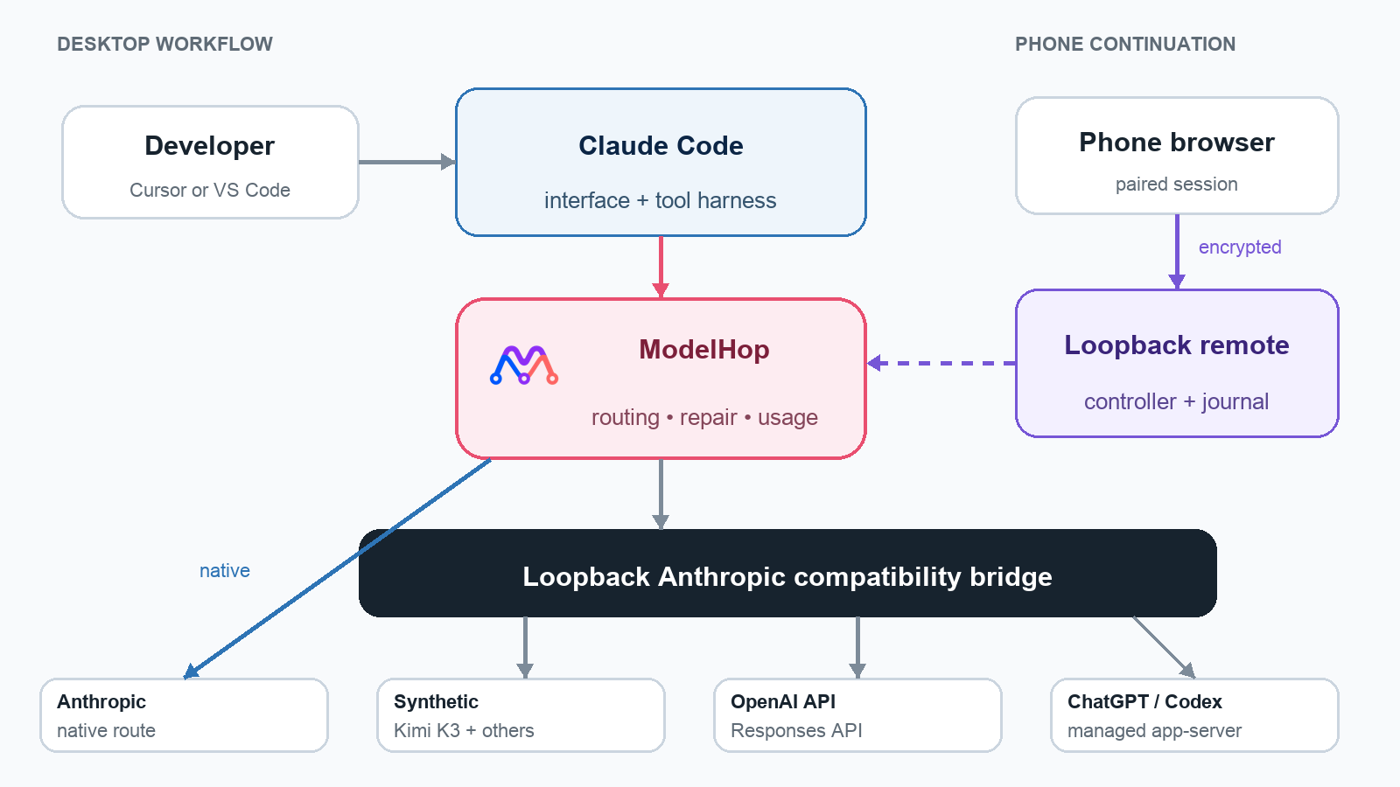
Claude Code remains the interface and tool harness; ModelHop selects and translates the inference route.

Local compatibility bridge
Synthetic and both OpenAI routes use an Anthropic-compatible server bound to 127.0.0.1. It handles /v1/messages and token counting while translating system instructions, text, images, streaming, tools, parallel calls, cancellation, and errors into the protocol Claude Code expects.
- OpenAI API. Responses API translation uses store: false, deterministic identifiers, flexible tool schemas, and encrypted local reasoning continuity.
- Codex and failure isolation. A pinned runtime uses ephemeral threads and Claude tools only; an unavailable bridge, credential, or model fails clearly without Anthropic fallback.

A provider switch in practice
- Validate and snapshot. Check credentials, models, and the current environment before changing anything.
- Repair compatibility. Repair tool metadata and thinking blocks locally, after backing up the original transcript.
- Apply, reload, and verify. Change only owned values, refresh Claude Code, then resume the intended route or restore the prior configuration.

Continue on Phone
EXPERIMENTAL ModelHop Remote continues a specific Mac-hosted Claude Code task on a phone. It is a focused control surface, not a general remote desktop or unrestricted shell.

One-command handoff
- Start from Claude Code. Choose the exact workspace conversation with ModelHop: Continue on Phone.
- Open the temporary link. A verified Quick Tunnel connects the QR link to the loopback controller.
- Compare the code. Match the same six digits on phone and laptop; every new device needs laptop approval.
- Keep working. Prompts, output, approvals, files, provider state, and usage stay tied to that Mac session.

A mobile surface built for coding tasks
- Conversation and activity. Send or queue prompts, steer, stop, retry, answer questions, inspect phases, and follow tool execution without raw protocol noise.
- Repository context. Browse multi-root hierarchies, search, preview source or images, select lines, follow Markdown references, and inspect Git status or diffs.
- Provider control with Auto-safe. See model, reasoning, quota, and usage while routine work continues; risky commands, credentials, pushes, releases, reset credits, and external writes still require a decision.

Continuity when the display disappears
Locking the phone, backgrounding the browser, or losing reception never cancels an active model turn. The detached Mac controller journals encrypted events for the same-link reconnect. Idle or eight-hour limits block later input but let in-flight work finish; cancellation is always explicit.

Exact-session hand-back
Return to Laptop validates the transcript, records durable recovery state, and opens that exact Claude session. If reopening fails, the phone route stays available; ModelHop never substitutes the last or an empty conversation.

Security and reliability

Local-first credential boundary
- Loopback services only. The inference bridge and mobile controller bind to 127.0.0.1; ModelHop never silently opens a LAN listener.
- Secrets stay on the Mac. Provider credentials do not enter the phone URL or mobile payload. Claude receives a bridge-only token, not the upstream OpenAI key.
- Redacted operation. Logs redact registered credentials and omit request content; failed configuration writes roll back from a local snapshot.
- Isolated Codex route. Native Codex shell, editing, web, MCP, apps, plugins, skills, memories, hooks, and subagents are excluded from bridged turns.

Remote-session protection
- Application encryption. Pairing uses ephemeral P-256 ECDH, HKDF-SHA-256, AES-256-GCM, and a laptop-confirmed short authentication code.
- Replay and duplication defences. Authenticated sequence metadata, replay rejection, and in-flight command coalescing prevent repeated remote actions.
- Workspace boundaries. Paths are canonicalized; traversal, escaped symlinks, and oversized reads are rejected. Text previews are capped at 5 MB and supported images at 25 MB.
- Fail closed. An unavailable tunnel, invalid identity, expired session, bridge failure, or model mismatch stops the operation rather than widening access or changing provider.
TRUST BOUNDARY Cloudflare Quick Tunnels provide a temporary public hostname, terminate HTTPS, can observe transport metadata, and serve the initial browser client. Paired session payloads are encrypted, but this Experimental delivery cannot protect against malicious client-code substitution by the tunnel operator. It is intended for short-lived personal sessions, not regulated remote access.

Testability
The project includes unit and integration coverage for translation, tools, credentials, context, repair, remote crypto, session recovery, path policy, and lifecycle behaviour. A deterministic mobile fixture and Playwright suite exercise phone viewports, interaction, accessibility, visual regressions, and production-asset packaging without provider credentials or a live tunnel.

Developer outcomes
- Use the model and allowance that fit the task—Kimi K3, direct OpenAI API, ChatGPT/Codex, or native Anthropic—without abandoning Claude Code’s interface and tools.
- Route by task economics so demanding work uses a stronger model while routine or subagent work uses a faster, lower-cost option.
- Switch when quota or context changes and preserve the conversation instead of rebuilding it in a fresh chat.
- Keep work moving away from the desk by monitoring, approving, and inspecting source, images, HTML output, logs, or diffs from a phone.

Product maturity
Area | Current status | Boundary
Anthropic route | Stable | Native Claude authentication and model catalogue.
Synthetic route | Stable | Provider-native effort metadata is not yet fully carried through.
OpenAI API route | Release candidate | Provider dashboard remains authoritative for billing.
ChatGPT / Codex route | Experimental | Depends on experimental Codex app-server dynamicTools.
ModelHop Remote | Experimental | Mac must remain powered, online, and awake; Quick Tunnels have no SLA.
Thinking / Workflows / Ultra | Development preview | Current working tree; Codex-native Ultra remains disabled.

Deliberate exclusions
- No silent provider fallback. A failed alternate route will not consume Anthropic usage behind the developer’s back.
- No direct mobile file editor. Changes continue through Claude Code and remain visible as reviewable diffs.
- No hosted ModelHop account or relay. The product coordinates the developer’s local editor, local bridge, selected providers, and temporary remote session.
- No standalone CLI configuration. ModelHop targets Anthropic’s Claude Code extension for Cursor and VS Code.

Getting started
START SIMPLE Choose one alternate provider, keep the default role routing, and confirm the active canonical model and usage in the status bar before changing anything else.

- Install Claude Code. Add Anthropic’s Claude Code extension to Cursor or VS Code.
- Install ModelHop. Install the ModelHop VSIX and reload the editor.
- Choose a provider. Use the ModelHop status item or ModelHop: Switch Provider command.
- Authenticate and route. Add the credential or complete Codex sign-in, then choose role mappings and reasoning.
- Keep the workflow. Continue in Claude Code, watch usage, and optionally hand the exact task to a phone.

What stays familiar
- Claude Code remains the interface and tool runner. ModelHop changes the inference route and preserves the surrounding workflow.
- The conversation remains the unit of work. Provider repair, context management, and exact-session hand-back are designed around continuity.
- The developer remains in control. ModelHop shows the provider, model, usage, maturity, and failure state instead of hiding them.

Project links
Repository: github.com/markrpg/modelhop-for-claude-code
Claude Code extension: Visual Studio Marketplace
Synthetic: Create an account (maintainer referral link)
License: MIT — use, modify, and distribute ModelHop under the project license.


