

Web Portal User Manual
For: Macaulay Metals

Document Version 1.0

Getting Started
Web Link: http://192.168.1.26/portal
How to use this guide
To get started with your new web portal, follow the instructions in this guide to complete the following tasks:

Step 1: Use your Internet browser, go to http://192.168.1.26/portal
Step 2: Login to Web Portal System
Logging in to Web Portal System
Transmissions via the Web Portal are protected behind a layer of user authentication and only those with authority to the site via username and password are able to access. Begin your session by entering your username and password into the login page of the system.
Every 90 days, the Web Portal will ask you to change your password to ensure security is kept at the highest level. If a password change is needed, once you login the system will ask that you enter a new password. Once complete you will be able to continue through the login process.
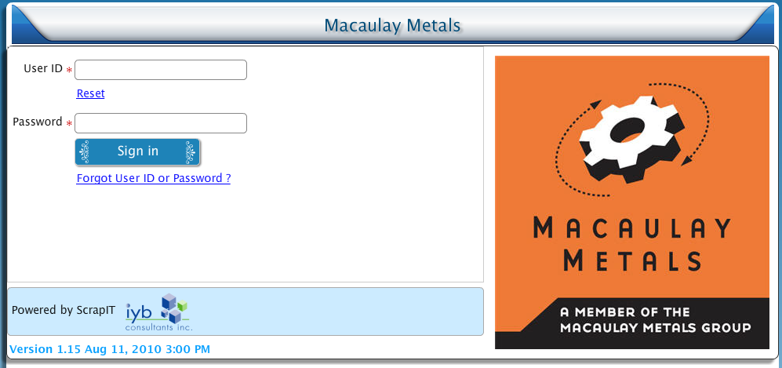

Easy access
- Log in to Web Portal from any computer, anywhere to check your order status, or print invoice history. If you're remote or on your home computer, you can still access Web Portal in your web browser.
- Never lose data, even if your computer crashes or is lost or damaged. All your work is hosted and safely backed up on Web Portal secure servers instead of on your computer.
- Enter your existing [User ID] and password, and then click Sign In

Forgot Web Portal User ID or Password
If you have forgotten your user id or password, but you are a registered subscriber, please enter your registered e-mail address in the text box and click the submit button.
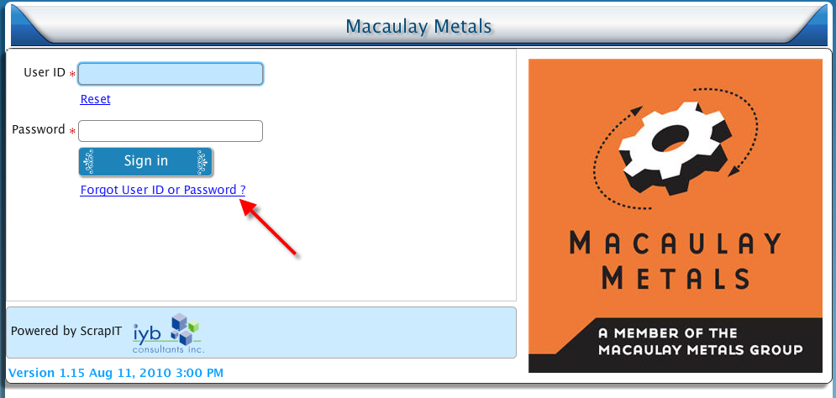

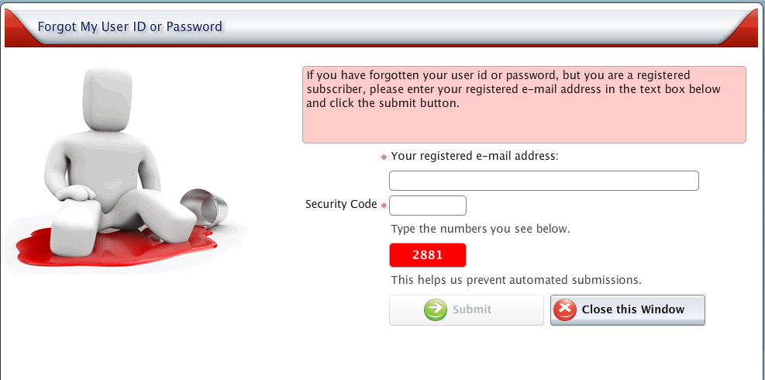

Step 3: Main Page
Once logged in, the first page you will access is your portal page.
Depends on your web user type, you will see either “Supplier Portal Page” or “Customer Portal Page” or both.

Supplier Portal Page
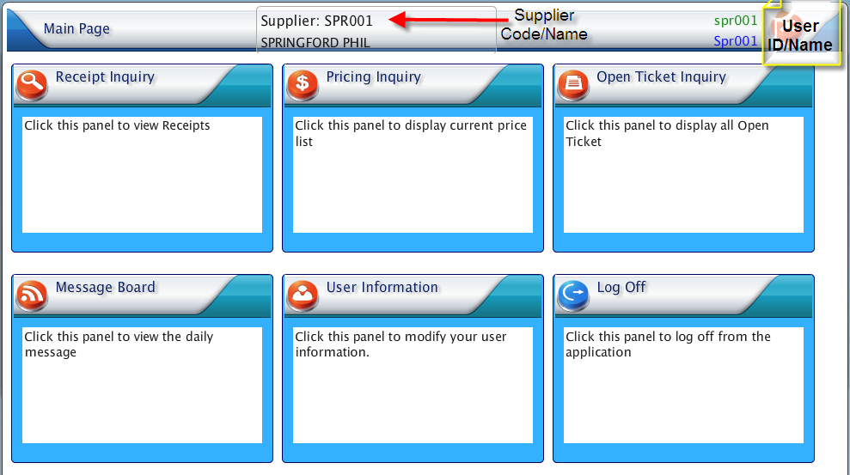
Customer Portal Page
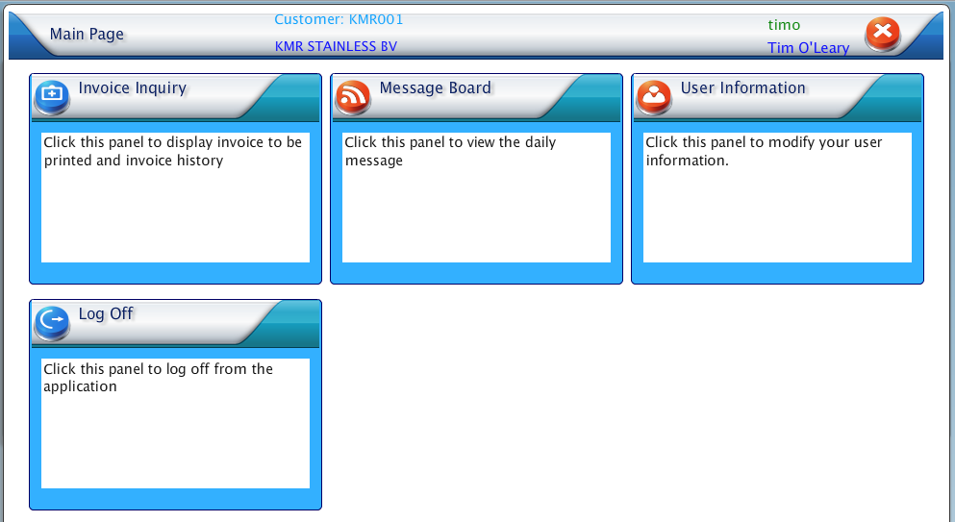

Change User Information
- Click the user information panel from your portal page
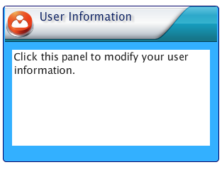
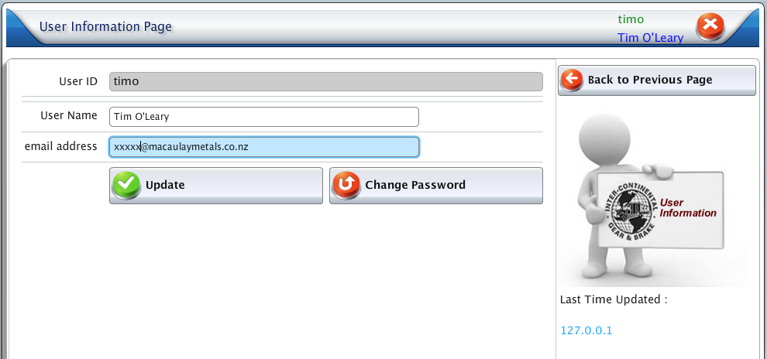

Note: Make sure to click “Update” Button to save the changes that you made.

Message Board
- Click the Message Board panel from your portal page to read the news that posted by Macaulay Metals

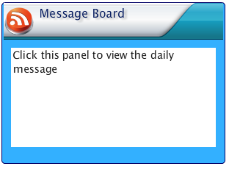
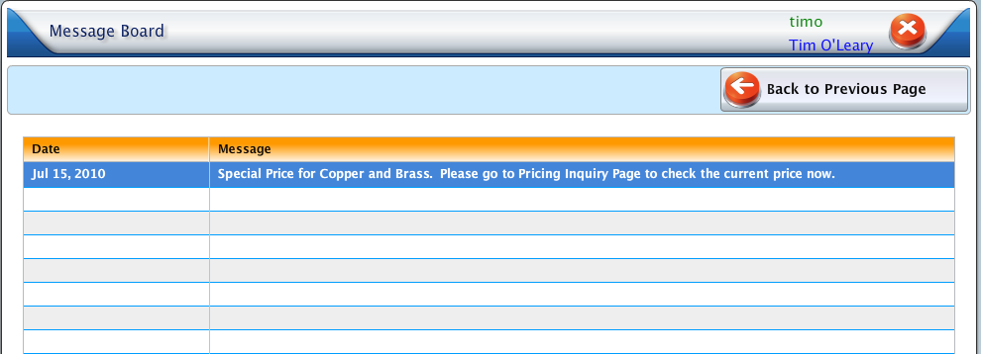

Step 4: Print Information to PDF or View Information in your browser
How to Print/View
- Click the icon under View PDF column
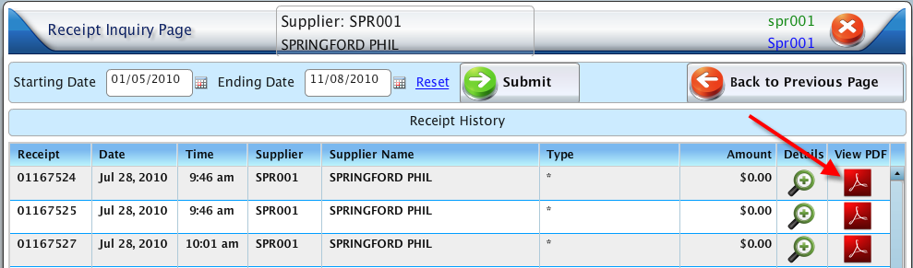
- Download the file or view it in your browser
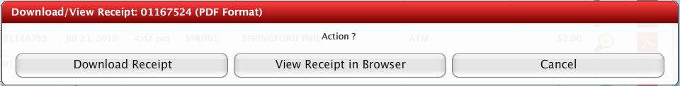
Download – you can give any name that you would like and file will be saved on your personal PC
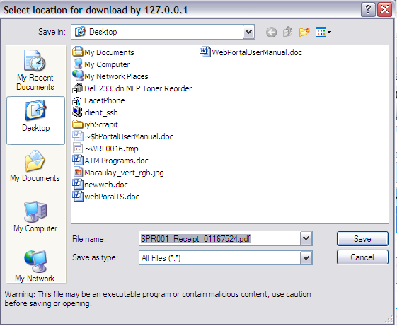
View in Browser
