Sensor Signal Reading Guide
Every live signal in the iMotions Lab 11.1 Sensor Preview, and how to read it
Martin's Family Clothing Consumer Behavior Research Laboratory, Jacksonville State University
Prepared October 12, 2026 for lab volunteers and MKT 488 students. Signal names read on the lab computer (iMotions Lab 11.1.47136.14). Definitions from the iMotions help center articles and manuals the lab holds. Updated the same evening with the lab's first Sensor Data export, which settled every Shimmer unit.

How to use this guide
The Sensor Preview is the operator's live view of every sensor. Open it with the Sensor Preview button beside Start Recording in the main iMotions window. The Signals menu on the left lists each sensor, its groups of signals, and a count such as 0/7 that says how many signals in that group are shown as charts. Click a signal's name to show or hide its chart.
On the lab computer the menu lists 72 signals in four sensors: EyeTracker (Smart Eye Aurora), Affectiva AFFDEX, External Events API, and the Shimmer unit Shimmer3-8956. This guide explains each one: what it shows, its units, what a good reading and a problem reading look like, and where the definition comes from. When the manuals do not say something, the guide says so rather than guessing.

Five rules for reading any signal
- A gap is missing data, not a zero. AFFDEX gives data only "for each frame of video where a face is detected," and the eye tracker reports nothing while the eyes are lost. A stretch with no line, or a straight line bridging a stretch, means no measurement.
- The live view is a check, not the result. "AFFDEX renders at 15 Hz during live collection and must be post-processed up to 30 Hz." Results come from post processing, notebooks, and exports, never from the preview.
- Read the axis before the line. The Signals menu lets you change "the color, filling, and range of the graphs," and on the lab computer each chart's axis scaled itself to the data, so a tiny change can fill the chart. With the Shimmer electrodes off, the skin chart looked busy, but its axis spanned only 0.014 to 0.015 microsiemens.
- Know each signal's scale. AFFDEX expressions run 0 to 100 as probabilities; Valence runs -100 to 100; head angles are in degrees; Interocular Distance is in pixels; skin conductance is in microsiemens; heart rate is in beats per minute.
- Read the last word of a Shimmer name. CAL means calibrated into physical units; RAW means the unit's own uncalibrated numbers (the export gives their unit as "Index," a count with no unit); ALG means Algorithm: the manuals never define it, but the export labels the two values calculated from the pulse wave with the data format "Algorithm."

Not in the manuals
The manuals do not explain everything. Missing are the units of the eye tracker signals, a few facial measures (including Yawn and Pain), the pulse wave, and the time between beats, plus what ALG means. This guide and the workshops say so wherever this matters, rather than guessing.
A short test recording would fill most of those gaps, because iMotions can write its own description and unit for every channel into the Sensor Data export (see How to confirm a unit the manuals do not give).
Update, October 12, 2026: for the Shimmer, it did. The lab's first Sensor Data export, from a Shimmer-only pilot, began with a #METADATA block giving iMotions' own description, unit, and data format for every column. It settled the pulse wave (millivolts), the time between beats (milliseconds), ALG (the data format "Algorithm": calculated, not measured), and every other Shimmer unit; the Shimmer table below now says "export" where a unit comes from that block. The eye tracker and facial gaps remain until the same export is run with the Aurora and the webcam.

Signal by signal

1. EyeTracker (Smart Eye Aurora)
Two groups: Pupil & Distance and Behavioral. Where the person looks (gaze) is not in this list; the gaze point is drawn on the stimulus in replay. The Aurora was not connected when the list was read, so no live values were observed, and no manual describes the Aurora's own signal list.
Signal | What it shows | Units | How to read it
Pupil | The size (diameter) of the pupil | Not stated in the manuals for the Aurora. The generic eye tracking import format uses "Pupil diameter size in millimeters." | Should break during blinks, when "the pupils are fully covered by the eyelid." Pupil changes "can be an indication of cognitive workload." Whether the signal is the left eye, the right eye, or an average is not stated.
Distance | How far the eyes are from the eye tracker | Not stated in the manuals for the live signal. The widget shows centimeters; the I-VT filter's Interpolated Distance is in millimeters. | Aim for about 60 cm: "The respondent's head is approximately 60 cm from the screen." The fixation filter "uses the distance between eyes and screen as it was recorded by the eye tracker."
Pitch, Yaw, Roll | From the names, most likely the head's angles as the eye tracker sees them | Not stated in the manuals | No manual describes these channels. They are not the AFFDEX head angles, which come from the webcam. Check direction on your own head before relying on them.

2. Affectiva AFFDEX: Behavioral
These four come from face detection and landmark positions, not from any expression. Use them to judge the seat and the camera.
Signal | What it shows | Units | How to read it
Pitch | The head tilted up or down | Degrees | The thresholding notebook labels Pitch above 0 as Up and below -20 as Down. AFFDEX works best within "5-10 degrees up/down."
Yaw | The head turned right or left | Degrees | Above +10 is Right and below -10 is Left. AFFDEX 5.1 and newer tolerate about 40 degrees left or right. Whose right (viewer or camera) is not stated; test it on your own face.
Roll | The head tilted toward a shoulder | Degrees | Below -10 is a right tilt; above +10 a left tilt. "Head tilt rotations are generally accommodated with face processing."
Interocular Distance | The distance between the two outer eye corners in the video, so how close the face is | Pixels | Larger means closer. The notebook treats more than 100 px as Forward; AFFDEX 5.1 tracks faces down to "at least 40px interocular distance." The separate Facebox width "should be at least 100px."
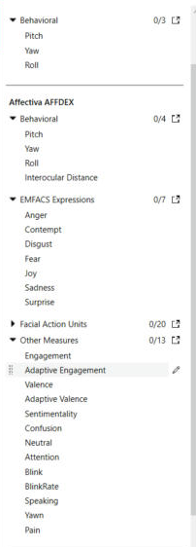
The AFFDEX lists in the Signals menu on the lab computer (Facial Action Units collapsed). Screen capture, iMotions Lab 11.1.47136.14, October 12, 2026.

3. Affectiva AFFDEX: EMFACS Expressions
The seven emotions, each "calculated from Facial Expression scores that correspond with each emotion," following Ekman and Friesen's EMFACS. Scores run 0 to 100: "50=50% probability it was expressed," and a high probability and the intensity of the expression "are not the same." The manuals define each emotion by the action units that raise or lower it. The manual's table says Outer Brow Raise and Lip Stretcher; the lab computer's names for what are most likely the same movements are Brow Raise and Lip Stretch.
Signal | Rises with | Falls with
Anger | Brow Furrow, Eye Widen, Lid Tighten, Upper Lip Raise, Chin Raise, Lip Press, Mouth Open | Inner Brow Raise, Brow Raise, Nose Wrinkle, Smile
Contempt | Brow Furrow, Smirk | Brow Raise, Smile
Disgust | Nose Wrinkle, Upper Lip Raise, Chin Raise, Mouth Open | Inner Brow Raise, Smile
Fear | Inner Brow Raise, Brow Raise, Brow Furrow, Eye Widen, Lip Stretch, Mouth Open | Nose Wrinkle, Smile
Joy | Cheek Raise, Smile | None listed
Sadness | Inner Brow Raise, Brow Furrow, Cheek Raise, Lip Corner Depressor, Chin Raise | Brow Raise, Nose Wrinkle, Smile
Surprise | Inner Brow Raise, Brow Raise, Eye Widen, Jaw Drop | None listed

4. Affectiva AFFDEX: Facial Action Units
Twenty movements of the face "as defined by the Facial Action Coding System," each scored 0 to 100 in every frame with a face (default threshold 50). Definitions are the captions printed in the AFFDEX articles. An action unit is a movement, not a feeling: talking and chewing move the same muscles.
Signal | The movement
Brow Furrow | Both eyebrows moved lower and closer together. It "can indicate concentration, confusion or dislike."
Brow Raise | Both eyebrows moved upward. It "spontaneously occurs during surprise."
Cheek Raise | The cheeks lifted, often with crow's feet wrinkles at the eye corners
Chin Raise | The chin boss and the lower lip pushed upward
Dimpler | The lip corners tightened and pulled inward
Eye Closure | Both eyelids closed; the blink notebook reads it as "the likelihood of the eyes being closed on a scale from 0 to 100"
Eye Widen | The upper lid raised enough to show the entire iris
Inner Brow Raise | The inner corners of the eyebrows raised
Jaw Drop | The jaw pulled downward
Lip Corner Depressor | The lip corners dropped downward, a frown; "often associated with sadness"
Lip Press | The lips pressed together without pushing up the chin boss
Lip Pucker | The lips pushed forward
Lip Stretch | The lips pulled back sideways
Lip Suck | The lips and the skin next to them pulled into the mouth
Lid Tighten | The eye opening narrowed and the eyelids tightened
Mouth Open | The lower lip dropped downward
Nose Wrinkle | Wrinkles along the sides and across the root of the nose as the skin is pulled upward
Smile | The lip corners pulled outward and upward toward the ears, combined with other signs around the face; "normally a sign of enjoyment"
Smirk | One lip corner, left or right, pulled upward and outward
Upper Lip Raise | The upper lip moved upward

5. Affectiva AFFDEX: Other Measures
Summary scores built from the action units, and signals that describe the face's state. The manuals explain some and not others; the table says which. Yawn and Pain appear only in the iMotions 11.1.12 release notes.
Signal | What it shows | Scale
Engagement | How expressive the face is, positive or negative: "a measure of facial muscle activation," a weighted sum of action units (11 in the AFFDEX 5.2 article). Not visual attention and not arousal. | 0 to 100
Adaptive Engagement | Engagement adjusted for "speech-related facial movements"; standard Engagement applies when no speech is detected | Not stated in the manuals
Valence | Whether the expression is positive or negative. Smile and Cheek Raise push it up; Inner Brow Raise, Brow Furrow, Nose Wrinkle, Lip Corner Depressor, Chin Raise, and Lip Press push it down. Default thresholds +50 and -50. | -100 to 100
Adaptive Valence | Valence adjusted for speech-related movements | Not stated in the manuals
Sentimentality | "Happy sadness," a bittersweet face "often seen when watching emotionally resonant material" | 0 to 100
Confusion | A brow and face pattern suggesting "mental workload" and "a lack of comprehension"; not part of EMFACS | 0 to 100
Neutral | Listed in the software; no manual defines it | Not stated in the manuals
Attention | Focus judged from the head: "Measure of focus based on the head orientation." Says nothing about where the eyes look. | 0 to 100
Blink | A blink, detected "when the eye closure score gets above and then below a certain threshold" | Not stated in the manuals
BlinkRate | "The number of blinks happening per minute" | Blinks per minute
Speaking | Face movements that go with talking, read from the face (the manual calls it Speech) | 0 to 100 on the manual's chart
Yawn | Yawning; named only in the iMotions 11.1.12 release notes | Not stated in the manuals
Pain | Expressed pain (from the wording, most likely a face that looks pained, not pain the person reports); named only in the same release note | Not stated in the manuals

6. External Events API: System Load Monitor
How hard the computer is working while iMotions collects data. "iMotions monitors the CPU and Memory load once a second (1 Hz)," and "Too high data loads (typically above 80%) can impact your data collection and synchronization of sensors." The switch is Global Settings > API > "Record System load"; keep it checked. The four channel names are not described in the manuals; the meanings below are read from the names. In the export the columns are named CPU Sys, Memory Sys, CPU Proc, and Memory Proc, with no unit or description, about one row per second.
Signal | What it shows (from the name) | Units
CPU System % | Processor load of the whole computer | Percent
Memory System % | Memory load of the whole computer | Percent
CPU iMotions % | Processor load from iMotions alone | Percent
Memory iMotions Mb | Memory used by iMotions | Mb (megabytes or megabits not stated)

7. Shimmer3 GSR+ (Shimmer3-8956)
Four groups, 19 signals. For a live check, show GSR Conductance CAL, Internal ADC A13 PPG CAL, and Heart Rate PPG ALG, and read the widget: on the lab computer GSR Quality read High with the electrodes on and Low with them off (the manuals do not describe this indicator). Lab values are from the lab director, seated, on October 12, 2026. "Export" in the Units column means the unit comes from the #METADATA block of the lab's pilot Sensor Data export of the same day.
Signal | What it shows | Units | How to read it
GSR Conductance CAL | How easily a tiny current passes between the finger electrodes; rises as sweat glands become active (arousal, not whether a feeling is positive or negative) | Microsiemens (µS); export: Micro Siemens | Good: slow and smooth, with rises a few seconds after an event (lab: 2.6 to 3.5 at rest in the Sensor Preview, 1.6 to 2.4 in the pilot recording). Problem: sharp spikes (movement), slow drift (held breath), or near 0 (electrodes off; lab: about 0.014). Signal quality notebook: SNR above 20 dB "seems sufficient"; a negative SNR means poor quality.
GSR Resistance CAL | The same skin signal as resistance; the graphs "are mirror images of one another" | Kilo-ohms (kOhm); export: Kilo Ohm | kOhm = 1,000 / µS exactly (true on every row of the pilot export), so 3 µS is about 333 kOhm. Analysis "is conventionally done on µSiemen values."
Internal ADC A13 PPG CAL | The pulse wave from the ear clip or finger probe: one wave per heartbeat | Millivolts (mV), export | Good: "clear peaks," one per beat (lab: about 1,300 to 1,700). Problem: pinned at top or bottom (lab, moving: about 2,800 or 0), or fuzz with no beats (lab, probe off: about 1,390 to 1,400).
Heart Rate PPG ALG | Heart rate calculated continuously from the pulse wave | Beats per minute; export: Beats pr. minute (sic) | Good: steady, stepping a few beats (lab: 82 to 91). Problem: 0, or jumps to 150 to 200, which mean the pulse was lost. In an export, -1 means no value (about 2 seconds of the pilot); remove every -1 and 0 before averaging.
IBI PPG ALG | Inter-beat interval: time between two beats | Milliseconds (ms), export | The export writes a value only on the row where a beat is detected and -1 on every other row. Average only the positive values; heart rate = 60,000 / mean IBI (pilot baseline: 753 ms, 79.7 beats per minute, matching the Heart Rate column).
Wide Range Accelerometer X, Y, Z CAL | Acceleration of the unit along three axes | m/s²; export: Meters pr second squared (sic) | Gravity is included (about 9.8 m/s²), so a still unit does not read 0 (pilot, hand still: about 10.35 m/s² combined, almost all on Z); look for changes. Used to flag movement that spoils GSR; the movement notebook's default threshold is 0.2 m/s² after filtering.
Timestamp RAW, Timestamp CAL, System Timestamp CAL | Clock channels. Export descriptions: Timestamp RAW and CAL are the Shimmer's clock "for when data was sampled"; System Timestamp CAL is the computer's clock "when sample arrived at computer." | RAW: Index (no unit); CAL: milliseconds; export | Align data with the export's Timestamp column instead: "Elapsed time since the recording started (in milliseconds)."
Wide Range Accelerometer X, Y, Z RAW | Uncalibrated numbers behind the accelerometer CAL signals | Index (no unit), export | Troubleshooting only.
VSenseBatt RAW, VSenseBatt CAL | The battery | RAW: Index (no unit); CAL: millivolts; export | Charge before every session; a low-battery threshold is not stated (pilot: about 4,010 to 4,050 mV).
Internal ADC A13 PPG RAW | Uncalibrated numbers behind the pulse wave | Index (no unit), export | Troubleshooting only.
GSR RAW | The uncalibrated skin reading | Index (no unit), export | The calibration article describes "a 12-bit number," but the pilot values (about 34,000 to 53,000) are larger than 12 bits can hold, so GSR RAW carries more than that reading. Use the CAL signals.
Packet reception rate RAW | Export description: "Percentage of received data packets (lower than 100 means packets where dropped)" (sic) | Index, export (a percentage) | Pilot: 99 on every row. The Shimmer streams over Bluetooth, which "is more susceptible to data loss."
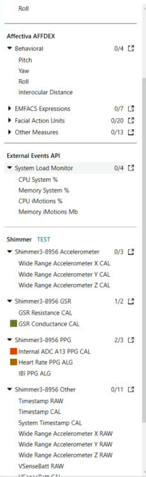
The Shimmer and System Load Monitor lists in the Signals menu on the lab computer. Screen capture, October 12, 2026.

What the three states look like on the lab computer
- Ready to record: GSR Conductance CAL drifted slowly from about 2.83 to 2.57 µS; the pulse wave showed one sharp peak per beat between about 1,300 and 1,700; heart rate stepped between 82 and 91; the widget read Collecting, Connection High, GSR Quality High.
- Moving: the pulse wave jumped to its top limit (about 2,800) or to 0 and stayed there, and heart rate read 0 except one brief value near 86.
- Electrodes and probe off: GSR Conductance CAL flickered around 0.014 µS on an axis stretched from 0.014 to 0.015; the pulse wave was fuzz between about 1,389 and 1,399 with no beats; heart rate read mostly 0 with false jumps to 150 to 200; the widget read GSR Quality Low while still Collecting.
- Face found and lost: AFFDEX Yaw and Pitch streamed while the lab director faced the webcam, then ran straight across a span, most likely a stretch with no face found.
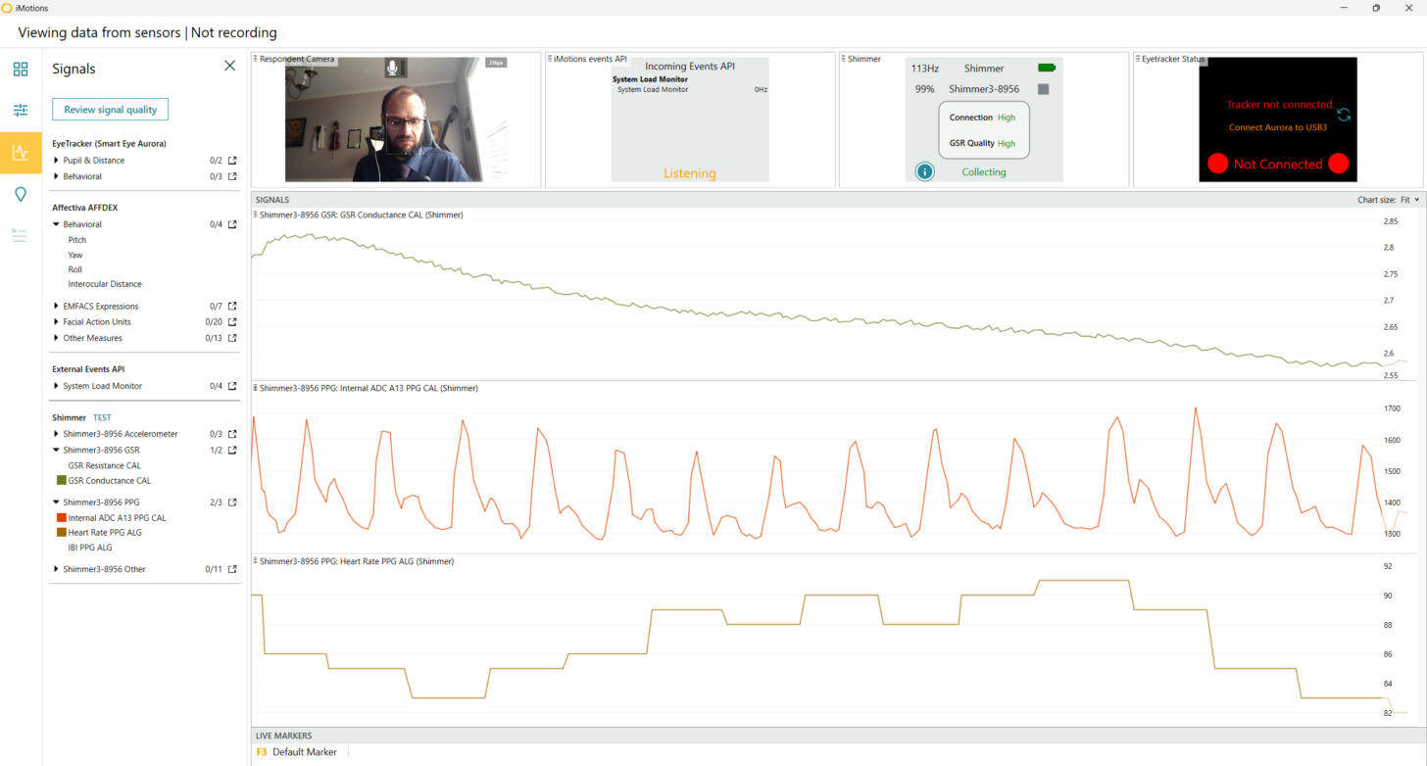
Ready to record: skin conductance changing slowly, one clear pulse peak per beat, and a steady heart rate. The lab director agreed to show his face. Screen capture, October 12, 2026.
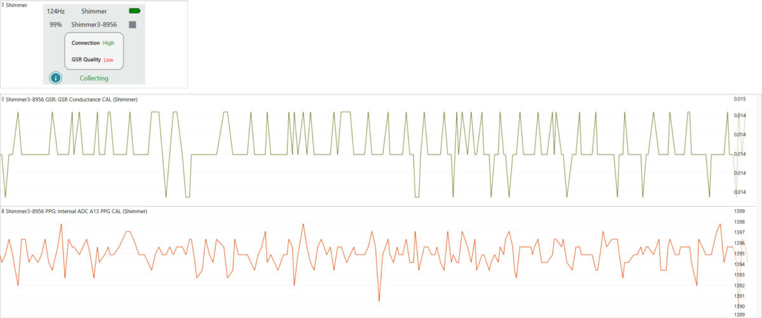
Electrodes and probe off: GSR Quality Low, a skin chart stretched from 0.014 to 0.015 µS, and a pulse chart with no beats. Nothing here is data. Screen capture, October 12, 2026.

Reading the Sensor Data export: what the pilot file taught
On October 12, 2026 the lab exported its Shimmer-only pilot (one seated respondent, 105 seconds: a 60 s baseline, a 30 s e.l.f. commercial, and a 15 s recovery). Reading that file settled the Shimmer units and showed what to check in every export.
- The file: one .csv per respondent (the pilot's was 001_PILOT01.csv). It opens with three blocks. #INFO names the study and the respondent, gives the respondent's age, gender, and group, the iMotions version, the recording and export times, and one '#Sensor info' row per device and notebook. #METADATA gives eleven rows about each column: Device, Provided By, Category, Description, Unit, Short unit, Instance, Group, Display name, Data format, and Channel identifier. Then come the data rows.
- Privacy: because #INFO names the respondent and gives age and gender, every export is identifiable participant data. Store it with the study data, never in a public folder or on GitHub.
- One row is one sample from one device. The other devices' columns are empty on that row, so first keep only the rows where that device's EventSource column reads 1 (the export describes it as "Can be used to filter data from" that device). The pilot had 13,426 Shimmer rows (about 128 per second), 100 System Load rows (about one per second), and 12 slide event rows.
- The settings are in the header. The '#Sensor info' row for GSR Peak Detection lists every value the flow used: phasic_length=8000, lowpass_filter_frequency=5, gap_length_threshold=4000, remove_signal_jumps=false, peak_onset_threshold=0.01, peak_offset_threshold=0, peak_amplitude_threshold=0.005, minimum_peak_duration=500, smoothing_filter=median. Copy them into the methods section from here.
- Codes are not values. Heart Rate PPG ALG read -1 for about 2 seconds (48 to 50 s into the recording); IBI PPG ALG reads -1 on every row except the one where a beat is detected. Remove them before any average; leaving them in pulled the pilot baseline heart rate from 79.6 to 77.1 beats per minute.
- Artifacts look like data. At about 19.5 s skin conductance fell from about 1.8 to as low as 0.2 µS and came back about one second later, while the accelerometer showed no movement. A published quality rule treats skin conductance outside 0.05 to 60 µS, or changing faster than 10 µS per second, as invalid, together with 5 seconds on either side (Kleckner et al., 2018). Here one step fell 0.64 µS within a single sample, about 80 µS per second, so the stretch is an artifact, and the one peak inside it, counted the moment the signal returned, is set aside. No other pilot peak was flagged. Its cause cannot be told from the data; a brief change in electrode contact is one possibility. Name such a rule in the plan before the real study.
- Description only: 8 peaks in the 60 s baseline (7 after the artifact rule), 4 in the 30 s commercial, and 2 in the 15 s recovery, 8.0 per minute in each; mean heart rate 79.6, 80.4, and 79.9 beats per minute. With one respondent these numbers test nothing.
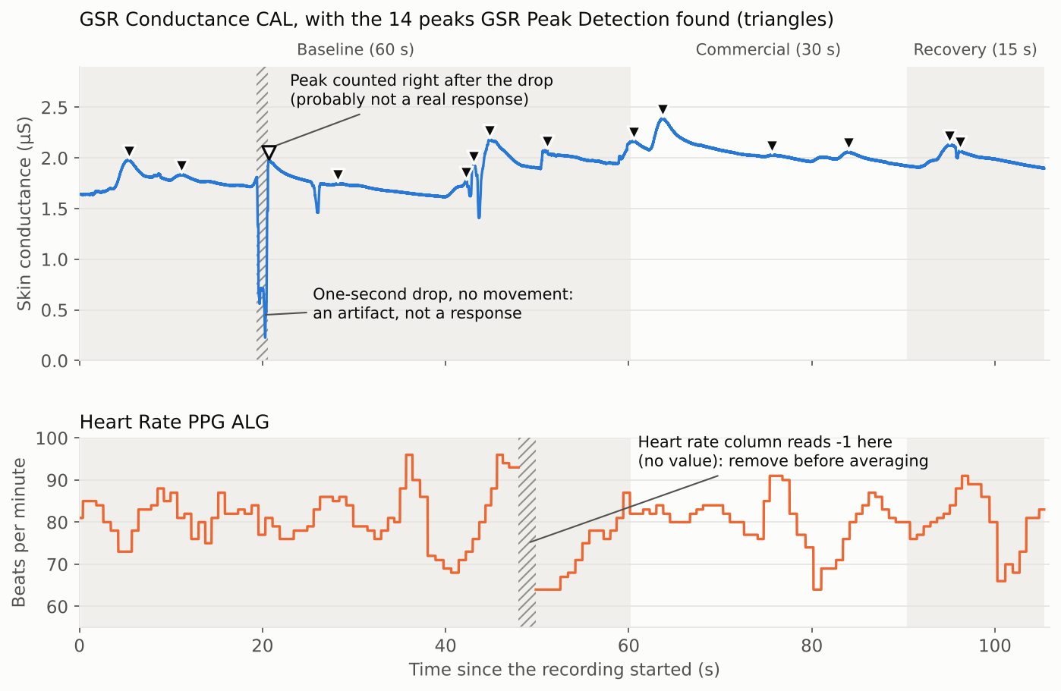
The pilot export drawn as charts: skin conductance with the 14 peaks GSR Peak Detection found (top) and heart rate (bottom). Hatched bands mark the one-second artifact and the stretch where heart rate reads -1; the hollow triangle is the peak that probably came from the artifact. Chart drawn by the lab from its pilot Sensor Data export, iMotions Lab 11.1.47136.14, October 12, 2026.

How to confirm a unit the manuals do not give
Many units above are not in the manuals. iMotions can state them itself in the Sensor Data export:
Record a short pilot (never use a lab study), then export Sensor Data. On the Sensors page, turn on 'show signal descriptions' ("brief descriptions of the data channels are shown below the names of the data channels"). The export article says to tick 'Channel metadata' on the File info page so that the #METADATA section gives "a short description of the data, the unit, etc." for every column. On the lab computer in 11.1 that option was not there, and the block was written anyway. Copy its Description, Unit, and Data format rows into this guide. Done for the Shimmer on October 12, 2026; still to do for the Aurora, AFFDEX, and the Enobio.

Items to verify on the lab computer
- Aurora: the units of Pupil and Distance, whether Pupil is one eye or an average, and the meaning and sign of Pitch, Yaw, and Roll (pilot with the Aurora connected and a respondent at about 60 cm).
- AFFDEX: the ranges of Neutral, Adaptive Engagement, Adaptive Valence, Speaking, Yawn, and Pain, and whether Blink is a 0 or 1 event or a 0 to 100 score; whose right a positive Yaw is.
- Shimmer: units settled by the export. Still open: what GSR Quality and the percentage under the Hz figure in the widget measure; what the vendor means by a heart rate of -1; and what the high bits of GSR RAW encode (Shimmer GSR+ User Guide).
- Peak results: export the GSR Metrics files (Export, then R PROCESSING, then GSR Metrics Export) and record their columns, and find where GSR Signal Quality writes its signal-to-noise ratio and percent missing; neither was in the Sensor Data file.
- System Load Monitor: whether System means the whole computer and iMotions the iMotions program, and whether Mb is megabytes.
- The AFFDEX version running in iMotions 11.1 (the manuals describe SDK 5.1 and 5.2).

Where the manuals disagree
- The AFFDEX 0 to 100 score is worded four ways across the manuals (confidence, probability that a trained coder would rate it present, probability it was expressed, how sure the algorithm is). Teach it as a probability, not a strength.
- The imotions.com module page swaps yaw and pitch ("yaw (up/down), pitch (left/right)"); the help center notebook pairs Pitch with up and down and Yaw with right and left. Follow the help center.
- Heart rate variability from PPG: older articles say HRV comes from ECG, "not with optical PPG data"; the iMotions 11.0.4 release notes added "Shimmer PPG" to the HR and HRV notebook. The release note is newer.
- Eye distance appears in centimeters in the generic import format and the widget, and in millimeters in the I-VT filter output.
- Peak Amplitude: the export's own description row says it is the rise of the phasic signal, but the Peak Detection and R Processed GSR export articles define it as the rise of the calibrated (GSR Interpolated) signal, and in all 14 pilot peaks the exported number matches the articles. Follow the articles.
- 'Channel metadata': the export article tells users to tick this option; on the lab computer in 11.1 it was not offered, but the #METADATA block was written by default.

Sources
iMotions A/S help center articles (help.imotions.com, reached signed in through my.imotions.com) and the matching manual PDFs held in the lab folder, used with permission for the Jacksonville State University lab course. Signal names and lab values: screen captures of the lab computer and the lab's pilot Sensor Data export (#METADATA rows and data), October 12, 2026. The export file is identifiable participant data and is not published.
- Export: Sensor Data. https://help.imotions.com/lab/exports/export-sensor-data
- Export: R Processed GSR Files. https://help.imotions.com/lab/exports/r-processed-exports/export-r-processed-gsr-files
- Sensor Preview Window. https://help.imotions.com/lab/data-collection/sensor-preview-window
- Collecting Data. https://help.imotions.com/lab/data-collection/collecting-data
- Importing Generic Screen-Based Eye Tracking into iMotions. https://help.imotions.com/lab/import-and-post-processing/importing-generic-screen-based-eye-tracking-into-imotions
- R-Notebook: Eye tracking-based blink detection. https://help.imotions.com/lab/analysis/eye-tracking/other-eye-tracking-analysis/r-notebook-eye-tracking-based-blink-detection
- Fixation and saccade classification with the I-VT filter. https://help.imotions.com/lab/analysis/eye-tracking/fixation-classifiers/fixation-and-saccade-classification-with-the-i-vt-filter
- Planning for Eye Tracker Calibration. https://help.imotions.com/lab/sensor-setup/screen-based-eye-trackers/planning-for-eye-tracker-calibration
- Affectiva (AFFDEX) Signals Overview. https://help.imotions.com/lab/analysis/facial-expression-analysis/affdex/affectiva-affdex-signals-overview
- Introduction to AFFDEX SDK 5.1 (manual PDF held by the lab).
- Enabling Affectiva AFFDEX in iMotions. https://help.imotions.com/lab/sensor-setup/facial-expression-analysis/enabling-affectiva-affdex-in-imotions
- Introduction to: Facial Expression Analysis. https://help.imotions.com/lab/getting-started/multimodal-data-overview/introduction-to-facial-expression-analysis
- R Notebook (FEA): Facial expression analysis thresholding and aggregation. https://help.imotions.com/lab/analysis/facial-expression-analysis/r-notebook-fea-facial-expression-analysis-thresholding-and-aggregation
- R-Notebook: Facial expression analysis-based blink detection. https://help.imotions.com/lab/analysis/facial-expression-analysis/affdex/r-notebook-facial-expression-analysis-based-blink-detection
- iMotions 11 release notes. https://help.imotions.com/lab/release-notes-and-downloads/imotions-11
- System Load Monitor and computer demands. https://help.imotions.com/lab/data-collection/system-load-monitor-and-computer-demands
- Timestamping and synchronization method. https://help.imotions.com/lab/getting-started/multimodal-data-overview/timestamping-and-synchronization-method
- Introduction to: EDA/GSR. https://help.imotions.com/lab/getting-started/multimodal-data-overview/introduction-to-eda-gsr
- Shimmer 3 GSR+: Device Connection and Configuration in iMotions. https://help.imotions.com/lab/sensor-setup/shimmer/shimmer-3-gsr-device-connection-and-configuration-in-imotions
- Shimmer 3 GSR+: Sensor Placement and Respondent Instructions. https://help.imotions.com/lab/sensor-setup/shimmer/shimmer-3-gsr-sensor-placement-and-respondent-instructions
- Shimmer 3 ECG: Sensor Placement and Respondent Instructions. https://help.imotions.com/lab/sensor-setup/shimmer/shimmer-3-ecg-sensor-placement-and-respondent-instructions
- GSR sensor output value internal calibration. https://help.imotions.com/lab/sensor-setup/shimmer/gsr-sensor-output-value-internal-calibration
- GSR R-Notebooks: GSR Signal Quality. https://help.imotions.com/lab/analysis/eda-gsr/gsr-r-notebooks-gsr-signal-quality
- GSR R-Notebooks: Peak Detection and Aggregation. https://help.imotions.com/lab/analysis/eda-gsr/gsr-r-notebooks-peak-detection-and-aggregation
- R Notebook Epoching. https://help.imotions.com/lab/analysis/signal-processing-r-notebooks/r-notebook-epoching
- R Notebook: Accelerometer Movement Detection. https://help.imotions.com/lab/analysis/biosensor-analysis/r-notebook-accelerometer-movement-detection
- PPG, BVP, and Optical Heart Rate. https://help.imotions.com/lab/sensor-setup/shimmer/ppg-bvp-and-optical-heart-rate
- Export: R Processed ECG Files. https://help.imotions.com/lab/exports/r-processed-exports/export-r-processed-ecg-files
- R Notebooks: ECG Heart rate and HRV Processing. https://help.imotions.com/lab/analysis/biosensor-analysis/r-notebooks-ecg-heart-rate-and-hrv-processing
- Kleckner, I. R., Jones, R. M., Wilder-Smith, O., Wormwood, J. B., Akcakaya, M., Quigley, K. S., Lord, C., & Goodwin, M. S. (2018). Simple, transparent, and flexible automated quality assessment procedures for ambulatory electrodermal activity data. IEEE Transactions on Biomedical Engineering, 65(7), 1460-1467. https://doi.org/10.1109/TBME.2017.2758643

