**Bazz Fuss**

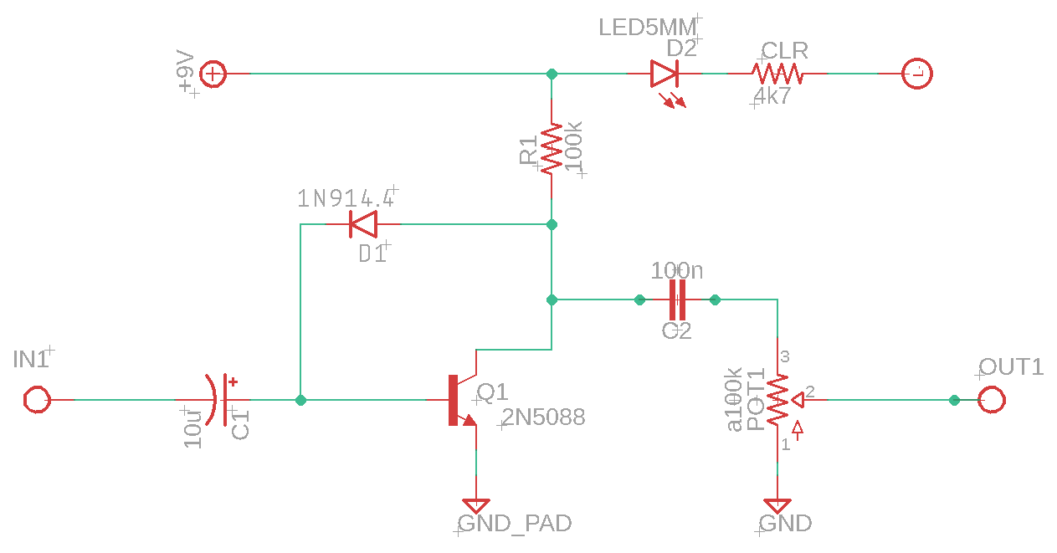

Documentation compiled by Mark Sescon

**Source**

[Bazz Fuss fun (home-wrecker.com)](http://home-wrecker.com/bazz.html)

**Parts**

| **BUDGET CONSCIOUS VERSION OF THE BILL OF MATERIALS** | | | | | |
| --- | --- | --- | --- | --- | --- |
| Part | Position | Cost | Qty. | Link | Notes |
| PCB | PCB | $2 for 5 boards | 1 | www.jlcpcb.com | Price is for five circuit boards. Note that shipping can be up to $10-15. |
| $11.95 for 3 boards | 1 | https://oshpark.com/shared_projects/UevAYGQK | Free shipping. |
| A100K potentiometer | POT1 | $0.39/each | 1 | [TAYDA 100K OHM Logarithmic Taper Potentiometer PCB Mount Round Shaft Dia: 6.35mm (taydaelectronics.com)](https://www.taydaelectronics.com/tayda-100k-ohm-logarithmic-taper-potentiometer-round-shaft-pc-mount.html) | Also known as a logarithmic potentiometer. You will want the PCB-mounted variety in the correct size. |
| 10uF radial electrolytic capacitor | C1 | $0.02/each | 1 | [10uF 50V 105C Radial Electrolytic Capacitor 5x11mm (taydaelectronics.com)](https://www.taydaelectronics.com/10uf-50v-105c-radial-electrolytic-capacitor-5x11mm.html) |  |
| 100n film capacitor | C2 | $0.10/each | 1 | [100nF 0.1uF 100V 5% Polyester Film Box Type Capacitor (taydaelectronics.com)](https://www.taydaelectronics.com/0-1uf-100v-5-polyester-film-box-type-capacitor.html) |  |
| 100k ohm ¼ watt resistor | R1 | $0.012 for 10 | 1 | [100K OHM 1/4W 1% Metal Film Resistor Royal OHM Top Quality (taydaelectronics.com)](https://www.taydaelectronics.com/10-x-resistor-100k-ohm-1-4w-1-metal-film-pkg-of-10.html) |  |
| 4.7k ohm ¼ watt resistor | R2 | $0.012 for 10 | 1 | [4.7K OHM 1/4W 1% Metal Film Resistor (taydaelectronics.com)](https://www.taydaelectronics.com/10-x-resistor-4-7k-ohm-1-4w-1-metal-film-pkg-of-10.html) | This is a “current limiting resistor” and affects the brightness of the LED. |
| 1n914 diode | D1 | $0.03 | 1 | [1N914 Small Signal Diode 200mA 100V (taydaelectronics.com)](https://www.taydaelectronics.com/1n914-small-signal-diode-200ma-100v.html) |  |
| LED (5mm) | D2 | $0.03 | 1 | [LED 5mm Red](https://www.taydaelectronics.com/led-5mm-red.html) | Any color will do. |
| LED Bezel |  | $0.04 | 1 | [5mm LED holder](https://www.taydaelectronics.com/5mm-bezel-led-holder-plastic.html) | Helps hold LED in place. |
| 1590b enclosure |  | $4.59/each | 1 | [1590B Style Aluminum Diecast Enclosure (taydaelectronics.com)](https://www.taydaelectronics.com/1590b-style-aluminum-diecast-enclosure.html) |  |
| knob |  | $0.48/each | 1 | [Aluminum Knob 37mm guitar (taydaelectronics.com)](https://www.taydaelectronics.com/hardware/knobs/39133-dup-aluminum-knob.html) | Ensure that the knob matches the potentiometer shaft size. |
| ¼ inch audio jacks |  | $0.87 | 2 | [6.35mm 1/4" Mono Chassis Socket / Jack (taydaelectronics.com)](https://www.taydaelectronics.com/hardware/6-35mm-1-4-plugs-jacks/6-35mm-1-4-mono-chassis-socket-jack.html) |  |
| DC jack |  | $0.28 | 1 | [DC Power Jack 2.1mm Panel Mount Round Bulkhead (taydaelectronics.com)](https://www.taydaelectronics.com/dc-power-jack-2-1mm-round-type-panel-mount-1.html) |  |
| 9v battery snap |  | $0.10 | 1 | [9V 9-Volt Battery Clip / Connector Snap (taydaelectronics.com)](https://www.taydaelectronics.com/9v-9-volt-battery-clip-connector.html) | PLEASE READ: If you want to exclusively use external power, please choose “DC jack.” If you want to use battery power, select “9v battery snap” *and* “DC jack (switch).” |
| DC jack (switch) |  | $0.13 | 1 | [DC Power Jack 2.1mm Enclosed Frame With Switch (taydaelectronics.com)](https://www.taydaelectronics.com/dc-power-jack-2-1mm-enclosed-frame-with-switch.html) |
| 22 awg wire |  | $0.09/foot | 2-3 feet | [AWG 22 Black Hook-Up Wire 1FT (30cm) Stranded (taydaelectronics.com)](https://www.taydaelectronics.com/awg-22-black-hook-up-wire-1ft-30cm-stranded.html) |  |
| 3pdt foot switch |  | $2.39 | 1 | [3PDT Stomp Foot / Pedal Switch (taydaelectronics.com)](https://www.taydaelectronics.com/3pdt-stomp-foot-pedal-switch.html) |  |

| **ALTERNATIVE VERSION OF THE BILL OF MATERIALS** | | | | | |
| --- | --- | --- | --- | --- | --- |
| Part | Position | Cost | Qty. | Link | Notes |
| PCB | PCB | $2 for 5 boards | 1 | www.jlcpcb.com | Price is for five circuit boards. Note that shipping can be up to $10-15. |
| $4.95 for 3 boards | 1 | https://oshpark.com/shared_projects/UevAYGQK | Free shipping. |
| A100K potentiometer | POT1 | $0.63 | 1 | https://lovemyswitches.com/16mm-potentiometers-1-4-smooth-shaft-right-angle-pcb-mount/ | Also known as a logarithmic potentiometer. You will want the PCB-mounted variety in the correct size. |
| 10uF radial electrolytic capacitor | C1 | $2.00 for 10 | 1 | [Aluminum Electrolytic Capacitor - General Purpose - Bag of 10 (stompboxparts.com)](https://stompboxparts.com/capacitors/aluminum-electrolytic-capacitor-general-purpose-bag-of-10/) | 10uf - 16v |
| 100n film capacitor | C2 | $2.00 for 10 | 1 | [Box Film Capacitors - Bag of 10 (stompboxparts.com)](https://stompboxparts.com/capacitors/box-film-capacitors-bag-of-10/) |  |
| 100k ohm ¼ watt resistor | R1 | $1.00 for 10 | 1 | [1/4w Metal Film Resistor - Bag of 10 (stompboxparts.com)](https://stompboxparts.com/resistors/1-4w-metal-film-resistor-bag-of-10/) |  |
| 4.7k ohm ¼ watt resistor | R2 | $1.00 for 10 | 1 | [1/4w Metal Film Resistor - Bag of 10 (stompboxparts.com)](https://stompboxparts.com/resistors/1-4w-metal-film-resistor-bag-of-10/) | This is a “current limiting resistor” and affects the brightness of the LED. |
| 1n914 diode | D1 | $1.00 for 10 | 1 | [1N914 - Small Signal Diode - 10 pack (stompboxparts.com)](https://stompboxparts.com/semiconductors/1n914-small-signal-diode/) |  |
| LED (5mm) | D2 | $1.25 for 10 | 1 | [5mm LED - Diffused - Pack of 10](https://stompboxparts.com/leds-bezels/5mm-led-diffused/) | Any color will do. |
| LED Bezel |  | $0.20 | 1 | [5mm LED Bezel - Black Plastic](https://stompboxparts.com/leds-bezels/5mm-led-bezel-black-plastic/) | Helps hold LED in place. |
| 1590b enclosure |  | $4.99 | 1 | https://lovemyswitches.com/1590b-enclosure-bare-aluminum-powder-coat/ |  |
| ¼ inch audio jacks |  | $0.99 | 2 | https://lovemyswitches.com/1-4-mono-jack-open-frame/ |  |
| DC jack |  | $1.25 each | 1 | https://lovemyswitches.com/thinline-lumberg-dc-power-jack-2-1mm/ | Lumberg. |
| 9v battery snap |  | $0.45 each | 1 | https://lovemyswitches.com/9v-battery-snap-hard-shell-side-wire/ | PLEASE READ: If you want to exclusively use external power, please choose “DC jack.” If you want to use battery power, select “9v battery snap” *and* “DC jack (switch).”  For the “DC jack (switch)” you can choose any color. |
| DC jack (switch) |  | $0.75 each | 1 | https://lovemyswitches.com/switched-2-1mm-dc-power-jack-white/ |
| 22 awg wire |  | $8 for 100 feet | 2-3 feet | n/a |  |
| 3pdt foot switch |  | $2.54 each | 1 | https://lovemyswitches.com/3pdt-latched-foot-switch-solder-lugs-red/ |  |

**Wiring Diagram**

