SPS – CW2

I have been tasked with creating a classifier that will correctly identify graffiti style symbols based on their key features. I was given 30 symbols
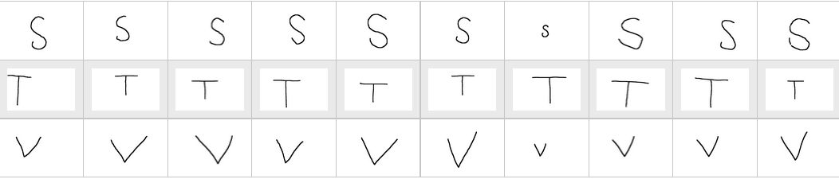Image 1: The 30 symbols provided for the coursework, the first 10 representing the letter "S" next 10 representing "T" and final 10 "V"
In order to classify the features I would apply a fast Fourier transform to the image. A Fourier transform provides a way of representing a signal in a different space, in this case in the frequency domain. Why use fft and what is it?
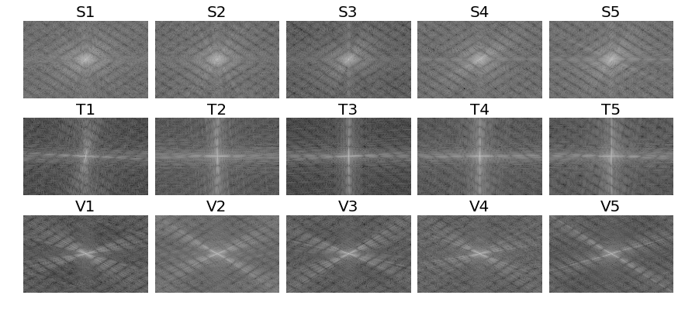Image 2: – The images produced after a fast Fourier transform is applied to the images. The first 5 examples of each letter are shown.

Image 3 – Three graphical representations of t
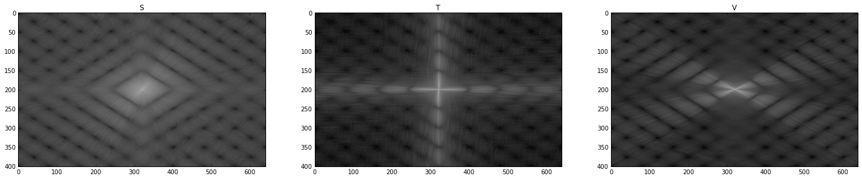Image 3: The images produced after combining all 10 training fft image's into one

approach to analysis in the Fourier domain
My approach to analysing the Fourier domain was to look at the images generated when applying at fft to each, and find regions that differed the most between the three letters. To get a better view of each letter I summed the magnitudes at each point in all 10 training images, this merged the 10 images into one.
When looking at the combined images it was clear that certain areas were very different to the others; The T image has a light cross originating at (u=0,v=0), the V image has a light X shape originating at (u=0,v=0). Unlike T and V, S does not have a clear light area and is more uniform in shade then the other two, this may make S more tricky to initially detect than the other two.
Since the regions that change the most between the images are the light regions I decided to filter the images so that only certain areas would “get through”. The light areas of the image had the highest magnitude The when applying the ffted images to each filter my features will be produced. .

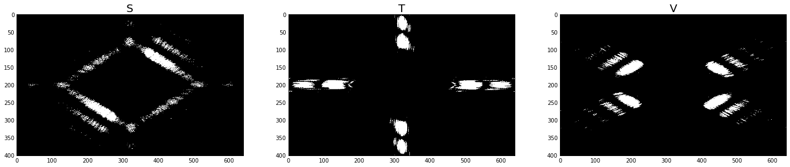

magnitude spectrum as it can be moved around
Explain converting to frequency spectrum made up of a phase and magnitude, T has a vertical line and a horizontal line leading to
iteratign through the matrix finding max magnitudes.

