**RULE-BASED EXPERT SYSTEM: FARMING GUIDE FOR SWINE RAISING WITH SWINE DISEASE IDENTIFIER USING FORWARD CHAINING METHOD**

A Capstone Project

presented to the Faculty of the College of Computer Studies,

Misamis University, Ozamiz City

In Partial Fulfillment

of the Requirements for the degree of

Bachelor of Science in Information Technology

Biscilou Angel R. Ohuman

Efer B. Ponsaran

Anthony S. Quiniñeza

March 2022

APPROVAL SHEET

This Capstone Project entitled “Rule-Based Expert System: Farming Guide for Swine Raising with Disease Identifier using Forward Chaining Method," developed by Biscilou Angel R. Ohuman, Efer B. Ponsaran, and Anthony S. Quinineza in partial fulfillment for the degree of Bachelor of Science in Information Technology has been examined and is recommended for acceptance and approval.

**JERRY LUMASAG, ENGR**

Adviser

Approved by the committee on oral examination with a grade of \_\_\_\_\_\_\_\_\_\_\_\_\_\_\_\_\_\_\_\_\_

Date \_\_\_\_\_\_\_\_\_\_\_\_\_\_\_\_

**ROSECLAREMATH A. CARORO, DIT**

Chairman

**HIDEAR B. TALIRONGAN, DIT FLORENCE JEAN B. TALIRONGAN, DIT**

Member Member

This Capstone Project is accepted in partial fulfillment of the requirement for the degree of Bachelor of Science in Information Technology.

**ROSECLAREMATH A. CARORO, DIT**

Dean, College of Computer Studies

ABSTRACT

Expert system is a branch of artificial intelligence that is really helpful in simulating and imitating the dynamic capacity of a human expert’s knowledge and experience in a particular field. This study focuses on the utilization of the forward chaining method of the rule-based algorithm to identify the common swine diseases that a farmer may encounter during the process of raising swine. Hence, when a swine disease is found, the system outputs the result and shows the disease's definition, course of treatment, and methods for prevention. The swine diseases included in the study are Intestinal Parasite, Pneumonia, Swine Dysentery, E-Coli, and Swine Fever. Additionally, the system also offers a manual that provides a step-by-step guide to help farmers raise swine from birth to commercialization. As knowledge engineers, we interviewed an expert that has an expertise when it comes to swine. The data obtained from the expert are utilized to create rules that are kept in the system's knowledge base and are also used as the content of the manual. Hence, the system could perform outputs perfectly regarding the identified disease and symptoms. The system was later evaluated by a number of 50 people including swine farmers and IT professionals to test the accuracy and the reliability of the rule based-expert system. Through the evaluation, it was revealed that the forward chaining method mechanism for identifying swine disease was practical, precise, and dependable, making the information of the mobile application reliable.

ACKNOWLEDGEMENT

First and foremost, we want to thank our almighty God for giving us strength and guiding us to finish this tough journey.

We want to thank our adviser Engr. Jerry Lumasag, for the guidance and advice he has given us and for acknowledging and correcting our mistakes to improve our study further. Furthermore, we are very grateful to have our instructor Dr. Florence Jean Talirongan, teach us the methodology to be carried out in our research. She taught us the proper guidelines for writing our papers, checked the progress of our studies, and motivated us always to work. Finally, we are expressing our utmost gratitude to our panel members Dr. Roseclaire Caroro, Dr. Florence Jean Talirongan, Dr. Hidear Talingrongan, for allowing us to carry out the research and broad knowledge guidelines throughout our study.

We are extending our gratitude to the expert Mr. Arnold Ladjamatli who volunteered to share his knowledge about swine raising that enlightened and helped us develop our system.

And finally, we are tremendously grateful to the family of Mr. and Mrs. Ponsaran, Ohuman, and Quinineza for their never-ending support throughout this challenging journey.

DEDICATION

This study is wholeheartedly dedicated to our beloved parents, who have been our source of inspiration and gave us strength when we thought of giving up, who continually provide their moral, spiritual, emotional, and financial support.

To our classmates, mentors, and friends who shared their words of advice and encouragement to finish this study.

And lastly, we dedicated this study to our Almighty God, thank you for the guidance strength, power of mind, skills and for giving us a healthy life. All of these, we offer to you

TABLE OF CONTENTS

**Page**

APPROVAL SHEET ii

ABSTRACT iii

ACKNOWLEDGEMENT iv

DEDICATION v

TABLE OF CONTENTS vi

LIST OF TABLES ix

LIST OF FIGURES x

1 INTRODUCTION 1

1.1 Background of the Study 1

1.2 Statement of the Problem 3

1.3 Statement of Objectives 3

1.3.1 General Objective 3

1.3.2 Specific Objective 3

1.4 Significance of the Study 4

1.5 Scope and Limitation 4

2 REVIEW OF RELATED LITERATURE 5

2.1 Rule-based Expert System 5

2.1.1 Rule-based algorithm 6

2.1.2 Forward chaining 6

2.1.3 Inference Engine 7

2.2 Swine Farming 7

2.2.1 Swine Diseases 8

2.2.2 Swine Diseases Treatment 8

3 METHODOLOGY 10

3.1 System Architecture 10

3.2 System Development Model 11

3.2.1 Planning and Requirement Phase 11

3.2.2 Analysis and Design 11

3.2.2.1 Knowledge tree 12

3.2.2.2 Predicates 15

3.2.2.3 Rules 16

3.2.3 Implementation Phase 18

3.2.4 Testing 18

3.2.5 Maintenance 18

3.3 System Evaluation 18

4 PROJECT IMPLEMENTATION AND DISCUSSIONS 20

4.1 Manual and Additional Information. 20

20

4.2 Disease Identifier Feature 21

4.3 Disease Identifier Feature Result 22

4.4 Auto-saving Feature 23

4.4.1 Viewing the Details of the Identified Disease 24

4.4.2 Deletion of the Identified Disease 25

4.5 System Evaluation Results 26

5 CONCLUSIONS AND RECOMMENDATIONS 29

5.1 Conclusion 29

5.2 Recommendations 29

REFERENCES 31

APPENDICES 34

Ozamiz City 39

COLLEGE OF COMPUTER STUDIES 39

CURRICULUM VITAE 40

LIST OF TABLES

Table 3.2.2.1 Legend On Expert For Swine Raising Disease, Signs And Symptoms 13

Table 3.3.1 Functionality Interpretation. 18

Table 3.3.2 Reliability Interpretation. 19

Table 3.3.4 Usability Interpretation 19

Table 4.5.1 Functionality Assessment Of The System 26

Table 4.5.2 Reliability Assessment Of The System 27

Table 4.5.3 Usability Assessment Of The System 27

LIST OF FIGURES

Figure 3.1 Architectural Design Of Rule-Based Expert System 10

Figure 3.2.2 Schematic Diagram Of The Rule Base Expert System Using Forward Chaining Method 12

Figure 3.2.2.1 Knowledge Tree 14

Figure 4.1 Viewing The Manual And Additional Information. 20

Figure 4.2 Disease Identifier Yes Or No Questions 21

Figure 4.3 Disease Identifier Result 22

Figure 4.4 Functionality Of The Auto-Saving Feature 23

Figure 4.4.1 Viewing The Details Of The Identified Disease 24

Figure 4.4.2 Deletion Of The Identified Disease 25

# 1 INTRODUCTION

## 1.1 Background of the Study

The expert system imitates the dynamic capacity of a human expert, which intends to tackle complex problems by thinking about credible information. Expert Systems (ES) are a significant part of artificial intelligence (AI). They are utilized to oversee different issues in the establishments by using human knowledge in different fields for analysis and consultation. These expert systems can be applied in all sectors of knowledge. An expert system is a computer program that controls facts, information, and logic to tackle issues productively and viably in a limited problem spot that regularly requires an expensive source of knowledge and human specialist. These systems utilize demonstrative reasoning and heuristic general guidelines to discover solutions like human specialists. The expert system can be divided into four categories based on its operating principle, The Rule-Based Expert System, Frame-Based Expert System, Fuzzy Logic-Based Expert System, and Expert System Based on Neural Network (Mohammed et al., 2019; Tan, 2017).

Expert system applications are popular in accounting, financial services, manufacturing, and medicine. They normally offer more assets to information technology since they have a prominent expected payback. Not surprisingly, the industry idlers were producing real estate and legal services. It was surprising that the transportation industry was also on the low end of the industrial applications. This long-term analysis of applications by industry also shows that the medical industry has taken over as the most popular in the industry for expert systems by far in the last ten years. And interest from the other industries has dropped significantly. An expert system in agriculture can provide the growers with dynamic information related to their actual situations, taking into consideration different specialties and different sources of information, reducing the update time of information in situations where it is centralized and accessible from different locations, and transferring real experience that is not documented in any form of media by gathering it from various experts extension workers and experienced growers (Dubey et al., 2013; Wagner, 2017).

China, which held the first spot in the agricultural producing country globally, has a study for implementing an expert system about milch cow disease diagnosis. It is a tricky part for the stockbreeding producing business because the disease was ordinarily caused by numerous conditions that are hard to detect and contains nutritional and environmental issues, micro-organism conditions, and a wrong method for milking, so they adopt the three algorithms for their interference which are the CBR (Case-Based Reasoning), Subjective Bayesian Theory, and D-S evidential theory or Dempster–Shafer theory. In the USA, they conducted a study to implement an expert system to determine the issues affecting black pepper growth. They have developed this expert system to help agrarian architects and farmers diagnose numerous black pepper diseases and propose proper treatment. They utilized a Rule-based algorithm consisting of two parts: the rule set and a dictionary. Ruleset specifies expert knowledge in a kind that can be considered as a rule of cause-and-effect sentences.

Moreover, rules can likewise convey uncertain information. Dictionary characterizes the metadata for all the information variables, like the type, domain, and name. In the Philippines, they present an expert system application as a diagnostic tool which gives farmers' information and knowledge on distinguishing problems in rice crops for effective rice production management because, it was indicated by the International Rice Research Institute (IRRI), farmers here in the Philippines lose an expected average of 37% of their rice yield to pest and diseases annually. In the USA, they also used a rule-based algorithm to characterize rice diseases. However, it was derived from a decision tree. This decision tree is created from the studies and interviews with experts in the area, then the decision tree will produce rules and was executed based on the production rules (IF-THEN) (Barhoom et al., 2000; Morco et al., 2017; Rong & Li, 2008).

The expert system comprises four main components: the knowledge base, working memory, inference engine, and user interface. The Knowledge base is the heart of an expert system that contains a collection of facts and rules which describe all the knowledge about the problem domain. Therefore, it stores all relevant information, data, rules, cases, and relationships the expert system uses. The working memory is comparable to a relational database system. It contains information that is provided by the end-user. This information is used to evaluate antecedents in the knowledge base. The inference engine's purpose is to look for information and relationships from the knowledge base and give answers, predictions, and suggestions in the manner a human expert would. The user interface manipulates the inputs between the user and the system. In this study, we will use Forward Chaining as our main method. The forward chaining method allows the inference engine to start reasoning or tracking data from facts that lead to a conclusion. In this methodology, tracking starts from input information and then concludes. This search procedure with known facts matches these with the IF part of the IF-Then rule. If facts match the IF section, then the rule is executed. A new fact (part THEN) is added to the database if a rule is executed. Each time matching starts from the top rule. Each rule is just bole executed once. The matching process stops when no more rules can be carried out (Abu-Nasser & Abu-Naser, 2018; Gusman & Hendri, 2019).

Without this technology, numerous people who don't have experience or expertise are forced to make decisions with incomplete information. Expert Systems (ES) will assist people in considering all of the relevant information and assimilating this information into an understandable format. Expert Systems (ES) will help people make environmentally sound and economically feasible farm management decisions (Robinson, 1996).

## 1.2 Statement of the Problem

In agriculture, raising swine is common livestock. However, in most cases, some beginners in raising swine may encounter problems like severe life-threatening diseases that lead to the swine's mortality. Improper raising of the swine may cause a big loss of income if the swine is in an unhealthy state that may lead to sickness or worst.

## 1.3 Statement of Objectives

### 1.3.1 General Objective

The study's main objective is to develop an android application that will indetify common swine disease as well as feature that includes step by step procedure in raising swine, piloting the areas within Ozamiz City, Misamis Occidental in the Department of Agriculture.

### 1.3.2 Specific Objective

Specifically, the study aims to:

1. Provide a manual to assist swine farmers in nurturing swine from birth to commercialization.
2. Identify the swine disease based on the pig farmer's observation regarding raising swine.
3. Provides conclusion and treatment to avoid or prevent the identified disease.
4. The system will perform an auto-saving feature to save the identified disease to be viewed again by the user.
5. Evaluate the system’s functionality, usability and reliability.

## 1.4 Significance of the Study

This study is beneficial in agriculture when it comes to swine raising. It will help farmers determine swine diseases from birth to commercialization more effectively and timely. It also guides farmers in nurturing swines from birth to commercialization.

## 1.5 Scope and Limitation

This study is an Expert System that can recognize swine illnesses as well as help swine farmers in developing or raising swine from birth to commercialization. Piglets to develop swine appropriate for commercialization are among the sorts of swine being obliged by the system. Digestive parasites, pneumonia, swine diarrhea, e-coli, and swine fever are the five kinds of normal swine illnesses that the system can distinguish. Diarrhea, live worms expelled in the feces, loss of appetite, bloody diarrhea, weight loss, slow growth, trembling, fever, reddening of eyes, and vomiting are the signs and symptoms that will be used as a basis for identifying a disease. Data is collected from local experts with specific swine farming experience. Forward chaining is used as a mechanism to identify swine disease based on the signs and symptoms that farmers observe in swine. Once the illness is identified, the mobile application provides conclusions and treatments for treating the identified illness.

The system is limited only in identifying common swine diseases occurs during the cultivating process. Other types of swine such as sows and boars are excluded. Besides, serious swine sicknesses and infections that require laboratory test are additionally barred.

# 2 REVIEW OF RELATED LITERATURE

## 2.1 Rule-based Expert System

Rule-based expert systems (RBES ) are Artificial Intelligence systems that emulate expert human reasoning processes over a set of rules and knowledge from a specific domain (Nicora et al., 2019). The structure of the expert system is usually composed of three parts, including production rule, database, and control strategy. Production rule is a "conditional + result" structure of the statement. The criterion "if a species is a dinosaur," for example, yields the answer "then the species is a reptile." Suppose the statement's condition is satisfied. The database stores the conditions and results in the production rule statement. When the production rule is executed, the database is queried for the corresponding condition, and the rule result is stored in the database as a condition for other rules. The control strategy explains how to apply the rules to solve the problem to select the appropriate rules. When a problem has numerous conditions, picking rules and conducting operations normally involves searching the database for matching conditions and then identifying the rules for the related conditions. Also, when many conditions are met, you must sort the strategy to determine which rule to apply first. The rule's operation (result) component is executed after selecting the rule. The operation of the control strategy is usually performed in a module ("inference engine"). The inference engine's inference process can be classified into forward and backward. (Tan, 2017).

According to Han Liu and his colleagues (2016), RBES can be designed in two ways: expert-based design and data-based design. The expert-based design follows traditional engineering approaches, whereas data-based design follows machine learning approaches (Liu et al., 2016). The expert-based design uses knowledge from the expert and implements it as a set of rules, and it is faster to implement than the data-based design, which requires a large quantity of data for an AI to train. It takes a great amount of time for an AI to be trained enough. In the study of David A. Sanders and his colleague on "A Rule-Based Expert System to Decide on Direction and Speed of a Powered Wheelchair," rule-based expert systems proved to be safe and robust. They were also efficient and simple to use in every field of study, but the only limitation is that the rules have been hard-coded, so they cannot continue to learn, but mixing the system with AI tools can tackle this with limitations (Sanders et al., 2019). There is one existing rule-based expert system here in the Philippines, and this is the study of Roselia C. Morco and its colleague on "e-RICE: An Expert System using Rule-Based Algorithm to Detect, Diagnose, and Prescribe Control Options for Rice Plant Diseases in the Philippines" studies about implementations of the expert system using rule-based algorithm to identify problems in rice plants and provide actionable advice to detect and diagnose rice plants diseases and prescribe possible control options (Morco et al., 2017). While their study is only to identify problems in rice plants, this system identifies problems, guidelines, and tips in three different targets (like pigs, corns, and bananas) for farming which can broaden the knowledge and expertise of the system compared to the existing one.

### 2.1.1 Rule-based algorithm

Rule Base Algorithm is designed to have an artificial intelligence strategy or machine learning that distinguishes, learns, or advances 'rules' to store, control, or apply. According to Cairns(2017), the rule-based algorithm is applied to any problem requiring classifying data and improving data analysis (Cairns et al., 2017). For example, the Rule Base Algorithm can improve an algorithm that helps classify and provides better decision rules since the algorithm handles most classifications systematically in improving the development effectiveness of a genetic algorithm(Xiong et al., 2017).In most cases, different types of the rule-based algorithm are used in different problems or scenarios, such as the fuzzy rule base, which is commonly used in classifications and generating methods. The effectiveness of a rule base algorithm is based on how you construct the algorithm with methods to develop the certainty of the algorithm(Elkano et al., 2018; Son, 2016; Woo et al., 2017)

### 2.1.2 Forward chaining

The forward Chaining method is a procedure for searching or tracking techniques ahead which starts with the current information and combines rules to produce a conclusion or goal. Forward Chaining is a search technique that starts with the known facts then matches these facts with the IF part of the rules IF\_THEN. It considers facts and rules and sorts them before concluding with a solution. Every time a rule is tested, the method will check whether conditions are true or false. Search techniques of the forward chaining method start from the facts that match with the premise in the IF part of IF-THEN rules. If the premise is to fit the facts, the rule is executed. There are three basic steps of the forward chaining method. (1.) Determine if a rule is applicable, the premises or conditions of all rules are matched/satisfied against the content from the rule base. All of the applicable rules will form a conflict set. The search is considered complete if no rule is added to the conflict set. If there are rules in conflict set, the system will select the rule to be executed. (2.) Choose one or more rules from the conflict set for execution. (3.) Activate the conclusion from the selected rule in the conflict set, then execute. Several approaches, such as first-come, first-served, priority values, and meta-rules, can choose the rule of conflict set in the second phase. Each rule is assigned a priority value, and if the conflict set contains more than one rule that matches the facts, the rules with the highest priority value are chosen for execution. The percentage value of a rule is calculated based on the number of symptoms that are fulfilled/selected by the user divided (÷) by the number of facts(symptoms) of the rules.(Gusman & Hendri, 2019; Hayadi et al., 2017; Nurlaeli & Subiyanto, 2017; Prambudi et al., 2018).

### 2.1.3 Inference Engine

The inference engine, commonly associated with the forward chaining method, determines which rules are activated and satisfied by facts or information of the system's input objects. The inference engine (forward Chaining) is a mechanism for selecting rules to be fired. It is based on a pattern-matching algorithm. The primary goal is to associate facts (input data) with applicable rules from the rule base. From the given point of view, forward Chaining is an inference approach employed in Expert Systems to conclude a decision that begins with tracing facts and premises. (Ariawan et al., 2016; Mirmozaffari, 2019; Munaiseche et al., 2018).

## 2.2 Swine Farming

Agriculture is the primary source of income in many developing nations, and greater agricultural production can boost farm revenue and reduce poverty in rural regions. The Philippines' agricultural farms are diverse. They have small groups of farmers who run huge farms. On the contrary, many farmers run small subsistence farms, the vast majority of which still use conventional agricultural practices (Koirala et al., 2016). Agriculture contributes to the Philippine economy and the subsistence of smallholder livelihoods (Chandra et al., 2017). According to Mishra (2017), Agriculture contributes a huge part to the Philippine economy, where almost 20% of the GDP includes farming and agriculture-related enterprises (Mishra et al., 2017).

Raising livestock, particularly native pigs, and producing field crops is an important source of income, particularly in rural areas. Pig raising is a common business enterprise among Filipino farmers' households, and many of them practice it as part of their farming activities (Villanueva & Sulabo, 2018). In the study of Barnes 2020, pork contributes to around 53% of the meat produced and 46% of the meat consumed in the Philippines. The big business in the Philippines produced 27.7 million pigs in 2018, with a total live weight of approximately 2.3 million metric tons. Smallholders raised approximately 63 % of pigs in the Philippines as of mid-2019. These farmers frequently keep pigs to supplement their income, often to cover specific expenses such as school tuition costs. However, the long-term viability of their pig production is dependent on household income, access to financing, and extension services. In addition, it is frequently hampered by high feed costs, which result in suboptimal nutrition, poor animal performance, disease, and marketing difficulties (Barnes et al., 2020)

### 2.2.1 Swine Diseases

As nations, economies, and industries become more interconnected as a result of globalization, disease introduction will continue to be a major threat to the livestock sector and the trade of animals and animal products, as well as farmers' livelihoods, food security, and public health (Beltran-Alcrudo et al., 2019).

In the study of Blomström et al and fellow, Viral infections are a major source of concern in the swine production industry because they cause not only severe disease but also subclinical infections with serious economic consequences. It is becoming clear that a variety of factors, including multiple microorganisms, frequently act synergistically to produce a specific clinical picture. This is especially evident in complex respiratory and enteric diseases (Blomström et al., 2018).

### 2.2.2 Swine Diseases Treatment

In the swine business, antibiotics are commonly used to treat and prevent diseases caused by bacterial infections. Based on their mechanisms of action, they can either kill or hinder the bacteria's growth or reproduction. Antibiotics are so vital instruments for preventing, controlling, and treating illnesses in food animals (Cheng et al., 2020).

In the study of Johnson et al and fellow, Antibiotics are fed to livestock and poultry to treat and prevent disease. Since January 2017, antibiotics deemed important for human medicine have been prohibited as animal growth promoters in the United States under the Veterinary Feed Directive (VFD). Antibiotic use in humans and animals promotes the evolution and spread of antibiotic resistance genes via mobile genetic elements such as phages and plasmids. These antibiotic resistance genes, once incorporated into the genomes of human-pathogenic bacteria, impede disease treatment.(Johnson et al., 2017).

# 3 METHODOLOGY

## 3.1 System Architecture

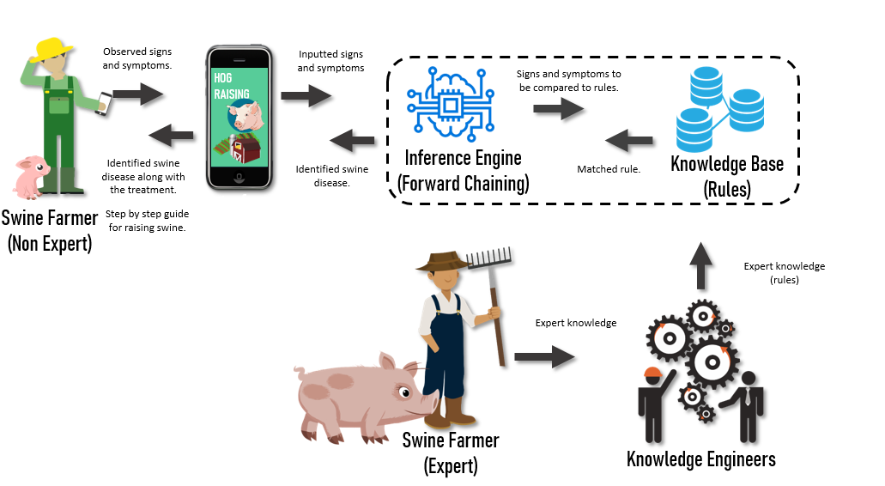The system contains a two features, whereas it provides a step by step guide that focuses on raising swine from birth to commercialization and swine disease indentifier. In the swine disease identifier, the system prompts a series of yes or no questions to the user. Based on the user's answer, the system will determine what disease the swine is experiencing. Suppose all the facts (signs and symptoms) based on the user’s answers match a rule. In that case, that rule will be executed and provide a conclusion along with the treatment and prevention to resolve or avoid the diseases/problem. In knowledge acquisition, this study will be interviewing a person who is an expert when it comes to swine raising. The knowledge gained from the expert will be constructed as a form of rules and will be stored to the knowledge base and also for the creation of the step by step manual for raising swine. Figure 3.1 presents the architectural design of the system.

Figure 3.1 Architectural Design of Rule-Based Expert System

## 3.2 System Development Model

The researchers used the waterfall process as the system development model for the expert system. The waterfall model consists 6 analythical phases which are planning and requirements, analysis and design, implementation, testing and maintenance. This phases will help fully utilize the development of the application. Each phase of the waterfall process must be completed after moving into the next phase, thus making sure that all phases must be defined and analyzed through thorough checking before proceeding.

### 3.2.1 Planning and Requirement Phase

During this phase, the researchers will interview swine farmers who are experts in cultivating swine. First, the researchers gathered important information that needed to be stored in the system's knowledge base and used as a manual on raising swine. The researchers then prepared an interview with the expert farmers. In this way, the researchers can identify the different types of common diseases that a farmer may encounter during the cultivation process.

### 3.2.2 Analysis and Design

As presented, Figure 3.2.2 shows the schematic diagram of the proposed android mobile application. The mobile application identifies the procedure of knowledge acquisition and the user's interaction with the application. The first is knowledge acquisition. The researchers (knowledge engineers) interviewed the experts. The information extracted from them is stored in the system's knowledge base. The non-expert farmer uses the mobile application to answer a series of yes or no questions asking for the symptoms for the system to recognize the swine disease. The android application provides the conclusion, treatment, and prevention to avoid the encountered disease. Also, the user can view the manual of raising swine from birth to commercialization.

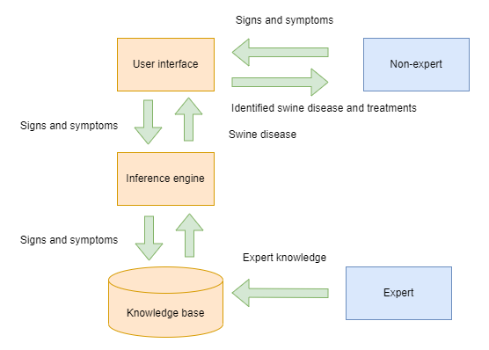

Figure 3.2.2 Schematic Diagram of the Rule Base Expert System using Forward Chaining Method

#### 3.2.2.1 Knowledge tree

The process flow presented in Figure 3.2.4 shows the knowledge tree with five swine diseases which are Intestinal Parasites, Pneumonia, Swine Dysentery, E-Coli, and Swine Fever. The non-expert swine raiser will be asked for the different signs and symptoms. Suppose all signs and symptoms are TRUE and correspond to the diagnosis of one of the five swine diseases. In that case, the patient will be given information about that particular disease, its treatment, and prevention. Legends are provided to fully understand the labels presented, which are presented in Table 3.2.3.

Table 3.2.2.1 Legend on Expert for Swine Raising Disease, Signs and Symptoms

|  |  |
| --- | --- |
| **Diseases** | **Sign and Symptoms** |
| Intestinal Parasite - IP  Pneumonia - PN  Swine Dysentery - SD  E – Coli - EC  Swine Fever - SF | Coughing - CO  Diarrhea - DR  Live Worms Expelled in the Feces - LWF  Loss of Appetite – LA  Bloody Diarrhea - BD  Weight Loss - WL  Slow Growth - SG  Trembling - TR  Fever - FV  Reddening of Eyes - ROE  Vomiting - VOM |

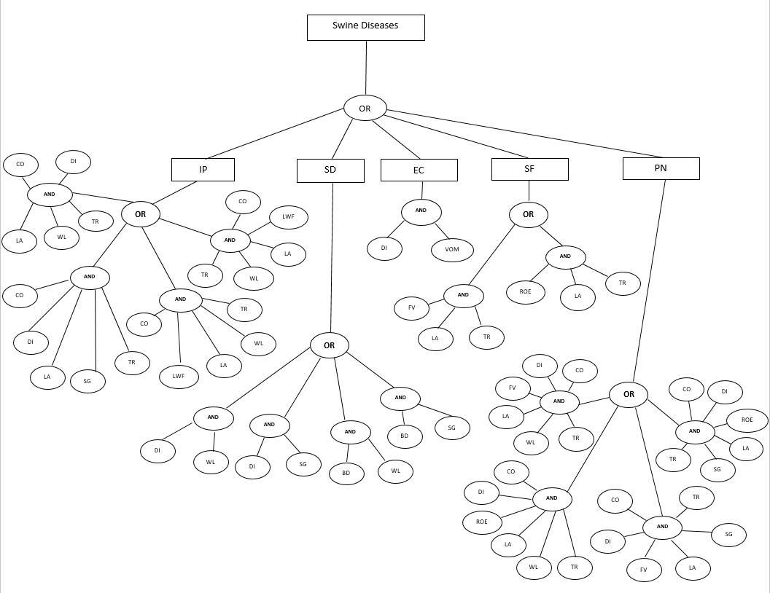

Figure 3.2.2.1 Knowledge Tree

#### 3.2.2.2 Predicates

**Intestinal Parasite**

The swine has a cough

The swine has diarrhea

The swine has a loss of appetite

The swine has weight loss

The swine is trembling

The swine has live worms expelled in the feces

The swine is experiencing slow growth

**Pneumonia**

The swine has a cough

The swine has diarrhea

The swine has a fever

The swine has a loss of appetite

The swine is experiencing weight loss

The swine is trembling

The swine has red eyes

The swine is experiencing slow growth

**Swine Dysentery**

The swine has diarrhea

The swine has weight loss

The swine is experiencing slow growth

The swine has bloody diarrhea

**E-Coli**

The swine has diarrhea

The swine is experiencing vomiting

**Swine Fever**

The swine has a fever

The swine has a loss of appetite

The swine is trembling

The swine has red eyes

#### 3.2.2.3 Rules

**Intestinal Parasites**

**RULE 1**

IP => CO **AND** DI **AND** LA **AND** WL **AND** TR

**RULE 2**

IP =>CO **AND** LW **AND** LA **AND** WL **AND** TR

**RULE 3**

IP =>CO **AND** DI **AND** LA **AND** SG **AND** TR

**RULE 4**

IP =>CO **AND** LW **AND** LA **AND** SG **AND** TR

**Pneumonia**

**RULE 5**

PN=>CO **AND** DI **AND** FV **AND** LA **AND** WL **AND** TR

**RULE 6**

PN=> CO **AND** DI **AND** ROE **AND** LA **AND** WL **AND** TR

**RULE 7**

PN=> CO **AND** DI **AND** FV **AND** LA **AND** SG **AND** TR

**RULE 8**

PN=> CO **AND** DI **AND** ROE **AND** LA **AND** SG **AND** TR

**Swine Dysentery**

**RULE 9**

SD=>DI **AND** WL

**RULE 10**

SD=> DI **AND** SG

**RULE 11**

SD=>BD **AND** WL

**RULE 12**

SD=> BD **AND** SG

**E-Coli**

**RULE 13**

EC=>DI **AND** VOM

**Swine Fever**

**RULE 14**

SF=> FV **AND** LA **AND** TR

**RULE 15**

SF=> ROE A**ND** LA **AND** TR

### 3.2.3 Implementation Phase

Implementation of the system will be created as a mobile-based using Cordova as its mobile application framework. The programming language and database in building the mobile application are JavaScript for creating the inference engine or the back-end, HTML for the frontend, and Web SQL as the database for the auto-saving feature. The android version requirement, the user's Android phone must be at least android version 8.0 and 3GB ram or above to run this android application.

### 3.2.4 Testing

The developed system undergoes a sequence of trial and error to ensure that the algorithm is correct and accurate when inferencing through the rule base. The system was distributed to the local farmers, IT experts, and IT practitioners to undergo a beta test to locate bugs and issues.

### 3.2.5 Maintenance

After the deployment, the researchers will further conduct a knowledge acquisition to further widen the system's knowledge on identifying the diseases concerning raising swine.

### 3.3 System Evaluation

The system evaluation consists of questions that may determine if the system meets the required aspects prior to its objectives. Researchers must first evaluate the system's functionality, reliability, and usability before the official deployment of the system. Veterinarians, local swine farmers, IT practitioners, and IT professionals are the respondents to the evaluation. Functionality refers to the system’s ability to create accurate results and functions. The interpretation of the functionality evaluation is based on the table 3.3.1 below.

Table 3.3.1 Functionality Interpretation.

|  |  |  |  |
| --- | --- | --- | --- |
| **Scale** | **Range** | **Response** | **Interpretation** |
| 5 | 4.24 - 5.00 | Strongly Agree | Very Functional |
| 4 | 3.43 - 4.23 | Agree | Somewhat Functional |
| 3 | 2.62 – 3.42 | Neutral | Functional |
| 2 | 1.81 – 2.61 | Disagree | Less Functio.nal |
| 1 | 1 – 1.80 | Strongly Disagree | Not Functional |

Moreover, the reliability refers to the system's quality being trustworthy or performing consistently well. The interpretation of the assessment is based on the table 3.3.2 below.

Table 3.3.2 Reliability Interpretation.

|  |  |  |  |
| --- | --- | --- | --- |
| **Scale** | **Range** | **Response** | **Interpretation** |
| 5 | 4.24 - 5.00 | Strongly Agree | Very Functional |
| 4 | 3.43 - 4.23 | Agree | Somewhat Functional |
| 3 | 2.62 – 3.42 | Neutral | Functional |
| 2 | 1.81 – 2.61 | Disagree | Less Functio.nal |
| 1 | 1 – 1.80 | Strongly Disagree | Not Functional |

On the other hand, the usability refers to how well the specific user can use the system. The interpretation of the evaluation is based on the table 3.3.4 below.

Table 3.3.4 Usability Interpretation

|  |  |  |  |
| --- | --- | --- | --- |
| **Scale** | **Range** | **Response** | **Interpretation** |
| 5 | 4.24 - 5.00 | Strongly Agree | Very Functional |
| 4 | 3.43 - 4.23 | Agree | Somewhat Functional |
| 3 | 2.62 – 3.42 | Neutral | Functional |
| 2 | 1.81 – 2.61 | Disagree | Less Functio.nal |
| 1 | 1 – 1.80 | Strongly Disagree | Not Functional |

# 4 PROJECT IMPLEMENTATION AND DISCUSSIONS

### 4.1 Manual and Additional Information.

The manual and additional information contains procedure on cultivating swine from birth to commercialization and gives additional helpful information such as things to prepare, tools to be used and food management.

## C:\Users\eferp\Desktop\SS Revise\271717606_443345457463938_4436446723676678942_n.jpgC:\Users\eferp\Desktop\SS Revise\271478549_1668201186905513_3142858870455777783_n.jpgC:\Users\eferp\Desktop\SS Revise\272482356_947028935933076_8785285394865879733_n.jpgC:\Users\eferp\Desktop\SS Revise\272140777_325097946210568_8918205638358942356_n.jpg

Figure 4.1 Viewing the Manual and Additional Information.

The mobile application will provide a manual about the step-by-step procedure of raising swine. The mobile application also provides additional information, e.g., basic sickness and information management concerning swine raising, that the user may view. The user can also view the Tagalog translation by pressing the see translation button.

## 4.2 Disease Identifier Feature

The disease identifier feature is used to help the farmers in identifying the disease that the swine is suffering from. It contains list of signs and symptoms that may guide the farmer on identifying the disease.

**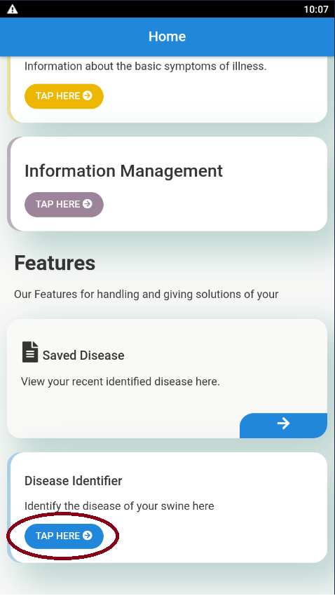**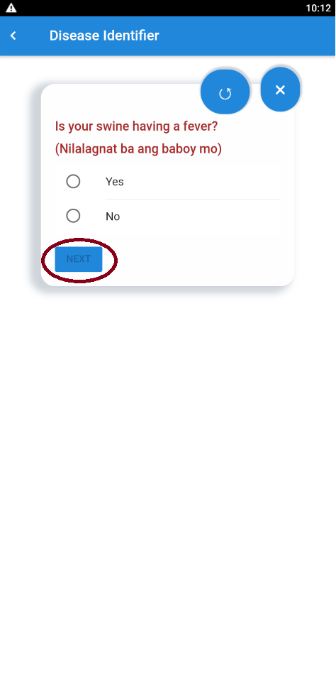

## 

Figure 4.2 Disease Identifier Yes or No questions

In the disease identifier feature, the user must answer a series of yes or no questions asking what symptoms they have observed on their swine. Then, to proceed to the next question, the user must tap the "next" button. In this way, the system can determine what disease the none expert farmer's swine is experiencing. Figure 4.2 demonstrates and shows the procedure on how to prompt into the disease identifier page and the querying part of identifying the disease/disease of the swine.

## 4.3 Disease Identifier Feature Result

The disease identifier feature result offers the information regarding on the identified disease such as the name of the disease, description, causes, treatment and prevention.

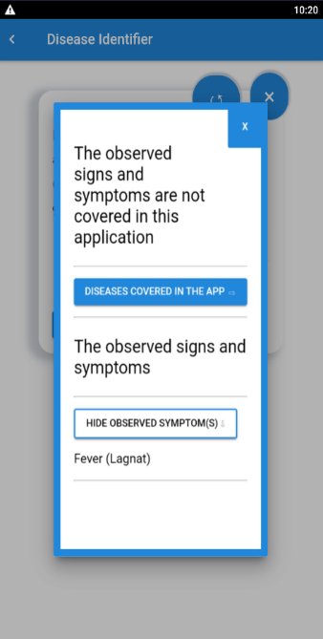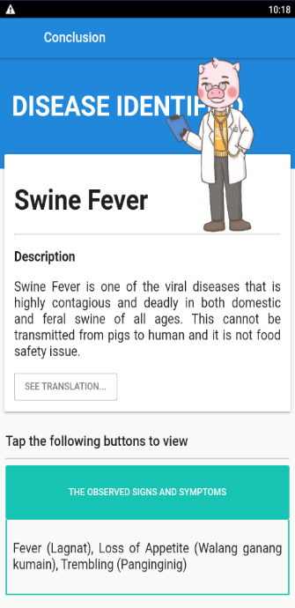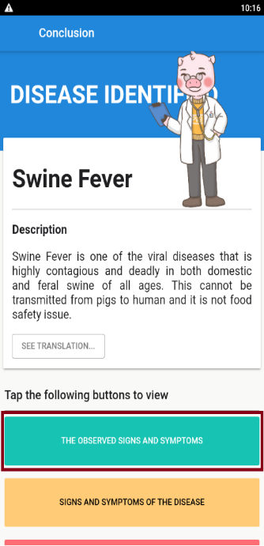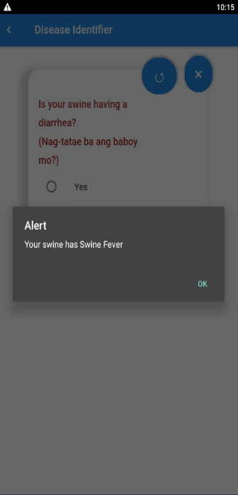

## 

Figure 4.3 Disease Identifier Result

After answering the yes or no questions provided by the system, the system then provides the conclusion along with the info of the disease, the treatment, and the preventions. The user can view their oberserved signs and symptoms and the additional info of the disease by pressing the following buttons. On the other hand, if the system cannot identify the disease based on the user's observed signs and symptoms, the system will display a separate dialog that informs the user that their observed symptoms are beyond the scope of the study, the user can still view their observed signs symptoms by tapping the "view observed symptoms" button.

## 4.4 Auto-saving Feature

The auto-saving feature saves the identified disease from the disease identifier page. This can help the farmer view the previous identified disease so that he/she will not go through the same sequence again.

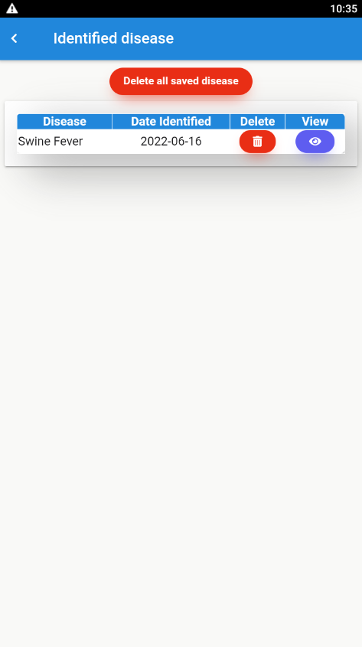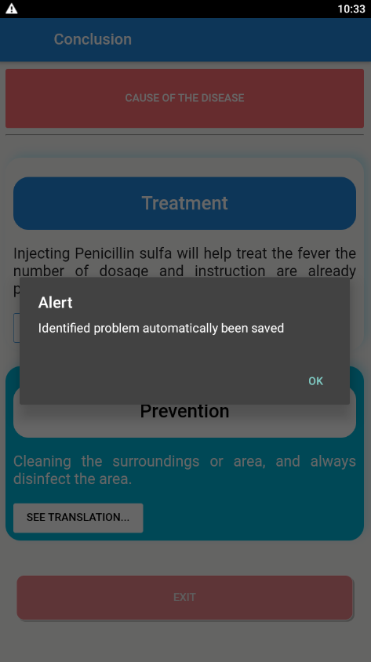

Figure 4.4 Functionality of the Auto-saving Feature

By tapping the exit button, the system will autosave the disease that has been identified; it will show the disease/disease name, the date when it was identified, and the options to view or delete it. The user can view the identified disease again by pressing the "Saved Diseases” button on the home page. Figure 4.4 depicts the functionality of the Autosaving Feature and the guide where to tap when prompting to the Saved Disease Page.

### 4.4.1 Viewing the Details of the Identified DiseaseC:\Users\eferp\Desktop\july capstone ss\4.png

This feature can view the details of the previous identified disease for the swine farmer to review.

## 

Figure 4.4.1 Viewing the details of the Identified Disease

The user can view the details of the identified disease/disease displayed lately from the results by tapping the view icon. Figure 4.4.1 shows the procedure on how to view the details of the identified disease

### 4.4.2 Deletion of the Identified Disease

This feature is an option for removing recognized diseases. It can remove all save disease or selected disease.

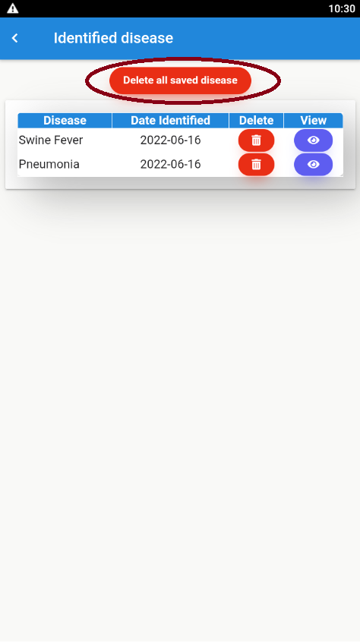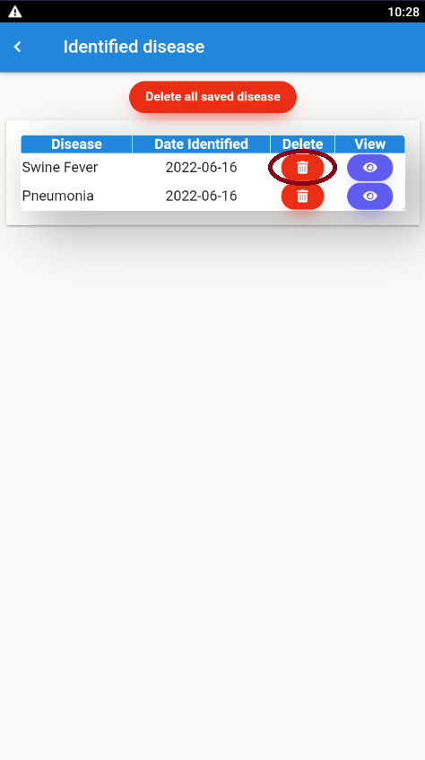

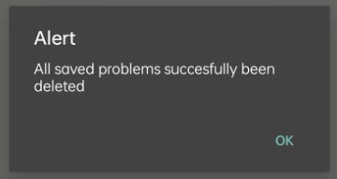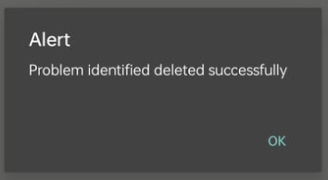

Figure 4.4.2 Deletion of the Identified Disease

Another feature of the mobile application is it gives the user the ability to delete one specific identified disease or delete it all at once. Figure 4.4.2 shows the deletion of the identified diseases.

## 4.5 System Evaluation Results

Selected 22 respondents composed of veterinarians, local swine farmers, IT practitioners, and IT professionals evaluated the system’s performance based on its functionality, reliability and Usability.

Table 4.5.1 Functionality Assessment of the System

|  |  |  |
| --- | --- | --- |
| **Statement** | **Weighted Mean** | **Interpretation** |
| 1. The system can archive the data of the recently identified swine disease. | 4.68 | Very Functional |
| 1. The system accurately identifies the swine disease and displays the proper results and treatments for the identified disease. | 4.64 | Very Functional |
| 1. The system is capable of deleting specific or all identified diseases. | 4.64 | Very Functional |
| 1. The system is capable of displaying the results of the recently identified diseases. | 4.68 | Very Functional |
| **Average Weighted Mean** | **4.66** | **Very Functional** |

Table 4.5.1depicts the average weighted mean resulting that it is very functional, specifically on the system's capability when archiving the identified disease when identified and viewing the details/result of the identified disease. The respondents rated high ratings on most criteria, meaning that the system can execute mostly the intended functions. However, the system's capability to identify and display good results treatments for the identified disease and the deleting specific or all at once identified diseases functions somewhat had a lower rating than the others. In this way, the researchers know what functionality needs to be improved.

Table 4.5.2 Reliability Assessment of the System

|  |  |  |
| --- | --- | --- |
| **Statement** | **Weighted Mean** | **Interpretation** |
| 1. The information provided by the system is clear and easy to understand. | 4.68 | Very Reliable |
| 1. The system provides error messages and alert messages to the user. | 4.5 | Very Reliable |
| 1. The system provides accurate information about swine medicines, symptoms of illnesses, and the step-by-step procedure for raising swine. | 4.55 | Very Reliable |
| **Average Weighted Mean** | **4.57** | Very Reliable |

Table 4.5.2 shows the evaluation results of the reliability assessment of the system. It is rated by 22 users, including IT experts, IT practitioners, and end-users who have little experience raising swine. The table proved that the reliability of this system is evaluated as "Very Reliable" by the evaluators having an average weighted mean of 4.57. Furthermore, it shows that all reliability statements are very reliable as the weighted mean is above 4.24.

Table 4.5.3 Usability Assessment of the System

|  |  |  |
| --- | --- | --- |
| **Statement** | **Weighted Mean** | **Interpretation** |
| 1. The system is easy to use. | 4.82 | Very Usable |
| 1. The fonts are clear and readable. | 4.59 | Very Usable |
| 1. The color combination chosen is pleasing and relaxing to the eyes. | 4.55 | Very Usable |
| 1. The words used by the system are easy to understand. | 4.73 | Very Usable |
| 1. The system displays constructive instructions for the user to follow. | 4.64 | Very Usable |
| 1. The functions of the system can be learned by the user straightforwardly. | 4.73 | Very Usable |
| 1. The buttons are easy to recognize. | 4.55 | Very Usable |
| 1. The whole system is user-friendly. | 4.73 | Very Usable |
| **Average Weighted Mean** | **4.66** | **Very Usable** |

Table 4.5.3 displays the evaluation results of the system as to its usability that is rated by IT experts, IT practitioners, and swine experts. The system's usability is evaluated as very usable by the evaluators having a weighted mean value of 4.66.

The respondents gave high ratings regarding usability because the system is used throughout its purpose. However, the color combination and buttons of the system may need some improvement since some respondents prefer other designs that may fit their desired design. Although the system is easy to use and user-friendly, the system meets the expectation of the respondents.

# 5 CONCLUSIONS AND RECOMMENDATIONS

## 5.1 Conclusion

In agriculture, raising swine is common livestock. In most cases, some beginners in raising swine may encounter diseases like severe life-threatening diseases and possibly cause death. Improper raising of the swine may cause a big loss of income if the swine is in an unhealthy state that may lead to sickness or worst. As a result, the researchers developed a mobile-based Expert System for guiding the non-expert swine raisers for raising swine that also identifies the diseases amidst the cultivation process from birth to commercialization, piloting the areas of the Department of Agriculture.

The study showed that the developed system Farming guide for swine raising with diseases identifier provides the following:

* 1. The system provides a manual to assist swine farmers in nurturing swine from birth to commercialization.
  2. The system can identify the swine disease based on the pig farmer's observation regarding raising swine.
  3. The system provides conclusion and treatment to avoid or prevent the identified disease.
  4. The system performed an auto-saving feature to save the identified disease to be viewed again by the user.
  5. The system evaluation results conclude that it is very functional, very reliable and very usable.

## 5.2 Recommendations

The system provided a manual for swine raising for the benefit of the Department of Agriculture to help non-expert farmers to raise swine and identify the swine diseases amidst the cultivation process from birth to commercialization. However, there is a minor feature that is in need to be added, which is;

* 1. In addition, there must also be a category of basic swine medicines associated to the diseases that are only present in the system**.**

# REFERENCES

Abu-Nasser, B. S., & Abu-Naser, S. . (2018). Rule-Based System for Watermelon Diseases and Treatment To cite this version : HAL Id : hal-01855441 Rule Based System for Watermelon Diseases and Treatment. *International Journal of Academic Information Systems Research (IJAISR)*, *2*(7), 1–7.

Ariawan, P. ., Sanjaya, D. ., & Divayana, D. G. . (2016). An evaluation of the implementation of practice teaching program for prospective teachers at Ganesha University of Education based on CIPP-forward chaining. *IJARAI) International Journal of Advanced Research in Artificial Intelligence*, *5*(2), 1–5. www.ijarai.thesai.org

Barhoom, A. M., Alaa, M., & Abu Naser, S. S. (2000). Black Pepper Expert System. *International Journal of Academic Information Systems Research (IJAISR), ISSN*, *2*(8), 9–16.

Barnes, T. S., Alvaran, P. J. J., Lantican, T. L. D. C., Lapuz, E. L., Ignacio, C., Baluyut, A. S., Parke, C. R., Palaniappan, G., Cameron, D., Ancog, R. C., Mananggit, M. R., de Castro, R., Meers, J., Palmieri, C., Turni, C., Villar, E. C., & Blackall, P. J. (2020). Combining conventional and participatory approaches to identify and prioritise management and health-related constraints to smallholder pig production in San Simon, Pampanga, Philippines. *Preventive Veterinary Medicine*, *178*(October 2019), 104987. https://doi.org/10.1016/j.prevetmed.2020.104987

Beltran-Alcrudo, D., Falco, J. R., Raizman, E., & Dietze, K. (2019). Transboundary spread of pig diseases: The role of international trade and travel. *BMC Veterinary Research*, *15*(1), 1–14. https://doi.org/10.1186/s12917-019-1800-5

Blomström, A. L., Ye, X., Fossum, C., Wallgren, P., & Berg, M. (2018). Characterisation of the virome of tonsils from conventional pigs and from specific pathogen-free pigs. *Viruses*, *10*(7). https://doi.org/10.3390/v10070382

Cairns, A. W., Bond, R. R., Finlay, D. D., Guldenring, D., Badilini, F., Libretti, G., Peace, A. J., & Leslie, S. J. (2017). A decision support system and rule-based algorithm to augment the human interpretation of the 12-lead electrocardiogram. *Journal of Electrocardiology*, *50*(6), 781–786. https://doi.org/10.1016/j.jelectrocard.2017.08.007

Chandra, A., Dargusch, P., McNamara, K. E., Caspe, A. M., & Dalabajan, D. (2017). A Study of Climate-Smart Farming Practices and Climate-resiliency Field Schools in Mindanao, the Philippines. *World Development*, *98*, 214–230. https://doi.org/10.1016/j.worlddev.2017.04.028

Cheng, D., Ngo, H. H., Guo, W., Chang, S. W., Nguyen, D. D., Liu, Y., Wei, Q., & Wei, D. (2020). A critical review on antibiotics and hormones in swine wastewater: Water pollution diseases and control approaches. *Journal of Hazardous Materials*, *387*(November), 121682. https://doi.org/10.1016/j.jhazmat.2019.121682

Dubey, S., Pandey, R. K., & Gautam, S. S. (2013). Literature Review on Fuzzy Expert System in Agriculture. *International Journal of Soft Computing and Engineering (IJSCE)*, *2*(6), 289–291.

Elkano, M., Galar, M., Sanz, J., & Bustince, H. (2018). CHI-BD: A fuzzy rule-based classification system for Big Data classification diseases. *Fuzzy Sets and Systems*, *348*, 75–101. https://doi.org/10.1016/j.fss.2017.07.003

Gusman, A. P., & Hendri, H. (2019). Expert system to diagnose child development growth disorders with forward chaining method. *Journal of Physics: Conference Series*, *1339*(1). https://doi.org/10.1088/1742-6596/1339/1/012045

Hayadi, B. H., Rukun, K., Wulansari, R. E., Herawan, T., Dahliusmanto, D., Setaiwan, D., & Safril, S. (2017). Expert system of quail disease diagnosis using forward chaining method. *Indonesian Journal of Electrical Engineering and Computer Science*, *5*(1), 206–213. https://doi.org/10.11591/ijeecs.v5.i1.pp206-213

Johnson, T. A., Looft, T., Severin, A. J., Bayles, D. O., Nasko, D. J., Wommack, K. E., Howe, A., & Allen, H. K. (2017). The in-feed antibiotic carbadox induces phage gene transcription in the swine gut microbiome. *MBio*, *8*(4), 1–14. https://doi.org/10.1128/mBio.00709-17

Koirala, K. H., Mishra, A., & Mohanty, S. (2016). Impact of land ownership on productivity and efficiency of rice farmers: The case of the Philippines. *Land Use Policy*, *50*, 371–378. https://doi.org/10.1016/j.landusepol.2015.10.001

Liu, H., Gegov, A., & Cocea, M. (2016). Rule-based systems: a granular computing perspective. *Granular Computing*, *1*(4), 259–274. https://doi.org/10.1007/s41066-016-0021-6

Mirmozaffari, M. (2019). Developing an Expert System for Diagnosing Liver Diseases. *European Journal of Engineering Research and Science*, *4*(3), 1–5. https://doi.org/10.24018/ejers.2019.4.3.1168

Mishra, A. K., Khanal, A. R., & Mohanty, S. (2017). Gender differentials in farming efficiency and profits: The case of rice production in the Philippines. *Land Use Policy*, *63*, 461–469. https://doi.org/10.1016/j.landusepol.2017.01.033

Mohammed, A. A., Ambak, K., Mosa, A. M., & Syamsunur, D. (2019). Expert system in engineering transportation: A review. *Journal of Engineering Science and Technology*, *14*(1), 229–252.

Morco, R. C., Corpuz, M. J. S., Calanda, F. B., Avestro, J. E., Bonilla, J. A., & Angeles, J. M. (2017). e-RICE: An Expert System using Rule-Based Algorithm to Detect, Diagnose, and Prescribe Control Options for Rice Plant Diseases in the Philippines. *ACM International Conference Proceeding Series*, 49–54. https://doi.org/10.1145/3168390.3168431

Munaiseche, C. P. C., Kaparang, D. R., & Rompas, P. T. D. (2018). An Expert System for Diagnosing Eye Diseases using Forward Chaining Method. *IOP Conference Series: Materials Science and Engineering*, *306*(1). https://doi.org/10.1088/1757-899X/306/1/012023

Nicora, G., Limongelli, I., Cova, R., Della Porta, M. G., Malcovati, L., Cazzola, M., & Bellazzi, R. (2019). A rule-based expert system for automatic implementation of somatic variant clinical interpretation guidelines. In *Lecture Notes in Computer Science (including subseries Lecture Notes in Artificial Intelligence and Lecture Notes in Bioinformatics): Vol. 11526 LNAI*. Springer International Publishing. https://doi.org/10.1007/978-3-030-21642-9\_15

Nurlaeli, & Subiyanto. (2017). Forward chaining method on diagnosis of diseases and pests corn crop. *AIP Conference Proceedings*, *1818*(March 2017). https://doi.org/10.1063/1.4976902

Prambudi, D. A., Widodo, C. E., & Widodo, A. P. (2018). Expert System Application of Forward Chaining and Certainty Factors Method for the Decision of Contraception Tools. *E3S Web of Conferences*, *31*, 1–6. https://doi.org/10.1051/e3sconf/20183110009

Robinson, B. (1996). Expert systems in agriculture and long-term research. *Canadian Journal of Plant Science*, *76*(4), 611–617. https://doi.org/10.4141/cjps96-109

Rong, L., & Li, D. (2008). A web based expert system for milch cow disease diagnosis system in China. *IFIP International Federation for Information Processing*, *259*, 1441–1445. https://doi.org/10.1007/978-0-387-77253-0\_95

Sanders, D. A., Gegov, A., Haddad, M., Ikwan, F., Wiltshire, D., & Tan, Y. C. (2019). A rule-based expert system to decide on direction and speed of a powered wheelchair. In *Advances in Intelligent Systems and Computing* (Vol. 868). Springer, Cham. https://doi.org/https://doi.org/10.1007/978-3-030-01054-6\_57

Son, C. (2016). Intelligent rule-based sequence planning algorithm with fuzzy optimization for robot manipulation tasks in partially dynamic environments. *Information Sciences*, *342*, 209–221. https://doi.org/10.1016/j.ins.2015.08.020

Tan, H. (2017). A brief history and technical review of the expert system research. *IOP Conference Series: Materials Science and Engineering*, *242*(1). https://doi.org/10.1088/1757-899X/242/1/012111

Villanueva, J. J. O., & Sulabo, R. C. (2018). Production , Feeding and Marketing Practices of Native Pig Raisers in Selected Regions of the Philippines. *Global Advanced Research Journal of Agricultural Science*, *7*(12), 383–392.

Wagner, W. P. (2017). Trends in expert system development: A longitudinal content analysis of over thirty years of expert system case studies. *Expert Systems with Applications*, *76*, 85–96. https://doi.org/10.1016/j.eswa.2017.01.028

Woo, Y. Bin, Jung, S., & Kim, B. S. (2017). A rule-based genetic algorithm with an improvement heuristic for unrelated parallel machine scheduling disease with time-dependent deterioration and multiple rate-modifying activities. *Computers and Industrial Engineering*, *109*, 179–190. https://doi.org/10.1016/j.cie.2017.05.007

Xiong, Y., Huang, S., Wu, M., She, J., & Jiang, K. (2017). A Johnson’s-Rule-Based Genetic Algorithm for Two-Stage-Task Scheduling Disease in Data-Centers of Cloud Computing. *IEEE Transactions on Cloud Computing*, *7*(3), 597–610. https://doi.org/10.1109/tcc.2017.2693187

# APPENDICES

**RULE-BASED EXPERT SYSTEM: FARMING GUIDE FOR SWINE RAISING WITH DISEASE IDENTIFIER USING FORWARD CHAINING METHOD**

Dear Respondents,

Good day!

We are the students from Misamis University under Bachelor of Science in Information Technology. We want to ask permission to evaluate/rate our developed mobile application's functionality, reliability, and usability, entitled "Swine Raising ES ."Your response will greatly help us determine the inadequateness of our system's features that will gradually help us improve our system.

Please remember that all information provided will be kept in utmost confidentiality and should be only used for academic purposes. We hope that this request will merit your approval. Your participation in this study is highly appreciated.

Thank you very much, and God bless.

Respectfully,

Efer Ponsaran

Biscilou Ohuman

Anthony Quiniñeza

Researchers

**LIST OF APPENDICES**

**APPENDIX I: Functionality Assessment of the System User’s Side**

**APPENDIX II: Usability Assessment of the System User’s Side**

**APPENDIX III: Reliability Assessment of the System User’s Side**

Directions. Please rate the system's functionality, reliability, and usability using the rating scale below. You should check (✓) the number that best represents your system evaluation for each statement.

Functionality Assessment of the System User’s Side

**Scale Range Responses Intepretation**

5 4.24 – 5.00 Strongly Agree Very Functional

4 3.43 – 4.23 Agree Somewhat Functional

3 2.62 – 3.42 Neutral Functional

2 1.81 – 2.61 Disagree Less Functional

1 1.00 – 1.80 Strongly Disagree Not Functional

|  |  |  |  |  |  |
| --- | --- | --- | --- | --- | --- |
| **Statements** | 5 | 4 | 3 | 2 | 1 |
| 1. The system is capable of archiving the data of the recently identified diseases. |  |  |  |  |  |
| 1. The system accurately identifies the swine disease and displays the proper results and treatments for the identified disease. |  |  |  |  |  |
| 1. The system is capable of deleting a single disease or all at once. |  |  |  |  |  |
| 1. The system can display the results of the recently identified diseases when viewed by the user. |  |  |  |  |  |

Reliability Assessment of the System User’s Side

**Scale Range Responses Intepretation**

5 4.24 – 5.00 Strongly Agree Very Functional

4 3.43 – 4.23 Agree Somewhat Functional

3 2.62 – 3.42 Neutral Functional

2 1.81 – 2.61 Disagree Less Functional

1 1.00 – 1.80 Strongly Disagree Not Functional

|  |  |  |  |  |  |
| --- | --- | --- | --- | --- | --- |
| Statements | 5 | 4 | 3 | 2 | 1 |
| 1. The information provided by the system is clear and easy to understand. |  |  |  |  |  |
| 1. The system provides error messages and alert messages as a response to the user. |  |  |  |  |  |
| 1. The system provides accurate information about the swine, symptoms of illnesses, and the step-by-step procedure for raising the swine. |  |  |  |  |  |

Usability Assessment of the System User’s Side

**Scale Range Responses Intepretation**

5 4.24 – 5.00 Strongly Agree Very Functional

4 3.43 – 4.23 Agree Somewhat Functional

3 2.62 – 3.42 Neutral Functional

2 1.81 – 2.61 Disagree Less Functional

1 1.00 – 1.80 Strongly Disagree Not Functional

|  |  |  |  |  |  |
| --- | --- | --- | --- | --- | --- |
| Statements | 5 | 4 | 3 | 2 | 1 |
| 1. The system is easy to use. |  |  |  |  |  |
| 1. The font style and font size are clear and readable. |  |  |  |  |  |
| 1. The color combination chosen is pleasing and relaxing to the eyes. |  |  |  |  |  |
| 1. The words used by the system are easy to understand. |  |  |  |  |  |
| 1. The system displays constructive instructions for the user to follow. |  |  |  |  |  |
| 1. The functions of the system can be learned by the user straightforwardly. |  |  |  |  |  |
| 1. The buttons are easy to recognize. |  |  |  |  |  |
| 1. The system as a whole is user-friendly. |  |  |  |  |  |

|  |  |  |
| --- | --- | --- |
| mu | **Misamis University** *Ozamiz City**COLLEGE OF COMPUTER STUDIES* | compstudNew |

**MU-CCS-028/19October2013**

\_\_\_\_\_\_\_\_\_\_\_\_\_\_\_\_\_\_\_\_\_\_\_\_\_\_\_\_\_\_\_\_

**GRAMMARIAN’S CERTIFICATE**

This is to certify that the undersigned, **ENGR.** **Jerry Lumasag** has reviewed and went through all the pages of the manuscript of the Thesis/Capstone Project entitled **“RULE-BASED EXPERT SYSTEM: FARMING GUIDE FOR SWINE RAISING WITH DISEASE IDENTIFIER USING FORWARD CHAINING METHOD”** as against the set of structural rules that govern the composition of sentences, phrases, and words in the English language.

Signed:

ENGR, Jerry Lumasag\_\_\_\_\_\_\_\_\_

Grammarian

Conforme:

BISCILOU ANGEL R. OHUMAN

Study/Project Leader (Signature over printed name)

# CURRICULUM VITAE

**RESEARCHER’S PERSONAL INFORMATION**

**NAME:** Efer B. Ponsaran

**NICKNAME:** PoyPoy

**BIRTHDATE:** December 3, 1998

**AGE:** 23

**ADDRESS:** Poblacion 4, Clarin, Misamis Occidental

**EMAIL:** efer009@gmail.com

**CIVIL STATUS:** Single

**RELIGION:** Iglesia ni Cristo

* **PARENTS**

**FATHER’S NAME:** Al U. Ponsaran

**MOTHER’S NAME:** Livisminda Felly B. Ponsaran

* **EDUCATIONAL BACKGROUND**

**PRIMARY:** Jaro I Elementary School

**SECONDARY:** Capiz National High School

**TERTIARY:** Misamis University

* **SKILLS:**
* Programming
* Knowledge of computer hardware
* Can work in a group
* **MOTTO IN LIFE: “Keep calm and carry on."**

**RESEARCHER’S PERSONAL INFORMATION**



**NAME:** Biscilou Angel R. Ohuman

**NICKNAME:** Baron

**BIRTHDATE:** October 23, 1999

**AGE:** 22

**ADDRESS:** Purok 7, Datu Panas, Buug Zamboanga Sibugay

**EMAIL:** baronromeroohuman@gmail.com

**CIVIL STATUS:** Single

**RELIGION:** Catholic

* **PARENTS**

**FATHER’S NAME:** Bislinio A. Ohuman

**MOTHER’S NAME:** Lucita R. Ohuman

* **EDUCATIONAL BACKGROUND**

**PRIMARY:** Saint Paul School of Buug

**SECONDARY:** Saint Paul School of Buug

**TERTIARY:** Misamis University

* **SKILLS:**
* Dancing
* Designer
* Front end developer
* **MOTTO IN LIFE: “Live a little”**

**RESEARCHER’S PERSONAL INFORMATION**



**NAME:** Anthony S. Quiniñeza

**NICKNAME:** Tonton

**BIRTHDATE:** November 13, 1999

**AGE:** 22 yrs. old

**ADDRESS:** Dampalan, Dapitan City Zamboanga del Norte

**EMAIL:** Anineza1999@gmail.com

**CIVIL STATUS:** Single

**RELIGION:** Roman Catholic

* **PARENTS**

**FATHER’S NAME:** Gilberto L. Quiniñeza

**MOTHER’S NAME:** Usalina S. Quiniñeza

* **EDUCATIONAL BACKGROUND**

**PRIMARY:** Dampalan Elementary School

**SECONDARY:** Potungan National High School

**TERTIARY:** Misamis University

* **SKILLS:**
* Computer and Device literate
* Programming
* Can work in a group
* **MOTTO IN LIFE: "Nothing lasts forever."**