# Bill Simpson-Young (NICTA)

# Phone: 93762266

# Email: [bill.simpson-young@sydney.edu.au](mailto:bill.simpson-young@sydney.edu.au)

# Week 1 - Introduction to technological innovation

Topics covered:

 - the importance of innovation; definitions of innovation; creative destruction

Reading list:

 - [General reading list](https://elearning.sydney.edu.au/bbcswebdav/pid-2654018-dt-content-rid-14449509_1/xid-14449509_1)- this is some recommended books and sites for learning about technological innovation generally

### › Definition of innovation:

Innovation involves (1) a new idea that is (2) applied commercially

Invention is the first occurrence of an idea for a new product or process, while innovation is the first attempt to carry it out into practice.

“Innovation is not simply invention; it is invention put to use. Invention without innovation is a pastime.”

“Ideas successfully applied.”

#### - Innovation involves idea + application of that idea (“ideas successfully applied”)

Innovation is more than the generation of creative ideas

It is implementation of those ideas into a new device/process

Innovation requires combining a creative idea with resources and expertise that make it possible to embody使具体化the creative idea in a useful form

#### - Innovation as creative destruction创造性破坏(Schumpeter) – see below(›Innovation as “creative destruction” )

### ›The importance of innovation:

- Innovation as driver of competitive success

#### -The importance of innovation to a country:--measure the innovation for a country—wk11

**-Innovation is a driver of productivity, growth, improvement in living conditions (health, education, reducing pollution etc.)**

Innovation, particularly technological change, is the most important contributory factor driving long run economic growth.

**› Technological innovation:**

- Is often the most important competitive driver in many industries

- Leads to improvements in productivity

- Is strongly linked with improvements in Gross Domestic Product (GDP)

- Is linked to improvements in standard of living including:

- Job creation

- Improved enjoyment of life

- Health improvements

- Education improvements

- Addressing national or global issues including by:

- Decreasing pollution

- Improving disaster response

#### -The importance of innovation to a company:--measure—wk10

**-Innovative companies usually have greater productivity, revenue, growth and social contributions**

**› “Compared to Australian businesses that don’t innovate, innovative Australian businesses are also - Australian Innovation System Report 2012**

- 42% more likely to report increased profitability利润率;

- Three times more likely to export and eighteen times more likely to increase the number of export markets targeted;

- Four times more likely to increase the range of goods or services offered;

- More than twice as likely to increase employment;

- More than three times more likely to increase training for employees; and

- More than three times more likely to increase social contributions such as community enhancement projects”

### ›Innovation as “creative destruction” –wk9

- Economy is in state of constant tumultuous骚乱的 change

- Innovation propels 推进the economy

- Entrepreneurs within new firms—startup? drive innovation:

- All companies react adaptively 自适应反应to change

- Creative responses to change come via innovative acts by entrepreneurs

- Different forms of innovations:

- New products; New organisations (e.g. mergers); New markets

- Innovating firms emerge 浮现after technological breakthrough

- “the opening up扩大开放 of new markets… and the organizational development ... illustrate the same process of industrial mutation变化, that incessantly不停地 revolutionizes the economic structure from within, incessantly destroying the old one, incessantly creating a new one”.

- Schumpeter called this process “creative destruction”.

- Creative destruction – waves that restructure entire industries and markets in favour of those who grasp and adapt to technological discontinuities faster!

### ›The importance of IT innovation:

Software innovation is now key to innovation in many industries.

#### -IT as “general purpose technology”

› IT is a “General Purpose Technology” (GPT)

› Like electricity – it enables other technologies

› GPTs differ from other technologies and:

- Are pervasive普遍的 – spreading to most sectors

- Continually improve in usefulness and lower in cost

- Spawn大量生产 innovation in other areas – making it easier to invent and produce new products or processes

#### -IT as enabler of innovation in other fields (e.g. bio-informatics, logistics, automotive, …)

**Example: bio-informatics, computational genomics**

Can use computational approaches on genome

**Example: SARS coronavirus冠状病毒 (SARS CoV)**

With the analysis and visualization of software from the chromosome to genome information, we can process data and then determine the genetic, geographic and evolutionary history of the virus.

**Example: Software for fleet**港湾 **logistics—**Freight货运 companies want to optimise routes to:

With the help of street level routes and delivery timings estimation, the routes can be automatically planned and distributed, and the current service and potential service can also be calculated to visually presenting. This save costs, enture timely delivery and reduce emissions.

**Example: Software in cars**

In the automotive industry, the majority of innovations come from software and computer systems. The microprocessors and software source code are a crucial part of the high-end cars. Meanwhile, the software development is not just simple implementation. For example, the majority of developing time is spending on the software development for hybrid transmission. The software also contributes on the air-bag system, antilock brakes, navigation system and many other aspects.

#### -IT innovation as creative destruction

Improvements in IT can change whole industries .e.g. Media industry, the trends of US Online advertising revenue growth dramatically from 1999 to 2010.But creation of one industry destruction of another, the printed newspaper advertising revenue adjusted for inflation from 1950 to 2011, and from 2000, it drops dramatically.

Creative destruction例子：online advertising的诞生让利润大幅增长，但是让printed news advertising覆灭了。

#### -Why “software is eating the world”—shown in short question—work with wk12

**Marc Andreessen**

Co-founder of Netscape, Co-founder of Andreessen-Horowitz

Early investors in Facebook, Groupon, Twitter, Skype, Zynga, Foursquare, etc

**“Why software is eating the world” (2011)**

› More major businesses/industries are being run on software and delivered as online services

› Technology required to transform industries through software finally works and can be delivered globally

› Front end: billions of people with smartphones

› Back end: software tools to launch global software powered start-ups with no need for infrastructure

**› Examples:**

- Largest bookseller in world is a software company - (Amazon – while Borders went bankrupt)

- Largest video service is a software company - (Netflix – while Blockbuster went bankrupt)

- Dominant music companies are software companies - (Apple, Spotify, Pandora – traditional record companies exist to provide them with content)

- Fastest growing game company is a software company - (Zynga who make Farmville)

- Largest direct marketing company is a software company - (Google)

# Question 2 (“software is eating the world”)

Marc Andreessen, co-developer of the first widely used web browser and successful technology investor, wrote in 2011 "Software is eating the world". What did he mean by this? Also identify two technology-related enablers that he says have made this possible and explain how they have done so.

**Sample good answer**

Marc Andreessen was referring to the prevalence普遍 of software firms that are now major players in various industries. His argument is that these software firms are figuratively ‘eating’ markets that have traditionally been dominated by manufacturing, retail and entertainment firms, not software firms.

The “single most dramatic example of this phenomena” Andreessen cites is the case of Amazon becoming the largest retailer of books (which it sells online), while Borders, a traditional leader in the retail book industry, filed for bankruptcy破产 protection in Feb 2011. The largest video service meanwhile, by number of subscribers, is Netflix, a software company who deliver their product online. These are both examples of software firms that have been able, due to the maturity and effectiveness of both their software and the modern internet which enables online delivery of their respective products, to enter and take over a market.

One enabler of this is the development and widespread adoption of the Internet which now reaches 2 billion people throughout the whole world (up from approximately 50 million a decade ago). This ensures that any Internet-based business has potential to reach a massive, global market.

Another enabler is the availability of software development tools and other internet-based services, including cloud computing, which are drastically 彻底地reducing the cost for start-ups of developing software-based products and delivering them to a global market. Start-ups can now do this without the need for large investments in infrastructure.

# [Week 2 - Industry dynamics of technological innovation](https://elearning.sydney.edu.au/webapps/blackboard/content/listContent.jsp?course_id=_52292_1&content_id=_2654017_1)

Topics: Diffusion of innovations; adoption of innovations; improvements in technological performance; design dominance; technology cycles

Pre-reading:

Please read the following and come prepared to discuss them at the lecture.  The first relates to what we discussed in week 1 and the second relates to some of what we will discuss in week 2.  
a) Marc Andreessen, "Why software is eating the world", Wall Street Jounal, August 2011.  The online version at Wall Street Journal is at<http://online.wsj.com/article/SB10001424053111903480904576512250915629460.html> but that requires a Wall St Journal subscription (which you may not have). Assuming you don't, here's some practice at finding and reading things through the Uni library site (in case you aren't used to doing this already)...   
- Go to <http://sydney.edu.au/> and press on the "Library" link at the top of the page  
- Search for "Why software is eating the world"  
- Click on the fourth entry (ie the Dow Jones one – it says “Review” in the title but it’s the actual article, not a review) and you can read the full text from there  
b) Fernando Suarez, "Battles for technological dominance: An integrative framework", Research Policy 33 (2004).  Read section 1 and section 2.  You can find this by going the the library website as above and searching for "suarez battles technological".

### ›Types of innovation according to different dimensions:

#### -1) What type of thing is being innovated?

-Product/service vs process vs business model innovation

**Product Innovation**

- Product innovation is embodied呈现in the outputs of organisations – could be product or service

**- Eg. IT-enabled innovation:**

- Software to generate 3D models from images

- New hardware/software features in cars (e.g. inter-car communication)

- New features in Facebook

- Examples in video games and iPod.

**Process Innovation**

- Process Innovation involves the discovery and implementation of a new or improved production or delivery method生产和运输方式

- The process could be related to production/engineering or related to business processes

- Example: The process for making a prototype product, from injection moulding铸模成形to 3D printing.

**Relation between product and process innovations**

› Product innovations can enable process innovations

- E.g. a new 3D printer may enable faster, cheaper prototyping

› Process innovations can enable product innovations

- E.g. cell-based assembly allows more custom products

› What is a product innovation for one organization might be a process innovation for another

- E.g., a package delivery service creates a new distribution service (product innovation) that enables its customers to distribute their goods more widely or more easily (process innovation)

**Business Model Innovation—wk5**

- New and radically彻底地new business models

- Many web-based innovations are built around business model innovations

- Eg Google, Groupon, Amazon Web Services, Uber, Airbnb

- (More on business process innovation in later lecture)

#### -2) How different is it from what’s already available?

-Radical彻底的vs incremental增加的innovation

› **The radicalness极端of an innovation** is the degree to which it is new and different from existing products and processes.

- E.g. 3D printer

› **Incremental innovations**渐进式创新may involve only a minor change from (or adjustment to) existing practices.

- E.g. a new feature in Microsoft Word

› The radicalness of an innovation is relative; it may change over time or with respect to关于different observers.

#### -3) What impact will it have on the consumer?

-Life-changing vs incidental偶然的innovation

**For the 3D printer, firstly it is a revolution in customization.** People will be able to create custom objects from their own designs used in their own personal 3D printers. Overall, the potential enjoyment that people can get from what they are buying/producing will be increased. **In the medical field, 3D-printed implants will help to increase the quality of life for many people in society**. Due to the incredible customization abilities of 3D printers, human body parts will be fitted exactly to individuals and their differences, helping to make better titanium bone implants, prosthetic limbs and devices used by dentists. The technology will allow new discoveries in medicine to happen faster, since cost and time doing research will be reduced through 3D prototypes. A patient being rushed into the emergency room for heart problems will be more likely to be saved since the necessary arteries/implants will be instantly printed in a nearby room to prepare for surgery.

The endnote add-on for MS word can help researcher, teacher and student add the reference for their article more easily. It is the tool for learning how to do research, cite sources, write term papers, and even match your manuscript 手稿to a scientific journal.

The Microwave - Percy L. Spencer

Percy Spencer, an engineer at Raytheon after his WWI stint in the Navy, was known as an electronics genius. In 1945, Spencer was fiddling with a microwave-emitting magnetron — used in the guts of radar arrays — when he felt a strange sensation in his pants. A sizzling, even. Spencer paused and found that a chocolate bar in his pocket had started to melt. Figuring that the microwave radiation of the magnetron was to blame (or to credit, as it would turn out), Spencer immediately set out to realize the culinary potential at work. The end result was the microwave oven — savior of eager snackers and single dudes worldwide.

#### -4) What impact will it have on the market?—later lecture week3

-Disruptive vs sustaining innovation—(more in week3 and week4)

Change the value system

#### -5) What scope of the product/service/process does it affect?

**-Architectural vs component innovation**

› An architectural innovation entails使需要 changing the overall design of the system or the way components interact.

- E.g. cloud computing

**- E.g. the system of allowing “signals” to be added to Google**

› A component innovation involves changes to one or more components of a product system without significantly affecting the overall design.

- E.g. changing the algorithm for face detection in a camera for higher performance

**- E.g. adding a new “signal” in the Google search engine**

› Most architectural innovations also require changes in the underlying adj. 潜在的；根本的 components.

#### -6) What impact will the innovation have on the producers?

**-Competence-enhancing vs competence destroying innovation**

› Competence-enhancing innovations build on the firm’s existing knowledge base

- E.g., Intel’s Pentium 4 built on the technology for Pentium III.

› Competence-destroying innovations render致使 a firm’s existing competencies obsolete淘汰.

- E.g. Kodak invented the first digital camera

- But they struggled to make the transition from analog film to digital photography as most of their competence related to analog film (rather than micro-electronics)

› Depends on the perspective观点 of a particular firm.

- E.g. digital cameras were not competence-destroying for Canon as they already had microelectronics expertise.

### ›Diffusion and adoption of innovations:

#### -A model for the diffusion of innovations (Rogers)

Everett Rogers, Sociologist and communications scholar (1931 – 2004)

› Originally a rural scholar studying agricultural innovations

› Interested in why some farmers adopted new innovations and not others

› He noticed that some farmers did not adopt innovations even if economically sensible

Rogers developed model of innovation in agriculture and then found it applied to other areas such as hybrid seed corn, antibiotics抗生素 and boiling water for sterilization杀菌.

› “New ideas tend to follow a pattern in entering society” i.e. how they “diffuse” into society

› The concepts are still widely used by governments and companies in understanding, planning and influencing adoption of new products

› “Diffusion is the process in which (1) an innovation is (2) communicated through certain channels (3) over time among (4) the members of a social system.” (Rogers, 1962)

#### -The innovation-development process

Stages in the Innovation-Development Process: (not always all used and not necessarily in this order)

1. Recognising a problem or need

2. Basic and applied research:

- Scientific investigation (applied=addressing practical problem)

3. Development:

- Putting a new idea into a form to meet the needs of users

4. Commercialisation:

- Production, manufacture, packaging, marketing, distribution

5. Diffusion and adoption:

- Spreading innovation through members of a social system

6. Consequences

#### -Categories of adopters (Rogers)

› Rogers identified 5 types of adopters

› Each has specific characteristics

skeptical  adj. 怀疑的；怀疑论的，不可知论的

aversion n. 厌恶；讨厌的人

laggard n. 落后者；迟钝者

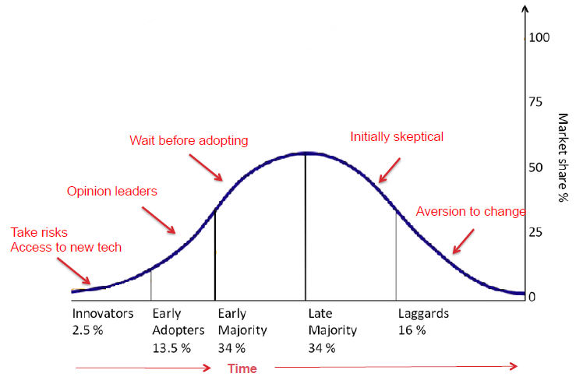

#### -The “chasm” - between early adopters and the early majority (Moore)

**From “Crossing the Chasm” book by Geoffrey Moore, High tech consultant, left**

› Discusses how hard it is for companies making high-tech products to get from early adoption to mainstream and provides approaches to help

[More in later lecture covering company innovation strategies]—wk5/8

#### -Technology adoption S-curve

**Cumulative**累积的 **adoption curve, right**

› Another way of representing the same information (cumulatively)

› This is known as a “technology adoption S-curve”, the right one

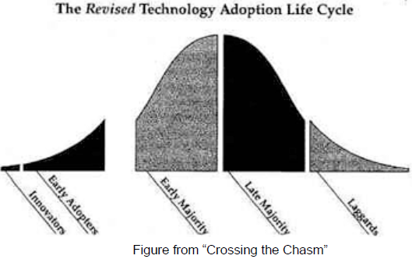 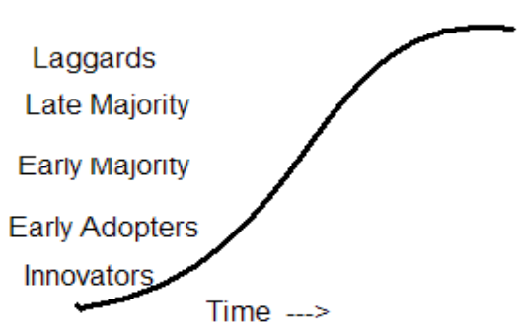

#### -The process of innovation adoption by individuals and organisations (Rogers)

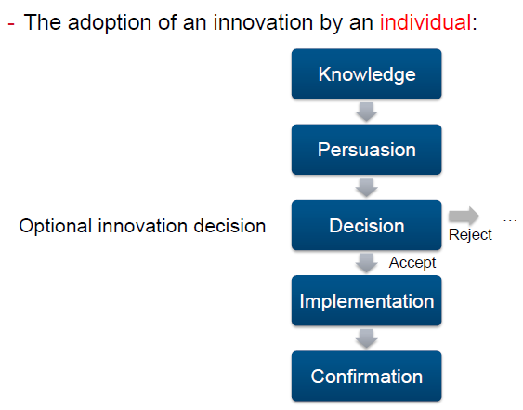 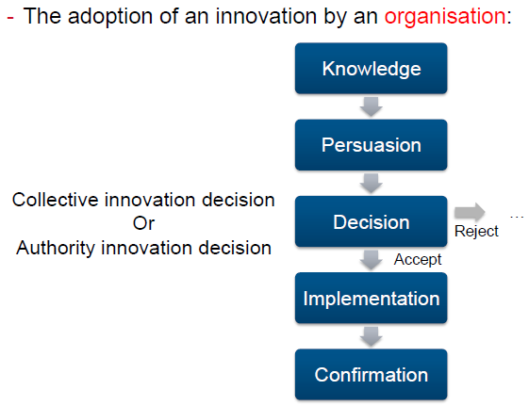

Optional随意的

Collective集合的 /authority权威

#### -Factors influencing speed of adoption (Rogers)

Rate of adoption of an innovation

Perceived attributes感知属性 of innovations that determine rate of adoption:

• Relative advantage相对优势–better than the idea it supercedes取代.

• Compatibility兼容性 –consistent with the existing values, past experiences, and needs of potential adopters.

• Simplicity (vs Complexity) –simple to understand and use.

• Trial-ability 可出试用版本 –may be experimented with on a limited basis (low cost, “free trial offer”).

• Observe-ability –results of an innovation are visible to others, who imitate模仿.

Rate also affected by:

• Extent of Change Agents’ Promotion Efforts代理商的推广工作(eg marketing)

• Other factors

**› Technologies being adopted faster now. Technologies get to 50% penetration**渗透 **more quickly but often don’t reach saturation**饱和 **due to other technologies replacing them (eg see VCRs).**

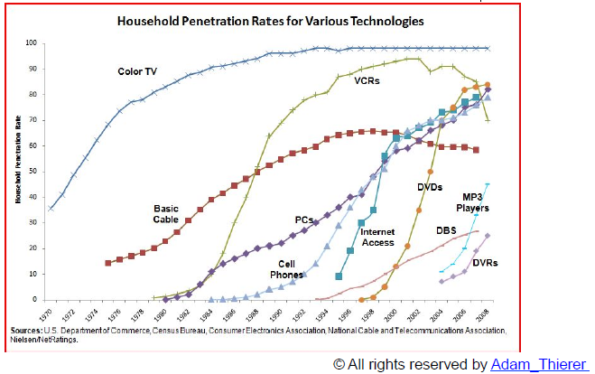

Question:

Why do you think more recent technologies (e.g. the Internet, DVDs) have steeper陡峭的 adoption curves than older technologies (e.g. telephones, TVs)?—Factors influencing speed of adoption

Technology replacement

#### -Technology adoption S-curve--above

### ›Improvements in technological performance:

#### -Technology performance S-curve

Technology Performance over time

› Another use of the “S-curve”: the “technology performance S-curve”

› Used to show and predict the performance improvement of a technology

› Shows that the performance of a technology starts slowly, then improves approximately exponentially以指数方式, then slows and eventually saturates使饱和

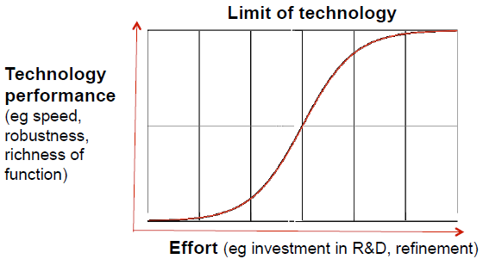 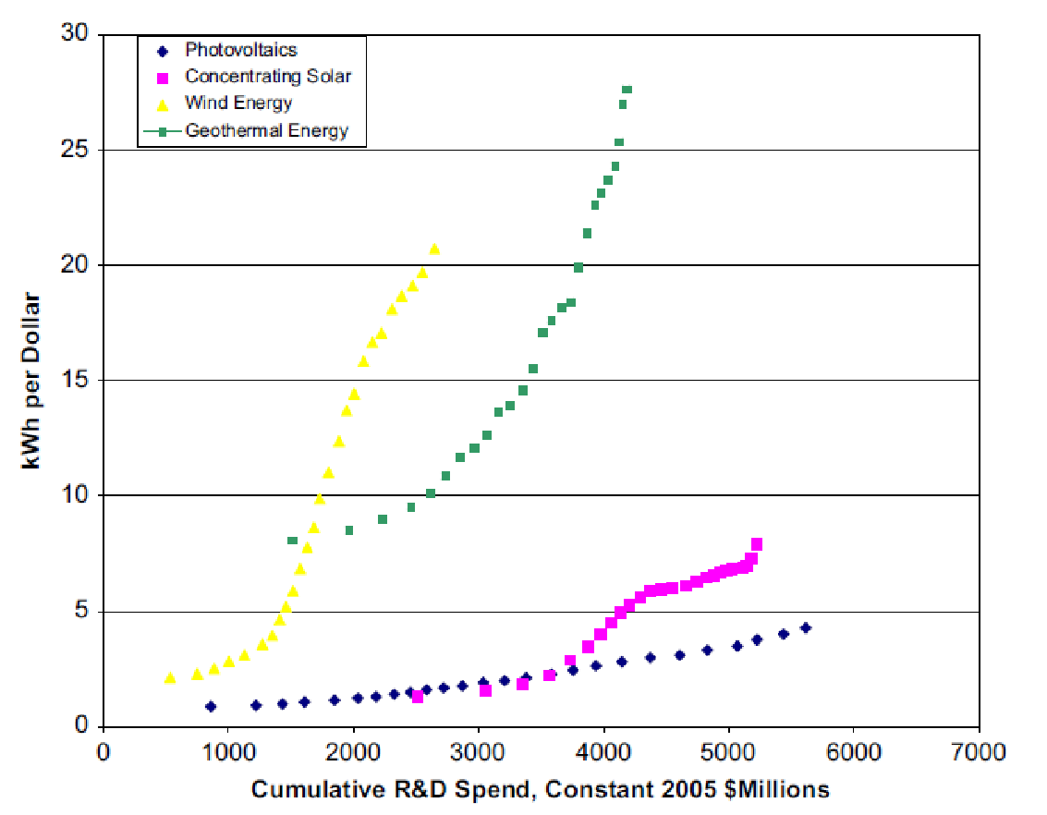

E.g. considering the supercomputer industry, where the traditional architecture involved single microprocessors. In the early stages of this technology a huge amount of money was spent in research and development, and it required several years to produce the first commercial prototype. Once the technology reached a certain level of development the know-how and expertise behind supercomputers started to spread, boosting dramatically the speed at which those systems evolved. After some time, however, microprocessors started to yield lower and lower performance gains for a given time/effort span, suggesting that the technology was close to its physical limit (based on the ability to squeeze transistors in the silicon wafer). In order to solve the problem supercomputer producers adopted a new architecture composed of many microprocessors working in parallel. This innovation created a new S-curve, shifted to the right of the original one, with a higher performance limit (based instead on the capacity to co-ordinate the work of the single processors).

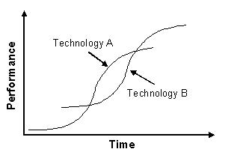

# Question 3 (S-curve)

The S-curve has been found to be a good representation for: (i) technology performance over time; and (ii) the diffusion of an innovation in society over time.

a) Describe the shape of the S-curve, using text and a diagram.

b) Explain why technology performance over time tends to take this shape.

c) Explain why innovation diffusion over time tends to take this shape.

d) Give an example of a technology whose performance over time could be represented as an S-curve.

### ›Modelling maturity and adoption of technology

#### -The Gartner “Hype-cycle”

Gartner Hype Cycles provide a graphic representation of the maturity and adoption of technologies and applications, and how they are potentially relevant to solving real business problems and exploiting new opportunities. Gartner Hype Cycle methodology gives you a view of how a technology or application will evolve over time, providing a sound source of insight to manage its deployment within the context of your specific business goals.

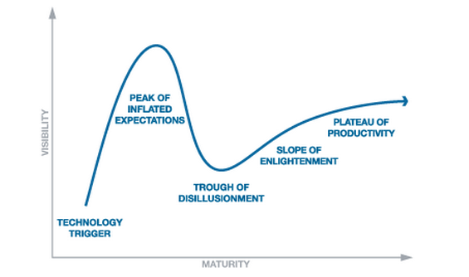

**Technology Trigger:** A potential technology breakthrough kicks things off. Early proof-of-concept stories and media interest trigger significant publicity. Often no usable products exist and commercial viability is unproven.

**Peak of Inflated Expectations:** Early publicity produces a number of success stories — often accompanied by scores of failures. Some companies take action; many do not.

**Trough of Disillusionment**幻灭**:** Interest wanes as experiments and implementations fail to deliver. Producers of the technology shake out or fail. Investments continue only if the surviving providers improve their products to the satisfaction of early adopters.

**Slope of Enlightenment**启迪**:** More instances of how the technology can benefit the enterprise start to crystallize and become more widely understood. Second- and third-generation products appear from technology providers. More enterprises fund pilots; conservative companies remain cautious.

**Plateau**高地 **of Productivity:** Mainstream adoption starts to take off. Criteria for assessing provider viability are more clearly defined. The technology's broad market applicability and relevance are clearly paying off.

**› Uses:**

- Strategic planning of technology development

- Companies considering adoption of a technology

- Investors investing in technology

**› Some criticisms**

- Development of each Gartner Hype-Cycle is not done scientifically – it is the opinions of market analysts at a point in time一个时期一个点的

- Technologies may appear already on the slope of enlightenment启迪 or disappear

- It only works for technologies that follow this model (eg it doesn’t deal well with technologies that never succeed or are quickly superseded取代)

- As it is widely-used, it is partly self-fulfilling自我实现(i.e. people may not adopt technologies as they don’t appear mature in the hype-cycle)

› Summary: Use with care

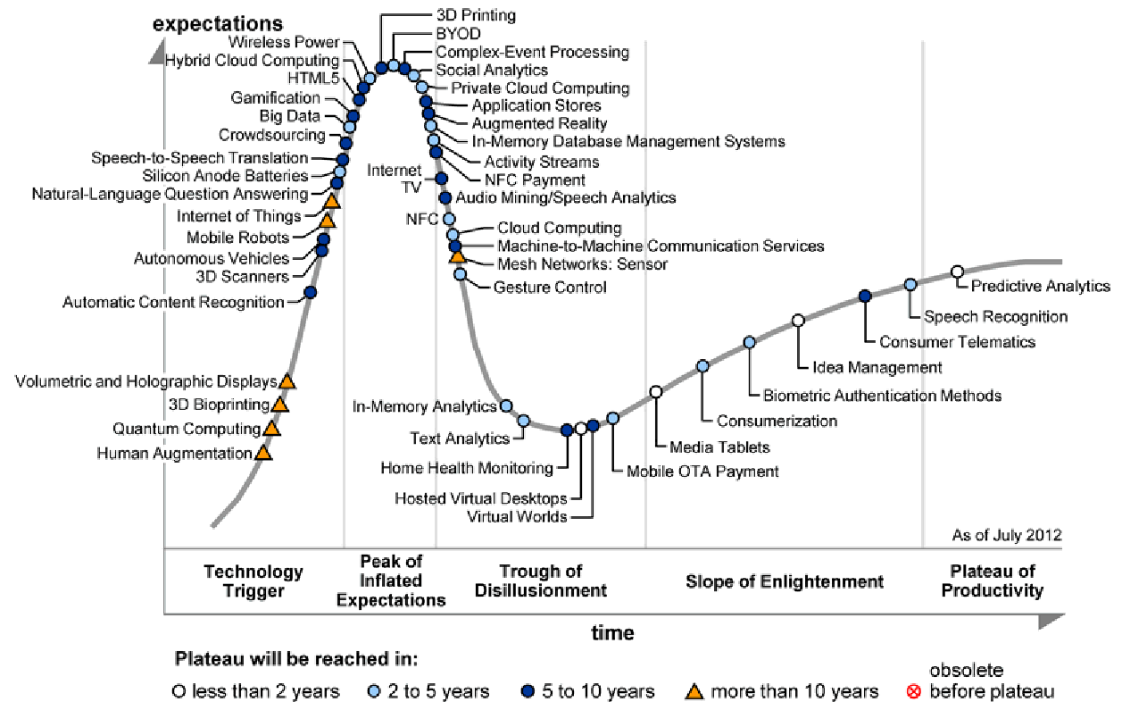

### ›Design Dominance: -- shown in short answer

#### -The concept of DD (Utterback & Abernathy)

The concept of Design Dominance

› Came from a study of the automotive industry in the 1970s (by Utterback and Abernathy)

› Their model allows explanation and prediction of the dynamics of product and process innovation in the industry

› A “Dominant Design” is the design around which the industry settles.

Note: Many different companies provide parts. These parts need to work together.

#### -The process by which DD happens (Utterback & Abernathy)

The concept of Design Dominance

1. When a new product is first introduced, it is usually “made-to-order”

2. If the product attracts significant market share (through whatever path

– technological superiority, good marketing etc), it forces imitation模仿 by competition

3. Competitive products are released

4. There is pressure to reduce costs in components leading to commoditisation 商品大众化

of components (for mass production)

5. This requires there to be a “dominant design” with components fitting within this design

6. The dominant design may be established by the first company to release a product, a later arrival or by a standards body

7. The dominant design becomes a base for the whole industry

8. This design may become a defacto事实上的 standard or a de jure法律上的 standard

#### -Phases of DD and technology cycles (Anderson & Tushman)

**The phases of Design Dominance**

› Utterback and Abernathy talked about two phases in reaching design dominance:

- The fluid phase:

- Uncertainty about the technology and its market

- Firms experiment with different product designs

- The specific phase (i.e. innovations are specific to the dominant design):

- There is a stable architecture (dominant design) for the technology

- Firms focus on incremental innovations to improve components

- Firms focus on process innovations to produce them efficiently and effectively

**Design Dominance and Technology Cycles**

› Further developed in the 90s (Anderson and Tushman)

› Work based on studies of the US minicomputer industry (etc)

› A new technology may cause a “technological discontinuity” in the industry leading to a new cycle

› They showed that technological discontinuities were competence enhancing or competence-destroying for particular companies

Note: If time short between technological discontinuities, no dominant design emerges

› In the cases studied by Anderson and Tushman, they found that:

- The dominant design was never in the same form as the original innovation

- The dominant design was not the leading edge of the technology

- The dominant design had the features that met the needs of the majority of the market

- Example: The IBM PC (and clones) were not the most advanced or the cheapest technology at the time it rose to dominance.

Ferment 发酵

elaboration细化阶段

penetration渗透

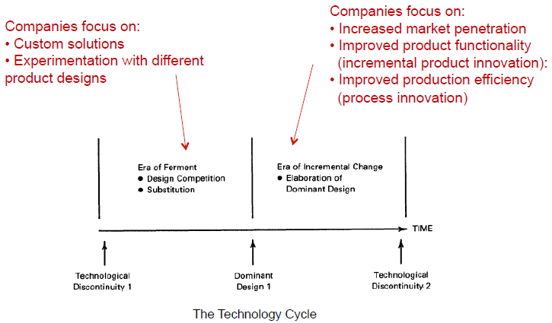

**› During the “era of incremental change”, firms typically focus on:**

- Increased market penetration

- Segment the market offering different models at different price points

- Improved product/component functionality (incremental product innovation):

- New features and increased performance (faster, more scalable, etc)

- Improved production efficiency (process innovation):

- Lower production prices through simplification of components or process innovation

**› This continues until the next technological discontinuity.**

**› The era of incremental change accounts for most of the technological process.**

› Anderson and Tushman noticed that during the era of incremental change, firms often:

- stopped investing in learning about alternative designs; and

- focused on developing competencies related to the dominant design.

› This helps to explain why firms entrenched盘踞in a dominant design often don’t recognise or react to discontinuous technologies:

- Eg Microsoft’s and AOL’s apparent明显的slowness in identifying and acting on the importance of the Internet

#### -Standards for dominant designs

› Sometimes standards are used to encourage or maintain a dominant design in an industry

› Standards may be defined by:

- a formal standards organisation (“de jure”); or

- wide public acceptance or market forces (“de facto”)

› Standards may be for controlling:

- Quality (products/services have required characteristics); or

- Compatibility (products/services can be used with other products/services)

- Compatibility standards can be:

- Sponsored (a party or parties hold a proprietary interest业主权益in a particular technology and in the adoption of it by others); or

- Non-sponsored

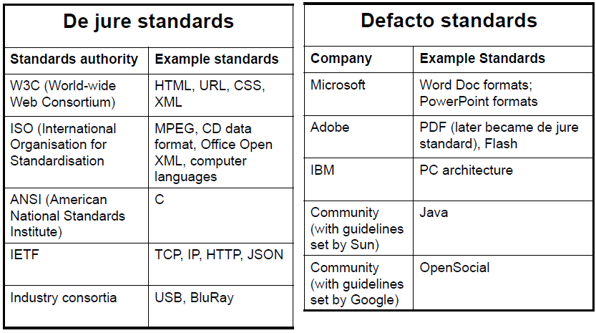

### ›Why dominant designs get selected in markets:

› Market forces: Increasing returns to adoption

- For many technologies (especially in IT), the more a technology is adopted, the more valuable it becomes to the industry because of:

**- Learning effects:**

- The industry gains knowledge in all aspects of the technology

**- Network effects:**

- The benefit of using a technology increases with the number of users.

**› Government regulations**

- Sometimes, the government sees the importance of a technology for a nation and regulates a specific dominant design (eg for TV, mobiles)

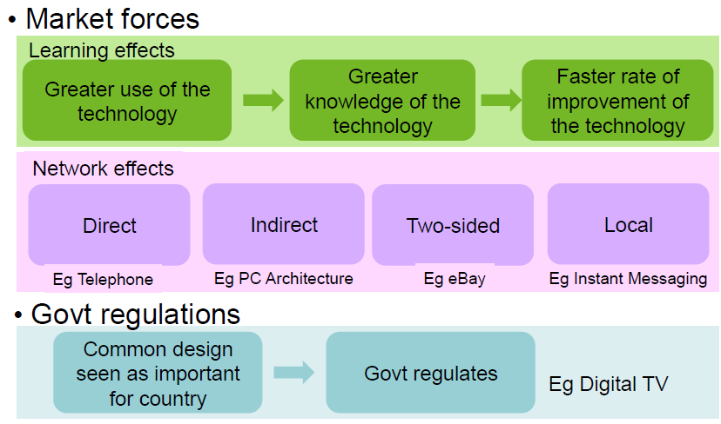

#### -Learning effects

› When a design is dominant, there is greater use of the technology.

› Greater use leads to greater knowledge accumulation积累about that technology

› Greater knowledge enables a fast rate of improvement of the technology

› Company structures and culture are based around the technology

#### -Network effects

- For technologies with network effects, the benefit from using a technology increases with the number of other users

- eg railways, telephone, Facebook, Skype

› Popularised in IT by Robert Metcalfe:

- Co-inventor of Ethernet以太网, Co-founder of 3Com

› Rationale for buying network interface cards:

- Cost of cards = N

- Value of cards = N2

› Known as “Metcalfe’s Law”

**Types of network effects**

› Direct network effects:

- Increase in usage leads to direct increase in value

- eg Email, Telephone, Twitter

› Indirect network effects:

- Increase in usage leads to increase in value of complementary互补性goods leading to increase in value of the original technology

- eg PC Architecture gained value from value of compatible兼容的 software

› Two-sided network effects:

- Increase in usage by one set of users increases value to another set

- eg marketplaces (such as eBay, Airbnb), reader/writer software

› Local network effects:

- Increase in use of local networks (within a larger network) leads to increase in value

- Eg Instant Messaging, Facebook

#### -Government regulations

- There are often strong consumer or economy benefits of having a single dominant design

- Rather than wait for market forces, sometimes government organisations step in介入 and impose强加 a standard

- Examples:

- Digital TV in Australia (using the DVB-T standard)

- compare with the standard for an HD media format which was not imposed by government but was left to market forces to sort out挑选出(Blu-ray vs HD DVD)

- GSM (General Standard for Mobile communications) for telecommunications:

- This was established in the EU early for all mobile communications whereas in US, there was a long battle between different technologies (which has left many problems).

### ›Frameworks for modelling design dominance

› Suarez (2004) proposed a framework for modelling design dominance

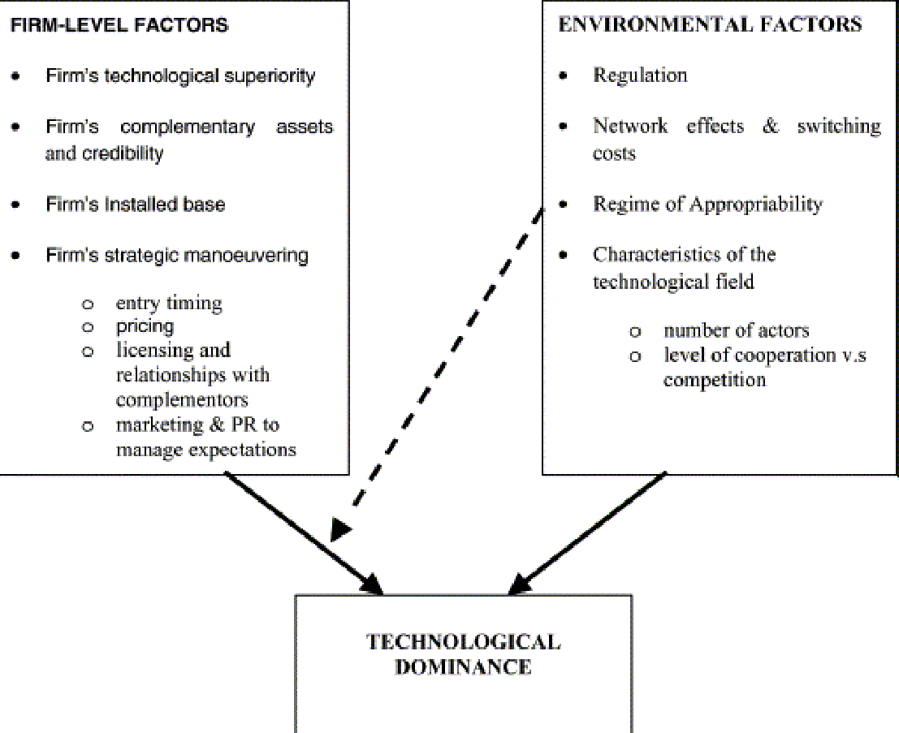

Firm- and environment-level factors influencing the outcome of technology battles.

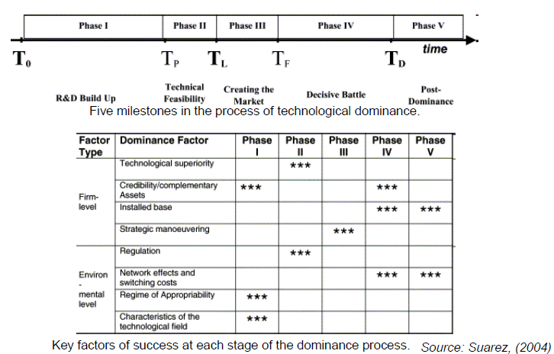

# Question 1 (maximum 450 words)

Utterback and Abernathy introduced the concept of "design dominance" in an industry. Explain the concept of "design dominance". Give an example of an IT-related architecture that has become (or became) a dominant design. Identify factors that led to that architecture becoming dominant over other possible architectures and explain how each of those factors contributed to this dominance.

The concept of dominant design depends on the settlement of the industry. It can be explained that when a new product is first introduced, it is usually “made-to-order”. If the product attracts significant market share (through whatever path – technological superiority, good marketing etc.), it forces imitation by competition. Competitive products are released. There is pressure to reduce costs in components leading to commoditisation of components (for mass production). This requires there to be a “dominant design” with components fitting within this design. The dominant design may be established by the first company to release a product, a later arrival or by a standards body. The dominant design becomes a base for the whole industry. This design may become a defacto standard or a de jure standard.

The example of dominant designs in IT is the IBM PC Architecture. The IBM PC is firstly developed in less than one year in a "skunkworks" project at IBM's Boca Raton Florida facility. It was rapid development cycle because of use of "off the shelf" parts for disk drives, processors, memory, operating system etc. In addition, its processor was from Intel and the operating system from Microsoft. Therefore, IBM published the bus and BIOS specifications, this was to drive generation of add-ons, but also enabled competitors to make “compatible” PCs. In 1981, the first IBM PC released. In 1982, the first roughly IBM compatible PC released (by Columbia’s MPC), which used many of the same components as the IBM PC (but higher specification) and used the published bus interfaces and wrote own BIOS. By end 1982, Eagle Computer and Compaq had released compatible PCs, with companies able to make their own PCs including BIOSes and being able to license the OS from Microsoft. At that time, IBM had many competitors producing similar products at lower cost. By 1986, IBM compatible PCs had >50% of market share. By 1990, IBM lost its lead in PC sales. Despite losing on PC sales, IBM realized the opportunity of the scale of the market and was successful in licensing patents related to various components of the PC. The IBM PC architecture became the dominant design even though the IBM PCs and compatibles were not the most advanced personal computer.

Below table shows the factors that led to that architecture becoming dominant over other possible architectures.

Some factors in its initial rise to dominance leading of the IBM PC architecture. Firstly, the open architecture with (mostly) specified interfaces. Secondly, the easily available components for assembling. Next, many different vendors with compatible system get a lot of competition on price. Finally, the software compatibility across a large range of vendors.

# [Week 3 - Disruptive innovation](https://elearning.sydney.edu.au/webapps/blackboard/content/listContent.jsp?course_id=_52292_1&content_id=_2654016_1)

Pre-reading:   
"Managing disruption: An interview with Clayton Christensen"

<http://www.iriweb.org/Public_Site/RTM/Volume_54_Year_2011/Jan-Feb2011/Managing_Disruption.aspx>

Lecture: [Disruptive innovation](https://elearning.sydney.edu.au/bbcswebdav/pid-2654016-dt-content-rid-14512342_1/xid-14512342_1)

### ›Disruptive innovations create new markets or change the value systems within existing markets—need reading

“**Disruptive innovations**” disrupt markets

i.e. They create new markets or change the value system in an existing market.

Innovations may not come from customers requirement, it usually comes from the daily job of the customer. By watching them work and analyze the deep requirement of the customer, innovation occurs.

e.g. Conan developed tabletop copiers which finally take place of Xerox's well-functioned printer.

Intuit developed QuickBooks that made it really easy to get the basic jobs of a small business done and freed up their time to do what really helped them make money.

Cisco(brand for router), which disrupted Lucent was just a classic disruptive technology to the conventional circuit-switched equipment, but the router originally couldn’t handle voice. It could handle data because the latency delay wasn’t as big an issue, and that enabled the Internet to happen Intel established microprocessor to keep its market share in low end of the market.

**Value Network/Value System**

› Term “value network” first used by Clayton Christensen

› Also called “value system”

› Similar concept to “industry value chain” but usually more focus on the whole system rather than on a thread through it for one product type

› A value network is:

› “the collection of upstream suppliers, downstream channels to market, and ancillary辅助的 providers that **support a common business model** within an industry.”

**Discussion based on reading**

› Discuss the cases from the Clayton Christensen interview:

- Canon disrupting the photocopy market where Xerox was dominant

- Intuit disrupting the small business accounting market with QuickBooks

- MinuteClinic disrupting the medical clinic

- Intel resisting抵抗disruption by developing the low-cost Celeron赛扬 processor

- Cisco disrupting the voice comms market with VoIP support in routers

- Kodak not dealing with disruption from digital photography

### ›“The innovator’s dilemma” (Christensen)

› Christensen identified the “innovator’s dilemma”…

› Effective established companies study the needs of their customers

› The companies innovate to meet these customer needs

› The companies sell new products/versions to their customers

› The most important existing customers are the high-end ones who spend the most so the focus is on them

› The dilemma is that the more a company focuses on the needs of their high-end customers, the more likely it is that they will miss opportunities in emerging technologies

› Examples:

- Kodak and digital camera

- Microsoft and the web browser (initially)

### ›Sustaining innovation vs disruptive innovation

› According to Christensen, innovations can be either disruptive or sustaining

- “Disruptive innovations” disrupt markets - (i.e. they create new markets or change the value system in an existing market)

- “Sustaining innovations” sustain markets - (i.e. there is no change to the value system in the market)

### ›Low-end disruption and new-market disruption

› Christensen distinguishes between:

- "low-end disruption” – there are customers who do not need the full functionality or performance of products already on the market so cheaper alternatives can take over.

- "new-market disruption" – there are customers who have needs that were not being addressed by existing products

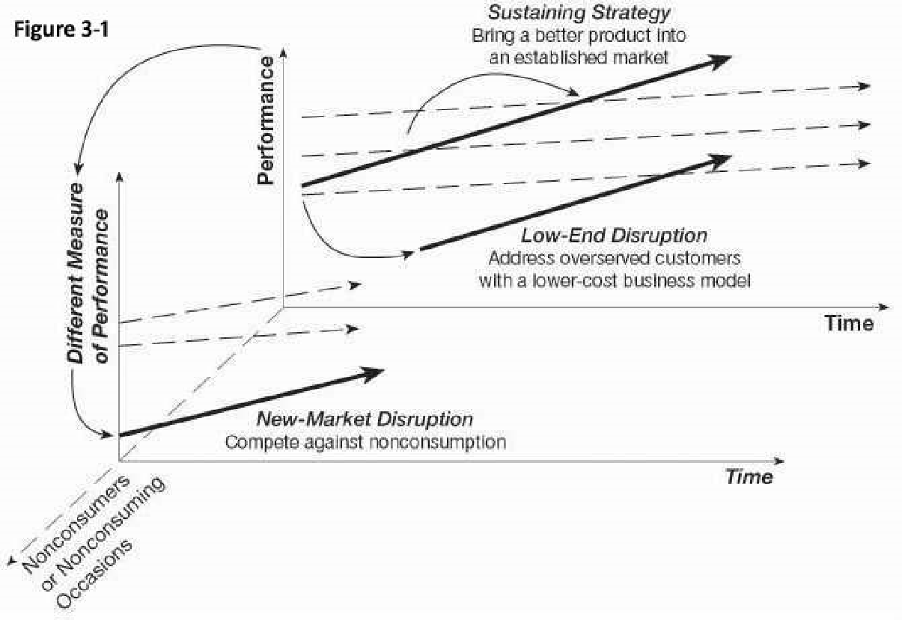

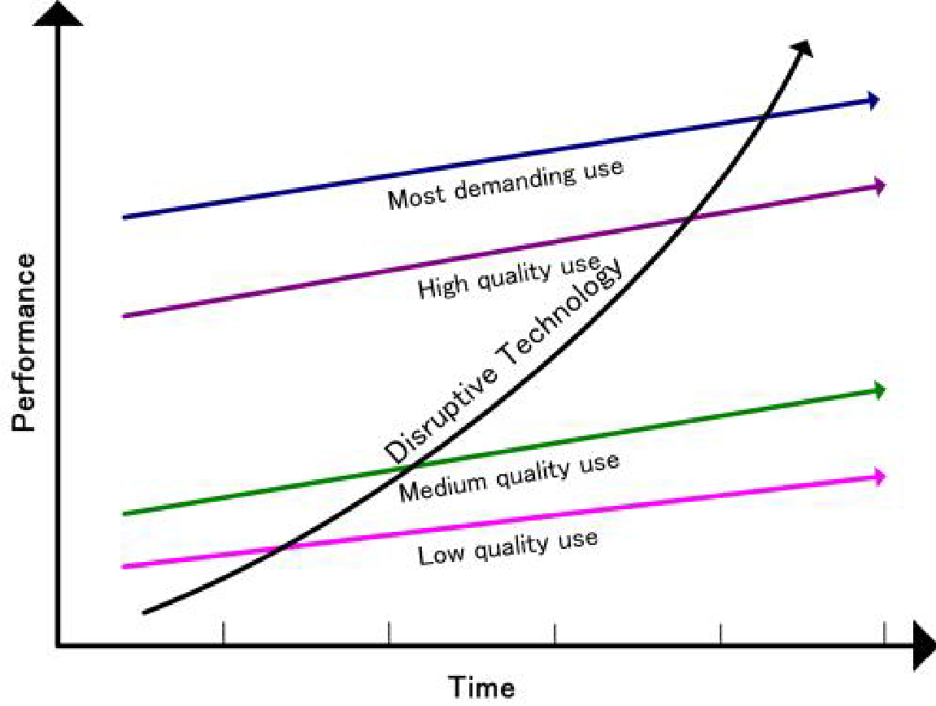

### ›Industry value chains and value networks

#### -What are they?

**Industry value chains**

› An industry value chain is how value is created and passed on between participants in an industry

› Diagrams can be used to show how value flows through the industry

› Value may be from licensing a technology, selling a product, providing a service, etc

Example industry value chain: Microprocessors

foundry代工厂

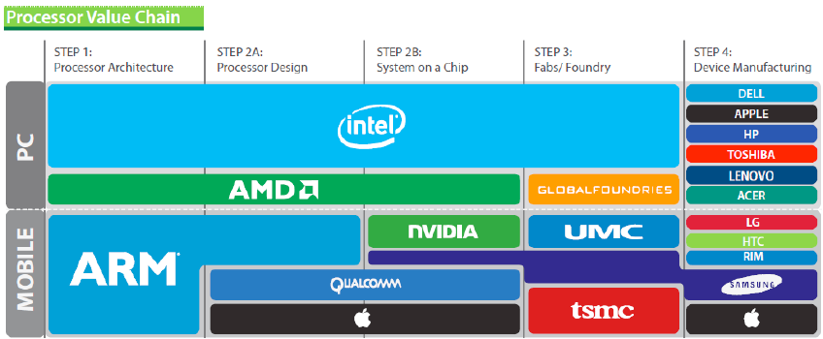

**Value network/value system**

› A value network is:

› “the collection of upstream suppliers, downstream channels to market, and ancillary providers that support a common business model within an industry.”

#### -Analysing a value network

› Analysing value chains/systems/networks is useful for:

› Understanding an industry (including relationships between companies)

› Understanding your company’s position within the market

› Deciding where your company wants to be within that market

› Looking for opportunities for disruptive innovations

**e.g. Mobile phone value network**

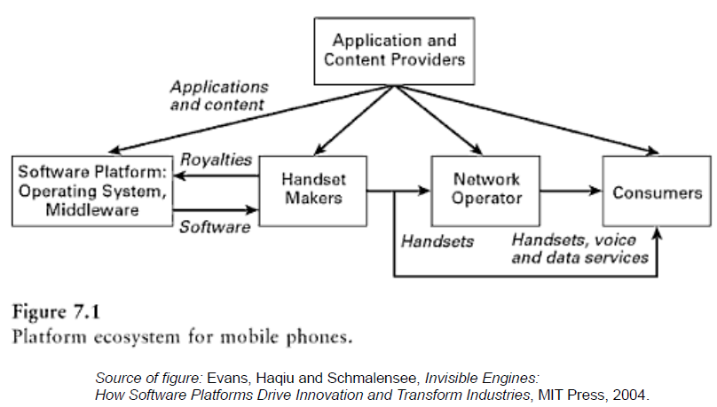

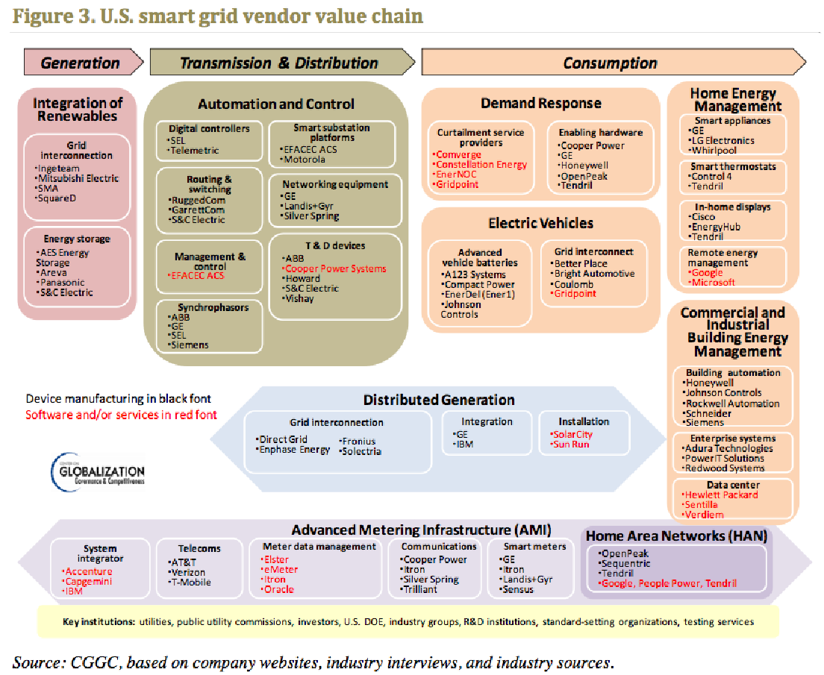

### ›Disrupting value networks

#### -disintermediation, reintermediation, ignoring

› Disrupting value networks can be done by:

a) Analysing the value network and attempting to change it:

#### - “Disintermediation” = “cutting out the middleman”

- Common using the Internet

- (eg book flights from the airline directly)

#### - “Reintermediation” = adding in a new intermediary中介

- Also common using the Internet

- (eg new types of travel agent – WebJet, Flightfox, etc)

#### b) Ignoring the current value network and having it change around you

- Also common using the Internet

- Facebook: “Move fast and break things”

### ›The relevance of disruptive innovation to established companies知名公司 and to startups – wk9

› Established companies doing the right thing (i.e. listening to their customers) may not see disruptive innovations coming

› Established companies can learn to notice potentially disruptive innovations at an early stage and act

› Understanding value chains/networks is useful:

**- If you are an established company:**

- In understanding emerging threats

- In designing a strategy to disrupt a market

**- If you are a startup:--wk9**

- In disrupting a market

**- If you are in corporate IT:**

- In understanding how products and solutions may change

# [Week 4 - Innovation Systems and Distributed Innovation](https://elearning.sydney.edu.au/webapps/blackboard/content/listContent.jsp?course_id=_52292_1&content_id=_2654015_1)

Topics: Innovation Systems; Distributed Innovation; Open Innovation; Crowdsourcing   
  
Pre-reading:   
"Crowdsourcing: A Model for Leveraging Online Communities" by Daren C. Brabham

<http://dbrabham.files.wordpress.com/2011/03/brabham_handbook_crowdsourcing.pdf>

Lecture: [Innovation systems and distributed innovation](https://elearning.sydney.edu.au/bbcswebdav/pid-2654015-dt-content-rid-14546824_1/xid-14546824_1)

## Tutorial: [Industry value chains/networks](https://elearning.sydney.edu.au/bbcswebdav/pid-2654015-dt-content-rid-14553901_1/xid-14553901_1)

### ›Innovation system models:

#### -Parties involved, framework conditions, government policy

› Companies are continually innovating to stay competitive

› Entrepreneurs are continually looking for opportunities to change the value network

› Companies are being created and being destroyed

› Industries are being created and being destroyed

› This doesn’t happen in isolation – there is a system (or eco-system) in which innovation happens.

**› For example:--wk12**

- The government invests in research and innovation programs

- Angel investors and venture capitalists provide money which allows scaling缩放

- Companies partner with universities to get new ideas and technologies

**› Governments understand the importance of innovation**

- Improving productivity, standard of living, health, education, etc

› So, create programs to support/encourage innovation

› More about programs later (later lecture)

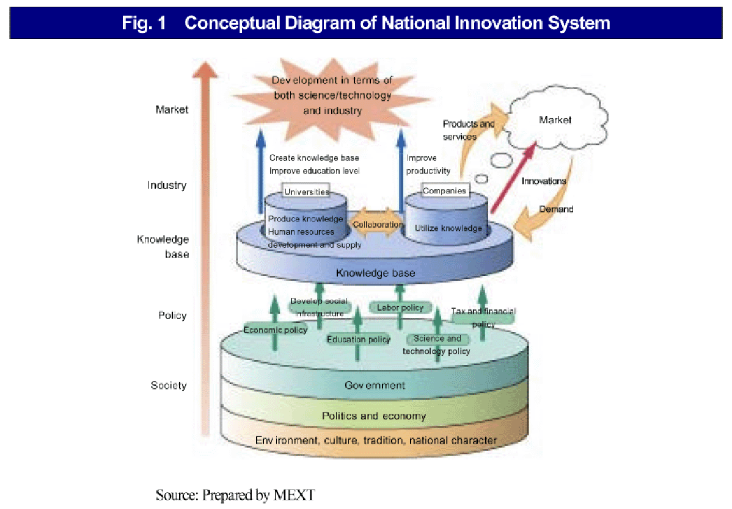

### ›Innovation eco-system

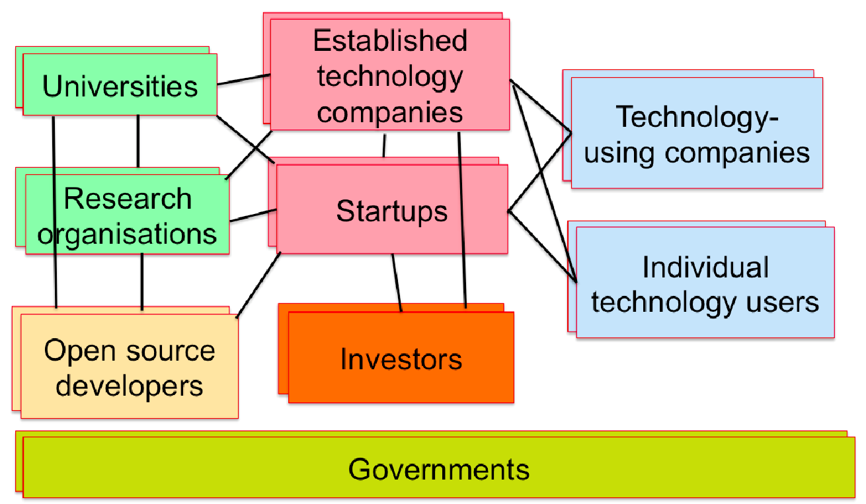

### ›Trends in late 20th century leading to more distribution of innovation

› Mobility of knowledge workers between companies

› Globalisation

› Better information and communication technologies (eg email, web)

› Availability of venture capital funding

› Easier to create and build new technology companies

› So more opportunities for collaborative innovation合作创新

### ›Joy’s Law – “Most of the bright people don’t work for you -- no matter who you are. [So] you need a strategy that allows for innovation occurring elsewhere” –本章后边引出open innovation

### ›Distributed innovation - “a system in which innovation emanates发出 not only from the manufacturer of a product but from many sources including users and rivals” (Eric von Hippel)

### ›Models for distributed innovation 分散式创新

#### › Getting outsiders to innovate (eg using Innocentive创新中心)

一家名为“创新激励”（InnoCentive）的互联网公司，在网上悬赏求解问题，赏金高达100万美元)

InnoCentive helps clients to engage a world of creative and diverse on-demand talent to rapidly generate novel ideas and solve important problems.

#### › Blending community and commerce (eg Threadless)

无线体恤公司Threadless网站让它的顾客来进行设计工作，选择生产线，确定产量，并负责市场推广，促销，以及销售工作。生产当然是外包的。而Threadless自己需要做的仅仅是维护网站而已。这意味着零市场风险和负的运营资本。

#### › The Self-organising community (eg Linux development community)

### ›Open innovation:

#### -What is open innovation?

Definition of “Open Innovation”

“the use of purposive inflows and outflows of knowledge to accelerate internal innovation and expand the markets for external use of innovation” (Chesbrough, 2006)

#### -Types of open innovation

**1. Outside-in process:**

- “Enriching 丰富与加深the company’s own knowledge base through the integration of suppliers, customers, and external knowledge sourcing”

**2. Inside-out process:**

- “Earning profits by bringing ideas to market, selling IP, and multiplying technology by transferring ideas to the outside environment.”

**3. Coupled process:**

- “co-creation with (mainly) complementary partners through alliances联盟, cooperation, and joint ventures 合资 during which give and take are crucial for success.”

#### -Benefits of open innovation

›Larger base of ideas to draw from for innovation

- “Not all of the smart people work for us” (Bill Joy from Sun Microsystems)

›Existing third-party technology can be used, reducing risk and cost of development from scratch

›Identification of new business opportunities with collaborators

›Share risks and pool resources with other companies

›Can be lower cost than large R&D departments

#### -Different types of open innovation programs

1. GE open innovation

GE understands solving the world’s toughest problems through advanced manufacturing techniques and processes requires collaboration. By crowdsourcing innovation—both internally and externally—GE is improving customer value and driving advancements across industries. By sourcing and supporting innovative ideas, wherever they might come from, and applying GE’s scale and expertise, GE’s approach to open innovation is helping to address customer needs more efficiently and effectively.

Open Innovation Manifesto

We believe openness leads to inventiveness and usefulness.

We also believe that it’s impossible for any organization to have all the best ideas, and we strive to collaborate with experts and entrepreneurs everywhere who share our passion to solve some of the world’s most pressing issues.

We’re initiating a fundamental shift in the way we do business - this is what we’ll stand for in our open collaboration efforts and how we will operate.

2. Cisco

3. Mediacamp

4. Samsung accelerator

5. Coca-Cola Journey

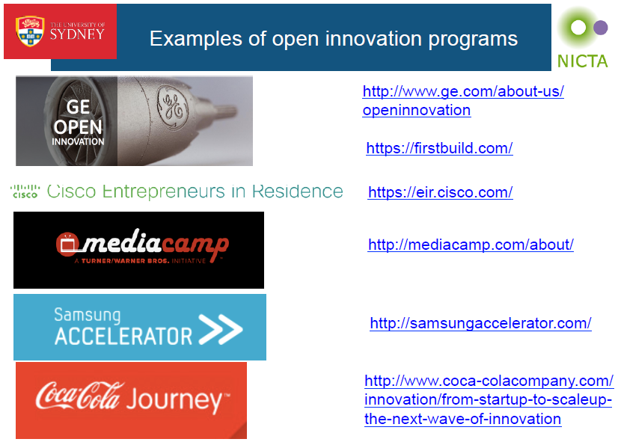

#### -Balancing internal and external innovation

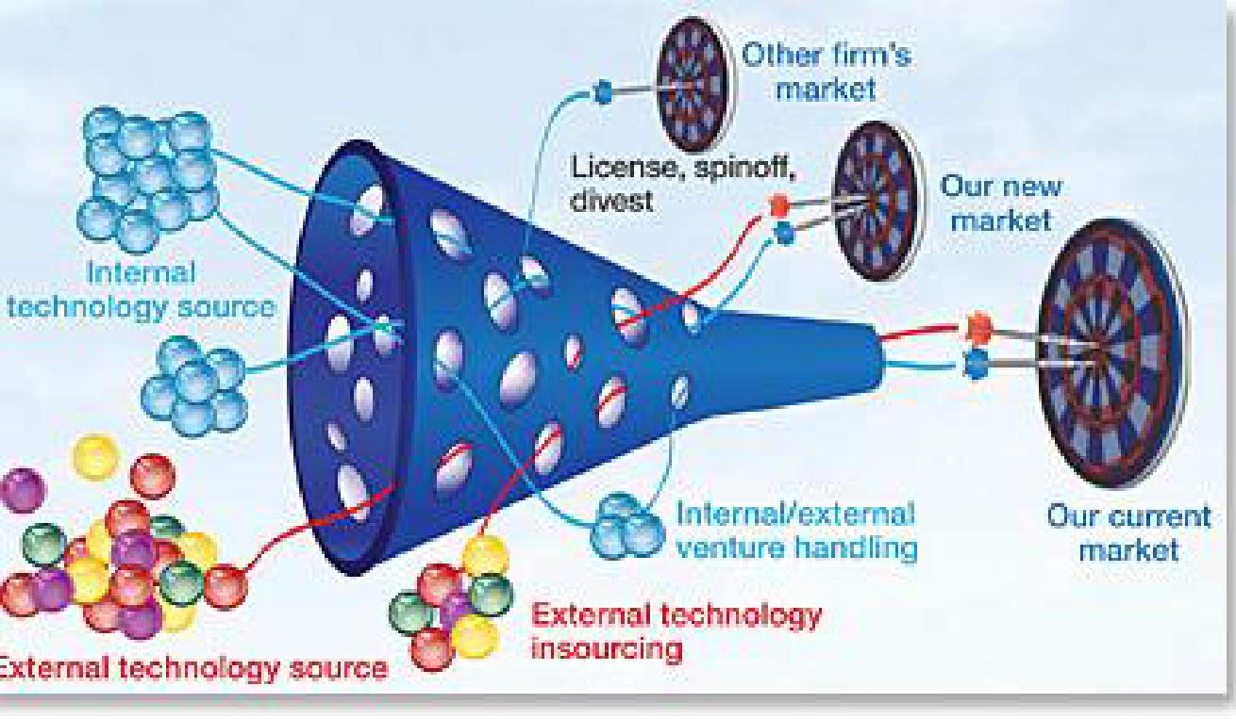

Both traditional (“closed”) innovation and open innovation have benefits. Many companies do both and balance them.

Take the R&D funding of P&G for an example, in 2002, P&G used mostly closed innovation. By 2007, P&G had moved to approximately 50/50 open and closed innovation.

#### -Risks of open innovation

Risks of open innovation (compared to closed innovation)

**› Lack of control**

- Will usually not have as tight control of external resources as internal ones

**› Higher complexity of managing innovation**

- Need to manage external relationship, intellectual property—wk13, confidentiality保密性 etc

**› Higher coordination costs**

- May cost to coordinate external resources

**› Possible loss of own capability over time**

- If have not using and building a capability but relying on others

**› Possible loss of competitive advantage compared to others**

- If allow others to build skills in area important to your business, they can sell their expertise to your competitors (contracts can help address the risk)

### ›Approaches for involving others in innovation:

#### -Product platforms

› Concept became popular in the 90s – used for reusable components/design frameworks

› Foundation of components around which a company builds related products

› Also known as “product family engineering”

› Platforms make it possible for companies to:

- Have a rich line-up of different products with the same core functions

- At different price-points

- For different customer types

- To do so efficiently through re-use of a common platform

› Examples:

Nero video editing software (http://www.nero.com)

Canon DiG!C chip

**-Benefits of product platforms to companies**

› For internal product platform:

- Reuse technology component in multiple products leading to:

- Faster development time so gets to market sooner

- Lower effective cost (as spread over multiple products)

- Innovative aspects of the platform can benefit a range of products

- Application development on platform can focus on innovative value-add

› But also platform can be made available externally, leading to new businesses and new business models

#### -Open APIs 应用程序接口(Application Programming Interface)

**-The growing importance of Open APIs (especially web-based services)**

According to the programmableWeb, the growth in web APIs since 2005 is from 001 to 10302.

#### -Releasing data sets

› Many governments have opened up government data (“Open Data”)

› Some companies are doing it too

› They are encouraging users to develop websites and apps using the data

- In some cases, static data (eg tables of static data)

- In some cases, live data feed 实时数据(eg an RSS feed or data service)

› Examples:

- The Australian federal government http://data.gov.au includes:

- Electoral boundaries选区

- Crime data, census人口普查 data

- NSW Government data.nsw - includes:

- Bus stop data, Electricity consumption data

- Examples of companies:

- GoGet car share data, Coca Cola Amatil data

#### -Crowdsourcing:

› Original definition (from 2006)

› = Crowd + Outsourcing

› “Simply defined, Crowdsourcing represents the act of a company or institution taking a function once performed by employees and outsourcing it to an undefined (and generally large) network of people in the form of an open call公开选拔. This can take the form of peer-production (when the job is performed collaboratively), but is also often undertaken by sole individuals.

The crucial prerequisite is the use of the open call format and the wide network of potential laborers.”

› Newer definition:

› “Crowdsourcing is a type of participative online activity in which an individual, an institution, a non-profit organization, or company proposes to a group of individuals of varying knowledge, heterogeneity, and number, via a flexible open call, the voluntary undertaking of a task. The undertaking of the task, of variable complexity and modularity模块化, and in which the crowd should participate bringing their work, money, knowledge and/or experience, always entails承担 mutual共同的 benefit. The user will receive the satisfaction of a given type of need, be it economic, social recognition, self-esteem自尊, or the development of individual skills, while the crowdsourcer will obtain and utilize to their advantage what the user has brought to the venture, whose form will depend on the type of activity undertaken.”

› (a) there is a clearly defined crowd;

› (b) there exists a task with a clear goal;

› (c) the recompense 报酬 received by the crowd is clear;

› (d) the crowdsourcer is clearly identified;

› (e) the compensation报酬 to be received by the crowdsourcer is clearly defined;

› (f) it is an online assigned process of participative type;

› (g) it uses an open call of variable extent;

› (h) it uses the internet.

**-Why companies do it**

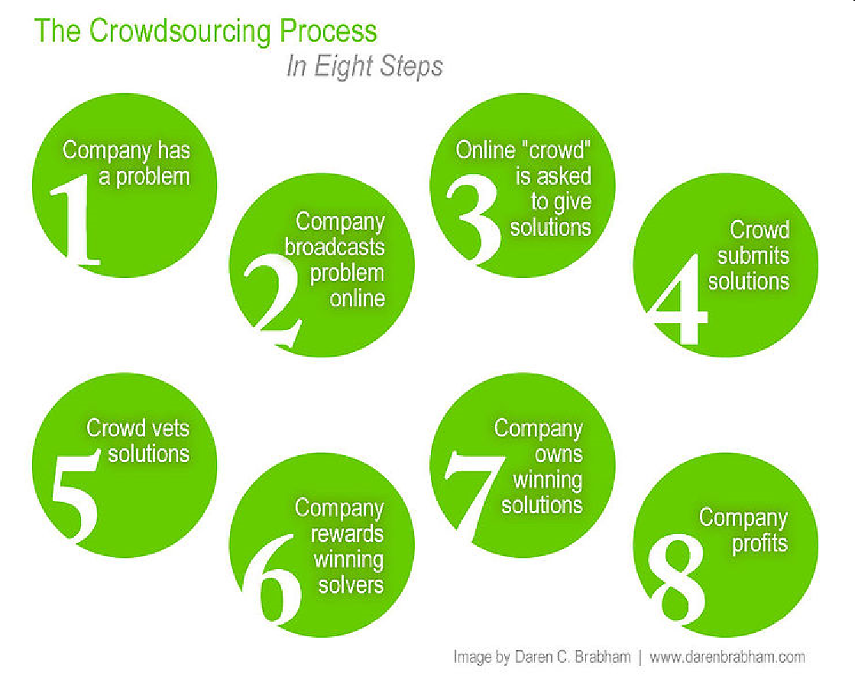

**-Why individuals contribute**

Many varying reasons including (from Brabham reading):

› “the desire to earn money;

› to develop one’s creative skills;

› to network with other creative professionals;

› to build a portfolio for future employment;

› to challenge oneself to solve a tough problem;

› to socialize and make friends;

› to pass the time when bored;

› to contribute to a large project of common interest;

› to share with others; and

› to have fun.”

**-Types of crowdsourcing**

› Knowledge discovery and management

- Example: <http://seeclickfix.com>

Report neighborhood issues and see them get fixed

› Broadcast search

- Example: <http://innocentive.com>

是第一家以现金激励为基础、促进全球性科学研究的(work2.0)沃客公司， 也是专门为全球科技研发界而创建的、首家互联网奖励机制公司

› Peer-vetted creative production

- Example: <http://threadless.com>

A company making T-shirt involves customers into the design of their products

› Distributed human intelligence tasking

- Example: <http://mturk.com>

The Mechanical Turk is a website provided by Amazon to create a platform for those who have interest working on human intelligence tasks to make money and for those have tasks needed to be solved.

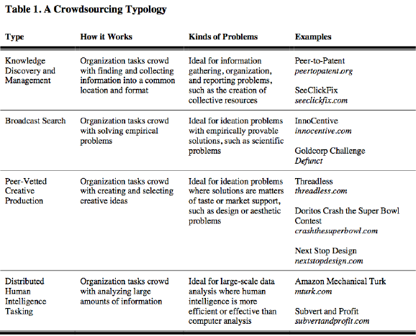

#### -User innovation—wk5

#### -Free and open source software—wk5

#### -Accelerators, investment, etc—wk9

# Question 3 (open innovation)

Identify and discuss 2 benefits that a company may gain and 2 risks that a company faces in using open innovation for product innovation. Support your discussion of each benefit and risk with an IT-related example (which can be either a real-world one or a fictional one for purposes of illustration).

The definition of open Innovation is “the use of purposive inflows and outflows of knowledge to accelerate internal innovation and expand the markets for external use of innovation” (Chesbrough, 2006).

The benefits of open innovation is listed below:

›Larger base of ideas to draw from for innovation - “Not all of the smart people work for us” (Bill Joy from Sun Microsystems)

›Existing third-party technology can be used, reducing risk and cost of development from scratch

›Identification of new business opportunities with collaborators

›Share risks and pool resources with other companies

›Can be lower cost than large R&D departments

Risks of open innovation (compared to closed innovation) is listed below:

›Lack of control - Will usually not have as tight control of external resources as internal ones

›Higher complexity of managing innovation - Need to manage external relationship, intellectual property, confidentiality and etc.

›Higher coordination costs - May cost to coordinate external resources

›Possible loss of own capability over time - If have not using and building a capability but relying on others

›Possible loss of competitive advantage compared to others - If allow others to build skills in area important to your business, they can sell their expertise to your competitors (contracts can help address the risk)

Open innovation can reduce R&D cost, customers’ need can be incorporated in the early stage of development and can be able to meet the fast changing need of customers, to preventing lagging behind with the customers’ expectations. However, companies may be at risk in releasing some trade secrets to other companies during research so that they have lost their competitive advantage. The complexity of controlling innovation may also affect the success rate of their particular innovation. Some algorithms may be too complex to develop under one small software house, open innovation can make use of the strategy to reduce the R&D cost and significantly reduce the possibility of not meeting customers’ need, thus reducing cost and and possibility of not meeting the customers’ targets. However, great ideas from the software house may lose of the competitive advantage as the ideas may not be discovered by the the large software house. Large software house has the resources to “copy” the great ideas from the software house to deploy such kind of services and take away the market share. For large software houses, open innovation may also make the project to be more complex as they may need time and resource to integrate those ideas and solutions into their products and to make it through the internal security audits.  
Take the SAP for example, The Global SAP Co-Innovation Lab (COIL) Network enhances the capabilities of SAP’s partner and customer ecosystem through an integrated network of world-wide expertise, and best-in-class technologies and platforms. They also put SAP’s efforts on communities as I believe they are a very important source for innovation today and even more so in the future. Those webpage network provide a forum so that the SAPers can post their problems, findings and project cases on it and discuss with other expertise. Only if the person is working on SAP ecosystem, he can read and find the large pool solutions for his case. The risk of this is that some of the security policy that needs to be added to control the risk of trade secrets. Besides, there is a group of SAP employee that works on the management of external relationship, intellectual property, confidentiality, etc.

One benefit is the access to a large number of people with diverse sets of skills enabling solving of problems not able to be solved within the company. For example, GE used the Kaggle crowdsourcing site to run a competition where participants from around the world used flight and weather data and were asked to predict flight arrival times. The winners produced a 40% improvement in accuracy over current approaches

# [Week 5 - User innovation and free and open source software](https://elearning.sydney.edu.au/webapps/blackboard/content/listContent.jsp?course_id=_52292_1&content_id=_2654014_1)

Topics for this week: User innovation and free and open source innovation

## Pre-reading: <http://www.wired.com/2013/11/open-source-a-platform-for-innovation/>

Lecture: [Week 5 lecture - User innovation and free and open source software](https://elearning.sydney.edu.au/bbcswebdav/pid-2654014-dt-content-rid-14626353_1/xid-14626353_1)

### ›Different modes of innovation: Who is doing the innovation?

#### -Producer innovation vs user innovation vs open collaborative innovation

**- “Producer innovation”:**

- Producer makes product/service for consumers

- Designs for innovations come from producer companies

- Producer innovators profit from many users of the same product/service

- Assumption that a producer serving many customers can afford to invest more in innovation than a single user innovating for themselves

- To encourage this investment, typical innovation policy allows producer to

“protect” innovation through patents

### ›User innovation

#### -Why users innovate

#### -The importance of user innovation in IT innovation

Approx 80% of the most important scientific instrument仪器 innovations were by users

Many product innovations in sports are innovations by users

Many innovations in IT are innovations by users

**Example of user innovation:**

**Apache web server**

› In 1994, the most popular web server was “httpd” by Rob McCool at NCSA (same place as Mosaic – most popular web browser at the time)

› This was available as open source

› Many httpd users (webmasters) modified the server code for their own sites

› Rob McCool left NCSA in mid 1994

› Eight httpd users emailed each other to discuss using each others changes

› In 1995, they created a common code base (it was “a patchy” web server so they called it “Apache”)

› By 1996, it was the world’s most used web server

› It still is

### ›Lead users

#### -Characteristics of lead users领先用户

› Face the needs that will be general in the market, but months or years before the general marketplace realises the needs.

› Will benefit significantly by obtaining a solution to those needs, and…

› Spend resources trying to solve those needs

› Are at the leading edge of trends and so are very knowledgeable about “state of the art” 技术发展最新水平

› Note: Lead users are not usually a company’s “lead customers” – they are usually not satisfied with current products so have had to create their own

› “Lead users” can provide concepts for products, services, processes and features to help companies innovate

› Sometimes, lead users actually do the innovation themselves (i.e. “user innovation”)

#### -Difference between lead users and typical users

› In some product categories (eg cleaning products), market research focuses on typical users (eg with interviews, focus groups)

› The feedback and opinions of typical users can be useful in developing new products.

› For IT and other high tech industries, typical users are not so effective

- Eg they often suffer from “functional fixedness” 功能固着

- Typical users not likely to suggest

› Involving lead users often leads to more effective innovation

› Lead users may be individuals, companies or communities

#### -Why companies engage with lead users

› “Lead users” can provide concepts for products, services, processes and features to help companies innovate

› Face the needs that will be general in the market, but months or years before the general marketplace realises the needs.

› Involving lead users often leads to more effective innovation

### ›Free and open source software:

#### -Proprietary software 专用软件

› Traditionally most software was proprietary

› Proprietary software is software built by or for a specific person, organization or group of organizations where:

- The owner holds intellectual property rights over the software; and

- The owner has total control over the software and how it is used

#### -“Free" software and “copyleft”

**Free software**

› “Free software is a matter of the users' freedom to run, copy, distribute, study, change and improve the software. More precisely, it means that the program's users have the four essential freedoms:

- The freedom to run the program, for any purpose (freedom 0).

- The freedom to study how the program works, and change it to make it do what you wish (freedom 1). Access to the source code is a precondition for this.

- The freedom to redistribute重发布 copies so you can help your neighbor (freedom 2).

- The freedom to distribute copies of your modified versions to others (freedom 3). By doing this you can give the whole community a chance to benefit from your changes. Access to the source code is a precondition 先决条件for this. “

**Copyleft**公共版权

“Copyleft is a general method for making a program (or other work) free, and requiring all modified and extended versions of the program to be free as well.” (Free Software Foundation)

› http://www.gnu.org/copyleft/

› Example of a copyleft licence is the GNU Public License (GPL) 通用公共许可证

#### -Open source software

› To be classified as OSS, the software must be (according to its licence):

- Freely redistributable可再发行的

- Source code must be available for free or at reasonable reproduction cost

- Modifications and derived works must be allowed and be distributable under same terms

- Can protect integrity 完整of author’s source code as long as allow source code patches补丁

- No discrimination区别 against people/groups

- No discrimination against fields of endeavour

- Must not be restricted to use with a specific product

- Must not place restrictions on other software distributed with it

- Must be technology-neutral技术中立

#### -Differences between “free” and open source software

› According to Stallman, "Open source is a development methodology; free software is a social movement.“

› Open Source covers a wider range of licence types

› More ability to mix Open Source software with proprietary software than is the case for free software

› The Open Source concept was developed to bring major software businesses and other high-tech industries into the mix.

› When avoiding distinguishing between these, people use the terms:

- FOSS (Free and Open Source Software); or

- FLOSS (Free/Libre自由 and Open Source Software)

#### -Open source hosting

› Offer hosting, version control, issue tracking, wikis, download support etc

› Some support code reviews etc

› Examples:

› Github (10 million repositories仓库):

- E.g. Ruby on Rails (web application framework), jquery (JavaScript query

engine), node.js (evented i/o for javaScript), Diaspora (distributed social

networking)

- Sourceforge (300k projects)

- Google Code (250k projects)

### ›Importance of free and open source software in innovation:

#### -In enterprise IT

› Many companies use open source software such as for:

- Internal IT infrastructure (eg Linux)

- Building and running web services (eg Apache, Apache Tomcat, JBoss)

- Building software for redistribution

› Open source software allows companies to rapidly innovate their infrastructure and services

› Open source grows from 10% in 2006 to 30% in 2012 of IT portfolio in companies

“73% of companies prefer open source or evaluate it on an equal footing with proprietary software”

#### -In startups

› Most infrastructure used in R&D and startups uses FOSS:

- Operating systems (eg Linux)

- System configuration management (eg Puppet, Chef)

› Most new software is built using FOSS:

- Software platforms (eg Java, Python, Ruby on Rails)

- Software libraries/frameworks (eg Spring framework, glibc)

- Software build and test automation (eg Jenkins, Cucumber)

› Most new software contains FOSS:

- To reduce time and cost of development

- To reduce testing and maintenance costs (assuming using stable FOSS)

- To provide compatibility with other software

- To focus on the core differentiator 区分者 of your own software

**e.g.**

› “Facebook has been developed from the ground up using open source software. Developers building with Platform scale their own applications using many of the same infrastructure technologies that power Facebook.”

### ›Free and open source licences

#### -Permissive vs restrictive

Whether the change is available

GPL--general public license

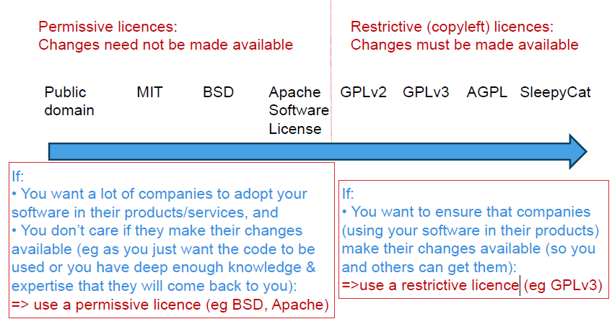

**When creating open source software: How do you know what licence to use?**

**=> use a permissive licence (eg BSD, Apache)**

You want a lot of companies to adopt your software in their products/services.

You don’t care if they make their changes available (eg as you just want the code to be used or you have deep enough knowledge & expertise that they will come back to you).

**=>use a restrictive licence (eg GPLv3)**

You want to ensure that companies (using your software in their products) make their changes available (so you and others can get them)

**=>use “Dual-licensing”. This is now very common**

Software can be licensed as GPL or proprietary licence

If a company doesn’t want to make their changes available, they can come to you to negotiate a proprietary licence

### ›Open source business models

#### -Different types

**1. Sell support and services**

- Example: Canonical (with Ubuntu)

**2. Sell certified version (with support and services)**

- Example: Cloudera (with Hadoop)

**3. Sell “enterprise edition” (effectively proprietary software)**

- Example: MySQL “standard edition” (not “community edition”)

**4. Dual licensing (copyleft so need commercial licence if modify source)**

- Example: Digia (with Qt)

**5. Cloud service using mostly open source**

- Examples: Facebook, Twitter

**6. Other advantage to the company**

- Example: Google (with Android)

### ›Managing the use of free and open source software

#### -Challenges, tools, etc.

**Challenges in using FOSS in products and services**

- Meeting obligations 义务of software licenses (ensuring appropriate notices, etc)

- Possibility of accidentally “contaminating污染 code”

- Eg a programmer introduces some GPL code from the Internet into some proprietary product code and then the product is release

- => legally, the company should release the proprietary source code

- Ensuring adequate足够的 quality of final product if some it includes some open source software of unknown quality

- Avoiding security vulnerabilities in underlying code (that may already be known to hackers)

› Companies developing products (hardware or software) or services and using open source software should have an open source policy and controls to ensure good governance.

› According to a Gartner report, <50% of Global 2000 IT Companies will implement an open source governance program by 2014.

› In a related survey, only 1/3 of companies surveyed had an OSS policy

**Tools for managing open source software**

› Most open source analysis tools provide ways for checking if open source software is used and check if usage conforms to a policy (eg a company OSS policy)

› Black Duck Software (http://www.blackducksoftware.com/)

- Software tools and online Knowledgebase containing open source software

› Palamida (http://www.palamida.com/)

› FOSSology (http://www.fossology.org/)

- Developed by HP – released as open source software

› Ohloh.net (http://code.ohloh.net/ )

- Owned by Black Duck Software

- Free online service for searching open source code

- Searching of over 15b lines of FOSS code

# [Week 8 - Idea generation and culture and structure for innovation](https://elearning.sydney.edu.au/webapps/blackboard/content/listContent.jsp?course_id=_52292_1&content_id=_2654011_1)

Topic: Idea generation and culture and structure for innovation

## Pre-reading: Paul Graham "How to get startup ideas" <http://paulgraham.com/startupideas.html>

Lecture:[Idea generation and culture and structure for innovation](https://elearning.sydney.edu.au/bbcswebdav/pid-2654011-dt-content-rid-14795085_1/xid-14795085_1)

### ›Where do new ideas come from?—from the video

#### -Importance of supporting networking of individuals

His fascinating tour takes us from the "liquid networks" of London's coffee houses to Charles Darwin's long, slow hunch to today's high-velocity web.

a collection of different interesting ideas from people with different background

good ideas comes from the conference table

where they share data and findings

beat the innovation

Market (devised for fiscal gain)

Non-market (not devised for fiscal gain)

Individual

network

### ›Generating new ideas for startups (Paul Graham):-- from the reading

#### -Addressing real problems

#### -Build something a small number of people want a lot

#### -Be at the leading edge of a field (“Live in the future, then build what’s missing”)

#### -Not “think up ideas” but “notice”

›Real problems:

-Address real problems, not made-up problems

›The “Well” analogy:

-Build something a small number of people want a lot, rather than something a large number of people want a little

›Getting yourself ready:

-Be at the leading edge of a field (even if just a user)

-“Live in the future, then build what's missing”

-External stimulus hitting a prepared mind

›Noticing:

-Not "think up ideas" but "notice“

-It’s OK to work on projects that produce “toys” as it prepares you to notice

-“Live in the future and build what seems interesting”

### ›Different modes of execution in companies (Moore)

#### -Invention, Deployment, Optimisation, Transition

#### -Require different culture, decision-making, etc

|  |  |  |  |  |
| --- | --- | --- | --- | --- |
| **Execution mode:** | **Invention** | **Deployment** | **Optimization** | **Transition** |
| **Core competence** | Creativity | Competitiveness | Control | Collaboration |
| **Decision style** | Intuition | Experimentation | Deliberation熟思 | Consensus一致同意 |
| **Functions most in alignment** | R&D, Creative Services | Sales, Engineering | Finance, Operations | HR, Marketing, Customer Support |

### ›Fostering a culture for innovation:

#### -Intrinsic motivation内在激励

#### -“Making progress on meaningful work”

›Some keys to an innovative culture at work:

1. Staff work on meaningful work

2. Staff have visibility of progress

3. Workplaces have many opportunities for people to interact on their work

### ›Size and structural dimensions of firms affecting innovation:

#### -Formalisation正规化

#### -Standardisation标准化

#### -Centralisation

›1) Formalisation: The degree to which the company uses rules and procedures to structure the behavior of employees.

›2) Standardisation: The degree to which company activities are performed in a uniform manner.

›3) Centralisation:

-Centralised authority: The degree to which decision-making authority is kept at top levels of the company

-Centralised activities: The degree to which activities are performed at a central location

#### -Differences between large companies, small businesses and scalable start-ups

›Size: Is Bigger Better?

-In 1940s, Schumpeter argued that large firms would be more effective innovators

-This is because they are:

-Better able to obtain financing

-Better able to spread costs of R&D

-As can spread over more products

-Eg Microsoft can spread cost of spell checker

-Large size may also enable:

-Greater economies of scale and learning effects

-Taking on large scale or risky projects

-However, large companies might also be disadvantaged for innovation because…

-R&D efficiency may decrease due to loss of managerial control

-Large companies can have more bureaucratic inertia墨守成规

-More commitments tie companies to current technologies

-Learning effects (see Week 2); external commitments

-Small firms are often more flexible and entrepreneurial创业的

-Many big companies have found ways of “feeling small”

-Break overall company into several subunits

-Can utilize different culture and controls in different units

-E.g. “skunk works” teams for doing new product development

### ›Approaches to organising firms for innovation:

#### -Mechanistic vs organic structures

›Mechanistic Structures have high formalisation and standardisation.

-Good for operational efficiency, reliability.

-Minimizes variation may stifle扼杀 creativity

›Organic structures have low formalisation and standardisation; described as “free flowing”

-May encourage creativity and experimentation

-May yield low consistency and reliability.

#### -Combining the best of small company and large company benefits

›Eric Schmidt, Google CEO (until April 2011)

›“One of the things that we've tried very hard to avoid at Google is the sort of divisional structure and the business unit structure that prevents collaboration across units. It’s difficult. So, I understand why people want to build business units, and have their presidents. But by doing that you cut down the informal ties that, in an open culture, drive so much collaboration. If people in the organization understand the values of the company, they should be able to self organize to work on the most interesting problems. And if they haven't, or are not able to do that, you haven't talked to them about what's important. You haven't built a shared value culture.”

− Some divisions (e.g., R&D, new product lines) may be small and organic.

− Other divisions (e.g., manufacturing, mature product lines) may be larger and more mechanistic.

− Some organisations try to do both in different divisions:

Tushman and O’Reilly (1996) called this the “ambidextrous organisation”

− Can also alternate through different structures over time.

− Sometimes new product development can be quite independent of even the main R&D division (eg “skunk works”)

# [Week 9 - Managing Innovation (in established companies and startups)](https://elearning.sydney.edu.au/webapps/blackboard/content/listContent.jsp?course_id=_52292_1&content_id=_2654010_1)

Pre-reading: Steve Blank (2013). "Why the lean start-up changes everything" Harvard Business Review, 91(5), 63-72.  
You can find it online or via the University's library site.

Lecture:  [Managing Innovation (in established companies and startup companies)](https://elearning.sydney.edu.au/bbcswebdav/pid-2654010-dt-content-rid-14865201_1/xid-14865201_1)  
I will talk about the innovation processes used in startup companies, how they differ from the processes   
used by established companies and how startups can work to take on much larger companies and sometimes beat them and sometimes disrupt whole   
markets.   
  
Tutorial :  
As a class, we will go through the process of (virtually) designing a new product/business to demonstrate the type of processes used in many startups.

### ›Differences between established companies and startups

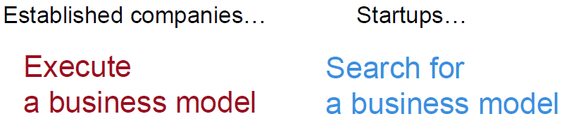

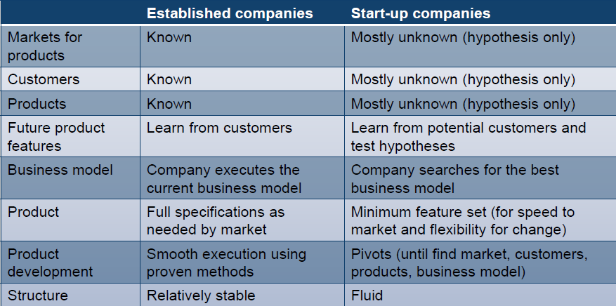

### ›Start-ups causing creative destruction across markets

›According to Schumpeter, entrepreneurs inside new companies usually drive innovation causing creative destruction across markets

### ›The importance of the entrepreneur

**›Dictionary definition:**

-“the owner or manager of a business enterprise who, by risk and initiative, attempts to make profits” (Collins English Dictionary, 2009)

-From French: someone who undertakes an activity

What’s an entrepreneur?

**›According to Schumpeter:**

-May be in small or large companies

-Is not necessarily an entrepreneur all the time

-May be a manager in a large company carrying out day-to-day management activities

-May or may not be person who provides funding

-Not necessarily the “risk-taker” (in economic sense)

-Schumpeter:

-“it is leadership rather than ownership that matters”

### ›Definitions of startups (e.g. from Steve Blank, Eric Reis)

**›Steve Blank:**

**“a temporary organization in search of a scalable, repeatable, profitable business model”**

**Eric Ries:**

“a human institution designed to deliver a new product or service under conditions of extreme uncertainty”

### ›Why traditional product processes are not suitable for startups

›Traditional new product introduction processes are not suitable in situations of uncertainty (eg most startups) as not enough is known about customers, needed features, etc

**Towards more systematic methods for startups**

›Emerging “management science” for startups

›Techniques to help startups build successful innovative companies despite level of uncertainty

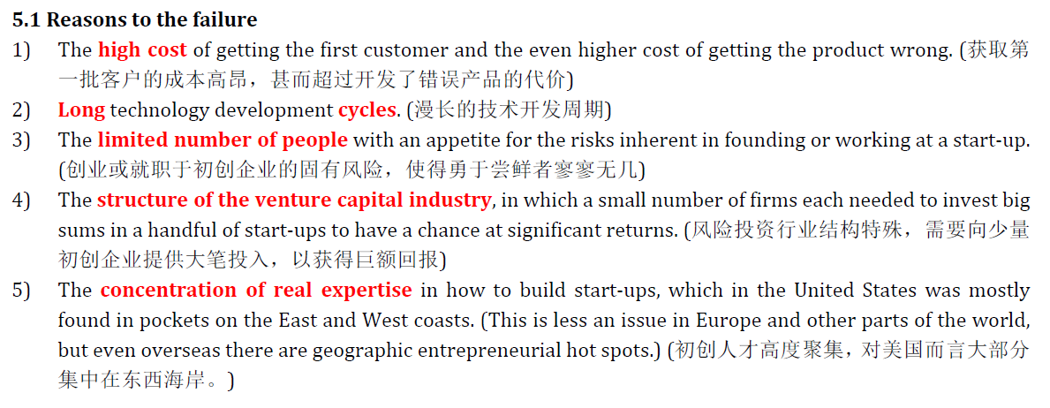

### ›New approaches for startups:

›The Customer Development process has been designed to help scalable可扩展 startups find a scalable business model

›The Lean Startup approach provides a useful model for IT startups which combines Customer Development and Agile Development

›The Business Model Canvas and Value Proposition Canvas provide useful templates to help guide development of business models

#### -The Customer Development process

Works where customers are unknown, product features unknown, market unknown, basis of competition unknown – i.e. Designed to solve “the 9 deadly sins”

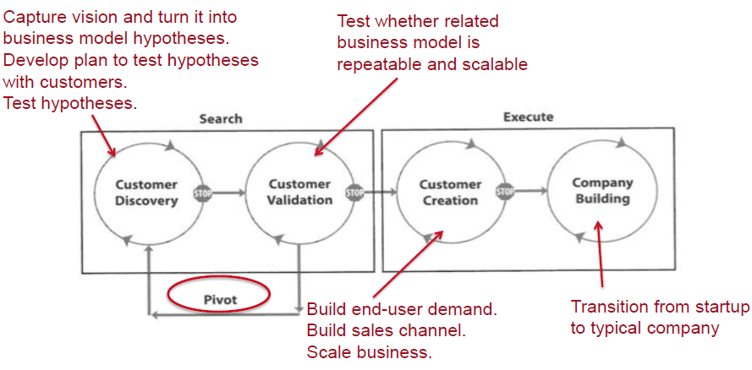

#### -The Lean Startup approach

›Eric Ries has developed the concept of “The Lean Startup”

›Combines Steve Blank’s Customer Development process with Agile Software Development

Marc Andreessen:

“Not every startup can be done lean” (consider Tesla)

Monopolies: “Winner takes all” markets

›Focus on big vision rather than incremental niche-making有利可图的市场 by pivoting旋转

›Focus on monopoly for a time in a market (eg Google, Twitter, Facebook) rather than continual competition

#### -The Business Model Canvas

›Created by Alexander Osterwalder et al, 2010

›Involved 470 practitioners in 45 countries

›Studied hundreds of business models and extracted key aspects into a model to make a common framework and tested it

Filling in the Business Model Canvas

›Startup = the search for a business model

›Business model canvas = a representation of a business model

›=> A startup is the processing of filling in a business model canvas

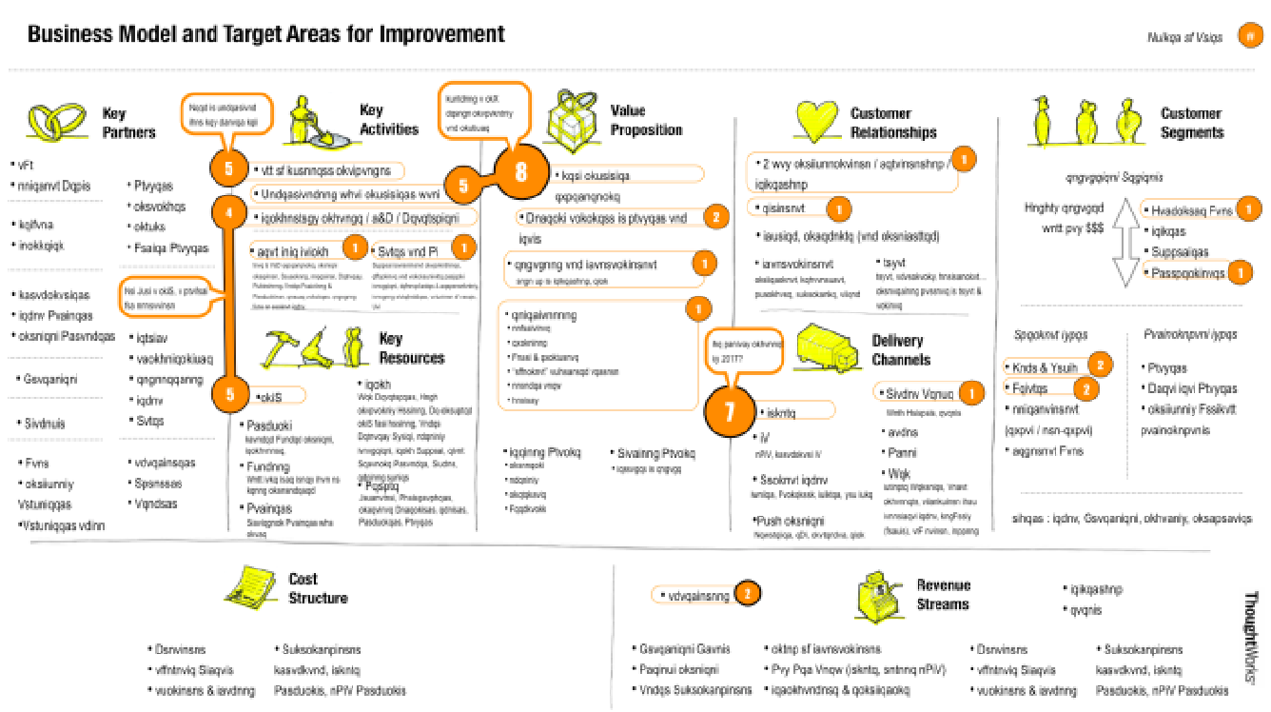

#### -The Value Proposition Canvas

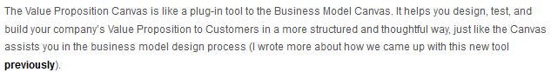

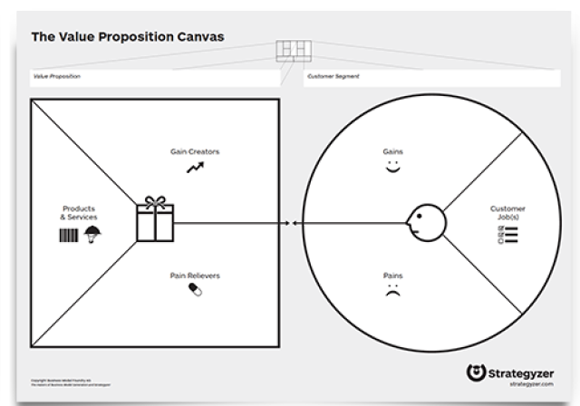

### ›Problem with using traditional project management methods for innovation

**Problem with traditional approaches**

›Impossible to know all requirements in advance

-The project takes time so the requirements at the time of capture may be different from those at the time of delivery

-Some requirements are only clear when users are using the product

-Too long to get customer validation of product

### ›Importance of managing with uncertainty

What’s wrong with this model when there is uncertainty?

(eg where customers are unknown, needed features unknown, basis for competition not known)

### ›The agile manifesto

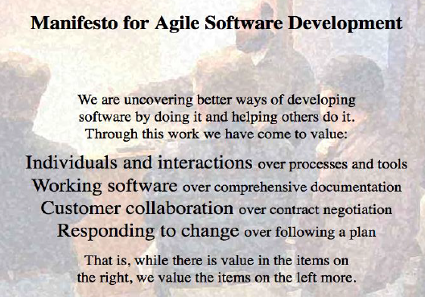

### ›Why agile approaches are well-suited to innovation—refer to below Q&A

# Question 4 (agile project management)

**Give three reasons why using an agile project management approach may be more successful than using a waterfall approach for innovation projects.**

Waterfall project undergo a series of task sequentially. Once a stage is finished, the early project stage would not be review again. Agile project management will have a better visibility towards the whole project, it is more convenient to change the project scope according to customers’ fast changing needs. Problems can also be easier corrected once if the project gone wrong, saving time and effort rather than discovered in the end, failing the whole project.

Innovation projects may experience a fast changing scope and results needed. Waterfall project sequential project development approach is not fit with the rapid change of the project requirements. It also provided a poor visibility to the outcome so that it is not possible to evaluate at the early stages of the project. Resource is intensively required for innovation and for those resources-less new startup will not have the luxury to make mistakes and restart the innovation after the delivery of wrong results and solutions. Agile provide visibility & its continuous review approach can allow innovations have a higher success rate. Thus Risk is reduced.

# [Week 10 - Innovation ecosystems](https://elearning.sydney.edu.au/webapps/blackboard/content/listContent.jsp?course_id=_52292_1&content_id=_2654004_1)

Topic: Innovation ecosystems

Lecture: [Innovation ecosystems](https://elearning.sydney.edu.au/bbcswebdav/pid-2654004-dt-content-rid-14914927_1/xid-14914927_1)

### ›Why is Silicon Valley a successful innovation ecosystem?

Why is Silicon Valley a successful innovation ecosystem?

**1.Strong research-driven universities (with endowments)**

Stanford University

University of California Berkeley Stanford

Universities operate within ecosystems

**2.Globally experienced repeat entrepreneurs**

Eg Elon Musk

Paypal, spacex, telsla

**3.Sophisticated risk capital**

Sophisticated angel investors Eg Ron Conway

Sophisticated venture capital

Sophisticated corporate investors

Importance in funding of innovation

1/3 of all venture capital investment in USA is invested in Silicon Valley (SV has < 1% of US population)

**4.Social capital**

“Some call it an ecosystem; others call it incestuous. In Silicon Valley every prominent player is just an adviser, an investor, a co-founder, an acquirer, or a director away from another. It’s an industry worth trillions that operates like a small town.”

**5.Knowledge sharing**

Churchhill club for igniting conversations

Importance in startup accelerators—combinator

Startup founders come back to mentor later founders

**6.Tolerance for risk taking**

›Entrepreneurs take risks by taking on ambitious missions

›Employees take risks by working for unproven startups

›Banks take risks by lending to unproven startups

›Attorneys take risks by doing pro bono work

›Property owners take risks by offering accommodation to unproven startups

**7.Creative destruction**

Creating new businesses while destroying old ones

**8.Constructive failure**

EO Personal Communicator (originally by Go Corp) Failed in market but staff went on to form:

Intuit, verisign trusted

**9.Positive aggregate returns**

Many failures so need large successes.

Eg in 1997, Benchmark capital invested $6.7m in eBay

in 1999, this was worth $5b

**10.Supportive government policy**

For example:

›Stock options not treated as taxable income until exercised

›Flexible labour laws

›Tax incentives to encourage new ventures

›Large defence R&D funding

### ›Sydney’s innovation ecosystem

›Co-working spaces: eg Fishburners

›Accelerators: eg Incubate, Startmate

›Incubators: eg ATP Innovations

›Government programs: eg R&D tax incentives

›Universities

›Established companies doing software product development

<https://www.mindmeister.com/108579446/australian-tech-startup-ecosystem>

# [Week 11 - Measuring Innovation (to improve/increase innovation)](https://elearning.sydney.edu.au/webapps/blackboard/content/listContent.jsp?course_id=_52292_1&content_id=_2654007_1)

Lecture: [Measuring Innovation (to improve/increase innovation)](https://elearning.sydney.edu.au/bbcswebdav/pid-2654007-dt-content-rid-14953899_1/xid-14953899_1)

### ›Measuring innovation of a country:

#### -Why measuring innovation in a country is important

-Innovation drives the economy

-So it is important to measure innovation

›Technological innovation is important to a country:

-Often the most important competitive driver in many industries

-Technological process innovation drives productivity

-Growth in Gross Domestic Product strongly linked to tech innovation

-Improvement in wellbeing often linked to increase in innovation

›Governments want to measure innovation to:

A.Increase innovation in the country by measuring it

Eg clear targets and indicators measuring progress towards targets

B.Identify problems in the national innovation system so they can be fixed

And monitor the effect of programs to address them

C.Determine the appropriate levels of investment in education, R&D, and industry support for innovation

#### -How it is usually done

-Measuring innovation of countries is difficult!

-Many organisations/countries are trying:

-Approaches are similar

-But not yet a widely-agreed model linking innovation inputs and outputs for a country

-There are some national, regional and global scoreboards

Some comments on **the Global Innovation Index**

›Some good aspects:

-Inclusion of newer measures (eg online creativity, e-participation)

-Measuring knowledge diffusion and absorption

-Attempt to use weighting for comparison between countries to show comparisons with emerging countries

›Some aspects that are questionable:

-Measuring patents and academic papers as an output of the innovation system

-ISO 9001 certificates as an innovation output

-No inclusion of standard measures such as “new products to market”

›Understanding these indicators can lead to a model of innovation in a country

### ›Measuring innovation of a company:

#### -Why measuring innovation of a company is important

**›1. Measurement clarifies and focuses long term goals and strategic objectives**

-To measure something, it must be well-defined.

-So measurement forces companies to have well-defined goals and clear measurable indicators of progress towards meeting those goals

**›2. Measurement provides performance information to stakeholders**

-Stakeholders (eg owners, shareholders) need to be able to understand the successful and unsuccessful programs within a company/organisation.

-Performance measures provide a clear succinct form of communication.

**›3. Measures encourage delegation rather than “micro-management”**

-Performance measures provide clarity of the responsibility of managers.

-This avoids the need for senior executives to micro-manage all management activities of their subordinates.

#### -How it is usually done

some common approaches for companies:

-Surveys with opinions of other executives

-Patent-based metrics (eg IEEE Patent Power)

-Output-based metrics (eg Revenue from new products to market)

-Investor expectation

-We don’t know how to do it well yet

-We don’t have good models of innovation yet to allow accurate metrics

1.Inputs

-$ and time invested in innovation

-Ideas generated per month

2.Throughputs

-Ideas entering pipeline (i.e. being seriously considered) after screening

-Time taken to go from idea to prototype to reality

3.Outputs

-Number of new products to market

-Revenue from new products to market

4.Leadership

-Executive time dedicated to innovation projects

5.Competence

-% of staff trained in innovation

6.Climate

-Extent to which management processes support/block innovation

7.Efficiency

-Change over time in innovation outputs over inputs

8.Balance

-Balance of different types and time frames of innovation

### ›Measuring innovation of a team/department

<https://www.youtube.com/watch?v=k2iymNBSabc>

(2 min video)

Info from video:

Tom Peters' brilliantly simple, easily executable method for ensuring that a good portion of your work qualifies as innovative.

Rate all your small project/program at a scale of 1 to 10. This is an easy and sample approach to measure your innovation.

Ensure 2-3 that scores 8 or above.

# [Week 12 - Guest lecture - Digital Disruption and an update from Silicon Valley](https://elearning.sydney.edu.au/webapps/blackboard/content/listContent.jsp?course_id=_52292_1&content_id=_2654009_1)

Guest lecture (David McKeague) - [Digital Disruption and an update from Silicon Valley](https://elearning.sydney.edu.au/bbcswebdav/pid-2654009-dt-content-rid-14992194_1/xid-14992194_1)

David is a frequent visitor to Silicon Valley and he will talk about the way in which startup companies can disrupt industries that are dominated by much larger established companies, how venture capital works, and areas of emerging hot technology that are attracting venture capital investment.

## Pre-reading: [Monsanto Buys Climate Corp For $930 Million](http://www.forbes.com/sites/bruceupbin/2013/10/02/monsanto-buys-climate-corp-for-930-million/)

## Further pre-reading if you're keen on learning more about Climate Corporation: [Climate By Numbers](http://www.newyorker.com/magazine/2013/11/11/climate-by-numbers)

David McKeague,

Founding CEO of Incoming Media

(regular visitor to Silicon Valley)

### ›The importance of tech start-ups – wk9

Digital Disruption of Traditional Industries – bring new things

Update on Incoming

### ›Why tech start-ups can sometimes beat big companies – wk9

### ›Digital disruption of traditional industries – wk3

Linkedin –> Recruitment

Coursera –> University

Khan Academy -> K-12

Uber –> taxi industry

Tesla & Google -> car industry

**Netflix ->TV industry**

### ›Funding for tech start-ups

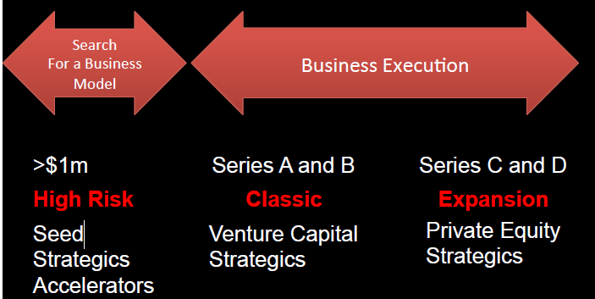

### ›Venture capital

For different VC, there are different layers in venture industry, e.g. the tier 1 VC is Andreessen Horowitz, NEA and so on. Next it comes the Mid-tier such as KPCB. And then the types are originals, strategic, Angel and Accelerator. It needs to pitch to venture, which early stage open comes from the university café.

### ›Product/market fit

Catch the right opportunity such as the path to market, the marketing timing, the fundable reason and the right teams to form a unique insight. Make a product definition to fit the market through an insight analysis, and then finally go to the market.

### ›Game plan variants

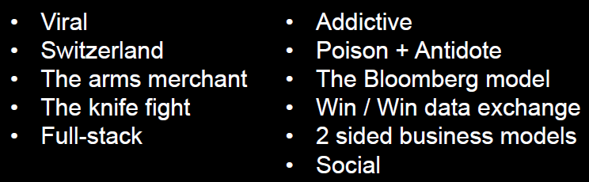

The Data Driven enterprise wires itself into the customers business work flow such that they can’t do business without them. i.e. The Bloomberg model.

### ›Emerging technology trends being invested in

Data Science, Cloud and Mobile, all of them forms a cycle triangle.

A.I.

• Robotics

• Internet Infrastructure

• Human Augmentation

• VR and AR

• One Million Jobs

• Programming Tools

• Hollywood 2.0

• Enterprise Software

• Financial Services

• Telecommunications

Data Science:

The Next Steps

• AI => ML + Systems Engineering

• Active Learning / why it must happen

Actively generating and testing hypothesis’s about the customer and testing them on the customer to learn their preferences even as they change over time.

• Better ML algorithms

• Get the Rocket Scientist out of the Loop

• Massive Sensors IOT

• Needles in haystacks

• Pre – ingestion

• Making Sense of Data Visualisation

# [Week 13 - Guest Lecture - The role of intellectual property in IT innovation and Exam Review](https://elearning.sydney.edu.au/webapps/blackboard/content/listContent.jsp?course_id=_52292_1&content_id=_2654008_1)

Topic A: intellectual property, software copyright, patents, etc

Topic B: exam review  
Guest lecture:  
Diana Nguyen has studied computer science and law, was previously a patent examiner and is now an intellectual property lawyer at company Cognizant.  Diana will talk about intellectual property in IT innovation with a focus on copyright, trademarks, patents and more.  
Guest lecture: [Intellectual property and innovation](https://elearning.sydney.edu.au/bbcswebdav/pid-2654008-dt-content-rid-15075479_1/xid-15075479_1)

Exam review:

[Exam info](https://elearning.sydney.edu.au/bbcswebdav/pid-2654008-dt-content-rid-15075470_1/xid-15075470_1)

[Unit review](https://elearning.sydney.edu.au/bbcswebdav/pid-2654008-dt-content-rid-15075471_1/xid-15075471_1)

Diana Nguyen, Lawyer, Cognizant (computer scientist, ex-patent examiner)

### ›What is Intellectual Property?

Intellectual property (IP) is a legal term that refers to creations of the mind. Examples of intellectual property include music, literature, and other artistic works; discoveries and inventions; and words, phrases, symbols, and designs. Under intellectual property laws, owners of intellectual property are granted certain exclusive rights. Some common types of intellectual property rights (IPR) are [copyright](http://en.wikipedia.org/wiki/Copyright), [patents](http://en.wikipedia.org/wiki/Patent), and [industrial design rights](http://en.wikipedia.org/wiki/Industrial_design_right); and the rights that protect [trademarks](http://en.wikipedia.org/wiki/Trademark), [trade dress](http://en.wikipedia.org/wiki/Trade_dress), and in some jurisdictions [trade secrets](http://en.wikipedia.org/wiki/Trade_secret). Intellectual property rights are themselves a form of property, called [intangible property](http://en.wikipedia.org/wiki/Intangible_property).

### ›Why protect IP?

Protection of intellectual property rights protects creativity. The efforts of writers, artists, designers, software programmers, inventors and other talents need to be protected in order to create an environment where creativity can flourish and hard work can be rewarded.

We need to provide the necessary intellectual property rights protection to our investors to assure them of a free and fair environment in which to do business. It is in our very interest to protect intellectual property rights.

### ›Ways of protecting IP:

#### -Copyright

#### -Trademarks

#### -Patents

#### -Confidentiality

#### -First mover and digital footprint

### ›Using other people’s stuff

### ›Risk minimisation

Australian Securities & Investments Commission

IP Australia

### 