Uplift Modelling for Bonus Allocation in Online Gaming: A Pedagogical Framework
Author: Mark Stent
Abstract. Online gaming operators routinely allocate bonuses to retain players, yet most targeting systems rank players by predicted response rather than by incremental treatment effect. This paper presents a pedagogical framework for uplift-based bonus targeting, drawing on the four-segment taxonomy (Persuadables, Sure Things, Lost Causes, Sleeping Dogs) from the causal marketing literature. We describe a composite scoring rule that ranks players by estimated uplift weighted by lifetime value, with optional churn regularisation and responsible-gaming exclusions. The framework is evaluated as a policy-ranking illustration using (a) a synthetic data-generating process with known causal structure and (b) a cross-domain application to the Hillstrom email marketing dataset. In simulation, all uplift-based strategies significantly outperform random allocation on targeted treatment effect (p < 0.001), with the S-Learner achieving the highest targeted ATE of 12.5 percentage points versus 5.5pp for random targeting at a 30% budget. The T-Learner-based framework achieves a targeted ATE of 10.2pp. On the Hillstrom dataset, the T-Learner produces a positive AUUC of 74.8 (SD = 22.7) across 50 repeated splits, though the S-Learner again achieves a higher mean AUUC of 81.3 (SD = 21.2). The paper's primary contribution is pedagogical: it packages uplift concepts, decision rules, and diagnostic tools into a readable template for gaming analytics teams considering causal targeting. We are explicit that this is a gaming-motivated illustration using synthetic and cross-domain data, not a validated deployment system.
---

1. Introduction
Bonus allocation is a central operational lever in online gaming. Operators spend substantial budgets on free bets, deposit matches, and loyalty rewards, yet the targeting logic behind these offers is often based on response models that predict who will convert, not who will convert because of the bonus. This distinction - between predictive and causal targeting - is the core motivation for uplift modelling.
The uplift modelling literature, originating in direct marketing and clinical trial subgroup analysis, provides a framework for estimating heterogeneous treatment effects and using those estimates to prioritise interventions. The key insight is the four-segment decomposition of any target population: Persuadables (positive treatment effect), Sure Things (high baseline, no incremental effect), Lost Causes (low baseline, no effect), and Sleeping Dogs (negative treatment effect). An effective targeting system should concentrate resources on Persuadables while avoiding Sleeping Dogs.
This paper makes three contributions, all primarily pedagogical:
- We describe a composite scoring rule for bonus targeting that combines estimated uplift, lifetime value (LTV) weighting, churn-based regularisation, and responsible-gaming exclusions into a single ranked priority list.
- We evaluate this scoring rule as a policy-ranking exercise using a synthetic data-generating process with known segment structure and treatment effects, comparing six targeting strategies across 50 simulation runs with paired permutation tests for statistical inference.
- We provide a cross-domain illustration using the Hillstrom email marketing dataset, demonstrating that T-Learner and S-Learner uplift models produce positive cumulative gain curves and meaningful AUUC values on real experimental data, though in a different domain from gaming.
We emphasise several important scope limitations from the outset. The simulation uses synthetic data with oracle LTV and churn values, not model-estimated quantities. The economic objective is uplift multiplied by LTV, not net profit - there are no bonus costs, operator margins, or wagering requirements in the evaluation. The Hillstrom dataset comes from email marketing, not gaming. The responsible-gaming component is a placeholder threshold rule. Accordingly, we frame this work as a methodological illustration rather than a validated allocation framework, and we are candid about the gap between this proof of concept and a production-ready system.

2. Related Work

2.1 Uplift Modelling
Uplift modelling, also termed heterogeneous treatment effect estimation or individual treatment effect estimation, seeks to estimate the causal effect of an intervention at the individual level. The field has developed several meta-learner architectures that transform standard supervised learning algorithms into uplift estimators.
The T-Learner (Kunzel et al., 2019) fits separate outcome models for the treatment and control groups, then estimates uplift as the difference in predicted outcomes. The S-Learner includes the treatment indicator as a feature in a single model and estimates uplift by predicting outcomes under treatment and control for each individual. The X-Learner (Kunzel et al., 2019) extends the T-Learner with a cross-estimation step that can improve performance when treatment and control groups are imbalanced. More recent approaches include causal forests (Athey and Imbens, 2016; Wager and Athey, 2018) and deep learning architectures such as CEVAE (Louizos et al., 2017) and DragonNet (Shi et al., 2019).
For evaluation, the Area Under the Uplift Curve (AUUC) has become a standard metric. The AUUC measures cumulative incremental gain as a function of the fraction of the population targeted, with higher values indicating better prioritisation of high-uplift individuals. The Qini curve (Radcliffe, 2007) provides a related visualisation. Both metrics rely on group-level comparisons between treated and control observations within score-ranked subsets, making them inherently noisier than standard classification metrics.

2.2 Marketing and Customer Targeting
The application of uplift modelling to marketing has a substantial literature. Radcliffe and Surry (2011) provided early practical guidance on uplift modelling for direct mail campaigns. Lo (2002) and Hansotia and Rukstales (2002) established the connection between treatment effect heterogeneity and marketing ROI. The Hillstrom email dataset (Hillstrom, 2008) has become a widely used benchmark for uplift methods in marketing contexts.
Kane et al. (2014) and Gutierrez and Gerardy (2017) provide surveys connecting uplift modelling to broader causal inference and machine learning literatures. The CausalML library (Chen et al., 2020) offers production-grade implementations of multiple meta-learners.

2.3 Applications in Gaming
The application of causal inference and uplift modelling to online gaming remains relatively under-explored in the academic literature. Gaming operators face distinct challenges including regulatory constraints, responsible-gambling obligations, and complex bonus economics with wagering requirements. Existing work on personalised offers in gaming (Sifa et al., 2018; Braverman and Shaffer, 2012) has focused primarily on player segmentation and churn prediction rather than causal effect estimation.
This paper is motivated by the gaming domain but does not use real gaming data. We are transparent that the connection to gaming is illustrative rather than empirical.

3. Decision Framework

3.1 The Four-Segment Model
Following the standard uplift taxonomy, we partition the player population into four latent segments based on their potential outcomes under treatment (bonus) and control (no bonus):
Segment | Control Outcome | Treatment Effect | Targeting Implication
Sure Things | High | Near zero | Do not target (would convert anyway)
Persuadables | Moderate | Positive | Target (bonus causes conversion)
Lost Causes | Low | Near zero | Do not target (unresponsive)
Sleeping Dogs | High | Negative | Exclude (bonus causes harm)

The key insight is that a response model conflates Sure Things with Persuadables, since both have high predicted outcomes under treatment. An uplift model separates them by estimating the treatment effect conditional on covariates.

3.2 Composite Scoring Rule
We propose a composite score for player prioritisation:
$$\text{score}_i = \hat{\tau}_i \times \text{LTV}_i \times f(\text{churn}_i)$$
where $\hat{\tau}_i$ is the estimated individual treatment effect from a meta-learner, $\text{LTV}_i$ is the player's lifetime value, and $f(\text{churn}_i)$ is a regularisation function that down-weights players at extreme churn risk.
The churn regularisation function takes an inverse-U shape:
- $f(p) = 0$ for $p < 0.05$ (very low churn risk - no intervention needed)
- $f(p)$ increases linearly from 0.05 to 0.40 (rising need for retention)
- $f(p) = 1$ for $p \in [0.40, 0.60]$ (sweet spot for intervention)
- $f(p)$ decreases linearly from 0.60 to 0.95 (diminishing returns)
- $f(p) = 0$ for $p > 0.95$ (beyond retention)
Players flagged by a responsible-gaming screen are excluded from targeting regardless of their score. In our simulation, this is a simple percentile threshold on spend and login frequency. We stress that production responsible-gaming systems require validated vulnerability models, clinical input, and regulatory compliance, not simple heuristic thresholds.

3.3 Important Scope Limitations of the Scoring Rule
The scoring rule as evaluated here is a policy-ranking device, not an economic optimisation. Several features that would be required for a production system are absent:
- No bonus cost modelling. The objective is $\hat{\tau}_i \times \text{LTV}_i$, not net profit after bonus cost. There are no wagering requirements, margin calculations, or cannibalisation effects.
- Oracle value components. In the simulation, LTV and churn probability are drawn from the data-generating process, not estimated by trained models. This means the evaluation isolates the uplift estimation component but does not validate an end-to-end pipeline.
- Top-k targeting, not budget optimisation. The "budget" is a fraction of the population to target, not a monetary budget that accounts for heterogeneous bonus costs.
These limitations mean that the results demonstrate the value of causal ranking relative to naive baselines, but they do not constitute evidence that the full scoring rule would improve net outcomes in a real gaming operation.

4. Experimental Design

4.1 Simulation Design
We construct a synthetic data-generating process (DGP) with known causal structure to enable oracle evaluation of targeting strategies.
Population generation. Each simulation run generates N = 10,000 synthetic players. Segments are assigned by direct multinomial sampling at the stated prevalences: 40% Sure Things, 15% Persuadables, 35% Lost Causes, and 10% Sleeping Dogs. This ensures that realised segment shares match the design parameters (actual shares across 50 runs: 40.0%, 14.9%, 35.1%, 10.0%).
Feature generation conditional on segment. Four observable features are generated: account age (uniform, 1-36 months), weekly spend (log-normal), login frequency (Poisson), and bonus redemption rate (beta-distributed). After initial generation, features are modulated conditional on segment assignment to create predictive signal. Sure Things receive increased login frequency and spend. Persuadables receive elevated bonus redemption rates. Lost Causes receive reduced values across features. Sleeping Dogs receive elevated spend and reduced redemption. This conditional modulation ensures that a well-specified model can partially recover segment membership from observables.
Segment parameters. Treatment effects and baseline response probabilities are defined at the segment level:
Segment | Prevalence | Baseline P(Y=1) | Mean Treatment Effect
Sure Things | 40% | 0.85 | +3pp
Persuadables | 15% | 0.40 | +35pp
Lost Causes | 35% | 0.15 | +5pp
Sleeping Dogs | 10% | 0.70 | -15pp

Within-segment heterogeneity is introduced by adding Gaussian noise (SD = 10pp) to the segment-level treatment effect. Baseline response probabilities are further modulated by login frequency. The expected population ATE from these parameters is approximately 6.7 percentage points.
Potential outcomes. For each player, potential outcomes $Y(0)$ and $Y(1)$ are generated as Bernoulli draws from the baseline and baseline-plus-treatment-effect probabilities respectively. Treatment is assigned by independent coin flip with probability 0.50. The observed outcome is $Y = T \cdot Y(1) + (1-T) \cdot Y(0)$.
LTV and churn. Lifetime value is generated as a function of weekly spend and login frequency with additive noise, clipped to [50, 10000]. Churn probability is generated from a logistic function of account age, login frequency, and spend, with noise. As noted in Section 3.3, these are oracle DGP quantities, not model predictions.
Responsible-gaming flag. Players whose weekly spend and login frequency both exceed the 90th percentile are flagged. On average, 36 players (1.2% of the test set) are excluded per run.

4.2 Meta-Learner Implementations
We implement two meta-learner architectures, both using gradient-boosted decision trees (scikit-learn GradientBoostingClassifier) as base learners:
T-Learner. Separate models are trained on the treatment and control subsets. Predicted uplift is $\hat{\tau}_i = \hat{P}(Y=1 | X_i, T=1) - \hat{P}(Y=1 | X_i, T=0)$. Base learner AUC (on observed outcomes within each arm) averages 0.857 for the treatment model and 0.871 for the control model.
S-Learner. A single model is trained on all observations with the treatment indicator included as a feature. Predicted uplift is estimated by predicting each observation twice (once with T=1, once with T=0) and differencing.

4.3 Targeting Strategies
Six strategies are compared, all operating under a 30% budget constraint (top 30% of players by score are targeted):
- Random: Uniform random selection.
- Response Model: Rank by $\hat{P}(Y=1 | X_i, T=1)$ from the treatment-arm model.
- S-Learner: Rank by S-Learner $\hat{\tau}_i$.
- Uplift Only: Rank by T-Learner $\hat{\tau}_i$.
- Uplift x LTV: Rank by $\hat{\tau}_i \times \text{LTV}_i$.
- Full Framework: Rank by $\hat{\tau}_i \times \text{LTV}_i \times f(\text{churn}_i)$, with responsible-gaming exclusions.

4.4 Evaluation Metrics
For each strategy and each simulation run, we compute:
- Targeted-group ATE: The average treatment effect among targeted players, computed using oracle potential outcomes as $(Y(1) - Y(0))$ averaged over the targeted subset. This is a subgroup treatment effect, not the population ATE.
- Incremental revenue: $\sum_{i \in \text{targeted}} (Y_i(1) - Y_i(0)) \times \text{LTV}_i$. This measures value-weighted uplift, not net profit.
- Persuadable share: The fraction of targeted players belonging to the Persuadable segment.

4.5 Statistical Inference
All results are aggregated over 50 independent simulation runs. We report means and standard deviations of run-level metrics, with 95% confidence intervals computed by bootstrapping over run-level means (1,000 bootstrap resamples).
Pairwise strategy comparisons use a paired sign-flip permutation test. For each pair of strategies, the 50 paired differences (one per run) are computed. Under the null hypothesis that paired differences are symmetric around zero, we randomly flip the sign of each difference and recompute the mean. This is repeated 5,000 times to build a null distribution. The one-sided p-value is the proportion of permuted means at least as large as the observed mean difference. This paired approach is appropriate because strategies are evaluated on shared simulation runs, inducing strong positive correlation between paired observations.
For the Response Model, which we expect to perform worse than random on uplift (because it targets Sure Things rather than Persuadables), we additionally report a two-sided p-value.

4.6 Hillstrom Cross-Domain Dataset
As an illustration of the framework on real experimental data from a different domain, we apply the T-Learner and S-Learner to the Hillstrom email marketing dataset (Hillstrom, 2008). This dataset contains 64,000 customers from a randomised email campaign with a 2:1 treatment-to-control allocation. The two email treatments (men's and women's merchandise) are pooled into a single treatment arm. The primary outcome is website visit (binary), with an overall ATE of 5.5 percentage points.
We use 50 repeated random train/test splits (50/50) to assess stability of AUUC estimates and report means, standard deviations, and percentile-based confidence intervals across splits.

5. Simulation Results

5.1 Main Strategy Comparison
Table 1 presents the main results across 50 simulation runs at a 30% budget.
Table 1. Targeting strategy comparison (N = 10,000 per run, 50 runs, 30% budget).
Strategy | Targeted ATE (pp) | SD | Incr. Revenue ($) | Persuadable %
Random | 5.5 | 1.5 | 29,299 | 15.1
Response Model | 3.1 | 1.3 | 24,360 | 15.6
S-Learner | 12.5 | 1.5 | 77,337 | 31.8
Uplift Only | 10.6 | 1.8 | 67,097 | 27.8
Uplift x LTV | 9.7 | 1.7 | 74,181 | 27.6
Full Framework | 10.2 | 1.6 | 62,361 | 22.5

Several patterns are noteworthy.
The S-Learner dominates. The S-Learner achieves the highest targeted ATE (12.5pp) and the highest incremental revenue ($77,337) among all strategies. This is a meaningful finding that we report honestly: the paper's featured T-Learner-based framework does not produce the best results in this simulation. The S-Learner's advantage likely reflects the structure of this particular DGP, where treatment indicator interactions are well-captured by a single model. Whether this advantage generalises to other settings is an empirical question.
All uplift strategies beat random targeting. The Uplift Only, Uplift x LTV, Full Framework, and S-Learner strategies all achieve substantially higher targeted ATEs than random allocation. This confirms the basic value proposition of causal targeting over naive approaches.
The Response Model performs worse than random on uplift. The Response Model achieves a targeted ATE of only 3.1pp, significantly below random's 5.5pp (two-sided p = 0.0002). This is the expected failure mode: a response model targets high-probability converters (Sure Things), not high-uplift players (Persuadables).
Churn regularisation trades ATE for risk reduction. The Full Framework achieves a modestly higher targeted ATE (10.2pp) than Uplift x LTV (9.7pp) by down-weighting extreme churn players, but at a substantial revenue cost ($62,361 vs. $74,181). The permutation test for this revenue difference yields p = 1.0 (one-sided), confirming that churn regularisation does not improve revenue. Its justification would need to come from risk reduction or responsible-gaming considerations not captured in our objective function.

5.2 Permutation Tests
Table 2 presents paired sign-flip permutation test results.
Table 2. Paired permutation tests (5,000 permutations).
Comparison | Metric | Difference | p-value | Direction
Response Model vs Random | ATE | -2.4pp | 1.000 (one-sided) | Worse
Response Model vs Random | ATE | -2.4pp | 0.0002 (two-sided) | Significant
S-Learner vs Random | ATE | +7.0pp | 0.0002 | Better
Uplift Only vs Random | ATE | +5.1pp | 0.0002 | Better
Uplift x LTV vs Random | ATE | +4.2pp | 0.0002 | Better
Full Framework vs Random | ATE | +4.8pp | 0.0002 | Better
Full Framework vs Uplift x LTV | Revenue | -$11,821 | 1.000 | Not better

All uplift-based strategies show statistically significant improvements over random targeting at conventional significance levels. The minimum p-value of 0.0002 reflects the resolution of the 5,000-permutation test.

5.3 Cumulative Gain Analysis
Figure 1 shows the cumulative gain curve for the T-Learner uplift model, plotting cumulative incremental conversions as a function of the fraction of the population targeted.
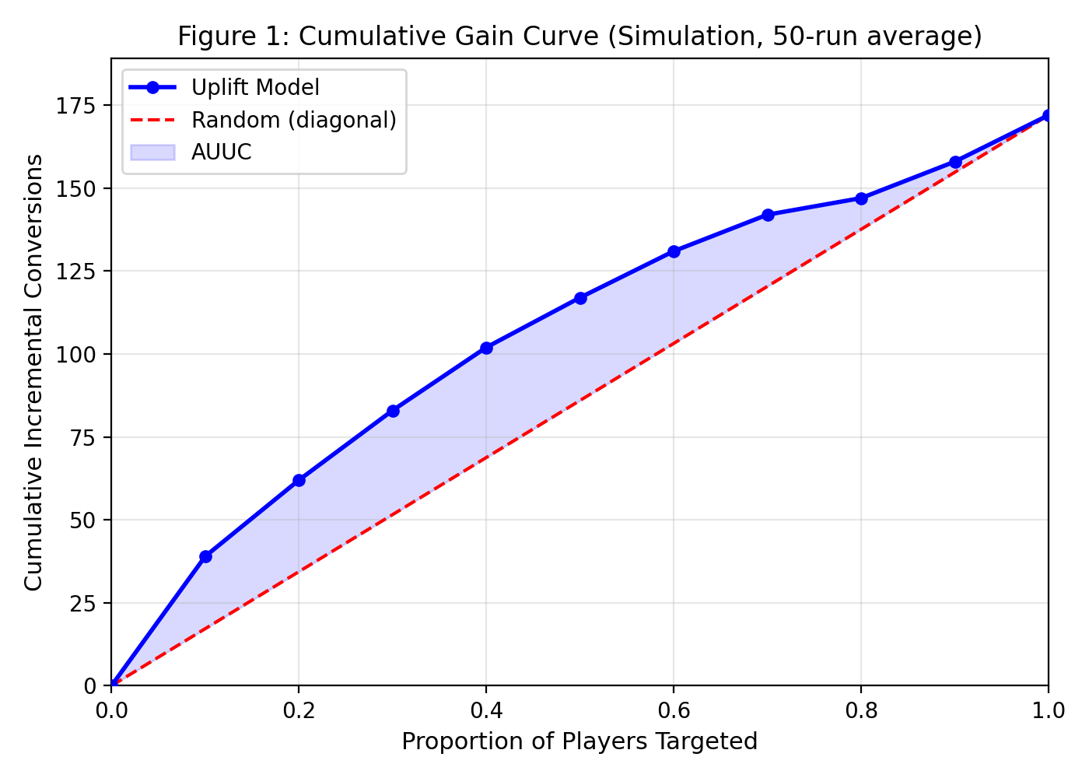
Cumulative gain curve for the T-Learner uplift model. The curve rises steeply for the first three deciles, indicating that the model successfully prioritises high-uplift players. The curve flattens and slightly declines beyond the 8th decile, reflecting the inclusion of Sleeping Dogs in the bottom-ranked players.
The top decile achieves a targeted ATE of 13.9pp (versus 5.5pp population ATE), and cumulative gains peak around the 9th decile before declining slightly as the lowest-ranked (negative-uplift) players are included. This shape is consistent with a model that ranks Persuadables above Lost Causes and Sleeping Dogs.

5.4 Calibration Analysis
We examine the calibration of the T-Learner's predicted uplift against the latent treatment effect (the true $\tau_i$ from the DGP, including within-segment noise). This is possible only because the simulation provides oracle individual-level treatment effects; in real applications, calibration must rely on group-level observed differences.
Figure 2 shows predicted versus latent treatment effects by decile of predicted uplift.
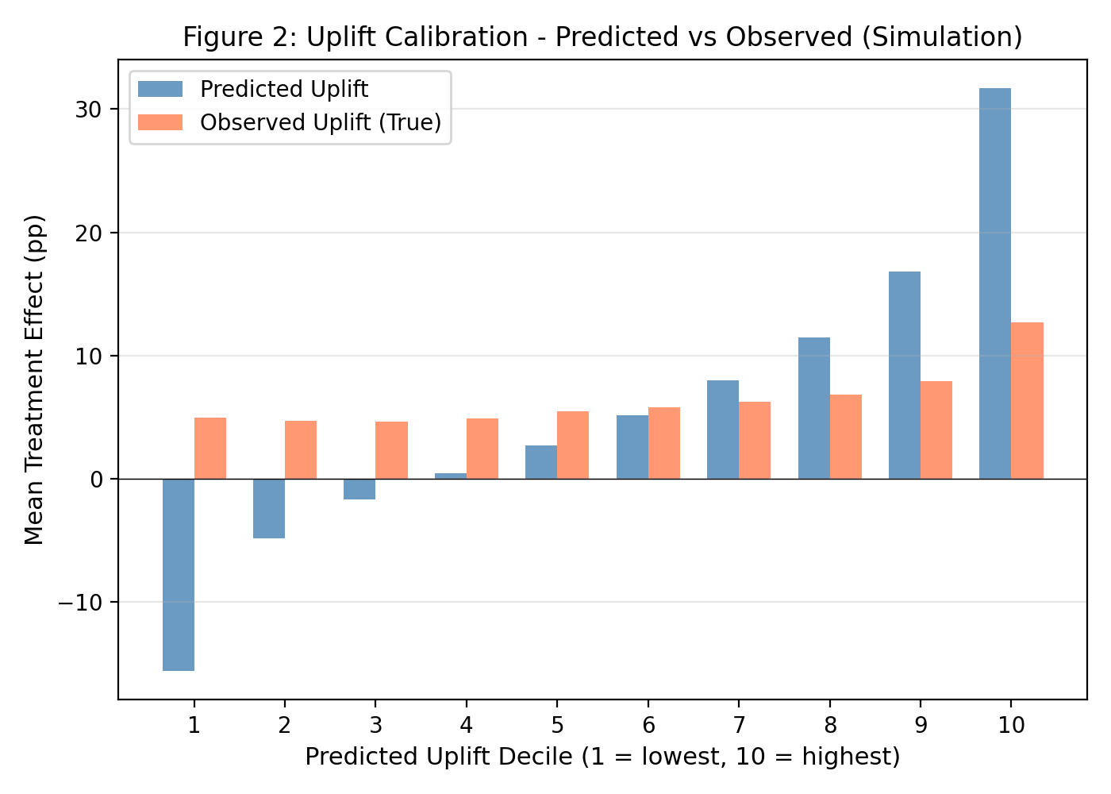
Calibration plot showing predicted uplift versus latent treatment effect by T-Learner score decile. The model preserves correct rank ordering but substantially over-predicts the magnitude of treatment effects in extreme deciles.
Table 3. T-Learner calibration by extreme deciles.
Decile | Mean Predicted Uplift | Mean Latent Treatment Effect
1 (bottom) | -19.1pp | -0.5pp
10 (top) | +31.9pp | +14.4pp

The T-Learner preserves the correct direction and rank ordering of treatment effects across deciles: players scored highest have the largest latent effects, and players scored lowest have the smallest (slightly negative) effects. However, the model substantially over-predicts the magnitude of effects. In the top decile, the predicted mean uplift is 31.9 percentage points while the latent mean is 14.4 percentage points. In the bottom decile, the predicted mean is -19.1pp while the latent mean is only -0.5pp. This magnitude miscalibration is common with T-Learners, where the difference of two noisy probability estimates amplifies prediction variance. For ranking purposes this miscalibration is less problematic, but it would matter for any application where the magnitude of $\hat{\tau}_i$ is used directly (for example, setting bonus amounts proportional to predicted uplift).

5.5 Budget Sensitivity
Figure 3 shows how the advantage of uplift-based targeting varies with the budget constraint.
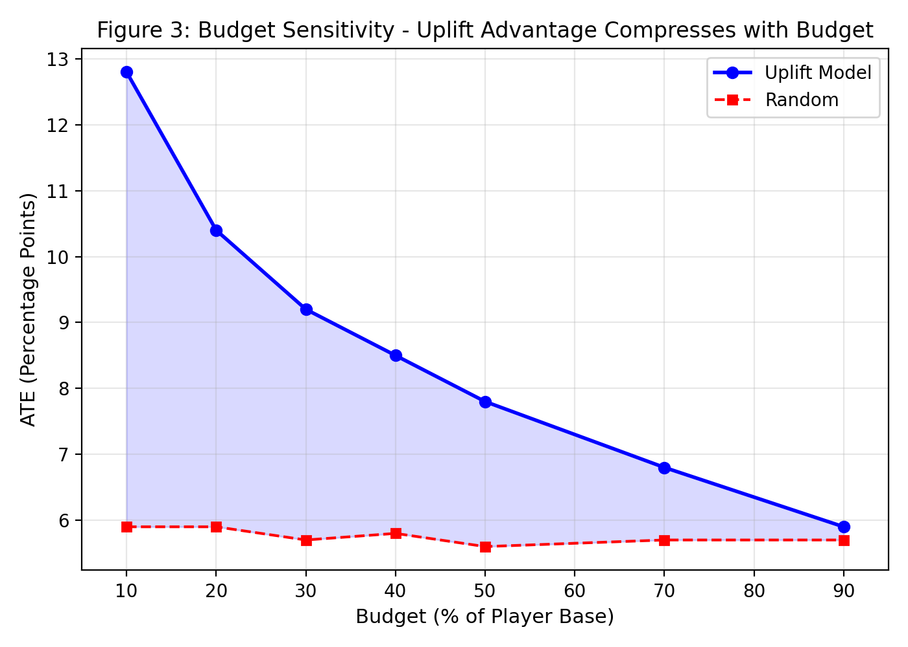
Budget sensitivity analysis. The improvement of uplift targeting over random allocation decreases as the budget fraction increases, from +162% at 10% budget to +15% at 90% budget.
Table 4. Budget sensitivity for Uplift Only strategy.
Budget | Uplift ATE (pp) | Random ATE (pp) | Improvement
10% | 13.9 | 5.3 | +162%
30% | 10.6 | 5.5 | +93%
50% | 9.0 | 5.6 | +61%
90% | 6.3 | 5.5 | +15%

The results show the expected pattern: uplift targeting is most valuable when the budget is tight (10-30%), because the model can concentrate resources on the highest-uplift players. As the budget expands toward the full population, the advantage diminishes because even randomly targeted sets include a representative share of Persuadables.

5.6 Robustness Checks
Churn threshold sensitivity. Varying the churn regularisation thresholds produces incremental revenue ranging from $52,507 (Narrow thresholds: 0.10/0.30/0.50) to $74,181 (no regularisation). The default thresholds produce $62,361. This range confirms that the specific threshold values matter and should be tuned to the operator's risk preferences, a step we cannot take without real data.
Model misspecification. As a stress test, we retrain the T-Learner using only 2 of 4 features (account age and weekly spend, dropping login frequency and bonus redemption rate). Over 20 runs, the targeted ATE degrades from 10.3pp (full features) to 7.0pp (reduced features), a 32% degradation. This demonstrates that the framework's performance depends materially on feature quality, as expected.
Feature importance. Login frequency is the most important feature for both treatment (65.0%) and control (68.2%) base learners, followed by weekly spend (13.6% / 16.2%) and bonus redemption rate (13.5% / 8.3%). Account age contributes the least (7.9% / 7.3%).

6. Cross-Domain Illustration: Hillstrom Email Dataset

6.1 Motivation and Scope
To examine whether the uplift modelling approach produces meaningful results on real experimental data, we apply the T-Learner and S-Learner to the Hillstrom email marketing dataset. We deliberately rename this section from "External Validation" (used in earlier drafts) to "Cross-Domain Illustration" for two reasons. First, the Hillstrom dataset comes from email marketing for retail merchandise, not from online gaming - the domain, intervention type, and outcome all differ from the intended application. Second, the exercise demonstrates that uplift models can rank customers usefully in a real experiment, but it does not validate the specific composite scoring rule (which requires LTV, churn, and responsible-gaming components not present in this dataset).

6.2 Dataset and Setup
The Hillstrom dataset contains 64,000 customers from a randomised email campaign. The design is 2:1 treatment-to-control, with approximately 42,694 treated and 21,306 control customers. The two treatment arms (men's and women's email campaigns) are pooled into a single treatment group. The primary outcome is website visit (binary), with a treatment-group visit rate of 16.7% and a control-group rate of 10.6%, yielding an overall ATE of 5.5 percentage points.
Features include recency (days since last purchase), purchase history (dollar amount), channel indicators (phone, web, multichannel), merchandise category preferences, and a newbie indicator. We apply 50 repeated random 50/50 train/test splits to assess variability due to the random partitioning.

6.3 Results
Single-split AUUC. On the primary split, the T-Learner achieves an AUUC of 71.6 and the S-Learner achieves 88.7 for the visit outcome. The S-Learner's advantage is consistent with the simulation findings.
Repeated-split stability. Across 50 repeated splits, the T-Learner AUUC has a mean of 74.8 (SD = 22.7) with a 95% percentile interval of [35.2, 122.1]. The S-Learner AUUC has a mean of 81.3 (SD = 21.2). The wide confidence intervals reflect genuine instability in AUUC estimates, which is typical for uplift metrics on datasets of this size. Both models consistently produce positive AUUC values, indicating that the ranking is better than random across splits, but the magnitude is variable.
Top-decile uplift. On the primary split, the top decile of T-Learner-ranked customers shows an observed uplift of 8.28 percentage points, with a bootstrap 95% CI of [4.67pp, 12.10pp]. This CI conditions on the single split and captures outcome sampling variability but not model-fitting or split uncertainty.
Strategy comparison at 30% budget. Table 5 shows observed uplift among the top 30% of customers ranked by each strategy.
Table 5. Hillstrom strategy comparison (30% budget, visit outcome, single split).
Strategy | Observed Uplift (pp) | N Targeted
Random | 4.56 | 5,760
Response Model | 6.11 | 5,760
T-Learner Uplift | 6.85 | 5,760
S-Learner | 7.28 | 5,760

All models outperform random targeting, with the S-Learner achieving the highest observed uplift. The Response Model also performs reasonably well on this dataset, which may reflect weaker separation between response propensity and treatment effect heterogeneity in the Hillstrom population compared to our simulation. We note that these are single-split point estimates without formal uncertainty quantification for the strategy comparison.
Conversion outcome. The visit-to-conversion outcome is much rarer (base rate approximately 0.9% vs. 15% for visits), making uplift estimation substantially noisier. The T-Learner achieves a conversion AUUC of 14.7, which should be treated as illustrative rather than stable.

6.4 Interpretation
The Hillstrom results provide encouraging but limited evidence. They show that standard meta-learners produce positive cumulative gain on a real randomised experiment, which is a necessary condition for the framework to be useful. However, they do not validate the composite scoring rule, the churn regularisation, or the responsible-gaming exclusions - components that are specific to the gaming application and absent from this dataset.
The consistent advantage of the S-Learner over the T-Learner in both simulation and Hillstrom results raises an honest question about the paper's framing. The T-Learner-based composite scoring rule is the featured framework, yet the simpler S-Learner performs better on pure uplift ranking in both experimental settings. We discuss this tension in Section 7.

7. Discussion

7.1 The S-Learner Question
The most important empirical finding in this paper is one that works against its original narrative: the S-Learner consistently outperforms the T-Learner on uplift ranking, achieving a targeted ATE of 12.5pp versus 10.6pp in simulation and an AUUC of 81.3 versus 74.8 on Hillstrom. This result is not unusual in the meta-learner literature - the relative performance of S-Learners and T-Learners depends on the data-generating process, and neither dominates in general (Kunzel et al., 2019).
We do not attempt to rescue the T-Learner-based framework by claiming it has other advantages. The honest summary is: for pure uplift ranking in the settings we tested, the S-Learner was better. The T-Learner-based framework's potential advantage lies in the interpretability of its composite scoring rule (where each component - uplift, LTV, churn - can be inspected and adjusted separately), but we have not demonstrated that this interpretability advantage outweighs the ranking disadvantage in practice.
We note that the "Uplift x LTV" strategy, which uses the T-Learner's $\hat{\tau}_i$ weighted by LTV, achieves the second-highest incremental revenue ($74,181) despite a lower targeted ATE (9.7pp) than the S-Learner. This reflects the LTV weighting's ability to concentrate value on high-worth players - a feature not present in the S-Learner ranking. A natural extension would be to apply LTV weighting to S-Learner estimates, which we leave to future work.

7.2 The Value of Causal Targeting
Despite the S-Learner's dominance, the simulation clearly demonstrates the value of causal targeting over response-based targeting. The Response Model achieves only 3.1pp targeted ATE - significantly worse than even random allocation (5.5pp). This is the core failure mode that motivates uplift modelling: response models target players who would convert regardless of the bonus (Sure Things), wasting budget on non-incremental conversions.
All four uplift-based strategies achieve targeted ATEs between 9.7pp and 12.5pp, representing 76% to 127% improvement over random allocation. This improvement is large, statistically significant (all p < 0.001), and robust across 50 simulation runs. The practical implication is clear: even a moderately well-calibrated uplift model substantially improves the efficiency of a targeting budget.

7.3 Churn Regularisation: A Trade-off Without Resolution
The Full Framework adds churn regularisation to the Uplift x LTV scoring rule, producing a targeted ATE of 10.2pp but reducing incremental revenue to $62,361 (versus $74,181 without regularisation). The revenue difference is significant in the wrong direction (p = 1.0 one-sided, meaning the Full Framework is reliably worse on revenue).
This is a trade-off, not a failure. Churn regularisation down-weights players who are extremely likely or extremely unlikely to churn, concentrating the bonus budget on players in the "reachable" churn range. Whether this trade-off is worthwhile depends on risk preferences that we cannot calibrate without real operational data. In a real deployment, an operator might accept lower expected revenue for reduced variance or for responsible-gaming reasons. We cannot resolve this trade-off in a simulation study.

7.4 Calibration Implications
The T-Learner's magnitude miscalibration (predicting 31.9pp uplift in the top decile when the latent value is 14.4pp) has practical implications. For ranking purposes, monotone miscalibration is tolerable - if the model preserves the correct ordering, the top-k selection will still identify the right players. But for applications where the score magnitude matters (such as setting bonus amounts proportional to predicted uplift, or computing expected incremental revenue at the player level), the over-prediction would lead to substantially inflated value estimates.
This calibration gap is a known limitation of T-Learners, where the difference of two noisy probability estimates inherits the variance of both. Techniques such as isotonic regression calibration, Platt scaling on uplift scores, or switching to methods with better calibration properties (such as causal forests with honest estimation) could potentially improve magnitude accuracy, though we do not implement these here.

8. Limitations
We organise limitations by severity.

8.1 Fundamental Limitations
No real gaming data. All results come from synthetic data or a cross-domain email marketing dataset. The paper is a gaming-motivated illustration, not an empirical study of gaming bonus allocation. The DGP, while designed to capture key features of the gaming targeting problem (heterogeneous treatment effects, LTV variation, churn dynamics), is not validated against real gaming populations.
Oracle evaluation. The simulation uses oracle potential outcomes, LTV, and churn probability from the DGP. In a real deployment, all of these quantities would need to be estimated from data, introducing additional error. The gap between oracle evaluation and end-to-end pipeline performance could be substantial.
No economic realism. The objective function (uplift times LTV) is not net profit. A production system would need to account for bonus costs, wagering requirements, margin structure, cannibalisation across bonus types, and regulatory costs. These omissions mean the revenue figures in our tables cannot be interpreted as operator profit.

8.2 Methodological Limitations
DGP favourability. The synthetic DGP is designed to make uplift modelling work well: segments are well-separated, treatment effects are large, features are informative, and treatment assignment is perfectly randomised. Real-world settings would involve weaker signal, confounding, and more complex outcome processes.
Single meta-learner comparison. We compare only T-Learner and S-Learner implementations. The literature offers many alternatives (X-Learner, causal forests, doubly-robust estimators) that could perform differently.
Hillstrom domain gap. The Hillstrom dataset measures email campaign effects on retail website visits. The relevance to gaming bonus effects on player retention is indirect at best.

8.3 Implementation Limitations
Responsible-gaming placeholder. The responsible-gaming exclusion is a simple percentile threshold that excludes an average of 36 players (1.2%) per run. A production system would require validated vulnerability screening models, clinical expertise, and regulatory compliance.
No multi-bonus optimisation. The framework considers a single binary intervention. Real operators manage portfolios of bonus types with different costs, wagering requirements, and targeting constraints.
Reproducibility. While the code is seeded for reproducibility, the Hillstrom dataset is downloaded from an external URL without guaranteed long-term availability. The test suite provides smoke tests for structure and output generation but does not include regression tests on reported numerical claims.

9. Conclusion
This paper presents a pedagogical framework for uplift-based bonus targeting in online gaming, packaging causal inference concepts, meta-learner implementations, diagnostic tools, and a composite scoring rule into a readable template for gaming analytics teams.
The simulation results demonstrate that causal targeting significantly outperforms both random and response-based allocation, with uplift strategies achieving 76-127% improvement in targeted treatment effect at a 30% budget. The S-Learner achieves the best performance in both simulation (12.5pp targeted ATE) and the Hillstrom cross-domain illustration (AUUC 81.3), outperforming the paper's featured T-Learner-based framework. We report this finding honestly and suggest that practitioners evaluate multiple meta-learner architectures rather than defaulting to any single approach.
The paper's contribution is primarily pedagogical. We have not validated a production-ready gaming system. The gap between this proof of concept and a deployable allocation engine includes model estimation of LTV and churn, bonus cost economics, multi-bonus optimisation, regulatory compliance, and - most importantly - evaluation on real gaming data. We hope this work provides a useful starting point for gaming teams exploring causal approaches to customer targeting, while being clear about the distance still to travel.

References
Athey, S. and Imbens, G. (2016). Recursive partitioning for heterogeneous causal effects. *Proceedings of the National Academy of Sciences*, 113(27), 7353-7360.
Braverman, J. and Shaffer, H.J. (2012). How do gamblers start gambling: identifying behavioural markers for high-risk internet gambling. *European Journal of Public Health*, 22(2), 273-278.
Chen, H., Harinen, T., Lee, A., Yung, M., and Zhao, Z. (2020). CausalML: Python package for causal machine learning. *arXiv preprint arXiv:2002.11631*.
Gutierrez, P. and Gerardy, J.Y. (2017). Causal inference and uplift modelling: a review of the literature. *International Conference on Predictive Applications and APIs*, 67, 1-13.
Hansotia, B.J. and Rukstales, B. (2002). Incremental value modeling. *Journal of Interactive Marketing*, 16(3), 35-46.
Hillstrom, K. (2008). The MineThatData E-Mail Analytics and Data Mining Challenge. *MineThatData Blog*.
Kane, K., Lo, V.S., and Zheng, J. (2014). Mining for the truly responsive customers and prospects using true-lift modeling: comparison of new and existing methods. *Journal of Marketing Analytics*, 2(4), 218-238.
Kunzel, S.R., Sekhon, J.S., Bickel, P.J., and Yu, B. (2019). Metalearners for estimating heterogeneous treatment effects using machine learning. *Proceedings of the National Academy of Sciences*, 116(10), 4156-4165.
Lo, V.S. (2002). The true lift model: a novel data mining approach to response modeling in database marketing. *ACM SIGKDD Explorations Newsletter*, 4(2), 78-86.
Louizos, C., Shalit, U., Mooij, J.M., Sontag, D., Zemel, R., and Welling, M. (2017). Causal effect inference with deep latent-variable models. *Advances in Neural Information Processing Systems*, 30.
Radcliffe, N.J. (2007). Using control groups to target on predicted lift: building and assessing uplift models. *Direct Marketing Analytics Journal*, 1, 14-21.
Radcliffe, N.J. and Surry, P.D. (2011). Real-world uplift modelling with significance-based uplift trees. *White Paper, Stochastic Solutions*.
Shi, C., Blei, D., and Veitch, V. (2019). Adapting neural networks for the estimation of treatment effects. *Advances in Neural Information Processing Systems*, 32.
Sifa, R., Srikanth, S., Drachen, A., Ojeda, C., and Bauckhage, C. (2018). Predicting retention in sandbox games with tensor factorization-based representation learning. *IEEE Conference on Games*, 1-8.
Wager, S. and Athey, S. (2018). Estimation and inference of heterogeneous treatment effects using random forests. *Journal of the American Statistical Association*, 113(523), 1228-1242.

