PUBLISHED BY THE AGENTICS FOUNDATION

The OIA Reference Model
The Open Intelligence Architecture: a structural reference for the design, deployment, and governance of enterprise intelligent systems.

By Mark Templeton
Version 0.5 · 2026

FOREWORD

From the Author
Reference architectures matter most when the technology they describe is moving faster than the organisations that have to deploy it. We are in such a moment now. Enterprise intelligent systems — the agents, models, and automation that increasingly do real work alongside human teams — are arriving inside our companies before the architectural vocabulary to govern them has stabilised. Boards are asking strategic questions their management teams cannot yet answer in structural terms. CIOs are committing capital before the architecture is drawn. CISOs are defending against threat surfaces the existing frameworks do not name. The OIA Reference Model is one attempt to give that vocabulary the shape it needs.
This is the v0.5 release. It absorbs the architectural refinements that emerged when the v0.1 model was pressure-tested against a working enterprise security portfolio, and it corrects the layer count to honestly reflect what was always there. The architecture is unchanged in spirit; it is sharper in seven specific places, with one new cross-layer span, and described as ten layers rather than nine.
More importantly, v0.5 is published alongside the OIA Lens System — three audience-specific Lens Maps for the executive audiences most directly accountable for AI inside the enterprise. The CISO Lens, the CIO/CTO Lens, and the Board and Risk Lens. These are not separate work; they are how the architecture reaches the people who must apply it. A reference model that the audiences cannot find themselves in is a reference model in name only. The Lens System is how the OIA earns its place at the table.
This work is not mine alone. The architectural foundation is the work of Reuven Cohen, who has been the primary author of the agentic infrastructure thinking that the OIA builds on, and whose breadth of contribution to this body of work I cannot adequately credit here. The pressure-testing, the practitioner perspectives, and the candour about what the enterprise actually needs came from John McKinley, Greg Lavender, and the CISO colleagues who took time to read drafts and tell me where the model was right and where it was not. The customer and partner perspectives that grounded the architecture in real deployment came from friends at Arista Networks, Nutanix, Proofpoint, Reltio, Thoma Bravo, and ACIUM — each contributing technological insights, customer perspectives, and the sage advice that comes from people who have actually had to ship enterprise software at scale. The model is better for all of it. Any errors that remain are mine.
The Foundation invites you to read the architecture as a working specification. Read the Lens that fits your role. Push back on what does not fit. Tell us what is missing. The OIA is meant to be foundational, and foundational means open to the audiences that will use it.

— Mark Templeton
Author

1. Introduction
The OIA Reference Model describes the structural shape of enterprise intelligent systems. Its purpose is to give the people who design, deploy, govern, and oversee these systems a shared architectural vocabulary that does not depend on any particular vendor's product map, any particular framework's compliance taxonomy, or any particular role's working language. The model is layered, audience-neutral, and additive to the existing reference architectures and management frameworks the enterprise already uses.
Three commitments shape the model. First, that intelligent systems have structural properties that distinguish them from the application architectures of the past — properties that change what ‘good' looks like at the architectural level, not just at the operational one. Second, that the architecture must be drawn against the structural shape of the problem rather than against any single role's perspective on it; security, infrastructure, governance, finance, and workforce concerns must each find themselves in the architecture without forcing distortion. Third, that a reference model is foundational only when the audiences accountable for the work can find themselves on the page, in language already theirs. The first two commitments shape the architecture. The third shapes the OIA Lens System, published alongside this Reference Paper as an integral part of the model.
This document specifies the architecture in full. Section 2 names the three defining properties of intelligent systems on which the architecture rests. Section 3 introduces the ten-layer stack and the seven cross-layer spans that thread through it. Sections 4 through 13 specify each layer in turn, from Layer 0 (Physical Compute) to Layer 9 (Human and Browser Interface). Section 14 specifies the seven cross-layer spans. Section 15 names the four named threat surfaces of the agentic era and where they land on the architecture. Section 16 introduces the Lens System briefly and points to its companion specification. Section 17 collects the open questions the model deliberately does not yet close. Section 18 closes.
This release is v0.5. The architecture preserves the v0.1 spine in full and absorbs seven specific refinements that emerged when the model was pressure-tested against a working enterprise portfolio. The most visible change is the layer count: v0.5 describes the architecture as ten layers, numbered 0 through 9, where v0.1 described nine. Layer 0 was always present; the count is simply more honest. The other six refinements sharpen specific parts of the architecture without altering its overall shape. They are introduced where they apply, with the v0.5 changes called out by name.

2. The Three Defining Properties of Intelligent Systems
Before the architecture, the properties. Three properties distinguish intelligent systems from the application architectures of the past, and shape what the architecture must address. Each property has primary architectural locations — the layer or span where it is most directly addressed — and each propagates concerns across the rest of the model. Without these properties, the layers below would describe a generic distributed system. With them, the layers describe enterprise intelligence specifically.

2.1 Persistence
Intelligent systems maintain state across interactions. Unlike traditional applications, where each session is structurally bounded and state is either explicit or transient, intelligent systems carry context, memory, learning, and judgment forward through time. A conversation continues across sessions. An agent's knowledge of an organisation accumulates. A model's behaviour reflects its training history. The persistence is not optional; it is what makes the system useful. It is also what makes the system harder to govern. Persistence is addressed primarily at Layer 8 (Continuity Fabric) and secondarily at Layer 3 (Agent Data Substrate) — the two state-holding layers that bracket the operational stack.

2.2 Autonomy
Intelligent systems act with degrees of autonomy that exceed what traditional applications offer. They take multi-step actions. They invoke tools. They make decisions inside scopes of authority that the humans who deployed them did not pre-approve case-by-case. They can act faster than humans can supervise them in the moment. The architectural consequence is that the boundary between ‘the system did what it was told' and ‘the system did what it decided' is structurally meaningful. Autonomy is addressed primarily at Layer 7 (Orchestration and Workflow), with significant interactions at Layer 5 (Inference and Retrieval) where the autonomy originates and at Layer 9 (Human and Browser Interface) where its outputs land.

2.3 Consequence
Intelligent systems produce outputs and take actions whose correctness, accountability, and auditability must be demonstrable — and demonstrable against current threat reality, not against the threat reality at the moment of deployment. A patched library, a swapped model, a freshly emerged jailbreak: each of these changes correctness mid-flight. Consequence is therefore not a one-time property to be verified at release; it is a continuous property to be governed throughout operation. Architectural posture is time-bound. Consequence is addressed not at any single layer but through the cross-layer spans — auditability, provenance, identity, security, sovereignty, energy, and (new in v0.5) verifiability.
Persistence, autonomy, consequence — each propagating concerns across the architecture, none addressable at any single layer.
These three properties are why the OIA is structured the way it is. The layers describe where the work happens; the spans describe how the consequences propagate. Without persistence, there is no need for Layer 8. Without autonomy, the orchestration concerns of Layer 7 collapse into ordinary service composition. Without consequence in its temporal sense, the cross-layer spans collapse into static compliance categories. The architecture earns its complexity by absorbing the structural reality of the technology it describes.

3. The Architecture
The OIA Reference Model describes enterprise intelligent systems as ten layers, numbered 0 through 9, with seven cross-layer spans threading through them. The bottom-up numbering convention is consistent with the OSI reference model, but the OIA introduces Layer 0 — Physical Compute — to acknowledge that intelligent systems, unlike networking, are deeply shaped by physical compute constraints that cannot be abstracted away. Layer 0 is the substrate; Layers 1 through 9 are the architectural stack that rests on it.
The diagram below shows the architecture in full — the ten layers with their primary purposes, and the seven cross-layer spans most architecturally salient at each. The detail of each layer follows in Sections 4 through 13; the detail of each span follows in Section 14. The diagram is the visual reference for the model as a whole.
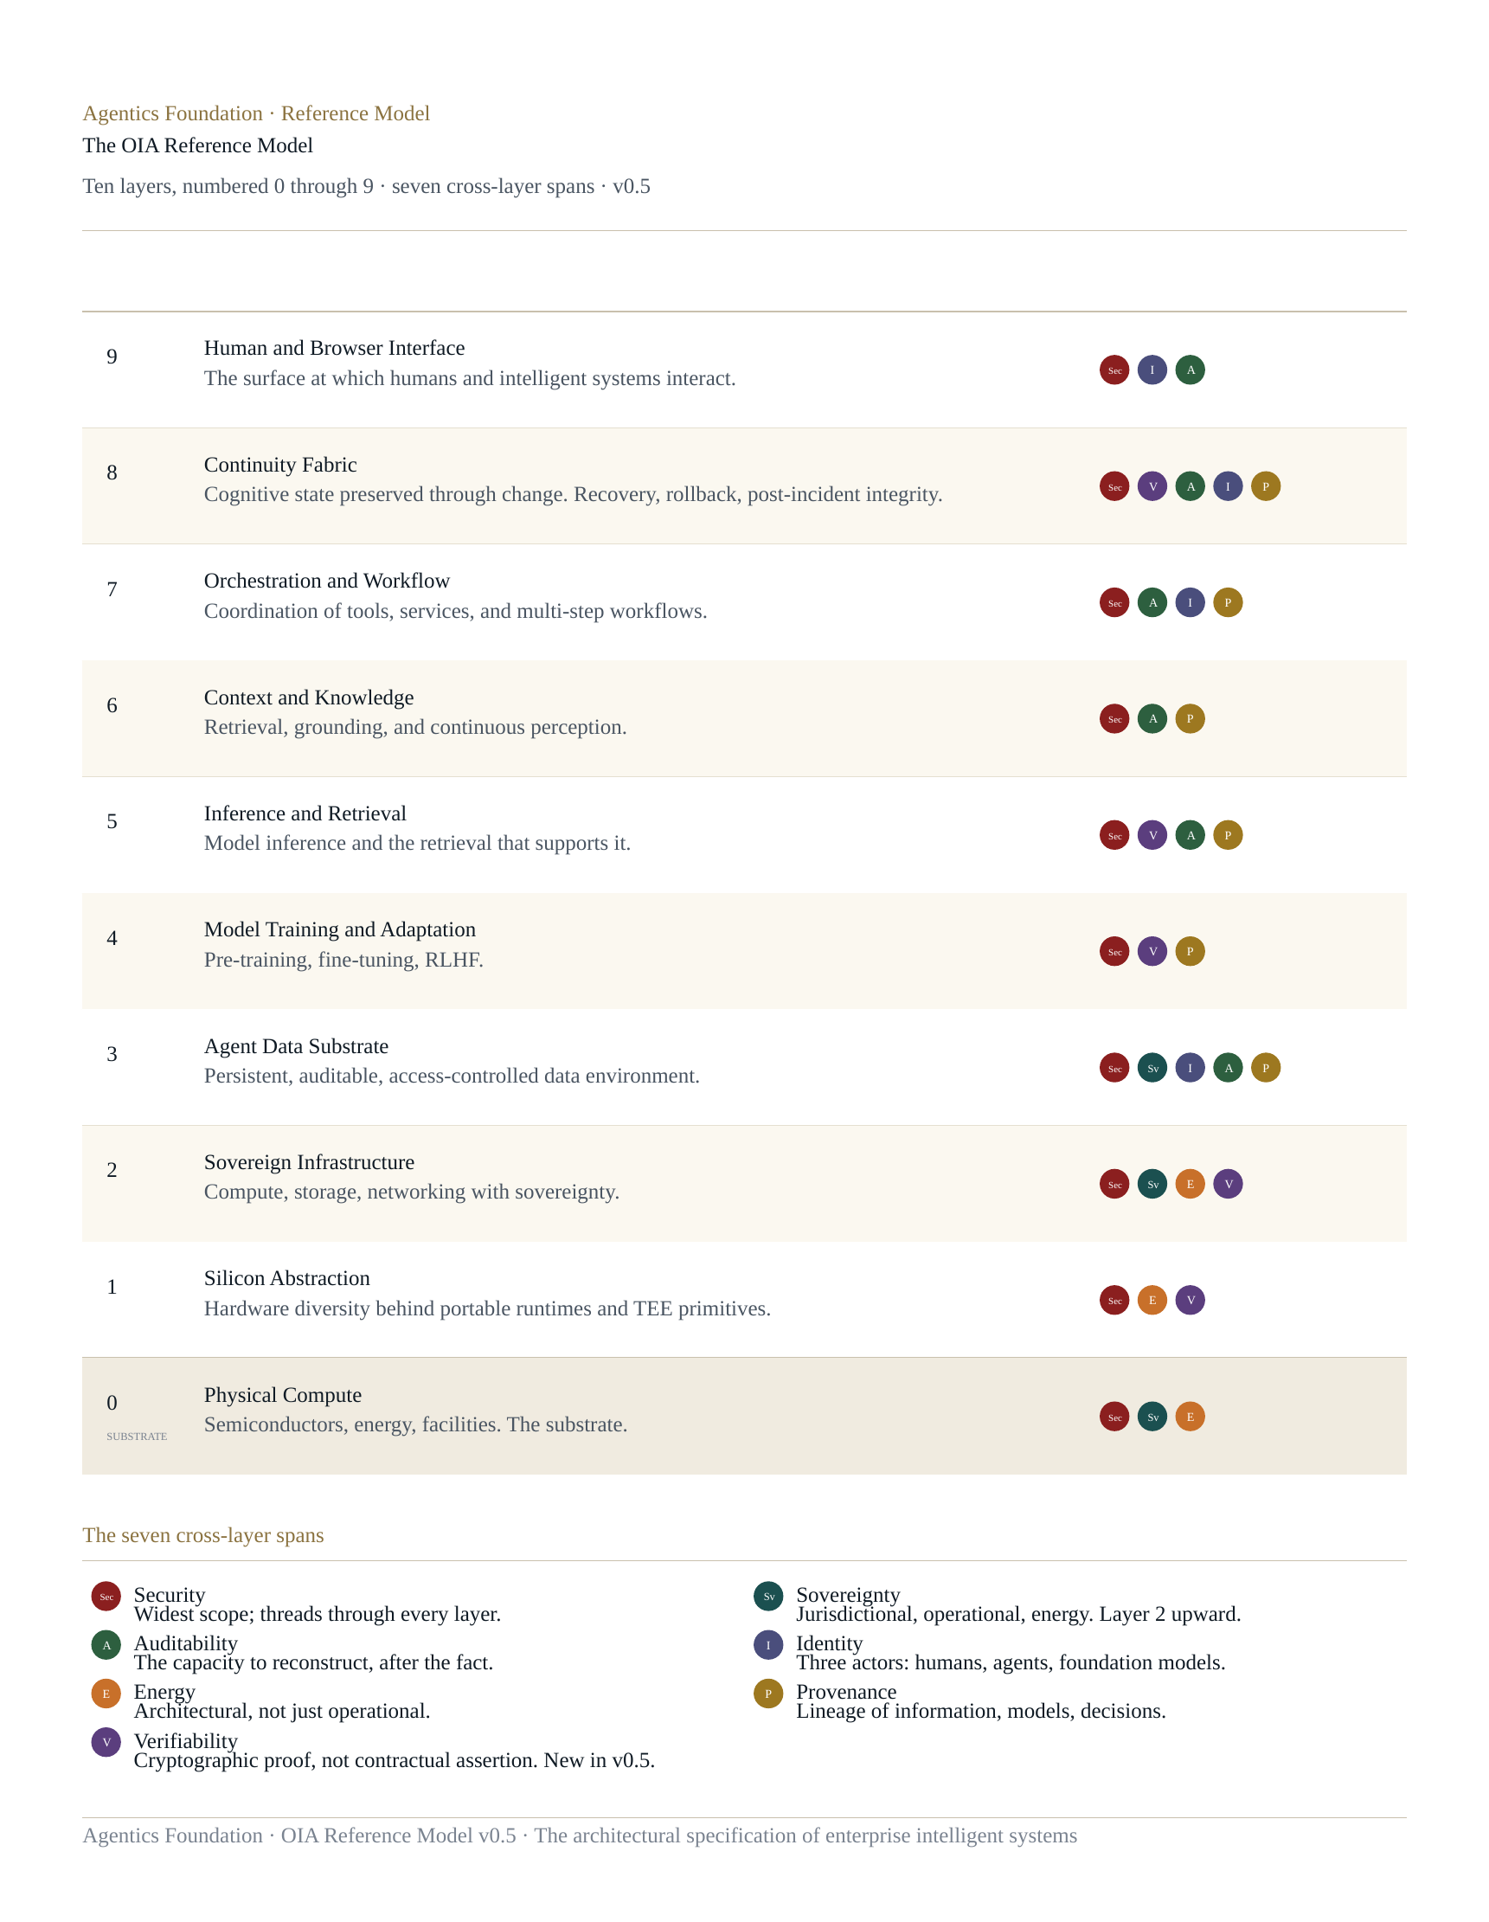
Ten layers, numbered 0 through 9, with Layer 0 the physical substrate beneath the architectural stack.
The architecture is read bottom-up. Layer 0 (Physical Compute) is the substrate — semiconductors, energy, facilities. Layer 1 (Silicon Abstraction) sits directly above, providing hardware diversity behind portable runtimes and the trusted execution primitives on which verifiability depends. Layer 2 (Sovereign Infrastructure) is the compute, storage, and networking layer with sovereignty made explicit. Layer 3 (Agent Data Substrate) is the persistent, auditable, access-controlled data environment that enterprise intelligence operates on. Layer 4 (Model Training and Adaptation) covers pre-training, fine-tuning, and reinforcement learning from human feedback. Layer 5 (Inference and Retrieval) is where models are run and where retrieval that supports inference is performed. Layer 6 (Context and Knowledge) handles grounding, retrieval-augmented generation, and continuous perception. Layer 7 (Orchestration and Workflow) coordinates tools, services, and multi-step workflows — including the agent-to-tool protocols that increasingly run on the Model Context Protocol. Layer 8 (Continuity Fabric) preserves cognitive state through change and provides recovery, rollback, and post-incident integrity for autonomous systems. Layer 9 (Human and Browser Interface) is the surface at which humans and intelligent systems interact.
Two layers hold state: Layer 3, which is the substrate of persistent data, and Layer 8, which is the active fabric that preserves cognitive continuity through change. The asymmetric pairing of these two layers — substrate below the operational stack, fabric above it — is the architectural recognition that intelligent systems hold state in two distinct ways, and that conflating them produces architecturally untenable designs.
Seven cross-layer spans thread through the architecture: Security, Sovereignty, Auditability, Identity, Energy and Environmental Concerns, Provenance, and Verifiability. Each is detailed in Section 14. The spans are not architectural ornament; they are the surface across which cross-functional governance of intelligent systems is conducted. Auditability matters to every audience. Identity threads through every layer. Verifiability — new in v0.5 — captures the property that operations of an intelligent system can be cryptographically proven, not merely contractually asserted, and is becoming foundational as enterprise AI moves from convenient to consequential.

LAYER 0 · THE SUBSTRATE

4. Layer 0: Physical Compute

Purpose
Layer 0 is the physical substrate beneath the architectural stack: semiconductors, energy, cooling, facilities, and the geographic siting that grounds them all. The physics of computation. The OIA names it as a layer rather than treating it as outside the model, because intelligent systems are uniquely sensitive to physical compute constraints in ways that traditional applications are not. Energy availability, semiconductor supply concentration, and physical co-location of training and inference workloads have become architectural concerns at the same level as application concerns.

Key concerns
Concentration of advanced semiconductor manufacturing in a small number of fabrication facilities, with the geopolitical implications that follow. Energy availability and grid capacity for training-scale workloads. Cooling capacity, water use, and environmental impact at hyperscale. Physical security and chain of custody for high-value compute infrastructure. Geographic siting under jurisdictional sovereignty constraints — the question of where an AI workload physically runs, not just where its data nominally resides. Long-cycle capital planning for facilities that may be in service for ten to fifteen years.

Cross-layer span concentration
Layer 0 is the origin of three cross-layer spans: Security (in its physical form), Sovereignty (in its jurisdictional and energy dimensions), and Energy and Environmental Concerns (which propagate upward as cost, capacity, and impact at every layer above). Sovereignty in particular is established at Layer 0 — if the substrate is in the wrong jurisdiction, no amount of architectural sovereignty above can recover the posture.

Reference technologies
Advanced semiconductor manufacturing nodes (3nm, 2nm, and below). Power-dense data centre designs (50kW per rack and rising). Liquid cooling and direct-to-chip thermal management. Behind-the-meter generation and grid-scale energy partnerships. Geographic siting frameworks for sovereign and regulated workloads.

Open questions
The boundary between physical sovereignty and operational sovereignty — specifically, how much of the physical substrate must be under domestic control for a workload to be considered sovereign in operational and regulatory terms. The energy economics of training-scale and inference-scale workloads at the limits of grid capacity. The long-cycle planning question of whether the current generation of semiconductor fabrication will support the projected scale of intelligent system deployment, or whether step-changes in efficiency are required.

LAYER 1

5. Layer 1: Silicon Abstraction

Purpose
Layer 1 provides hardware diversity behind portable runtimes and trusted execution primitives. It is the layer at which a CUDA kernel and a ROCm kernel and a custom AI accelerator's instruction set are all expressed through abstractions that allow workloads above to be portable across silicon. It is also the layer at which hardware-attested execution — the foundation of the Verifiability span new in v0.5 — is rooted. Trusted Execution Environments, secure enclaves, and confidential GPU primitives all live here.

Key concerns
Portability of intelligent system workloads across heterogeneous accelerator silicon. Performance ceilings of abstraction — how much overhead can be tolerated before the abstraction becomes commercially impractical. Attestation primitives for hardware-verified execution. The maturation of TEE and confidential computing primitives from foundational work to enterprise-grade integration. The economics of single-vendor accelerator dependency versus multi-vendor abstraction.

Cross-layer span concentration
Layer 1 is the architectural anchor for the Verifiability span (new in v0.5). Hardware-attested execution — Intel TDX, AMD SEV-SNP, NVIDIA Confidential GPU, the Confidential Computing Consortium body of work — is the ground on which verifiable rather than asserted trust is built. Energy concerns also concentrate here, since accelerator efficiency is the primary lever between physical compute capacity and useful inference throughput.

Reference technologies
WebAssembly as the increasingly consequential portable runtime for intelligent system components. CUDA, ROCm, and competing accelerator abstractions. Trusted Execution Environments: Intel TDX, AMD SEV-SNP, ARM CCA. Confidential GPU primitives, particularly NVIDIA's Confidential Computing for H100 and Blackwell generations. The Confidential Computing Consortium's specifications and reference implementations.

Open questions
The maturity gap between hardware-attested execution as a primitive and hardware-attested execution as an enterprise-deployable feature, particularly for confidential GPU workloads at training scale. The portability ceiling of intelligent system workloads across genuinely diverse accelerator silicon. The economic and regulatory pressures that will determine whether the enterprise adopts confidential computing as the default trust model or treats it as a high-assurance specialty.

LAYER 2

6. Layer 2: Sovereign Infrastructure

Purpose
Layer 2 is the compute, storage, and networking layer with sovereignty made explicit. Where traditional cloud infrastructure abstracts geography away, intelligent systems require it back: where workloads run, where data resides, where credentials and keys are held, and under what jurisdiction each of these can be compelled. Layer 2 is also where the Sovereign AI conversation becomes architectural rather than procurement-driven. National strategies for sovereign AI — in the European Union, in Asia-Pacific, in regulated sectors of the United States — land at this layer.

Key concerns
Three dimensions of sovereignty must be addressed: jurisdictional (which legal regime can compel access to data, models, or operation), operational (whether the entities operating the infrastructure are domestic or under foreign control), and energy (whether the energy powering the workload is under sovereign supply, increasingly relevant as AI workloads pressure national grids). The dependency map of an enterprise's AI infrastructure across these three dimensions is rarely visible in current procurement documentation. Multi-cloud AI deployment patterns frequently exhibit de facto multi-cloud architecture without de jure multi-cloud governance, creating exposure that becomes visible only at audit or incident response.

Cross-layer span concentration
Layer 2 is where the Sovereignty span is established. Sovereignty propagates upward through every layer above; if it is not addressed at Layer 2, it cannot be recovered higher. Verifiability anchors here as well — hardware-attested execution at Layer 1 reaches its operational expression at Layer 2 in the form of attested compute, storage, and networking. Security and Energy spans concentrate here too.

Reference technologies
Sovereign cloud regions and dedicated infrastructure programs from the major hyperscalers. National sovereign AI infrastructure initiatives. Confidential computing-enabled compute regions at scale. Cross-border data governance frameworks (Schrems II compliance patterns, India's data residency regime, China's regulatory architecture, the EU AI Act's territorial provisions). On-premises and edge AI deployment patterns where sovereignty drives architectural choice.

Open questions
The harmonisation — or lack of it — across emerging sovereign AI regimes. The economics of dedicated sovereign infrastructure versus sovereign-tier services within multi-tenant infrastructure. The architectural implications of energy sovereignty as AI training and inference workloads scale to gigawatt-class consumption. The question of whether sovereign AI is most usefully framed as an architectural concern, a regulatory concern, or a procurement concern — and the OIA's view that all three are real but architecturally primary.

LAYER 3

7. Layer 3: Agent Data Substrate

Purpose
Layer 3 is the persistent, auditable, access-controlled data environment that enterprise intelligent systems operate on. It is the lower of the two state-holding layers in the architecture, paired with Layer 8 (Continuity Fabric) above the operational stack. Layer 3 holds the structured and unstructured data, the embeddings and indexes, the customer information, the institutional knowledge, and the operational records that intelligent systems read, write, and reason over. It is also where the data-protection concerns that have shaped a generation of enterprise security architecture have to be re-thought for an environment in which intelligent systems are now agents acting on the data, not merely applications operating against it.

Key concerns
Persistent state with provenance: not merely whether the data exists, but where it came from, how it has been transformed, and what authority underwrites each operation that touched it. Auditability designed in from the outset rather than retrofitted as a logging layer. Access control that addresses three classes of actor — humans, agents, and foundation models — with appropriate identity governance for each (the Identity span absorbs this, new in v0.5). Sovereign data residency under a coherent jurisdictional regime. The AI-Inside problem (new in v0.5): the structural observation that essentially every enterprise SaaS now embeds foundation models, creating data egress to model providers that traditional DLP frameworks were not designed to detect or govern.

Cross-layer span concentration
Layer 3 is where five spans concentrate visibly: Security, Sovereignty (continuing from Layer 2), Identity (across the three actors), Auditability (originating here as the substrate of evidence), and Provenance (originating here as the substrate of lineage). The combination is what makes Layer 3 architecturally heavier than its data-storage description suggests.

Reference technologies
Lakehouse architectures designed for AI workloads. Vector databases and hybrid retrieval systems. Data observability platforms with AI-aware lineage. Data Loss Prevention frameworks adapted to detect embedded-LLM data flows (the AI-Inside problem). Identity and access management systems designed for non-human principals. Confidential computing-protected data environments for regulated workloads.

Open questions
The AI-Inside problem at scale: how the enterprise gains visibility into LLM data flows that originate inside SaaS applications it has procured rather than agents it has deployed. The governance model for data created by agents, where provenance traces to a model rather than a human authority. The architectural treatment of synthetic data — whether it is a class of data with its own provenance requirements, or a class of model output that happens to be persisted. The intersection of data sovereignty and agent operation, where the agent's operational location and the data's residential location may be in different regimes.

LAYER 4

8. Layer 4: Model Training and Adaptation

Purpose
Layer 4 covers pre-training, fine-tuning, reinforcement learning from human feedback, and the continuous adaptation processes by which foundation models are produced and adapted to enterprise use. It is the layer at which model weights are created and changed. It is also where the most resource-intensive workloads in the architecture concentrate, with training-scale infrastructure now reaching gigawatt-class energy consumption. The enterprise relationship with this layer ranges across a spectrum: from organisations that train foundation models themselves, through organisations that fine-tune and adapt third-party models, to organisations that consume models through inference APIs without engaging at this layer at all.

Key concerns
Provenance of training data, including the increasingly contested questions of consent, licensing, and the regulatory treatment of training as a use of intellectual property. Reproducibility of training runs and adaptation processes — a property that has been honoured in the breach as model production has industrialised. The integrity of fine-tuning and RLHF, where adaptation can either improve safety properties or compromise them depending on the data and the procedure. Verifiability of training and adaptation operations as a hardware-attested chain (new in v0.5), particularly for fine-tuning that handles sensitive or regulated data. Capital efficiency under genuine uncertainty, where training infrastructure investment has long lead times and rapidly evolving requirements.

Cross-layer span concentration
Provenance and Verifiability concentrate at Layer 4. Provenance because the training data lineage is the foundation of every downstream provenance claim; if it cannot be reconstructed at Layer 4, no amount of operational logging higher in the stack can substitute. Verifiability because attested fine-tuning — fine-tuning conducted inside hardware-verified execution boundaries — is becoming a meaningful enterprise option for regulated adaptation, especially where the adaptation involves customer data that cannot leave a sovereignty boundary. Security and Energy spans also concentrate here.

Reference technologies
Distributed training frameworks for large-model workloads. Parameter-efficient fine-tuning techniques (LoRA, QLoRA, and successors). RLHF and reinforcement learning from AI feedback pipelines. Confidential training environments using TEE-enabled accelerators. Provenance and dataset governance frameworks aligned with emerging regulatory regimes.

Open questions
The legal and regulatory treatment of training data, particularly under the EU AI Act's transparency provisions and emerging copyright regimes worldwide. The economics of attested fine-tuning at scale — whether it remains a regulated-workload specialty or becomes an enterprise default. The architecture of continuous adaptation, where fine-tuning is no longer a discrete event but an ongoing process. The question of where training and adaptation should sit on the partner-or-own-stack spectrum for typical enterprises, and how that placement changes as adaptation tooling matures.

LAYER 5

9. Layer 5: Inference and Retrieval

Purpose
Layer 5 is where models are run and where the retrieval operations that support inference are performed. It is the layer at which a foundation model's weights are loaded into accelerator memory and turned into outputs that propagate up the stack. It is also the layer at which the model's trustworthiness becomes a live operational concern, not a release-time concern. The model that decided is no longer necessarily the model deployed: provider weight swaps, alignment drift, jailbreak emergence, and LLM-specific common vulnerabilities and exposures all change correctness mid-flight in ways that traditional CVE feeds were not designed to surface.

Key concerns
Continuous trust scoring of every model in production use, against current threat reality. The recognition that foundation models are now actors inside the enterprise alongside humans and agents (the three-actor framing of the Identity span, new in v0.5) — actors whose trustworthiness is dynamic and must be governed dynamically. Model compromise as a named threat surface (new in v0.5): the trusted model that is no longer trustworthy. Inference cost economics, particularly for high-volume inference workloads where token economics drive infrastructure choices. Retrieval architecture and the integrity of retrieval pipelines that ground model outputs in enterprise context.

Cross-layer span concentration
Layer 5 is where Verifiability becomes operationally meaningful: attested inference, where a model is run inside a hardware-verified execution boundary, is increasingly a requirement for regulated and high-assurance workloads. Security concentrates here through the model compromise threat surface. Provenance threads from Layer 4 through Layer 5 to higher layers, carrying the lineage of which model produced which output. Auditability captures inference operations as evidence.

Reference technologies
Inference serving frameworks designed for production scale. Model gateways and abstraction layers that allow providers to be swapped. Continuous model evaluation platforms that score model behaviour against evolving benchmarks. Confidential inference environments using TEE-enabled accelerators. Retrieval-augmented generation pipelines with provenance preservation.

Open questions
The maturity of model trust scoring as an enterprise discipline — whether it converges on a small number of frameworks or remains organisation-specific. The economics and architecture of attested inference at production scale, particularly for the highest-volume consumer-facing applications. The provider-vs-self-hosted question, which now sits at the centre of most enterprise AI architecture conversations and turns on the capacity to govern trust at Layer 5 effectively in either configuration.

LAYER 6

10. Layer 6: Context and Knowledge

Purpose
Layer 6 handles retrieval, grounding, and continuous perception — the operations by which a model's general capability is grounded in the specific context of an enterprise's data, decisions, and ongoing reality. It is the layer at which retrieval-augmented generation pipelines run, at which agent context windows are assembled and managed, and at which the boundary between what the model knows from training and what the model has been given for the current task is enforced. It is also the layer at which adversarial pressure increasingly concentrates, because the easiest way to compromise an intelligent system is often to compromise the context on which it grounds.

Key concerns
Context poisoning, prompt injection, and the broader category of attacks that compromise model output by compromising model input. Provenance of retrieved context, with the trust properties of each retrieved item carried forward into the inference that uses them. Context window management at agent scale, where dozens of tools, hundreds of documents, and continuously perceived state must be assembled coherently. The boundary between general knowledge encoded in model weights and specific knowledge supplied at inference time — a boundary that affects auditability, attribution, and the legitimacy of model outputs in regulated settings.

Cross-layer span concentration
Provenance, Auditability, and Security concentrate at Layer 6. Provenance because grounding is the architectural locus where the lineage of supporting evidence either is or is not preserved into the model's output. Auditability because the context window assembled for a given inference is one of the primary artefacts a regulator or auditor will want to reconstruct. Security because adversarial control of context is now one of the most active threat vectors against enterprise AI.

Reference technologies
Retrieval-augmented generation frameworks designed for enterprise context. Semantic search and vector retrieval at production scale. Agent context management systems and continuous perception integrations. Prompt injection defence frameworks and output filtering. The OWASP Top 10 for LLM Applications as the practitioner reference for the threat surface concentrating at this layer.

Open questions
The architectural treatment of long-running agent context, where state accumulates across sessions and the boundary between context and memory becomes architecturally unclear. The provenance properties of indirectly retrieved context, where evidence is selected by another model whose own behaviour is dynamic. The maturity of prompt injection defence at production scale — whether it converges on standardised frameworks or remains a defence-in-depth concern requiring application-specific design.

LAYER 7

11. Layer 7: Orchestration and Workflow

Purpose
Layer 7 coordinates tools, services, and multi-step workflows. It is the layer at which an intelligent system stops being a model that responds and becomes an agent that acts — invoking external tools, taking multi-step actions, holding intent across operations, and operating inside a scope of authority that the deploying organisation must define and govern. It is the architectural locus of autonomy, and consequently of most of the threat surface specific to the agentic era.

Key concerns
Three of the four named threat surfaces of the agentic era originate or propagate through Layer 7. Agent-in-the-middle attacks (new in v0.5): a rogue MCP server or other adversarial intermediary inserts itself between a trusted agent and a real tool, relaying sanitised responses while exfiltrating, the agentic equivalent of an SSL strip. Agent spoofing: agent identities inheriting trust they should not have, across contexts and lifetimes — the inheritance problem that the existing identity infrastructure was not designed to govern. Mimicry as it propagates from Layer 9 into agentic action surfaces. Beyond named threats: intent verification (does the agent understand what was asked of it), action auditability (can the chain of decisions and tool invocations be reconstructed), tool integrity (is the tool the agent is calling the tool the deploying organisation approved), and kill-chain detection across multi-step agent operations.

Cross-layer span concentration
Identity concentrates at Layer 7 through the agent identity governance challenge. Auditability concentrates here because Layer 7 is where the actions that audit will most often need to reconstruct take place. Security concentrates here through the threat surfaces named above. Provenance threads through, carrying the lineage of decisions and tool invocations into the operational record.

Reference technologies
The Model Context Protocol (MCP) as the increasingly dominant agent-to-tool integration protocol, with its associated security architecture for tool registries, vetted tool calls, and MCP gateway patterns. Agent frameworks at the application layer (multiple competing frameworks, none yet dominant). Workflow engines adapted for agent-driven coordination. Identity infrastructure designed for non-human principals operating across trust boundaries.

Open questions
Agent identity at architectural scope: how an enterprise governs agents the way it governs humans, including onboarding, scope assignment, behavioral baselining, and offboarding. The MCP security architecture as it matures from emerging protocol to enterprise-deployed standard. The framework-fragmentation question: whether the enterprise must pick a winning agent framework or whether Layer 8 (Continuity Fabric) can absorb cross-framework continuity in a way that lets multiple frameworks coexist.

LAYER 8 · THE ARCHITECTURAL CENTREPIECE

12. Layer 8: Continuity Fabric

Purpose
Layer 8 is the active layer at which cognitive state, learning, and judgment are preserved, verified, and carried across the transitions the stack undergoes; and at which recovery, rollback, and post-incident integrity for autonomous systems are made architecturally tractable. The two framings are the same property described in different vocabularies. The first framing is structural — continuity of cognitive state through change — and the second is operational — the place where you handle recovery, rollback, and the consequences of an autonomous action that should not have been taken. v0.5 brings the operational framing forward explicitly because it gives Layer 8 a concrete failure mode and a concrete responsibility that practitioners across audiences can engage with.
Layer 8 is the architectural centrepiece. It is the layer that the rest of the architecture is paired against.

Key concerns
Continuity of state across model swaps, framework changes, and provider transitions — the recognition that no agent framework, model provider, or orchestration platform can be allowed to own the enterprise's cognitive state, because all of them will eventually change. Recovery and rollback for autonomous systems: the practitioner-facing question of what to do when an agent has acted, the action was wrong, and the audit chain is broken because the model that decided is no longer the model deployed. Post-incident integrity: reconstructing what actually happened across distributed agent operations, model swaps, and time. Witness chains and verifiable continuity logs that allow state transitions to be cryptographically attested rather than merely recorded.

Cross-layer span concentration
Layer 8 is where five spans concentrate: Security, Verifiability, Auditability, Identity, and Provenance. The combination is what makes Layer 8 architecturally heavier than its continuity description suggests. Verifiability in particular extends from its hardware roots at Layer 1 through Layer 8 in the form of witness chains and attested state transitions — the property that the continuity record is not merely logged but proved.

Reference technologies
Witness-chain architectures for verifiable state transitions. Continuity primitives that operate above and outside specific agent frameworks. Cryptographic state attestation patterns. Recovery and rollback patterns for autonomous systems, including the emerging discipline of compensating-action design for actions that cannot be undone. Cross-framework continuity protocols (early; this is one of the genuinely open architectural problems).

Open questions
Layer 8 is the layer at which the OIA acknowledges the most architectural distance between the model and the available reference technologies. The industry has not yet settled on continuity primitives that work across agent frameworks. Witness-chain implementations are early. The practitioner playbook for autonomous-action rollback is being written in real time across early enterprise deployments. The Continuity Fabric is therefore the layer most consistently identified across audiences as the gap that the existing technology stack does not yet fill — and consequently the layer where the most important architectural and product work in the next several years will concentrate.

LAYER 9

13. Layer 9: Human and Browser Interface

Purpose
Layer 9 is the surface at which humans and intelligent systems interact. It is where prompts are entered, where outputs are read, where conversational interfaces operate, and where the boundary between human and agent action is most often resolved (or fails to be). It is also where mimicry — the threat surface unique to the agentic era in which AI-generated content is indistinguishable from human-authored content — first lands, before propagating through Layer 7 (Orchestration) into action and Layer 3 (Agent Data Substrate) into persisted state.

Key concerns
Mimicry as a named threat surface (one of the four named in v0.5): the question of whether an entity at the interface is a human or an agent, and whether the content presented is human-authored or AI-generated. Deepfake voice and video as social engineering at unprecedented scale. The boundary between human-in-the-loop and human-on-the-loop oversight, increasingly relevant as agent autonomy increases. The architectural treatment of conversational interfaces, where the same surface that humans use is also the surface through which adversarial agents may attempt to interact with the enterprise. The recognition that Layer 9 is not only the top of the stack but also frequently the entry point of attack.

Cross-layer span concentration
Identity, Security, and Auditability concentrate at Layer 9. Identity because the human-versus-agent boundary must be resolved here. Security because the named threat surface of mimicry originates here. Auditability because human-system interaction is among the most heavily regulated and most heavily audited surfaces in the enterprise.

Reference technologies
Conversational interface frameworks designed for enterprise deployment. Liveness and provenance verification for human-system interaction. Deepfake detection tooling. Content authenticity primitives (C2PA, related provenance standards). Identity verification systems adapted for agent-rich environments. Browser-based and application-embedded AI interfaces, including the emerging category of browser-as-agent-runtime.

Open questions
The maturity of mimicry defence at the consumer-facing scale of most enterprise interfaces — whether existing tooling is adequate or whether step changes in detection capability are required. The architectural treatment of browser-based agents that operate at Layer 9 on behalf of the user, particularly as their action surfaces extend into Layer 7. The accountability question for actions taken at Layer 9 by agents acting on behalf of a human — where the boundary of authority is, and how it is recorded.

14. The Seven Cross-Layer Spans
The seven cross-layer spans are the surface across which cross-functional governance of intelligent systems is conducted. They thread vertically through the architecture, each anchored at one or more layers and each propagating concerns through several others. Where the layers describe where the work happens, the spans describe how the consequences propagate. The combination of layer specification (Sections 4 through 13) and span specification (this section) is what makes the OIA a complete architectural reference rather than a layer catalog.
Six of the seven spans are preserved unchanged from v0.1. Verifiability is added in v0.5 to capture the architectural property surfaced during the Proofpoint pressure test of the model: that the operations of an intelligent system can be cryptographically proven, not merely contractually asserted. Each span is specified below in canonical form.

14.1 Security
Security is the cross-layer span with the widest scope. Every layer has security properties; coherence requires that guarantees at lower layers surface to higher layers without being lost. The named threat surfaces of the agentic era — mimicry, agent-in-the-middle, agent spoofing, model compromise — each land at one or more specific layers but require a security posture that is coherent across the stack to defend against. Security is anchored conceptually at every layer, with concentration at Layer 5 (model compromise), Layer 7 (agent-in-the-middle, agent spoofing), Layer 9 (mimicry), and Layer 3 (data exfiltration including the AI-Inside problem).

14.2 Sovereignty
Sovereignty has three dimensions: jurisdictional (which legal regime can compel access), operational (whether operating entities are domestic or foreign-controlled), and energy (whether the energy powering the workload is under sovereign supply). Sovereignty is established at Layer 2 (Sovereign Infrastructure) and threads upward through every layer above; it cannot be retrofitted higher in the stack if it was not addressed at Layer 2. Energy sovereignty originates at Layer 0.

14.3 Auditability
Auditability is the capacity to reconstruct, after the fact, what happened and why. It cannot be retrofitted as a logging layer; it must be designed into every layer from the outset. The audit committee's request to ‘show me the evidence' resolves to specific architectural artefacts at every layer, and an OIA-aware audit can specify what evidence is expected at each. Auditability originates as a substrate property at Layer 3 and is realised at every layer above.

14.4 Identity
Identity addresses three classes of actor inside the enterprise: humans, agents, and foundation models. Each class carries a distinct identity lifecycle, scope-of-authority pattern, and trust posture. The three-actor framing is new in v0.5 and reflects the architectural recognition that foundation models are now actors whose trustworthiness is dynamic and must be continuously scored against current threat reality. Identity threads through almost every layer, with concentration at Layer 7 (agent identity governance), Layer 9 (human-versus-agent boundary), and Layer 5 (model-as-actor).

14.5 Energy and Environmental Concerns
Energy, originating at Layer 0, propagates upward as cost, capacity, and environmental impact at every layer above. Energy concerns have moved from operational to architectural as AI training and inference workloads have scaled to gigawatt-class consumption. The OIA treats energy as a span rather than as a Layer 0 property because its consequences — economic, regulatory, environmental, sovereign — land at every layer from substrate to interface.

14.6 Provenance
Provenance is the lineage of information, models, decisions, and actions. It is distinct from auditability: auditability is the capacity to reconstruct after the fact; provenance is the property that enables reconstruction. Provenance originates at Layer 3 (Agent Data Substrate) and extends upward through the stack, carrying the lineage of training data, model adaptation, retrieval evidence, agent decisions, and tool invocations. Without provenance preserved at each layer, auditability fails at every layer above.

14.7 Verifiability
Verifiability is the span new in v0.5. It captures the property that operations of an intelligent system can be cryptographically proven, not merely contractually asserted. Trust verified, rather than trust granted. Verifiability is anchored at Layer 1 (Silicon Abstraction) by hardware-attested execution primitives — Intel TDX, AMD SEV-SNP, NVIDIA Confidential GPU, the Confidential Computing Consortium body of work — and threads through Layers 2, 4, and 5 in the operational forms of attested compute, attested fine-tuning, and attested inference. Verifiability extends to Layer 8 in the form of witness-chain logic for verifiable continuity. The span captures what is becoming a foundational alternative to vendor promise: trust that is mathematically demonstrable rather than contractually asserted, increasingly required for regulated and high-assurance enterprise AI.

15. The Four Named Threat Surfaces of the Agentic Era
The OIA names four threat surfaces of the agentic era as canonical inside the architecture. They are not introduced as new architectural elements; they are named in the appropriate layer specifications above and surfaced collectively here. The naming gives security audiences a shared vocabulary that ties to the architecture rather than to any specific framework. The four threats are: mimicry, agent-in-the-middle, agent spoofing, and model compromise.
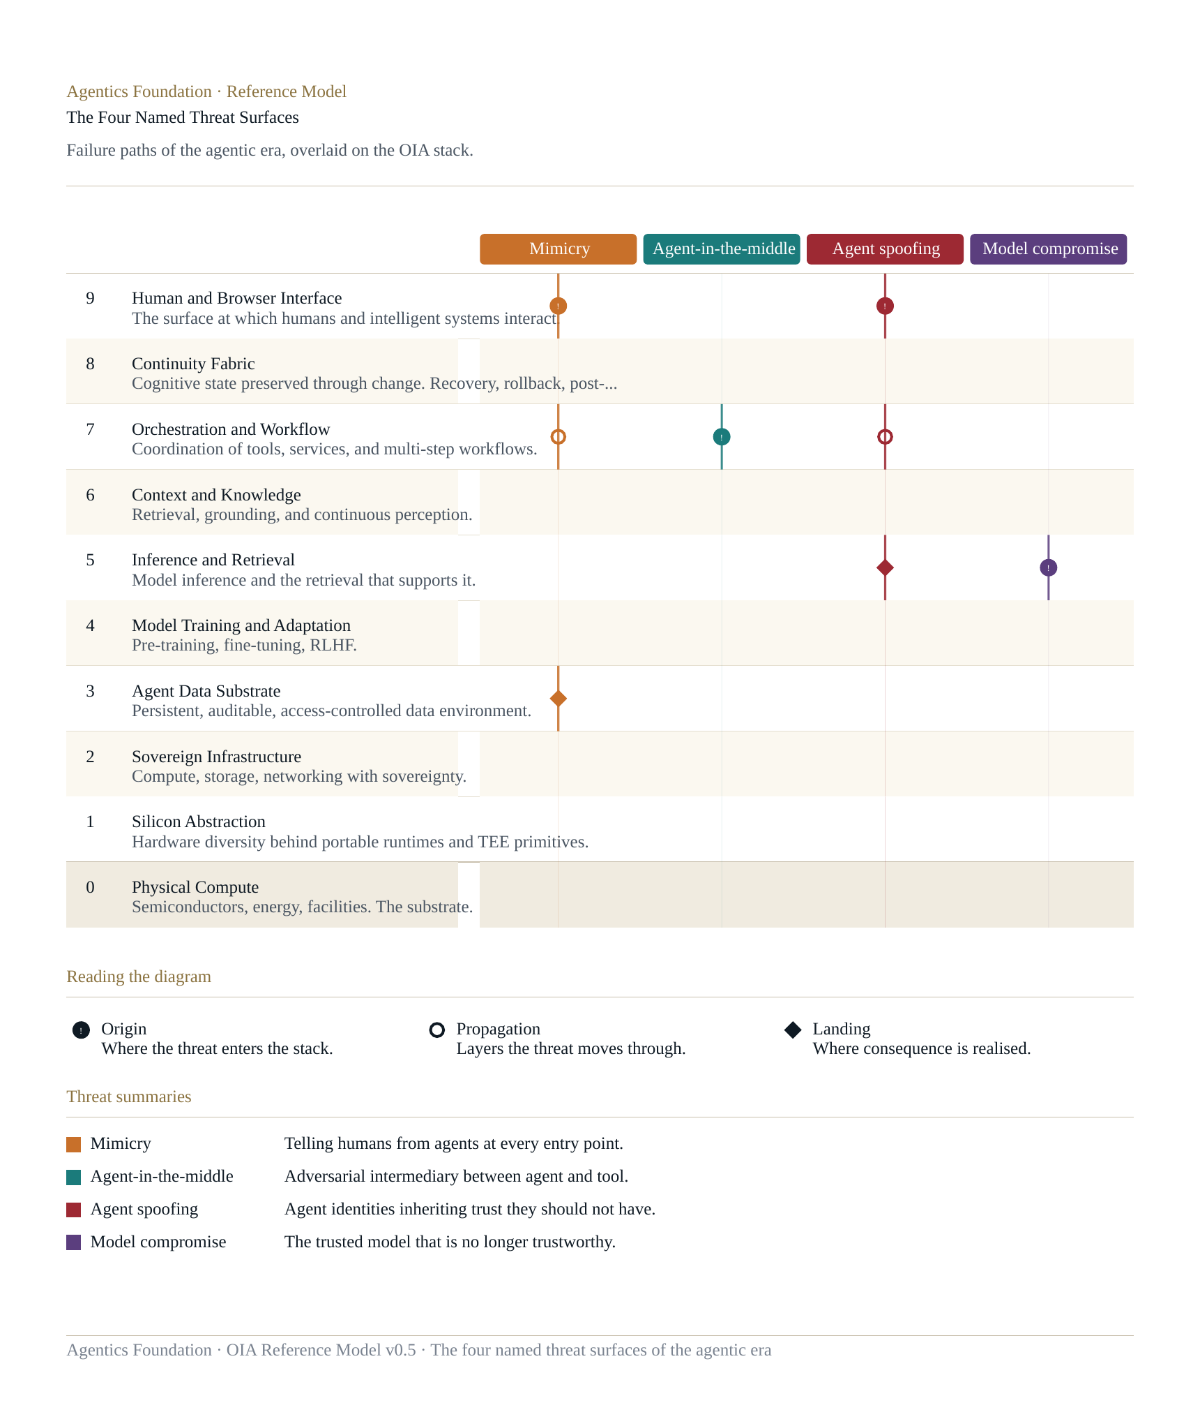
The diagram above shows the four threats overlaid on the stack as origin, propagation, and landing markers. Reading the four together surfaces an architectural observation that is easily missed when each threat is considered in isolation: three of the four originate or propagate through Layer 7 (Orchestration and Workflow), and the fourth originates at Layer 5 (Inference and Retrieval). Layers 7 and 5 are therefore where the security architecture of the agentic era concentrates its weight — not at the perimeter, where prior security architectures expected attacks to land, but inside the operational stack where intelligent systems do their work.
Mimicry. The boundary problem of telling humans from agents at every entry point, and of distinguishing AI-generated content from human-authored content. Layer 9 origin, propagating through Layer 7 into action surfaces and into Layer 3 as persisted state. Defence concentrates at Layer 9 (interface-level liveness, content provenance) but extends through the stack.
Agent-in-the-middle. Adversarial intermediaries between agents and tools, including rogue MCP servers — the agentic equivalent of the SSL-stripping attack that targeted browser-server connections in the previous generation. Layer 7 origin and primary domain. Defence concentrates on tool registry integrity, vetted tool calls, and gateway architecture for MCP and adjacent protocols.
Agent spoofing. Agent identities inheriting trust they should not have, across contexts and lifetimes. The inheritance problem at the agent-identity level. Identity span concentration, Layers 5 through 9. Defence concentrates on agent identity governance — onboarding, scope assignment, behavioural baselining, offboarding — alongside conventional identity infrastructure.
Model compromise. The trusted model that is no longer trustworthy. Weight swap, alignment drift, jailbreak emergence, LLM-specific CVEs. Layer 5 origin. Defence concentrates on continuous model trust scoring, attested inference, and the recognition of foundation models as actors whose trustworthiness is dynamic and must be governed dynamically.
These four surfaces do not constitute a complete catalog of every adversarial pattern facing intelligent systems. They are the four that have emerged with the agentic era and that v0.5 names canonically inside the architecture. Other threat surfaces — prompt injection, data poisoning, model inversion, training data extraction, and others — remain real and are addressed in the per-layer specifications above. The four named threats are the four that the architecture treats as structurally central to the agentic era specifically.

16. The OIA Lens System
The OIA Reference Model is published alongside the OIA Lens System — a set of audience-specific overlays that translate the architecture into the language of the executive audiences accountable for AI inside the enterprise. The Lens System is not a separate body of work; it is an integral part of the OIA Model. A reference architecture without a clear path into the audiences who must apply it is incomplete; the Lens System closes that gap.
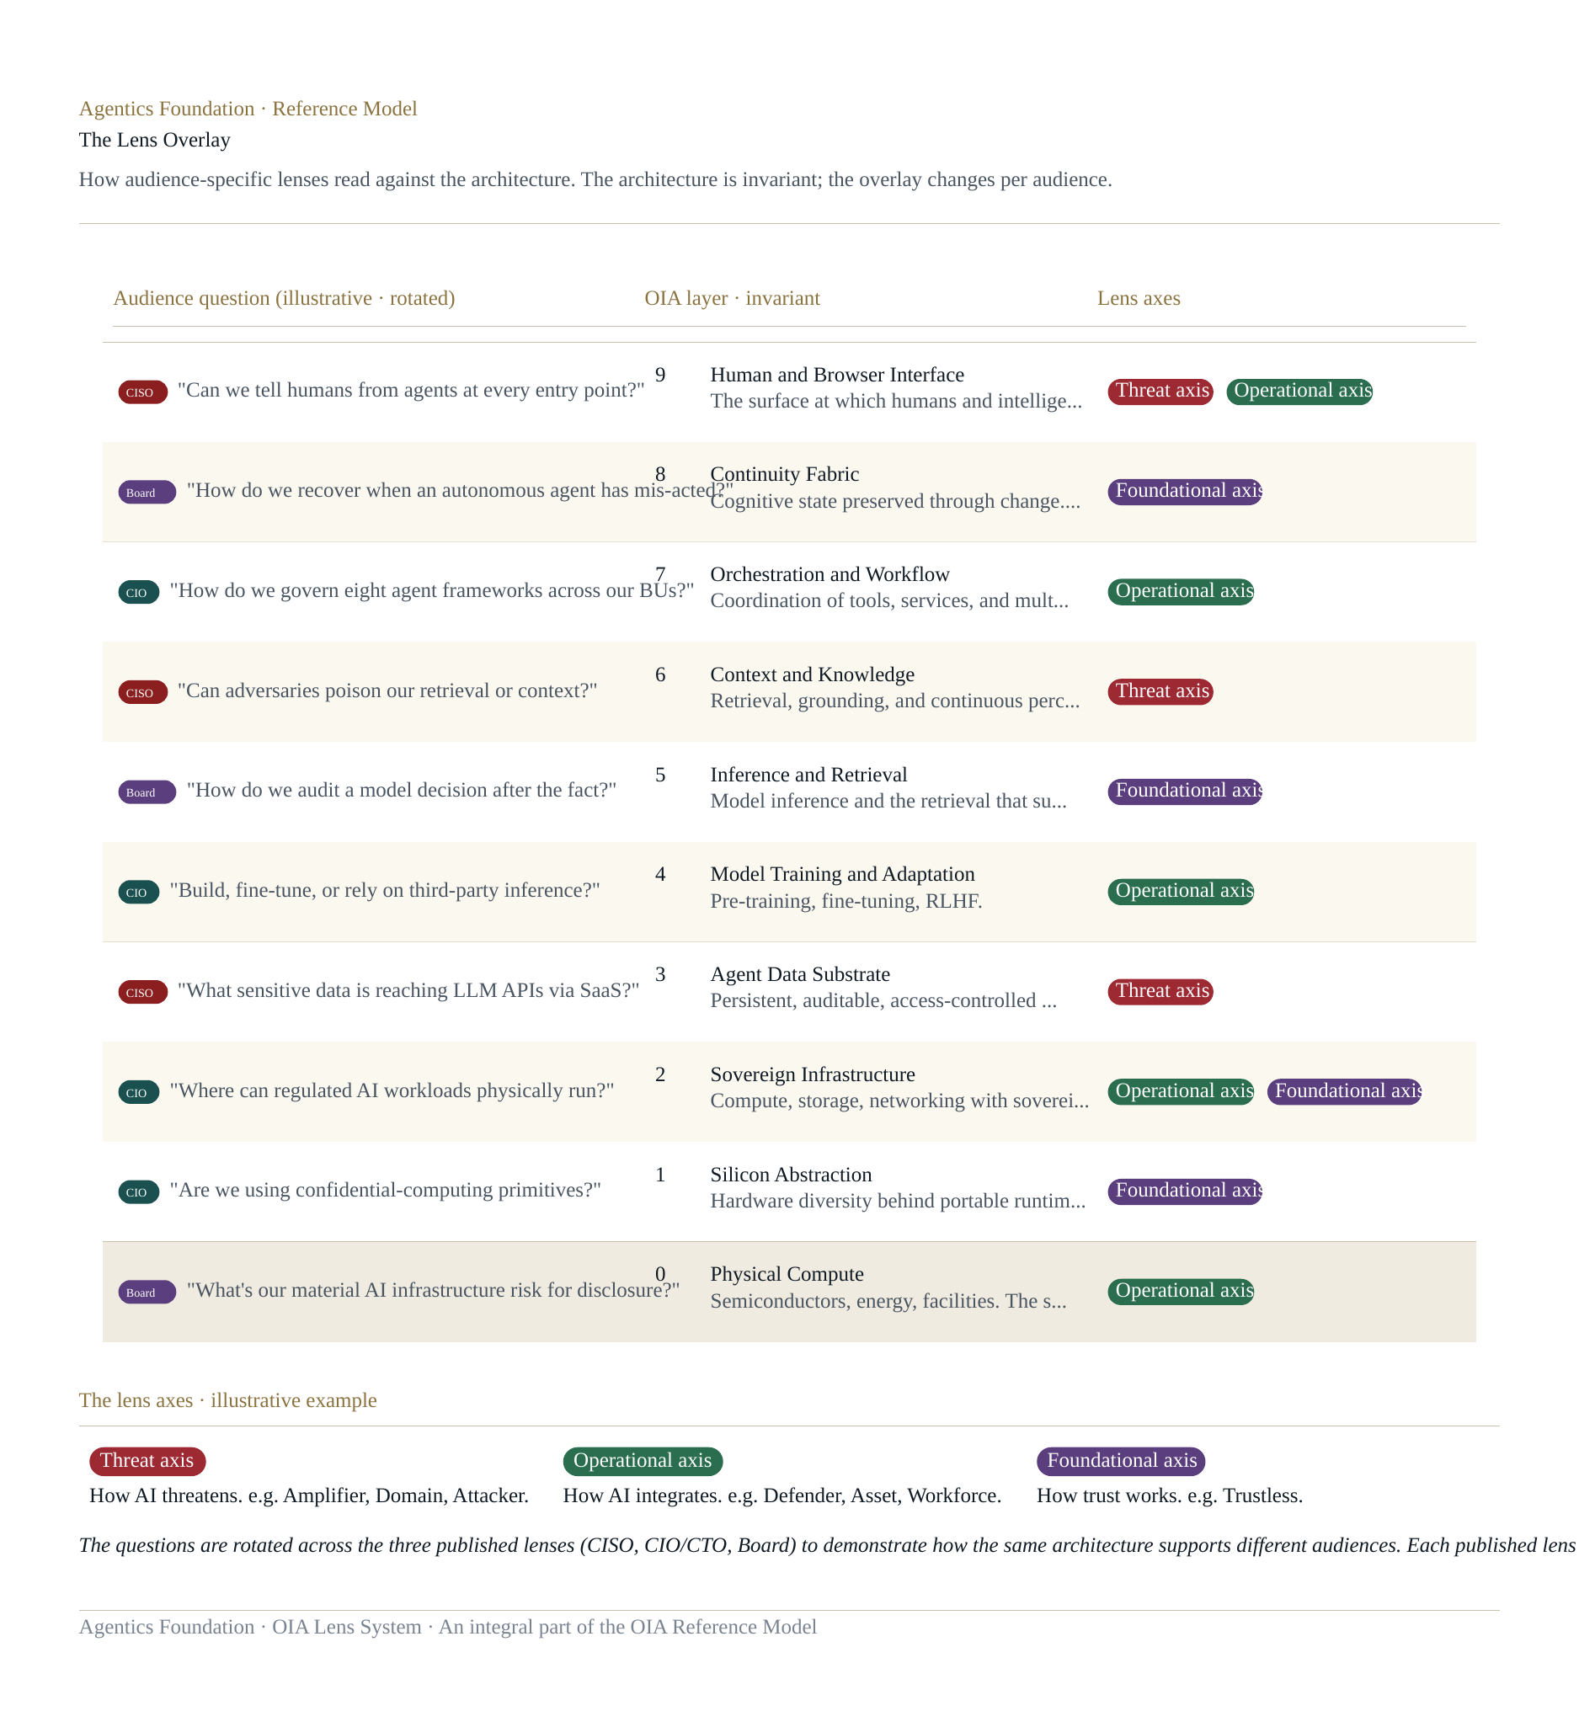
Three lenses are published in the first release. The CISO Lens for the security organisation, calibrated to the threat surfaces, framework references, and planning questions of chief information security officers. The CIO/CTO Lens for the technology organisation, calibrated to the operational, capital, and architectural questions of chief information and technology officers. The Board and Risk Lens for directors, audit and risk committee members, and chief risk officers. Each lens reads the same ten layers and seven cross-layer spans, but through the questions, the risks, the framework anchors, and the interpretive frames of its audience. The architecture is invariant; the overlay changes per audience.
Three further lenses are anticipated for subsequent release: a CFO Lens for the finance audience, a General Counsel and Compliance Lens for the legal and regulatory audience, and a CHRO Lens for the workforce transformation audience. These will be authored under the same approach as the first three when practitioner engagement and demand support them.
The Lens System is specified in detail in its companion document, The OIA Lens System, published alongside this Reference Paper. Readers approaching the OIA from a specific role should read the Reference Paper for the architecture and the Lens that fits their role for the application. Readers responsible for cross-functional alignment on AI — board members, chief executives, and the executive teams who must coordinate across audiences — should read the Reference Paper for the architecture and the Lens System overview for the application.

17. Open Questions
The OIA does not close every question its layers raise. The model is most useful when the genuinely unresolved is named clearly, so that practitioner attention concentrates where it can do real work. v0.5 carries forward all of v0.1's open questions without closing any of them, and adds further questions surfaced by the Proofpoint pressure test. Each question is anchored to the layer or span where it lives architecturally.
The most consequential open questions, gathered here as a single readable list:
- Layer 8 (Continuity Fabric). Continuity primitives that work across agent frameworks. Witness-chain implementations at enterprise scale. The practitioner playbook for autonomous-action rollback. The most architecturally consequential gap in the present technology stack.
- Layer 7 (Orchestration). Agent identity governance at architectural scope — onboarding, scope assignment, behavioural baselining, offboarding. The maturation of MCP security architecture from emerging protocol to enterprise-deployed standard.
- Layer 5 (Inference). Continuous model trust scoring as an enterprise discipline. The economics of attested inference at production scale. The provider-versus-self-hosted question and the architecture that makes either configuration governable at Layer 5.
- Layer 4 (Training and Adaptation). The legal and regulatory treatment of training data. The economics and architecture of attested fine-tuning. Continuous adaptation as an architectural pattern rather than a discrete event.
- Layer 3 (Agent Data Substrate). The AI-Inside problem at scale: enterprise visibility into LLM data flows originating inside SaaS applications. The governance model for data created by agents. The architectural treatment of synthetic data.
- Layer 2 (Sovereign Infrastructure). Harmonisation across emerging sovereign AI regimes. The economics of dedicated sovereign infrastructure versus sovereign-tier services. Energy sovereignty as workloads scale.
- Layer 1 (Silicon Abstraction). The maturity gap between hardware-attested execution as a primitive and as an enterprise-deployable feature. Whether confidential computing becomes the default trust model or remains a high-assurance specialty.
- Layer 0 (Physical Compute). The boundary between physical and operational sovereignty. The energy economics of training and inference at the limits of grid capacity. The long-cycle planning question of whether current semiconductor capability supports projected deployment scale.
- Verifiability span (new in v0.5). The maturation of verifiable rather than asserted trust as an enterprise default rather than a regulated-workload specialty. The end-to-end verifiability story across silicon, infrastructure, training, inference, and continuity — how the layers' attestations chain into a single verifiable posture.
- Identity span. The agent identity problem in particular: how agent identities are scoped, attested, prevented from inheriting trust they should not have, and governed across contexts and lifetimes. The OIA's open question here is structural — the existing identity infrastructure was not designed for non-human, dynamically-trustworthy actors.
These questions are open in the architectural sense — the model names them as unresolved and points to where in the stack they live, but does not prescribe the answers. The Foundation invites practitioners working on any of these to contribute to their resolution through the open development of the model.

18. Closing
The OIA Reference Model is a working specification of the architecture of enterprise intelligent systems. It is published as v0.5 in 2026, alongside the OIA Lens System for the executive audiences accountable for AI inside the enterprise, and alongside the OIA Visual Reference for the diagrams that render the architecture in a single visual frame. Together these documents constitute the Foundation's complete reference for the OIA at this stage of its development.
The architecture will continue to develop. The open questions named in Section 17 are real, and several of them will resolve in the next several years through the work of practitioners, vendors, regulators, and standards bodies. As they resolve, the OIA will absorb the resolutions and publish subsequent versions. The model is meant to be foundational, and foundational means open to the audiences that will use it and to the technological progress that will refine it.
The Foundation invites readers — executives, practitioners, supporting organisations, and the broader community — to engage with the architecture, push back on what does not fit, and contribute to what comes next.

AGENTICS FOUNDATION · THE OIA REFERENCE MODEL · V0.5 · 2026

