PUBLISHED BY THE AGENTICS FOUNDATION

The OIA Visual Reference
Three diagrams that render the OIA Reference Model and the Lens System: the architecture, the lens overlay, and the four named threat surfaces of the agentic era.

Companion to the OIA Reference Model v0.5.
Version 0.5 · 2026

Reading the OIA Visually
The OIA Reference Model is described primarily in language. Its ten layers, seven cross-layer spans, and three defining properties of intelligent systems are written specifications meant to be precise rather than evocative. But specifications are read more clearly when their structure is also seen. The three diagrams in this companion render the architecture and its applications in a single visual frame each — not as a substitute for the prose, but as the picture readers can hold in mind while reading it.
The diagrams are designed for reuse. Each is published as an SVG file alongside this document, intended to be embedded into the Reference Paper, the Digest, the Lens System, the thought leadership deck, and any presentation or publication where a visual reference to the OIA is helpful. The same design system runs through all three: ten layers stacked bottom-up, restrained typography, the gold-and-warm-neutral palette of the Foundation document family, and a substrate boundary at Layer 0 that distinguishes the physical foundation from the architectural stack above it.
Three diagrams are presented in sequence. The OIA Stack is the architectural reference itself, showing the ten layers and the seven cross-layer spans that thread through them. The Lens Overlay shows how an audience-specific Lens Map reads against the same stack, with illustrative content drawn from the working examples of the three published lenses. The Four Named Threat Surfaces shows the failure paths of the agentic era — mimicry, agent-in-the-middle, agent spoofing, and model compromise — overlaid on the stack as origin, propagation, and landing markers.

DIAGRAM 1 · THE ARCHITECTURE

The OIA Stack
The architectural reference. Ten layers, numbered 0 through 9, with Layer 0 the physical substrate beneath the architectural stack. Each layer carries its name and primary purpose. The colored chips on the right of each layer indicate the cross-layer spans most architecturally salient at that layer. The legend below the stack lists all seven spans, with Verifiability the new addition in v0.5.
This is the diagram that establishes the architecture as a whole. It is the reference visual for any document, presentation, or conversation about the OIA. When a CISO, a CIO, or a board director needs to find their concerns located on the architecture, this is the picture they hold while reading the more specific Lens Map for their audience.
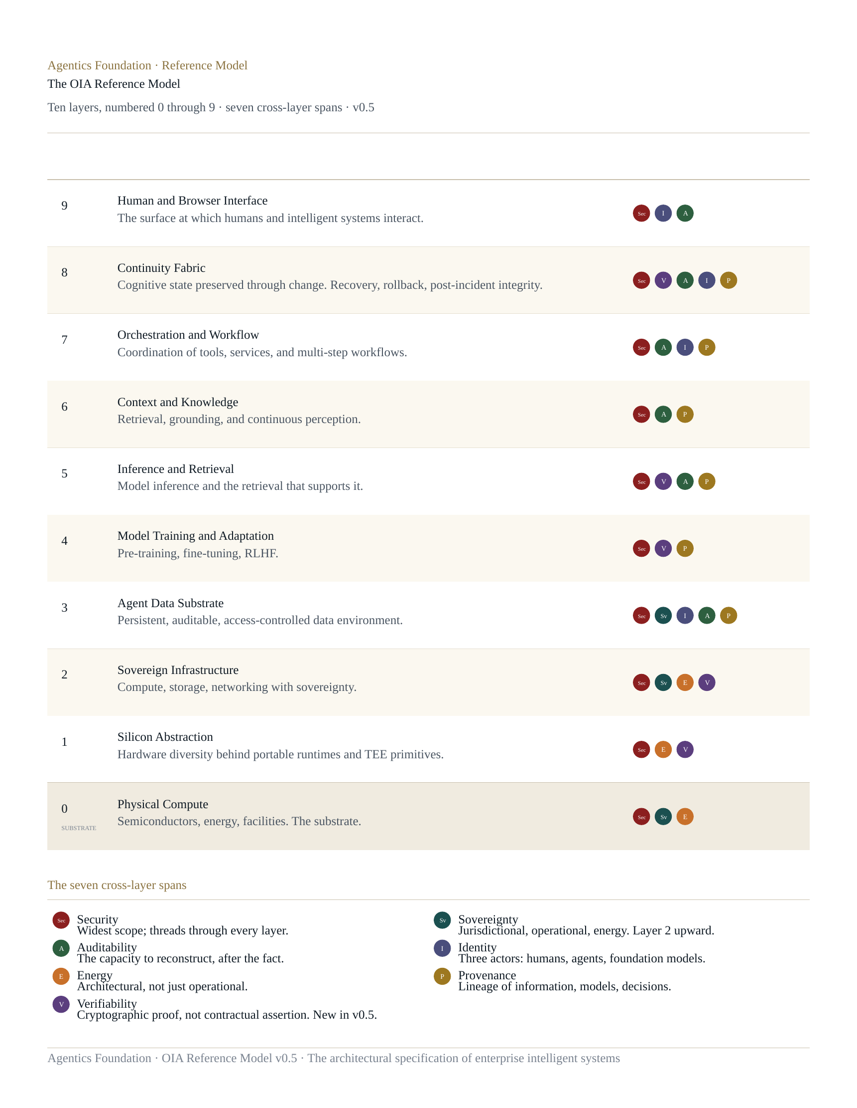
The substrate distinction at Layer 0 is deliberate. Unlike networking architectures where the physical medium can be abstracted away, intelligent systems are deeply shaped by physical compute constraints — energy availability, semiconductor supply, cooling capacity, geographic siting — that propagate upward through every layer above. The substrate band at Layer 0 marks this distinction visually, while preserving the layer's place inside the model.

DIAGRAM 2 · THE LENS OVERLAY

The Lens Overlay
Where the Stack diagram shows the architecture, this diagram shows how the architecture is read. Three columns sit on the same ten layers: the audience question on the left (in the audience's own voice), the OIA layer in the centre (invariant across all audiences), and the lens axes on the right (the interpretive frames the audience uses to relate to AI as a category). The architecture is the spine; the overlay changes per audience.
The questions and chips shown here are illustrative — drawn from the working examples that exist across the three published lenses. Each Lens Map (CISO, CIO/CTO, Board and Risk) provides its own definitive content for these columns. The pattern is the methodology of the Lens System; the words belong to the audience.
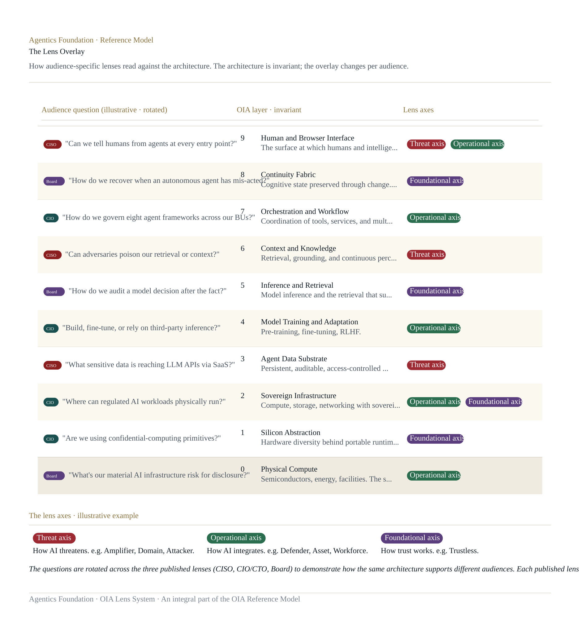
The bottom of the diagram shows the three axes commonly used to organise interpretive lenses within a Lens Map: a threat axis (how AI threatens), an operational axis (how AI integrates), and a foundational axis (how AI's trust model works). The CISO Lens uses all three; some lenses for other audiences may use fewer. The methodology of the Lens System bounds the lens count to between five and seven across two or three axes — enough to be coherent, restrained enough to be clear.

DIAGRAM 3 · THE FOUR NAMED THREAT SURFACES

Threat Surfaces of the Agentic Era
The third diagram overlays the four named threat surfaces of the agentic era — mimicry, agent-in-the-middle, agent spoofing, and model compromise — onto the OIA stack. Each threat is shown as a vertical column. The markers on each column indicate where the threat originates (filled circle), where it propagates (ring), and where its consequence lands (diamond). The visual makes architecturally explicit what the Reference Paper's threat vocabulary names in prose.
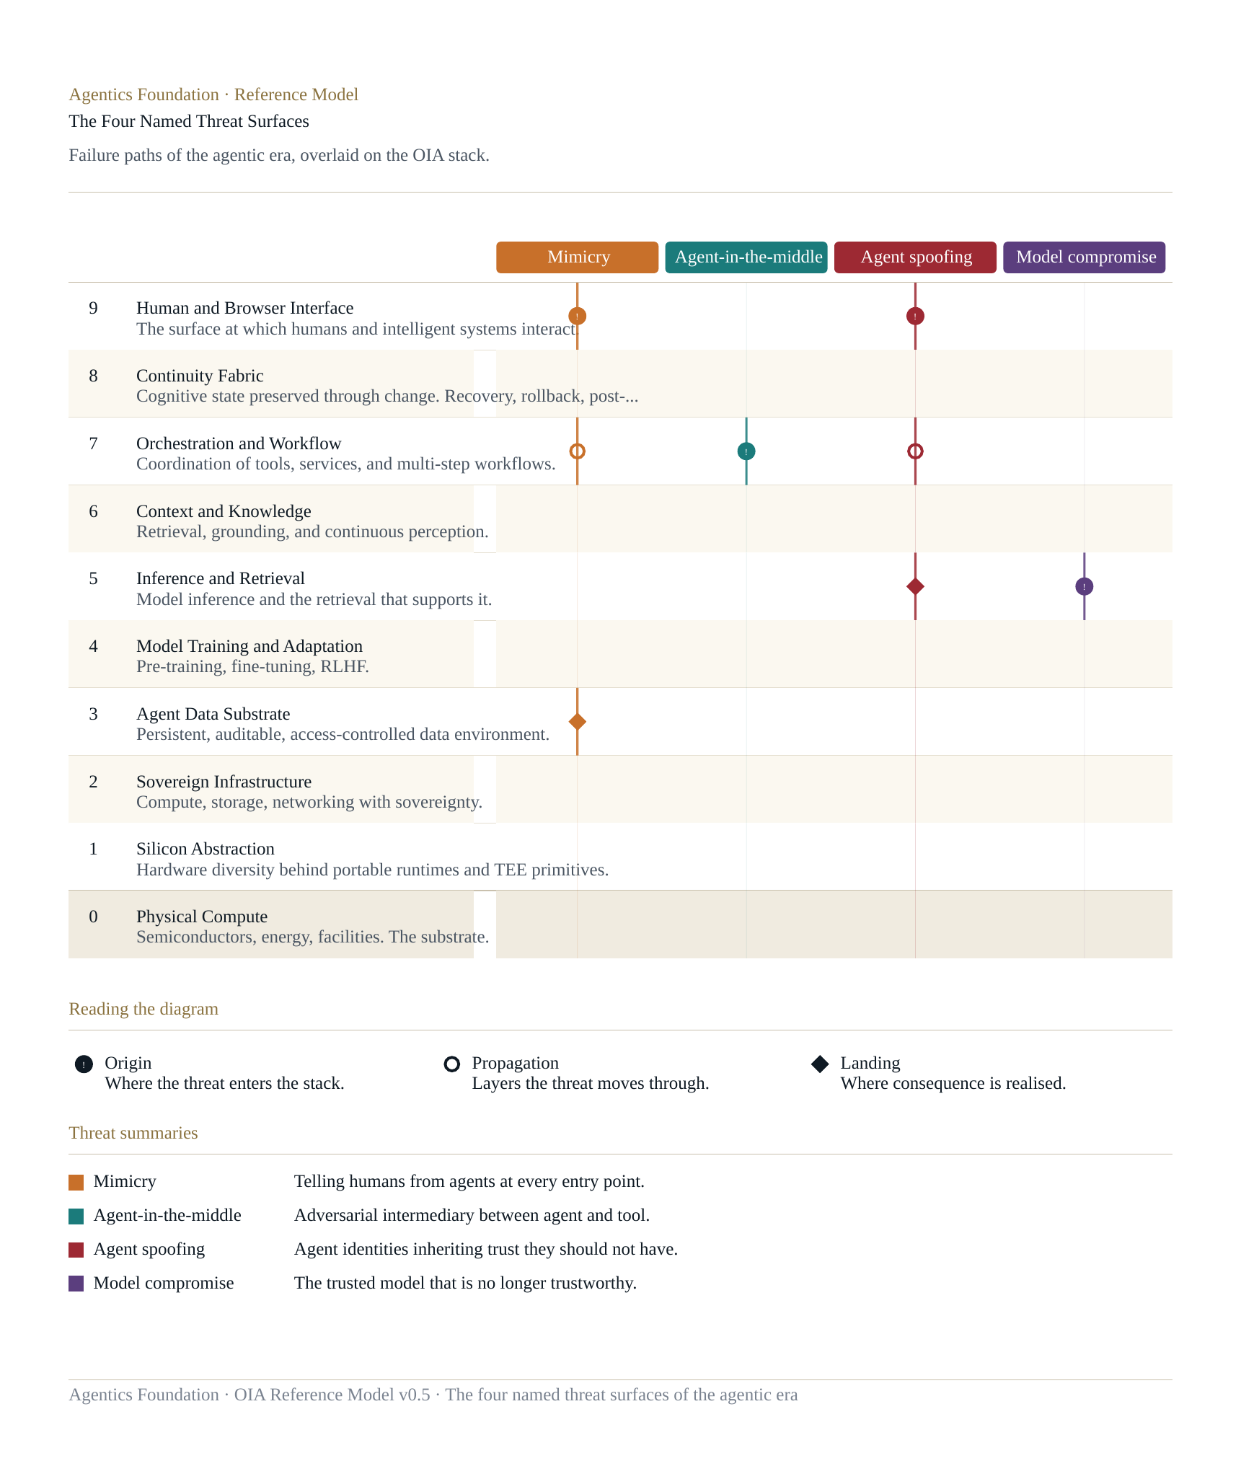
The four threats are not a comprehensive catalog of every adversarial pattern facing intelligent systems; they are the four that have emerged with the agentic era and that v0.5 names canonically inside the architecture. Mimicry tests the boundary between humans and agents at every entry point. Agent-in-the-middle is the agentic equivalent of an SSL strip, where a rogue intermediary inserts itself between agent and tool. Agent spoofing is the inheritance problem at Layer 7 — agent identities carrying trust they should not have, across contexts and lifetimes. Model compromise is the live problem at Layer 5: the trusted model that is no longer trustworthy, through weight swap, alignment drift, jailbreak emergence, or LLM-specific CVE.
Reading the four threats together, the diagram surfaces an observation that the prose makes only obliquely: three of the four originate or propagate through Layer 7 (Orchestration and Workflow), and the fourth originates at Layer 5 (Inference and Retrieval). Layers 7 and 5 are therefore where the security architecture of the agentic era concentrates its weight — not at the perimeter, where prior security architectures expected attacks to land, but inside the operational stack where intelligent systems do their work.

Using These Diagrams
The three diagrams are published as both standalone SVG files and as embedded images in this companion document. The SVG files are the canonical visual reference. They are vector-clean, embed cleanly into Word, PowerPoint, web pages, and any other surface where a publishable visual representation of the OIA is useful. The Foundation invites supporting organisations and practitioners to use these diagrams in their own thought leadership, presentations, customer materials, and analyst engagements, with appropriate attribution to the Agentics Foundation.
Visual references for any reference architecture are most powerful when they remain consistent. We ask that organisations using these diagrams use the published versions rather than redrawing them. If a specific application requires a variation, we welcome the contribution back to the Foundation as a candidate for the canonical set.

AGENTICS FOUNDATION · OIA VISUAL REFERENCE · V0.5 · 2026

