Software Requirements Specification

for

Scheduling Manager
Version <0.1>

Prepared by
Group Name: Group 4
Daniel Kelly
Mason Hardy
Nickolas Haugen
Benjamin McSwain
Mark Walters

Instructor: | Amanda Schwartz
Course: | CSCI540

Specific Requirements

External Interface Requirements

User Interfaces

Figure 1: This window is the login window. The window is accessible by all users. If the user is the employer then the login button links to the employer schedule form. If the user is an employee then the login button links to the employee availability information entry form.

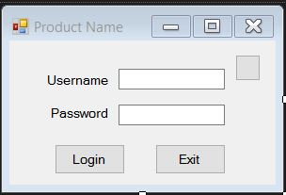

Figure 2: Employees can enter the times and days for a given week that they can work. The employee can also ask off. As well as, submit their availability and view the final(uneditable) schedule.

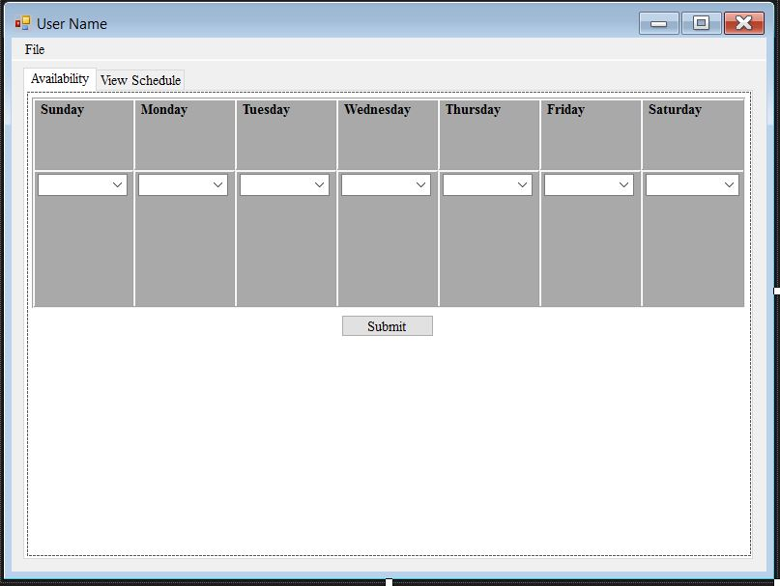

Figure 3: The Employer login button links to this screen. Employer is able to edit employees, view individual employee availability, select business hours, generate a schedule from employee availability, edit the generated schedule and submit it. As well as view the final(uneditable) schedule.

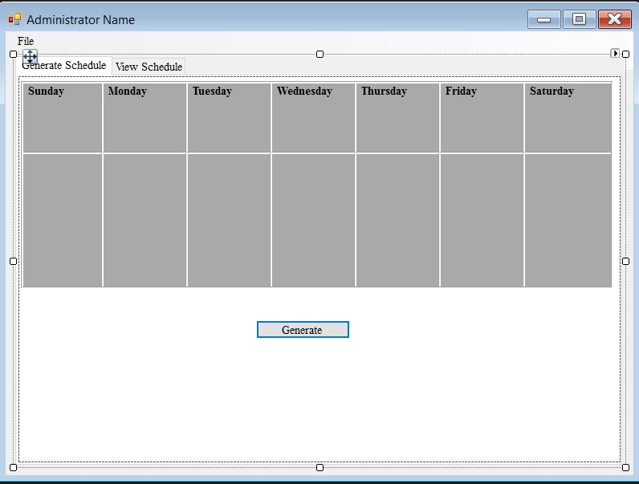

Figure 4: This is where an employer can add new employee accounts. Will be able to edit login info as well.

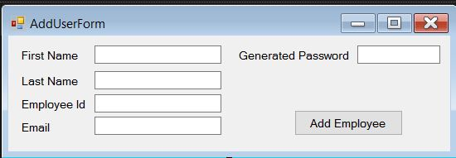

Figure 5: Where employers can edit employee information.
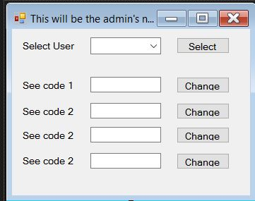

Figure 6: Final schedule viewable by both employer and employee. It is uneditable. Back button returns you to AdminScheduleForm.

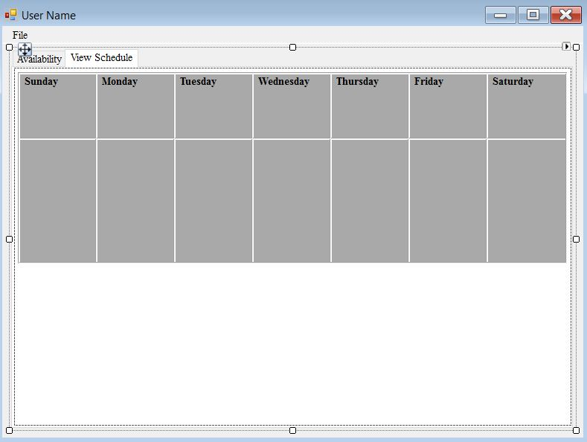

Software Interfaces

The program will work on a computer that has Windows XP or higher. The computer should have the latest Java Runtime Environment installed to run the program. Employee and administrative data will be stored in a SQL server database.

Functional Requirements
The software will be capable of allowing users to create a profile which has a certain level of clearance. The two levels will be referred to as an employee profile and an employer profile. In figure 4(add_edit_deleteUsersForm) the employer will have the ability to click the add new employee button to add a new employee to the database. The edit button can be used to edit employee data such as name, address, etc. The delete button will delete the employee from the database.

Once an employee is added to the database, he/she may sign in using their login information provided by the employer. Employee profiles have the ability to view their official job title, edit their available times for scheduling, request time off, and view the schedule. In figure 2(UserForm) the employee will be able to click a radio button corresponding to a specific day of the week and check the appropriate time boxes to specify which hours they are available to work each day. To finalize the changes in their availability, the employee will click the Submit Employee Schedule button. The Request Time Off button will take the employee to a different page where he/she can request a specific day or days to have time off. Finally, the View Final Schedule button will display figure 6(FinalScheduleForm) allowing the employee to see the final generated schedule.

When the employer logs on to the Scheduling program, he/she is taken to figure 3(AdminScheduleForm). Here he/she will be presented with a generated editable schedule based on the employees’ availability. If the employer approves of the computer-generated schedule, he/she may use the Submit Final Schedule button to create a finalized version of the schedule. On this form, he/she can also use the Enter Business Hours button to set the hours of operation for the business. He/she can use the View Employee Schedule button to view the availability of each employee (see figure 5) or use the View Final Schedule button to view the schedule generated for the week.

Behaviour Requirements

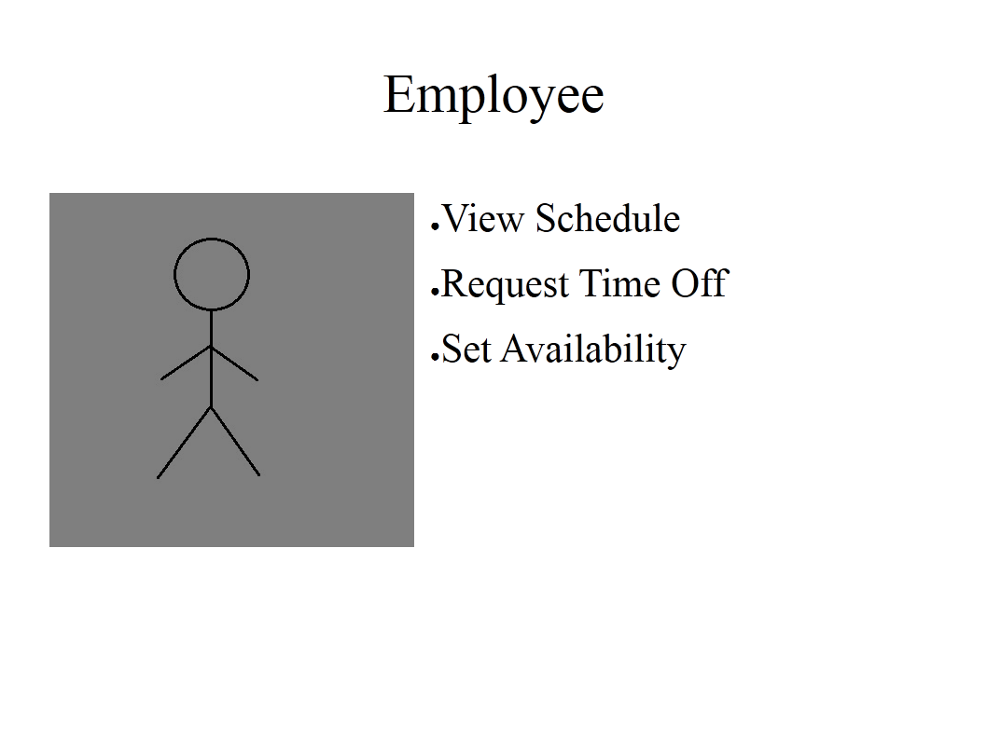
Use Case View
