INTEGRATED WEB AND MOBILE BUSINESS MANAGEMENT SYSTEM WITH PRODUCT RECOMMENDATION, PREDICTIVE ANALYTICS, AND INTEGRATED CHATBOT FOR BATTLEFRONT COMPUTER TRADING

A Capstone Project presented to the Faculty of the
College of Computing and Information Sciences
State University of Northern Negros

In Partial Fulfillment of the Requirements for the Degree
Bachelor of Science in Information Systems

By:

Daulong, Jj Niño S.
Delgado, Mark Daniel B.
Liganad, Bernie V.
Pilar, James Philip E.

2026

DISCLAIMER

This capstone project entitled “Integrated Web and Mobile Business Management System with Product Recommendation, Predictive Analytics, and Integrated Chatbot for Battlefront Computer Trading” is prepared solely for academic purposes in partial fulfillment of the requirements of the Bachelor of Science in Information Technology/Information Systems program. The content, analyses, and results presented herein are intended to demonstrate the application of theoretical and practical knowledge gained during the program and are not meant for commercial distribution or direct business implementation without further refinement and authorization. The authors declare that while the study utilized various sources of information, proper acknowledgment and citations were made to uphold academic integrity, and any similarities to existing systems or studies are purely coincidental. The institution and faculty advisers bear no responsibility for the commercial use, misinterpretation, or misuse of this study.
Declaration on the Use of AI Tools
The authors acknowledge that Artificial Intelligence (AI) tools, including large language models (LLMs), grammar checkers, and reference managers, were utilized in the preparation of this document for purposes such as improving writing clarity, grammar, formatting, and generation of initial drafts of certain sections (e.g., background of the study and literature support). However, all outputs generated through AI were critically reviewed, revised, and validated by the authors to ensure accuracy, relevance, and compliance with academic standards. The authors remain fully responsible for the integrity, originality, and authenticity of the final work.

NAME OF PROJECT MANAGER

TABLE OF CONTENTS

List of Figures

List of Tables

List of Appendices

CHAPTER I
INTRODUCTION
In today's competitive retail environment, computer hardware and peripherals trading businesses face increasing pressure to streamline operations, respond quickly to customer needs, and make data-informed decisions. The rise of e-commerce and mobile technology has reshaped how customers browse, compare, and purchase computer parts, pushing small and medium-sized trading businesses to move beyond manual, paper-based, or spreadsheet-driven processes (Chaffey & Ellis-Chadwick, 2019; Turban et al., 2018). Businesses that fail to adopt integrated digital systems risk losing customers to competitors offering faster service, personalized recommendations, and round-the-clock support (Laudon & Traver, 2021).
Battlefront Computer Trading, a computer hardware and peripherals retailer, currently relies on manual and semi-manual methods for recording sales, monitoring inventory, and assisting customers who inquire about product compatibility, availability, and pricing. Stock levels are tracked using handwritten logs and basic spreadsheets, which are prone to human error, delayed updates, and mismatched records between the physical store and online inquiries. Customer inquiries relayed through social media and phone calls are answered manually by staff, resulting in slow response times, especially during peak hours or after business hours. Moreover, the absence of a structured recommendation mechanism means that walk-in and online customers rarely receive personalized product suggestions based on their budget, intended use, preferred brand, and product preferences, which can lead to missed upselling opportunities and customer dissatisfaction.
In the Philippine setting specifically, digital adoption among small and medium enterprises remains uneven despite its growing necessity. The Philippine Statistics Authority reported that MSMEs represented 99.50% of business establishments in the country in 2022, underscoring how critical this sector is to the local economy. However, studies on Philippine MSMEs during and after the pandemic have documented persistent barriers to digitalization, including limited capital for initial technology investment, low digital literacy among owners and employees, unstable internet connectivity in outlying areas, and fear of cybersecurity risks such as data breaches or financial fraud. Research on e-commerce-adopting MSMEs in the Philippines has similarly found that while many businesses have gained access to digital sales channels, a considerable number still struggle to fully capitalize on them due to financing constraints, logistics issues, and gaps in digital skills. These local findings reinforce the relevance of a system such as the one proposed for Battlefront Computer Trading, which is designed to directly address several of these documented barriers, manual processes, delayed customer response, and the absence of data-driven decision support within the scale of a single small business rather than an enterprise-wide transformation.
An Integrated Web and Mobile Business Management System addresses these challenges by consolidating sales, inventory, and customer engagement functions into a single digital platform accessible through both a web portal and a mobile application. Beyond standard sales and inventory features, the proposed system incorporates a rule-based product recommendation module that uses relevant customer interactions, including product searches, product views, shopping cart activity, and purchase history, to generate personalized product suggestions. The recommendation process considers product characteristics, available inventory, and recorded customer behavior while maintaining eligibility and availability restrictions. Unlike recommendation approaches that require large-scale model training, the implemented approach applies defined rules and weighted behavioral signals to support product discovery within Battlefront Computer Trading's catalog. (Ricci, Rokach, & Shapira, 2015; Aggarwal, 2016), which encompasses content-based, collaborative, and rule-based approaches. While collaborative filtering (Sarwar et al., 2001) has demonstrated strong cross-selling results at scale, it requires substantial historical user-item interaction data that a newly deployed system for a single retail branch does not yet possess; this study therefore adopts a behavior-driven, rule-based ranking approach that uses weighted customer interaction signals, product characteristics, and inventory availability to generate relevant recommendations within the business's product catalog. The system further incorporates predictive analytics to forecast product demand and optimize inventory restocking, reducing instances of stockouts and overstocking (Chase, 2018). Finally, an integrated chatbot provides customers with immediate answers to common inquiries, such as product availability, specifications, and order status, reducing the workload on sales staff while improving customer response time (Adamopoulou & Moussiades, 2020).
Beyond addressing Battlefront Computer Trading's immediate operational concerns, the study contributes to the broader movement of digital transformation among small and medium computer trading enterprises in the Philippines. By demonstrating how recommendation systems, predictive analytics, and conversational interfaces can be integrated into an ordinary retail and inventory system, the study provides a practical model that similarly positioned businesses may adopt to remain competitive in an increasingly technology-driven retail landscape.
In this context, the present study proposes the design and development of an Integrated Web and Mobile Business Management System with Product Recommendation, Predictive Analytics, and Integrated Chatbot for Battlefront Computer Trading. The system is envisioned to streamline sales and inventory operations, provide customers with intelligent product recommendations, forecast demand for better inventory planning, and offer round-the-clock customer assistance through an integrated chatbot, ultimately enabling Battlefront Computer Trading to operate more efficiently across both physical and online channels.
Objectives of the Study
The main objective of this study is to design and develop an Integrated Web and Mobile Business Management System with Product Recommendation, Predictive Analytics, and Integrated Chatbot for Battlefront Computer Trading.
Specifically, it aims to:
- Develop an integrated web and mobile business management system that streamlines product management, inventory monitoring, sales processing, customer order management, and business reporting for Battlefront Computer Trading.
- Implement product recommendation, predictive analytics, and chatbot functionalities that enhance customer experience, support sales forecasting and inventory planning, and improve business decision-making.
- Evaluate the level of the system’s quality based on McCall’s Software Quality Model, focusing on product operation, product revision, and product transition criteria.
- Determine the level of usability of the developed system using the Computer System Usability Questionnaire (CSUQ) to assess user satisfaction and system effectiveness.
Scope and Limitations
This study focuses on the design and development of an Integrated Web and Mobile Business Management System with Product Recommendation, Predictive Analytics, and Integrated Chatbot for Battlefront Computer Trading.
The system is designed to:
The proposed system will provide an integrated web-based business management platform with customer-facing e-commerce functions and a dedicated application programming interface (API) supporting a separately developed React Native and Expo mobile application. The administrative platform will support product and category management, inventory monitoring, controlled stock adjustments, damage reporting, customer and supplier returns, order processing, sales reporting, forecasting, and customer information management. Administrative responsibilities will be governed by role-based access control (RBAC), with Staff, Manager, and Owner designated as the intended administrative roles of the final system.
Customers will be able to register and verify their accounts, browse the product catalog, manage shopping carts and wishlists, place orders, view order histories, and access personalized product recommendations and chatbot assistance. The product recommendation module will use rule-based techniques and recorded customer interactions, including product searches, product views, shopping cart activity, and purchase history, to generate relevant product suggestions based on available products and inventory at the Sagay City branch. The system also includes a PC Builder module that assists customers in selecting computer components, evaluating compatibility based on reviewed product specifications, and managing saved computer builds.
The predictive analytics module will use monthly historical sales data and Additive Holt–Winters triple exponential smoothing to estimate product demand for the upcoming quarter. The integrated chatbot will combine predefined inquiry handling, authorized system information retrieval, and bounded artificial intelligence assistance to respond to supported customer inquiries. In addition, the system will support configured payment methods, test-mode online payment processing through PayMongo, estimated delivery charges, and internal shipment and Cash on Delivery (COD) management workflows.
The system is intended for controlled implementation and evaluation at Battlefront Computer Trading's Sagay City branch. Historical sales and inventory records will be subject to validation before their use in operational analysis and forecasting. Development or demonstration datasets will be identified separately from verified business records to ensure that generated forecasts and evaluation results are interpreted according to their actual data sources.
The proposed system is subject to the following limitations:
The product recommendation module relies on the product catalog and inventory data available within the system and does not retrieve real-time pricing or availability from external supplier databases or competitor markets. The predictive analytics and sales forecasting functions are based solely on the historical transaction and inventory data provided by Battlefront Computer Trading and do not incorporate external market trends, seasonal economic factors, or supplier-side disruptions. The chatbot is limited to supported product inquiries, order status requests, store information, and frequently asked questions. It combines predefined inquiry handling, authorized retrieval of system information, and bounded artificial intelligence assistance to generate responses grounded in available business data. The module provides limited multilingual support for English, Filipino (Tagalog), Hiligaynon (Ilonggo), and Cebuano (Bisaya), with English used as a fallback when responses cannot be reliably generated in the selected language. The chatbot does not support open-domain conversations, complex complaint resolution, or product recommendations, which are handled separately by the Product Recommendation Module.
The mobile application is primarily designed for customer-facing e-commerce functions, while administrative functions requiring complex data entry, bulk inventory uploads, and detailed report generation are optimized for the web-based platform. The operational scope of the study is limited to Battlefront Computer Trading's Sagay City branch. Requirements gathering and administrative evaluation will focus on the branch, while customer usability evaluation may be conducted through appropriate in-person or online arrangements using convenience sampling. Multi-branch inventory synchronization and customized deployment for other branches are beyond the scope of the study.
The system incorporates online payment processing through PayMongo in a controlled test-mode environment, alongside supported manual and in-store payment procedures. Payment confirmation depends on authenticated provider information and established payment-processing rules. Live merchant transactions and production payment acceptance are not covered by the demonstrated implementation.
The system also provides regional shipping estimates, parcel-weight-based delivery calculations, internal LBC booking simulation, manual shipment status management, and Cash on Delivery collection and remittance records. These capabilities do not constitute direct integration with LBC's live courier services. Actual courier booking, real-time carrier tracking, route optimization, and automated external remittance remain outside the verified implementation.
Significance of the Study
The development of an Integrated Web and Mobile Business Management System with Product Recommendation, Predictive Analytics, and Integrated Chatbot for Battlefront Computer Trading is significant as it contributes to improved retail operations, customer experience, and the advancement of intelligent business systems for small and medium enterprises. The following stakeholders are expected to benefit from this study:
For Battlefront Computer Trading:
The system will serve as a decision-support tool that streamlines sales recording, inventory monitoring, and customer engagement. By providing accurate demand forecasts and automated customer assistance, the business can reduce stockouts, minimize manual workload, and improve overall customer satisfaction.
For Customers:
Customers gain access to a more convenient shopping experience through personalized product recommendations, an accessible chatbot for immediate inquiries, and real-time information on product availability, whether browsing in-store or through the web and mobile platforms.
For the Academic Institution:
The project serves as a reference for integrating information systems, recommendation techniques, and conversational interfaces into a real-world retail application. It also provides future capstone project groups with a benchmark for developing similarly integrated business systems.

For Future Researchers:
This study contributes to the growing body of knowledge on integrating recommendation systems, predictive analytics, and chatbots into small business management platforms, particularly within the Philippine MSME context. Future researchers may use this as a reference for expanding such systems with additional features, such as more advanced machine learning models or omnichannel integration.
For the Researchers:
The project enables the proponents to apply theoretical knowledge in software development, data analytics, and human-computer interaction to address a real-world business challenge. It also enhances their competencies in systems design, research, and critical thinking, preparing them for professional careers in information technology.
Definition of Terms
To provide clarity and common understanding, the following key terms are defined as used in this study:
Chatbot
  - Conceptual: A category of information systems defined as software that accepts natural language as input and generates natural language as output to engage in a conversation, often acting as interactive virtual characters designed to assist people by occupying roles traditionally served by humans (Miklosik et al., 2021).
  - Operational: In this study, it refers to an integrated customer assistance module that handles supported inquiries concerning products, product availability, customer orders, store information, and frequently asked questions. The module combines predefined inquiry rules, authorized database information retrieval, and bounded artificial intelligence assistance through Google Gemini 3.5 Flash-Lite to respond to supported customer inquiries. It provides limited multilingual support for English, Filipino (Tagalog), Hiligaynon (Ilonggo), and Cebuano (Bisaya), with English used as a fallback when responses cannot be reliably generated in the selected language.
E-Commerce Platform
  - Conceptual: A digital marketplace that links businesses to a vast audience of customers by providing a complete package of integrated tools and services, including advertising campaigns, trustworthy shipping networks, and artificial intelligence-driven personalization, to democratize market access and reduce the operational costs associated with maintaining independent digital infrastructure (Turban et al., 2018; Laudon & Traver, 2021).
  - Operational: In this study, it refers to the customer-facing digital interface of the developed system where users can browse products offered by Battlefront Computer Trading, manage shopping carts, place orders, track order status, and manage their accounts through the web or mobile application.
Integrated Business Management System
  - Conceptual: An enterprise-wide information system designed to integrate, automate, and optimize core business processes and transactions, including financial management, human resources, supply chain operations, and customer relationships, into a single, unified platform to enhance organizational efficiency and facilitate data-driven decision-making (Moon, 2007; Addo-Tenkorang & Helo, 2011; Boush, 2025).
  - Operational: In this study, it refers to the centralized web and mobile system developed for Battlefront Computer Trading that unifies product catalog management, inventory monitoring, sales processing, customer order management, and business reporting into a single backend accessible via a responsive web platform and a cross-platform mobile application.
Inventory Management
  - Conceptual: A systematic process of resource optimization that utilizes real-time property monitoring and digitalized tracking to ensure the equitable distribution of materials, enhance custodianship, and provide precise, transparent accounting of organizational assets (Ahmad, 2023).
  - Operational: In this study, it refers to the administrative function that monitors available and quarantined stock, records inventory movements, and controls stock adjustments through authorized workflows at Battlefront Computer Trading's Sagay City branch. The system identifies low-stock products based on configured reorder levels and maintains distinct records for damaged goods, returns, and stock corrections.
Predictive Analytics
  - Conceptual: A branch of advanced analytics that utilizes historical and current data combined with statistical modeling, data mining, and machine learning to identify patterns and forecast future outcomes, trends, or behaviors, thereby enabling organizations to proactively mitigate risks and optimize opportunities (IBM, n.d.-a).
  - Operational: In this study, it refers to the module that analyzes eligible product-level historical monthly sales data using Additive Holt–Winters triple exponential smoothing. The module uses 36 completed months of supported sales history to estimate demand for the following three months, which are combined into a quarterly demand forecast to assist inventory planning and business decision-making.
Product Recommendation System
  - Conceptual: A machine learning and rule-based tool that utilizes historical sales data and user behavior analysis (UBA) to predict a user’s interest in unseen products and suggest similar items, thereby enhancing the shopping experience, capturing user preferences, and improving a company’s market responsiveness (Zhao & Keikhosrokiani, 2022).
  - Operational: In this study, it refers to a rule-based recommendation module that uses customer searches, product views, cart activity, purchase history, and product catalog information to suggest relevant products. The module considers product eligibility and available inventory when generating personalized recommendations.
Sales Forecasting
  - Conceptual: A data-driven process that utilizes historical demand patterns and predictive modeling to estimate future sales volume and consumer demand, providing a critical foundation for organizational decision-making, inventory optimization, and financial planning to enhance profitability (IBM, n.d.-b).
  - Operational: In this study, it refers to the statistical estimation of future product demand using historical monthly sales quantities and Additive Holt–Winters triple exponential smoothing. Three monthly estimates are combined to produce an anticipated quarterly demand quantity for a selected product.
Store Locator
  - Conceptual: An interactive digital tool integrated into a retailer’s website that enables visitors to search geographical databases to find physical store locations within the proximity of a specific postal code or address, providing detailed information such as postal addresses, contact details, and operating hours (Wandosell et al., 2019).
  - Operational: In this study, it refers to the branch directory and location feature that presents published store information, including available addresses, contact information, operating hours, and geographic locations. The directory includes Sagay City, Escalante City, San Carlos City, Guihulngan City, and Bacolod City. Only the Sagay City branch is supported as the operational inventory and ordering location within the system.
Conceptual Framework

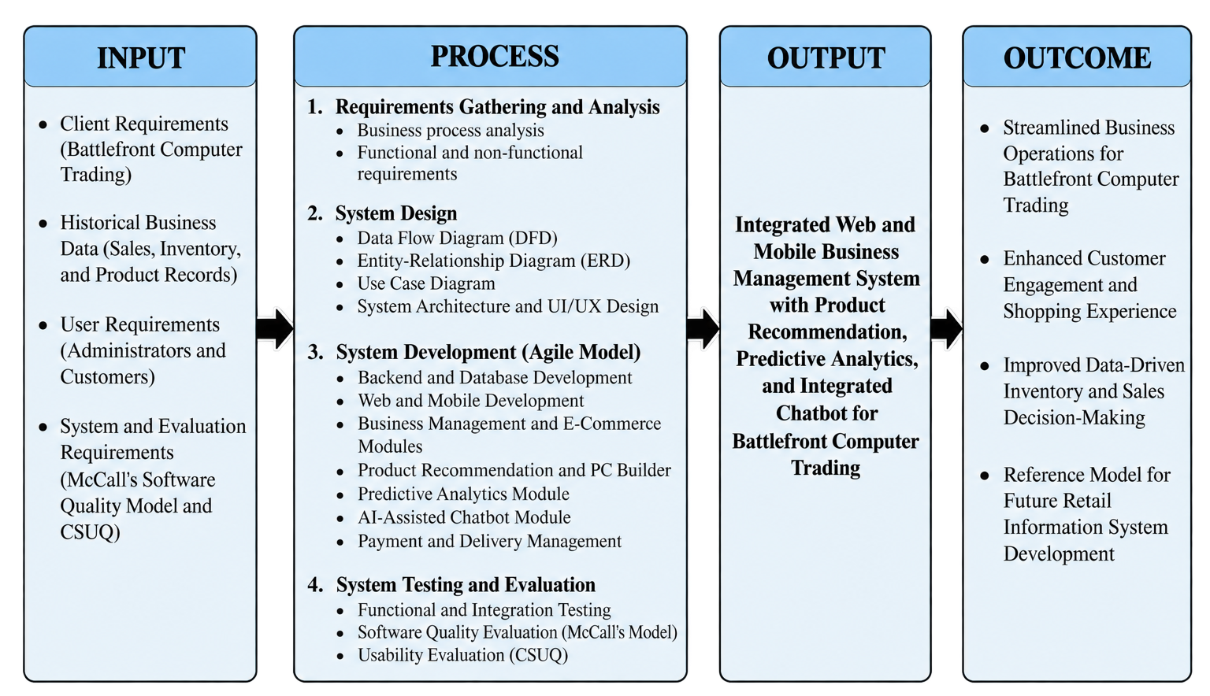
The conceptual framework of this study is anchored on the Input-Process-Output-Outcome (IPO-O) model, which illustrates the systematic approach used in developing the Integrated Web and Mobile Business Management System with Product Recommendation, Predictive Analytics, and Integrated Chatbot for Battlefront Computer Trading.
Fig. 1. Conceptual Framework
This conceptual framework illustrates the overall flow of the study using the Input–Process–Output–Outcome (IPOO) model. The inputs consists of the client's business requirements, historical business data, user requirements, and evaluation instruments. These inputs are processed through requirements analysis, system design, Agile-based system development, and system testing and evaluation. The resulting output is an Integrated Web and Mobile Business Management System with Product Recommendation, Predictive Analytics, and Integrated Chatbot capable of streamlining business operations and enhancing customer engagement. Ultimately, the system is expected to improve Battlefront Computer Trading's business operations, enhance customer experience, support data-driven decision-making, and serve as a reference for future retail information systems.
CHAPTER II
REVIEW OF RELATED LITERATURE AND PRIOR ARTS
Product Recommendation Systems in E-Commerce and Retail
Recommendation systems remain a central tool for increasing sales and improving customer experience in online and retail settings. Islek and Oğuducu (2022) developed a hierarchical recommendation system that incorporates online user reviews into the recommendation process, showing that layering review-derived signals on top of purchase data produces more relevant product suggestions than purchase history alone. This provides a conceptual basis for generating relevant product suggestions based on product characteristics and customer-defined criteria. However, the present study adopts a rule-based, behavior-driven recommendation approach that utilizes recorded customer searches, product views, shopping cart activity, and purchase history to generate relevant product suggestions. This approach evaluates customer interaction patterns alongside product characteristics and inventory availability without requiring the training of a separate machine-learning recommendation model.
Predictive Analytics for Inventory and Demand Forecasting
Accurate demand forecasting continues to be central to reducing stockouts and overstocking, particularly for smaller retailers with limited working capital. Franco, Guevara, Castaneda, Mansilla-Lopez, and Garcia-Nunez (2026) proposed a lightweight Random Forest-based forecasting framework built specifically for micro and small enterprises (MSEs), achieving a Mean Absolute Percentage Error of 2.41% and outperforming K-Nearest Neighbors, Decision Tree, and XGBoost models while remaining computationally inexpensive enough for resource-constrained businesses. The present study adopts Additive Holt–Winters triple exponential smoothing as its production forecasting method. Unlike a basic moving average, this method accounts for level, trend, and seasonal components in monthly sales observations. Its use is intended to provide product-level quarterly demand estimates from monthly historical data while remaining suitable for a structured, single-business forecasting application.
Complementing this, Alam, Thakur, and Islam (2024) conducted a qualitative case study of inventory management practices among small and medium enterprises in Bangladesh and found that most SME owners still rely on manual, experience-based stock decisions rather than structured forecasting tools, largely due to limited technical capacity and financing. This reinforces that the absence of predictive inventory tools in small trading businesses, such as Battlefront, reflects a broader, well-documented pattern among resource-constrained SMEs rather than an isolated local gap.
Chatbots and Conversational Interfaces in Customer Service
Chatbots have grown in popularity as a low-cost way for businesses to provide round-the-clock customer support. Marcineková, Sujová, and Ďurica (2025) conducted a mixed-method case study of an AI-powered chatbot deployed in a Slovak micro-enterprise's e-commerce operation and found that the chatbot cut average response time by nearly 46% and produced a statistically significant increase in customer satisfaction, though it still struggled with ambiguous or emotionally complex queries, underscoring that even a modest, catalog-aware chatbot can meaningfully improve customer service in a small retail business without requiring a large-scale generative AI system.
At a larger operational scale, Panigrahi, Shrivastava, Qureshi, Mewada, Alghamdi, Almakayeel, Almuflih, and Qureshi (2023) examined AI chatbot adoption among manufacturing SMEs and found that chatbot-enabled supply chain visibility positively influenced sustainable supply chain performance, mediated by the firm's innovation capability. While their focus was manufacturing supply chains rather than retail customer service, the finding that chatbot value depends on integration with a firm's existing operational data supports this study's design decision to link the chatbot directly to Battlefront's product catalog and inventory records rather than deploying it as a standalone FAQ tool.
Philippine Setting
Product Recommendation Systems in Philippine Retail
Locally, Samonte, Villaluz, Cabamongan, Gayeta, Palomo, and Samonte (2022) developed Market-e, a Philippine e-commerce platform for local wet-market vendors that embedded a recommender feature alongside an inventory management module. Their evaluation, which combined Nielsen's Heuristic Evaluation with the Questionnaire for User Interface Satisfaction across consumers, vendors, and store owners, found that the inventory feature was rated as the system's most impactful component. This finding directly supports the present study's decision to pair a recommendation engine with inventory management rather than treating them as separate systems, and demonstrates that Filipino researchers have already validated this combination as usable and beneficial for local retail operations.
Predictive Analytics for Inventory and Demand Forecasting in the Philippines
A directly comparable local study is that of Arnaiz, Cristal, Fernandez, Gubaton, Tanael, and Centeno (2023), who developed a time-series-based inventory management and demand forecasting system for a Philippine retail store. Their system addressed the same core problems this study aims to solve manual inventory tracking, inaccurate demand prediction, and excess or expired stock and demonstrated that time-series forecasting is a viable, locally proven approach for small Philippine retailers, reinforcing the feasibility of the predictive analytics module proposed for Battlefront Computer Trading.
Chatbots and Conversational Interfaces among Filipino Consumers
In the Philippine context, Pastorfide and Vasquez (2025) examined AI chatbot adoption among 392 online shoppers in Nueva Ecija using the Expectation Confirmation Theory alongside ISO/IEC 25010 quality criteria. Their findings showed that Filipino consumers place particularly high value on 24/7 availability, prompt and accurate responses, and notably multilingual support that includes Tagalog, which scored as the single highest-rated customer expectation in their study. This finding has direct implications for the present study's chatbot design: a chatbot built for Battlefront Computer Trading's customer base should account for code-switching between English and Filipino/Tagalog rather than assuming English-only interactions.
Broader Philippine MSME Digital Adoption
Beyond the studies already discussed, broader research on Philippine MSME digitalization provides useful context. Cordova, Lim, Ong, Caraan, Dela Cruz, and Jimenez (2025) found that while Philippine MSMEs are increasingly adopting basic digital tools such as social media marketing and digital payment platforms, they have largely not adopted more advanced technologies such as cloud computing or ERP-level systems, citing cultural resistance, limited technical expertise, and financial constraints as the leading barriers. This supports the present study's framing of an integrated recommendation-forecasting-chatbot system as addressing a documented, evidence-based gap in Philippine MSME technology adoption rather than an assumed one.
Prior Arts
E-Commerce Platforms with Recommendation Features
Commercial platforms continue to demonstrate the value of recommendation-driven retail. Regional marketplaces such as Shopee and Lazada apply algorithmic product recommendations during browsing and checkout, reflecting the continued commercial reliance on recommendation-driven cross-selling in Southeast Asian e-commerce. At the small-business scale, Samonte et al.'s (2022) Market-e platform, discussed above, demonstrates that Filipino-built systems have already applied comparable recommendation techniques successfully, validating that the underlying approach scales down from large marketplaces to single-vendor retail contexts such as Battlefront Computer Trading.
Inventory and Sales Management Systems
Commercial small-business tools such as Loyverse and Vend provide point-of-sale and inventory tracking but generally rely on descriptive reporting rather than predictive analytics, while larger ERP platforms such as SAP Business One incorporate demand forecasting modules that are often too costly and complex for small trading businesses to adopt. Arnaiz et al.'s (2023) locally developed forecasting system and Franco et al.'s (2026) MSE-oriented Random Forest model, both discussed earlier, represent closer-scale alternatives, though neither was built for a computer hardware catalog specifically.
AI-Powered Retail Chatbot Platforms
Commercial chatbot platforms such as Tidio and ManyChat allow retail businesses to automate responses to common inquiries across web and social channels. While useful for general customer engagement, generic chatbot platforms may provide limited responses when customers ask catalog-specific questions involving product availability, specifications, order information, and store details. This supports the development of a catalog-aware chatbot grounded in Battlefront Computer Trading’s own product, inventory, order, and store information. Pastorfide and Vasquez's (2025) Nueva Ecija study and Marcineková et al.'s (2025) Slovak micro-enterprise case study, both discussed above, indicate that customers and small business owners alike evaluate chatbots primarily on functional suitability and response accuracy rather than novelty suggesting that a catalog-aware chatbot built specifically around Battlefront's product line could outperform generic platforms on the dimensions users care about most.
Philippine-Based Prior Arts
Cordova et al.'s (2025) findings on Philippine MSME digital adoption, discussed above, further confirm that advanced, integrated digital tools remain rare among small Philippine trading businesses, reinforcing that a locally built, integrated system such as the one proposed here would fill a documented rather than assumed gap.
Limitations of Current Systems
Taken together, these prior arts show that recommendation, forecasting, and chatbot capabilities have each been demonstrated locally and internationally, but no reviewed system, commercial or academic, combines even two of the three within a single Philippine computer hardware retail context, let alone all three. Samonte et al. (2022) combined recommendation with inventory but not forecasting or a chatbot; Arnaiz et al. (2023) and Franco et al. (2026) combined inventory with forecasting but not recommendation or a chatbot; Pastorfide and Vasquez (2025), Marcineková et al. (2025), and Panigrahi et al. (2023) evaluated chatbots in isolation from inventory or forecasting concerns. This gap directly motivates the proposed Integrated Web and Mobile Business Management System with Product Recommendation, Predictive Analytics, and Integrated Chatbot for Battlefront Computer Trading.
Table 1. Gap Analysis
Prior Art | Product  Recommendation | Predictive  Analytics | Chatbot  Support | Gap Addressed by This Study
Market-e  (Samonte et al., 2022) | ✓ |  |  | No forecasting or chatbot module
Loyverse / Vend / SAP Business One |  | ✓ (SAP only) |  | No recommendation or chatbot; SAP too costly for small trading businesses
Time-Series Inventory & Forecasting System (Arnaiz et al., 2023);  MSE Stock Forecasting Model (Franco et al., 2026) |  | ✓ |  | No recommendation or chatbot module
Tidio / ManyChat;  Nueva Ecija AI Chatbot Study (Pastorfide & Vasquez, 2025);  Slovak Micro-Enterprise Chatbot (Marcineková et al., 2025) |  |  | ✓ | Not catalog-specific; no recommendation or forecasting integration
AI Chatbot Adoption in Manufacturing SMEs  (Panigrahi et al., 2023) |  |  | ✓ (supply-chain focus) | Supply-chain visibility only; no retail recommendation or forecasting
Synthesis
On product recommendation, the reviewed literature confirms that layering behavioral or review-derived signals on top of purchase data improves suggestion relevance and cross-selling potential (Islek & Oğuducu, 2022), and that Filipino-built systems have already validated pairing recommendation with inventory management at small-business scale (Samonte et al., 2022). Neither study, however, combines recommendation with forecasting or conversational support.
On predictive analytics, lightweight forecasting methods reduce stockouts and overstocking even under the resource constraints typical of small enterprises (Franco et al., 2026; Arnaiz et al., 2023), while Alam et al. (2024) confirm that the absence of such tools in businesses like Battlefront reflects a broader, well-documented pattern among SMEs rather than an isolated local gap.
On chatbots, the literature shows consistent gains in response time and customer satisfaction (Marcineková et al., 2025), with both Filipino and international customers expecting prompt, accurate, and context-appropriate service (Pastorfide & Vasquez, 2025; Panigrahi et al., 2023). This literature also highlights a methodological limitation relevant to the present study: Marcineková et al. (2025) identified difficulties in handling ambiguous or emotionally complex inquiries. These findings support the development of a domain-specific chatbot that combines predefined inquiry handling, controlled artificial intelligence-assisted classification, and context-grounded response generation using authorized product, order, and store information. The chatbot remains limited to supported customer-service inquiries rather than unrestricted open-domain conversations.
Methodologically, the reviewed literature supports the selection of forecasting and recommendation approaches appropriate to the available business data and system requirements. Although Franco et al. (2026) demonstrated the effectiveness of a lightweight machine-learning forecasting approach, the present study implements Additive Holt–Winters triple exponential smoothing to represent level, trend, and seasonality in historical monthly product sales. Meanwhile, the findings of Islek and Oğuducu (2022) demonstrate the relevance of customer interaction information to product recommendation. The present study applies this principle through deterministic, behavior-driven recommendation rules using available catalog and customer activity data rather than a separately trained recommendation model.
Across all three capabilities, however, both international and Philippine-based prior arts consistently address recommendation, forecasting, and chatbot support separately rather than as an integrated system and no reviewed prior art, commercial or academic, combines even two of the three within a comparable retail context. Broader research on Philippine MSME digital adoption (Cordova et al., 2025) further confirms that small trading businesses in the Philippines have not yet widely adopted advanced, integrated digital tools, largely due to cost and capability barriers rather than lack of need. This synthesis directly supports the present study's contribution: a single, locally-grounded, catalog-specific system for Battlefront Computer Trading that closes the integration gap left open by both the commercial platforms and the academic prior arts reviewed above.
CHAPTER III
METHODOLOGY
Research Design
This study will employ a descriptive-developmental research design to guide the design, development, and evaluation of an Integrated Web and Mobile Business Management System with Product Recommendation, Predictive Analytics, and Integrated Chatbot for Battlefront Computer Trading. The descriptive aspect will focus on analyzing existing sales, inventory, and customer service processes, while the developmental component will cover the actual design, implementation, and testing of the recommendation engine, predictive analytics module, chatbot, and their integration into a functional web and mobile system.
Research Locale / Site Study
This study will be conducted at Battlefront Computer Trading, specifically its Sagay City Branch, located in Sagay City, Negros Occidental. The system's branch directory includes Battlefront Computer Trading locations in Sagay City, Escalante City, San Carlos City, Guihulngan City, and Bacolod City. However, the Sagay City branch serves as the sole operational branch represented by the system's inventory, ordering, sales, and checkout workflows, while the other locations are maintained for customer information and reference purposes.
First, it is the branch where the researchers were able to secure direct access and permission from the business owner to gather data, observe existing operations, and deploy the developed system for testing and evaluation. Second, the Sagay City Branch currently relies on manual and semi-manual methods, such as handwritten logs and basic spreadsheets, for recording sales and monitoring inventory, making it a representative and relevant setting for evaluating a system designed to address these exact operational gaps. Third, the branch maintains regular walk-in customer traffic and a small, accessible team of personnel, both of which will be necessary for the study to gather evaluation data from actual system users, in addition to the IT expert evaluators.
Given these considerations, the Sagay City Branch of Battlefront Computer Trading will serve as the primary setting for requirements gathering, system deployment, and the testing and evaluation activities described in the succeeding sections of this chapter, consistent with the scope and delimitation stated in Chapter 1.
Software Development Methodology
This study will adopt the Agile Software Development Life Cycle (SDLC) (Beck et al., 2001) as the primary methodology for designing and implementing the system. Agile will be adopted due to its iterative and incremental approach, which allows for continuous testing, stakeholder feedback, and refinement ideal for developing a system with multiple interacting components such as recommendation, forecasting, and conversational features.
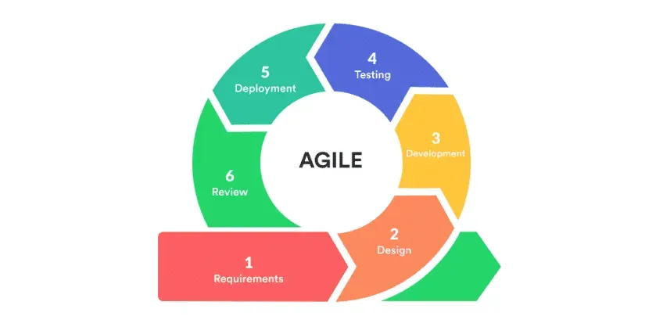
Fig. 2. Agile Software Development Life Cycle Model
The development process will follow several key phases:
Requirements Phase
Initial meetings with the owner and staff of Battlefront Computer Trading will be conducted to identify user requirements, common customer inquiries, and system expectations. Data privacy and security considerations for storing customer and transaction information will also be addressed during this phase.
Historical Sales and Inventory Data Template
A structured data collection template will be prepared to organize relevant historical sales and inventory records obtained with the authorization of Battlefront Computer Trading. The data required for predictive analytics will include product identifiers, transaction dates, quantities sold, and relevant sales-history coverage information. Historical records will be assessed for completeness, consistency, and suitability before their use in the Additive Holt–Winters forecasting process. Customer interaction information used for product recommendations will be managed separately through the application's authorized search, product-view, cart, and purchase activity records.
All customer-related data will be handled in compliance with the Data Privacy Act of 2012.
Data Collection and Preprocessing
Historical transaction records will be collected, validated, and prepared for product-level monthly demand analysis. The forecasting process will require a continuous 36-month historical period with sufficient supporting sales-history coverage. Missing or unverifiable historical periods will not automatically be treated as genuine zero-sales observations. Development-generated historical datasets, when used for testing or demonstration, will be distinguished from verified business records to maintain the accuracy and integrity of the study's evaluation.
Schedule Feasibility
The proposed system will be assessed in terms of the time available for its development, testing, and deployment from June to October 2026. The project will follow the adopted Software Development Life Cycle (SDLC) using Agile methodology, with activities organized into manageable sprints and milestones. The schedule will cover requirements gathering, system design, web and mobile application development, intelligent module integration, system testing, and evaluation. These activities will be distributed across the five-month academic development period to support iterative progress, efficient resource allocation, and timely completion of the proposed system.
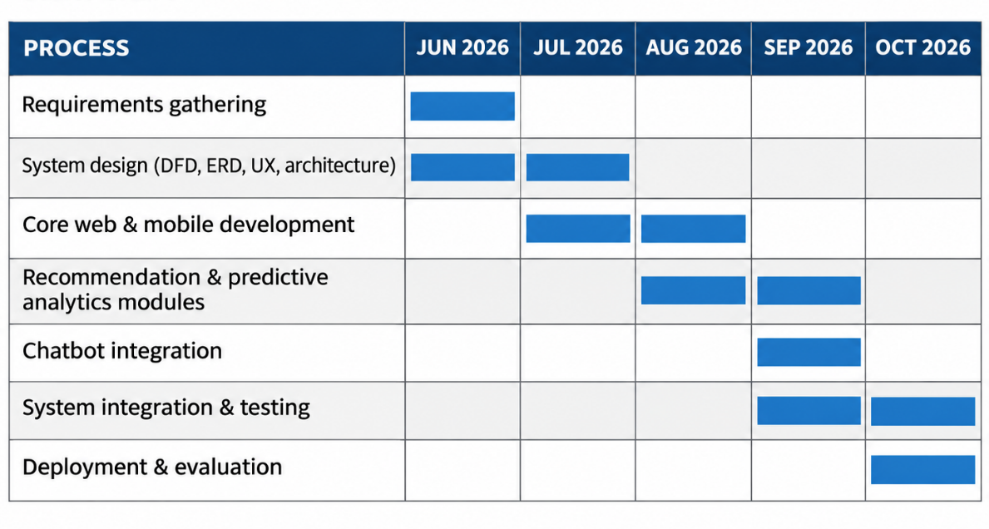
Fig. 3. Gantt chart
As illustrated in Figure 3, the proposed project activities are scheduled from June to October 2026. The development period encompasses requirements gathering, system design, web and mobile application development, integration of product recommendation and predictive analytics modules, chatbot integration, system testing, deployment, and evaluation. These activities are organized into overlapping phases following the Agile methodology to accommodate continuous development, testing, and refinement. The five-month schedule provides a structured timeline for completing the proposed system within the prescribed academic period.
Economic Feasibility
Economic feasibility evaluates whether the proposed system can be developed and implemented at a reasonable cost while ensuring that the expected benefits outweigh the projected expenses. To support this, the researchers prepared a cost-benefit analysis (CBA) that highlights both the initial and recurring costs of the project in comparison to its anticipated operational and strategic benefits for Battlefront Computer Trading.
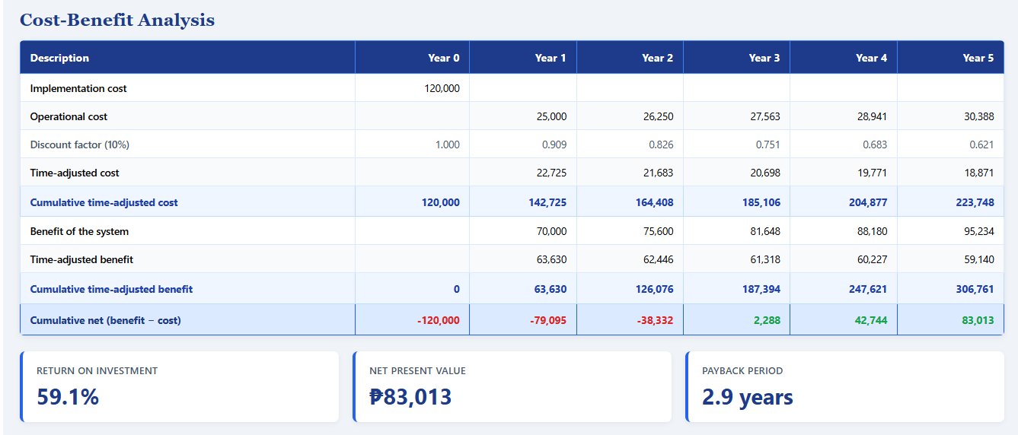

Table 2. Cost-Benefit Analysis

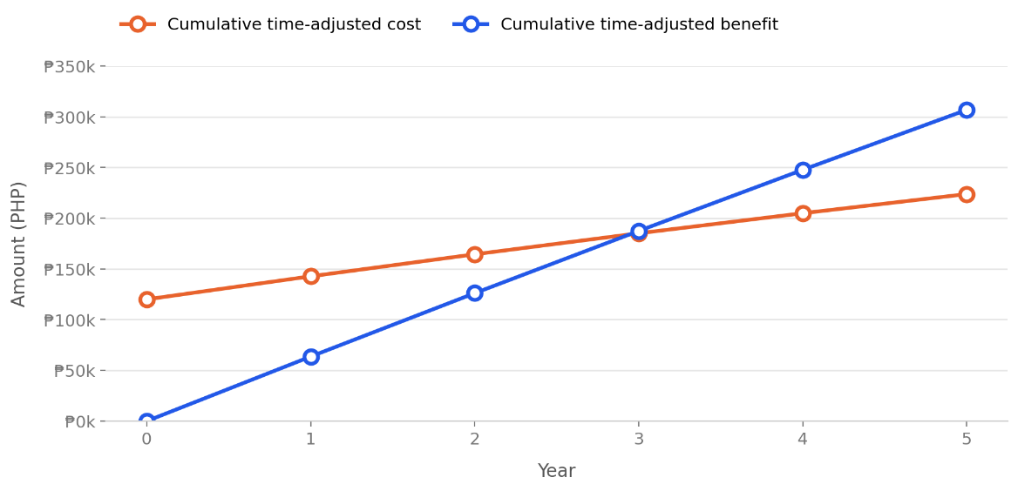

Fig. 4. Time Adjusted Payback Period
As shown in Table 2 and Fig. 4, the system requires an initial implementation cost of ₱120,000 in Year 0, with operational costs starting at ₱25,000 in Year 1 and increasing by approximately 5% annually to account for ongoing hosting, maintenance, and support, reaching ₱30,388 by Year 5. On the benefit side, the system is projected to generate ₱70,000 in Year 1, growing by roughly 8% annually as adoption increases and reaching ₱95,234 by Year 5, driven by reduced manual workload, minimized stockouts through better demand forecasting, increased cross-selling through product recommendations, and improved customer response time through the chatbot. When both cost and benefit streams are adjusted for the time value of money at a 10% discount rate, the cumulative time-adjusted benefit overtakes the cumulative time-adjusted cost between Year 2 and Year 3, resulting in a payback period of 2.9 years. Over the 5-year horizon, the project yields a Net Present Value (NPV) of ₱83,013 and, using the same time-adjusted (discounted) cost and benefit streams, a Return on Investment (ROI) of 37.1%, computed as NPV divided by the discounted total cost of ₱223,765. The 5% annual increase in operational costs, 8% annual growth in benefits, and 10% discount rate used in this analysis are researcher-formulated assumptions intended for initial project planning and feasibility estimation, rather than figures derived from Battlefront Computer Trading's actual historical financial data.
Based on these findings, the long-term benefits outweigh the development and implementation costs, making the project economically feasible.
Design Phase
Intelligent Module Design
The intelligent modules of the proposed system will be designed to support product recommendations, demand forecasting, and automated customer inquiries through distinct but integrated processing approaches. The product recommendation module will apply deterministic, behavior-driven rules using recorded customer interactions, product characteristics, and inventory availability. The predictive analytics module will implement Additive Holt–Winters triple exponential smoothing using 36 completed months of eligible product sales history to generate three monthly demand estimates, which will be combined into a quarterly forecast.
The chatbot module will use predefined inquiry categorization, controlled language normalization, and authorized retrieval of information from the system database. For uncertain supported inquiries, a bounded intent classifier using Google Gemini 3.5 Flash-Lite may assist in identifying the appropriate inquiry category. The same language model may be used to formulate natural-language responses based on the information retrieved by the application. This design maintains the distinction between deterministic business information processing and generative language output, ensuring that business facts remain governed by the system rather than generated independently by the language model.
The following logic components are employed within the intelligent modules:
- Behavior-Driven Rule-Based Ranking – Generates product recommendations by applying weighted ranking rules to customer searches, product views, shopping cart activity, purchase history, related-product patterns, and product popularity while considering catalog eligibility and inventory availability.
- Historical Data Preparation – Organizes and validates eligible product-level monthly sales records to provide the required historical inputs for demand forecasting. Quarterly sales aggregation is used separately for reporting and comparative forecasting analysis.
- Additive Holt–Winters Triple Exponential Smoothing – Analyzes 36 completed months of eligible product-level sales data to identify level, trend, and seasonal patterns. The method generates demand estimates for the following three months, which are combined into a quarterly forecast to support inventory planning and business decision-making.
- Query Categorization – Classifies customer inquiries into supported categories (product, order, store, and FAQ) or redirects unsupported requests through predefined fallback responses.
- Context-Grounded Response Generation – Combines supported customer inquiries with authorized system information and uses Google Gemini 3.5 Flash-Lite through the Laravel AI SDK to generate context-aware responses based on available business data.
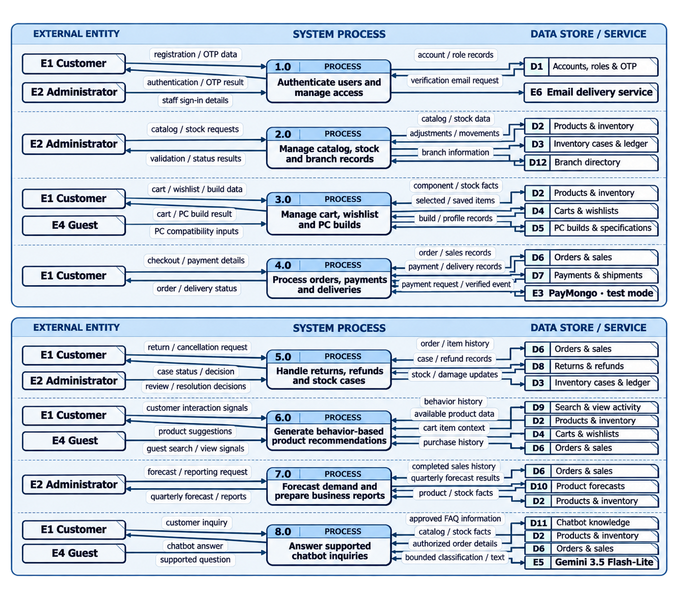
Fig. 5. Data Flow Diagram
Figure 5 presents the Data Flow Diagram (DFD) of the proposed Integrated Web and Mobile Business Management System for Battlefront Computer Trading using Gane and Sarson notation. The diagram is divided into two sections, illustrating eight major system processes and the movement of information among customers, guests, administrators, external services, and data stores.
The first section (Processes 1.0–4.0) illustrates the system's primary business operations. Process 1.0 handles user authentication, account verification, and access management through account records and email verification services. Process 2.0 manages product information, inventory records, stock adjustments, and branch information. Process 3.0 handles customer shopping carts, wishlists, and saved computer builds, while allowing guests to submit component selections for compatibility checking. Process 4.0 processes customer orders, payment information, and delivery operations, including integration with PayMongo in a controlled test-mode environment. These processes exchange information with the corresponding data stores to maintain accurate business records and support authorized transactions.
The second section (Processes 5.0–8.0) illustrates the system's additional operational and intelligent functionalities. Process 5.0 manages customer return and cancellation requests, refund records, and inventory-related cases. Process 6.0 generates behavior-based product recommendations using customer interaction signals, product availability, shopping cart information, and purchase history. Process 7.0 processes historical sales data to generate quarterly demand forecasts and business reports for authorized administrators. Process 8.0 handles supported customer inquiries by retrieving approved chatbot knowledge, product information, and authorized order details, with Google Gemini 3.5 Flash-Lite providing controlled assistance in inquiry classification and response generation.
Overall, the Data Flow Diagram demonstrates how the system integrates administrative operations, customer transactions, product recommendations, predictive analytics, and chatbot assistance through structured information processing. It serves as a reference for understanding the relationships between system processes, external entities, and data stores while supporting data consistency, controlled access, and the functional requirements of the proposed system.
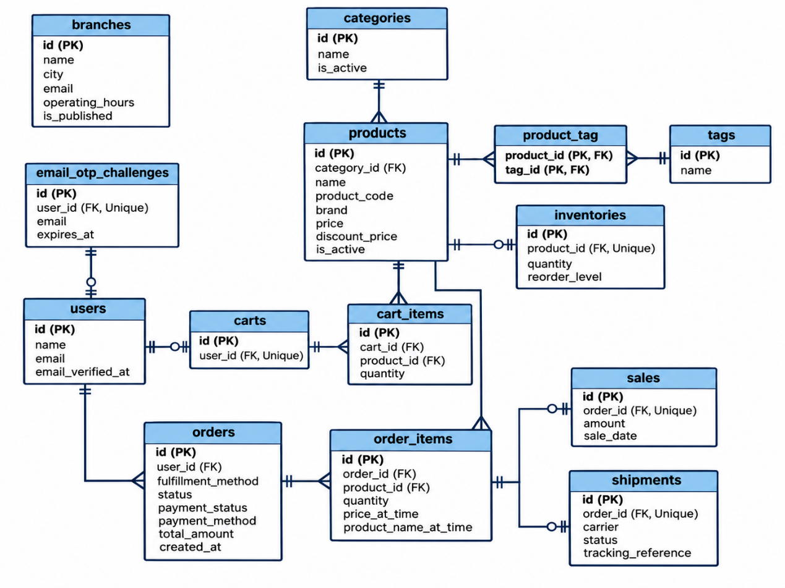

Fig. 6. Entity-Relationship Diagram – Core Business Records

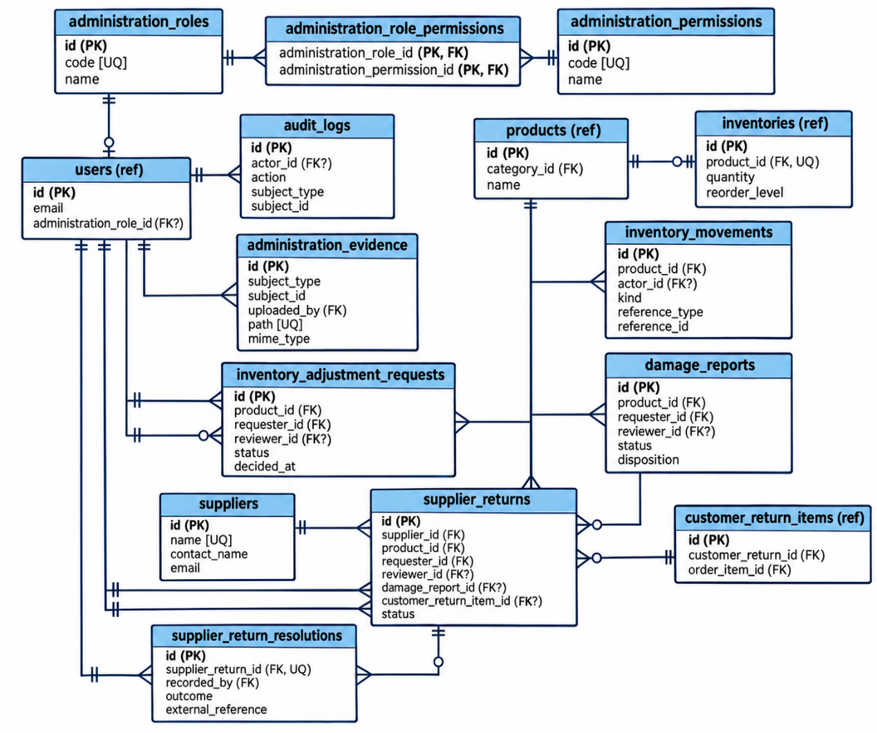

Fig. 6. Entity-Relationship Diagram – Administration and Inventory

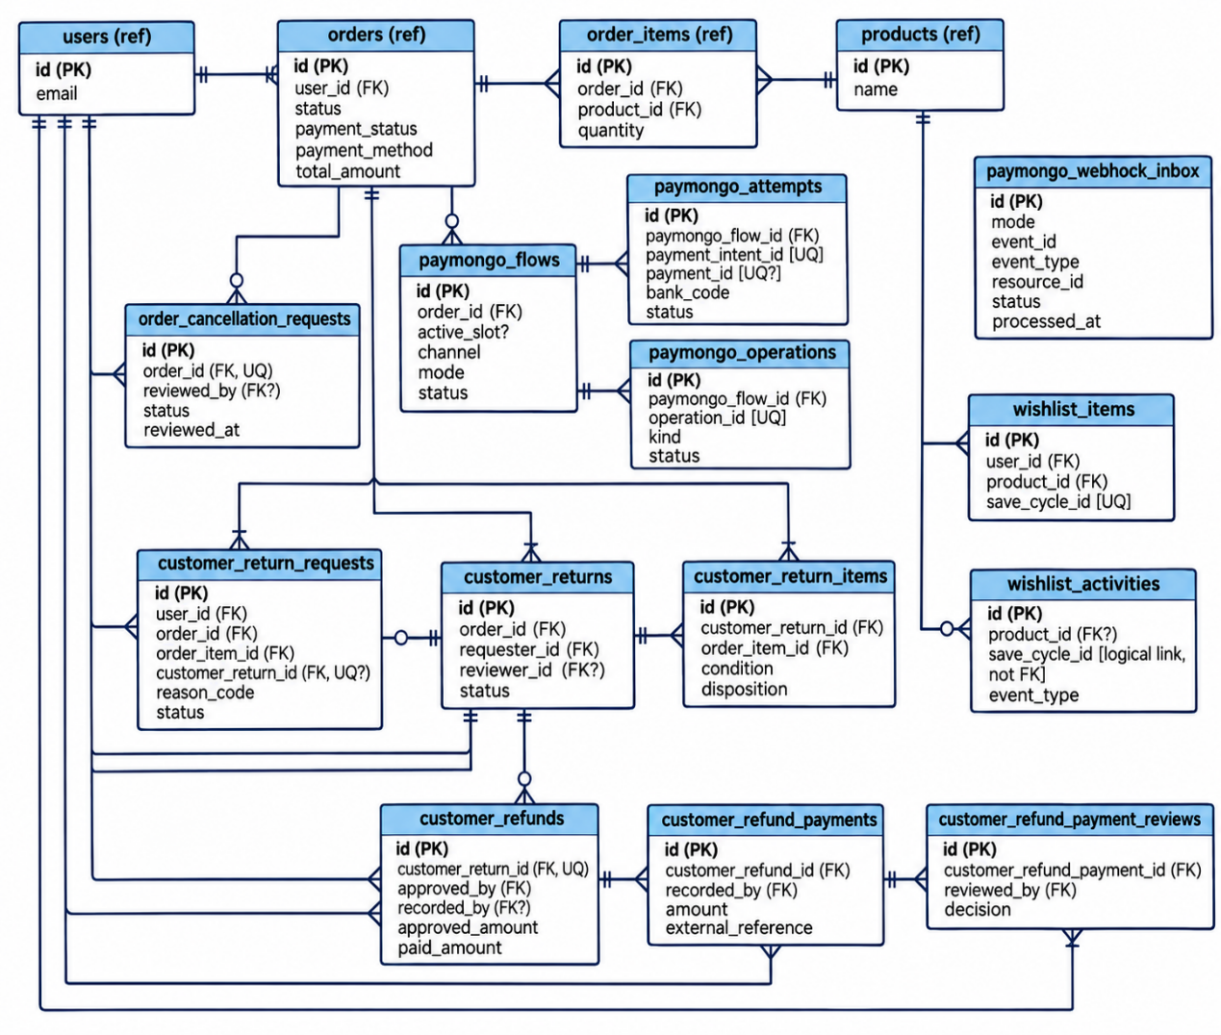
Fig. 6. Entity-Relationship Diagram – Payments, Returns, and Wishlist
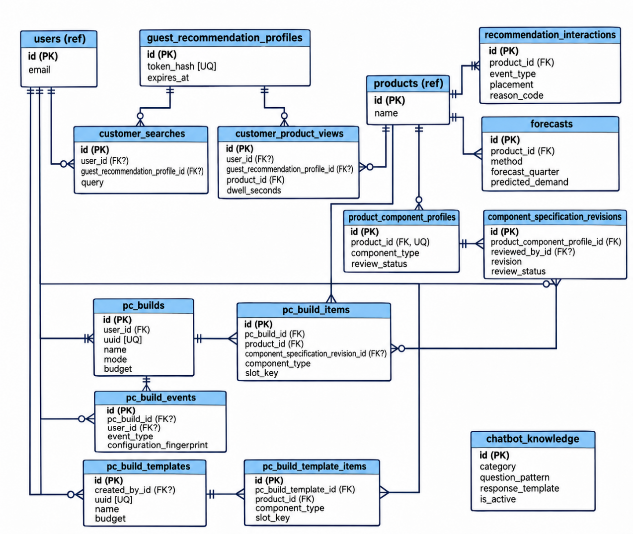
Fig. 6. Entity-Relationship Diagram – Intelligent Modules
Figure 6 illustrates the Entity-Relationship Diagram (ERD) of the proposed system using Crow’s Foot notation. The diagram is divided into four sections: Core Business Records, Administration and Inventory, Payments, Returns, and Wishlist, and Intelligent Modules. These sections present the principal database entities and their relationships, supporting user management, business transactions, inventory operations, payment processing, product recommendations, predictive analytics, PC Builder functionality, and chatbot services. Overall, the ERD provides a structured representation of the system’s database design, supporting data consistency, referential integrity, and efficient information management.
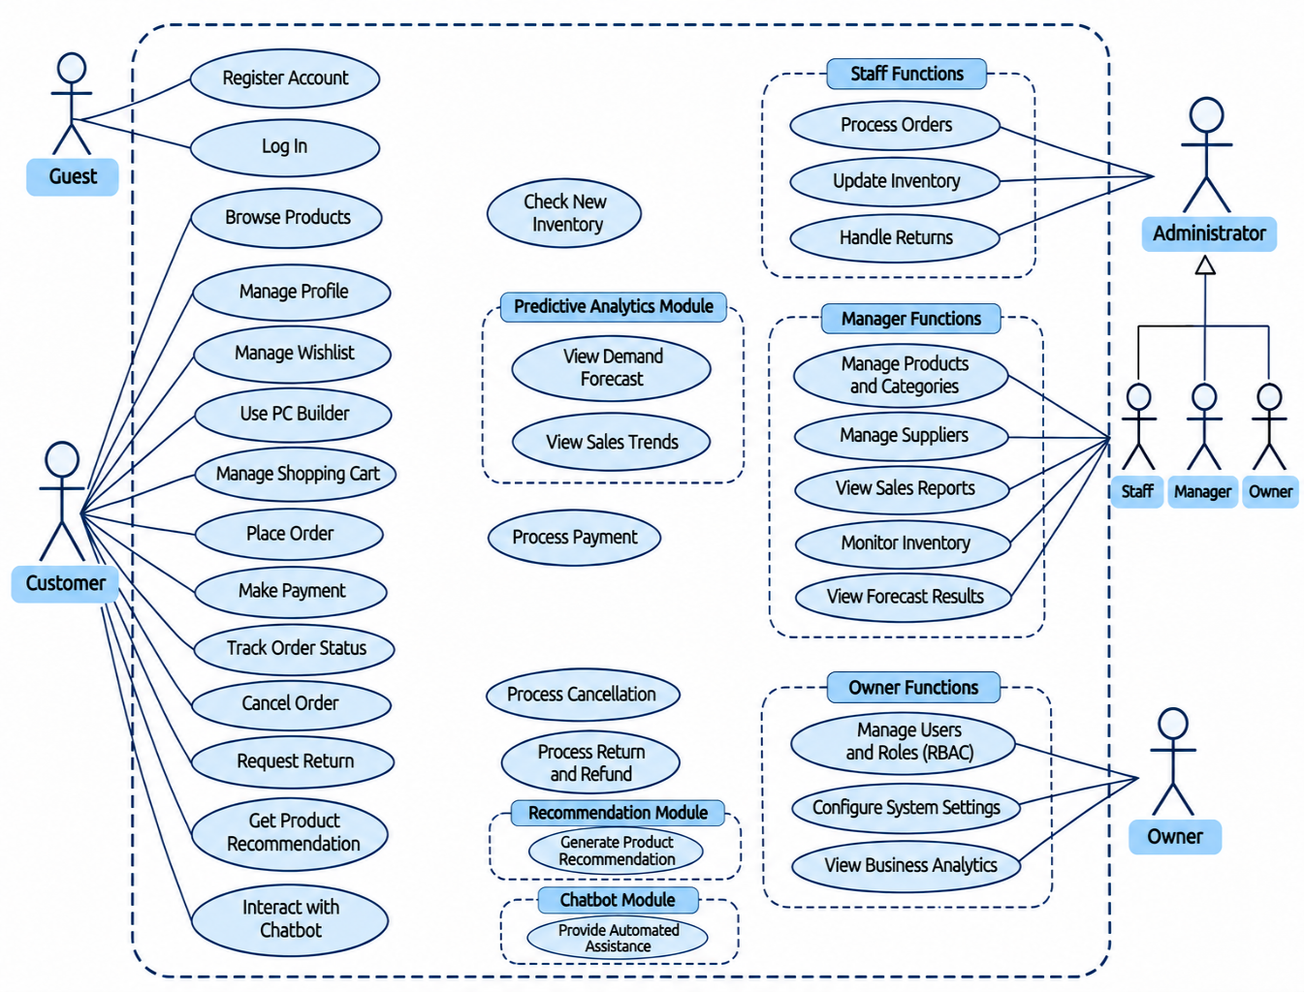
Fig. 7. Use Case Diagram
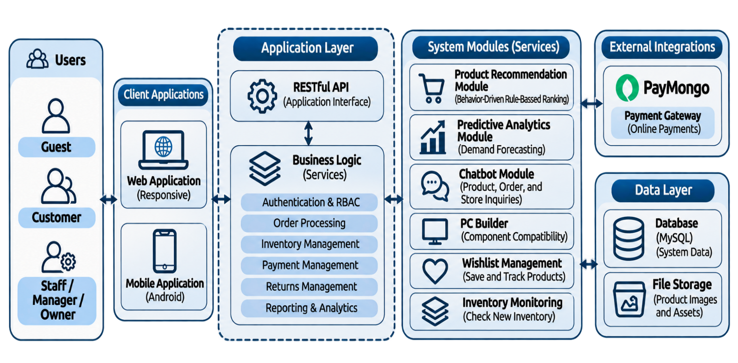
Figure 7 illustrates the Use Case Diagram of the proposed Integrated Web and Mobile Business Management System for Battlefront Computer Trading. The diagram presents the interactions of guests, customers, and administrators with the system's major functionalities. Customer functions include account management, product browsing, wishlist and shopping cart management, PC Builder, order placement and tracking, payment processing, return requests, product recommendations, and chatbot assistance. Administrative functions are organized into three roles: Staff, Manager, and Owner, with responsibilities involving order processing, inventory management, returns, product management, sales reporting, predictive analytics, and role-based access control (RBAC). Overall, the diagram provides a representation of the system's functional requirements and user interactions based on their assigned roles and responsibilities.

Fig. 8. System Architecture
Figure 8 presents the system architecture of the proposed Integrated Web and Mobile Business Management System for Battlefront Computer Trading. The system follows a Laravel-based monolithic backend organized into presentation, application, and data layers, together with controlled external service integrations. The presentation layer consists of a web application developed using Vue 3 and Inertia.js and a separately developed React Native and Expo mobile application that communicates with the backend through a RESTful JSON API. The application layer manages authentication, product catalog operations, inventory control, customer ordering, payment workflows, reporting, product recommendations, PC Builder functionality, forecasting, and chatbot services. The predictive analytics component implements Additive Holt–Winters triple exponential smoothing, while the chatbot integrates Google Gemini 3.5 Flash-Lite through the Laravel AI SDK. Online payment functionality is supported through test-mode PayMongo integration. The data layer uses MySQL to maintain business records and relationships. This architecture enables shared backend business rules while supporting separate web and mobile interfaces.
Development Phase
The user interface and backend functionalities of the system will be developed using both web-based and mobile technologies. The chatbot module will integrate Google Gemini 3.5 Flash-Lite through the Laravel AI SDK to assist with supported inquiry classification and context-grounded natural-language response generation, while product, inventory, order, and store information will remain subject to the application's authoritative business rules.
The development phase of the Battlefront Computer Trading Management System involves careful planning and utilization of appropriate frameworks, hardware, and software to ensure the system is functional, secure, and scalable. On the software side, the Laravel (PHP) framework will be employed to streamline coding and speed up the implementation of business logic, handling both the web application through Inertia.js-integrated Vue 3 components and a dedicated RESTful API for the separately developed React Native and Expo mobile application.
MySQL serves as the relational database management system, storing product information, user accounts, order and sales records, inventory levels, and chatbot knowledge data. Laravel Herd will be used as the local development environment, providing a pre-configured PHP runtime, Nginx web server, and instant site linking without the need for manual server or virtual host configuration, allowing the development team to focus on application logic rather than environment setup. Visual Studio Code will serve as the primary integrated development environment (IDE) for coding, while Git and GitHub will provide version control and collaboration capabilities for the development team throughout the project. Postman will be used for manual API endpoint testing during development, while Laravel's built-in testing framework (Pest/PHPUnit) will be used for automated unit and feature testing of core business logic such as order processing and inventory updates.
On the hardware side, development will be carried out on a Windows-based laptop with 16GB of RAM and over 470GB of storage, which will provide sufficient memory and disk headroom to run the Laravel/Herd development environment, MySQL database, Vue/Inertia build tools, and the Android emulator for React Native and Expo development simultaneously without significant performance degradation. A stable internet connection will also be essential for repository access via GitHub, package installations through Composer and npm, and communication with the Gemini API during chatbot testing. Furthermore, the development process will follow the Agile methodology, specifically a Scrum-inspired framework, which will structure the project into sprints beginning with the core system (authentication, product and inventory management), followed by the e-commerce flow (cart and checkout), then the intelligent modules (recommendation and forecasting), and finally the chatbot and mobile application integration. This iterative structure will allow adjustments to be made based on adviser feedback at each stage, reducing the risk of project delays or overlooked requirements. Altogether, the combination of reliable hardware, suitable software tools, and a structured Agile framework will provide a strong foundation for building an efficient and reliable computer trading management system.
Testing Phase
In the testing phase, the developed system will be evaluated by three respondent groups using instruments appropriate to their roles and experience with the system. Three (3) IT experts will assess the system's software quality using a researcher-made questionnaire anchored on McCall's Software Quality Model. Three (3) Battlefront Computer Trading personnel and thirty (30) customer respondents will evaluate the system's usability using the Computer System Usability Questionnaire (CSUQ). All respondents will be provided with an appropriate system demonstration or hands-on trial before completing their respective evaluation instruments.
McCall’s Software Quality Model
To evaluate the software quality of the developed system, three (3) IT experts will assess the system using a researcher-made questionnaire anchored on McCall's Software Quality Model. The evaluation will cover three main categories of software quality:
- Product Operation (e.g., correctness, usability, reliability, efficiency)
- Product Revision (e.g., maintainability, flexibility, testability)
- Product Transition (e.g., portability, reusability, interoperability)
Evaluators will rate each criterion using a 5-point Likert scale ranging from "Strongly Disagree" to "Strongly Agree."
Computer System Usability Questionnaire (CSUQ)
To evaluate the usability of the developed system, the standardized Computer System Usability Questionnaire (CSUQ) will be administered to three (3) Battlefront Computer Trading personnel and thirty (30) customer respondents. The instrument assesses system usefulness, information quality, and interface quality. Battlefront personnel will evaluate the administrative and operational functionalities, while customer respondents will assess the customer-facing features after completing a guided trial or hands-on exploration of the system. Responses will be gathered using the CSUQ's seven-point scale, and the results of both respondent groups will be analyzed separately.
During the testing phase, each feature of the Battlefront Computer Trading Management System will be evaluated against the defined requirements to ensure proper functionality and alignment with the project objectives. Unit testing will be conducted to verify the accuracy and reliability of individual modules, such as order processing, inventory tracking, and user authentication, before integrating them into the whole system. This approach will allow the team to identify and resolve errors early, ensuring that every component performed as expected prior to full system integration and deployment. Afterward, quality testing will be carried out to assess overall performance and stability, followed by usability testing to evaluate ease of use, user experience, and system adaptability to real-world retail operations.
Deployment Phase
The deployment phase of the business management system is the stage where the fully tested application is installed and made available for actual use by the intended users. This process involves setting up the production server environment, configuring the database, and ensuring that all modules such as ordering, payment, and administrative functions are properly integrated and operational. Before the full rollout, a pilot deployment may be conducted with a smaller group of users to identify any remaining issues and make final adjustments.
Once the system is confirmed stable, it will be formally launched for the broader user community, with necessary documentation and user guides provided to ensure smooth adoption. Training sessions may also be conducted for administrators and staff to familiarize them with managing the system effectively. Additionally, continuous monitoring and post-deployment support will be implemented to address technical issues, apply system updates, and ensure that the business management system remains reliable and efficient in serving its users.
Review Phase
The review phase of the business management system ensures that the project outcomes are assessed against the initial objectives and requirements. This stage involves evaluating the system’s performance, usability, and overall effectiveness through feedback gathered from both users and administrators after deployment. The results are then compared to the expected deliverables, allowing the project team to identify strengths, weaknesses, and areas for improvement in the system.
Furthermore, the review phase includes analyzing usage reports, error logs, and maintenance records to determine the stability and reliability of the application. Insights from this evaluation are documented and serve as a reference for future system enhancements or similar projects. By systematically reviewing the system, stakeholders can confirm whether it meets institutional needs and makes informed decisions about potential upgrades, expansions, or long-term sustainability strategies.
Feasibility Study
The proposed Integrated Web and Mobile Business Management System will be assessed for feasibility in terms of schedule and economic viability.
Schedule Feasibility:
The project development schedule will cover June to October 2026, following the Agile Software Development Life Cycle (SDLC). The five-month period will accommodate requirements gathering, system design, development of the core system and intelligent modules, integration testing, deployment, and evaluation. As presented in Figure 3, the proposed schedule organizes these activities into defined phases and overlapping development periods to support the timely completion of the system within the prescribed academic timeframe.
Economic Feasibility:
A cost-benefit analysis will be conducted comparing the initial implementation cost of ₱120,000 against projected operational costs and benefits over a five-year horizon. The analysis will show the payback period, Net Present Value, and Return on Investment to determine whether long-term benefits will outweigh development and implementation costs. Detailed cost-benefit projections will be presented in the Economic Feasibility subsection of the Software Development Methodology section.
Both assessments will confirm whether the proposed system is feasible for development and implementation by Battlefront Computer Trading.
Sources of Data
Data for this study will be obtained from: (a) historical sales and inventory records from Battlefront Computer Trading, which will be collected and organized as described in the Data Collection and Preprocessing subsection; (b) responses from the three respondent groups (IT Experts, Battlefront Personnel, and Customer Respondents) which will be gathered through the questionnaire instruments outlined in the Research Instruments section; and (c) academic literature and technical documentation to be reviewed in Chapter II.
Population and Sampling
Target Population
The target population of this study consists of three respondent groups relevant to the evaluation of the proposed Integrated Web and Mobile Business Management System for Battlefront Computer Trading. The first group comprises IT experts with relevant knowledge and experience in software development and information technology who are qualified to evaluate the system's software quality using McCall's Software Quality Model. The second group consists of three (3) administrative personnel from Battlefront Computer Trading's Sagay City branch, specifically the Owner, Manager, and Staff, who will evaluate the usability of the system's administrative and operational functionalities using the Computer System Usability Questionnaire (CSUQ). The third group comprises customer respondents who will evaluate the usability of the system's customer-facing features using the same standardized questionnaire.
Population Size
The population of qualified IT experts is not fixed, as potential evaluators may be selected from individuals with relevant technical qualifications and professional experience. The participating Battlefront personnel will consist of three (3) designated administrative representatives from the Sagay City branch, specifically the Owner, Manager, and Staff. The broader population of potential customer respondents is not precisely determined; therefore, participants will be recruited based on their accessibility, willingness to participate, and eligibility to evaluate the system's customer-facing functionalities.
Sample Size
A total of thirty-six (36) respondents will participate in the study, distributed as follows:
Respondent Group | Sample Size
IT Experts | 3
Battlefront Personnel (Owner, Manager, Staff) | 3
Customer Respondents | 30
Total | 36

Sampling Technique
The study will employ non-probability sampling techniques appropriate to the characteristics of each respondent group. Purposive sampling will be applied to the three (3) IT experts, who will be selected based on their technical qualifications and experience in software development and evaluation. The three (3) Battlefront personnel will also be selected purposively based on their administrative roles and direct involvement in the business's operational processes.
Convenience sampling will be employed for the thirty (30) customer respondents. Participants will be selected based on their availability, accessibility, and willingness to participate in the study. Customer recruitment will not be limited to individuals physically visiting Battlefront Computer Trading's Sagay City branch. Respondents may participate through appropriate in-person or online arrangements, provided that they are given sufficient opportunity to explore the system's customer-facing functionalities before completing the evaluation questionnaire.
Sample-Size Determination
The sample sizes will be determined according to the study's evaluation objectives, respondent qualifications, accessibility, and available data-gathering resources. Three (3) IT experts will be selected to evaluate the system's software quality using McCall's Software Quality Model, while three (3) Battlefront personnel will represent the administrative perspectives of the Owner, Manager, and Staff in evaluating system usability through the CSUQ. Thirty (30) customer respondents will be recruited through convenience sampling to assess the usability of the system's customer-facing functionalities.
The sample sizes will be based on the specific evaluation requirements and practical considerations of the study rather than a probability-based sample-size formula. Consequently, the findings will reflect the assessments of the participating respondents and will not be assumed to represent the entire customer population.
Inclusion and Exclusion Criteria
IT Experts:
- Inclusion: Individuals with relevant academic or professional experience in software development, information technology, or software quality evaluation, who are qualified to assess the system using McCall's Software Quality Model.
- Exclusion: Individuals without sufficient technical knowledge or relevant experience in software development and system evaluation.
Battlefront Personnel:
- Inclusion: The designated Owner, Manager, and Staff representative of Battlefront Computer Trading who are directly involved in administrative or operational activities and are willing to evaluate the system's usability using the CSUQ.
- Exclusion: Individuals without relevant involvement in the business's administrative or operational processes or who are unwilling to complete the required system evaluation.
Customer Respondents:
- Inclusion: Individuals who voluntarily agree to participate in the study, are capable of using the system's customer-facing features, and complete a guided trial or hands-on exploration before answering the CSUQ.
- Exclusion: Individuals who decline participation, do not complete the required system trial, or are unable to provide an informed evaluation of the customer-facing functionalities.
Appropriateness of the Sampling Method
Purposive sampling is appropriate for the IT experts because software quality evaluation requires specific technical qualifications and experience. Similarly, purposive sampling is suitable for the Battlefront personnel because the selected respondents represent the administrative roles directly involved in the system's operational processes.
Convenience sampling is appropriate for the customer respondents because it allows the researchers to recruit accessible and willing participants without requiring physical recruitment at the business establishment. This approach supports the practical evaluation of the system within the available resources and timeframe of the study. However, because the respondents are selected through non-probability sampling, the findings will be interpreted as the perceptions of the participating users rather than statistically representative conclusions about the broader customer population.
Research Instrument
To gather the data needed to evaluate the developed Integrated Web and Mobile Business Management System for Battlefront Computer Trading – Sagay City Branch, the researchers will utilize two evaluation instruments. A researcher-made questionnaire anchored on McCall's Software Quality Model will be administered to three (3) IT experts to assess the system's software quality. Meanwhile, the standardized Computer System Usability Questionnaire (CSUQ) will be administered to three (3) Battlefront personnel, consisting of the Owner, Manager, and Staff, and thirty (30) customer respondents to evaluate the usability of the system's administrative and customer-facing functionalities, respectively.
Data gathering will be divided into three (3) distinct but related respondent groups: IT Experts, Battlefront Personnel, and Customer Respondents. The IT experts will evaluate the system's software quality using the McCall's-based questionnaire, considering their technical knowledge and experience in software development and evaluation. Battlefront personnel will assess the usability of the system's administrative and operational functionalities using the CSUQ, while customer respondents will use the same instrument to evaluate their experience with the customer-facing features. All respondents will be provided with an appropriate system demonstration or hands-on trial before completing their respective evaluation instruments.
The evaluation criteria used in the McCall's-based questionnaire, administered exclusively to IT Experts, will be anchored on McCall's Software Quality Model, which organizes software quality into three main categories: Product Operation, Product Revision, and Product Transition. The instrument will cover Product Operation (correctness, reliability, efficiency, integrity, and usability), Product Revision (maintainability, flexibility, and testability), and Product Transition (portability, reusability, and interoperability). These criteria will enable the IT experts to assess the system's technical and operational quality based on their professional knowledge and experience. Meanwhile, Battlefront Personnel and Customer Respondents will evaluate system usability using the CSUQ. The personnel will assess the administrative and operational interfaces, while customer respondents will evaluate the customer-facing functionalities. The results of these two groups will be analyzed separately to reflect their different experiences with the system.
Each part of the data-gathering process begins with a brief introduction explaining the purpose of the study and an informed consent statement affirming that participation is voluntary and that all responses will be treated with confidentiality. This is followed by a short respondent profile section limited only to information relevant to establishing the respondent's qualification or exposure to the system, a set of evaluation statements (answerable through the five-point Likert scale for the McCall's-based parts, or the CSUQ's own seven-point scale for the Battlefront Personnel and Customer Respondent group), and an open-ended portion for comments and recommendations.
Evaluation statements in the McCall's-based questionnaire, administered to IT Experts, will be rated using a five-point Likert scale, with 5 interpreted as Strongly Agree, 4 as Agree, 3 as Neutral, 2 as Disagree, and 1 as Strongly Disagree. Computed mean scores will be interpreted using the following ranges: 4.21–5.00 (Strongly Agree), 3.41–4.20 (Agree), 2.61–3.40 (Neutral), 1.81–2.60 (Disagree), and 1.00–1.80 (Strongly Disagree). The Computer System Usability Questionnaire (CSUQ), administered separately to Battlefront Personnel and Customer Respondents, will use a seven-point response scale. Its results will be analyzed using the scoring procedures appropriate to the adopted version of the instrument.
Prior to actual administration, the instrument will be submitted to a panel of qualified experts for content validation to ensure the relevance, clarity, and appropriateness of each item, as well as its alignment with the objectives of the study. Items found to be ambiguous, biased, or otherwise inappropriate will be revised accordingly based on the validators' recommendations.
Instrument Validation and Reliability
Validation:
The researcher-made questionnaire will be submitted to at least three (3) expert validators possessing expertise in software quality, information systems, or research methodology. Validators will assess each item for relevance, clarity, appropriateness, and comprehensiveness. Items receiving consensus agreement will be retained; items marked for revision will be modified accordingly. A pilot test with 2-3 representatives of the intended respondent groups will be conducted to test comprehensibility and time requirements before final administration.
The CSUQ will be administered in its original form without additional validation, as it is an established, validated instrument by IBM with demonstrated psychometric properties. It will be scored according to IBM's original procedures.
Reliability:
Internal consistency reliability of the researcher-made questionnaire will be assessed using Cronbach's Alpha (α ≥ 0.70 considered acceptable), which will be computed separately for each McCall's factor for the IT Expert respondent group after data collection.
Data Gathering Procedure
To ensure the systematic and ethical gathering of data, the researchers followed a structured procedure prior to, during, and after the administration of the research instrument.
Before actual data gathering, the researchers will seek formal permission from the owner of Battlefront Computer Trading – Sagay City Branch to conduct the study and involve the designated administrative personnel in the system evaluation. A formal request letter explaining the objectives and procedures of the study will be presented for approval. The researchers will coordinate with the business owner to schedule the administrative evaluation without disrupting normal business operations. Customer respondents will be recruited separately through convenience sampling using appropriate in-person or online arrangements, with participation subject to voluntary informed consent.
Prior to distribution, the finalized and validated research instrument will be reproduced in sufficient copies for each of the three respondent groups. The researchers will likewise ensure that the developed system is fully functional and ready for demonstration or trial use during the data-gathering period, since the evaluation of the system by all three respondent groups is dependent on their actual exposure to it.
For the IT Experts, the researchers will personally coordinate with individuals who meet the qualifications set for this evaluator group, such as instructors or practitioners with a background in software development or information technology. Each expert will be given access to the developed system for review and testing, either through a live demonstration or hands-on exploration of its features, before being asked to accomplish the questionnaire. The researchers will be present during this process to answer clarifying questions and to ensure that each item is understood as intended.
For the Battlefront Personnel, the researchers will coordinate directly with the business owner and the identified staff members. Prior to answering the questionnaire, the personnel will be given adequate time to use the developed system in the course of their actual work, or will be guided through its relevant features, to ensure that their responses are based on genuine experience with the system rather than assumption.
For the Customer Respondents, the researchers will recruit thirty (30) participants through convenience sampling based on their availability, accessibility, and willingness to participate. Recruitment will not be limited to individuals physically visiting Battlefront Computer Trading's Sagay City branch and may be conducted through appropriate in-person or online arrangements. Before participating, respondents will be informed of the purpose of the study and asked to provide voluntary consent. They will then be given a guided trial or hands-on exploration of the system's customer-facing functionalities before completing the Computer System Usability Questionnaire (CSUQ). Data gathering will continue until the target of thirty (30) qualified customer respondents is reached.
Throughout the data-gathering process, the researchers will remain available, either in person or through appropriate online communication channels, to clarify instructions, address concerns, and assist respondents when necessary. Respondents will be reminded of the voluntary nature of their participation and will be assured that their responses will be treated with strict confidentiality and used solely for the purposes of this study.
After each respondent completes the questionnaire, the researchers will check the accomplished forms for completeness before collection. Retrieved questionnaires will then be organized, encoded, and prepared for tabulation and statistical treatment, as discussed in the following section.
Statistical Treatment / Data Analysis
To answer the objectives of this study and to make meaningful interpretation of the data gathered from the three respondent groups, the following statistical tools will be employed in the analysis of the collected data.
Frequency and Percentage Distribution. Frequency counts and percentages will be used to summarize and describe the demographic and profile characteristics of the respondents, such as sex, educational attainment, position, years of experience, area of expertise, length of service, and frequency of visiting the business, depending on the respondent group. The formula to be used is:
P = (f / N) × 100
where P is the percentage, f is the frequency of responses in a given category, and N is the total number of respondents.
Weighted Mean. For the IT Experts, the weighted mean will be used to determine the average level of agreement with the evaluation statements under each McCall's Software Quality Model factor. The computation will be based on the responses of the three (3) IT expert evaluators using the five-point Likert scale. This will be computed using the formula:
WM = Σ(fw) / N
where WM is the weighted mean, f is the frequency of evaluators who selected a particular rating, w is the corresponding weight of the rating (5, 4, 3, 2, or 1), and N is the total number of evaluators.
For the IT Experts, the computed weighted mean for each evaluation item and the overall mean for each McCall's Software Quality Model factor will be interpreted using the following five-point Likert scale and corresponding ranges of means:

Numerical Rating Verbal Interpretation Range of Mean
5 Strongly Agree 4.21 – 5.00
4 Agree 3.41 – 4.20
3 Neutral 2.61 – 3.40
2 Disagree 1.81 – 2.60
1 Strongly Disagree 1.00 – 1.80

For Battlefront Personnel and Customer Respondents, the CSUQ responses will be analyzed separately according to the instrument's seven-point response scale. Mean scores will be computed for each of the three CSUQ subscales: System Usefulness, Information Quality, and Interface Quality, as well as an overall usability score for each respondent group. The results will be interpreted using the scoring procedures appropriate to the adopted version of the CSUQ rather than the five-point McCall's interpretation scale.
Composite/Overall Mean. To summarize the system evaluation results, mean scores will be computed according to the instrument administered to each respondent group. For the IT Experts, the evaluation scores will be summarized under the applicable McCall's Software Quality Model factors. For Battlefront Personnel and Customer Respondents, CSUQ subscale and overall usability scores will be computed separately. These results will provide a summary of the system's software quality and perceived usability based on the assessments of the participating respondents.
Ranking. Ranking will be used to arrange the McCall's Software Quality Model factors evaluated by IT Experts and the CSUQ subscales evaluated separately by Battlefront Personnel and Customer Respondents according to their computed mean scores. This will allow the researchers to identify the relative strengths and weaknesses of the developed system within each evaluation framework and respondent group.
Standard Deviation. The standard deviation will be computed alongside the mean to determine the degree of variability or consistency of responses within each respondent group. A lower standard deviation will indicate a more consistent or uniform level of agreement among respondents, while a higher standard deviation will indicate a more dispersed or varied set of responses.
All quantitative data gathered from the accomplished questionnaires will be encoded, organized, and analyzed using Microsoft Excel. Descriptive statistical methods, including frequency and percentage distribution, weighted mean, and standard deviation, will be applied as appropriate to each evaluation instrument. The results obtained from the three (3) IT Experts using McCall's Software Quality Model will be analyzed separately from the CSUQ results of the three (3) Battlefront Personnel and thirty (30) Customer Respondents. The CSUQ results of the personnel and customers will likewise be presented separately. The findings will be organized into tables containing the computed mean scores, corresponding interpretations, and rankings, where applicable, to support the analysis and discussion in Chapter IV of the study.
Ethical Considerations
In the conduct of this study, the researchers adhered to accepted ethical standards in research involving human participants to protect the rights, welfare, dignity, and privacy of all respondents, as well as the interests of Battlefront Computer Trading – Sagay City Branch as the business establishment involved.
Permission and Institutional Approval. Prior to data gathering, the researchers will secure formal permission from the owner of Battlefront Computer Trading – Sagay City Branch to involve the designated administrative personnel and conduct the system evaluation. Customer respondents will be recruited separately through convenience sampling, with participation permitted through appropriate in-person or online arrangements. All participants will be informed of the study's purpose and procedures before providing voluntary consent. Where applicable, the study will also be submitted for review and approval by the appropriate research ethics body, thesis adviser, or institutional panel before implementation.
Voluntary Participation. Participation in this study will be entirely voluntary for all three respondent groups: IT Experts, Battlefront Personnel, and Customer Respondents. No respondent will be coerced, pressured, or induced through incentives to participate. Each respondent will be informed that they may decline to participate, refuse to answer any specific item, or withdraw from the study at any point without penalty or negative consequence.
Informed Consent. Before administering the questionnaire, the researchers will explain the purpose, nature, and procedures of the study to each respondent in a manner appropriate to their background. This will include a clear explanation of what the respondent will be asked to do (e.g., review the system, use it in daily operations, or undergo a guided trial) and how their responses will be used. Respondents will proceed to answer the questionnaire only after indicating their voluntary consent, either through a signed consent form or by proceeding to answer the instrument, whichever is adopted by the researchers.
Confidentiality and Data Privacy. All information gathered from the respondents, including their responses and any personal information volunteered (e.g., position, years of experience), will be treated with strict confidentiality and used solely for the purposes of this academic research. No respondent will be required to disclose their full name, and identifying information will be kept to the minimum necessary for the study. Data collected will be stored securely and will be accessible only to the researchers and their adviser. In handling personal information, the researchers will comply with the provisions of the Data Privacy Act of 2012 (Republic Act No. 10173) and its Implementing Rules and Regulations.
Anonymity. Where full anonymity is not possible, such as in cases where a respondent's position or role needs to be identified for analytical purposes the researchers will ensure that individual responses cannot be traced back to a specific respondent in the presentation, analysis, and discussion of results. Data will be reported only in aggregate or summarized form.
Minimal Risk and Non-Maleficence. The study posed no more than minimal risk to the respondents. Participation involved answering a paper- or device-based questionnaire and, for some respondents, a brief guided trial of the system, none of which exposed respondents to physical, psychological, financial, or reputational harm. The guided trial of the system's customer-facing features will not require customer respondents to disclose sensitive personal or financial information. Any demonstration involving orders, payments, or other customer transactions will use appropriate test data or controlled procedures to protect respondents' privacy and personal information.
Protection of Business Interests. Recognizing that the study involves the internal operations and proprietary information of Battlefront Computer Trading, the researchers will ensure that no confidential business data, trade secrets, or sensitive operational records are disclosed, published, or used beyond what is necessary for the academic evaluation of the developed system. Any business-related data obtained in the course of the study will be used strictly for academic purposes and with the consent of the business owner.
Non-Disruption of Business Operations. Data gathering activities involving Battlefront Personnel will be scheduled in coordination with the business owner to avoid disrupting normal business operations. Customer usability evaluations will be arranged according to respondents' availability through appropriate in-person or online procedures to minimize inconvenience and support voluntary participation.
Honesty and Integrity in Reporting. The researchers commit to reporting all data and findings honestly and accurately, without fabrication, falsification, or manipulation of results. No validation results, expert ratings, or reliability coefficients will be reported unless they are actually obtained through the validation and reliability testing procedures described in this study.
Respect for Respondents' Rights. Throughout the study, the researchers will uphold the respondents' right to be treated with respect, courtesy, and fairness, regardless of their role, position, or background. Respondents will be given the opportunity to ask questions about the study at any time before, during, or after their participation.
Overall, these ethical considerations will be observed to ensure that the study is conducted in a manner that respects the rights and welfare of all individuals and parties involved, while upholding the integrity and credibility of the research process.
References
Adamopoulou, E., & Moussiades, L. (2020). Chatbots: History, technology, and applications. Machine Learning with Applications, 2, Article 100006. https://doi.org/10.1016/j.mlwa.2020.100006
Addo-Tenkorang, R., & Helo, P. (2011). Enterprise resource planning (ERP): A review literature report. In Proceedings of the World Congress on Engineering and Computer Science 2011 (Vol. II). WCECS.
Aggarwal, C. C. (2016). Recommender systems: The textbook. Springer.
Ahmad, A. (2023). e-AIMSS (Electronic Asset Inventory and Management System in School) for resource optimization and organizational productivity. International Journal of Multidisciplinary Educational Research and Innovation, 1(3), 121–139. https://doi.org/10.5281/zenodo.8326056
Alam, M. K., Thakur, O. A., & Islam, F. T. (2024). Inventory management systems of small and medium enterprises in Bangladesh. Rajagiri Management Journal, 18(1), 8–19. https://doi.org/10.1108/RAMJ-09-2022-0145
Arnaiz, A. A. P., Cristal, L. S., Fernandez, A. O., Gubaton, M. R. F., Tanael, D. V., & Centeno, C. J. (2023). Optimizing inventory management and demand forecasting system using time series algorithm. World Journal of Advanced Research and Reviews, 20(3), 021–027. https://doi.org/10.30574/wjarr.2023.20.3.2456
Beck, K., Beedle, M., van Bennekum, A., Cockburn, A., Cunningham, W., Fowler, M., Grenning, J., Highsmith, J., Hunt, A., Jeffries, R., Kern, J., Marick, B., Martin, R. C., Mellor, S., Schwaber, K., Sutherland, J., & Thomas, D. (2001). Manifesto for agile software development. Agile Alliance.
Bertalanffy, L. von. (1968). General system theory: Foundations, development, applications. George Braziller.
Boush, K. (2025, November 10). What is ERP? Benefits and solutions. Microsoft Dynamics 365. https://www.microsoft.com/en-us/dynamics-365/resources/what-is-erp
Chaffey, D., & Ellis-Chadwick, F. (2019). Digital business and e-commerce management (7th ed.). Pearson.
Chase, R. B., & Jacobs, F. R. (2018). Operations and supply chain management (15th ed.). McGraw-Hill Education.
Cordova, W., Lim, C. T. N., Ong, H. T., Caraan, H. S., Dela Cruz, G. A. R., & Jimenez, E. F. C. (2025). Digital innovation and entrepreneurial success in the Philippine MSME sector: Challenges and opportunities. ECONOMICS – Innovative and Economics Research Journal, 13(3), 69–82. https://doi.org/10.2478/eoik-2025-0056
Franco, J. K., Guevara, N. M., Castaneda, P., Mansilla-Lopez, J., & Garcia-Nunez, A. D. (2026). A machine learning-based stock forecasting method for inventory optimization in micro and small enterprises. Engineering, Technology and Applied Science Research, 16(1), 32081–32088. https://doi.org/10.48084/etasr.15535
IBM. (n.d.-a). What is predictive analytics? IBM Think. Retrieved August 16, 2026, from https://www.ibm.com/think/topics/predictive-analytics
IBM. (n.d.-b). What is sales forecasting? IBM Think. Retrieved August 16, 2026, from https://www.ibm.com/think/topics/sales-forecasting
Islek, I., & Oğuducu, Ş. G. (2022). A hierarchical recommendation system for e-commerce using online user reviews. Electronic Commerce Research and Applications, 52, Article 101131. https://doi.org/10.1016/j.elerap.2022.101131
Laudon, K. C., & Traver, C. G. (2021). E-commerce 2021: Business, technology, society (16th ed.). Pearson.
Marcineková, K., Sujová, A. J., & Ďurica, R. (2025). Implementing AI chatbots in customer service optimization—A case study in micro-enterprise. Information, 16(12), Article 1078. https://doi.org/10.3390/info16121078
Moon, Y. B. (2007). Enterprise resource planning (ERP): A review of the literature. International Journal of Management and Enterprise Development, 4(3), 235–264.
Panigrahi, R. R., Shrivastava, A. K., Qureshi, K. M., Mewada, B. G., Alghamdi, S. Y., Almakayeel, N., Almuflih, A. S., & Qureshi, M. R. N. (2023). AI chatbot adoption in SMEs for sustainable manufacturing supply chain performance: A mediational research in an emerging country. Sustainability, 15(18), Article 13743. https://doi.org/10.3390/su151813743
Pastorfide, D. M., & Vasquez, J. M. C. (2025). AI chatbots integration in online shop in Nueva Ecija, Philippines: Study utilizing the Expectation Confirmation Theory and ISO/IEC 25010 criteria. International Journal of Engineering Applied Sciences and Technology, 9(12), 27–41.
Republic Act No. 10173, Data Privacy Act of 2012 (Phil.).
Ricci, F., Rokach, L., & Shapira, B. (Eds.). (2015). Recommender systems handbook (2nd ed.). Springer. https://doi.org/10.1007/978-1-4899-7637-6
Roscoe, J. T. (1975). Fundamental research statistics for the behavioral sciences (2nd ed.). Holt, Rinehart and Winston.
Samonte, M. J. C., Villaluz, A. C., Cabamongan, E., Gayeta, J. A., Palomo, A., & Samonte, D. C. (2022, July 26–28). Market-e: An e-commerce platform for local markets [Conference presentation]. 5th European International Conference on Industrial Engineering and Operations Management, Rome, Italy. https://doi.org/10.46254/EU05.20220372
Sarwar, B., Karypis, G., Konstan, J., & Riedl, J. (2001). Item-based collaborative filtering recommendation algorithms. In Proceedings of the 10th International Conference on World Wide Web (pp. 285–295). ACM. https://doi.org/10.1145/371920.372071
Turban, E., Outland, J., King, D., Lee, J. K., Liang, T.-P., & Turban, D. C. (2018). Electronic commerce 2018: A managerial and social networks perspective (9th ed.). Springer.
Zhao, X., & Keikhosrokiani, P. (2022). Sales prediction and product recommendation model through user behavior analytics. Computers, Materials & Continua, 70(2), 3855–3874. https://doi.org/10.32604/cmc.2022.019750

