Stress-Test-Derived Leverage Limits Reduce Uniswap v3 Collateral Liquidations: A Historical Simulation

Abstract
Decentralized finance liquidity providers (LPs) who use their Uniswap v3 positions as collateral on lending platforms such as Aave often face liquidations because these platforms rely on fixed Loan-to-Value (LTV) rules. These rules do not account for Impermanent Loss which can increase rapidly when asset prices move outside an LP's chosen price range.
To address this, we simulated Uniswap v3 LP positions using historical ETH/USD price data and compared the standard fixed-LTV lending model with a hybrid risk-management framework that incorporates stress testing and conservative exposure limits. Under the conventional 65% LTV model, liquidations were frequent. The simulation resets 500 positions daily and tests each position over one day. The resulting 23,731 liquidations are single-day failures across roughly 1.9 million position-days (about 1.25%) and do not reflect the state of a portfolio held across the entire 2015–2025 period. The proposed framework reduced liquidations by roughly 94% (to 1,402, about 0.07% of total position-days) while maintaining healthier collateral positions and holding effective leverage at a lower, stress-test-derived level (about 0.485, which is conservative as compared to the preset 0.65 cap).
The stress-testing procedure computes each position's limit every day, but because it applies the same shock grid and a single fitted baseline every time, the resulting leverage stays nearly constant. A static control that fixes leverage at this same level reproduces the outcome to within 1.5%, indicating that the reduction mostly comes from the lower leverage level itself and not from its daily change.
These findings suggest that incorporating impermanent loss-aware risk controls into DeFi lending protocols could significantly reduce liquidations while keeping leveraged positions safer through periods of volatility. By combining the accessibility of DeFi with the risk management techniques used in traditional finance, lending platforms could become more stable, although in this simulation the lower liquidation rate came with about 25% less borrowed capital and a comparable reduction in fee income (Section 5).

Introduction
Cryptocurrency markets are some of the most volatile markets in the world, with sudden price swings sometimes wiping out billions of dollars in just a few hours. These events show how risky leveraged trading can be and why better risk management is needed in decentralized finance.
One of the biggest examples occurred in November 2022, when the FTX exchange collapsed after an $8 billion hole was found in its balance sheets [1]. The collapse caused widespread panic, leading to approximately $1–2 billion in immediate liquidations as cryptocurrency prices continued to fall [2]. A few years later, in October 2025, rising U.S.-China trade tensions and the announcement of 100% tariffs on Chinese imports caused the largest single-day liquidation event in crypto history. In around 24 hours, more than $19–20 billion in leveraged positions were liquidated, and Bitcoin fell by 12% [3][4][5][6].
During this period of extreme volatility, Uniswap v3 experienced a lot of trading volume, creating an opportunity for LPs to earn large fees. However, many LPs were liquidated before they could benefit. Because lending protocols rely on fixed LTV (loan-to-value) rules that ignore impermanent loss, many users were either forced to over-collateralize their positions or were liquidated.
The purpose of this project is to compare the fixed LTV liquidation model used by decentralized lending protocols such as Aave with the portfolio margin systems used in traditional finance, including methods introduced by the SEC in 2006 [11]. In traditional finance, margin requirements are recalculated as market risk changes, while most decentralized protocols apply the same fixed liquidation rules in every market condition.
To examine why LPs are liquidated so often and whether a more dynamic approach helps, we built a simulation using real historical ETH prices and 500 simulated Uniswap v3 LP positions, and compared the fixed-LTV model against a dynamic portfolio margin model that uses risk-based stress testing and gradual adjustments instead of fixed thresholds.
Our simulations show that this approach can reduce liquidations by roughly 94% by computing and holding effective leverage consistently below the fixed limit. As Section 4.6 shows, fixing leverage at that same level with no daily adjustment reproduces the reduction almost exactly, so the benefit comes from the lower leverage level itself. The stress test's contribution is to derive that level from each position's risk rather than to vary it meaningfully over time, since the fixed shock grid and baseline keep it nearly constant (Section 3.3). By avoiding unnecessary liquidations, positions can remain active and continue earning trading (swap) fees, supporting deeper and more stable liquidity on Uniswap.

2. Literature Review

2.1 Uniswap V3 & Impermanent Loss
Decentralized exchanges such as Uniswap allow users to trade cryptocurrencies without having to rely on a bank or another central authority. Instead of matching buyers and sellers directly, Uniswap uses automated market makers, which are smart contracts that hold pools of two different tokens such as ETH and USDC. When someone wants to swap one token for another, they trade directly with the pool instead of another person.
Most automated market makers use the constant product formula:
x * y = k
where:
- x = the amount of the first token in the pool (such as ETH),
- y = the amount of the second token (such as USDC),
- k = a constant value that remains the same after every trade.

This formula automatically keeps the pool balanced. For example, if a trader buys ETH, they must deposit USDC into the pool. As ETH leaves the pool and USDC enters, the values of x and y change, but their product k stays constant. The exchange rate is determined by the ratio of y to x, which represents how much USDC one ETH is worth. Liquidity providers supply equal values of both tokens to these pools and earn a small percentage of every trade that takes place [9].
In Uniswap v2, liquidity was spread across every possible price. This meant that a large portion of an LP's capital was sitting in price ranges where almost no trading occurred. Uniswap v3 introduced concentrated liquidity, allowing LPs to choose the price range where they wanted to provide liquidity. For example, an LP might decide to provide liquidity only while ETH trades between $2,500 and $3,500. Because their funds are concentrated where most trading occurs, they can earn much higher fees. However, if the price moves outside that range, the position stops earning trading fees and becomes entirely one asset. Either all ETH or all USDC, depending on which direction the price moved.
While concentrated liquidity increases potential returns, it also increases a risk known as impermanent loss. Impermanent loss occurs because the pool automatically buys and sells assets as prices change, causing an LP's position to be worth less than if they had held the tokens without providing liquidity. For the traditional full-range model used in Uniswap v2, impermanent loss can be calculated using the formula [9]:
IL = (2√r)/(1+r) - 1
The variable r is the ratio between the current price and the price when liquidity was first added.
In Uniswap v3, this risk becomes much greater once the market price moves outside an LP's chosen range. Narrower ranges can generate higher trading fees during stable markets, but they also cause impermanent loss to increase much more rapidly during large price swings, such as those seen during the FTX collapse and the October 2025 liquidation event. This makes Uniswap v3 LP positions riskier than traditional collateral.
After creating a Uniswap v3 position, some LPs use that position as collateral on lending protocols such as Aave to borrow additional assets. They then invest those borrowed funds into another liquidity position, allowing them to earn fees on a larger amount of capital. This strategy, often called a leverage loop, can significantly increase returns if markets remain stable. However, it also increases risk because Aave still evaluates the collateral using fixed LTV rules. These rules do not account for how quickly impermanent loss can reduce the value of a Uniswap v3 LP position during periods of high volatility, creating the liquidation problem explored in this paper.

2.2 DeFi Lending Protocols
DeFi lending protocols such as Aave and Compound allow users to borrow cryptocurrency without going through a bank or credit check. Instead, borrowers deposit cryptocurrency as collateral and then borrow another asset against it. Other users supply assets to lending pools and earn interest, while borrowers pay interest on their loans.
To reduce risk, these protocols require over-collateralization. This means users must deposit more value than they borrow. This extra collateral helps protect lenders if the value of the collateral falls. The amount a user can borrow is determined by the LTV ratio. The LTV sets the maximum percentage of a position's value that can be borrowed. For volatile assets such as ETH, protocols like Aave typically allow an LTV between 65% and 82% [7]. This means a user can borrow up to 65–82% of the current value of their collateral.
Lending protocols also use a Liquidation Threshold, which is slightly higher than the LTV, usually around 70–85% and creates a buffer [7]. To monitor the safety of a loan, protocols calculate a value called the health factor (HF):
HF = (Vc × LT) / Vd
where:
- Vc = current value of the collateral,
- LT = liquidation threshold,
- Vd = value of the borrowed assets.

If HF is greater than or equal to 1, the position is considered safe. If HF falls below 1, the position can be liquidated. During liquidation, part or all the collateral is sold to repay the debt and protect lenders. The liquidator receives a portion of the borrower’s collateral as a reward, typically 5–15% [10].
While this system works well for simple forms of collateral such as ETH or stablecoins, it becomes much more complicated when Uniswap v3 LP positions are used as collateral. Unlike regular crypto assets, the value of an LP position can change rapidly because of impermanent loss. As prices move, the value of the position may decline much faster than the protocol would expect.
The problem is that fixed LTV rules do not adjust for this risk. Most decentralized lending protocols use the same borrowing limits regardless of market conditions. During major market events, such as the FTX collapse or the October 2025 liquidation event, impermanent loss can quickly push a position's health factor below 1. Once this happens, the position may be fully liquidated, even if it could have recovered later.
As a result, many liquidity providers are forced to over-collateralize their positions to avoid liquidation. Others are liquidated too early and lose access to future trading fees because their liquidity positions are removed from the pool. These issues make DeFi lending less efficient for complex collateral such as Uniswap v3 LP positions than for simpler assets like ETH or stablecoins.

2.3 Traditional Finance Portfolio Margining
In traditional finance, investors can borrow money to trade stocks, options, and other assets using margin. Unlike most DeFi lending protocols, brokers do not rely on a single fixed borrowing limit. Instead, many use portfolio margining. This method evaluates the risk of an entire portfolio rather than individual positions [11].
Portfolio margining relies on stress testing. Computers simulate different market conditions by applying a series of price and volatility shocks to a portfolio. For example, a broker might test what happens if an asset's price moves ±3%, ±6%, ±9%, ±12%, or ±15% (NYSE Rule 431(g)(2)(G))[15]. The portfolio is then evaluated under each scenario, and the worst projected loss is used to determine the required margin [14].
This approach is useful because it captures risks that are not linear. In options trading, losses can accelerate as prices move further from expectations. A similar effect occurs in Uniswap v3, where impermanent loss can increase rapidly once the price moves outside an LP's chosen range. By testing multiple price scenarios, portfolio margin systems are better able to account for these risks.
Another advantage is flexibility. In traditional finance, margin requirements are updated as market conditions change. If risk increases, brokers may require additional collateral or reduce exposure gradually. Full liquidation is usually a last resort. Most decentralized protocols, however, rely on LTV limits and liquidate positions once a threshold is crossed.
Table 1. Fixed-LTV lending compared with traditional-finance portfolio margining
Feature | DeFi Fixed LTV (Aave / Compound) | TradFi Portfolio Margin | What it means for Uniswap v3 LPs
Calculation method | One fixed borrowing limit (e.g., 65–82% LTV for ETH). | Stress-tests the whole portfolio at many price levels; margin is set by the worst-case loss. | Captures impermanent loss risk better, so fewer surprise liquidations.
Adjustment frequency | Stays the same until the liquidation threshold is crossed. | Recalculated regularly as prices and volatility change. | Lets the system react before a position becomes unsafe.
Liquidation style | Binary: the position is fully liquidated once the health factor drops below 1. | Graduated: margin calls and a short cure period first, with full liquidation as a last resort. | Positions can survive volatility and keep earning fees instead of being wiped out.
Non-linear (impermanent loss) risk | Ignored; treats the position's value as if it changes in a straight line. | Captured by testing several price points along the curve. | Important for concentrated v3 positions, where IL accelerates outside the chosen range.
Leverage allowed | Usually low (about 1.2–1.8x after over-collateralization). | Often higher for lower-risk, diversified positions. | Could in principle allow higher leverage at the same risk; in this study the stress test set a lower cap instead (Section 4.6).

Because of these differences, portfolio margining in traditional finance can support higher leverage for lower-risk portfolios while reducing unnecessary liquidations. This makes it a useful model to test for DeFi lending protocols that accept Uniswap v3 LP positions as collateral. By incorporating stress testing, protocols may be able to better account for impermanent loss and allow LPs to keep earning trading fees during volatile markets. This study tests whether that mechanism carries over to Uniswap v3 collateral. In our simulation, the stress test sets a lower leverage cap than the fixed-LTV model, so the benefit appears as less risk at lower leverage (Sections 4.5–4.6).

3. Methodology

3.1 Data Sources
To test how Uniswap v3 liquidity provider positions perform under both fixed DeFi lending rules and a TradFi-inspired margin system, we used daily ETH/USD closing prices from 2015 to 2025, giving more than 3,800 data points. Because USDC is designed to stay close to $1, ETH/USD serves as a reasonable proxy for ETH/USDC prices.
This time period includes several major market events, including the 2021 bull market, the May 2021 crash, the FTX collapse in November 2022, and the October 2025 liquidation event. Using a long price history allowed us to test how both models performed across different market conditions.
The dataset contained only daily closing prices. To estimate daily price changes, we treated each day's closing price as the following day's opening price [12]. Although this does not capture intraday price movements, it provides a reasonable approximation for a long-term simulation focused on liquidation behavior rather than minute-by-minute trading. Each date in the series is a daily snapshot taken at 00:00 UTC, so the price change recorded for a date covers the preceding calendar day. For example, the 12 March 2020 “Black Thursday” crash appears in our data under 13 March 2020; dates in this paper follow the series.
Price data was collected from CoinGecko and cross-checked with Yahoo Finance during major market events. Additional liquidation statistics were referenced from sources such as DefiLlama and CoinGlass [8], but all results reported in this paper were generated from our own simulations.

3.2 DeFi Simulation
To model how DeFi lending protocols such as Aave and Compound handle LP positions, we built a simulation using fixed LTV rules and real historical ETH prices. The model was implemented in Python 3.13 using standard scientific libraries (pandas and NumPy, with scikit-learn added for the hybrid model's regression step, Section 3.3), and the complete code and dataset are publicly available in the project’s GitHub repository [12]. The goal was to measure how often Uniswap v3 LP positions would be liquidated under a traditional DeFi lending system.
We simulated 500 LP positions with different deposit sizes and liquidity ranges. To measure how positions withstand a single trading day, we recreated the pool of 500 positions fresh each day, using that day’s opening price to create a position. Because the dataset sets each day’s opening price equal to the previous day’s close, positions are always created at the real market price instead of a fixed assumed level. The same random seed (42) is used for both models, so the DeFi and hybrid simulations work on identical price and position data.
Initial deposits were randomly generated between $6,000 and $10,000 and allocated between ETH and USDC using a randomized split (30–70% ETH). The ETH/USDC split for each position was chosen at random, but this is a minor modeling detail: once a position is opened within its price range, how much of each token it holds is mostly determined by where the current price falls in that range. The random split simply produces a mix of ETH-heavy and USDC-heavy positions.
Each position was given a price range between ±10% and ±60% around its opening price. This is a deliberately wide, conservative choice. In practice, most ETH/USDC liquidity providers use much tighter ranges, and a large share of real positions sit out of range at any given time [13]. Because our positions use wider ranges than most real positions, the results probably understate how often tightly-ranged positions would be liquidated in practice.
Each position borrowed against its collateral using a fixed 65% LTV, which is similar to the borrowing limits commonly used for volatile assets on protocols such as Aave [7].
To determine whether a position remained safe, we calculated its health factor using a 70% liquidation threshold. If a position’s health factor fell below 1, it was considered eligible for liquidation. The simulation then applied Aave-style liquidation rules, including a 50% close factor and a 10% liquidation bonus. Each daily run was evaluated from that day’s opening price to its closing price, and this was repeated across all 3,800+ days of historical price data, giving a fresh set of positions and a one-day survival test for every day in the dataset. The simulation recorded daily liquidations, average health factors, and cumulative liquidation totals. Because the model relied entirely on fixed LTV rules and did not adjust for changing market conditions, it closely reflects how many current DeFi lending protocols operate.
Position valuation
Each position is a Uniswap v3 concentrated-liquidity position, valued with the standard v3 liquidity mathematics [9][13]. A position opened at price P0 (USDC per ETH) with fractional range width w has range bounds Plow = P0(1 - w) and Phigh = P0(1 + w). Its liquidity L is the largest value that fits both deposit caps within the range,
L = min( Emax / (1/√P0 - 1/√Phigh), Umax / (√P0 - √Plow) ),
where Emax and Umax are the position's maximum ETH and USDC deposits; only the token amounts implied by this L are deposited. At a later price P, while the price is in range (Plow < P < Phigh), the position holds qETH = L(1/√P - 1/√Phigh) and qUSDC = L(√P - √Plow); it becomes single-sided outside the range, holding only USDC when P ≥ Phigh (qETH = 0) and only ETH when P ≤ Plow (qUSDC = 0). Its collateral value in USDC is
V(P) = qETH × P + qUSDC.
Because the pool rebalances between the two tokens as the price moves, V(P) already embodies impermanent loss; we also report impermanent loss explicitly as
IL(P) = V(P) / Vhold(P) - 1,
where Vhold(P) = qETH0 × P + qUSDC0 is the value of simply holding the amounts deposited at P0. This is the concentrated-range counterpart of the full-range formula in Section 2.1. The loan and health factor then follow Section 2.2: the loan is Vd = 0.65 × V(Popen) at the day's open, and at the close HF = V(Pclose) × 0.70 / Vd, with liquidation when HF < 1.
Worked example 1 (position survives).
Position id#0 in the 12 March 2020 record (trading_day_20200312.csv, repository [12]) opens at Popen = $200.75 with V(Popen) = $4,811.05, so the loan is 0.65 × 4,811.05 = $3,127.19. The position has range width w = 0.282, so Plow = $144.06 and Phigh = $257.44, and its liquidity is L = 1,258.40; at the open it holds 10.3866 ETH and $2,725.96 USDC. At the close, Pclose = $194.22 gives V(Pclose) = $4,738.42 against a hold value of $4,743.22, so IL = 4,738.42 / 4,743.22 - 1 = -0.10% and HF = 4,738.42 × 0.70 / 3,127.19 = 1.06. The health factor stays above 1 and the position is not liquidated.
Worked example 2 (position is liquidated).
On the next trading day, 13 March 2020, ETH falls about 43% (open Popen = $194.22, close Pclose = $110.60). For the first position in that day's independent cohort (trading_day_20200313.csv, repository [12]), V(Popen) = $6,663.85 and the loan is 0.65 × 6,663.85 = $4,331.50. The position has range width w = 0.589, so Plow = $79.79 and Phigh = $308.64, and its liquidity is L = 845.17; at the open it holds 12.5377 ETH and $4,228.80 USDC. The closing price of $110.60 is still inside the range. The concentrated position revalues to V(Pclose) = $4,906.25 against a hold value of $5,615.44, an impermanent loss of 4,906.25 / 5,615.44 - 1 = -12.6%. The health factor falls to 4,906.25 × 0.70 / 4,331.50 = 0.79, below 1, so the position is liquidated.
The simulation steps:
- Create positions - at the start of each day, 500 positions were created at that day’s opening price, so every position began in a realistic in-range state.
- Compute value (open) - each position’s collateral value was calculated at the opening price, accounting for concentrated liquidity.
- Issue the loan - a loan was issued equal to 65% of the opening value, matching Aave’s typical borrowing limit for volatile collateral.
- Compute value (close) - the position was re-valued at the day’s closing price, capturing both the price move and the impermanent loss caused by the pool rebalancing between the two tokens.
- Compute the health factor - the health factor was computed as the closing collateral value times the 70% liquidation threshold, divided by the loan. A position with a health factor below 1 was marked for liquidation.
- Apply liquidation rules - liquidated positions were closed using Aave-style parameters (a 50% close factor and a 10% liquidation bonus).
- Record and repeat - daily liquidation counts, average health factors, and cumulative totals were recorded, and the process repeated for all 500 positions across every day in the dataset.

3.3 TradFi Inspired Hybrid-Solution
After building the fixed-LTV DeFi model, we created a second simulation inspired by traditional finance portfolio margining. The goal was to test whether stress testing and dynamic borrowing limits could reduce unnecessary liquidations for Uniswap v3 liquidity providers. Like the DeFi model, the hybrid was implemented in Python; it additionally uses scikit-learn for the regression step described below, and its full code is available in the same GitHub repository [12].
The hybrid model used the same seeded daily position and historical ETH price data as the DeFi simulation, so both models were tested on identical positions each day. Positions still began with a 65% LTV, but instead of relying on a fixed borrowing limit, the model reevaluated risk every day using a series of stress tests.
If stress tests showed that a position was becoming risky, the model gradually reduced its borrowing power using a sliding-scale approach. The reduction was based on the tiers of the worst-case projected health factor. Positions with a worst-case health factor of 1.2 or above kept the full 65% LTV; those below 1.2 were capped at 55%, those below 1.0 at 45%, and those below 0.8 at 35%. This reduced risk before liquidation became necessary.
Stress test and tiered deleveraging
The hybrid model sets each position's borrowing limit from a daily stress test. Each day the position is then evaluated under a fixed grid of 11 price shocks applied to the opening price:
shocks: {-15, -12, -9, -6, -3, 0, +3, +6, +9, +12, +15}%
(the ±3/6/9/12/15% grid of Section 2.3 together with a 0% base case). For each shock a projected health factor combines two parts: a market baseline from a linear regression of the fixed-LTV model's average health factor on the daily price change (fit once on the DeFi run's output), and the position's own impermanent loss at the shocked price, added at half weight (IL adjustment factor 0.5). The worst-case health factor is the minimum projected value across the 11 shocks. Because this regression is estimated once on the full 2015–2025 run and then applied to every day within that same period, the baseline is calibrated in-sample: on any given day it uses price information that would not have been available in real time. A real-time version would refit the regression each day using only earlier data (an expanding window). We expect the effect on our results to be small, because Section 4.6 shows that the stress-test layer as a whole changes the liquidation count by only about 1.5% relative to a static cap at the same level.
The borrowing limit is computed in two steps. First, a tiered cap: worst-case HF ≥ 1.2 keeps the full 65% LTV; below 1.2 it is capped at 55%, below 1.0 at 45%, and below 0.8 at 35%. The boundaries track solvency relative to the HF = 1 liquidation point - 1.2 is a comfortable 20% buffer, 1.0 is break-even, and 0.8 is a severe 20% breach - so leverage is trimmed more sharply as the worst case crosses each threshold. Second, a continuous stress-based backstop limits the loan at an LTV of 0.65 × (worst-case HF + 0.6), reducing gradually as the worst-case health factor falls. The applied limit is the smaller of the tiered cap and the backstop, and the loan is never greater than the position's original 65% amount. A position is liquidated only if its health factor at the closing price still falls below 1. The impermanent-loss weight of 0.5 and the backstop term of 0.6 are modeling choices and were not calibrated; they affect the results only through the leverage level the procedure produces, and testing other values is left to future work.
Because the shock grid is the same every day and the market baseline is a single fitted function of the price change, the worst-case health factor is nearly fixed by construction; day-to-day variation enters only through the half-weighted impermanent-loss term. This procedure therefore yields a nearly constant effective LTV (Section 4.5), and Section 4.6 shows the outcome is insensitive to the exact tier boundaries - a static cap at the resulting level reproduces it to within 1.5%.
The hybrid model simulation steps:
- Create positions - as in the DeFi model, each position was started at the day’s opening price.
- Run the stress tests - a projected health factor computed under each of 11 hypothetical price shocks, from -15% to +15%, combining a regression baseline with each position’s impermanent loss (see above).
- Find the worst case - the lowest projected health factor across all 11 shocks was taken as the position’s worst-case risk for the day.
- Set a tiered borrowing limit - the maximum allowed LTV was reduced according to that worst case: positions that stayed comfortably safe kept the full 65%, while mildly, moderately, and severely stressed positions were capped at 55%, 45%, and 35% respectively. A secondary stress-based check was also applied as a backstop.
- Reduce leverage - if the safe loan was below the position’s current borrowing, the position was partially de-leveraged rather than fully closed.
- Confirm at the close - the position was re-valued at the closing price and its health factor checked. A full liquidation occurred only if it still fell below 1, which was rare.
- Record and repeat - reductions applied, health factors, and effective LTVs were recorded for all 500 positions across every day.
As a result, many positions were able to remain active during volatile market conditions. The hybrid model sets each position's borrowing limit at the day's opening price, before the price move, and fully liquidates a position only if its closing health factor still falls below 1. The simulation recorded liquidations, health factors, borrowing levels, and position adjustments for every day of the 2015–2025 dataset, and these results were compared directly with the fixed-LTV DeFi model.

4. Results
The results show a clear difference between the fixed-LTV DeFi model and the TradFi-inspired hybrid model. While both simulations used the same historical ETH price data and the same 500 Uniswap v3 LP positions, the hybrid model produced far fewer liquidations and maintained healthier positions during periods of market volatility.

4.1 Market Conditions
Figures 1 and 2 show ETH prices and daily price changes from 2015 to 2025. Because both models used the same historical data, the price charts are nearly identical. The purpose of these figures is to highlight the major periods of volatility that tested each model.
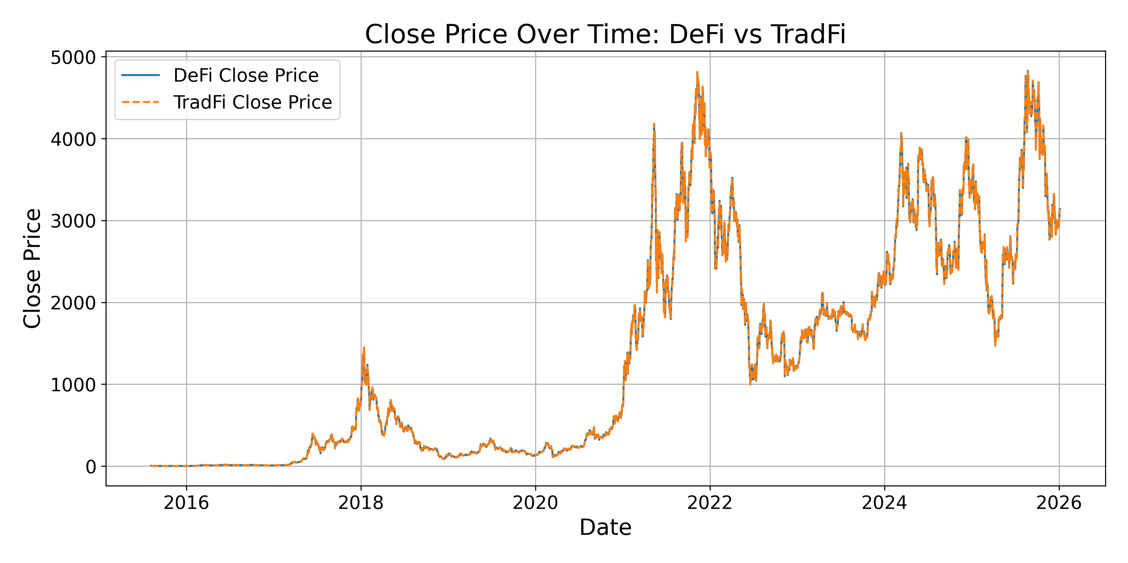Figure 1. ETH/USD daily closing prices, 2015–2025. Horizontal axis: date; vertical axis: price in U.S. dollars. The fixed-LTV and hybrid runs use identical price data, so the two plotted series overlap.
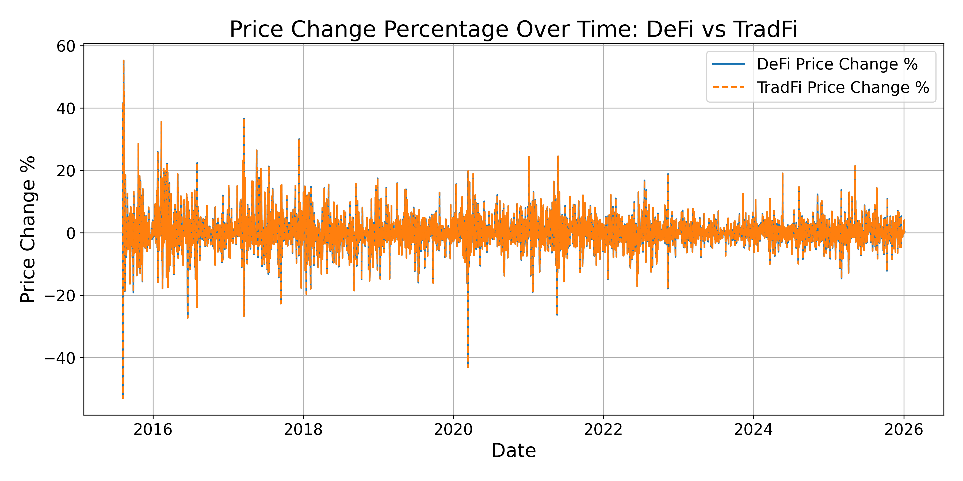Figure 2. Daily ETH price change, 2015–2025. Horizontal axis: date. Vertical axis: one-day return in percent. Large spikes show the periods of extreme volatility that stress each model.

4.2 Liquidation Performance
The largest difference between the two models was the number of liquidations. As shown in Figure 3, the fixed-LTV DeFi model experienced frequent liquidation events throughout the dataset, particularly during major market downturns. The hybrid model remained much more stable and rarely triggered full liquidations.
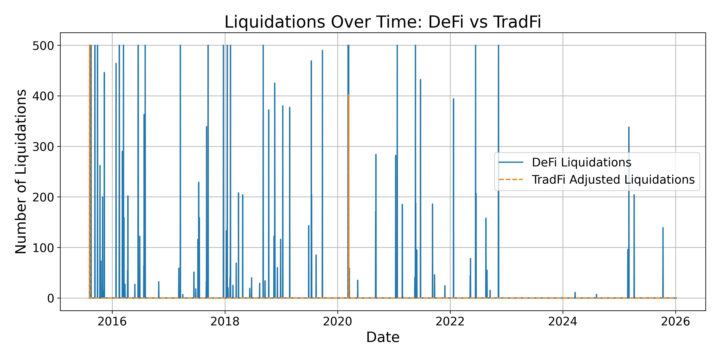Figure 3. Daily liquidation counts under the fixed-LTV (DeFi) and hybrid models. Horizontal axis: date. Vertical axis: positions liquidated that day, out of 500. The fixed-LTV series spikes repeatedly while the hybrid series stays close to zero.
Results for the entire dataset:
Table 2. Liquidations over the full run (3,804 days × 500 positions = 1,902,000 position-days)
 | Fixed-LTV (DeFi) | Hybrid
Liquidations | 23,731 | 1,402
Liquidations per position-day | 1.25% | 0.074%
Reduction in liquidations | Baseline | 94.09%

500 positions are re-formed and tested each day across more than 3,800 days, roughly 1.9 million position-days, so the 23,731 and 1,402 counts correspond to liquidation rates of about 1.25% and 0.07% of position-days, meaning that these totals are sums of single-day outcomes. The multi-day, path-dependent case is explained as an extension in Section 5. The hybrid model reduced liquidations by roughly 94%, showing that stress testing and proactive risk management can significantly improve position survival during volatile markets. Section 4.6 shows how much of this reduction comes from the lower leverage level itself as opposed to the daily stress-based adjustment.

4.3 Average Health Factors Over Time
Figure 4 compares the average health factor (HF) across 500 positions. For most of the time, the DeFi model remained near the liquidation threshold, averaging around 1.0–1.1. During periods of high volatility, many positions fell below HF = 1, triggering liquidations. The hybrid model, however, maintained a much higher average health factor of approximately 1.45. Since borrowing limits were adjusted before positions became unsafe, most positions remained above the liquidation.
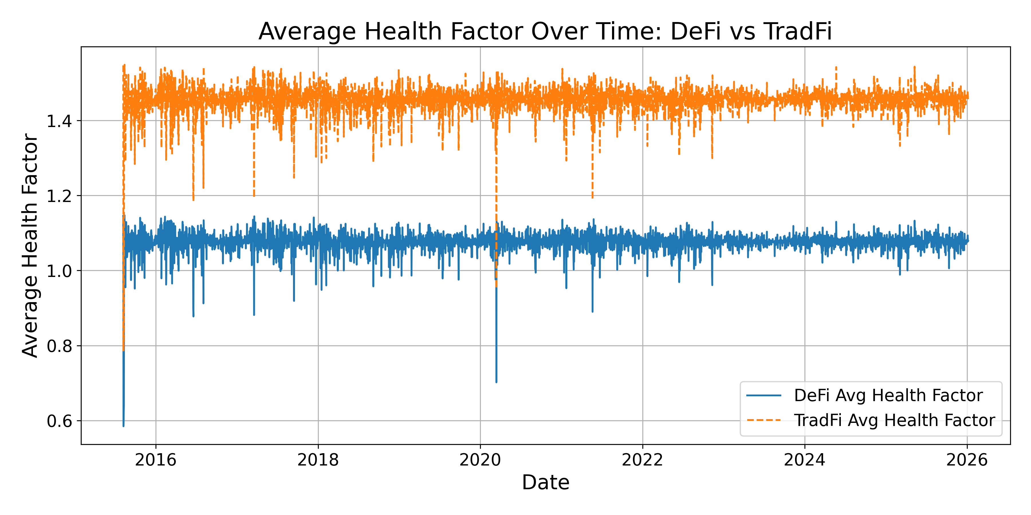Figure 4. Average health factor across the 500 daily positions. Horizontal axis: date. Vertical axis: mean health factor, with 1.0 the liquidation point. The fixed-LTV model runs near 1.0–1.1; the hybrid model stays near 1.45.

4.4 Cumulative Liquidations and Reductions
Figures 5 and 6 show how the two approaches managed risk over time. In the fixed-LTV model, cumulative liquidations increased rapidly. Eventually they reached nearly 24,000. In contrast, the hybrid model remained near 1,400 total liquidations.
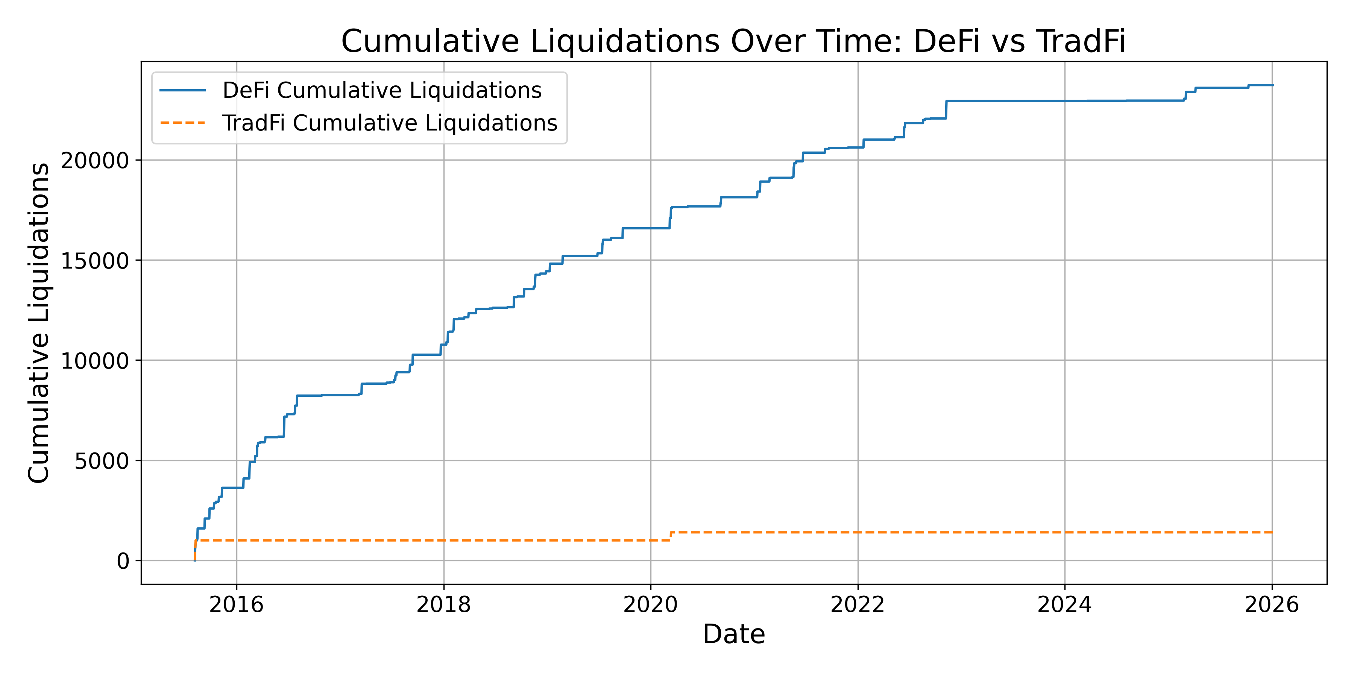Figure 5. Cumulative liquidations over the run. Horizontal axis: date. Vertical axis: running total of liquidations. The fixed-LTV total climbs toward roughly 24,000 while the hybrid total stays near 1,400.

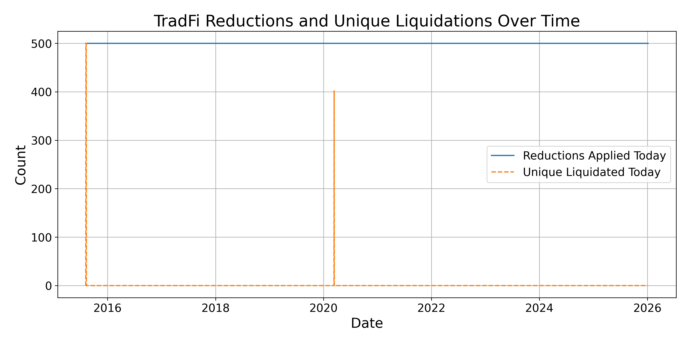Figure 6. Hybrid-model daily position reductions versus full liquidations. Horizontal axis: date. Vertical axis: count out of 500. Partial deleveraging is applied to nearly all positions each day. Full liquidations are rare.

4.5 Effective LTV
Figure 7 shows the average effective LTV ratio in the hybrid model. The hybrid model reduces the effective LTV from the 0.65 starting limit to a consistently conservative level, averaging 0.485 with a standard deviation of 0.0021 across the simulation window. This reduction is re-derived and applied to every position on every day of the run, so the deleveraging is executed dynamically. Its magnitude, however, is quasi-static: because the shock grid and market baseline are the same every day (Section 3.3), the effective LTV stays near this average rather than tightening further as market stress rises. The protection comes from actively deleveraging each position to a lower, stress-test-based level every day, in contrast to the preset 65% limit that the fixed-LTV model applies without regard to actual market conditions.
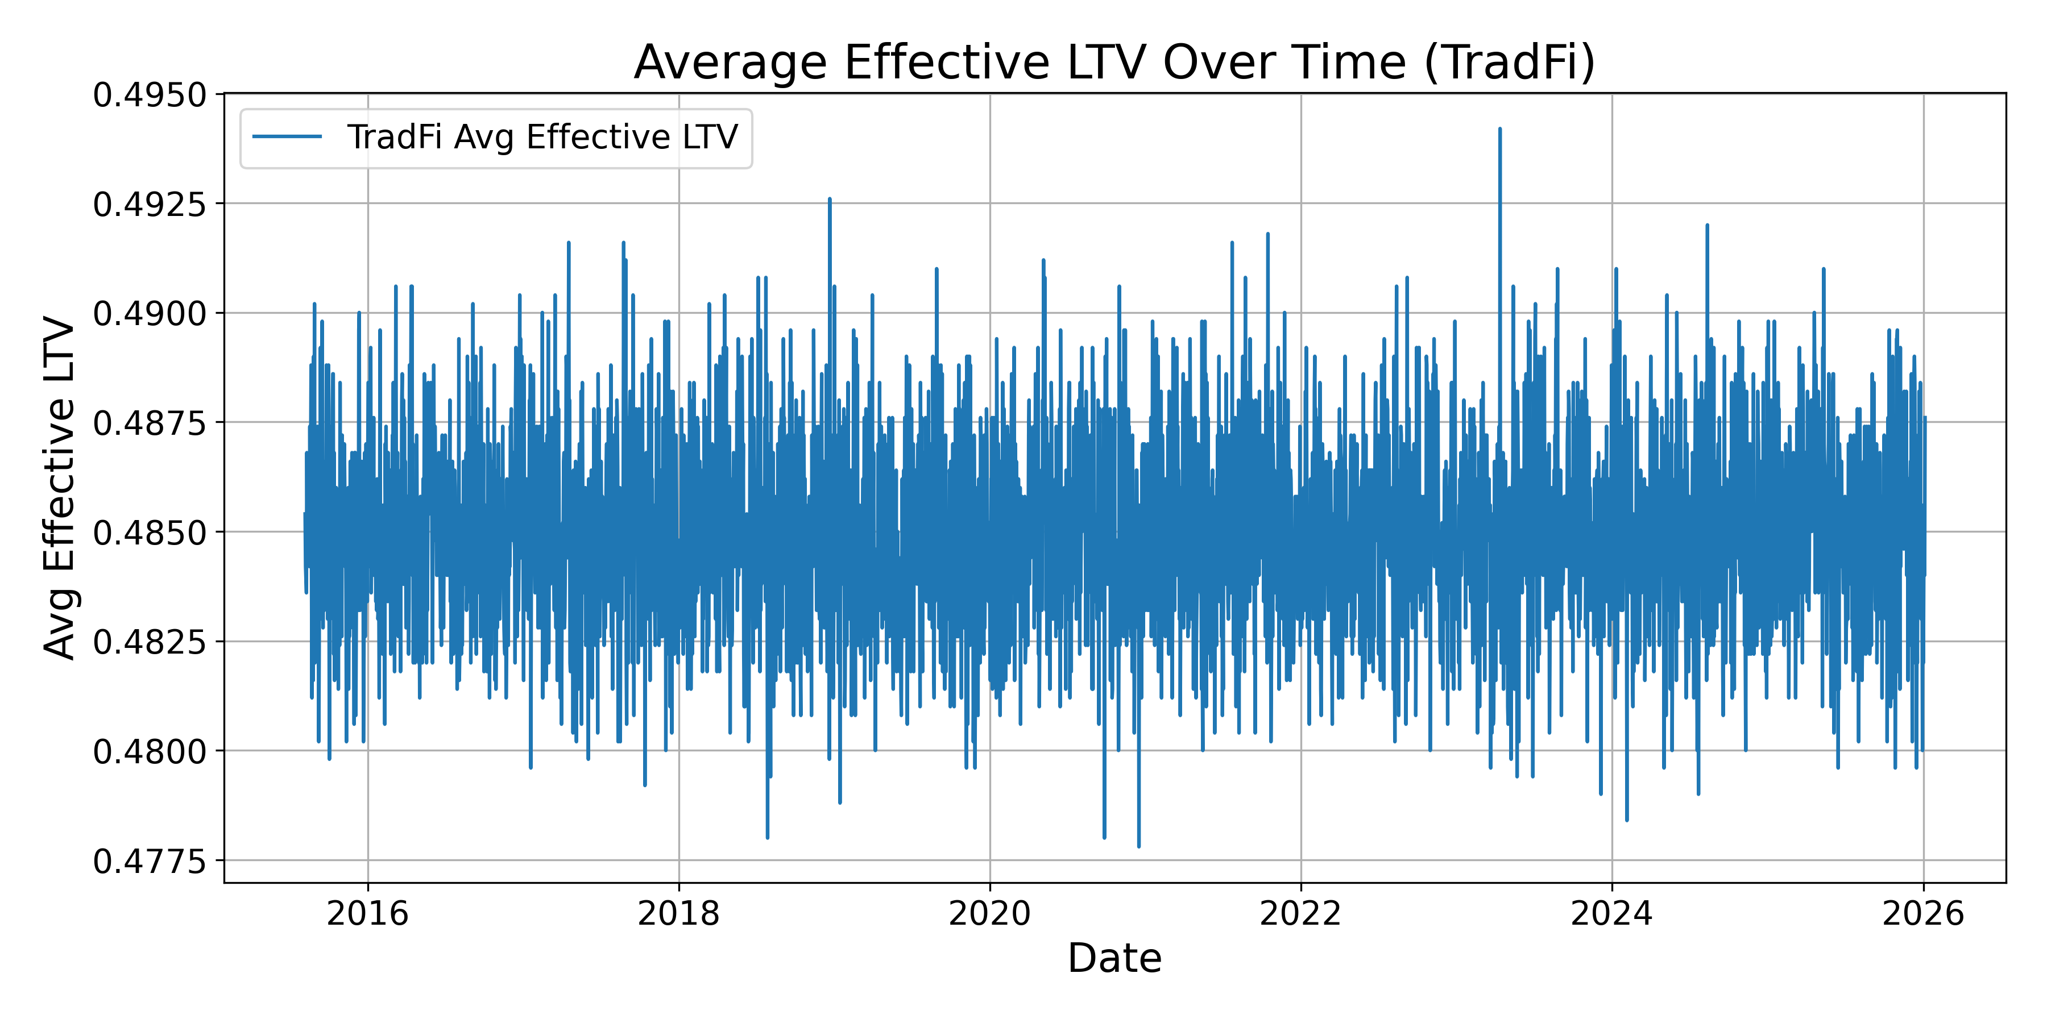Figure 7. Average effective LTV in the hybrid model. Horizontal axis: date. Vertical axis: mean effective loan-to-value. The value stays near 0.485 throughout, reflecting the fixed shock grid and baseline described in Section 3.3.
Additional results include:
- Days with DeFi liquidations: 104
- Days with hybrid liquidations: 3
Table 3. Days with hybrid-model liquidations
Date | ETH open → close | One-day change | Fixed-LTV liquidations | Hybrid liquidations
8 Aug 2015 | $2.83 → $1.33 | −53.0% | 500 | 500
10 Aug 2015 | $1.33 → $0.69 | −48.3% | 500 | 500
13 Mar 2020 | $194.22 → $110.60 | −43.0% | 500 | 402
Dates and prices as recorded in our series (daily 00:00 UTC snapshots; see Section 3.1).
All 1,402 hybrid liquidations occur on these three days, which are the three largest one-day price drops in the dataset. On each of them the hybrid model loses most or all of the 500-position cohort, and so does the fixed-LTV model. On the other 101 days with fixed-LTV liquidations, the hybrid model liquidates no positions. The fixed-LTV model begins liquidating on drops of about 10%, while the hybrid model has no liquidations on any drop up to 27.3%, the next-largest move in the sample. The lower leverage therefore protects positions through moderate and severe drops, but it does not protect them against single-day crashes of 40% or more. The dataset contains no one-day moves between −27.3% and −43%, so it cannot show at what drop size the hybrid's protection ends. Two of the three days fall in ETH's first days of trading in August 2015, when prices were below $3 and the market was very thin, and our price series has no entry for 9 August 2015, so the 10 August change covers two days.

4.6 What Drives the Reduction: Static-LTV Control
To isolate and test the contribution of the dynamic stress-testing layer, we ran a static control that fixes the effective LTV at a constant 0.485 - the level the hybrid model holds on average - with no stress-based adjustment. Across the same 500 daily positions and the same 2015-2025 price history, the static control produced 1,381 liquidations, within 1.5% of the hybrid model's 1,402 (a difference of 21). Under the current assumptions and historical data, the fixed conservative margin accounts for most of the reduction, while the dynamic layer adds little. The benefit therefore comes primarily from the reduced leverage level itself rather than from any stress-driven variation in it: because the hybrid's daily adjustment is quasi-static, fixing the cap at 0.485 reproduces almost the same result, confirming that the conservative level is what lowers liquidations.

4.7 Performance during market crashes
The differences between the two models became even more noticeable during major market downturns.
Table 4. Liquidations and lowest daily health factor during major crashes
Crash | DeFi  Liquidations | DeFi lowest daily HF | Hybrid  Liquidations | Hybrid lowest daily HF | Reduction  %
March 2020  COVID Crash | 1,059 | 0.70 | 402 | 0.95 | 62
May 2021  Crypto Crash | 1,255 | 0.89 | 0 | 1.19 | 100
FTX Collapse  2022 | 872 | 0.96 | 0 | 1.30 | 100
2025 Tariff Crash | 204 | 1.00 | 0 | 1.36 | 100
October 2025  Crypto Crash | 139 | 1.01 | 0 | 1.36 | 100
Lowest daily HF is the minimum, over the crash window, of each day's average closing health factor across the 500 positions. Windows are calendar months (March 2020, November 2022, April 2025, October 2025), except the May 2021 crash, which covers 1 May–30 June 2021. Because this is an average across 500 positions, some positions can be liquidated even on days when the average stays at or above 1.

During the March 2020 COVID crash, the May 2021 crypto crash, the 2022 FTX collapse, the 2025 tariff crash, and the October 2025 crypto crash, the hybrid model was able to avoid or reduce liquidations while the fixed-LTV model liquidated hundreds or thousands of positions. The lowest daily average health factor in each window shows how close each model came to the liquidation point. In the fixed-LTV model it fell to between 0.70 and 1.01. In the hybrid model it stayed at 1.19 or above in every window except March 2020, when the 43% Black Thursday drop (recorded under 13 March in our series) pushed it to 0.95.

5. Discussion
The results suggest that LTV rules that are not based on current market conditions are not well suited for Uniswap v3 liquidity provider positions. Because these positions are affected by impermanent loss, their value can change rapidly during volatile markets. As a result, many positions in the DeFi simulation were liquidated even though they may have remained healthy under a more flexible system.
The TradFi-inspired hybrid model performed much better. By stress-testing positions under multiple price scenarios and deriving each position's borrowing limit from that test, it reduced liquidations by roughly 94% while maintaining higher average health factors. Instead of relying on a single liquidation threshold, the model re-evaluated each position daily and reduced its borrowing from the 65% starting limit to a lower, stress-test-based level - averaging 0.485 across the run rather than applying a single preset cap, helping positions survive periods of market stress. As Section 4.6 shows, a static control fixed at that same 0.485 level reproduces the reduction to within 1.5%, so the improvement comes from the lower leverage level itself vs. its daily changes. The stress test's role and value are to derive that level from each position's risk, and the fixed shock grid and baseline keep that level nearly constant over time (Section 3.3).
The lower leverage that keeps the positions safe has a negative effect, though. The reduction of the effective leverage from 0.65 to about 0.485 allocates roughly 25% less in borrowed capital, and because fee income scales with the amount of the deployed capital, the hybrid loses a comparable share of the fees that the additional leverage would have earned. To summarize, the result achieves less risk through reduced leverage, which is different from the traditional-finance goal of maintaining the same risk at higher leverage (Section 2.3). A more complete evaluation would weigh the two models on a risk-adjusted basis (the liquidations avoided per unit of borrowing forgone) which is not in scope for this simulation.
These findings support the main idea of this project: liquidation risk for LP positions is not constant, so risk management systems should adapt as market conditions change. There are several limitations to this study. The simulation used daily closing prices and did not capture intraday volatility. It also relied on simplified assumptions and did not include factors such as actual trading fees, transaction costs, or future protocol changes. Because the model was tested on historical data, future market conditions may produce different results.
Similarly, rather than keeping a fixed set of positions open over the entire period, the simulation created a new set of 500 positions every day. This was done to keep the positions realistically close to historical prices and compare the fixed-LTV and hybrid models under identical daily conditions. This approach probably understates the risk of multi-day crashes, where losses would compound for long-held positions. A useful extension would be to model positions that persist across multiple days, which would capture the cumulative effect of prolonged crashes more directly.
Despite these limitations, the hybrid model liquidated fewer positions than the fixed-LTV approach on 102 of the 104 days on which the fixed model had liquidations, and never more. On the two largest price drops, both models lost the entire cohort (Section 4.5). Future research could incorporate real on-chain data, trading fees, and more advanced risk models. Overall, the results suggest that adopting some risk-management techniques from traditional finance could make DeFi lending systems more efficient and resilient for liquidity providers.

6. Conclusion
This project examined how Uniswap v3 liquidity provider positions perform when used as collateral in DeFi lending protocols. Using more than 3,800 daily ETH price data points from 2015–2025, we compared a standard fixed LTV model with a TradFi-inspired stress-tested margining approach.
The results showed that fixed LTV rules can lead to excessive liquidations because they do not account for the non-linear effects of impermanent loss. In our simulation, the fixed-LTV model produced 23,731 liquidations across 500 positions, while the hybrid model reduced that number to 1,402, a reduction of roughly 94%. The hybrid approach also maintained higher average health factors and allowed positions to remain active during periods of market volatility.
These findings support the idea that risk management systems should account for how LP positions change in value as market conditions change. Rather than relying on a single liquidation threshold, the hybrid model used stress testing to derive each position's borrowing limit from its own risk. The limit was consistently lower than the fixed cap, and a static control fixed at the same level reproduces the reduction to within 1.5% (Section 4.6), so the benefit comes from the lower leverage level rather than daily adjustments. As a result, fewer positions were liquidated and more were able to continue earning trading fees. Although the model has limitations, including the use of daily price data and simplified assumptions, the results suggest that stress-test-based conservative margining could be a more effective approach for managing complex collateral in DeFi lending protocols. Future research could build on this work by incorporating real on-chain data, trading fees, and more advanced risk models.
A further research direction, inspired by the near-constant effective LTV reported in Section 4.5, is to make the margin genuinely responsive to market conditions. Designing and validating such mechanisms is left to future work. A related extension is to compare the stress-test-derived level with a range of fixed caps and with other values of the impermanent-loss weight and backstop term.
Overall, this study demonstrates that borrowing ideas from traditional finance may help create more efficient and resilient DeFi lending systems, especially for liquidity providers using concentrated liquidity positions.

Acknowledgments
The author used a generative AI assistant (Anthropic’s Claude) for language editing, literature and reference searching, and general guidance on the publication process. All research design, code design and structure, data analysis, and conclusions are the author’s own. The author reviewed and verified all outputs, including the accuracy of all references, and is solely responsible for the content.
Funding: None.
Conflicts of interest: None.

References
1. FTX Trading Ltd. (Debtors), "Preliminary Analysis of Shortfalls at FTX.com and FTX.US," In re FTX Trading Ltd., Case No. 22-11068 (JTD), U.S. Bankruptcy Court for the District of Delaware, filed 2 March 2023. Available via the Debtors’ claims agent at https://cases.ra.kroll.com/FTX.
2. Investopedia, "FTX Crypto Exchange Collapse: Causes, Consequences, and Lessons", https://www.investopedia.com/what-went-wrong-with-ftx-6828447
3. FTI Consulting, "Crypto Crash Oct 2025: Leverage Meets Liquidity", https://www.fticonsulting.com/insights/articles/crypto-crash-october-2025-leverage-met-liquidity
4. CoinDesk, "'Largest Ever' Crypto Liquidation Event Wipes Out 6,300 Wallets on Hyperliquid", https://www.coindesk.com/markets/2025/10/11/largest-ever-crypto-liquidation-event-wipes-out-6300-wallets-on-hyperliquid
5. Aurpay, "Crypto Crash October 2025: $19B Liquidation Explained" https://aurpay.net/aurspace/crypto-crash-october-2025-bitcoin-liquidation-explained
6. Insights4.vc, "Inside the $19B Flash Crash", https://insights4vc.substack.com/p/inside-the-19b-flash-crash
7. Aave Documentation, "Risk Parameters – LTV, Liquidation Thresholds, and Penalties," accessed January 19, 2026, https://docs.aave.com/risk/
8. DefiLlama, "Uniswap Protocol TVL and Fees,", https://defillama.com/protocol/uniswap
9. Adams, H., Zinsmeister, N., Salem, M., Keefer, R., & Robinson, D. (2021). Uniswap v3 Core. Uniswap Labs. Retrieved from https://app.uniswap.org/whitepaper-v3.pdf
10. Fu, W., Chitra, T., Chiang, R., & Morrow, J. (2021). Aave Market Risk Assessment. Gauntlet Research Report, April 2021. Retrieved from https://www.gauntlet.xyz/resources/aave-market-risk-assessment
11. U.S. Securities and Exchange Commission, "Order Approving a Proposed Rule Change to Expand the Products Eligible for Customer Portfolio Margining" (SR-NYSE-2005-93), Exchange Act Release No. 34-54125 (July 11, 2006), 71 Fed. Reg. 40766; and "Order Approving a Proposed Rule Change Relating to Customer Portfolio Margining" (SR-NYSE-2006-13), Exchange Act Release No. 34-54918 (Dec. 12, 2006), 71 Fed. Reg. 75790. https://www.sec.gov/files/rules/sro/nyse/2006/34-54918.pdf
12. Project code, data, and output records (defischolar_margin_risk), GitHub, https://github.com/markurusov1/defischolar_margin_risk/tree/v2
13. Heimbach, L., Schertenleib, E., & Wattenhofer, R. (2022). Risks and Returns of Uniswap V3 Liquidity Providers. arXiv:2205.08904. https://arxiv.org/abs/2205.08904
14. Options Clearing Corporation (OCC), "Customer Portfolio Margin" (TIMS methodology). https://www.theocc.com/Risk-Management/Customer-Portfolio-Margin
15. New York Stock Exchange, NYSE Rule 431 (“Margin Requirements”), paragraph (g) (Portfolio Margin); portfolio-margin methodology approved by SEC Exchange Act Release No. 34-52031 (July 14, 2005), 70 Fed. Reg. 42130.

