Applying Traditional Finance Portfolio Margin Risk Strategies to Uniswap v3 Collateral in DeFi Lending
Mark Urusov
Seton Hall Preparatory School

Abstract
Decentralized finance liquidity providers (LPs) who use their Uniswap v3 positions as collateral on lending platforms such as Aave often face liquidations because these platforms rely on fixed Loan-to-Value (LTV) rules. These rules do not account for Impermanent Loss which can increase rapidly when asset prices move outside an LP's chosen price range.
To address this, we simulated Uniswap v3 LP positions using historical ETH/USD price data and compared the standard fixed-LTV lending model with a hybrid risk-management framework that incorporates stress testing and conservative exposure limits. Under the conventional 65% LTV model, liquidations were frequent, with 23,731 liquidation events observed over roughly a decade of daily price data (2015–2025).
The proposed framework reduced liquidations by 94.09% while maintaining healthier collateral positions, achieving this through reducing effective leverage from the preset fixed limit to a market-aware consistently conservative level rather than full liquidation.
These findings suggest that incorporating impermanent loss-aware risk controls into DeFi lending protocols could significantly reduce liquidations while keeping leveraged positions safer through periods of volatility. By combining the accessibility of DeFi with the risk management techniques used in traditional finance, lending platforms can become more stable and efficient, benefiting liquidity providers.

Introduction
Cryptocurrency markets are some of the most volatile markets in the world, with sudden price swings sometimes wiping out billions of dollars in just a few hours. These events show how risky leveraged trading can be and why better risk management is needed in decentralized finance.
One of the biggest examples occurred in November 2022, when the FTX exchange collapsed after an $8 billion hole was found in its balance sheets. The collapse caused widespread panic, leading to approximately $1–2 billion in immediate liquidations as cryptocurrency prices continued to fall [1][2]. A few years later, in October 2025, rising U.S.-China trade tensions and the announcement of 100% tariffs on Chinese imports caused the largest single-day liquidation event in crypto history. In around 24 hours, more than $19–20 billion in leveraged positions were liquidated, and Bitcoin fell by 12% [3][4][5][6].
During this period of extreme volatility, Uniswap v3 experienced a lot of trading volume, creating an opportunity for LPs to earn large fees. However, many LPs were liquidated before they could benefit. Because lending protocols rely on fixed LTV (loan-to-value) rules that ignore impermanent loss, many users were either forced to over-collateralize their positions or were liquidated.
The purpose of this project is to compare the fixed LTV liquidation model used by decentralized lending protocols such as Aave with the portfolio margin systems used in traditional finance, including methods introduced by the SEC in 2006 [12]. In traditional finance, margin requirements adjust as market risk changes, while most decentralized protocols apply the same fixed liquidation rules in every market condition, creating unnecessary liquidations.
To examine why LPs are liquidated so often and whether a more dynamic approach helps, we built a simulation using real historical ETH prices and 500 simulated Uniswap v3 LP positions, and compared the fixed-LTV model against a dynamic portfolio margin model that uses risk-based stress testing and gradual adjustments instead of fixed thresholds.
Our simulations show that this approach can reduce liquidations by more than 97% by proactively lowering effective leverage during periods of stress instead of increasing leverage. By avoiding unnecessary liquidations, positions can remain active and continue earning yield farming fees, supporting deeper and more stable liquidity on Uniswap.

2. Literature Review

2.1 Uniswap V3 & Impermanent Loss
Decentralized exchanges such as Uniswap allow users to trade cryptocurrencies without having to rely on a bank or another central authority. Instead of matching buyers and sellers directly, Uniswap uses automated market makers, which are smart contracts that hold pools of two different tokens such as ETH and USDC. When someone wants to swap one token for another, they trade directly with the pool instead of another person.
Most automated market makers use the constant product formula:
x * y = k
where:
- x = the amount of the first token in the pool (such as ETH),
- y = the amount of the second token (such as USDC),
- k = a constant value that remains the same after every trade.

This formula automatically keeps the pool balanced. For example, if a trader buys ETH, they must deposit USDC into the pool. As ETH leaves the pool and USDC enters, the values of x and y change, but their product k stays constant. The exchange rate is determined by the ratio of y to x, which represents how much USDC one ETH is worth. Liquidity providers supply equal values of both tokens to these pools and earn a small percentage of every trade that takes place [10].
In Uniswap v2, liquidity was spread across every possible price. This meant that a large portion of an LP's capital was sitting in price ranges where almost no trading occurred. Uniswap v3 introduced concentrated liquidity, allowing LPs to choose the price range where they wanted to provide liquidity. For example, an LP might decide to provide liquidity only while ETH trades between $2,500 and $3,500. Because their funds are concentrated where most trading occurs, they can earn much higher fees. However, if the price moves outside that range, the position stops earning trading fees and becomes entirely one asset. Either all ETH or all USDC, depending on which direction the price moved.
While concentrated liquidity increases potential returns, it also increases a risk known as impermanent loss. Impermanent loss occurs because the pool automatically buys and sells assets as prices change, causing an LP's position to be worth less than if they had held the tokens without providing liquidity. For the traditional full-range model used in Uniswap v2, impermanent loss can be calculated using the formula [10]:
IL = (2√r)/(1+r) − 1
The variable r is the ratio between the current price and the price when liquidity was first added.
In Uniswap v3, this risk becomes much greater once the market price moves outside an LP's chosen range. Narrower ranges can generate higher trading fees during stable markets, but they also cause impermanent loss to increase much more rapidly during large price swings, such as those seen during the FTX collapse and the October 2025 liquidation event. This makes Uniswap v3 LP positions riskier than traditional collateral.
After creating a Uniswap v3 position, some LPs use that position as collateral on lending protocols such as Aave to borrow additional assets. They then invest those borrowed funds into another liquidity position, allowing them to earn fees on a larger amount of capital. This strategy, often called a leverage loop, can significantly increase returns if markets remain stable. However, it also increases risk because Aave still evaluates the collateral using fixed LTV rules. These rules do not account for how quickly impermanent loss can reduce the value of a Uniswap v3 LP position during periods of high volatility, creating the liquidation problem explored in this paper.

2.2 DeFi Lending Protocols
DeFi lending protocols such as Aave and Compound allow users to borrow cryptocurrency without going through a bank or credit check. Instead, borrowers deposit cryptocurrency as collateral and then borrow another asset against it. Other users supply assets to lending pools and earn interest, while borrowers pay interest on their loans.
To reduce risk, these protocols require over-collateralization. This means users must deposit more value than they borrow. This extra collateral helps protect lenders if the value of the collateral falls. The amount a user can borrow is determined by the LTV ratio. The LTV sets the maximum percentage of a position's value that can be borrowed. For volatile assets such as ETH, protocols like Aave typically allow an LTV between 65% and 82% [8]. This means a user can borrow up to 65–82% of the current value of their collateral.
Lending protocols also use a Liquidation Threshold, which is slightly higher than the LTV, usually around 70–85% and creates a buffer [8]. To monitor the safety of a loan, protocols calculate a value called the health factor (HF):
HF = (Vc × LT) / Vd
where:
- Vc = current value of the collateral,
- LT = liquidation threshold,
- Vd = value of the borrowed assets.

If HF is greater than or equal to 1, the position is considered safe. If HF falls below 1, the position can be liquidated. During liquidation, part or all the collateral is sold to repay the debt and protect lenders. The liquidator receives a portion of the borrower’s collateral as a reward, typically 5–15% [11].
While this system works well for simple forms of collateral such as ETH or stablecoins, it becomes much more complicated when Uniswap v3 LP positions are used as collateral. Unlike regular crypto assets, the value of an LP position can change rapidly because of impermanent loss. As prices move, the value of the position may decline much faster than the protocol would expect.
The problem is that fixed LTV rules do not adjust for this risk. Most decentralized lending protocols use the same borrowing limits regardless of market conditions. During major market events, such as the FTX collapse or the October 2025 liquidation event, impermanent loss can quickly push a position's health factor below 1. Once this happens, the position may be fully liquidated, even if it could have recovered later.
As a result, many liquidity providers are forced to over-collateralize their positions to avoid liquidation. Others are liquidated too early and lose access to future yield farming fees because their liquidity positions are removed from the pool. These issues make DeFi lending less efficient for complex collateral such as Uniswap v3 LP positions than for simpler assets like ETH or stablecoins.

2.3 Traditional Finance Portfolio Margining
In traditional finance, investors can borrow money to trade stocks, options, and other assets using margin. Unlike most DeFi lending protocols, brokers do not rely on a single fixed borrowing limit. Instead, many use portfolio margining. This method evaluates the risk of an entire portfolio rather than individual positions [12].
Portfolio margining relies on stress testing. Computers simulate different market conditions by applying a series of price and volatility shocks to a portfolio. For example, a broker might test what happens if an asset's price moves ±3%, ±6%, ±9%, ±12%, or ±15% (NYSE Rule 431(g)(2)(G)). The portfolio is then evaluated under each scenario, and the worst projected loss is used to determine the required margin [15].
This approach is useful because it captures risks that are not linear. In options trading, losses can accelerate as prices move further from expectations. A similar effect occurs in Uniswap v3, where impermanent loss can increase rapidly once the price moves outside an LP's chosen range. By testing multiple price scenarios, portfolio margin systems are better able to account for these risks.
Another advantage is flexibility. In traditional finance, margin requirements are updated as market conditions change. If risk increases, brokers may require additional collateral or reduce exposure gradually. Full liquidation is usually a last resort. Most decentralized protocols, however, rely on LTV limits and liquidate positions once a threshold is crossed.
Feature | DeFi Fixed LTV (Aave / Compound) | TradFi Portfolio Margin | What it means for Uniswap v3 LPs
Calculation method | One fixed borrowing limit (e.g., 65–82% LTV for ETH). | Stress-tests the whole portfolio at many price levels; margin is set by the worst-case loss. | Captures impermanent loss risk better, so fewer surprise liquidations.
Adjustment frequency | Stays the same until the liquidation threshold is crossed. | Recalculated regularly as prices and volatility change. | Lets the system react before a position becomes unsafe.
Liquidation style | Binary: the position is fully liquidated once the health factor drops below 1. | Graduated: margin calls and a short cure period first, with full liquidation as a last resort. | Positions can survive volatility and keep earning fees instead of being wiped out.
Non-linear (impermanent loss) risk | Ignored; treats the position's value as if it changes in a straight line. | Captured by testing several price points along the curve. | Important for concentrated v3 positions, where IL accelerates outside the chosen range.
Leverage allowed | Usually low (about 1.2–1.8x after over-collateralization). | Often higher for lower-risk, diversified positions. | Safer higher leverage could let LPs earn more without adding excess risk.

Because of these differences, portfolio margining can often support higher leverage while reducing unnecessary liquidations. This makes it a useful model for DeFi lending protocols that accept Uniswap v3 LP positions as collateral. By incorporating stress testing and dynamic risk management, protocols may be able to better account for impermanent loss, reduce over-collateralization, and allow LPs to keep earning yield farming fees during volatile markets.

3. Methodology

3.1 Data Sources
To test how Uniswap v3 liquidity provider positions perform under both fixed DeFi lending rules and a TradFi-inspired margin system, we used daily ETH/USD closing prices from 2015 to 2025, giving more than 3,800 data points. Because USDC is designed to stay close to $1, ETH/USD serves as a reasonable proxy for ETH/USDC prices.
This time period includes several major market events, including the 2021 bull market, the May 2021 crash, the FTX collapse in November 2022, and the October 2025 liquidation event. Using a long price history allowed us to test how both models performed across different market conditions.
The dataset contained only daily closing prices. To estimate daily price changes, we treated each day's closing price as the following day's opening price [13]. Although this does not capture intraday price movements, it provides a reasonable approximation for a long-term simulation focused on liquidation behavior rather than minute-by-minute trading.
Price data was collected from CoinGecko and cross-checked with Yahoo Finance during major market events. Additional liquidation statistics were referenced from sources such as DefiLlama and CoinGlass [9], but all results reported in this paper were generated from our own simulations.

3.2 DeFi Simulation
To model how DeFi lending protocols such as Aave and Compound handle LP positions, we built a simulation using fixed LTV rules and real historical ETH prices. The model was implemented in Python using standard scientific libraries (such as pandas and NumPy), and the complete code and dataset are publicly available in the project’s GitHub repository [13]. The goal was to measure how often Uniswap v3 LP positions would be liquidated under a traditional DeFi lending system.
We simulated 500 LP positions with different deposit sizes and liquidity ranges. To measure how positions withstand a single trading day, we rebuilt the pool of 500 positions fresh each day, using that day’s opening price to create a position. Because the dataset sets each day’s opening price equal to the previous day’s close, positions are always created at the real market price rather than a fixed assumed level. The same random seed is used for both models, so the DeFi and hybrid simulations work on identical price and position data.
Initial deposits were randomly generated between $6,000 and $10,000 and allocated between ETH and USDC using a randomized split (30–70% ETH). The ETH/USDC split for each position was chosen at random, but this is a minor modeling detail: once a position is opened within its price range, how much of each token it holds is mostly determined by where the current price falls in that range. The random split simply produces a mix of ETH-heavy and USDC-heavy positions.
Each position was given a price range between ±10% and ±60% around its opening price. This is a deliberately wide, conservative choice. In practice, most ETH/USDC liquidity providers use much tighter ranges, and a large share of real positions sit out of range at any given time [14]. Because our positions use a range, the results probably understate how often tightly-ranged positions real world would actually be liquidated.
Each position borrowed against its collateral using a fixed 65% LTV, which is similar to the borrowing limits commonly used for volatile assets on protocols such as Aave [8].
To determine whether a position remained safe, we calculated its health factor using a 70% liquidation threshold. If a position’s health factor fell below 1, it was considered eligible for liquidation. The simulation then applied Aave-style liquidation rules, including a 50% close factor and a 10% liquidation bonus. Each daily run was evaluated from that day’s opening price to its closing price, and this was repeated across all 3,800+ days of historical price data, giving a fresh set of positions and a one-day survival test for every day in the dataset. The simulation recorded daily liquidations, average health factors, and cumulative liquidation totals. Because the model relied entirely on fixed LTV rules and did not adjust for changing market conditions, it closely reflects how many current DeFi lending protocols operate.
The simulation steps:
- Create positions - at the start of each day, 500 positions were created at that day’s opening price, so every position began in a realistic in-range state.
- Compute value (open) - each position’s collateral value was calculated at the opening price, accounting for concentrated liquidity.
- Issue the loan - a loan was issued equal to 65% of the opening value, matching Aave’s typical borrowing limit for volatile collateral.
- Compute value (close) - the position was re-valued at the day’s closing price, capturing both the price move and the impermanent loss caused by the pool rebalancing between the two tokens.
- Compute the health factor - the health factor was computed as the closing collateral value times the 70% liquidation threshold, divided by the loan. A position with a health factor below 1 was marked for liquidation.
- Apply liquidation rules - liquidated positions were closed using Aave-style parameters (a 50% close factor and a 10% liquidation bonus).
- Record and repeat - daily liquidation counts, average health factors, and cumulative totals were recorded, and the process repeated for all 500 positions across every day in the dataset.

3.3 TradFi Inspired Hybrid-Solution
After building the fixed-LTV DeFi model, we created a second simulation inspired by traditional finance portfolio margining. The goal was to test whether stress testing and dynamic borrowing limits could reduce unnecessary liquidations for Uniswap v3 liquidity providers. Like the DeFi model, the hybrid was implemented in Python; it additionally uses scikit-learn for the regression step described below, and its full code is available in the same GitHub repository [13].
The hybrid model used the same seeded daily position and historical ETH price data as the DeFi simulation, so both models were tested on identical positions each day. Positions still began with a 65% LTV, but instead of relying on a fixed borrowing limit, the model reevaluated risk every day using a series of stress tests.
If stress tests showed that a position was becoming risky, the model gradually reduced its borrowing power using a sliding-scale approach. The reduction was based on the tiers of the worst-case projected health factor. Positions with a worst-case health factor of 1.2 or above kept the full 65% LTV; those below 1.2 were capped at 55%, those below 1.0 at 45%, and those below 0.8 at 35%. This reduced risk before liquidation became necessary.
The hybrid model simulation steps:
- Create positions - as in the DeFi model, each position was started at the day’s opening price.
- Run the stress tests - the position was re-valued under 11 hypothetical price shocks, from −15% to +15%, with impermanent loss recalculated in each scenario.
- Find the worst case - the lowest projected health factor across all 11 shocks was taken as the position’s worst-case risk for the day.
- Set a tiered borrowing limit - the maximum allowed LTV was reduced according to that worst case: positions that stayed comfortably safe kept the full 65%, while mildly, moderately, and severely stressed positions were capped at 55%, 45%, and 35% respectively. A secondary stress-based check was also applied as a backstop
- Reduce leverage - if the safe loan was below the position’s current borrowing, the position was partially de-leveraged rather than fully closed.
- Confirm at the close - the position was re-valued at the closing price and its health factor checked. A full liquidation occurred only if it still fell below 1, which was rare.
- Record and repeat - reductions applied, health factors, and effective LTVs were recorded for all 500 positions across every day.
As a result, many positions were able to remain active during volatile market conditions. Instead of fully liquidating positions whenever risk increased, the model made smaller adjustments that allowed LPs to continue earning yield farming fees while maintaining healthier collateral levels. The simulation tracked liquidations, health factors, borrowing levels, and position adjustments throughout the entire 2015–2025 dataset. These results were then compared directly with the fixed-LTV DeFi model to evaluate whether a TradFi-inspired approach could improve lending outcomes for Uniswap v3 LP positions.

4. Results
The results show a clear difference between the fixed-LTV DeFi model and the TradFi-inspired hybrid model. While both simulations used the same historical ETH price data and the same 500 Uniswap v3 LP positions, the hybrid model produced far fewer liquidations and maintained healthier positions during periods of market volatility.

4.1 Market Conditions
Figures 1 and 2 show ETH prices and daily price changes from 2015–2025. Because both models used the same historical data, the price charts are nearly identical. The purpose of these figures is to highlight the major periods of volatility that tested each model.
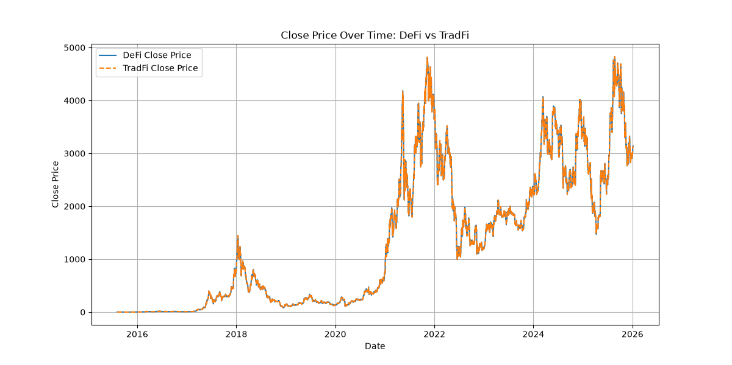Figure 1. ETH/USD closing prices from 2015–2025.
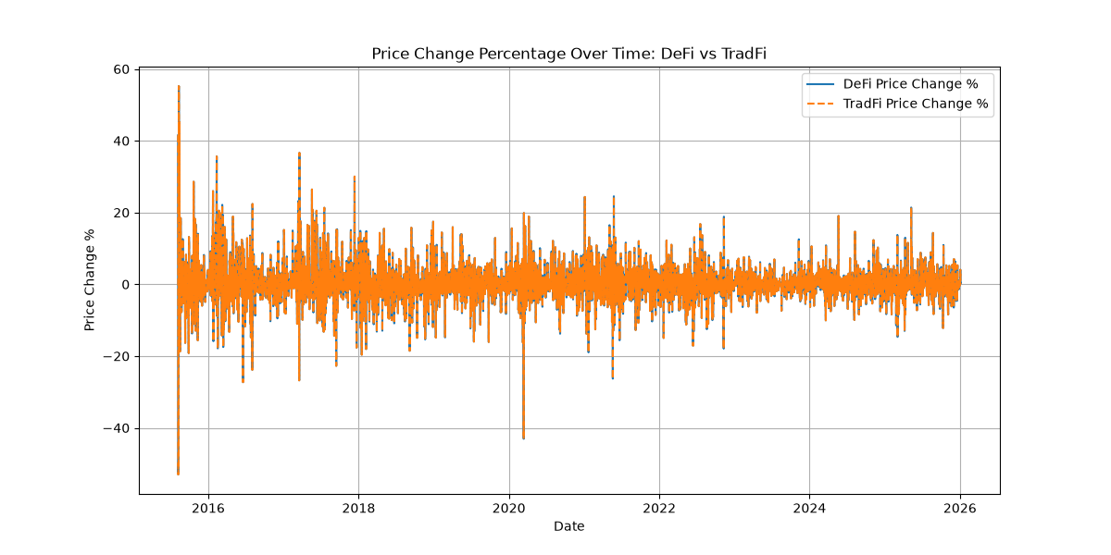Figure 2. Daily ETH price changes. Large spikes represent periods of extreme volatility.

4.2 Liquidation Performance
The largest difference between the two models was the number of liquidations. As shown in Figure 3, the fixed-LTV DeFi model experienced frequent liquidation events throughout the dataset, particularly during major market downturns. The hybrid model remained much more stable and rarely triggered full liquidations.
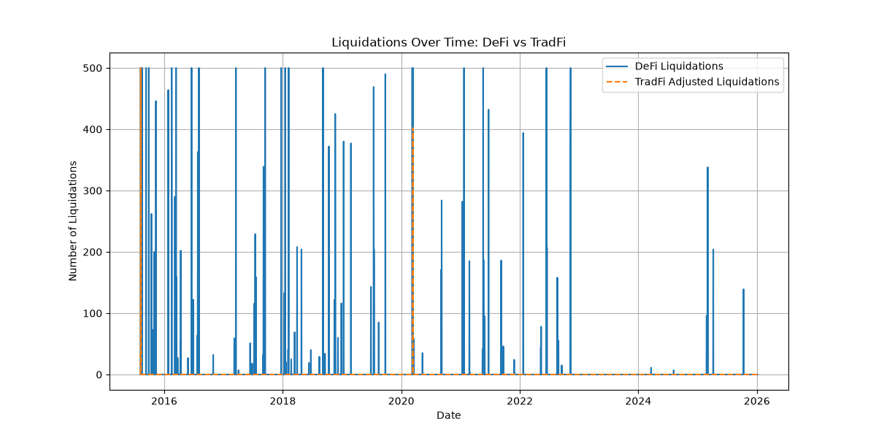Figure 3. Daily liquidations under the DeFi and hybrid models.
Results for the entire dataset:
- DeFi liquidations: 23,731
- Hybrid liquidations: 1,402
- Reduction: 94.09%
The hybrid model reduced liquidations by roughly 94%, showing that stress testing and proactive risk management can significantly improve position survival during volatile markets.

4.3 Average Health Factors Over Time
Figure 4 compares the average health factor (HF) across 500 positions. For most of the time, the DeFi model remained near the liquidation threshold, averaging around 1.0–1.1. During periods of high volatility, many positions fell below HF = 1, triggering liquidations. The hybrid model, however, maintained a much higher average health factor of approximately 1.45. Since borrowing limits were adjusted before positions became unsafe, most positions remained above the liquidation.
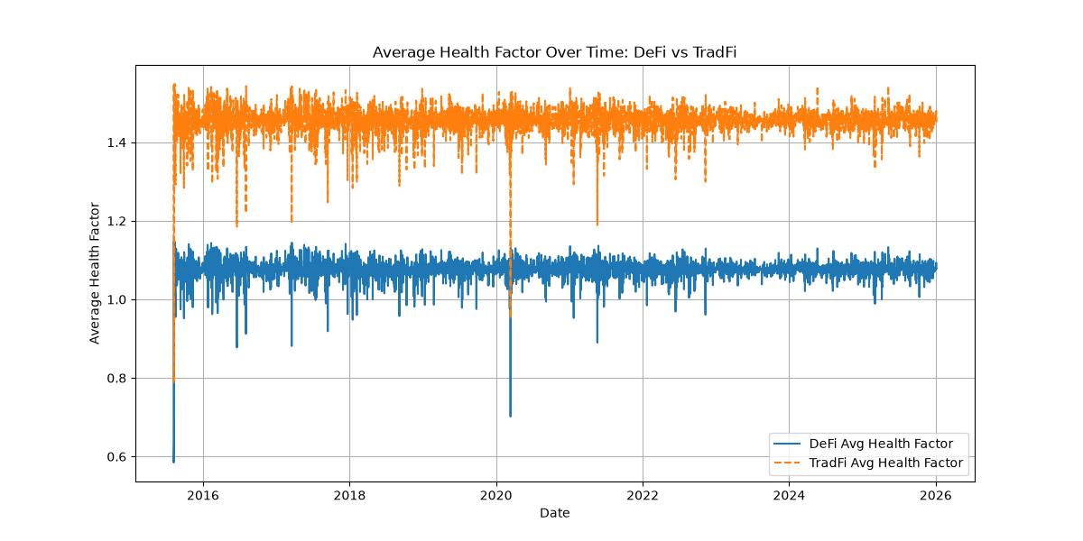Figure 4. Average health factor over time.

4.4 Cumulative Liquidations and Reductions
Figures 5 and 6 show how the two approaches managed risk over time. In the fixed-LTV model, cumulative liquidations increased rapidly. Eventually they reached nearly 24,000. In contrast, the hybrid model remained near 1,400 total liquidations.
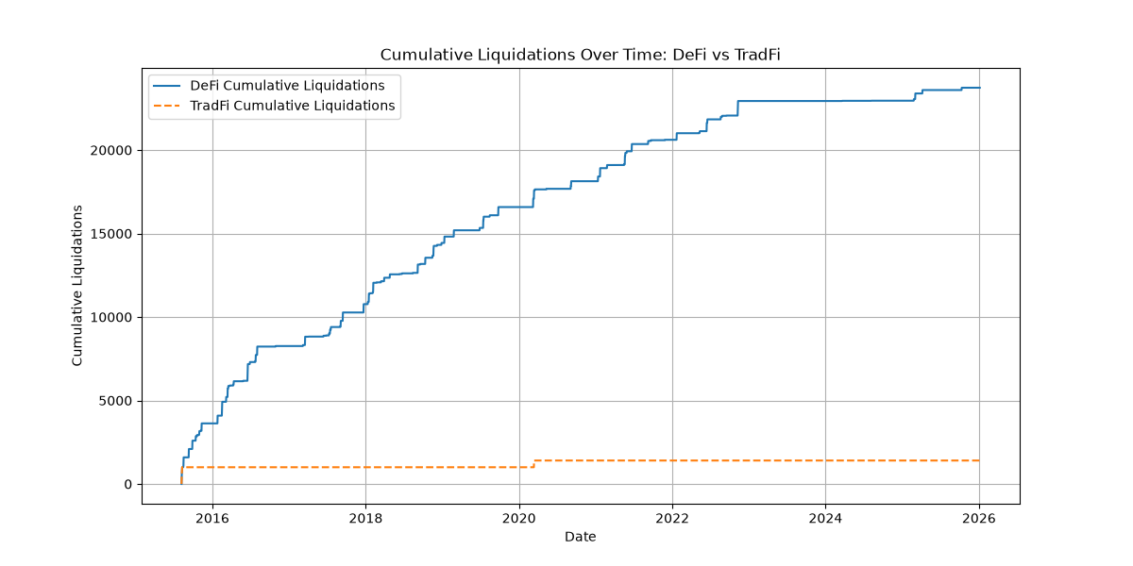Figure 5. Cumulative liquidations over time.

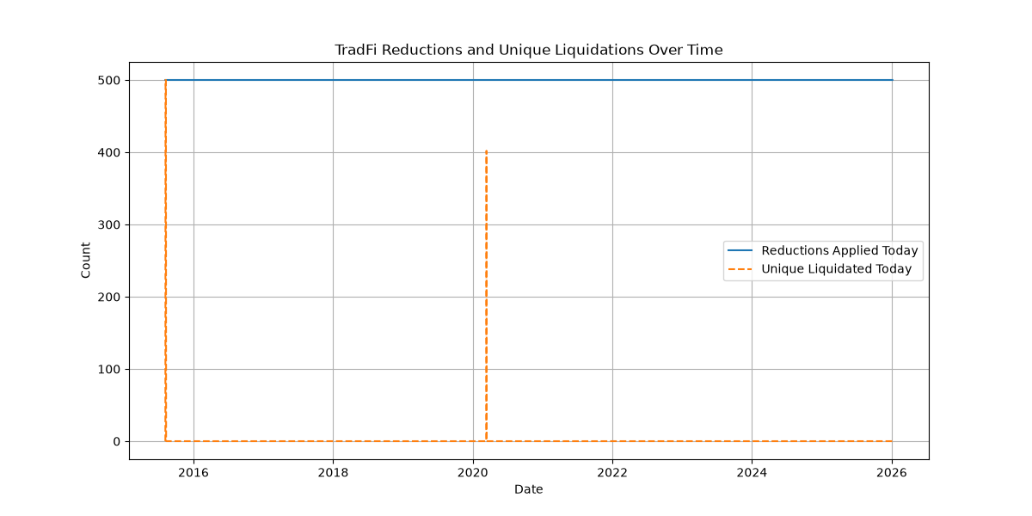Figure 6. Position reductions compared with full liquidations.

4.5 Effective LTV
Figure 7 shows the average effective LTV ratio in the hybrid model. The hybrid model reduces the effective LTV from the 0.65 starting limit to a consistently conservative level, averaging 0.485 with a standard deviation of 0.0021 across the simulation window. This reduction is re-derived and applied to every position on every day of the run, so the deleveraging is executed dynamically. Its magnitude, however, is quasi-static: because the stress test's inputs vary little over time, the effective LTV stays near this average rather than tightening further as market stress rises. The protection comes from actively deleveraging each position to a lower, stress-derived level every day, in contrast to the preset 65% limit that the fixed-LTV model applies without regard to actual market conditions.
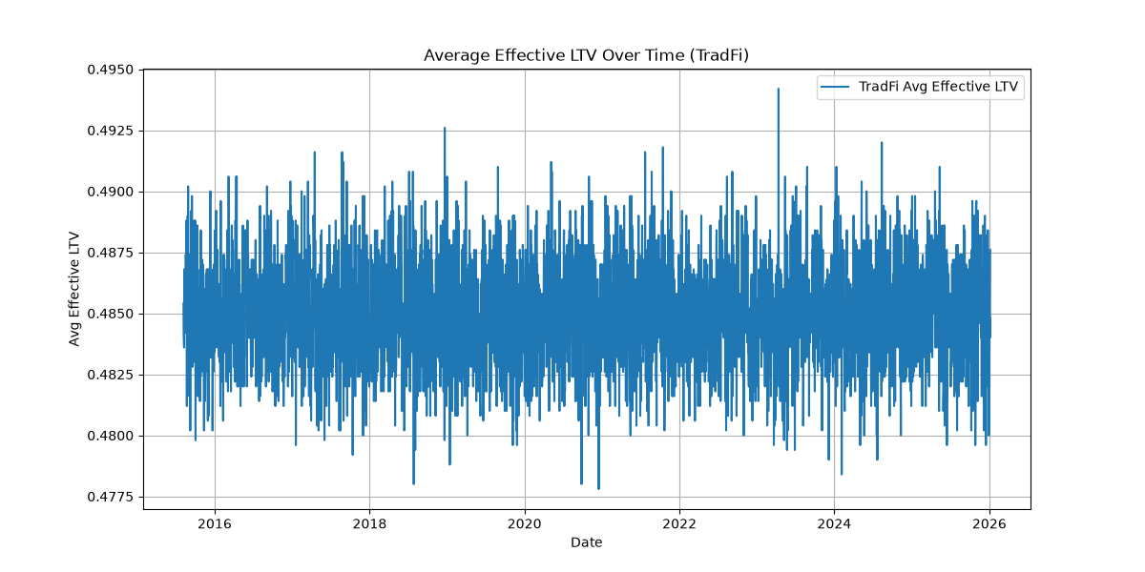Figure 7. Average effective LTV in the hybrid model.
Additional results include:
- Days with DeFi liquidations: 104
- Days with hybrid liquidations: 3

4.6 Static-LTV Control
To isolate and test the contribution of the dynamic stress-testing layer, we ran a static control that fixes the effective LTV at a constant 0.485 - the level the hybrid model holds on average - with no stress-based adjustment. Across the same 500 daily positions and the same 2015-2025 price history, the static control produced 1,381 liquidations, within 1.5% of the hybrid model's 1,402 (a difference of 21). Under the current assumptions and historical data, the fixed conservative margin accounts for most of the reduction, while the dynamic layer adds little. The benefit therefore comes primarily from the reduced leverage level itself rather than from any stress-driven variation in it: because the hybrid's daily adjustment is quasi-static, fixing the cap at 0.485 reproduces almost the same result, confirming that the conservative level is what lowers liquidations.

4.7 Performance during market crashes
The differences between the two models became even more noticeable during major market downturns.
Crash | DeFi  Liquidations | DeFI  Average HF | Hybrid  Liquidations | Hybrid Average HF | Reduction  %
March 2020  COVID Crash | 1,059 | 1.06 | 402 | 1.44 | 62
May 2021  Crypto Crash | 1,255 | 1.07 | 0 | 1.45 | 100
FTX Collapse  2022 | 872 | 1.07 | 0 | 1.45 | 100
SVB Collapse  2023 | 0 | 1.08 | 0 | 1.46 | 0
2025 Tariff Crash | 204 | 1.08 | 0 | 1.45 | 100
October 2025  Crypto Crash | 139 | 1.07 | 0 | 1.45 | 100

During several of the largest crashes in the dataset, the hybrid model was able to avoid liquidations while the fixed-LTV model liquidated hundreds or thousands of positions. Average health factors also remained above 1.2 in the hybrid model, compared with roughly 1.07–1.08 in the DeFi model, suggesting that stress testing and gradual position adjustments are most valuable during periods of extreme market volatility.

5. Discussion
The results suggest that LTV rules that are not based on current market conditions are not well suited for Uniswap v3 liquidity provider positions. Because these positions are affected by impermanent loss, their value can change rapidly during volatile markets. As a result, many positions in the DeFi simulation were liquidated even though they may have remained healthy under a more flexible system.
The TradFi-inspired hybrid model performed much better. By stress-testing positions under multiple price scenarios and deriving each position's borrowing limit from that test, it reduced liquidations by 94.09% while maintaining higher average health factors. Instead of relying on a single liquidation threshold, the model re-evaluated each position daily and reduced its borrowing from the 65% starting limit to a lower, stress-derived level - averaging 0.485 across the run rather than applying a single preset cap, helping positions survive periods of market stress.
These findings support the main idea of this project: liquidation risk for LP positions is not constant, so risk management systems should adapt as market conditions change. There are several limitations to this study. The simulation used daily closing prices and did not capture intraday volatility. It also relied on simplified assumptions and did not include factors such as actual yield farming fees, transaction costs, or future protocol changes. Because the model was tested on historical data, future market conditions may produce different results.
Similarly, rather than keeping a fixed set of positions open over the entire period, the simulation created a new set of 500 positions every day. This was done to keep the positions realistically close to historical prices and compare the fixed-LTV and hybrid models under identical daily conditions. This approach probably understates the risk of multi-day crashes, where losses would compound for long-held positions. A useful extension would be to model positions that persist across multiple days, which would capture the cumulative effect of prolonged crashes more directly.
Despite these limitations, the hybrid model consistently outperformed the fixed-LTV approach across multiple market cycles and major crashes. Future research could incorporate real on-chain data, trading fees, and more advanced risk models. Overall, the results suggest that adopting some risk-management techniques from traditional finance could make DeFi lending systems more efficient and resilient for liquidity providers.

6. Conclusion
This project examined how Uniswap v3 liquidity provider positions perform when used as collateral in DeFi lending protocols. Using more than 3,800 daily ETH price data points from 2015–2025, we compared a standard fixed LTV model with a TradFi-inspired stress-tested margining approach.
The results showed that fixed LTV rules can lead to excessive liquidations because they do not account for the non-linear effects of impermanent loss. In our simulation, the fixed-LTV model produced 23,731 liquidations across 500 positions, while the hybrid model reduced that number to 1,402, a reduction of 94.09% [7]. The hybrid approach also maintained higher average health factors and allowed positions to remain active during periods of market volatility.
These findings support the idea that risk management systems should account for how LP positions change in value as market conditions change. Rather than relying on a single liquidation threshold, the hybrid model used stress testing and gradual adjustments to reduce risk before positions became unsafe. As a result, fewer positions were liquidated and more were able to continue earning yield farming fees. Although the model has limitations, including the use of daily price data and simplified assumptions, the results suggest that market-conditions-aware conservative margining could be a more effective approach for managing complex collateral in DeFi lending protocols. Future research could build on this work by incorporating real on-chain data, trading fees, and more advanced risk models.
A further research direction, inspired by the near-constant effective LTV reported in Section 4.5, is to make the margin genuinely responsive to market conditions. Designing and validating such mechanisms is left to future work.
Overall, this study demonstrates that borrowing ideas from traditional finance may help create more efficient and resilient DeFi lending systems, especially for liquidity providers using concentrated liquidity positions.

Acknowledgments. The author used a generative AI assistant (Anthropic’s Claude) for language editing, literature and reference searching, and general guidance on the publication process. All research design, code design and structure, data analysis, and conclusions are the author’s own. The author reviewed and verified all outputs, including the accuracy of all references, and is solely responsible for the content.

References
1. Wikipedia, "Bankruptcy of FTX", https://en.wikipedia.org/wiki/Bankruptcy_of_FTX
2. Investopedia, "FTX Crypto Exchange Collapse: Causes, Consequences, and Lessons", https://www.investopedia.com/what-went-wrong-with-ftx-6828447
3. FTI Consulting, "Crypto Crash Oct 2025: Leverage Meets Liquidity", https://www.fticonsulting.com/insights/articles/crypto-crash-october-2025-leverage-met-liquidity
4. CoinDesk, "'Largest Ever' Crypto Liquidation Event Wipes Out 6,300 Wallets on Hyperliquid", https://www.coindesk.com/markets/2025/10/11/largest-ever-crypto-liquidation-event-wipes-out-6300-wallets-on-hyperliquid
5. Aurpay, "Crypto Crash October 2025: $19B Liquidation Explained" https://aurpay.net/aurspace/crypto-crash-october-2025-bitcoin-liquidation-explained
6. Insights4.vc, "Inside the $19B Flash Crash", https://insights4vc.substack.com/p/inside-the-19b-flash-crash
7. Internal prototype simulation (hybrid_simulator.py and summary.txt output: 94.09% liquidation reduction, 104 DeFi liquidation days vs. 3 TradFi), Github, https://github.com/markurusov1/defischolar_margin_risk/tree/v2.
8. Aave Documentation, "Risk Parameters – LTV, Liquidation Thresholds, and Penalties," accessed January 19, 2026, https://docs.aave.com/risk/
9. DefiLlama, "Uniswap Protocol TVL and Fees,", https://defillama.com/protocol/uniswap
10. Adams, H., Zinsmeister, N., Salem, M., Keefer, R., & Robinson, D. (2021). Uniswap v3 Core. Uniswap Labs. Retrieved from https://app.uniswap.org/whitepaper-v3.pdf
11. Aave Governance Forum & Risk Reports (e.g., Chaos Labs / Gauntlet analyses), "Liquidation Mechanics and Penalty Structure," 2022–2025. Retrieved from https://governance.aave.com/
12. U.S. Securities and Exchange Commission, "Order Approving a Proposed Rule Change to Expand the Products Eligible for Customer Portfolio Margining" (SR-NYSE-2005-93), Exchange Act Release No. 34-54125 (July 11, 2006), 71 Fed. Reg. 40766; and "Order Approving a Proposed Rule Change Relating to Customer Portfolio Margining" (SR-NYSE-2006-13), Exchange Act Release No. 34-54918 (Dec. 12, 2006), 71 Fed. Reg. 75790. https://www.sec.gov/files/rules/sro/nyse/2006/34-54918.pdf
13. Project code and data (defischolar_margin_risk), GitHub, https://github.com/markurusov1/defischolar_margin_risk/tree/v2/data/eth-usd-max.csv

14. Heimbach, L., Schertenleib, E., & Wattenhofer, R. (2022). Risks and Returns of Uniswap V3 Liquidity Providers. arXiv:2205.08904. https://arxiv.org/abs/2205.08904

15. Options Clearing Corporation (OCC), "Customer Portfolio Margin" (TIMS methodology). https://www.theocc.com/Risk-Management/Customer-Portfolio-Margin

