

No E-Mail submissions will be accepted.  
Submission formats and file naming:

File name : Pts_firstName_lastName_lab_2

File format: pdf or MS Word format

e.g. Pts_Donald_Trump_lab_2.pdf

Reading materials

Use the following link and write a one page summary about the movie.

|  |
| --- |
| **How a CPU is made**    <https://youtu.be/qm67wbB5GmI>  This video dives into the detailed process of manufacturing a CPU. The video talks about steps required to transform basic raw materials functional processors that serve as the brain of modern computers. Each stage of this process highlights the complexities involved and innovation that goes into thes CPUS.  The process starts with the production of silicon wafers which are the base material for CPUs. Silicon, which comes from sand, is formed and shaped into wafers. These wafers act as the layer which all the CPU components are built. Which is necessary for the fabrication process.  Then comes the photolithography stage, where light is used to print patterns onto the silicon wafer. These patterns are the blueprint for the CPU’s various circuits, transistors and pathways. This step is intricate, and extreme precision is used to ensure the circuits are perfect at a microscopic level.  After the patterns are in place, the process moves to etching and doping. During the etching stage, specific parts of the silicon wafer are chemically removed to create the intended pathways and spaces within the circuit design. Following this, doping introduces small impurities to the silicon, altering its electrical properties and enabling the creation of functioning transistors. These transistors are the tiny on-off switches that form the foundation of all CPU operations.  Once the circuits and transistors are formed, the focus shifts to layering and metallization. Several layers of materials are added and patterned to create the necessary interconnections between the transistors. Metallization, which involves adding thin layers of metal like copper, ensures that the components are electrically connected so that the CPU can perform its tasks effectively. Each additional layer is carefully aligned to avoid errors and maintain the integrity of the design.  Finally, after the CPU has been fabricated, it undergoes testing and packaging. Every individual CPU is subjected to a rigorous series of tests to verify that it operates correctly and meets the required performance standards. Once confirmed as functional, the delicate silicon is encased in protective packaging, making it ready for integration into electronic devices. This final step ensures the CPU is durable and easy to handle during installation in a computer. |

**1)** Convert to decimal:

(a) 100111012 (b) EFAA21616 (c) 6708



**2)** Convert to hexadecimal and then to binary:



(a) 18610 (b) 34910 (c) 90810 (d) 23010

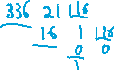

**3)** Convert to hexadecimal:

(a) 100102 (b) 11101002 (c) 100000010011112



**4)** Convert to octal:

(a) 18910 (b) 29810 (c) 308010

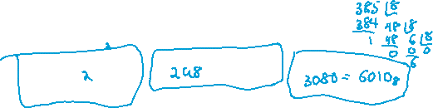

**5)** Use two’s complement representation and show that:

Hint:

* You need to convert all numbers to binary format first.
* Use 10-bit representation for each number.

(a) 22410 – 34510 = -12110

(b) 20010 - 1110 = 18910

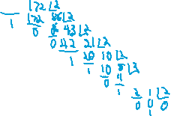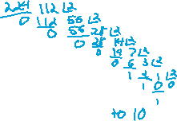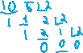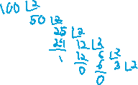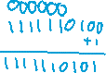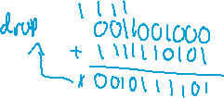

**6)** Complete the following table



|  |  |  |  |  |
| --- | --- | --- | --- | --- |
| **Decimal** | **Binary** | **S** | **F(in Hex)** | **E** |
| -3.125 |  |  |  |  |
|  | 0.11011 |  |  |  |
|  | 1010.1010 |  |  |  |
|  |  |  |  |  |



**7)** Convert -81.0625 into 32-bit, IEEE-754 in binary.



|  |  |  |  |  |
| --- | --- | --- | --- | --- |
| **Decimal** | **Binary** | **S** | **Eb(in Hex)** | **F(in Hex)** |
| -81.0625 |  |  |  |  |

