

No E-Mail submissions will be accepted.  
Submission formats and file naming:

File name: firstName_lastName_lab_Logisim_3

File format: pdf or MS Word format

e.g. Jim_Carrey_lab_Logisim_3.pdf

|  |
| --- |
| **ocir.jpg** |
| **simcir.jpg** |

Begin with the provided Logisim file (logisim_lab_3.circ) as your starting point. Using the given images (I and II), incorporate two circuits into logisim_lab_3.circ.

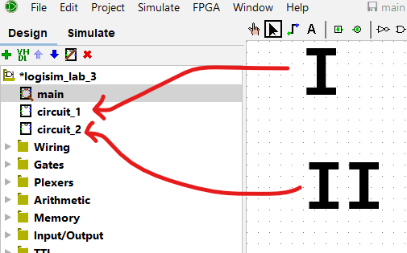

1. Include screenshots of your completed circuits.

2) Submit your file (logisim_lab_3.circ).

3) Fill out the truth table.

|  |  |  |  |  |
| --- | --- | --- | --- | --- |
| **A** | **B** | **C** | **I** | **II** |
| 0 | 0 | 0 | 0 | 0 |
| 0 | 0 | 1 | 1 | 1 |
| 0 | 1 | 0 | 0 | 0 |
| 0 | 1 | 1 | 0 | 0 |
| 1 | 0 | 0 | 0 | 0 |
| 1 | 0 | 1 | 1 | 1 |
| 1 | 1 | 0 | 1 | 1 |
| 1 | 1 | 1 | 0 | 0 |

4) Provide a discussion of your findings.

From our chart, we can tell that these circuits do the same thing, even though circuit II is made using only NAND gates, whereas circuit I using Not, and AND OR gates.