

No E-Mail submissions will be accepted.  
Submission formats and file naming:

File name : Pts_firstName_lastName_lab_3

File format: pdf or MS Word format

e.g. Pts_Donald_Trump_lab_3.pdf

Reading materials

Use the following link and write a one page summary about the movie.

|  |
| --- |
| **Why The First Computers Were Made Out Of Light Bulbs**  <https://www.youtube.com/watch?v=FU_YFpfDqqA&ab_channel=Veritasium>    This video talks about the transformative impact of the Fast Fourier Transform (FFT) algorithm on science and society. The video explains how FFT is used to analyze signals and break them down into their individual frequencies. This can be used in many areas, from understanding sound waves and medical imaging to modern communication technologies like WiFi, GPS, and 5G.  The FFT's was first researched by a Carl Friedrich Gauss in 1805, who made a precursor to the algorithm to solve astronomical problems.In 1965 that James Cooley and John Tukey formally published the FFT, creating a revolution in computing. The algorithm was actually rediscovered with the fast development of digital computers, allowing FFT to be applied to a wide range of applications.  One of the FFT's most significant applications is in global security. For example, the algorithm is useful in analyzing seismic data to differentiate between natural earthquakes and underground nuclear explosions. Which has been helpful for monitoring compliance with nuclear test ban treaties especially during the cold war.  It was also discussed how early analog computers used components like light bulbs to perform FFT-like operations physically. These machines were able to process signals in innovative ways that laid the groundwork for the digital revolution.  The Video emphasizes the profound influence of FFT on life, describing it as one of the most important algorithms ever developed. It is a bases of modern signal processing and is integrated into countless systems we use daily. The video's message is that advancements in computation, like the FFT, have changed our understanding of the world and help improve humanity's technological abilities. |

1) Use truth table to prove the following identities:

(a) A + BC = (A+B)(A+C)

(b) A(B+C) = AB + AC

|  |  |  |  |  |  |  |  |  |  |  |  |  |  |  |
| --- | --- | --- | --- | --- | --- | --- | --- | --- | --- | --- | --- | --- | --- | --- |
|  | **A** | **B** | **C** | **A+B** | **A+C** | **(A+B)(A+C)** | **BC** | **A+BC** |  | **B+C** | **A(B+C)** | **AB** | **AC** | **AB+AC** |
| 0 | 0 | 0 | 0 |  |  |  |  |  |  |  |  |  |  |
| 1 | 0 | 0 | 1 |  |  |  |  |  |  |  |  |  |  |
| 2 | 0 | 1 | 0 |  |  |  |  |  |  |  |  |  |  |
| 3 | 0 | 1 | 1 |  |  |  |  |  |  |  |  |  |  |
| 4 | 1 | 0 | 0 |  |  |  |  |  |  |  |  |  |  |
| 5 | 1 | 0 | 1 |  |  |  |  |  |  |  |  |  |  |
| 6 | 1 | 1 | 0 |  |  |  |  |  |  |  |  |  |  |
| 7 | 1 | 1 | 1 |  |  |  |  |  |  |  |  |  |  |



2) Write the Boolean expression equivalent to the following logic circuits. Do not simplify.

(a)

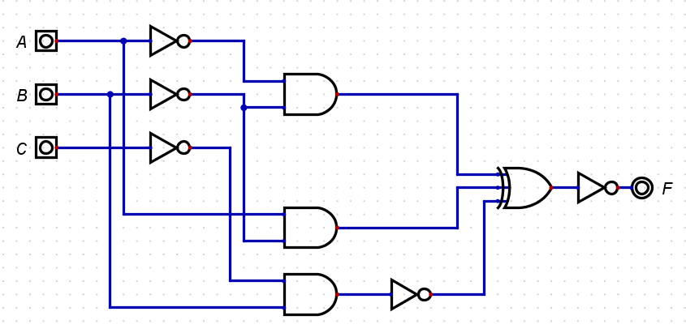



(b)

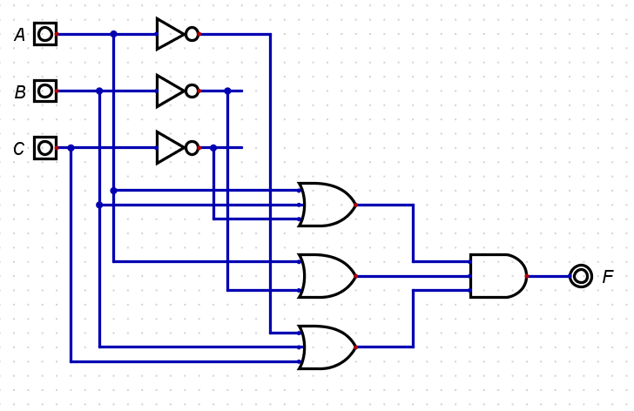



3) Create a logic circuit using Logisim to represent the given Boolean expressions F and G, exactly as provided. Please include a screenshot of your circuit design for each case of F and G.

1. F = A'(B+C')

b) G = (A+C)'(B+C')

4) Using the following table:

1. Obtain the logical expressions for **sum** and **Cout** (SOP).
2. Obtain the simplified versions of **sum** and **Cout using Karnaugh map (use the tables given below)**.
3. Draw the logic circuit for each function obtained in the part b.

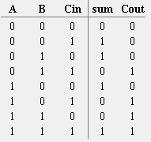



|  |  |  |  |  |  |  |  |  |  |  |  |  |  |  |  |  |  |  |  |  |  |  |  |  |  |  |  |  |  |  |  |  |  |  |  |  |  |  |  |  |  |  |  |  |  |  |
| --- | --- | --- | --- | --- | --- | --- | --- | --- | --- | --- | --- | --- | --- | --- | --- | --- | --- | --- | --- | --- | --- | --- | --- | --- | --- | --- | --- | --- | --- | --- | --- | --- | --- | --- | --- | --- | --- | --- | --- | --- | --- | --- | --- | --- | --- | --- |
|  | |  |  |  |  |  |  | | --- | --- | --- | --- | --- | --- | | **sum** | **B, Cin** | | | | | | **A** |  | 00 | 01 | 11 | 10 | | 0 |  |  |  |  | | 1 |  |  |  |  | | |  |  |  |  |  |  | | --- | --- | --- | --- | --- | --- | | **Cout** | **B, Cin** | | | | | | **A** |  | 00 | 01 | 11 | 10 | | 0 |  |  |  |  | | 1 |  |  |  |  | |

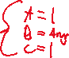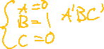

5) Simplify each of the following expressions.

1. (A + B)(B + A')
2. A + B' + C + (AB')'
3. (B' + (AB)' + A + C)'

