

No E-Mail submissions will be accepted.  
Submission formats and file naming:

File name : Pts_firstName_lastName_lab_4

File format: pdf or MS Word format

e.g. Pts_Joe_Biden_lab_4.pdf

Reading materials

Use the following link and write a one page summary about the movie.

|  |
| --- |
| Computer History: Memory & Storage 1950-1985 <https://youtu.be/9XJapKLq_6k>    The video explains the early days of computing, The processors and memory of the time relied on thermionic valves—essentially vacuum tubes acting as electronic switches. But these were fragile and if just one valve failed, the program would crash, or if the machine was turned off, all data was lost.  Computers have always been built to store and bits of information using electronic switches. it took two vacuum tubes to store just one bit of data. Since a single character is one byte it required 16 valves just to store one letter.  To make storage more efficient, early computers used delay line memory, which looks like coils of wire or columns of mercury. They explained how sound or stress waves were sent through these lines, and bits of data moved from one end to the other at the speed of sound. If the computer still needed the data, it was fed back in to it again.  The magnetic drum, a large spinning cylinder, functioned like a hard drive, storing data on its surface which was read and written by magnetic heads. It had very limited capacity, and a large drum could only hold 4 kb of data.  In the 1950s, the video talks about one of the first commercial computers in Britain LEO or Lions Electronic Office. And how it was used by Lions tea shops and the ford motor company to process payrolls. Then it notes that this was the beginning of mass data processing, something that businesses today rely on completely.  But maintaining these early computers was a challenge. We see how engineers had to replace burnt-out vacuum tubes daily. A test is shown where they deliberately fluctuate the voltage to see which components fail—those that survive are deemed fit for another 24 hours of use.  The next section talked about punched cards as the primary method for data input, and the video describes how tedious and time-consuming it was to prepare them. As an alternative, punched paper tape was also used to store programs and data.  Then, in the late 1950s and early 1960s, a revolutionary new type of memory called core memory, which consisted of tiny magnetic rings threaded with wires. Each core represents one bit depending on its magnetization. But the data was erased when read, requiring the computer to rewrite it afterward. Despite this, core memory was reliable, non-volatile, and remained in use for future systems  In the 1960s, transistors were introduced. While this made computers smaller and more reliable, so they were still quite large in the begging. Next came the silicon chip, thousands of microscopic transistors. This led to rapid improvements in memory and processing power. Since the early 1970s, chip capacity has doubled every year, while storage costs have been cut in half.  In 1980s came optical storage. This can store data in a similar way to music CDs. But is still mechanically slow, making it less than ideal for fast data retrieval. |

1) Simplify the following logical expressions using Boolean identities table?



|  |  |  |
| --- | --- | --- |
| a) A'(A' + B) = | b) B' + B'A = | c) (1 + B)' + A = |
| d) (A + A')' = | e) (AA') ' = | f) A + B + (AB)'= |
| g) A + (A'+B')' = | h) (AB)' + A' = | k) (A'+ B)' + A = |



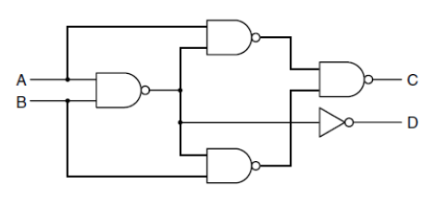2) Using the following circuit obtain C and D. What does this circuit do?



|  |  |  |  |
| --- | --- | --- | --- |
| A | B | C | D |
| 0 | 0 |  |  |
| 0 | 1 |  |  |
| 1 | 0 |  |  |
| 1 | 1 |  |  |

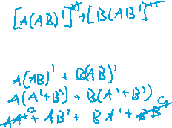

3) Given the following truth table, implement the Boolean function F using a MUX (8X1).



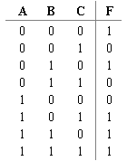



4) Consider the following circuit and complete the following truth table (Q1, Q2, Q3, and Q4 = ?).



|  |  |  |  |  |  |  |  |  |  |  |  |  |  |  |  |  |  |  |  |
| --- | --- | --- | --- | --- | --- | --- | --- | --- | --- | --- | --- | --- | --- | --- | --- | --- | --- | --- | --- |
| |  |  |  |  |  |  | | --- | --- | --- | --- | --- | --- | | A | B | Q1 | Q2 | Q3 | Q4 | | 0 | 1 |  |  |  |  | | 1 | 0 |  |  |  |  | |  |

5) Consider the following circuit and complete the following truth table (**Q** and **Cout = ?)**.

|  |  |  |  |  |  |  |
| --- | --- | --- | --- | --- | --- | --- |
| **A** | **B** | **Cin** | **p** | **q** | **Q** | **Cout** |
| **1** | **1** | **1** | **1** | **1** |  |  |
| **1** | **1** | **0** | **1** | **0** |  |  |
| **0** | **1** | **0** | **0** | **1** |  |  |
| **1** | **0** | **0** | **0** | **0** |  |  |

