

No E-Mail submissions will be accepted.  
Submission formats and file naming:

File name : Pts_firstName_lastName_lab_7

File format: pdf or MS Word format

e.g. Pts_Donald_Trump_lab_7.pdf

Reading materials

Use the following link and write a one page summary about the movie.

|  |
| --- |
| **Parity Generator and Parity Checker Explained**  <https://youtu.be/c8qAti1zBVQ> |

1) The word “Covid19” is given.

(a) Represent in an 8-bit ASCII code.

Covid19 => 01000011 01101111 01110110 01101001 01100100 00110001 00111001

Table from <https://www.cs.cmu.edu/~pattis/15-1XX/common/handouts/ascii.html>

|  |  |  |
| --- | --- | --- |
| Letter | ASCII (dec) | ASCII (bin) |
| C | 67 | 01000011 |
| o | 111 | 01101111 |
| v | 118 | 01110110 |
| i | 105 | 01101001 |
| d | 100 | 01100100 |
| 1 | 49 | 00110001 |
| 9 | 57 | 00111001 |

(b) Add even parity bit to each character (from left) and represent each character in hex,

|  |  |  |  |
| --- | --- | --- | --- |
|  | ASCII(Hex) | Code word = Parity bit + data  Binary format | Code word = parity bit + data  Hex format |
| **K** | 0x4B | 001001011 | 0x04B |
| **C** |  |  |  |
| **o** |  |  |  |
| **v** |  |  |  |
| **i** |  |  |  |
| **d** |  |  |  |
| **1** |  |  |  |
| **9** |  |  |  |

2) Use the given formula below to obtain the 7‐bit Hamming codeword for the following 4‐bit data words:

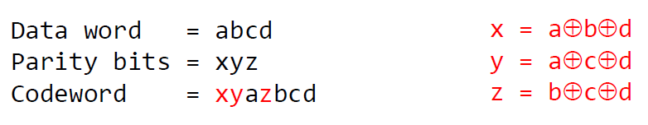

1. 1010
2. 1100
3. 1110

3) Which of the following 7-bit Hamming codes is corrupted?

1. 1011011
2. 0011001
3. 1010000

4) Obtain the 12‐bit Hamming code word for the following 8‐bit data word.

11011011

5) The following string of hex digits encodes extended ASCII characters in an even parity Hamming code: 0D3 DD3 0F2 5C1 1C5 CE3. Decode this string and write down the characters that are encoded (**8 data bits + 4 check bits = 12 bits**).

e.g. **49C**

010010011100 ⇒ 010010011101 ⇒ 01001101 0x4D (77) ⇒ M

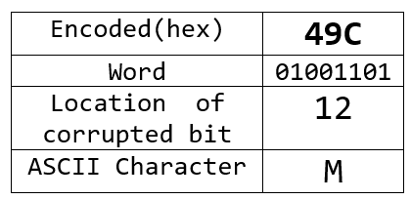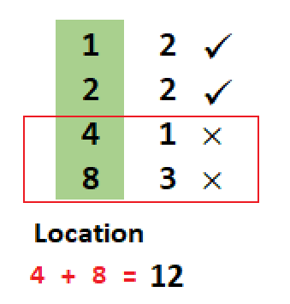

|  |  |  |  |  |  |  |
| --- | --- | --- | --- | --- | --- | --- |
| Encoded(hex) | **0D3** | **DD3** | **0F2** | **5C1** | **1C5** | **CE3** |
| Word |  |  |  |  |  |  |
| Location of corrupted bit |  |  |  |  |  |  |
| ASCII Character |  |  |  |  |  |  |

6) Encode the data bit sequence 100110000 using the generator 1101 and give the codeword.

8 bits:

Example: A (0x41) = 01000001

