

No E-Mail submissions will be accepted.  
Submission formats and file naming:

File name : Pts_firstName_lastName_Assembly

File format: pdf or MS Word format

e.g. Pts_Donald_Trump_Assembly.pdf

[**https://bellard.org/jslinux/**](https://bellard.org/jslinux/)

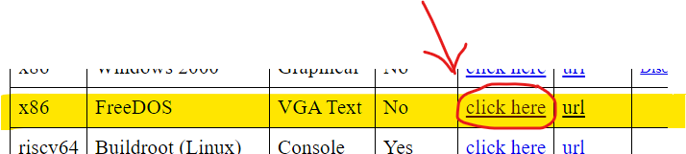

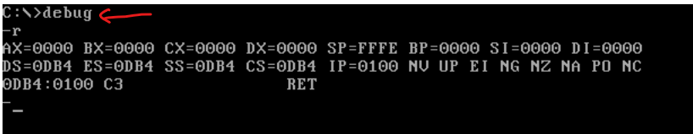

**1)** Write an assembly code to calculate AX XOR BX. You are only allowed to use:

1. MOV (to load a value into a register e.g. AX)
2. NOT, OR, AND
3. AX, BX, DX, CX registers

Include a screenshot of the debug environment displaying your assembly code.

e.g.

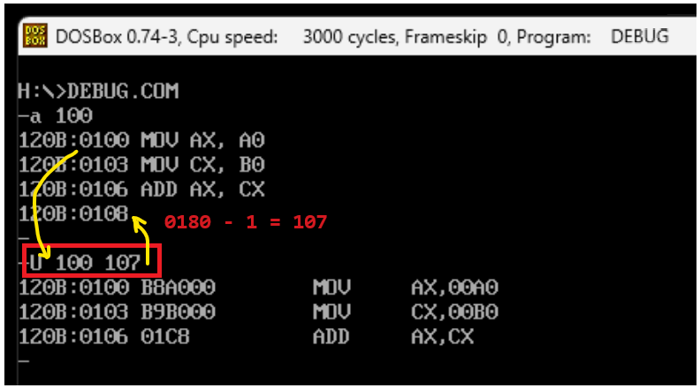

**2)** Write an assembly code obtain two complements of AX = 00AB (use MOV to load this value). Include a screenshot of the debug environment displaying your assembly code. You are only allowed to use:

1. MOV (to load a value into a register e.g. AX)
2. NOT, ADD
3. AX register

**3)** Write an assembly code to calculate the sum of AX and CX. Save the result in AX and store the AX value in memory location 300. Assume AX=00AB and CX=01F0 (use MOV to load these values). Include a screenshot of the debug environment displaying your assembly code. You are only allowed to use:

1. MOV (to load a value into a register e.g. AX)
2. ADD
3. AX and CX registers