Instructions:

Make sure you are not running any Excel file while running the macro in this file.

*IMPORTANT: You must allow running macros, otherwise nothing works!

Sheet1:

Click on "Add-on" menu and then "Launch Editor", a simple map editor will be launched.

Rules: You can only draw inside of the black boundary.

How to use:

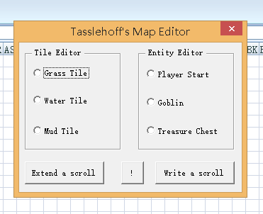

Step1: Select a range inside of the black boundary

Step2: Select one of the "Tile Editor" buttons (say "Grass Tile), and then click "!" button to paint the map.

Step3: Click on one cell inside of the black boundary and chosse one of the "Entity Editor" items, and click "!" to paint an entity.

Step4: "Write a scroll" to save the file (D:\game.xml), and you can also use "Extend a Scroll" to open the file you just saved.

Sheet2

Step1: This is a simple time table of a telephone interviewing company, and you, as the supervisor, would like to write a summary on the performance of one interviewer and send it to her. Buy you wanna automate everything.

Step2: Click "Report" the file will be autosaved at D:\sheet2.docx

Step3: Since many company mail system does not allow attachments from outsiders, I left the auto-sending email function out of the button, but it's there in the file, you only need to Alt-F8 and the name is "Sheet2.CDO_Mail_Small_Text". BTW this program sends an email to tangluyu0315@gmail.com, you can modify the code to put your own mail address for testing.



In code editor, put your own address instead of tangluyu0315@gmail.com