The abundance of Eulaema nigrita depending on forest cover
  - Markus Albrektsson BIOS15
  - 2025-11-30

Intro
The abundance of the orchid bee Eulaema nigrita in the Brazilian Atlantic forest was measured by sampling using hand nets and traps. 178 areas were sampled. The proportion of forest was also measured at each location. It is hypothesized that the abundance of E. nigrita will decrease as the proportion of forest increases.

Analysis methods
A negative binomial regression model was fitted to the data. E. nigrita abundance as the response variable. Forest cover, as a proportion, and sampling effort, as log hours, were predictors. Sampling effort was included in the model to control for its effect. It was mean centred as that is when estimates of E. nigrita abundance and effect of forest cover would be of highest interest.
E. nigrita abundance ~ Forest cover + Sampling effort
A negative binomial regression was chosen because the response variable was count data with overdispersion.

Results
The predicted abundance of E. nigrita was 106 with no forest cover and 27 with full forest cover. This corresponds to a 7.4% decrease in E. nigrita abundance with a 10% increase in forest cover (Table 1).
Table 1: Back-transformed parameter estimates. The intercept being abundance of E. nigrita at mean sampling effort and no forest cover. Forest cover in proportion of area covered and mean centred sampling effort in log hours.
Parameter | Estimate | Lower 95 % CI | Higher 95 % CI
Intercept | 106 | 80 | 140
Forest cover | 0.26 | 0.14 | 0.47
Sampling effort  (mean centred) | 1.43 | 1.27 | 1.62

Model fit was assessed and resulted in a pseudo r-square of delta = 0.25. The predicted negative relationship between increasing forest cover and decreasing E. nigrita abundance is illustrated in Figure 1. The graph is sized to best illustrate the predicted relationship and thus some datapoints exist outside of the plot range. The full range of datapoints can be found in the appendix (Fig. 1A).
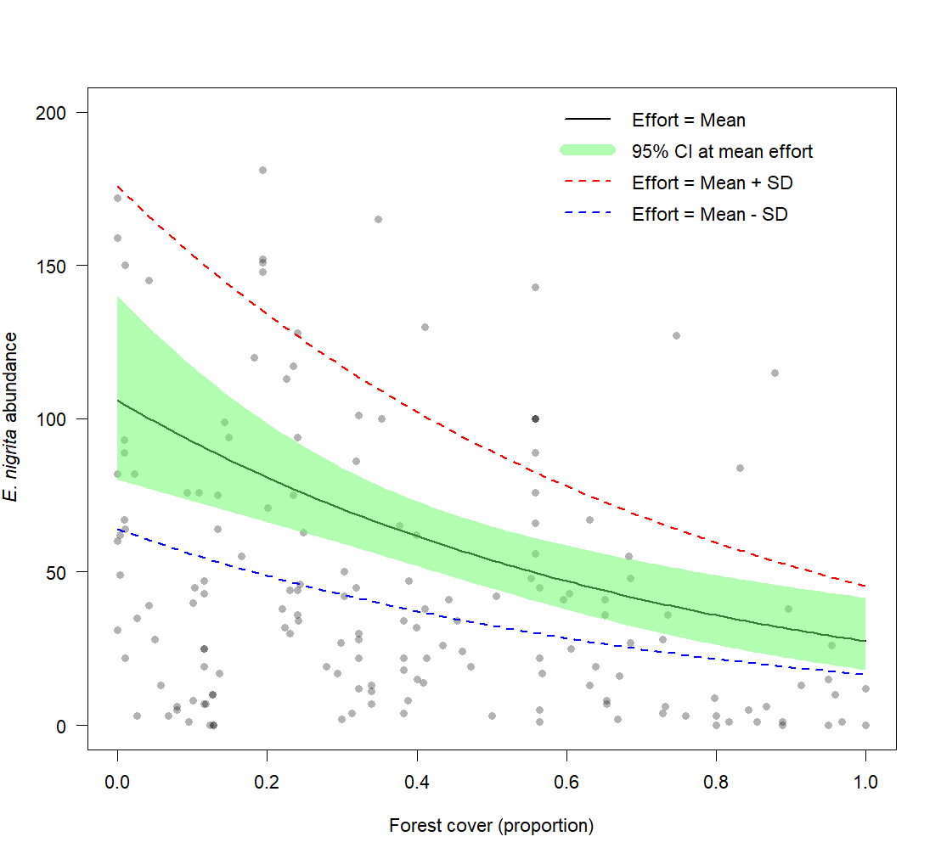
Figure 1: E. nigrita abundance depending on forest cover as a proportion of area covered. Black line represents predicted values from model at mean effort. Green transparent area represents the 95% confidence interval of those values. Dashed red and blue lines represent predicted values from model at ± 1 standard deviation from mean effort. Some datapoints exist outside of the graph range.

Conclusions
The abundance of E. nigrita does decrease with an increase in forest cover, here shown by the output of this model with a good fit. The abundance in full forest cover is a fourth of that in an open landscape according to the model. A combination of foraging opportunity, as the availability of suitable flowers, nesting and climate variability between open landscape and closed forest likely further explains this pattern. Perhaps a need for some landscape heterogeneity is the cause of low abundances in full forest cover. The land use in areas with lack of forest is here not further described and could likely explain more.

Appendix
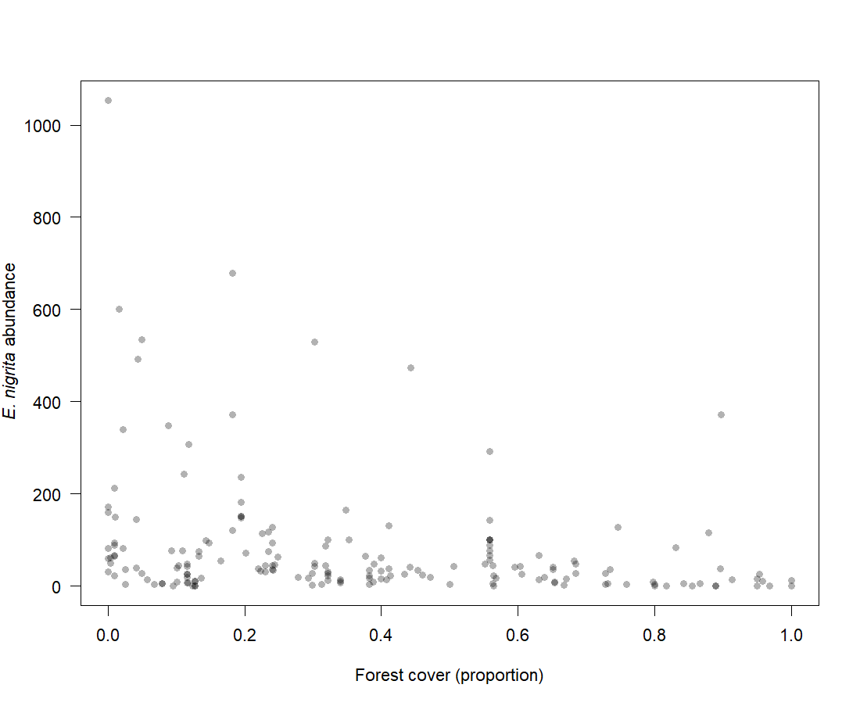
Figure 1A: E. nigrita abundance depending on forest cover as a proportion of area covered. All datapoints in graph.

R-code

# GLM analysis ----

## Looking at data ----

dat <- read.csv("Eulaema.csv")
head(dat)
names(dat)
names(dat)[11] <- "forest"

hist(dat$Eulaema_nigrita) # Data very skewed

pairs(dat[,c(1, 5:12)], panel=panel.smooth)
# interested in forest cover and want to control for effort

# Response count data and continous covariates -> poisson GLM

# mean center effort, for later interpretation
dat$mceffort <- dat$effort - mean(dat$effort)

## Forest and effort poisson ----

m <- glm(Eulaema_nigrita ~ forest + mceffort, family = "poisson", data = dat)
summary(m)
# this is very overdispersed based on residual deviance almost 100 times as big as resid dfs

coefm <- summary(m)$coef
coefm
exp(coefm[1,1]) # intercept at 109 bees (0% forest, mean effort)
exp(coefm[2,1]) # slope is 0.25, decrease to 25% of bee intercept at forest 100%
exp(coefm[3,1]) # not as interesting (when forest 0%, bee count increase 1.3 with one unit effort (log) )

par(mfrow=c(2,2))
plot(m)
par(mfrow=c(1,1))
# qqplot: points not on line

# do a negative binomial instead to account for overdispersion

## Forest and effort negative binomial ----

nb <- glm.nb(Eulaema_nigrita ~ forest + mceffort, data = dat)
summary(nb)
# resid deviance and dfs more similar

coefnb <- summary(nb)$coef
coefnb
# parameter estimates and 95% CI
exp(coefnb[1,1]) # intercept at 106 bees (0% forest, mean effort)
exp(coefnb[1,1] - 1.96*coefnb[1,2])
exp(coefnb[1,1] + 1.96*coefnb[1,2])
exp(coefnb[2,1]) # slope is 0.26, decrease to 26% of bee intercept at forest 100%
exp(coefnb[2,1] - 1.96*coefnb[2,2])
exp(coefnb[2,1] + 1.96*coefnb[2,2])
exp(coefnb[1,1] + coefnb[2,1]) # intercept at 27 bees (100% forest, mean effort)
exp(coefnb[3,1]) # not as interesting (when forest 0%, bee count increase 1.4 with one unit effort (log) )
exp(coefnb[3,1] - 1.96*coefnb[3,2])
exp(coefnb[3,1] + 1.96*coefnb[3,2])

par(mfrow=c(2,2))
plot(nb)
par(mfrow=c(1,1))
# qqplot looks better

# Assess fit of the model
# McFaddens
1-(nb$deviance/nb$null.deviance) # 0.23 is kind of good (0.2 to 0.4 is "excellent")
# Another pseudo r2 option
r.squaredGLMM(nb) # delta 0.25

# Plot the predicted values and CI

plot(dat$forest, dat$Eulaema_nigrita, las=1, col=rgb(0,0,0,.3), pch=16,
ylim = c(0,200),
xlab = "Forest cover (proportion)",
ylab = expression(paste(italic("E. nigrita")," abundance")),
main = "")

predforest <- seq(min(dat$forest), max(dat$forest), 0.01)
predmceffort <- rep(mean(dat$mceffort), length(predforest))
y_hat = predict(nb, newdata=list(forest=predforest,
mceffort=predmceffort), type="link", se.fit=T)
lines(predforest, exp(y_hat$fit), lwd = 2)

predmceffort2 <- rep(mean(dat$mceffort) + sd(dat$mceffort), length(predforest))
y_hat2 = predict(nb, newdata=list(forest=predforest,
mceffort=predmceffort2), type="response")
lines(predforest, y_hat2, lty=2, lwd = 2, col="red")

predmceffort3 <- rep(mean(dat$mceffort) - sd(dat$mceffort), length(predforest))
y_hat3 = predict(nb, newdata=list(forest=predforest,
mceffort=predmceffort3), type="response")
lines(predforest, y_hat3, lty=2, lwd = 2, col="blue")

# 95% CI

# lines(predforest, exp(y_hat$fit+1.96*y_hat$se.fit), lty=2, lwd = 2)
# lines(predforest, exp(y_hat$fit-1.96*y_hat$se.fit), lty=2, lwd = 2)

polygon(c(predforest,rev(predforest)),
c(exp(y_hat$fit+1.96*y_hat$se.fit), rev(exp(y_hat$fit-1.96*y_hat$se.fit))),
col = rgb(.4,1,.4,.5),
border = FALSE)

# Legend

legend("topright", lty=c(1, 1, 2, 2), lwd=c(2,10,2,2), col=c(1, rgb(.4,1,.4,.5), "red", "blue"),
bty="n",
legend=c("Effort = Mean",
"95% CI at mean effort",
"Effort = Mean + SD",
"Effort = Mean - SD"))

AIC(m) # 16899
AIC(nb) # 1840

