Adult weight of butterfly larvae reared on two different host plants
  - Markus Albrektsson BIOS15
  - 2025-11-13

Intro
Female butterflies were raised on two different host plants: Barbarea and Berteroa. The grown butterflies laid eggs on the same two plant species. Data on the development of the larvae was collected. The larval host plant and maternal host plant as well as the sex, development time, growth rate, and adult weight of the larvae. The focus of this analysis is if adult larvae weight is affected by the plant species it was reared on as well as its maternal host plant species.

Analysis methods
Adult larvae weight was expected to depend on the host plant species it fed on, the host plant of its mother and a potential interaction so that larval host plant effects would depend on the maternal host plant. The expected relationship of response variable and predictor variable:
AdultLarvalWeight = LarvalHost + MaternalHost + LarvalHost * MaternalHost
Using this relationship, I fitted a two-way ANOVA model to the data. I then performed an ANOVA on the model to see if the larval host plant and/or the maternal host plant had an effect on the adult larvae weight.

Results
The mean adult larvae weight was larger for larvae reared on Barbarea (Table 1).
Table 1: The mean adult larvae weight in mg for each combination of larval and maternal host plant.
Maternal host | Larval host
 | Barbarea | Berteroa
Barbarea | 65.35490 | 53.50364
Berteroa | 66.72436 | 50.37692

The proportion of variance explained by the larval host plant was 33.7 % while that of maternal host plant was 0.02 % and the interaction was 0.9 %. Adult larvae weight does depend on the larval host plant to a large degree. Main effects from maternal host plant were negligible. An interaction between them is not clear (Fig. 1).

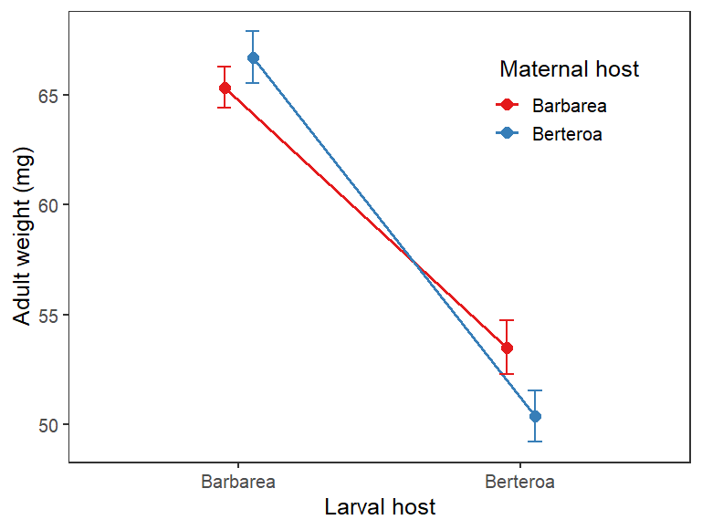
Figure 1: Adult larvae weight depending on larval and maternal host plant. Error bars indicate standard errors.
Adult larva that fed on Barbarea weighed more than those fed on Berteroa; 22 % more for those with a mother fed on Barbarea and 32 % more for those with a mother fed on Berteroa. The 95 % confidence interval of estimated mean adult larvae weight of groups with different maternal host plant overlap, but not with different larval host plant (Table 2).
Table 2: 95 % confidence interval of estimated mean adult larvae weight of each combination of larval and maternal host plant.
Larval host | Maternal host | 95 % confidence interval
 |  | 2.5 % | 97.5 %
Berteroa | Berteroa | 47.78934 | 52.96450
Berteroa | Barbarea | 50.98762 | 56.01966
Barbarea | Berteroa | 64.61161 | 68.83711
Barbarea | Barbarea | 63.50736 | 67.20245

Conclusions
The variance in adult larvae weight can be explained by a large degree (33.7 %) whether it feeds on Barbarea and Berteroa. This is reasonable and an expected direct effect of food quality affecting development. There is some indication of an interaction where larvae with a mother reared on Berteroa seem more sensitive to difference in larval host plant. This could be investigated further.

R-code

# Exercise 3

# y ~ factor1 * factor2
# AdultWeight ~ LarvalHost * MaternalHost

dat = read.csv("butterflies.csv")
names(dat)

# Summary statistics of mean adult weight of the larvae for each treatment combination
means = tapply(dat$AdultWeight, list(dat$MaternalHost, dat$LarvalHost), mean)
means

m <- lm(AdultWeight ~ LarvalHost * MaternalHost, data = dat) # fit linear model
anova(m) # perform anova
am <- anova(m)

# Proportion of variance gotten from sum of squares
am$`Sum Sq`[1]/sum(am$`Sum Sq`) # Larval host
am$`Sum Sq`[2]/sum(am$`Sum Sq`) # Maternal host
am$`Sum Sq`[3]/sum(am$`Sum Sq`) # Interaction

# get summary
summary(m)

# Suppress intercept by adding -1 to predictor factor
# This worked when i just included the interaction term
ms <- lm(AdultWeight ~ LarvalHost:MaternalHost -1, data = dat)
summary(ms)$coef

confint(ms) # gives the 95% CI of the estimated means

# For plot
sumdat <- as_tibble(dat) %>%
group_by(LarvalHost, MaternalHost) %>%
summarise(
mean_AdultWeight = mean(AdultWeight),
sd_AdultWeight = sd(AdultWeight),
n = n(),
se_AdultWeight = sd_AdultWeight/sqrt(n)
)

ggplot(data = sumdat,
aes(x = LarvalHost, y = mean_AdultWeight, colour = MaternalHost, group = MaternalHost)
) +
geom_point(position = position_dodge(width = 0.2), size = 3) +
geom_line(position = position_dodge(width = 0.2), linewidth = 1) +
geom_errorbar(position = position_dodge(width = 0.2),
aes(ymin = mean_AdultWeight - se_AdultWeight,
ymax = mean_AdultWeight + se_AdultWeight),
width = 0.1) +
scale_color_brewer(palette = "Set1") +
labs(x = "Larval host",
y = "Adult weight (mg)",
colour = " Maternal host") +
theme_bw(base_size = 14) +
theme(legend.position = c(0.8, 0.8),
panel.grid = element_blank())

