

Bachelor Thesis

for obtaining the academic degree Bachelor of Science (B.Sc.) in Media Informatics,
Department VI of Beuth University of Applied Sciences Berlin

Design and Implementation of a Tool to Collect Execution- and Service-Data of Big Data Analytics Applications

Markus Lamm
Matriculation number: 786697
markus.lamm@gmail.com

Berlin, 06.09.2016

Supervisor: Prof. Dr. Stefan Edlich
Consultant: Prof. Dr. Böhler

ACKNOWLEDGMENTS

ABSTRACT

Illustration Index
Illustration 1: Use-Case diagram 16
Illustration 2: Class diagram CollectorClient 17
Illustration 3: Class diagram CollectorManager 18
Illustration 4: Class diagram JvmCollector 19
Illustration 5: Class diagram DstatCollector 19
Illustration 6: Class diagram FlinkJmxCollector 20
Illustration 7: Class diagram FlinkRestCollector 21
Illustration 8: Class diagram KafkaBrokerJmxCollector 21
Illustration 9: Component diagram 22
Illustration 10: Sequence diagram Client discovery 22
Illustration 11: Sequence diagram Client scheduling 23
Illustration 12: Deployment diagram 23

Index of Tables

Table of Contents
Introduction 7
Goals of work 7
Structure of this thesis 7
Theoretical foundations 8
Big-Data-Analytics-Architectures 8
Stream-Processing 8
Apache Flink 8
Apache Kafka 8
Data Analysis 9
Java Management Extensions (JMX) 9
Representational State Transfer (REST) 9
Requirements and Target Definition 10
Architecture and Implementation 12
Microservices, Service Discovery 12
Event-Stream 12
System-Overview 12
CollectorClient 12
CollectorManager 12
CollectorDataProcessor 12
Message-Broker 12
Indexer 12
Persistence 12
Evaluation 13
Conclusion 14
Appendix 16
Use-Case diagram 16
Class diagrams 17
CollectorClient 17
CollectorManager 18
JvmCollector 19
DstatCollector 19
FlinkJmxCollector 20
FlinkRestCollector 21
KafkaBrokerJmxCollector 21
Component diagram 22
Sequence diagrams 22
Client discovery 22
Client scheduling 23
Deployment-Diagram 23
Setup instructions for the prototype application 23

Introduction

According to a survey in Germany, nine out of ten companies (89 percent) analyze internal data for operational decision-making processes using modern Big Data Analytics Architectures, where 48 percent of respondents see the greatest potential of Big Data [BITK14]. The analysis of continuous data streams is taking up a growing importance for companies and therefore constitutes an important factor for business success.

Collecting, storing and analyzing system and operational data of Big Data Architectures is therefore an essential tool in order to ensure successful operation. By analyzing the existing data, problems can be tracked and potential sources of error identified as early as possible.

Goals of work

The main goal of the thesis is the design and implementation of a software system to ingest and store system and operational data of big data analytics frameworks. It should be investigated which data is available for Apache Flink and Apache Kafka . With regard to a possible user interface and further analytic-processes in the future, the measuring data must be collected on the source systems, transported and stored at a central data storage system to be accessible for other components.
Central questions of elaboration will be:

- What sources exist to gather data from Apache Kafka and Apache Flink?
- What data is relevant and shall be collected?
- How can the data be collected from existing sources
- How can the data be stored regarding to further analytics or display in a graphical user interface?

Structure of this thesis
First chapter introduction and goals
Second introduction to BDSA

Theoretical foundations

Big-Data-Analytics-Architectures

Stream-Processing

Apache Flink

Apache Kafka

Data Analysis

Java Management Extensions (JMX)

Representational State Transfer (REST)
(Dstat system utility)

Requirements and Target Definition

Architecture and Implementation

Microservices, Service Discovery

Event-Stream

System-Overview

CollectorClient

CollectorManager

CollectorDataProcessor

Message-Broker

Indexer

Persistence

Evaluation

Conclusion

Appendix

Use-Case diagram
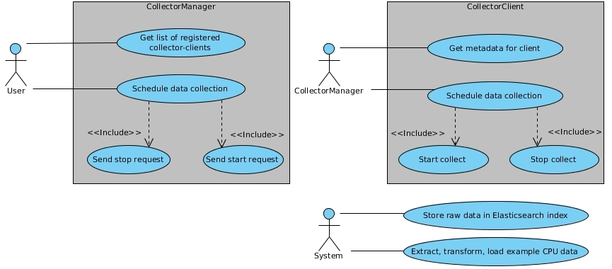
Illustration 1: Use-Case diagram

Class diagrams

CollectorClient
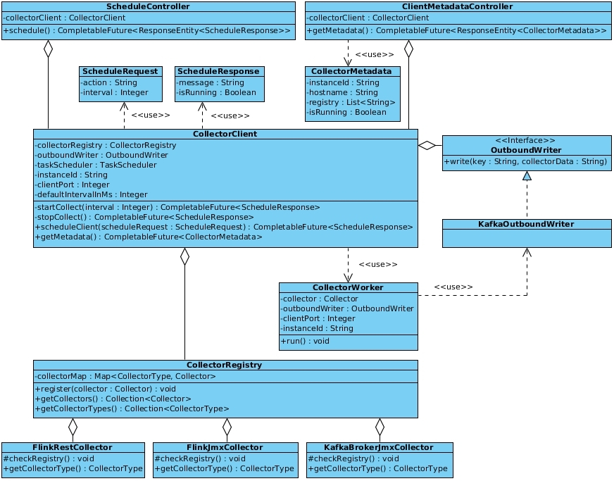
Illustration 2: Class diagram CollectorClient

CollectorManager
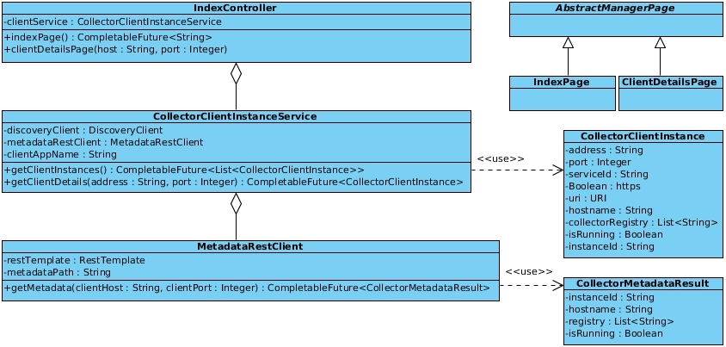
Illustration 3: Class diagram CollectorManager

JvmCollector
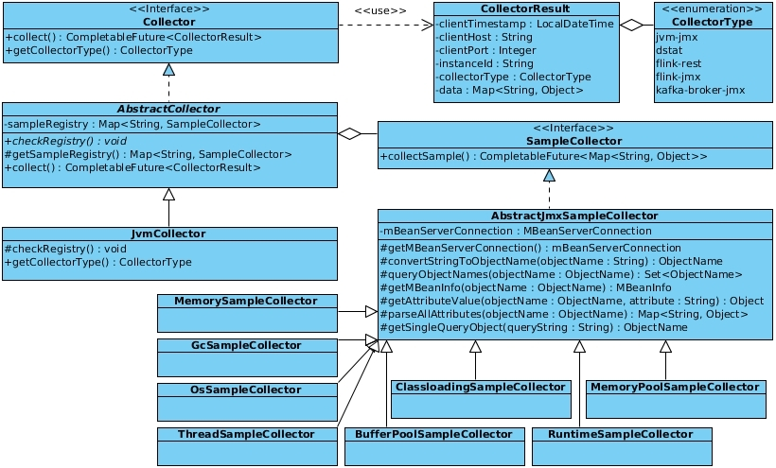
Illustration 4: Class diagram JvmCollector

DstatCollector
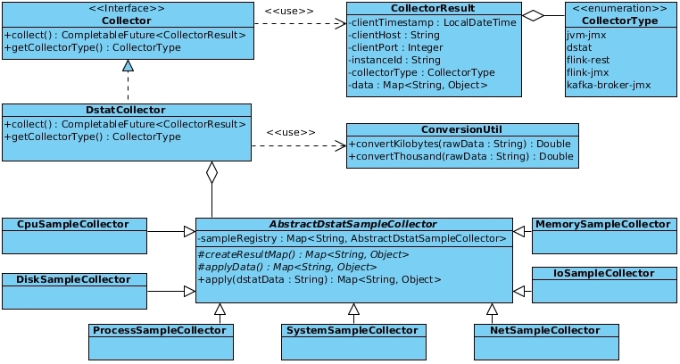
Illustration 5: Class diagram DstatCollector

FlinkJmxCollector
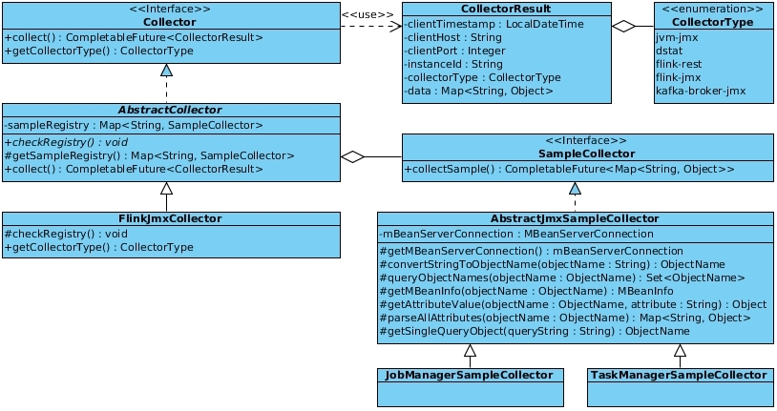
Illustration 6: Class diagram FlinkJmxCollector

FlinkRestCollector
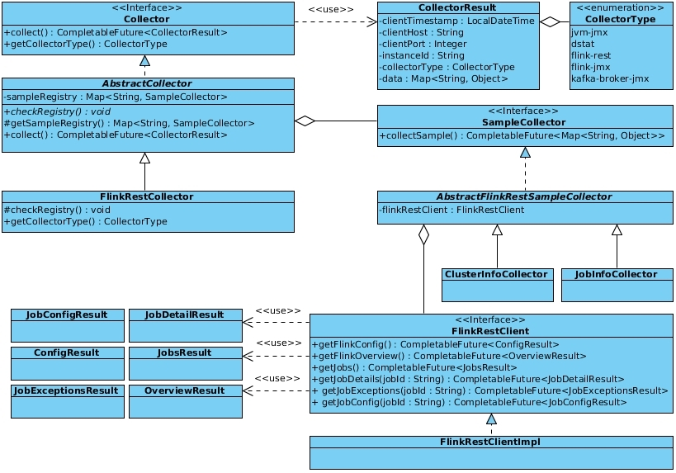
Illustration 7: Class diagram FlinkRestCollector

KafkaBrokerJmxCollector
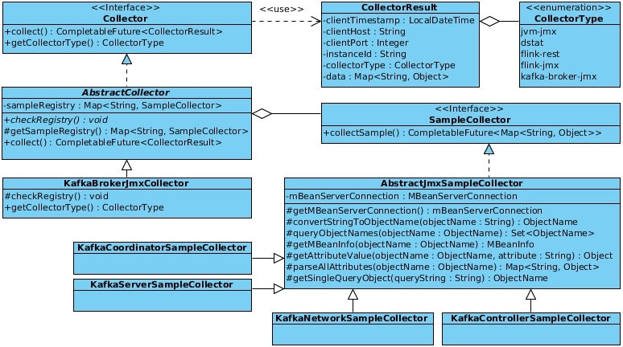
Illustration 8: Class diagram KafkaBrokerJmxCollector

Component diagram
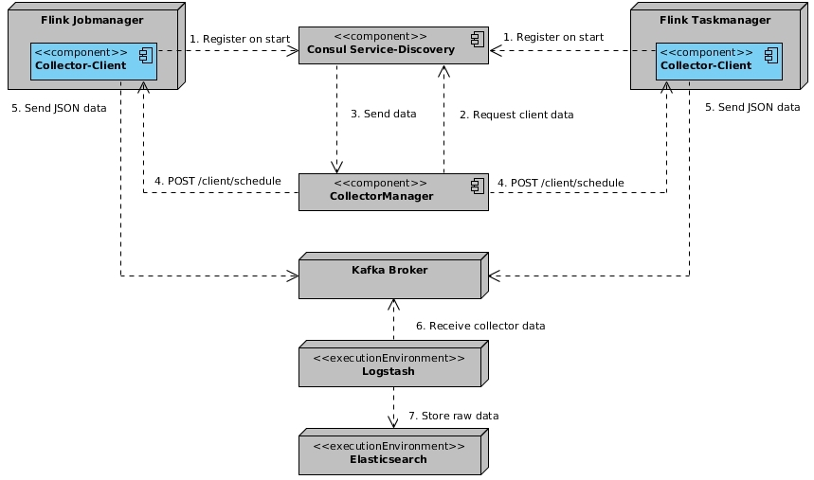
Illustration 9: Component diagram

Sequence diagrams

Client discovery
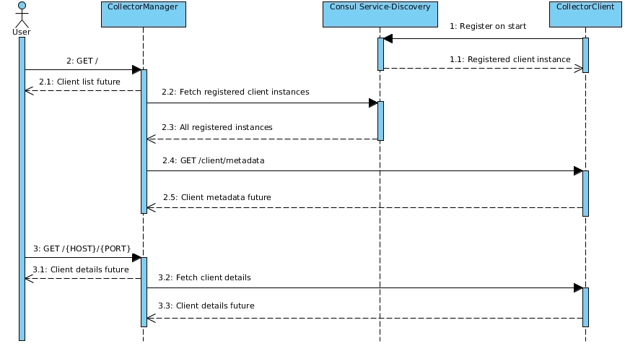
Illustration 10: Sequence diagram Client discovery

Client scheduling
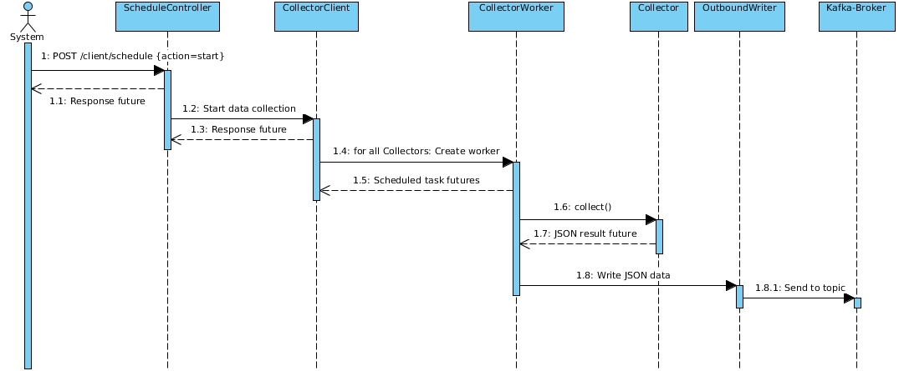
Illustration 11: Sequence diagram Client scheduling

Deployment-Diagram
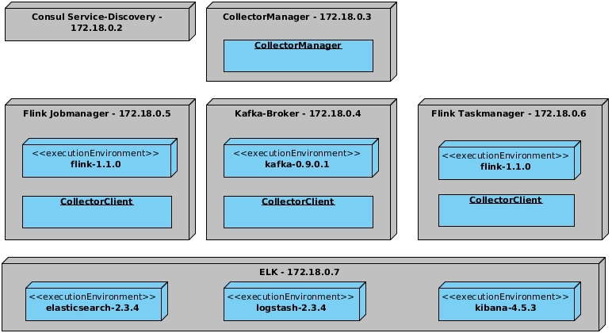
Illustration 12: Deployment diagram

Setup instructions for the prototype application

