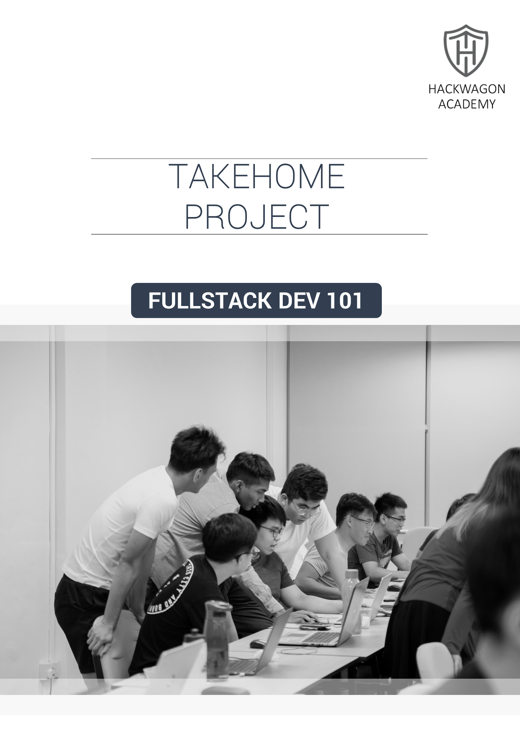

PROJECT: WEB APP DEVELOPMENT WITH BOOTSTRAP, JQUERY, AJAX

We’ve now learnt Bootstrap, JQuery and AJAX, which allows to build a fully featured web application. By simply understanding these 3 technologies, you’re able to create most web application use cases out there.

YOUR OBJECTIVE

Your objective is to combine your knowledge of Bootstrap, JQuery and AJAX to create **any** website of your choice that integrates with an API. This is to experience connecting the front-end development to a back-end server.

The purpose of this exercise is for you to marry your knowledge of what you’ve learnt thus far, and come up with a useful project that you yourself will use.

REQUIREMENTS

**Ensure to make use of the following:**

* Bootstrap
* JQuery
* AJAX

**Some suggested libraries to use:**

* moment.js - for easy time and date formatting
* Chart.JS - for display of graphs and charts
* OpenWeatherMap API (<https://openweathermap.org/>) - for free real-time weather and temperature data
* Exchange Rate & Currency Converter API (<https://currencylayer.com/>) - for free real-time exchange rate data for over 168 countries
* Cryptocurrency Price API (<https://coinmarketcap.com/api/>) - Display your own charts and graphs, or real-time pricing for different cryptocurrencies
* Financial Information and Stock data (<https://financialmodelingprep.com/developer/docs>) - Display stock prices of companies of your choice
* Comprehensive list of free online APIs (<https://github.com/toddmotto/public-apis>) - With categories ranging from News to Finance, to Weather, and even jobs.

**Expected output:**

* Build an aesthetic looking page, you will be graded on the aesthetic appeal of your page.
* Build at least 1 web components driven by REST APIs, or by 3rd party JS libraries

YOUR DELIVERABLES

Make sure you submit your completed assignment in a zip file, containing all .html files as well as all .js files.

MARKING RUBIC

|  |  |  |  |
| --- | --- | --- | --- |
|  | **Outstanding (4m-5m)** | **Very Good (2m-3m)** | **Good (1m-2m)** |
| **Requirements** | All the requirements for the project has been fulfilled. | There may be one or two requirements of the project not fulfilled. | None of the requirements of the project has been fulfilled. |
| **Creativity and Design** | Website shows a large amount of original thought, the ideas are creative and innovative. | Good use of graphics and other design elements. Evidence of originality and creativity. | Little evidence of original thinking, minimal use of design elements with lots of text, little use of other elements such as graphics, icons and pictures. |
| **Coding Convention** | Code is well organized, easy to read. Complexity is minimized and names are well chosen, descriptive and consistent. | Code is mostly readable with some minor issues. Styles are good and names are generally well chosen. | Code is frequently difficult to read with complexity abound. Style is poor and names are not self-documenting and do not follow consistent conventions. |
| **Layout** | The web page has an exceptionally attractive and usable layout, which is easy to locate all important elements. | The web page has an attractive and usable layout. It is easy to locate all important elements. | The web page has a usable layout, but may appear to be busy or boring. |
| **Content** | The web page has a well-stated clear purpose and theme | The site has a clearly stated purpose and theme, however there may be one or two elements that do not seem to be related. | The purposes and theme of the site are somewhat vague. |