Domain Modeling: the Heart of the Rational Unified Process for Straight Through Processing (RUP4STP)

Introduction

Forward thinking financial service organizations such as investment managers, broker / dealers, and custodian banks, are positioning themselves for a Wall Street recovery by updating their information technology infrastructure. This often involves adding a messaging layer to automate the exchange of information within internal systems and between internal systems and external trading partners. To understand how to make use of the messaging layer, many systems and processes throughout the trading cycle need to be examined to discover their functional characteristics, user communities, and data sources. Domain modeling can be very helpful to assist system architects to visualize the current state of the trading environment, and then to reason about how to optimize various systems to achieve a streamlined, efficient Straight Through Processing environment.

What is Domain Modeling?

According to the RUP, a domain model is a business object model which focuses on “product, deliverables, or events that are important to the business domain”. A domain model is an “incomplete” business model in that it omits individual worker responsibilities. The point of domain modeling is to get “the big picture” of the interrelationships between business entities in a complex organization. The domain model typically shows the major business entities, their functional responsibilities, the relationship between the entities, and a high level description of the data that each entity provides. In RUP4STP, the Rational Unified Process for Straight Through Processing, domain modeling plays a central role in understanding the current environment and in planning for the future. Our Current Trading Model artifact is a visual representation of the trading cycle as it exists now. The Future Trading Model illustrates how various trading partners and internal systems might be configured to optimize processing and workflows to achieve a compressed settlement cycle. Whereas the default business modeling discipline in RUP is abstract and can be applied to all industries, the business modeling discipline in RUP4STP is specialized for the securities trading domain, using concepts, guidelines and activities that are familiar to IT professionals working in that industry. To download an example of a Current Trading Model with Rational Rose, click here.

Establishing the Scope of the Domain Model

If you examine the Workflow Detail: Develop Domain Model, which is included in the Business Modeling discipline of the standard RUP, you will see that the Business Vision is an essential input into this process. Likewise, in RUP4STP, we need to first establish an overarching STP vision to frame the scope of our modeling efforts. What is it that we are tying to achieve? Another activity in RUP4STP, Create System Inventory, walks the system analyst through the steps of discovering the mainframe, client/server, web-based, desktop, and manual systems that are used currently to process trades. This is similar to the standard RUP activity, Find Business Workers and Entities. With the System List, we can begin our Current Trading Model, using class diagrams to represent basic collaborations between systems.

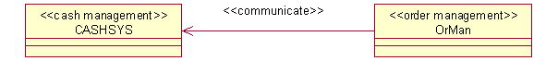
Figure 1: Basic System Collaboration

The business systems will be elaborated when we perform the RUP4STP activity, Refine Current Trading Model. At this early stage, however, we are trying to determine our STP priorities. To do so, we need to get a high level view of which systems are candidates to be replaced, re-architected, or re-designed. A skeleton Future Trading Model can be created from an initial review of the Current Trading Model.

Elaborating the Domain Model

To better understand the responsibilities of our Current Trading Model, we must analyze the data it uses, how the data is manipulated, and which user communities consume the value added information processed by each business entity. The RUP4STP activity, Analyze Data Sources, references the System Inventory and the Current Trading Model to gather all sources of data used by each system. In large financial service organizations, it is not uncommon for many different systems to make use of the same data source. Indeed, several departments may be purchasing the same data source from the same outside vendor. The RUP4STP artifact, Correlation of Data Sources and Methods, will highlight any of these duplicate feeds. The real nitty-gritty of a domain elaboration, though, occurs in standard RUP during the Detail a Business Entity activity. RUP4STP’s analogous activity is Specify Uses of Data. Here’s where we undertake an examination of the operations, attributes, and behavior for which each entity or system is responsible.

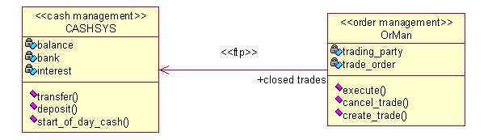
Figure 2: Basic System Collaboration - Elaborated

You may wish to shed additional light upon key business processes in the domain by supplementing the static view of system collaborations with activity or sequence diagrams to show behavior. The diagram below provides a high level context for the processing of a trade in an investment manager organization.
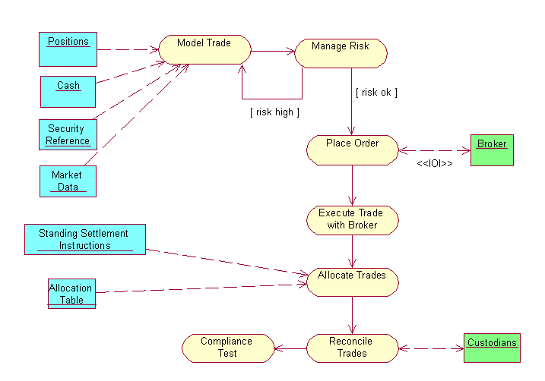
Figure 3: Domain Model - Activity Diagram

Reviewing the Domain Model

You will always want to review and validate your domain model with subject matter experts. When planning for Straight Through Processing, however, you will also want to be cognizant of “red flags” that indicate impediments to STP: manual procedures, slowly executing processes, and redundant data processing. We will want to document any business rules that are applied to our trade data, particularly, data transformation or “scrub” procedures as well as data validation rules. In financial service firms, these transformation and validation procedures are often manually intensive.

One key artifact of RUP4STP that is not found in the generic RUP business modeling discipline is the Trade Timeline. This very important artifact looks at the operational history of each system to determine the elapsed time required to complete its processing. By acknowledging each system’s dependencies, predecessors, and successors, we are able to construct a PERT chart of the pre-trade, trade execution, post-trade, and reporting segments in the trade processing cycle.

Taking into account specialized business rules like scrub and validation procedures, the weaknesses of the Current Trading Model, and the Trade Timeline, the system architect can now represent the optimum trading environment in UML by refining the Future Trade Model. With the goal of compressing trade processing cycles, perhaps ultimately to within one day, the system architect, along with the project manager and business sponsors, will prioritize STP related projects depending on the organization’s Return on Investment..

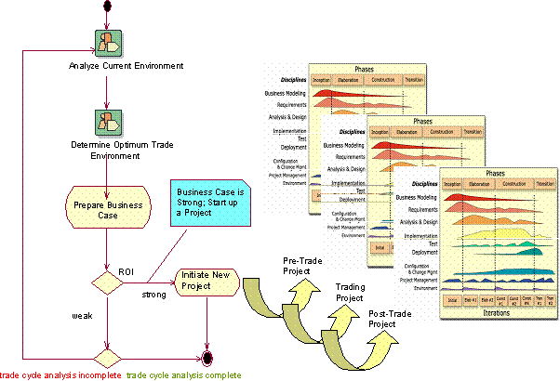
Figure 4: Domain Analysis Spawns Projects

Conclusion

Domain modeling can contribute significantly to creating a better understanding of complex IT challenges such as achieving Straight Through Processing. Documenting your data sources, understanding how these data sources are used, the functional characteristics of each business system, and the collaboration between systems enables you to begin thinking about re-design, re-architecting, or replacing slow or redundant procedures in your business process. Specialized, industry-specific plug-ins to RUP, such as RUP4STP, can accelerate your understanding of your business domain and stimulate ideas for optimizing the exchange of information within your organization and between you and your external trading partners.

RUP4STP is the exclusive trademark of Rambyte, Ltd. The process model and content for RUP4STP were jointly developed by Rambyte, Ltd. and Venture Financial Systems Group, Ltd. For more information, visit the RUP4STP product web site.
See “Straight Through Processing”, Vincent Manning
Rational Unified Process, 2002.05.01, “Workflow Detail: Develop a Domain Model”.
Download and unzip the model, then navigate to Logical View: Current Trade Model

