1a: MTS single screen “square square”
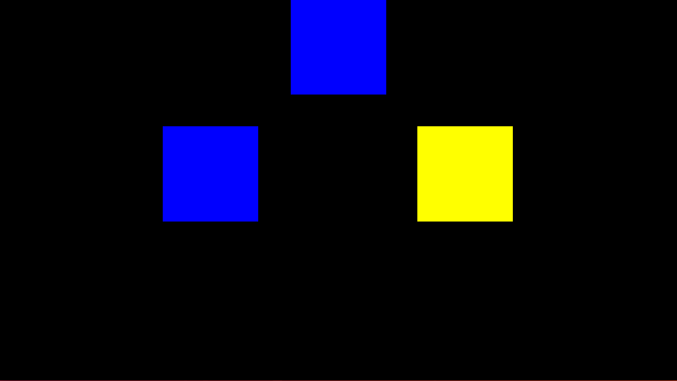

1b: MTS single screen “square circle”
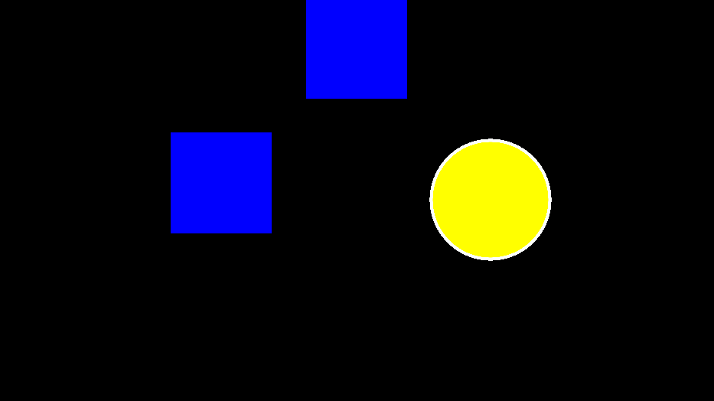

2: MTS single screen “star circle”


3a: MTS dual screen “bluestar yellowcircle” 100-100
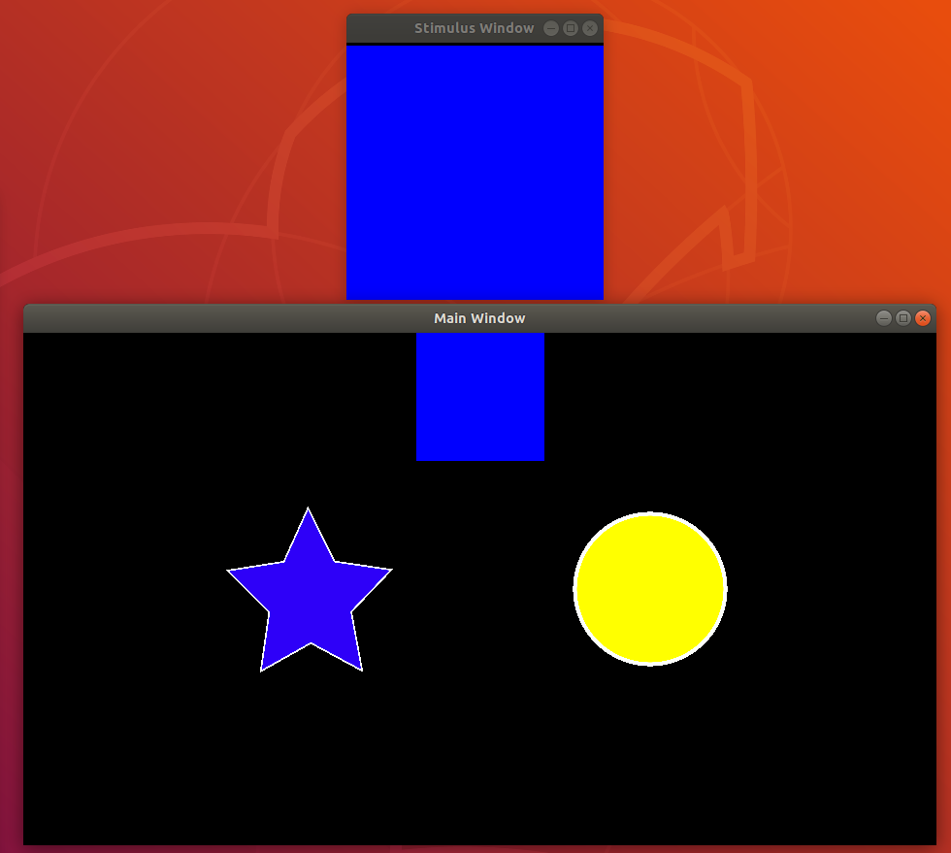

3b: MTS dual screen “bluestar yellowcircle” 50-100
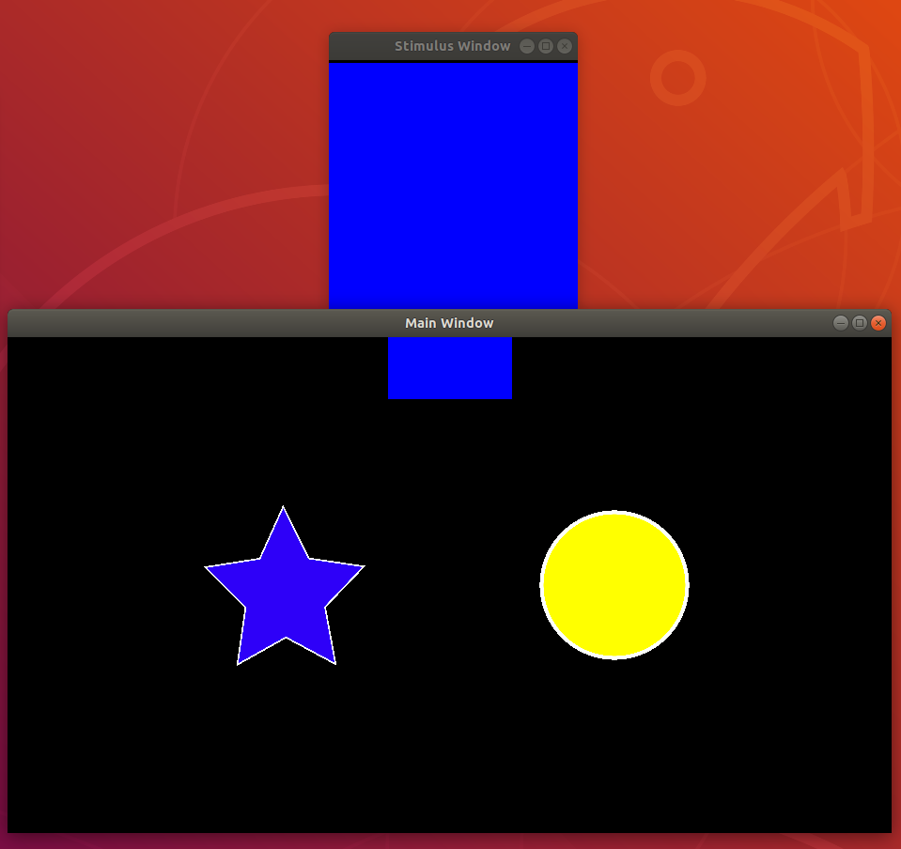

3c: MTS dual screen “bluestar yellowcircle” 25-100
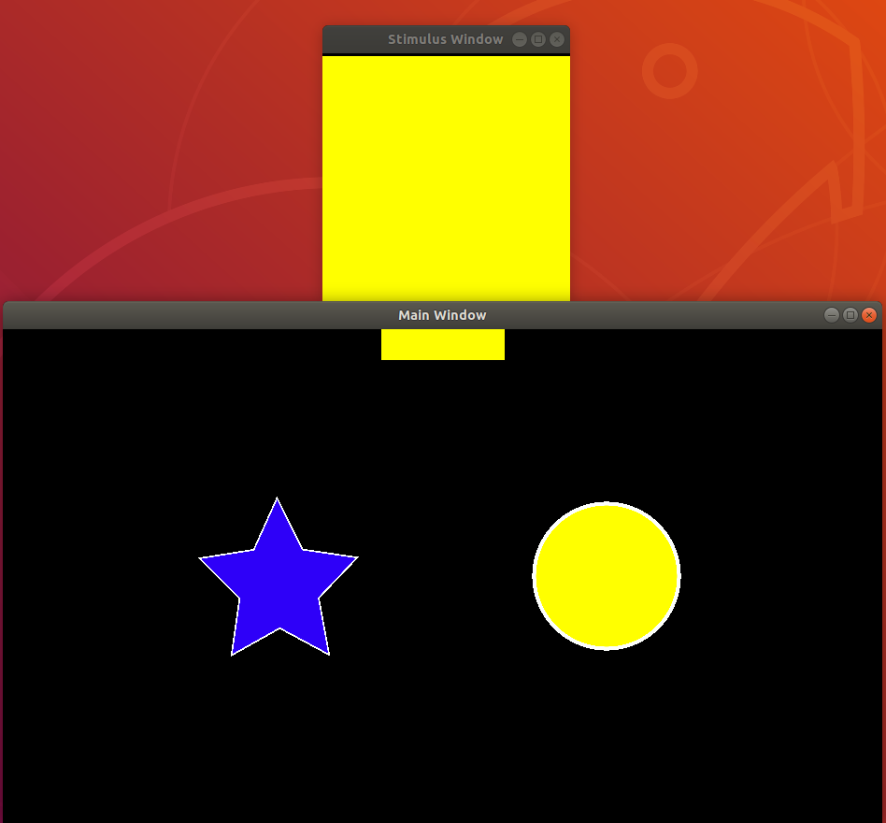

4: MTS dual screen “bluestar yellowcircle” 0-100
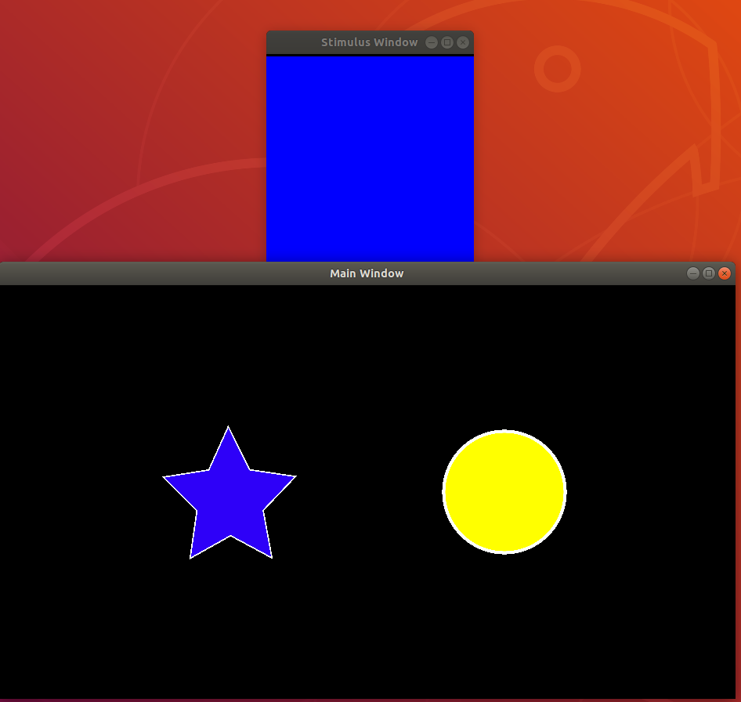

5: MTS dual screen “whitestar yellowcircle” 0-100
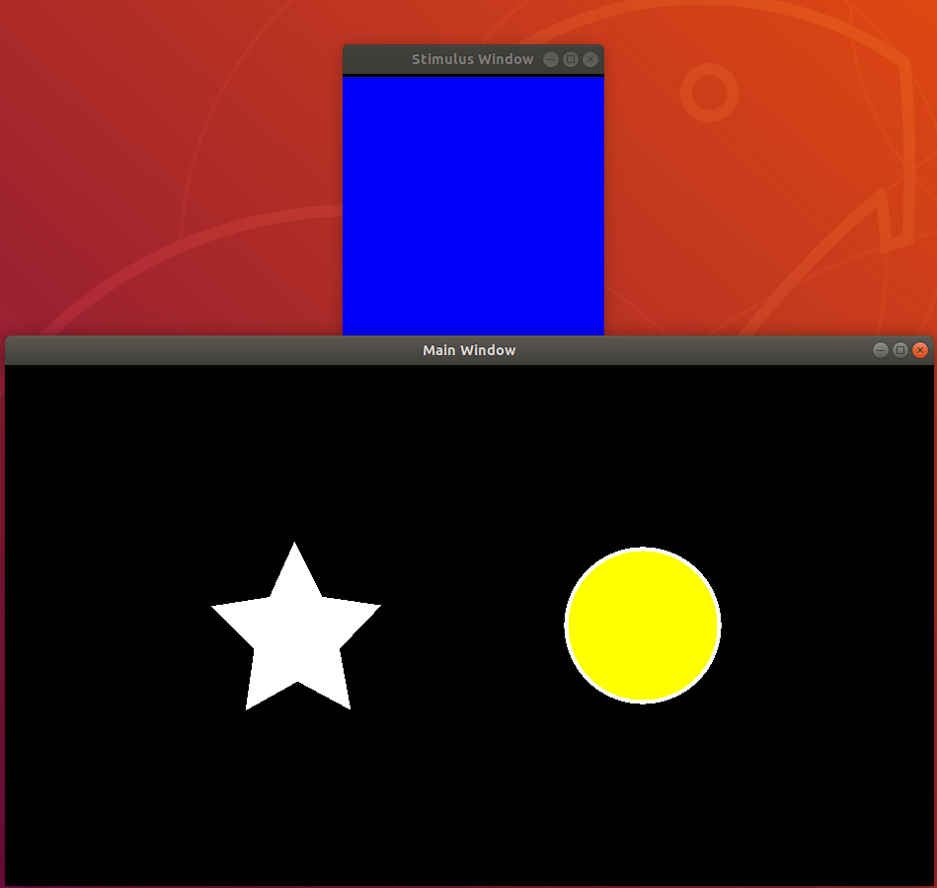

6: MTS dual screen “whitestar whitecircle” 0-100
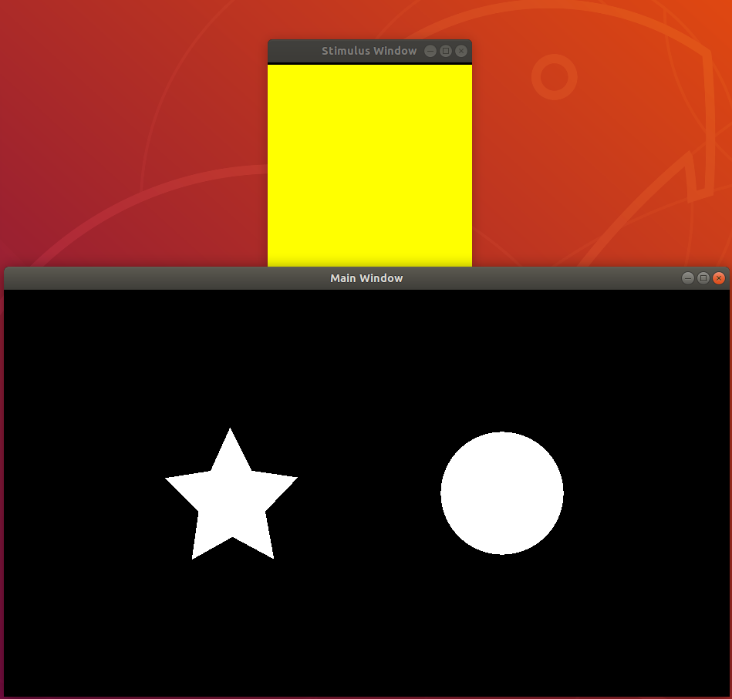

7: Single Stimulus Discrimination, delay 0
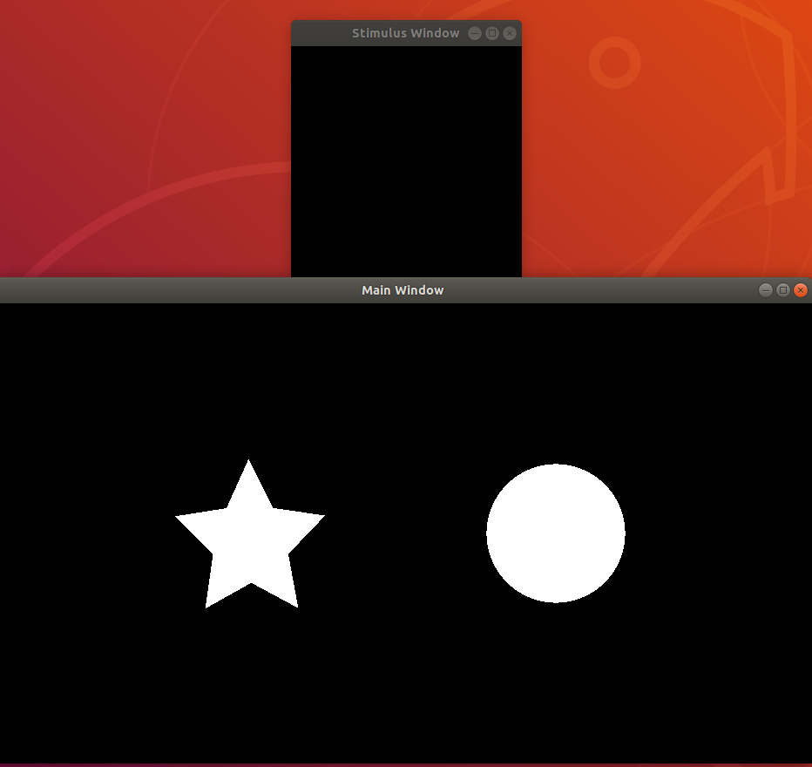

8: Single Stimulus Discrimination, delay 500 ms
