- command: ["python","app.py"]
Make sure in docker-compose use this and try to execute all the commands
Using docker build, start and up
- docker compose build
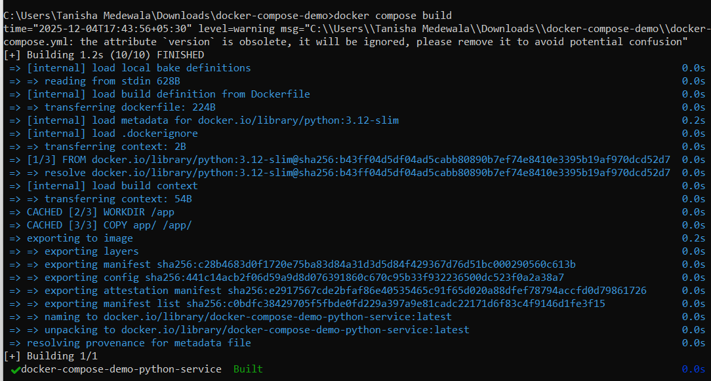
- docker compose create
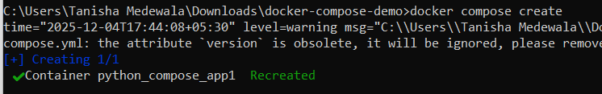
- docker compose up
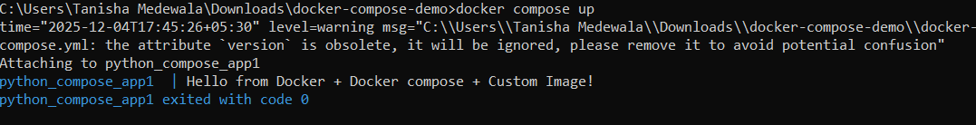
- press enter
- docker ps

- Checking how docker compose works in detached mode, it doesn’t give the output but show the results in logs
- docker compose down
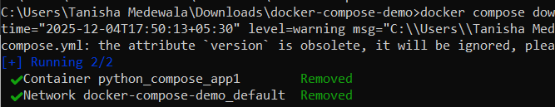

- docker compose up -d
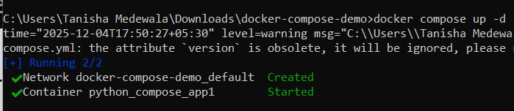

- docker compose logs
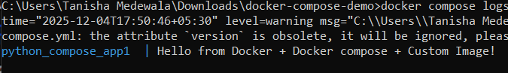

- Now change it to docker-compose this command
command: ["sh", "-c", "python app.py && tail -f /dev/null"]
- docker-compose build or
docker compose build
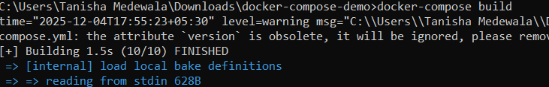
- docker-compose up -d
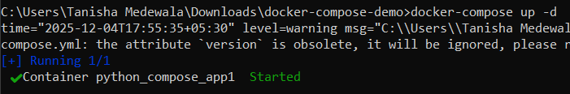
- docker compose logs
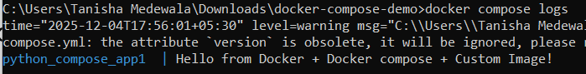

- docker ps

Executing python service
- docker compose build
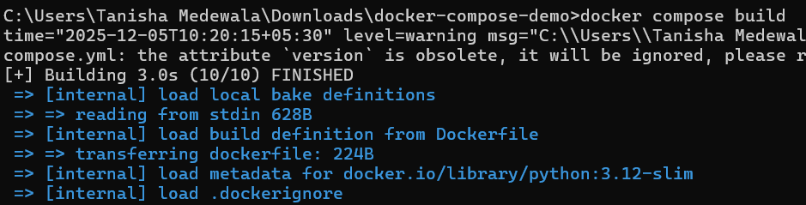
- docker compose start
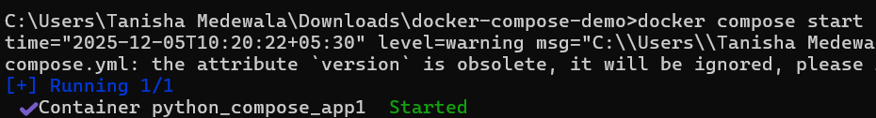
- docker compose exec python-service sh
- python app.py
- exit
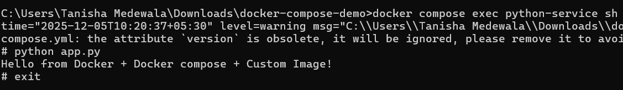
- docker compose exec python-service python
- from app import main
- main()
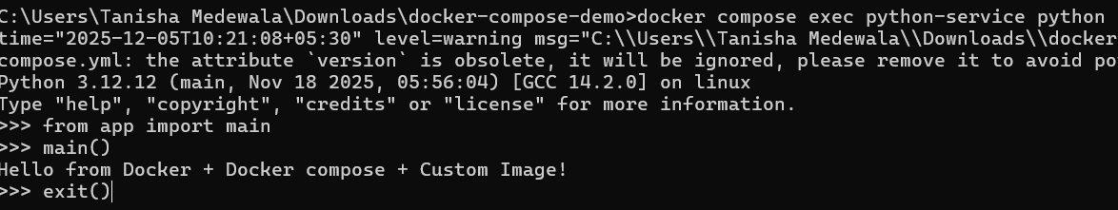

1. docker compose build
What it does:
- Builds the image from Dockerfile
- Shows Dockerfile build logs
What it does NOT do:
- Does NOT create a container
- Does NOT run CMD
- Does NOT show app logs

2. docker compose up
What it does:
- Builds image (if missing)
- Creates container
- Runs CMD or command:
- Shows application logs live
3. docker compose up -d (detached mode)
What it does:
- Same as up
- But runs in background
What it does NOT do:
- Does NOT show app logs in terminal
You must run:
docker compose logs -f

4. docker compose up --build
Same as up BUT forces image rebuild.

5. docker compose up --force-recreate
- Recreates the container even if unchanged
- Always executes CMD again
- Good for: resetting containers
6. docker compose create
What it does:
- Builds image (if needed)
- Creates container
- DOES NOT START IT
So CMD does NOT run yet.
You must start it manually:
docker compose start

7. docker compose start
VERY IMPORTANT
- ONLY starts an already-created container
- It NEVER re-runs CMD
- It NEVER re-runs the app
- It NEVER shows app logs
It simply resumes the old process.

8. docker compose restart
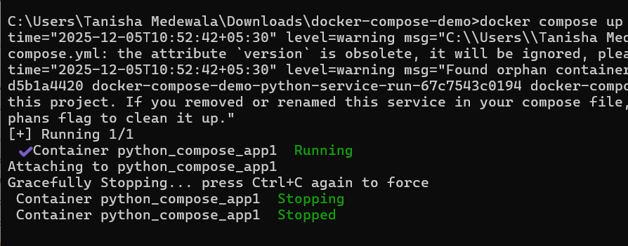
- Stops and starts the container
- Does NOT re-run CMD
- The original process is restarted ONLY if it supports restart
9. docker compose run python-service
- Runs a one-off container
- Executes CMD or provided command
- Shows app logs
10. docker compose logs
- Only shows existing logs
- No build, no container start, no CMD executio

Usecase: command: ["sh", "-c", "python app.py && tail -f /dev/null"]

What docker compose up does
When you run:
docker compose up
Compose:
- starts your container
- executes your command
- attaches your terminal to the container’s logs
But after the Python script finishes, only tail -f /dev/null is running.
tail -f /dev/null produces zero logs, so your screen shows:
Attaching to python_compose_app1
…and then black screen forever.
This means your container is running correctly

Activity – Case Study of Ecommerce
One time data ingestion
1.docker compose up –-build ingest
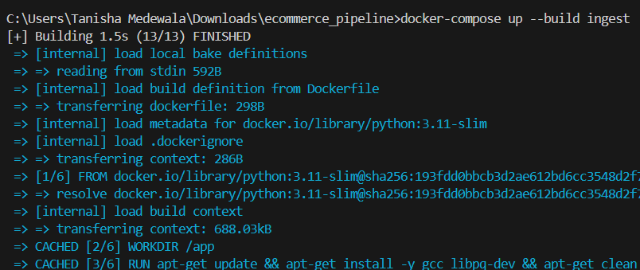
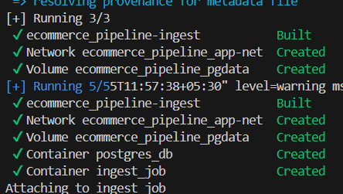
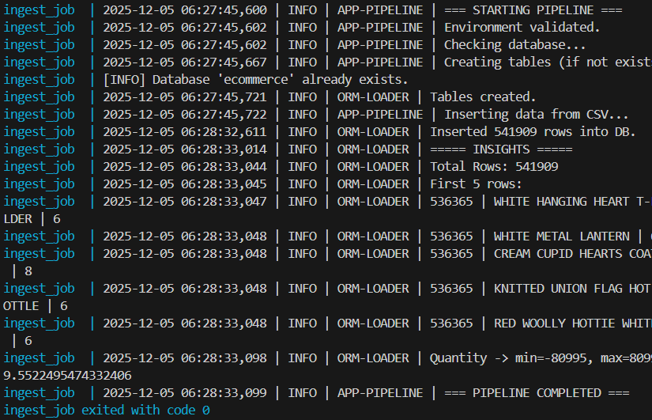

2. docker logs ingest_job
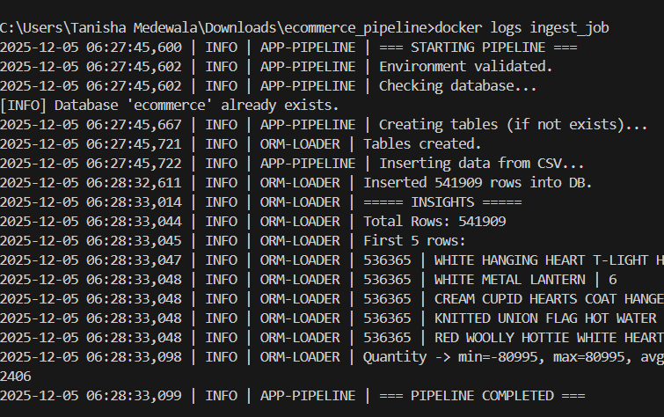

3.docker logs postgres_db
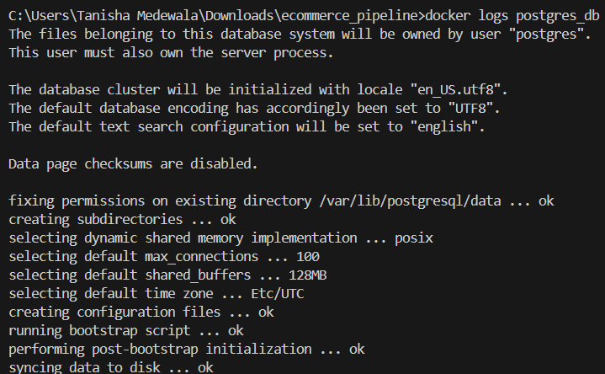
4. docker exec -it postgres_db psql -U postgres -d ecommerce
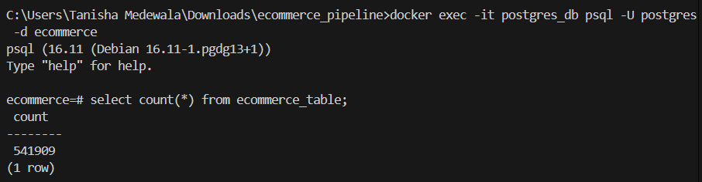
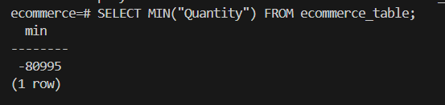
5. docker volume ls
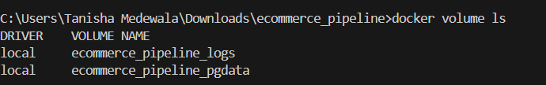
6. docker volume inspect ecommerce_pipeline_pgdata
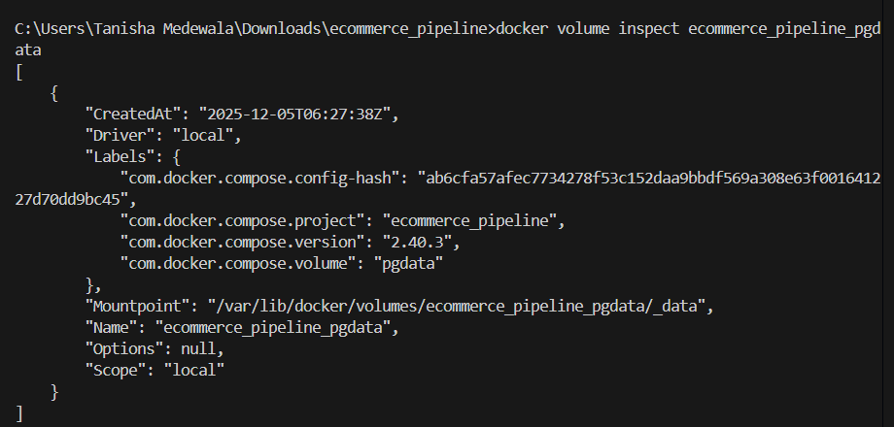

7. docker exec -it postgres_db sh
# ls /var/lib/postgresql/data
