**General ethos**

I got the inspiration when I saw a video showing a website where you can use stock free classical images. I had a look around and decided to use something wider and set that as a background image to the header of the page. From there to match it I decided to use a gradient of colours that varied on the same painting. That came to be some sort of greyish colour. For the background of div-s that are on the page I decided to go with some darker blue colour that would match the university colours as well. I decided to go in the direction of a more relaxed website, because the idea is to make an introductory website about yourself and your degree. I think all of those would together give a nice colourway with a bit of a different design. The website that I used for the painting is <https://artvee.com/> and I specifically chose this image: <https://artvee.com/dl/tarquinius-priscus-entering-rome/>. The website allows you to use the images freely.

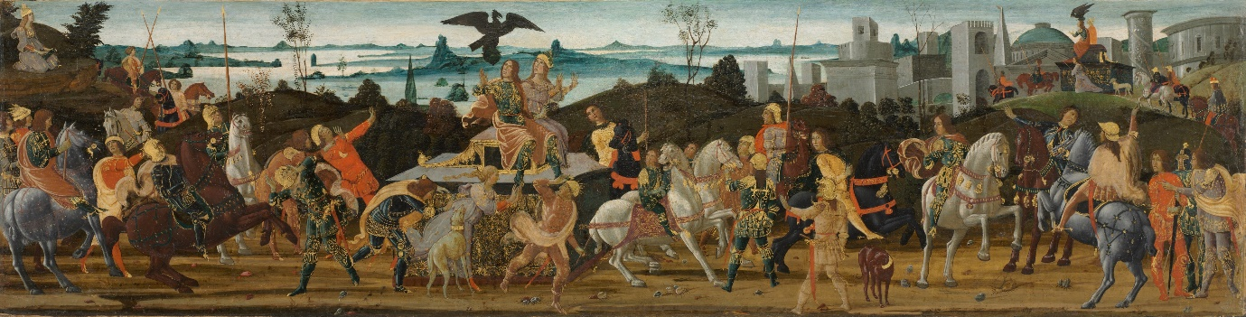

Photo 1. Tarquinius Priscus Entering Rome

**Site map**

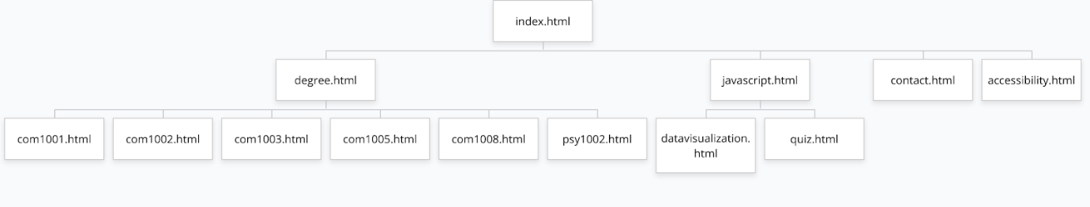

Photo 2. Structure of the website

Index.html is the main page, where there will be a navigation bar at the top of the page, with links to all the other pages. The order is based on what people would generally want to do. I decided to give each module its own page so each one would have more space and it would also be easier to look for a specific module if needed. I decided to put all JavaScript related pages under one page, so afterwards I can keep using the website and add more JavaScript related projects there. Each project has its own dedicated page, and the JavaScript page contains all the links. And the remaining pages would be on their own on the navigation bar along other main pages.

**Accessibility**

To make my website more accessible I will be having a list of different ways to make it suitable for them. I will be adding alt text to images that are necessary, so they can be read using text-to-speech. There will be good contrast between text and background and other elements. It will be possible to use different extensions on the page so people that need those can also access the page. To find out how to make my website more accessible I used the <https://www.w3.org/TR/WCAG21/> site.

**Legal issues**

I will divide the different legal issues into subsections and then discuss them

**Copyright concerns regarding the website**

I will not be using any images that have been copyrighted and I have not been licensed to use. I will only use my own drawn pictures or stock images. With stock images, I will make sure to accept and follow the terms of copyright and make sure that whoever I am taking the images from is the rightful owner.

I will only be using text that has been written by myself.

I will not be using someone else’s scripts for my code and will only write my own, with some inspiration may be taken from other scripts to come up with my own code.

**Defamation**

I will not be stating false information about anyone or anything, that would damage their reputation.

To find out what legal issues are related to websites I used the <https://www.bitlaw.com/internet/webpage.html> site to find the information I have stated above.

**Design Mock-Ups**

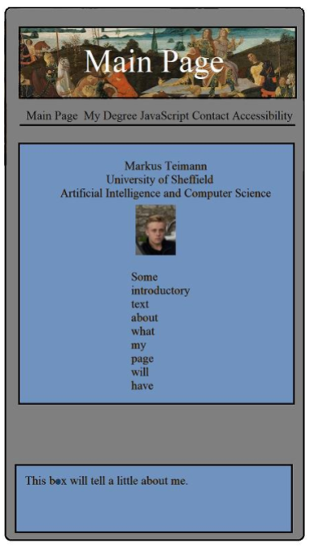

    Photo 3. Mobile mock-up of the website

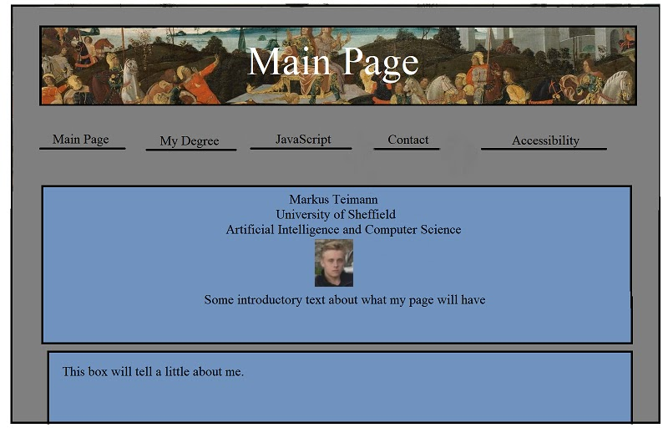

Photo 4. Desktop mock-up of the website

I will be using two breakpoints. One for smaller width phones that have a max width of 400px and one for larger screens including tablets and desktops, that have a minimum width of 768px. I decided to only use these as I will not have that many differing pages. The Main Page along with My Degree page, including all module specific pages, and the Accessibility page will all be quite similar, with only minor adjustment needed for much bigger and/or larger screens. The ones that will be affected the most will be pages that require JavaScript and Contact page, so because of that I think 2 breakpoints will be sufficient to display the screen nicely for all sizes.

All pages will be like the ones brought out here, other than the JavaScript pages, Canvas page and Quiz page, which I have given mock-ups of below.

**Menu System**

For the menu I decided to go with Plain Navigation as said on the <https://cmd-t.webydo.com/from-simple-to-unusual-a-look-at-navigation-in-web-design-1057d0baef7b> site. That would fit my site the best, because first, it fits the design the best. I could have used a hamburger menu, but that just did not look good to me. So, I decided to keep the Plain Navigation with main pages on the top listed in row. Secondly, the other reason why I went for this was because I did not want a dropdown menu for mobile. It would cover up the whole screen and just ruin the design. I want to keep it simple and plain, one click takes you to one page and if needed you can continue going on from there. My page is also quite small, so it will not be very confusing to find anything, so there is no need for a very complex menu. I will be using the same design also for the desktop version, but just with some hover effects to give it some character.

**Canvas and JavaScript demo**

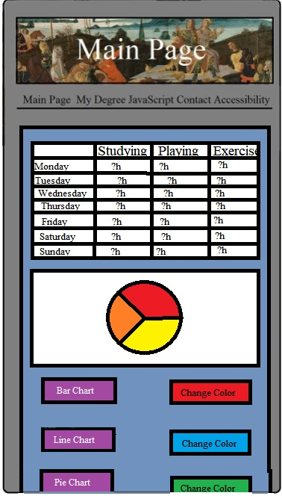

Photo 5. Mock-up design of the canvas page, mobile view

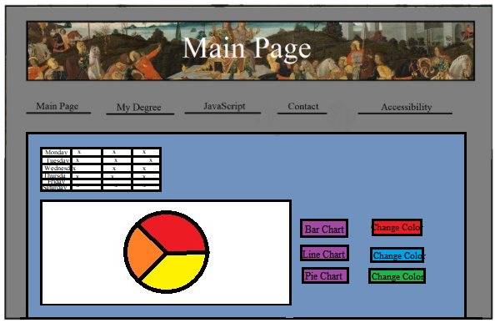

Photo 6. Mock-up design of the canvas page, desktop view

Both desktop and mobile view will be both quite similar except for the canvas size and arrangement of the buttons and the canvas itself. To figure out the basic I used RWD mobile-first web design introductory pages, such as <https://www.w3schools.com/css/css_rwd_intro.asp> and  <https://developers.google.com/search/mobile-sites>. Based on those sites I decided to put the buttons below the canvas for the mobile view so they are easy to access and can view the canvas nicely. For the desktop I put the buttons next to the canvas so all information including the table is in one viewport. For the colours I will have three sets of different colour schemes, all made sure to have big contrast between them so the canvas can be viewed by anyone. I will be displaying the hours I spent on studying, playing games and exercise per week. I will be using bar, line, and pie charts to display that information.

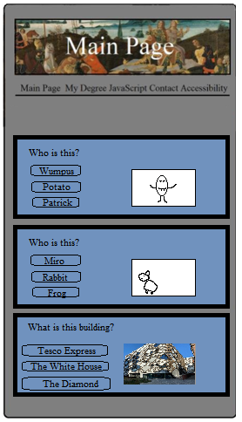

Photo 7. Mock-up design of the quiz page, mobile view

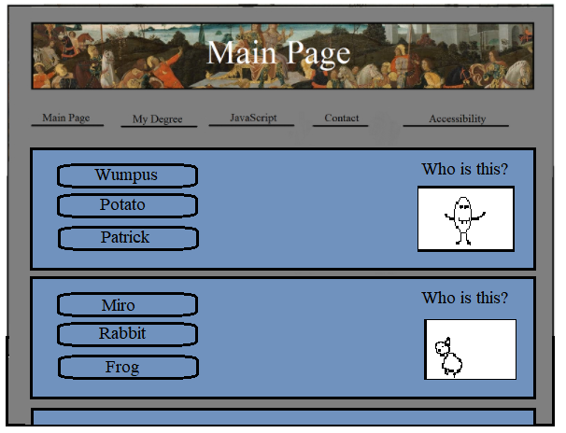

Photo 8. Mock-up design of the quiz page in desktop view

# Reference

Artvee

<https://artvee.com/>

Artvee, Tarquinius Priscus Entering Rome (C. 1470)

<https://artvee.com/dl/tarquinius-priscus-entering-rome/>

W3C, Web Content Accessibility Guidelines (WCAG) 2.1

<https://www.w3.org/TR/WCAG21/>

Bitlaw, Web Site Legal Issues

<https://www.bitlaw.com/internet/webpage.html>

Webydo, A Look into Navigation in Web Design

<https://cmd-t.webydo.com/from-simple-to-unusual-a-look-at-navigation-in-web-design-1057d0baef7b>

W3Schools, Responsive Web Design – Introduction

<https://www.w3schools.com/css/css_rwd_intro.asp>

Google, Advanced SEO

<https://developers.google.com/search/mobile-sites>