**Changes**

I have made some minor changes to the overall design of the website. For the navigation I decided to give each item its own line and changed the colour of the line to white. Also, for the background I decided to change it up a bit to not give it a boring one colour background. I decided to use CSS to give it a look like a line cuts through the background at an angle and the colour is white from there on. I also changed the colours of the button on the canvas so the colour is instead a gradient of all the colours that will be displayed.



Photo 1. The new background design

**Organisation**

As all the pages are quite similar in design, I firstly created the index page where I made the navigation bar, set the background colour, the header, and the background colour for div elements. I then copied the template to all pages and wrote the content on top of that. That made sure that my pages were consistent in design. To keep everything organised I made each type of file its own folder, so it is easy to navigate, all html files are in a folder called sites, CSS under stylesheets, JavaScript code under JavaScript. I did not use debugging tools for JavaScript, I only used HTML and CSS validators. The menu design and organisation I left the same. The main pages appear on the navigation bar at the top and the subpages can be found under the main pages when clicked there. I initially had one JavaScript file to control the canvas and one for the quiz. But as I started increasing the screen size, I realised the canvas is too small for desktop view, so I decided to create another one with different values that would suit the desktop view. I had to create another one, because resizing left the canvas with exceptionally low quality. I also ended up making another breakpoint just for the canvas page because the size of the page could not be decreased a lot for the viewport to still include the canvas and buttons, so I made another one that would play around with the placement of canvas and buttons a little bit.

**Optimisation**

To test the optimisation of my website I used Google Lighthouse when making the webpage and constantly checked how the test results were, as they were mainly quite good there was no need for much optimisation. The only thing I did was compressing my JPG and PNG images to decrease the loading time by a few seconds.

**Security**

Using email forms can cause someone to spam my email, for that there should spam filtering on in my email. So that nothing other than the email address can be put into the form the HTML checks for the validity of what is input. Also, it would be useful and more secure if anti-virus software would check the contents of what is sent so it can be ensured that no malware has been sent to my email. It would be better to use HTTPS with my website to have an SSL certificate. I got the information from <https://seopressor.com/blog/http-vs-https/>.

**Debugging**

I used <https://validator.w3.org/> to do my debugging on HTML. I have brought out an example when I tested my index.html code. I had a <br> between <li> items, which was not correct, so I removed it and edited the CSS for it to produce the same effect. The other error that I had was that I had left nav and header outside of the body, I then simply put them into there, and I got rid of all the errors.

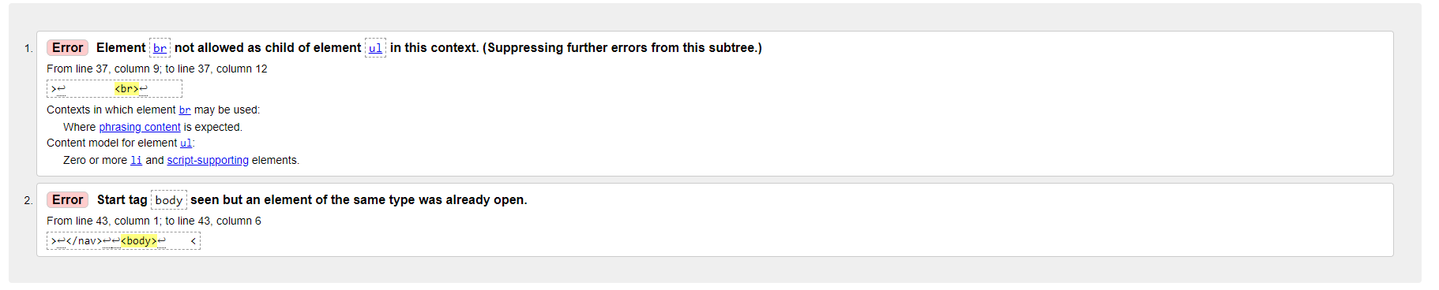

Photo 2. HTML validator result of index.html

I also had 2 errors for all my module pages, where I had left the px next to the width values that I later removed and got rid of the error. I also had a similar error to before where I had left <br> in between nav and after removing it and adjusting the CSS instead I got the same result as before.

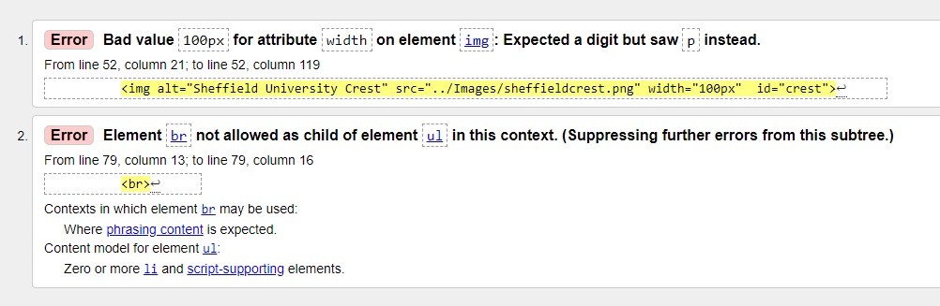

Photo 3. HTML validator result of com1001.html

I also had a few minor errors for contact.htm, datavisulization.html and mydegree.html, but they were all fixed quickly, such as no space between two attributes and an id tag instead of class, when there were multiple occurrences of the same id.

I used <https://jigsaw.w3.org/css-validator/> to validate my CSS files. I had no errors in any of my CSS files, happily.

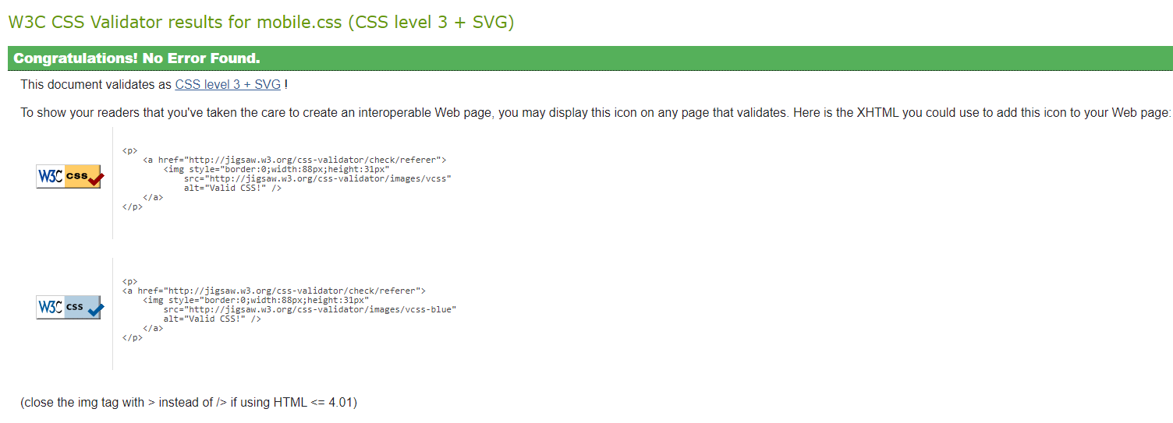

Photo 4. CSS validator results of mobile.css

**Testing**

I was constantly checking Google Lighthouse to see my accessibility and performance results to ensure that my website is good quality and easy to use for everyone. As mentioned in the design document I used two breakpoints, one for desktop and one for smaller phones and using the emulation tools available in Google Chrome I was able to check and make sure my website looks good when using a range of different devices. I have brought out some examples below.

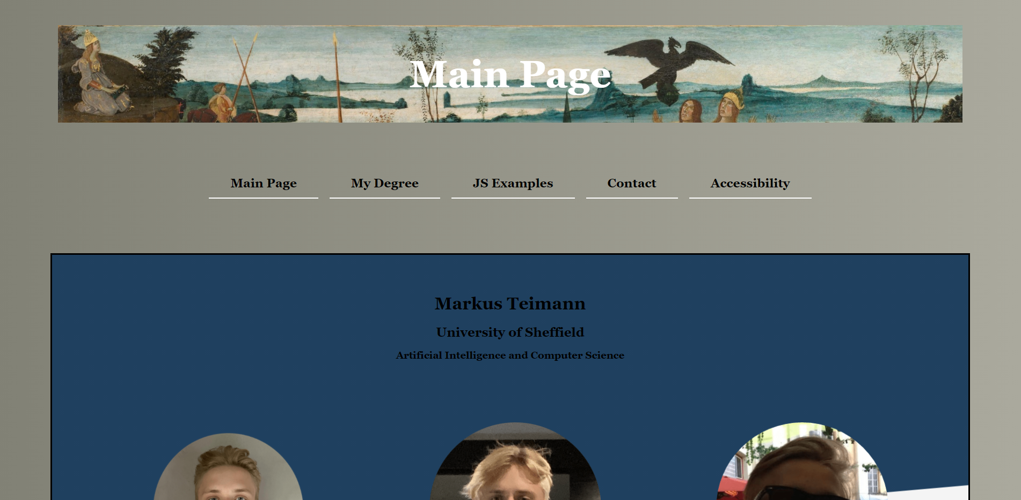

Photo 5. Viewport of the Main Page when using a laptop

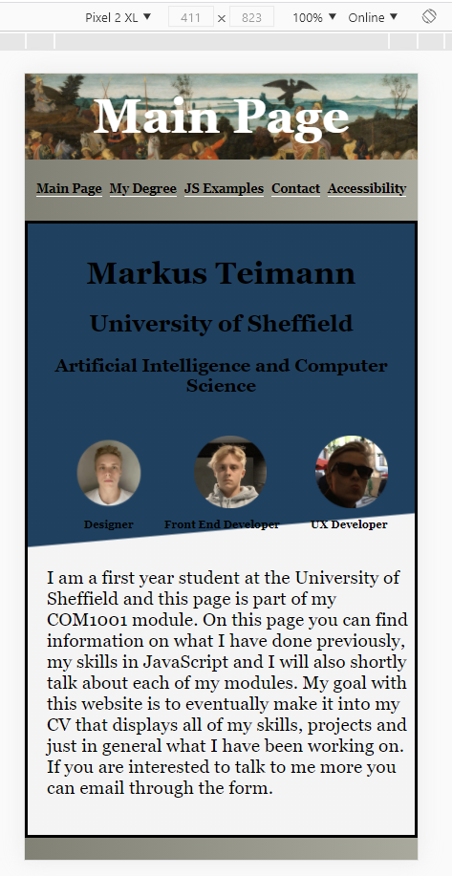

Photo 6. Viewport of the Main Page when using a bigger phone such as Pixel 2 XL.

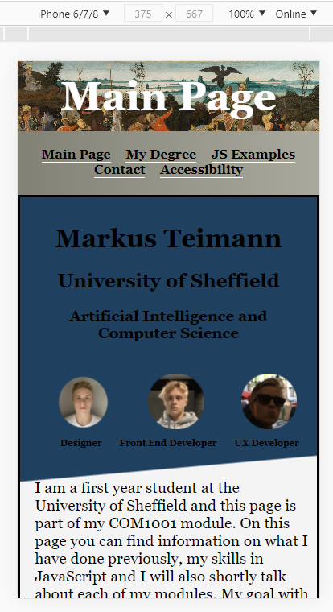

Photo 7. Viewport of the Main Page when using a smaller phone such as iPhone 6

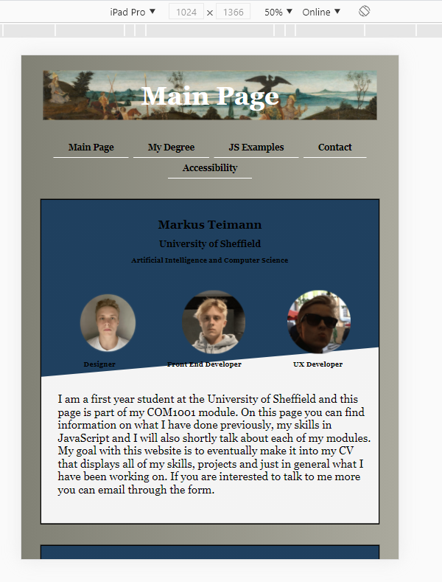

Photo 8. Viewport of the Main Page when using a big device such as iPad Pro

To validate website, I used Google Lighthouse. The results were exceptionally good for both mobile and desktop. For mobile all values except accessibility were mostly in the range of 94 to 100. Accessibility was mostly in the range of (examples below) 95 to 100. For desktop, the results were even better, with all values except accessibility being around 100. Accessibility was still good with averaging about 95 for that.

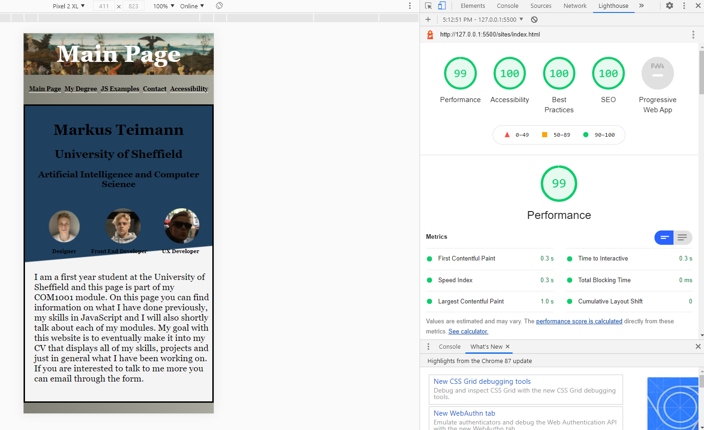

Photo 9. Accessibility results on Google Lighthouse of desktop

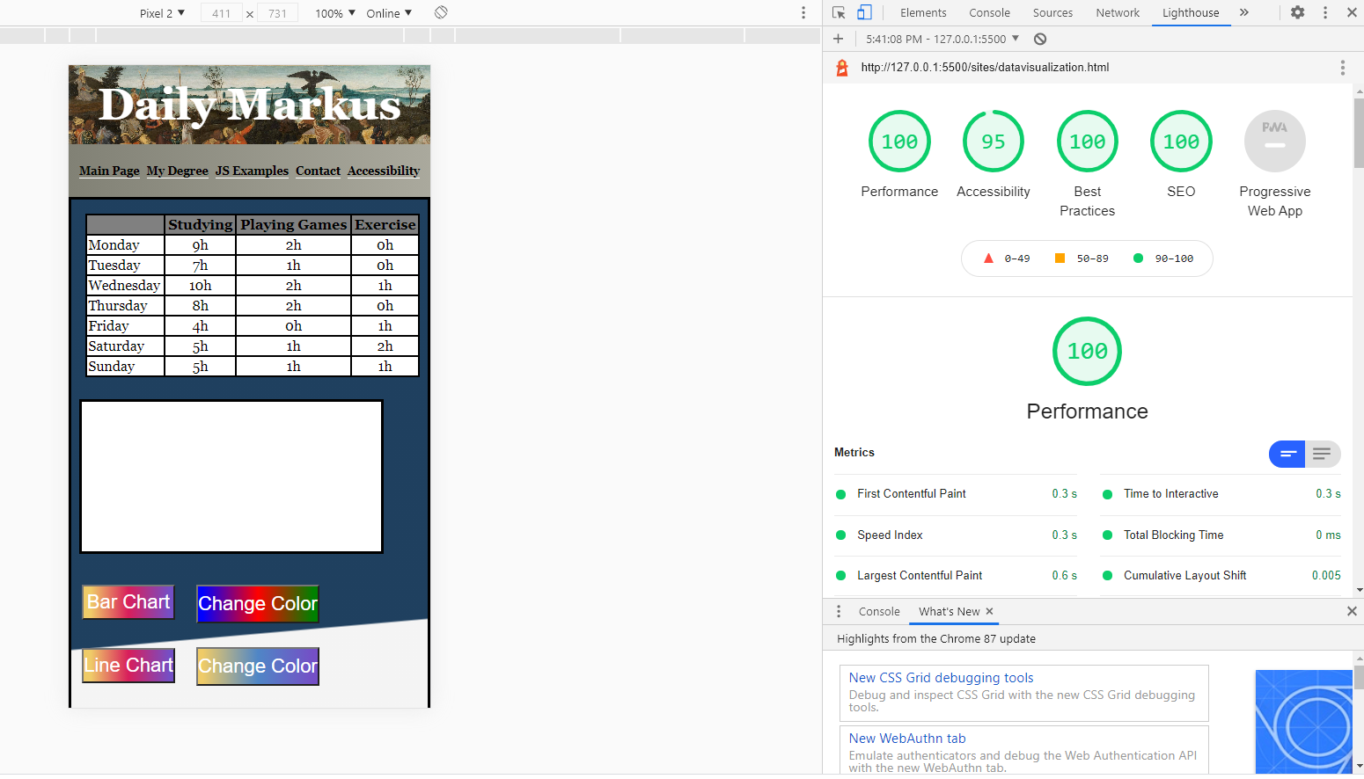Photo 10. Accessibility results on Google Lighthouse of desktop

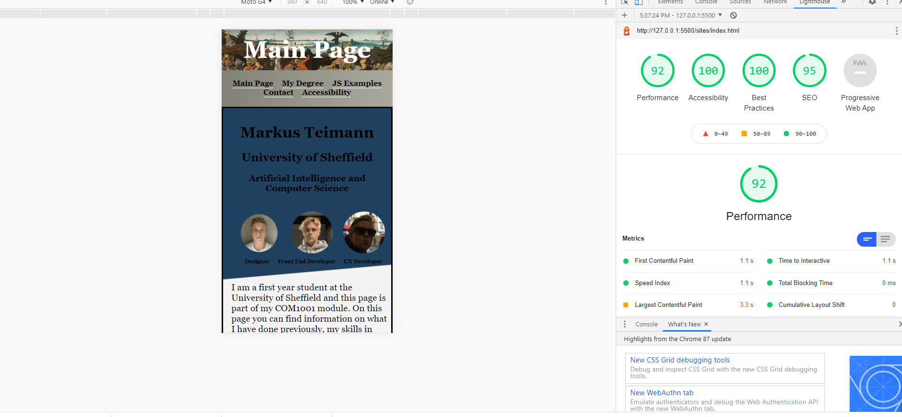

Photo 11. Accessibility results on Google Lighthouse of mobile.

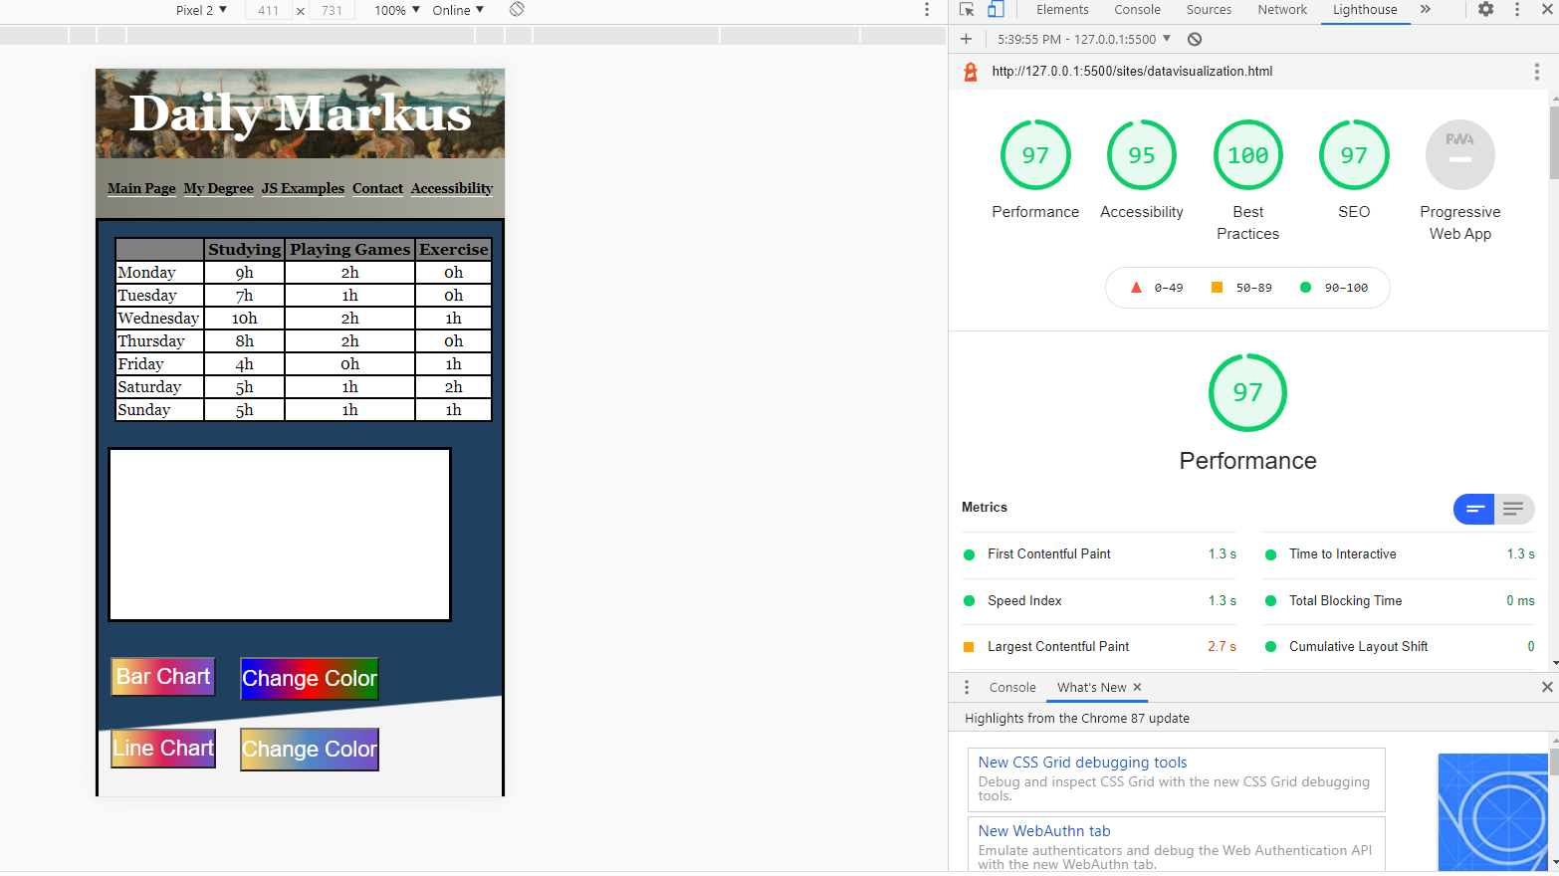Photo 12. Accessibility results on Google Lighthouse of mobile

# References

W3C, Markup Validation Service

<https://validator.w3.org/>

W3C, CSS Validation Service

<https://jigsaw.w3.org/css-validator/>

 Jiathong, HTTP vs HTTPS: The Difference And Everything You Need To Know

<https://seopressor.com/blog/http-vs-https/>